CAPUT XXVIII

Posterō diē, cum iam omnia ad iter faciendum parāta essent, Drūsilla, forās ēgrediēns,
On-following day when already all-things for journey making prepared had-been Drusila out going
forte līmen pede offendit; quō cāsū paulum āfuit quīn in caput praecipitārētur.
by-chance threshold with-foot hit by-which mishap little it-was-way that-not onto head she-was-thrown-forward
Quae "Ēheu!" inquit. "Ōmen quam īnfaustum ! Profectō dī nōs vetant hodiē 5iter facere."
She oh-no said omen how inauspicious obviously gods us forbid today journey to-make
"Nolī tam facile perturbārī," inquit Cornēlius. "Haec omnia sunt fortuīta; nec nōs decet
Don’t so easily be-upset said Cornelius these all-things are accidental and-not is-proper
religiōne vānā terrērī. Audācter in raedam ēscende. Simulatque iter facere incipiēmus,
by-superstition meaningless to-be-scared boldly into wagon climb-up as-soon-as journey to-make we-will-begin
tū nōn diūtius hoc memineris."
You not longer this will-remember
10 Tālī cohortātiōne inducta Drūsillā in raedam ēscendit, etsī mēns eius adhūc ōmine
By-such encouragement influenced Drusilla into wagon got although mind her still by-omen
īnfaustō sollicita erat. Cornēlius autem, quō facilius uxōris animum ā cūrīs tālibus āverteret,
unlucky troubled was Cornelius now so-that more-easily wife’s mind from cares such he-could-divert
praetervolantēs aquilās quāsdam dēmōnstrāns: "Aspice," inquit, "ōmen pulcherrimum.
flying-past eagles certain pointing-out look he-said omen very-fine
Rōmānae avēs, quasi ducēs viae, praeeunt; 15 optimīs certē auspiciīs eās sequimur."
Roman birdss as-if leaders of-way go-aheaad with-excellent certainly portents then we-are-following
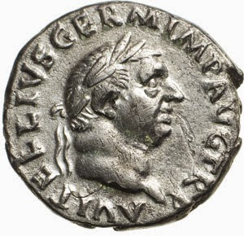
Denarius of Vitellius with inscription: A[ULUS] VITELLIUS GERM[ANICUS] IMP[ERATOR] AUG[USTUS] TR[IBUNICIA] P[OTESTATE]
http://blog.artemideaste.com/2015/02/vitellius-ninth-of-twelve-caesars.html
"Nōnne memoriae trāditum est," inquit Pūblius, "imperātōrem Vitellium ōlim fortiter
Not-? to-memory handed-down has-been said Publius emperor Vitellius once bravely
accēpisse ōmen etiam magis horrendum?"
to-have-received omen even more dreadful
"Rēctē quaeris," inquit pater. "Nam eō ipsō diē, quō ā 20 mīlitibus imperātor salūtātus
Rightly you-ask said father for on-that actual day on-which by soldiers as- emperor hailed
est, triclīnium flagrāvit. Cumque omnēs quasi ōmine adversō anxiī essent, ille sōlus hilaris:
he-was dining-room caught-fire and-when all as-if from-omen unfavouraable anxious were he alone cheerful
'Bonō,' inquit, 'animō ēstote; nōbīs adlūxit!' Quibus verbīs ōmen in bonum vertit.
With-good he-said spirit be to-us it-has-brought-light with-which words omen into good-one he-turned
"Ac dē dictātōre Caesare aliquid eius generis scrīptum esse 25 recordor. Nam ille in
And about dictator Caesar something of-this kind written to-be I-remembder for he into
Āfricam ōlim trānsvectus, cum ex nāvē ēgressus ad lītūs cymbā pervēnisset, pede offēnsō,
Africa once conveyed when from ship having-disembarked to shore in-skiff he-had-reached with-foot caught
prōnus in harēnam prōlāpsus est. Quō casū comitēs perterritī sunt, at ille: 'Aspice ōmen
face-down onto sand fell forward by-which event companions terrified were but he look-at omen
optimum,' inquit; 'Āfricam oppressī!'"
very-good said Africa I-have-beaten-down
"Apud Suētōnium," inquit Pūblius, "aliud memoriā dignum nūper animadvertī. Cum
In Suetonius said Publius another of-memory wothy recently I-noticed when
enim Līvia Augusta 30 vīllam suam Vēientānam ōlim revīseret, aquila praetervolāns in eius
for Livia Augusta villa her at-Veientian once was-going-out eagle past-flying into her
gremium dīcitur demīsisse gallīnam albam, quae rāmulum laurī rōstrō tenēret.
lap is-said to-have-dropped hen white which twig of-laurel in-beak was-holding
"Cumque nutrīrī gallīnam rāmulumque pangī Līviae placuisset, tanta gallīnarum
And-when to-be-cared-for hen and-twig to-be-planted Livia it-had-pleased so-great of-hens
subolēs prōvēnit, ut posteā ea vīlla 35 'ad Gallīnās' vocārētur, tāle vērō laurētum, ut
brood resulted that afterwards villa `Ad Gallinas’ was-called such indeed laurel-grove that
inde rāmulōs Caesarēs triumphātūrī dēcerperent.
From-there twigs the-Caesars about-to-celebrate-triumphs plucked
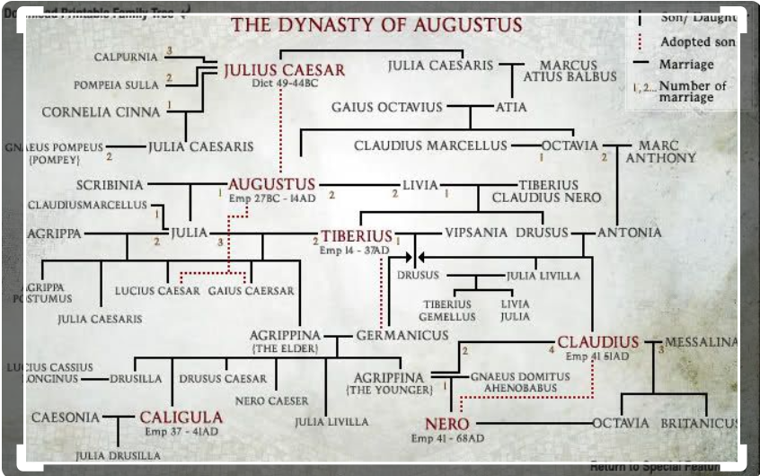
https://www.pbs.org/empires/romans/special/family_tree.html
"Quotiēnscumque arbor discerpta erat, altera eōdem locō pangēbātur. Et observātum est
Whenever a-tree torn-up had-been another in-same-place used-to-be-planted and observed it-was
sub mortem cuiusque imperātōris arborem ab ipsō īnstitūtam ēlanguisse. Novissimō 40
just-before death of-each emperor tree by himself put-in-place to-have-withered in-last
igitur Nerōnis annō silva tōta radīcitus exāruit, omnēsque gallīnae illae periērunt; nam
therefore of-Nero year grove whole from-roots dried-up and-all chickens those died for
prōgeniēs Caesarum in Nerōne dēfēcit."
the-line of-the-Caesars in Nero ran-out
Dum hīs et tālibus sē oblectant, Drūsilla cūrās suās paulum remīsit;
While with-these and such-things themselves they-were-amusing Drusilla cares her a-little laid-aside
cumque iam ferē quīndecim mīlia passuum fēcissent 45 iter, līberī, quī male ēsuriēbant,
and-when now about fifteen thousands of-paces they-had-made journey children who terribly were-hungry
patrem ōrāvērunt, ut equōs cōnsistere iubēret, sub arboribus ut cibum ederent, quem corbulīs
father begged that horses to-stop he-should-order under trees so-that food they-could-eat which in-baskets
sēcum portāvissent.
with-themselves they-had-brought
Potestāte factā, omnēs libenter ex raedīs dēscendērunt ac mox per herbam ōtiōsī
With-permission given all gladly from wagons got-down and soon over grass calm
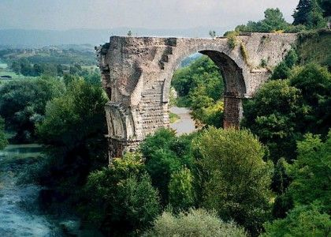
Remains of the Bridge of Augustus which carried the Via Flaminia over the River Nar (Nera) near Narnia (Narni) in Umbria

dispositī sunt. Līberī, cibō consūmptō, 50 longius vagātī erant, quō lātius loca
seated were children with-food eaten further wandered has so-that more-widely places
explōrārent,cum subitō Sextus maximō clāmōre ē silvā parvā ērūpit, ac quantum celeritāte
they-could-explore when suddenly Sextus with-very-loud cry out-of wood small burst and as-much with-speed
potuit ad raedās tendēbat.
[as]-he-could to wagons began-heading
"Periī!" inquit Drūsilla, perterrita exsiliēns. "Ubi est 55 Cornēlia? Mē miseram! Nesciō
I’m-dead said Drusila terrified jumping-up where is Cornelia me wretched I-know-not
quid malī puellae accidit! Haud falsō admonuī hunc diem nōbīs īnfaustum fore! Ō mē
what of-evil to-girl has-happened not falsely I-warned this day for-us unlucky to-be-going-to-be
miseram! Quō mē vertam?"
miserabe where myself am-I-to-turn
Interim Cornēlius et Pūblius cum servīs obviam Sextō properāverant, ut līberīs
Meanwhile Cornelius and Publius with slaves to-meet Sextus had- hurried so-that to-children
opitulārentur, sī quid opus esset. 60 At Sextus, cum patris complexū receptus esset, prīmō
they-could-give-help if any need there-was but Sextus when father’s with-embrace received he-had-been first
prae metū nihil omnīnō ēnūntiāre potuit. Tum, singultū vōcem interpellante, dīxit duōs
from fear nothing at-all say-out could then with-sob voice interrupting he-said two
hominēs, quī subitō ex arborum umbrā exsiluissent, Cornēliam arreptam in silvam
men who suddenly from of-trees shadow had-jumped Cornelia snatched into forest
dēnsiōrem sēcum abstulisse.
denser with-thm to-have-taken-away
65 Quō audītō, omnēs sine morā in silvam sē praecipitāvērunt; ubi autem, etsī longē et
With-which heard all without delay into forest selves hurled where however although far and
lātē quaerēbant, puellae vestīgium reperīre potuērunt nūllum. Quārē ad raedās reversī inter
wide they-kept-searching of-girl trace find they-could none so to wagons returning among
sē breviter cōnsuluērunt, quid iam optimum factū esset.
Selves briefly they-discussed what now best to-do was
Interim Drūsilla dolōre paene āmēns, veste discissā ultrō 70 citrōque cursitābat, sē
Meanwhile Druilla with-grief almost out-of-mind with-clothing torn to and-fro kept-running herself
suōsque omnēs vehementer incūsāns quod ōmine tam manifēstō nōn admonitī essent et
and-her-family all forcefully blaming because by-omen so clear not warned they-had-been and
deīs invītīs iter facere eō diē persevērāssent.
with-gods unwilling journey to-make on-that day they-had-insisted
Cui tandem Cornēlius: "Nōlī dēspērāre, uxor," inquit. "Sine dubiō hī hominēs latrōnēs
To-whom at-last Cornelius do-not despair wife said without doubt these people bandits
sunt; sed pecūniā75 tantum opus est, quā fīlīa redimātur. Puellam ipsam laedere nōn volent."
are but of-money only need is by-which could-be-ransomed girl herself to-harm not they-will-want
At iam subitō Pūblius: "Quid est hoc," inquit, "quod videō? Nōnne procul est mulier,
But now suddenly Publius what is this he-said that I-see not-? in-ditance there-is woman
quae aliquid nobīs manū significāre cōnātur?" Quae cum dīceret, digitō mōnstrābat saxum, in
who something to-us with-hand to-convey is-trying this when he-was-saying with-finger he-was-showing rock on
quō stābat mulier, quae modo dīversā ex parte silvae ēgressa erat.
which was-standing woman who just-now different from part of-forest come-out had
80 "Ita est, ut tū dīcis," inquit Cornēlius. "Mulier manū aliquid tenēre vidētur, quod nunc
Thus it-is as you say daid Cornelius woman in-hand something to-be-hold ing seems which now
in saxō pōnit. Iam autem in silvam sē recēpit. Tū, Pūblī, cum Onēsimō et Stasimō
on rock she-is-placing now however into forest herself she-has-taken-back you Publius with Onesimus and Stasimus
ad saxum properā, ut statim sciātur quid sit id, quod ibi ab eā relictum est." Quō audītō,
to rock hurry so-that at-once may-be-known what is it which there by her left has-been with-which heard
illī celeriter abiērunt.
they quickly went-away
85 In saxō inventa est charta, litterīs cruentīs īnscrīpta, quam Stasimus effūsō cursū
On rock found was paper in-letters of-blood written which Stasimus with-full-speed running
ad dominum rettulit. Chartā raptim perlēcta, Cornēlius ēnūntiāvit fīliam ā latrōnibus captam
to master brought-back with-paper rapidly read-through Cornelius announced daughter by bandits captured
esse, quī spondērent sē puellam incolumem pārentibus trāditūrōs, sī intrā diēs trēs pater
to-have-been who pledged selves girl safe to-parents going-to-hand-over if within days three father
inermis sine comite ad saxum illud trīgintā 90 sēstertia adferret, quibus fīlia
unarmed without companion to rock that thirty thousand- sesterces brought with-which daughter
redimerētur; aliter puellam gladiō occīsum īrī.
could-be-ransomed otherwise girl with-sword killed going-to-be
Quae ubi cognita sunt, Drūsilla ululātū ācrī in terram cecidit, ibique exanimāta iacēbat.
These-things when learned were Drusila with-wail piercing to ground fell and-there unconscious lay
Quam cum Anna cūrāret, Stasimō Cornēlius imperāvit ut summā celeritāte contenderet ad 95
Her while Anna was-caring-for to-Stasimus Cornelius gave-order that with-greatest speed he-should-hurry to
oppīdum Narniam (quod iam haud procul aberat), ut inde equōs citōs addūceret.
town Narnia which now not far was-away so-that from-there horses swift he-could-bring
Tum, Drūsillā in raedam sublātā, omnēs maestī ad oppidum profectī sunt. Sed dīmidium
Then with-Drusilla onto wagon lifted all sad to town set off but half
viae vix cōnfectum erat, cum occurrit Stasimus equīs cum recentibus.
of-way hardly completed had-been when met [them) Stasimus horses with Fresh
100 Hōs ipsī et Onēsimō trādidit Cornēlius, cum mandātō ut Rōmam quam
These to-[Stasimus]-himself and to-Onesimus handed-over Cornelius with instruction that to-Rome as-possible
celerrimē properārent, ut inde reportārent pecūniam, quā iam opus esset; nē diem
as-quickly they-should-hurry so-that from-there they-could-bring-back of-which now need there-was not day
noctemve intermitterent, nēve aut sibi aut equīs parcerent.
or-night they-should- stop not either selves or horses should- spare

Servī libenter cursū incitātō abiērunt. Cornēlius autem cum 105 cēterīs in oppidum
Slaves willingly at-speed full went-off Cornelius now with the-others into town
perrēxit, ubi nox sollicita et inquiēta exācta est.
continued where night anxious and disturbed spent was
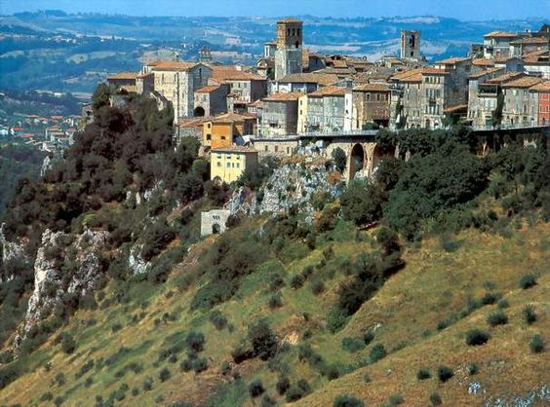
Modern Narni (ancient Narnia)
https://www.pinterest.es/pin/205617539209393406/

Sed māne praeter opīnīonem Onēsimus et Stasimus praestō fuērunt, quī nūntiāvērunt sē
But in-the-morning outside expectation Onesimus and Stasimus on-the-scene were who announced selves
in itinere obviōs factōs esse cuidam Tulliō, amīcō Cornēlī, quī pecūniam grandem sēcum
on journey in-way-of become to-have a-certain Tullius friend of-Cornelius who money large-amount with-self
portāret, quīque mūtuum dare vellet quodcumque ad puellam līberandam 110 opus esset.
was-carrying and-who on-loan to-give wanted whatever for girl being-freed needed was
Quō audītō, omnēs gaudiō et spē suspēnsī, adventum Tullī cupidē exspectābant. Quī,
With-which heard all with-joy and hope anxious arrival of-Tullius eagerly were-awaiting he
cum hōrā ferē quārtā pervēnisset, crumēnā solūtā, Cornēliō trīgintā sēstertia
when at-hour about forth he-had-arrived with-money-bag untied to-Cornelius thirty thousand-sesterces
in mēnsā numerāvit.
on table counted
Tum ille cum Stasimō sōlō profectus, ut ad locum pervēnit 115 ubi raedae prīdiē
Then he with Stasimus alone having-set-out when to place he-reached where wagons previous-day
cōnstiterant, ibi servum quoque relīquit et inermis ad saxum cōnstitūtum prōgressus est.
had-halted there slave also he-left and unarmed to rock appointed advanced
Iam subitō ē silvā signum est audītum, latrōque ingēns ē latebrīs ad saxum rēctā
Now suddenly from forest signal was heard and-bandit huge from hiding-place to rock directly
prōcessit. Quī cum vīdisset Cornēlium inermem pecūniam attulisse, signum alterum dedit, ac
proceeded He when he-had-seen Cornelius unarmed money to-have-brought signal another gave and
mulier 120 Cornēliam ē silvā prōdūxit.
woman Cornelia from forest led-forward
Dum illa, gaudiō ēlāta, in complexum patris sē praecipitat, latrō, pecūniā arreptā, in
While she with-joy elated into embrace of-father herself hurled robber with-money seized into
silvam cum muliere celeriter rediit; utque prīmum Cornēlius et fīlia sē circumspexērunt,
forest with woman quickly returned and-when first Cornelius and daughter themselves looked-around
nēmō iam in cōnspectū erat. 125
nobody now in sight was
Quō animadversō, Cornēlius: "Age, fīlia mea," inquit; "adde gradum. Stasimus cum
With-which noticed Cornelius come -on daughter my said increase pace Stasimus with
equīs haud procul exspectat ; ac brevī in gremiō eris mātris, quae nunc in dēversōriō metū
horses not far-off is-waiting and soon in embrace you-will-be of-mother who now in inne from-fear
exanimāta iacet."
fainting lies
Quae cum dīceret, Cornēliam ad equōs dūcēbat; quibus 130 celeriter in oppidum
Which-things while he-was-saying Cornelia to horses he-was-leading on-which quickly into town
provectī, ab omnibus summō gaudiō acceptī sunt; ac māter et fīlia in lacrimās effūsae,
having-riddne by all with-greatest joy received they-were and mother and daughter into tears bursting
mūtuō complexū tenēbantur.
in-mutual embrace were-held
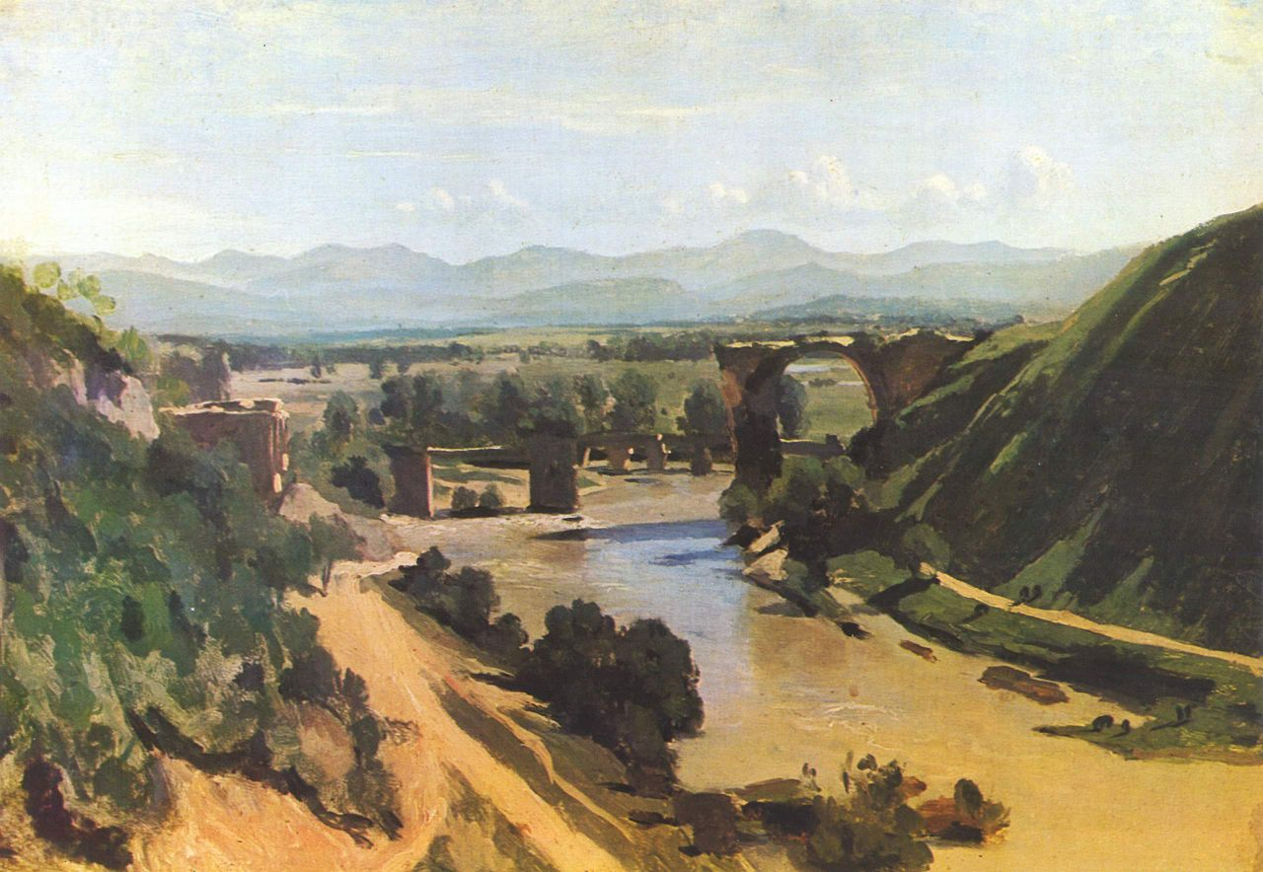
Jean-Baptiste-Camille Corot’s `The Bridge at Narni’ (1826)
CAPUT XXIX

Manē viātōrēs, cum grātiās maximās Tulliō ēgissent, Nūceriam versūs profectī sunt;
In-morning the-travellers when thanks gratest to-Tullius they-had-paid Nuceria towards set off
quō pervēnērunt, cum iam nūbēs nigrae in caelō cōgerentur. Paulō post imber est cōnsecūtus.
at-which they-reached when already clouds black in sky were-gathering a-little later shower folllowed

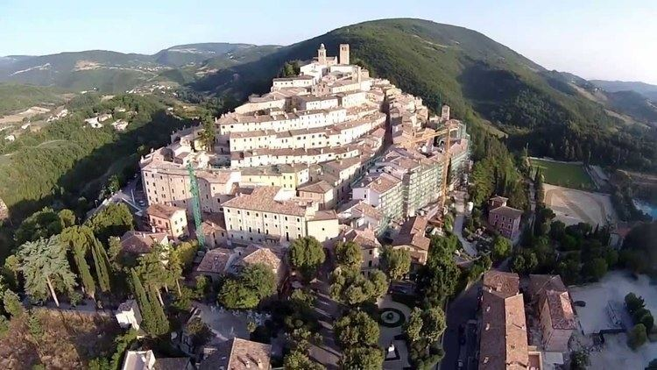
Nuceria (modern Nocera)
https://en.wikipedia.org/wiki/Nocera_Umbra

5 Haec nox haud sine trepidātiōne perācta est. Nam cum omnēs, dē itinere fessī mātūrē
This night not without fear passed was for when all from journey tired early
cubitum discessissent, subitō mediā nocte vōx audīta est Cornēliae, quae perterrita opem
to-go-to-bed had-left suddenly in-middle-of night voice heard was of-Cornelia who terrified help
implōrābat.
was-pleading-for
Quō clāmōre audītō, Drūsilla, ē somnō excussa, 10 lūmine accēnsō ad fīliae lectum
With-which cry heard Drusilla from sleep shaken-out with-light lit to daughter’s bed
quam celerrimē perrēxit. Ibi in lacrimās effūsa et terrōre paene exanimāta sedēbat Cornēlia;
as-possible as-quickly proceeded there into tears having-burst and from-terror almost fainting sat Cornelia
cui māter: "Quid factum est, fīliola mea?" inquit, cum puellam trepidantem complexū suō
to-who mother what happened little-daughter my asked when girl trembling in-embrace her
reciperet.
was-holding
"Ō māter, māter!" inquit Cornēlia. "Mihi vīsa sum iterum 15 in silvā errāre. Et ē
O mother mother said Cornelia to-myself I-seemed again in forest to-wander and from
spēluncā subitō ērūpit gigās immānis, quī vōce horrendā clāmāvit: 'Ubi est puella mea?' Tum
from-cave suddenly burst-out giant enormous who in-voice terrible shouted where is girl my then
ego trepidāns: 'Quae est puella tua?' inquam. At ille, mē digitō ingentī dēmōnstrāns: 'Tū, tū,'
I trembling which is girl your said and he me with-finger huge pointing-to you you
inquit. Quō audītō, clāmōrem sustulī maximum, ac tū statim cum lūmine ad mē venistī."
said with-which heard shout I-raised very-loud and you at-once with light to me came
20 Vix ea dicta erant, cum repente forīs audīta est vōx dīcentis: 'Tū, tū,' ac Cornēliā
Scarcely these-things said had-been when suddenly outside heard was voice of-one- saying `Tu tu’ and Cornelia
cōnsternāta mātrem artē amplexa est.
alarmed mother tightly embraced
Illa autem rīdēns: "Quid, fīlia mea? Nōnne tū umquam noctuam audīvistī? Accēde hūc
She however smiling what daughter not-? you ever owl have-heard come-up here
ad fenestram. Nūbēs iam discessērunt, et nox clāra et serēna est."
to window clouds now have-gone and night clear and calm is
25 Cum Cornēlia ē fenestrā stēllās aspiceret, iterum ex arbore propinquā audīta est vōx
When Cornelia from windoe stars ws-looking-at again from tree neighbouring head was voice
noctuae: 'Tū, tū.' Tum puella quoque adrīsit. Quīn etiam vānī terrōris eam iam pudēbat; quārē
of-owl Tu Tu then girl also smiled indeed even of-pointless fright on- her shame-came so
rūrsus quiētī sē dedit, nec quidquam ultrā trepidātiōnis hāc nocte fuit.
again to-quiet herself she-gave and-not anything further of-alarm this night there-was
30 At posterō diē aliquid morae erat, quod, cum hōrā profectiōnis adesset, Stasimus
But on-next day something of-delay there-was because when hour of-departure was-present Stasimus
nusquam reperīrī potuit. Dum autem Cornēlius vehementer commōtus neque vōcī neque īrae
nowhere be-found could while however Cornelius stongly agitated neither voice nor anger
parcit, accessit caupōnis servus, quī dīxit Stasimum multō māne ad quendam fundum
spares approached innkeeper’s slave who said Stasimum very early-in-morning to a-certain farm
vīcīnum abiisse, sī forte ibi ōva recentia 35 reperīret.
neighbouring to-have-gone-off in-case there eggs fresh he-could-find
"Celeritāte, nōn ōvīs, nunc opus est," inquit Cornēlius adhūc īrā incēnsus; "et iūre istī
For-speed not eggs now need is said Cornelkius still with-anger burning and justly to-that
scelestō accidat, sī sine eō hinc proficīscāmur. Ī, Onēsime, trēs equōs quaere, ut
villain it-would-happen if without him from-here we-were-to-sert-off go Onesimus three horses look-for so-that
temporis minimum āmittātur."
of-time minimum may-be-lost
40 Equīs adductīs, Pūblius et Onēsimus celeriter ēscendērunt atque ad fundum profectī
With-horses brought Publius and Onesimus quickly mounted and towards farm set
sunt, cum equum tertium habēnīs dūceret Onēsimus, ut Stasimus quoque vehī posset, cum ad
out while horse third by-reins was-leading Onesimus so-that Stasimus also ride could when to
dēversōrium redīrent.
inn they-were-returning
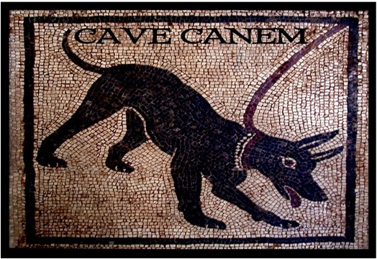
Warning sign from Pompeii
https://www.cafepress.com/+,573791180

Ubi ad fundum appropinquāvērunt, in mūrō magnīs litterīs 45 īnscrīptus hic titulus
When to farm they-got-clse on wall in-large letters inscribed this phrase
appārēbat : cavē canem ; ac ultrā mūrum audiēbātur canis lātrātus et vōcēs hominum
appeared beware-of dog and beyond wall was-heard dog’s barking and voices of-people
altercantium.
arguing
"Crēdō Stasimum, ut solet, in aliquod perīculum incidisse," inquit Pūblius. Quae
I-believe Stasimus as he-usually-does into some danger to-have-fallen said Publius Which
cum dīxisset, equō dīmissō, in saxum ēscendit, unde aspicere poterat quae ultrā mūrum
when he-had-said with-horse sent-off onto rock he-climbed from-where to-watch he-was-able what beyond wall
fierent.
was-happening
50Tum vidēbat Stasimum, quī temerē mūrum trānsiluerat, ā cane in arborem refugere
Then he-could-see Stasimus who rashly wall had-leapt-over from dog in tree to-take-refuge
cōactum esse. Ibi in rāmō sedēns, ille servus vafer lūdificābat agricolam īrātum, quī furcā
forced to-have-been there on branch sitting that slave rascally was-making-fun-of farmer angry who with-fork
armātūs īnfrā stābat. Interim canis frūstrā in arborem saltū cōnābātur ēscendere, cum loca
armed beneath was-standing meanwhile dog in-vain into tree by-leaping was-trying to-go-up while surroundings
longē et lātē lātrātū resonārent.
far and wide with-barking were-echoing
55 "Dēscende īlicō," inquit agricola, "aut tē, ut fūrem manifēstum, furcā trānsfīgam."
Come-down at-once said farmer or you as thief obvious with-fork I’ll-run-through
"Surdus sum," inquit Stasimus, ad aurem manū admōtā. "Maius clāmā, sī vīs."
Deaf I-am said Stasimus to ear with-hand moved louder shout please
Tum maximā vōce agricola: "Dēscende, mastīgia, priusquam 60 tē hāc furcā
Then in-very-loud voice farmer come-down villain before you with-this fork
trānsfīgam."
I-run-through
"Tantum strepitum facit canis," inquit Stasimus, "ut nihil plānē audīre possim. Dīxistīne
So-much noise makes dog said Stasimus that nothing clearly hear I-can Did-you-say
tē mihi aliquid datūrum?"
yourself to-me something going-to-give
"Ita vērō," inquit agricola,īrā ēlātus. "Malum maximum tibi dabō, furcifer, sī umquam
Yes indeed said farmer with-anger carried-away evil very-great to-you I-will-give rogue if ever
manūs tibi iniciam."
hands on-you I-will-get
65 At Stasimus, quasi audīre attentē cōnārētur: "Mālae meae rēctē sē habent," inquit,
But Stasimus as-if to-hear attentively he-was-trying cheeks my alright themselves have said
"sed aurēs mūnere suō fungī nōlunt."
but ears job their carry-out are-unwilling
"Haec furca mūnere suō fungētur," inquit agricola, "nisi tū īlicō in terram tē dēmittēs.
This fork job its will-carry-out said farmer unless you at-once to ground yourself get-down
Dēscendis an nōn dēscendis?"
Are-you-coming-down or not coming-down
"Nunc quidem," inquit Stasimus, "nōn dēscendō; nam in 70 rāmō sedeō."
Now indeed said Stasimus not I-am-coming-down for on branch I-am-sitting
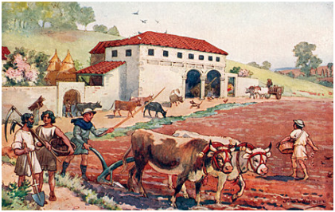
A Roman farm
https://www.alamy.com/stock-photo/roman-farming.html

Quō audītō, agricola furibundus in arborem furcam prōicere parābat, cum Pūblius ē saxō
With-which heard farmer furious into tree fork to-throw was-preparing when Publius from rock
vōcem ēmittēns: "Heus tū," inquit. "Quid, obsecrō, factum est? Servum nostrum Stasimum
voice projecting Hey you said What please happened has slave our Stasimus
ego quaerō. Sī eum in hīs locīs vagantem vīdistī, ostende, sīs."
I am-looking-for if him in these places wandering you-have-seen point-out please
75 Cui agricola: "Quisquis es, adulēscēns, hominī negōtiōsō molestiam exhibēs. Nam
To-whom farmer whoever you-sre young-man for-man busy trouble you-are-making for
fūrem manifēstum canis in hanc arborem refugere coēgit, cui nūllō modō persuādēre potuī
thief obvious dog in this tree to-take-refuge has-forced whom by-no-means to- persuade I’ve-been-able
ut inde dēscenderet."
that from-there he-should-descend
"Id minimē mīrandum est," inquit Pūblius rīdēns, "cum 80 canis saevus arborem
That not-at-all to-be-wondered-at is said Publius laughing since dog ferocious tree
cūstōdiat et tū hominem dēscendentem furcā accipere parātus sīs. Sed suspicor hunc esse
is-guarding and you man coing-down with-fork to-receive ready are but I-suspect this to-be
servum, quem quaerō. Manē ille ē dēversōriō ōva ēmptum profectus est; at nunc, ut vidētur,
slave whom I’m-looking-for in-morning he from hotel eggs to-buy set out but now as it-seems
mōre suō turbās hīc impudenter concitat."
in-custom his trouble here impudently is-stirring-up
85 "Quis sit, plānē nesciō," inquit agricola dentibus frendēns. "Sed prō impudentiā suā
Who he-is clearly I-don’t-know said farmer with-teeth gnashing but for impudence own
certō sciō eum hodiē mihi poenās maximās datūrum."
certainly I-know him today to-me penalties greatest going-to-give
"Ohē, senex," inquit Pūblius; "nōlī saevīre. Sine hominem impūne dēscendere, ac tibi
Hey there old-man said Publius don’t get-mad allow man without-punishment to-descend and for-yourself
hoc accipe." Quō dictō, aureum prōiēcit, quī in terram ante pedēs agricolae cecidit; cuius īra,
this accept with-which said gold-coin he-threw-forward which on ground before feet of-farmer fell whose anger
90 aureō vīsō, paulātim resīdere coepit.
with-gold seen gradually to-subside began
"Celeritāte nunc opus est," inquit Pūblius. "Iam diū in oppidō exspectāmur. Canem
For-speed now need there-is said Publius now long-time in town we-have-been-expected dog
revocā, senex."
call-off old-man
Tum ille, aureō sublātō, canem vinculō redūcere coepit; Stasimus autem celeriter ex
Then he with-gold picked-up dog by-chain bring-back began Stasimus for-his-part quickly from
arbore dēsiluit, et cursū effūsō 95 mūrum petīvit.
tree leapt-down and at-top-speed wall made-for
Canis, cum hostem fugientem vīdisset, summā vī adnīsus vinculum rūpit, et Stasimum,
Dog when enemy fleeing had-seen with-greatest force having-striven chain broke and Stasimus
quantum celeritāte poterat, secūtus est. Ille vix in mūrum ēscendēbat, cum canis saltū sē
with-as-much speed [as]it-could followed He scarcely onto wall was-clambering when dog with-leap self
prōiciēns vestem eius dentibus apprehendit pannumque 100 inde dēripuit longum.
hurling-forward clothing his with-teeth caught and-strip from-there ripped long
Pūblius et agricola, cum Stasimum vīdissent in mūrō stantem, dum vestem discissam
Publius and farmer when Stasimus they-had-seen on wall standing whilst clothing torn
trīstis aspicit, in cachinnōs maximōs effūsī sunt. Ille autem ex mūrō dēsiluit, arreptōque
sadly looks-at into laughter very-loud burst he however from wall leapt-down and-with-grabbed
lapide iterum celeriter ascendit. 105
stone again quickly climbed-up
Quō animadversō, canis dēnuō in mūrum impetum fēcit; sed inde ācriter ululāns refūgit,
With-which noticed dog again on wall attack made but then piercingly howling it-fled
cum Stasimus lapidem summā vī in eius caput impēgisset.
when Stasimus stone with-greatest force onto his head had-hurled
Quā iniūriā incēnsus, agricola cum furcā subsidiō canī prōcurrit. Cēterī autem celeriter
By-which injury incensed farmer with fork as-help for-dog ran-forward the-others however quickly
in equōs ēscendērunt, atque incītātō 110 cursū ad oppidum revectī sunt.
Onto horses climbed and at a gallop to town returned
Quōs cum vīdisset, Cornēlius: "Quid tibi vīs, Stasime?" inquit. "Propter tē duārum
Whom when he-had-seen Cornelius what for-yousef do-you-want Stasimus said because-of you of-two
hōrārum iactūram iam fēcimus. Sīcubi nōs posthāc ita dēserēs, tē nōn exspectābimus.
hours loss already we-have-made if-anywhere us after-this thus you-will-desert you not we-will-wait-for
Etiam 115 nunc vix contineor quōminus tē, ut merēris, ulcīscar."
Even now scarcely I-control-myself that-not you as you-deserve I-punish
"Veniam dā, ere, obsecrō," inquit Stasimus. "Putāvī ōva recentia ē fundō līberīs grāta
Forgiveness give master I-beg said Stasimus I-thought eggs fresh from farm to-children pleasing
fore, nec dubitāvī quīn multō ante tempus profectiōnis ego redīre possem."
to-be-going-to-be and-not doubted that much before time of-departure I return could
"Cūr igitur nōn temperī redīstī?" inquit Cornēlius. 120
Why therefore not on-time you-returned asked Cornelius
At ille: "Dum ōva quaerō, dē viā errāvī. Tum mihi obviam vēnit sīmius mōrōsus,
But he while eggs I-was-looking-for off path I-strayed then to-me up came monkey ill-tempered who
quī in rāmō arboris mē sedēre coēgit, cum interim canis saevus circumsilīret."
Who on branch of-trees me to-sit forced whilst meanwhile dog savage was-leaping-around
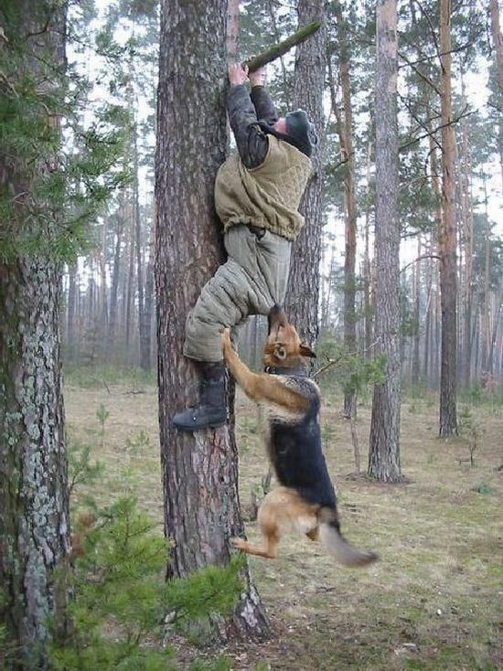
Stasimus’s problem persists down the centuries
https://www.pinterest.fr/pin/570057265304759435/?autologin=true
Quō audītō, Cornēlius quamvīs invītus rīsit omnēsque in raedās iussit sine morā
With-which heard Cornelius although unwillingly smiled and-all into wagons ordered without delay
ēscendere. Cuius dictō viātōrēs libenter 125 pāruērunt ac brevī ex oppidō equīs volentibus
to-get whose at-word travellers happily obeyed and soon from town with-horses willing
vectī sunt.
rode
CAPUT XXX

Postquam aliquamdiū tacitī prōvectī sunt, patrī Pūblius: "Ubi hanc noctem āctūrī
After for-some-time silent they rode to-father Publius where this night going-to-spend
sumus?" inquit.
we-are asked
"Vereor nē necesse sit aliquam in vīllam hāc nocte dēvertere," inquit Cornēlius. "Nam in
I-fear lest necessart it-may-be some into villa on-this night togo-for-shelter said Cornelius for in
hīs regiōnibus, quō tendimus, nūlla sunt oppida magna." 5
these regions to-which we-are-heading no are towns big
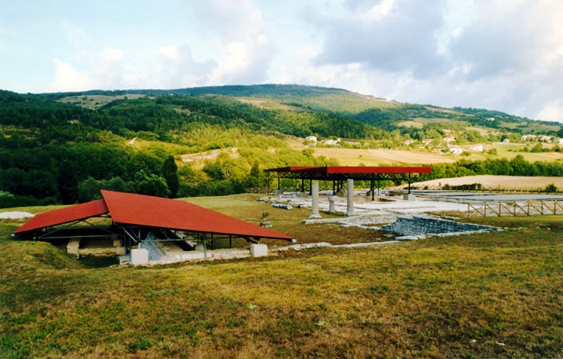
Excavations on the site of Sentinum
https://en.wikipedia.org/wiki/Sentinum

"Putavī nōs fortasse Sentīnī morātūrōs," inquit Pūblius.
I-thought us perhaps at-Sentinum going-to-stop said Pūblius
"Hoc oppidum ā viā nimis longē abest," inquit pater, "et celeritātī studeō."
This town from road too far is-away said father and on-speed I’m-keen
"Ecquid clārum Sentīnī umquam factum est?" inquit Sextus. 10
Anything well-known at-Sentinum ever done was asked Sextus
"Maximē vērō," inquit pater. "Sed dē proeliō ōlim ibi commissō fortasse Pūblius
very-much-so indeed said father but about battle once there fought perhaps Publius
quaedam nārrāre potest."
some-things relate can
Quibus verbīs inductus, Pūblius haud invītus: "Abhinc annōs amplius quadringentōs,"
By-which words induced Publius not unwilling ago years more-than four-hundred
inquit, "Rōmānī ad Sentīnum ācerrimē cum Samnītibus et Gallīs pugnāvērunt. 15
said Romans at Sentinum very-fiercely with Samnites and Gauls fought
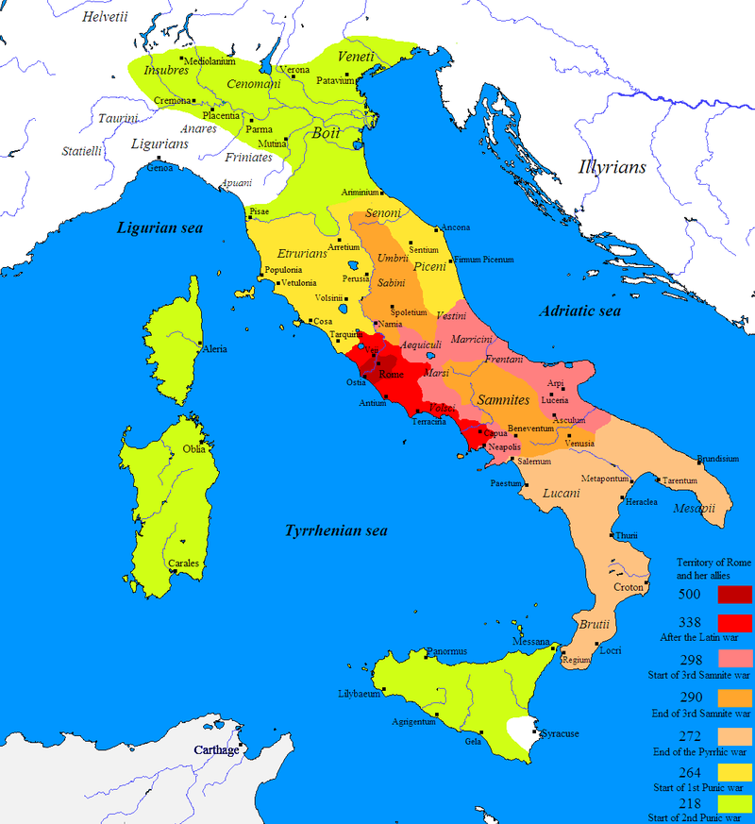
Stages in the Roman Conquest of Italy
https://en.wikipedia.org/wiki/Samnite_Wars#/media/File:Roman_conquest_of_Italy.PNG
"Cōnsul ūnus, cum Samnītibus congressus, prīmō satis habēbat sē ab hostibus dēfendere,
Consul one with Samnites having-come-into-contact at-first enough considered himself from enemy to-defend
ratus sī proelium diūtius extractum esset, fore ut hostium sīc minuerētur impetus, Rōmānīs
thinking if battle longer drawn-out had-been would-be that of-enemy thus was-blunted attack for-romans
autem vīrēs paene integrae servārentur.
however strength almost entire was-preserved
"Alterō autem in cornū P. Decius Mūs, quī contrā Gallōs cōnstiterat, 20 quia lentius
the-other however on wing Publius Decius Mus who against Gauls had-taken-position because too-slow
vidēbātur pedestre certāmen, equitēs vehementer in pugnam concitāvit. Quōs autem, cum in
seemed infantry contest cavalry forcefully into battle spurred-on them however when on
cōnfertissimōs Gallōs impetum fēcissent, novum genus pugnae perterruit.
very-densely-packed Gauls attack had-made new kind of-fighting terrified
25 "Iam enim advēnerant hostēs recentēs, essedīs carrīsque superstantēs, quī ingentī
Now for had-arrived enemies fresh on-chariots and-carts standing-erect who with-very-loud
sonitū rotārum cōnsternābant equōs, quibus tālis tumultus īnsolitus erat. Quae rēs Romanīs
sound of-wheels were-stampeding horses for-whom such uuproar unfamiliar was Which thing for-Romans
victōriam paene explōrātam in fugam vertit.
victory almost certain into rout turned
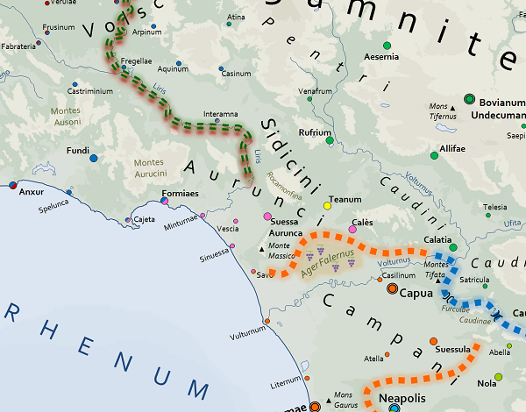
Territory of the Campanians, Aurunci, Sidicini and Volsci
https://www.vesuviolive.it/ultime-notizie/241937-aurunci-storia-e-leggenda-di-un-popolo-che-si-ribello-a-roma/
"Decius, cum frūstrā suīs cēdentibus resistere cōnātūs esset:30 'Quid ultrā moror,' inquit,
Decoius when in-vain his-men retreating to-oppose tried had why more do-I-delay said
'mortem fātō dēbitam? Nostrae enim gentī datum est, ut depellendīs cīvitātis perīculīs piāculō
death to-fate owed to-our for clan assigned it-has-been that for-warding-off of-state dangers for-sacrifice
sīmus. Quārē ego, ut anteā pater, nunc et mē ipsum et hostium legiōnēs dīs īnferīs dabō.'
we-be therefore I as before father now also me myself and of-enemy legions to-gods below I-will-give
"Haec locūtus, M. Līvium, pontificem, quem abīre ā sē vetuerat 35, praeīrē iussit
These-things having-said Marcus Livius priest whom to-depart from self he-had-forbidden to-dictate he-ordered
verba, quibus sē legiōnēsque hostium prō exercitū populī Rōmānī dēvovēret. Quō rīte factō,
words woth-which self and-legions of-enemy for army of-people Roman he-could sacrifice with-this duly done
quā cōnfertissima cernēbātur Gallōrum aciēs, eā concitāvit equum, īnfestīsque telīs sē īnferēns
where most-tightly-packed was-seen of-Gauls battle-line there he-spurred-on horse and-with-aimed weapons self hurling
statim occīsus est."
at-once killed was
"Heu!" inquit Cornēlia. "Quā rē fit, obsecrō, ut fortissimī 40 et optimī omnēs exitūs
O no said Cornelia for-what reason it-happens please that bravest and best all ends
tam miserōs inveniant?"
so wretched meet
"Deciō quidem," inquit pater, "illa mors prō patriā oppetīta pulcherrima vidēbātur; et
To-Decius at-any-rate said father that death for fatherland met most-beautiful seemed and
populō Rōmānō certē multum prōfuit. Nam mīlitibus perterritīs iam rediit animus, et eō
for-people Roman certainly much was-advantageous for to-soldiers terrified now returned spirit and on-that
diē victōria clāra ā nostrīs parta est."
day victor famous by our-men obtained was
45 "Quō modō animus mīlitibus redīre potuit," inquit Cornēlia, "cum dux ab hostibus
In-what way morale to-soldiers return could asked Cornelia when leader by enemy
occīsus esset?"
killed had-been
At pater: "Pontificī Līviō līctōrēs Decius trādiderat, eumque iusserat imperium
But father to-priest Livius lictors Decius had-handed-ovder and-him he-had-ordered legal-authority
suum recipere; quī, cum cōnsulem occīsum vīdisset, statim clāmāre coepit Rōmānōs vīcisse,
his to-receive he when consul killed he-had-seen at-once to-shout began Romans to-have-won
quod dux mortuus ad īnferōs sēcum dēvōtam hostium aciem vocāret, 50 et iam apud Gallōs
because leader dead to underworld with-him marked-for-death enemy army was-calling and now among Gauls
omnia terrōris plēna esse.
all-things of-terror full to-be
"Eōdem ferē tempore opportūnē subvēnērunt mīlītēs recentēs, quōs cōnsul alter,
At-same about time opportunely arrived-to-help soldiers fresh whom consul the-other
Samnītibus fugātīs, collēgae auxiliō mīserat. Itaque Gallī, etsī exstructīs ante sē scūtīs confertī
with-Samnites routed to-colleague as-help had-sent and-so Gauls although with-held-out before selves shields packed
stābant, impetum Rōmānōrum sustinēre nōn potuērunt. Multī, 55 ubi cōnstiterant,
they-were-standing attack of-Romans to-withstand not were-able many where they-had-taken-stand
ibīdem cecidērunt, aliī ā tergō circumventī et trucīdātī sunt."
In-same-place fell others from rear surrounded and slaughtered were
"Haec mē admonent," inquit Pūblius, "dē aliō facinore ēgregiō, quod ā scrīptōre Līvīō
These-things me remind said Publius about another deed outstanding which by writer Livy
memoriae trāditum est."
to-memory handed-down has-been
"Quid factum est, obsecrō?" inquit Sextus. "Eōdemne 60 modō posteā cīvis alius prō
Whar done was please asked Sextus in-same-? way afterwards citizen another for
victōriā Rōmānōrum tēlīs hostium sē obiēcit?"
victory of-Romans weapons of-enemy self threw-against
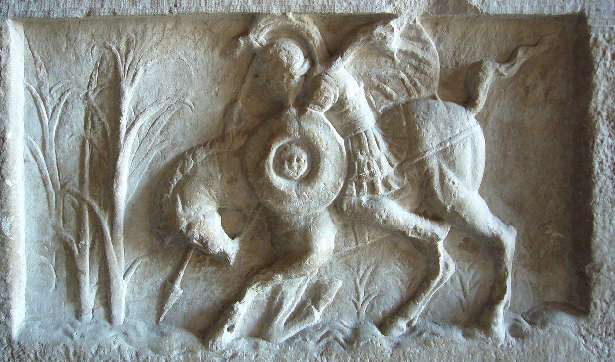
Roman relief depicting Marcus Curtius
Lalupa - https://commons.wikimedia.org/w/index.php?curid=37054225

"Pater eiusdem Decī sē similiter prō patriā dēvōvit," inquit frāter; "sed aliud erat, dē quō
Father of-same Decius self similarly for fatherland sacrificed said brother but other-thing was about which
cōgitābam:
I-was-thinking
"Ōlim Rōmae, aut mōtū terrae aut aliquā vī aliā 65 hiātus immēnsae altitūdinis subitō
Once in-Rome either by-movement of-earth or by-some force other cleft of-immense depth suddenly
in forō factus est, quī congestiōne terrae quamvīs adsiduā nūllō modō complērī potuit.
in forum made was which by-packing-in of-earth although continuous in-no way to-be-filled was-able
"Vātēs canēbant id, quod optimum Rōmānī habērent, eī locō dēdicandum esse,
Seers were-predicting that which best Romans had to-that place needing-to-be-dedicated to-be
sī rem pūblicam perpetuam esse vellent. Quārē diū quaesītum est quid esset illud optimum. 70
if state ever-lasting to-be they-wanted therefore for-long-time asked it-was what was that best-thing
"Tum ferunt M. Curtium, iuvenem bellō ēgregium, cīvēs suōs castīgāsse, quod
Then they-say Marcus Curtius youth in-war outstanding fellow-citizens his to-have-scolded because
dubitārent an ūllum Rōmānīs bonum maius esset quam arma et virtūs.
they-doubted whether any to-Romans good-thing greater was than weapons and courage
"Deinde, ubi silentium factum est, templa deōrum immortālium Capitōliumque intuēns,
Then when silence established was temples of-gods immortal and-Capitoline looking-at
et manūs nunc in caelum 75 nunc in patentem terrae hiātum porrigēns, ille sē dēvōvit;
and hands now to sky now to yawning of-earth cleft stretching-out he himself dedicated-as-sacrifice
tum equō quam poterat maximē ōrnātō īnsidēns, armātus sē in hiātum immīsit.
then on-horse as-he-could very-greatly adorned sitting armed self into cleft launnched
"Dōna et frūgēs super eum ā multitūdine virōrum et mulierum congesta sunt; et locus
Gifts and fruits-of-earth on-top-of him by crowd of-men and of-women piled were and place
'lacus Curtius' 80 appellātus est, quod ille vītam suam ibi prō perpetuitāte reī pūblicae largītus
Lacus Curtius called was because he life his there for perpetuity of-state generously-given
erat."
had
"Mihi quidem," inquit Cornēlius, "ille vir vidētur etiam tālī ēlogiō dignus, quāle
To-me al-least said Cornelius that man seems also of-such eulogy worthy as
Simōnidēs scrīpsit in Lacedaemoniōs, quī Thermopylīs cecidērunt: 85
Simonides wrote on Lacedemonians who at-Thermopylae fell

" 'Dīc, hospes, Spartae, nōs tē hīc vīdisse iacentīs,
Say stranger to-Sparta us you here to-have-seen lying
Dum sanctīs patriae lēgibus obsequimur.' "
While sacred of-fatherland laws we-follow

"Haec omnia ēgregia et maximē laudanda sunt," inquit Cornēlia; "sed exitūs habent, quī
These all-things outstanding and greatly praiseworthy are said Cornelia but endings have which
maestitiam maximam mihi iniciant. Nōnne tū vīs, pater, aliquid iūcundius 90 nārrāre?"
sadness greatest in-me instill Don’t you wish father something pleasanter to-narrate
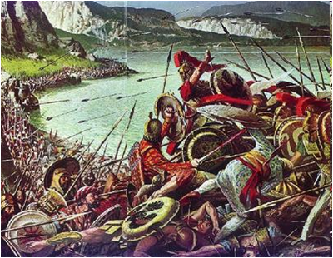
The Battle of Thermopylae (480 B.C.)
https://alchetron.com/Battle-of-Thermopylae

"Ita vērō," inquit ille. "Expōnam, sī vīs, quō modō Caesar dictātor inopiam aquae
Yes indeed said he I-will-tell if you-want in-what way Caesar dictator scarcity of-water
sublevāverit, cum Alexandrēae ab hostibus obsīderētur:
relieved when at-Alexandria by enemies he-was-under-sige
"Urbs illa est ferē tōta suffossa, specūsque ad flūmen Nīlum 95 pertinentēs habet, quibus
City that is almost all undermined and-channels to river Nile connecting has by-which
aqua in prīvātās domōs indūcitur; ubi paulātim liquēscit ac subsīdit. Nam cum prīmō ē Nīlō
water into private homes is-brought where gradually it-becomes-clear and settles for when first from Nile
īnfluit, adeō est līmōsa et turbida, ut multīs variīsque morbīs eōs adficiat, quī statim bibunt.
It-lows-in so it-is muddy and clouded that with-many and-various diseases those it-affects who immediately drink
100 "Aquā ex hīs specibus extractā Caesar quoque aliquamdiū ūtēbātur. Tum hostēs, ratī
Water from these channels extracted Caesar also for-some-time continued-using then enemy thinking
fore ut Rōmānī sē dēdere cōgerentur, sī aquātiōne prohibitī essent, magnum et difficile
going-to-be that Romans selves to-surrender were-forced if from-getting-water prevent ed-had-been great and difficult
opus aggressī sunt.
task embarked on
"Nam rotīs et māchinīs maximam vim aquae ex marī exhausērunt 105, quam in loca ā
For with-wheels and machines very-great quantity of-water from sea they-extracted which into places by
Caesare occupāta fundere nōn intermittēbant. Quō modō aqua, quae ē specibus ā Rōmānīs
Caesar occupied pouring not they-left-off by-which method water which from channels by Romans
trahēbātur, in diēs salsior fīēbat, adeō ut postrēmō bibī omnīnō nōn posset.
was-being-extracted day-by-day saltier was-becoming so-much that finally be-drunk at-all not it-could

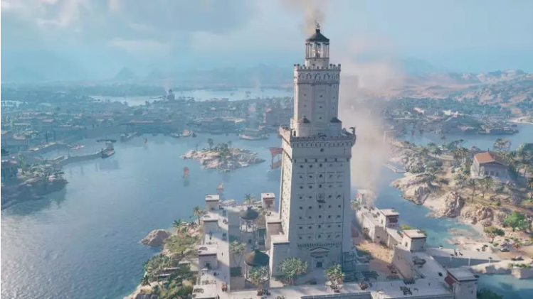

The harbor of Alexandria with the Pharos lighthouse
https://www.realmofhistory.com/2020/01/07/animation-grandeur-ancient-alexandria-lighthouse/

"Tum nostrī ad summam dēspērātiōnem pervēnērunt; Caesar autem eōrum timōrem
Then our-forces at greatest desperation arrived Caesar however their fear

cohortātiōne et ratiōne minuit. 110 Nam docuit, puteīs fossīs, aquam dulcem reperīrī posse,
by-encouragement and reasoning reduced for he-explained with-wells built water fresh to-be-found to-be-able
quia lītora omnia nātūra aquae dulcis vēnās habērent; sīn autem hōc modō aquārī nōn possent,
because shores all by-nature of-water fresh channels had but-if however in-this way get-water not they-could
aditum ad mare patēre, et cotīdiē nāvibus sē aquam petītūrum.
access to sea to-be-open and daily with-ships himself water going-to-seek
"Tālī ōrātiōne confirmātīs suīs, centuriōnibus negōtium 115 dedit ut, reliquīs operibus
by-such speech having-been re-assured his-men to-centurions work he-gave that with-other tasks
intermissīs, ad fodiendōs puteōs animum cōnferrent. Quō susceptō negōtiō atque omnium
discontinued on being-dug wells mind they-should-concentrate with-which undertaken work and of-all
animīs ad labōrem incitātīs, ūnā nocte inventa est magna vīs aquae dulcis, nec posteā
minds to labour urged in-one night found was great quantity of-water fresh and-not afterwards
similī inopiā labōrātum est."
from -similar scarcity trouble occurred
"Optimē!" inquit Cornēlia. "Vellem fābulae omnēs exitūs 120 tam iūcundōs habērent."
Very good said Cornelia I-would-like stories all endings so pleasant had
Dum haec fīunt, raedae celeriter prōvehēbantur; ac vesperāscente iam diē
While these-things are-happening wagons swifly were-being-drawn and coming-towards-evening already with-day
viātōrēs ad quandam vlllam hospitiō acceptī sunt.
travellers in a-certain villa with-hospitality received were
CHAPTER XXXI

Cibō et somnō refectī manē abiērunt, ac quārtā ferē hōrā ad flūmen Metaurum
With-food and sleep refreshed in-morning they-left and at-fourth about hour to river Netaurus
pervēnērunt. Quod cum ponte trānsīrent, Cornēlius: "Ad hoc flūmen," inquit, "commissum
arrived which when by-bridge they-were-crossing Cornelius at this river he-said fought was
proelium, quod spēs omnēs Hannibalis funditus ēvertit."
battle which hopes all of-Hannibal utterly destroyed
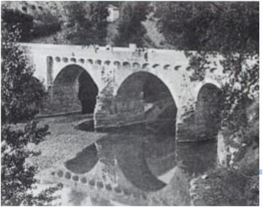
The `Ponte di Traiano’ on the Metaurus in the 1930s.
Lorenzo Quilici &Stefania Quilici Gigli, Strade romane, ponti e viadotti, 1996. p.163
https://books.google.com.hk/books?id=hLz37Hxn7uIC

5 "Ipsene aderat," inquit Sextus, "cum hīc pugnātum est?"
Himself-? He-was-present asked Sextus when here fought it-was
"Immō longē aberat," inquit pater, "ac Rōmānī hōc locō congressī sunt cum eius frātre,
In-fact far he-was-away said father and Romans in-this place joined battle with his father
Hasdrubale, quī ex Hispāniā cum exercitū subsidiō properābat."
Hasdrubal who from Spain with army to-help was-hurrying
"Minus igitur mīrandum est," inquit Sextus, "sī Poenī victī sunt. 10 Nam Hannibal, cum
Less therefore to-be-wondered-at it-is said Sextus if Carthaginians defeated were for Hannibal when
ipse cōram adesset, perrārō superātus esse vidētur. Sed dē hōc proeliō plūra libenter
himself in-person was-present very-rarely beaten to-have-been seems but about this battle more gladly
audiāmus. Ā prīncipīō exordīre, sī vīs."
let-us-hear from beginning start please
Tum pater: "Hannibal haud procul ā Venusiā trahēbat bellum, spērāns brevī
Then father Hannibal not far from Venusia was-prolonging war hoping soon
adfore frātrem; quārē nōndum volēbat dēcertāre cum cōnsule C. Claudiō Nerōne, quī to-be-going-to-be-present brother therefore not-yet he-wanted to-join-battle with consul Gaius Claudius Nero who
haud longē 15 castra posuerat
not far-off camp had-placed.
"Cum alter cōnsul, M. Līvius, adventum Hasdrubalis exspectāret hīs in regiōnibus, per
When the-other consul Marcus Livius arrival of-Hasdrubal was-waiting-for these in regions through
quās nunc iter facimus, forte equitēs hostium, quī litterās ad Hannibalem dēferēbant, ā 20
which now journey we-make by-chance cavalry of-enemy who letter to Hannibal were-carrying by
Rōmānīs sunt interceptī et ad Nerōnem adductī.
Romans were intercepted and to Nero brought

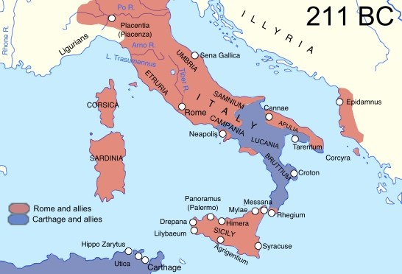
Hannibal’s position in southern Italy (the Via Flaminia reached the coast about 24 kilometres north of Sena Gallaica (modern Senigallia))
http://masculineepic.com/index.php/2019/12/05/the-battle-of-the-metaurus-the-day-that-saved-rome/

"Cōnsiliō Poenōrum ex hīs cognitō, Nerō, relictō Q. Catiō lēgātō, quī castrīs
With-plan of-Carthaginians from-this learned Nero having-been-left Quintus Catius legate who of-camp
praeesset, ipse magnīs itineribus ad collēgam Līvium contendit. Tum, coniunctīs cōpiīs,
could-be-in-charge self with-great marches to colleague Livius hurried then having-been-joined forces
cōnsulēs Hasdrubālem sē recipere cōnantem consecūtī sunt atque inīquō locō proelium
consuls Hasdribal himself to-take-back trying followed and on-unfavourable ground battle
committere coēgērunt. 25
to-join compelled
"Cum diū atque ācriter dīmicātum esset, Nerō ē dextrō cornū (ubi sēgnius
When long and fiercely fighting there-had-been Nero from right wing where more-sluggishly
pugnābātur) cohortēs aliquot dētrāxit, quās post aciem circumductās subitō in dextrum
fighting-was-going-on cohorts some detached which behind battle-line brought-round suddenly onto right
hostium latus immīsit. Tum omnibus ex partibus, ā fronte, ā latere, ā tergō, hostēs trucīdātī
of-enemy flank he-launched then all from directions from front from side from-rear enemy slaughtered
sunt. 30
were

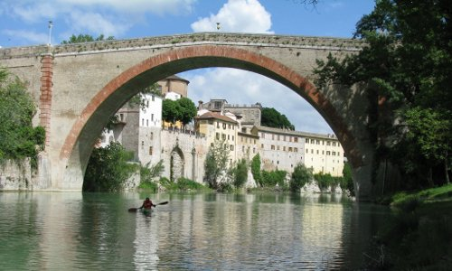
The Metaurus at Forum Sempronii (Fossembrone), about 30 kilometres from the coast
https://www.elgatarel.it/en/2018/07/13/canoe/
"Elephantī vērō ā suīs rēctōribus plūrēs quam ā Rōmānīs sunt interfectī. Nam rēctōrēs
Elephants indeed by their-own handlers more than by Romans were killed for handlers
scalprum cum malleō habēbant. Id, cum saevīre bēstiae ac ruere in suōs coeperant, rēctor inter
chisel with hammer had this when to-go-mad beasts and rush at wn-lines had-begun handler between
aurēs positum, in articulō quō coniungitur capitī 35 cervīx, quam maximā poterat vī adigēbat.
[their]ears placed in joint by-which is-joined to-head neck which with-greatest he-could force drove-home
Quō vulnere elephantī statim concidērunt.
From-which injury elephants at-once collapsed
"Interim Hasdrubal officiō bonī imperātōris fungēbātur. Ille pugnantēs hortandō
Meanwhile Hasdrubal the-duty of-good commander kept-carrying-out he those-fighting by-urging-on
sustinuit, ille fessōs nunc precandō nunc castīgandō accendit, ille fugientēs revocāvit
he-supported he those-tired now by-beseeching now by-scolding fired-up he those-fleeing called-back
omissamque pugnam aliquot locīs restituit. 40
and-given-up battle some in-places he-revived
"Postrēmō, cum haud dubia victōria Rōmānōrum esset, nē superstes esset exercituī
Finally when not in-doubt victory of-Romans was so-not survivor he-should-be of-army
tantō, in hostēs concitātō equō sē immīsit. Ibi, ut patre Hamilcare et Hannibale frātre dignum
so-great into enemy spurred-on with-horse himself he-hurled there as of-father Hamilcar and Hannibal father worthy
erat, pugnāns cecidit."
of fighting he-fell
45 "Dēnuō quaerō," inquit Cornēlia, "cūr optimī et fortissimī semper exitūs tam miserōs
Again I-ask said Cornelia why best and bravest always deaths so wretched
inveniant."
meet
"Eratne autem Hasdrubal vir vērē optimus?" inquit Sextus. "Semper audīvī Poenōs
Was-? however Hasdrubal man realy best asked Sextus often I-have-heard Carthaginians
paene omnēs perfidōs et impiōs fuisse."
Almost all treacherous and wicked to-have-been
"Sīc memoriae trāditum est," inquit pater. "Quīn etiam 50 hodiē quoque 'Pūnica fidēs'
Thus to-memory handed-down it-has-been said father in fact today also Punic faith
prō 'perfidia' saepe dīcitur. Sed maiōrēs nostrī, virī reī pūblicae amantissimī, glōriam cīvitātis
for treachery often is-said but ancestors our men to-republic most-devoted glory of-state
sē auctūrōs fortasse putābant, sī hostēs quam maximē īnfāmēs fēcissent.
themselves going-to-increase perhaps thought if enemies as much-as-possible notorious they-had-made
"Quārē operae pretium est animadvertere scrīptōris Līvī 55 verba repugnantia; quī, etsī
Therefore worthwhile it-is to-notice of-writer Livy words to-the-contrary he although
inhūmānam crūdēlitātem in Hannibale fuisse dīcit, commemorat tamen post proelium ad
inhuman cruelty in Hannibal to-have-been relates however after battle at
lacum Trasumēnum commissum Poenum fūneris causā corpus Flaminī cōnsulis magnā
Lake Trasimene fought the-Carthaginian of-funeral for-sake-of body of-Flaminius consul great
dīligentiā quaesīvisse; quod nōn fēcisset profectō, sī mōnstrum hominis fuisset."
with-care to-have-searched-for which not he-would-have-done of-course if monster of-a-man he-had-been
60 "Quid agēbat Hannibal," inquit Sextus, "dum fortūna ita frātrem dēserit?"
What was-doing Hannibal asked Sextus while fortune thus brother deserted
"Castrīs sē tenēbat," inquit pater, "nec suspicātus est quantum malī suīs rēbus accidisset,
In-camp self was-keeping said father nor did he suspect how-much of-evil to-own situation had-occured
priusquam Nerō victor rediit. Tum caput Hasdrubalis, quod cōnsul magnā cūrā servātum
before Nero victorious returned then head of-Hasdrubal which consul with-great care saved
65 attulerat, ante statiōnēs hostium prōiectum est. Quō signō Hannibal cognōvit sē omnia
had-brought before guard-posts of-enemy thrown was with-which sign Hannnibal realised self all
perdidisse."
to-have-lost
"Vah!" inquit Cornēlia horrēscēns; "mihi quidem in cōnsule Rōmānō inhūmāna
Waa said Cornelia shuddering to-me indeed in consul Roman inhuman
crūdēlitās fuisse vidētur."
cruelty to-have-been seems
"Dē dēspērātiōne Hannibalis," inquit Pūblius, "cum 70 cognōvisset frātrem occīsum
About desperation of-Hannibal said Publius when he-had-learned brother kiled
esse, dīcit poēta Horātius; cuius verba, sī poterō, memoriā referam:
to-have-been says poet Horace whose words if I-can from-memory I-will-deliver

'Carthāginī iam nōn ego nūntiōs
To-Carthage now not I messages
Mittam superbōs. Occidit, occidit
Will-send proud has-died has-dies
Spēs omnis et fortūna nostrī
Hope all and fortune of-our
Nōminis, Hasdrubale interēmptō » 75
Name with-Hasdrubal done-away-with

"Bellumne tōtum ita ad fīnem adductum est?" inquit Sextus.
War-? whole thus to end brought was said Sextus
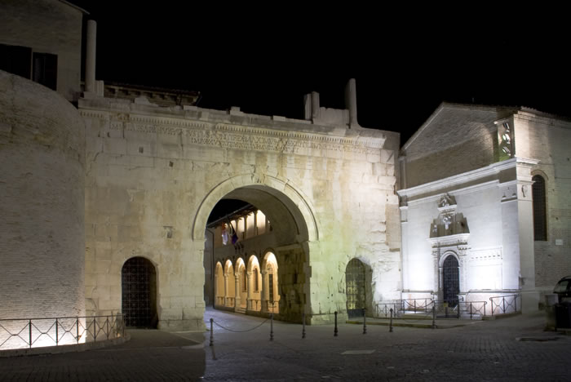
Arch of Augustus at Forum Fortunae (modern Fano)
Nicola Romani, https://en.wikipedia.org/wiki/Fano#/media/File:Arco_di_Augusto_Fano_illuminato.jpg

"Nūllō modō," inquit pater. "Sed Hannibal in extrēmās Italiae partēs sē recipere coāctus,
In-no way said father but Hannibal into furthest of-Italy parts self to-take-back forced
postrēmō in Āfricam 80 revocātus est, ut patriam dēfenderet. Rōmānī enim iam eō cōpiās
finally to Africa recalled was so-that fatherland he-could-defend Romans for already to-there forces
trānsvēxerant."
had-brought-across
Cum haec dicta essent, ad locum amoenum perventum est, ubi viātōrēs ex raedīs
When these-things said had-been to place attractive reached it-was where travellers from wagons
dēscendērunt, ac, per herbam dispositī, cēpērunt cibum, cum interim equī in umbrā
descended and over grass scattered took food while meanwhile horses in shade
reficiēbantur. Tum 85 iterum profectī hōrā nōnā Fānum Fortūnae pervēnērunt, quō in
were-being-refreshed then again setting-out at-hour ninth Shrine of-Fortune reached which in
oppidō hanc noctem agere cōnstituerant.
town this night to-spend had-decided
Mox līberī, quī cupidē cēnae tempus exspectābant, ad Annam accessērunt, quae Lūcium
Soon children who eagerly of-dinner time were-expecting to Anna came-up who Lucius
humī lūdentem servābat ; et Cornēlia: "Adeō ēsurīmus," inquit, "ut quō modo tempus terātur
on-ground playing was-looking-after and Cornelia so we-are-hungry said that in-what way time might-be-passed
90 excōgītare nōn possīmus. Nōnne tū nōs adiuvāre potes?"
to-think not we-are-able not-? You us to-help you-are-able
Tum illa: "Meministisne," inquit, "mē quondam vōbīs multa nārrāre quōdam dē Moyse,
Then she do-you-remember asked me once to-you many-things to-tell a-certaihn about Moses
quī gentem meam servitūte lībērāvit et ex Aegyptō ēdūxit in fīnēs maiōribus nostrīs ā deō
who nation my from-slavery freed and from Egypt led-out into territory for-ancestors our by god
dēstinātōs?" 95
destined
"Haec omnia memoriā tenēmus," inquit Sextus. "Perge porrō dīcere."
These-things all in-memory we-hold said Sextus continue further to-say
"Ex eō tempore," inquit Anna, "quō Moysēs nātus est, rēx eārum regiōnum ēdictum
From that time said Anna at-which Moses was born king of-those regions edict
prōposuerat ut puerī īnfantēs gentis nostrae occīderentur omnēs. Nam in diēs crēscēbat
had-issued that boys infant of-nation our should-be-killed all for day-by-day was-growing
multitūdō, 100 ac metuēbat rēx nē quandō populus, quem servitūtē premēbat, sēditiōnem
throng and was-afraid king lest at-some-time people whom with-slavery he-was-oppressing revolt
commovēret et summā rērum potīrētur.
might-launch and control of affairs might-gain
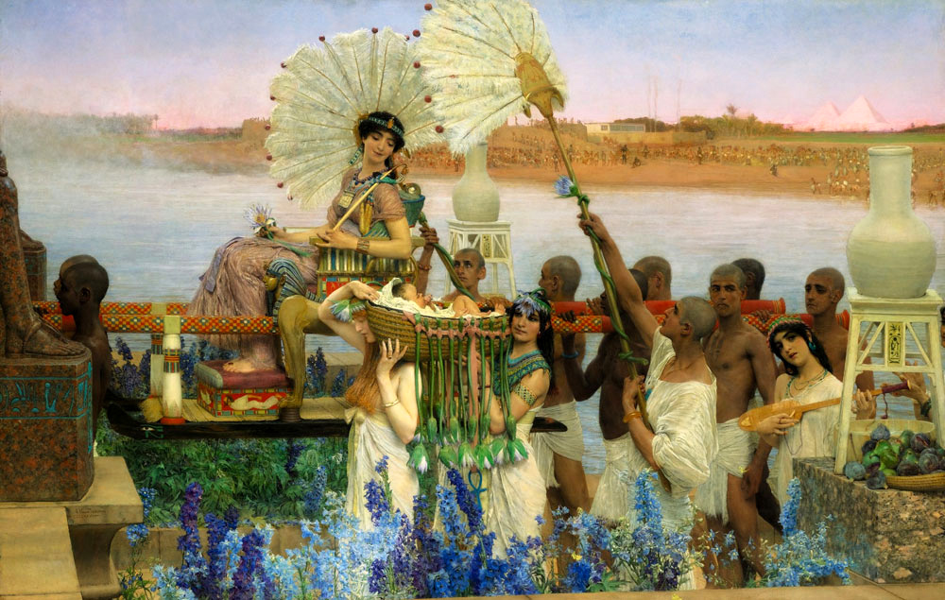
Pharaoh’s daughter finds Moses
https://en.wikipedia.org/wiki/Finding_of_Moses#/media/File:Moses_-_Alta-Tadema.jpg
"Moysem autem īnfantem māter domī trēs mēnsēs occultāvit. Tum alveō factō
Moses however infant mother at-homr three months hid then with-basket made imposuit puerum, atque inter harundinēs prope flūminis rīpam abscondit. Interim soror puerī
placed-in boy and among reeds near of-river bank hid menwhile sister of-boy
haud 105 procul ēventum exspectābat.
not far result was-waiting-for
"Paulō post ad lavandum rēgis fīlia flūmen adiit; dumque ancillae in rīpā vagantur,
a-little lated for washing of-king daughter river came-to and-while maids in bank are-wandering
alveum animadvertit. Quō apertō, rēgia virgō, cum īnfantem flentem vīdisset, misericordiā
basket noticed with-which opened royal maiden when infant crying sh-had-seen by-pity
mōta: 'Hic est,' inquit, 'ūnus dē īnfantibus proscrīptīs.' 110
moved this is said one from infants condemned-to-die
"Tum subitō soror praestō: 'Vīsne mē vocāre mulierem,’ inquit, 'quae īnfantem nūtrīre
Then suddenly sister stepping-up do-you-want me to-call woman she-says who infant nurse
possit?'
could
'Ī, eam arcesse,' inquit illa. Puella igitur laeta abiit, suamque statim mātrem vocāvit.
Go her fetch said she girl there happy went-away and-her at-once mother called
"Hōc modō Moysēs servātus est; quem, cum iam iuvenis esset, fīlia rēgis in locum
In-this way Moses saved was him when now young-man he-was daughter of-king in place
fīliī adoptāvit."
of-son adopted
"Haec est fābula lepidissima," inquit Cornēlia. 115
This is story very-delightful sadi Cornelia
At Sextus: "Tuīs verbīs," inquit, "dē cāsū Rōmulī et Remī admoneor, quī quoque in
And Sextus by-your words said of case of-Romulus and Remus I-am-reminded who also in
alveō expositī sunt. Sed mīror quam mox edāmus." Tum post sē respiciēns: "Nōnne
basket exposed were but I-wonder how soon we-are-eating then behind self looking-back not-?
Onēsimum iam appropinquantem videō? Is certē est. Eāmus." Quō dictō, celeriter līberī
Onesimus now approaching I-see him certainly it-is let’s-go with-which said quickly children
abiērunt. 120
left
CAPUT XXXII

Posterō diē via dūcēbat secundum lītus maris Hadriaticī, ubi ventī recentēs vim equīs
On-the-next-day road led along shore of-sea Adriatic where winds fresh energy in-horses
incutiēbant, ac Cornēlius: "Omnia prōsperē cēdere videntur, et spērō nōs hodiē Arīmīnum
were-instilling and Cornelius all-things well to-go seem and I-hope us today Ariminum
usque prōgredī posse." 5
as-far-as to-advance to-be-able
Hōc audītō, Pūblius: "Mihi recordārī videor," inquit, "flūmen Rubicōnem haud procul ab
With-this heard Publius t-myself to-remember I-seem said fiver Rubicon not far from
Arīminō in mare īnfluere."
Ariminum into sea to-flow
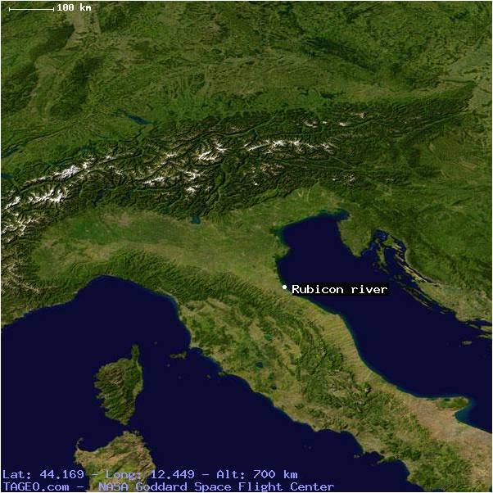
Location of the Rubicon
"Quīn etiam," inquit pater, "ōstium flūminis quīnque ferē mīlia passuum ab oppidō
Indeed so said father mouth of-river five about miles from town
abest."
is-away
"Cūr tam multa dē flūmine Rubicōne?" inquit Sextus. 10 "Ecquid memoriā dignum ibi
why so many-things about river Rubicon asked Sextus anything memory deserving there
factum est?"
done was
"Dignissimum vērō," inquit pater. "Parvus scīlicet est amnis, sed ab Italiā reliquā
Very-deserving indeed said father small to-be-sure is river but from Italy rest-of
dīvidēbat prōvinciam ōlim Caesarī dictātōrī dēcrētam. Quārē cum ille Rubicōnem transībat,
it-used-to-divide province once to-Caesar dictator assigned thus when he Rubicon he-was-crossing
bellum patriae apertē īnferēbātur." 15
war on-fatherland openly was-being-made
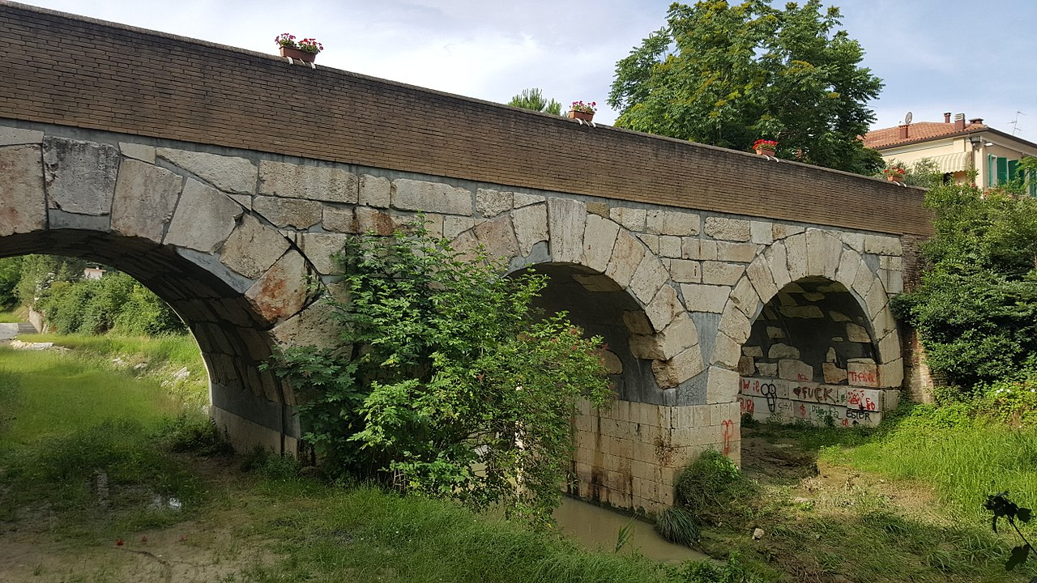
Roman bridge at Savignano sul Rubicone
https://it.wikipedia.org/wiki/Rubicone#/media/File:Il_Ponte_sul_Rubicone.jpg

"Cum rēs tantum in discrīmen addūcerētur," inquit Sextus, "crēdō eum diū
When matter so-great into crisis was-being-brought said Sextus I-believe him for-long
dubitāsse utrum trānsīret necne."
to-have-been-in-doubt whether he-should-cross or-not
"Rēctē dīcis," inquit pater. "Sed Pūblius noster dē hāc rē profectō saepe lēgit, nec dubitō
Correctly you-say said father but Publius our about this affaur of-course often has-read nor do-I-doubt
quīn ille libenter quaedam vōbīs nārrātūrus sit." 20
that he gladly some-things to-you going-to-tell is
"Optimē," inquit Sextus. "Quō modō rēs ācta est, frāter?"
Excellent said Sextus in-what way thing done was brother
Tum ille: "Caesar in commentāriīs suīs plūrima dīcit dē iniuriīs sibi inlātīs, et dē causīs
Then he Caesar in commentaries his very-many-things says about wrongs to-him done and about reasons
cūr arma sūmenda essent; sed dē trānsitū huius flūminis ipse nihil trādit.
why arms needing-to-be-taken-up were but about crossing of-this river himself nothing hands-down
"Apud Suētōnium autem multa inveniō, quae ad hanc rem pertinent. Nam ille dīcit
In Suetonius however many-things I-find which to this affair are-relevant for he says
Caesarem, cum ad flūmen vēnisset, 25 conversum ad proximōs dīxisse: 'Etiam nunc redīre
Caesar when to river he-had-come turning to those-nearest to-have-said even now go-back
possumus; sīn autem hunc pontem parvum trānsierimus, omnia armīs agenda
we-are-able but-if however this bridge small we-will-have-crossed all-things with-weapons needing-to-be-done
erunt.'
will-be
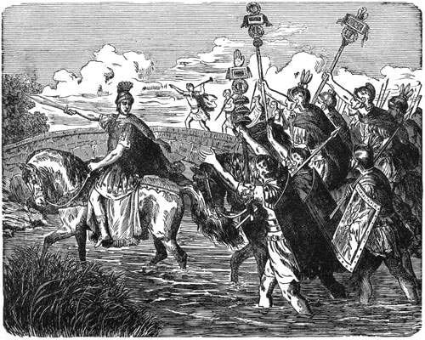
`Iacta ālea est’
https://www.thoughtco.com/meaning-cross-the-rubicon-117548

"Tum quīdam iuvenis ēgregiā corporis magnitūdine et speciē prope sedēns repente
Then a-certain youth with-extraordinary of-body size and appearance nearby sitting suddenly
appāruit, quī harundine canēbat. 30 Ad quem audiendum nōn sōlum pāstōrēs sed etiam mīlītēs
appeared who on-reed-pipe was-playing for him hearing not only shepherds but also soldiers

concurrērunt.
ran-together
"In eīs erant aeneātōrēs quīdam; quōrum ab ūnō tubā arreptā, iuvenis ad flūmen prōsiluit
among them were trumpet-players certain of-them from one with-trumpet snatched youth towards river leapt-forward
et ingentī spīritū classicum exōrsus ad alteram rīpam contendit.35
and with-huge blast trumpet-call beginning to other bank rushed
"Tum Caesar: 'Sequāmur,' inquit, 'quō deōrum ostenta et inimīcōrum iniūriae vocant.
Then Caesar Let-us-follow said where of-gods signs and of-enemies injustice summon
Iacta est ālea.' Hōc modō flūmen trānsitum est."
Cast is die in-this way river crossed was
At Sextus: "Cum haec rēs Rōmam dēlāta esset," inquit, "vereor nē Pompēius nūntium
But Sextuis when this thing to-Rome reported had-been said I-fear that Pompey news
haud libenter accēperit." 40
not happily received
"Commōtus est nōn sōlum Pompēius," inquit Pūblius, "sed etiam cīvitās tōta; multīque
Alarmed was not only Pompey said Publius but also state whole and-many
statim ex urbe ēgressī salūtem fugā petiērunt. Etiam Cicerō multum dubitābat utrum uxōrī
at-once from city having-gone-out safety through-flight sought even Cicero much was-in-doubt whether wife
fīliaeque suādēret ut Rōmae manērent necne."
and-daughter should-urge that at-Rome they-remain or-not
"Quid, obsecrō, eīs timēbat?" inquit Cornēlia. "Caesar 45 certē cum fēminīs nōn bellum
What please for-them he-was-fearing asked Cornelia Caesar certainly with women not war
gestūrus erat."
going-to-wage was
"Rēctē conicis," inquit pater. "Sed omnia tum turbida erant; ac Cicerō etiam hōc modō
Rightly you-guess said father but all-things then in-confusion were and Cicero also in-this way
loquitur: 'Sīn homō āmēns dīripiendam urbem datūrus est' —quibus verbīs ostendit quantō
speaks But-if man mad to-be-ransacked city going-to-give is with-which words he-shows how-much
in perīculō omnia versārī exīstimāverit."50
in danger all-things to-be he-reckoned
"Mihi quoque maximē mīrandum vidētur," inquit Pūblius, "Cicerōnem et aliōs prīncipēs
To-,e also very amazing it-seems said Publius Cicero and other leaders
cīvitātis tantam inhūmānitātem Caesarī imputāsse."
of-state such-great inhumanity to-Caesar to-have-imputed
At pater: "Dē eius rēbus in Galliā gestīs fāma iam ēvulgāta 55 erat; nec vērō Gallīs aut
But father about his actions in Gaul taken news already spread had and-not indeed Gauls or
Germānīs umquam pepercerat Caesar, sī eōrum supplicium cēterīs documentō futūrum esse
Germans ever had-spared Caesar if their punishment to-the-rest warning going-to-be to-be
putābat. Propter haec, ut opīnor, dē eius voluntāte in rem pūblicam omnēs tantopere
he-thought because-of this as I-think about his intention towards the-republic all greatly
timuērunt.
were-afraid
"Quam eōrum opīniōnem ēventus tamen multum fefellit. 60 Nam Caesar, simulatque
this of-them opinion event however much belied for Caesar as-soon-as
Rubicōnem trānsiit et cum cīvibus Rōmānīs bellum est susceptum, omnēs summā cōmitāte
Rubicon he-crossed and with citizens Roman war was undertaken all with-gretest kindness
tractābat.
began-treating
"Nam quō modō cum cīvibus āctūrus esset, statim ille ostendit, cum Corfīnium cēpit,
For in-what way with citizens going-to-deal he-was at-once he showed when Corfinium he-took

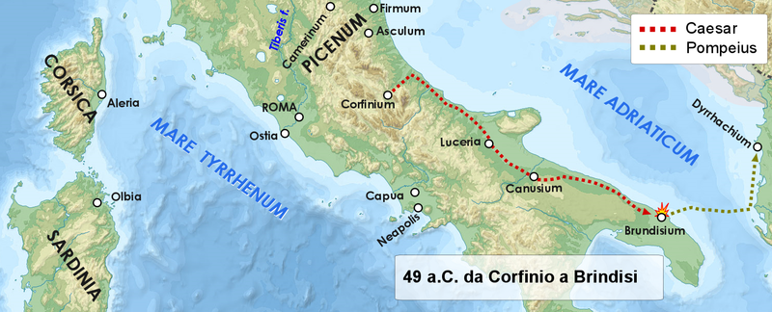
Caesar’s pursuit of Pompey in 49 B.C.
https://commons.wikimedia.org/wiki/File:Da_Corfinio_a_Brindisi_49_aC.png
ubi L. Domitius ā Pompēiō 65 relictus erat, cum ipse ex Italiā fugeret."
Where Lucius Domitius by Pompey left had-been whe he-himself from Italy was-fleeing
"Quid factum est?" inquit Sextus. "Urbe dēdita," inquit pater, "praefectī ex castrīs
What done was said Sextus with-city surrendered said father commanders from camp
ēgressī sunt. Tum Caesar, apud eōs pauca dē ipsōrum ingrātō animō locūtus, Domitium
came out then Caesar among them a-few-things about their ungrateful attitude having-spoken Domitius
reliquōsque incolumēs dīmīsit; mīlitēs 70 autem suum in exercitum recēpit."
and-rest unharmed he-dismissed soliders however own into army he-received
"Hui!" inquit Cornēlia. "Quis putāret Caesarem tam mītem fore?"
Waah said Conelia Who would-think Caesar so gentle to-be-going-to-be
Et Sextus: "Prō tantā clēmentiā, opīnor, omnēs eī grātiam maximam habuērunt." 75
And Sextus for such clemency I-think all to-him gratitude greatest had
"Rēs longē aliter ēvēnit," inquit pater. "Mīlītēs quidem sē satis fidēliter gessērunt, sed
Affair far differently worked-out said father soldiers indeed themselves enough loyally conducted but
Domitius et reliquī praefectī paene omnēs statim sē contulērunt ad Caesaris inimīcōs, ut
Domitius and rest-of commanders almost all immediately themselves took to Caesar’s enemies so-that
alibī in aciē contrā eum pugnāre possent."
elsewhere in battle-line against him fight they-could
"Videō," inquit Pūblius, "Sextum haec haud ita attentē 80 audīre. Crēdō mē posse
I-see said Publius Sextus hese-things not so attentively to-be-listening-to I-believe me to-be-able
aliud nārrāre, quod eī magis placeat."
something-else to-relate which him more would-please
At Sextus: "Age, dīc, frāter," inquit. "Haec quae audīvimus optima sunt, sed mē minus
And Sextus Come-on speak brother said These-things which we-have-heard excellent are but me less
dēlectant."
delight
"Ōlim," inquit Pūblius, "cum Agricola Britanniam armīs subigeret, cohors quaedam
Once said Publius when Agricola Britain with-arms was-subduing cohort a-certain
Usīpōrum memorābile ausa est facinus; occīsō enim centuriōne et mīlitibus, quī ad
of-Usipi memorable dared crime haing-been-killed for centurion and [Roman] soldiers who for
trādendam 85 disciplīnam manipulīs immixtī erant, trēs nāvēs occupāvērunt, cum
giving training with-units embedded had-been three ships seized when
gubernātōrēs vī ac minīs sēcum ascendere cōgerent.
helmsmen with-force and threats with-them to-embark they-forced

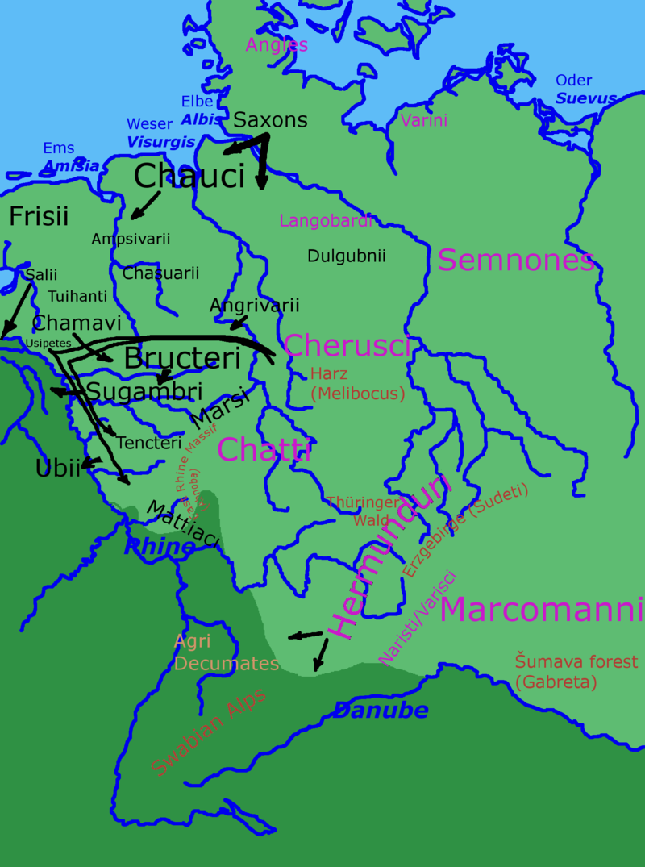
Germanic tribes in Roman times (Usipetes in small print south of the Chamavi)
By Andrew Lancaster - Using Gimp, CC BY-SA 3.0, https://commons.wikimedia.org/w/index.php?curid=27186214

"Tum secundum lītus vectī, etsī saepe ad aquandum et cibum raptum ē nāvibus
Then along shore having-sailed although often for getting-water and food to-seize from ships
Ēgressī erant, postrēmō in tantam pervēnērunt inopiam, ut prīmō īnfirmissimīs suōrum, tum
disembarked they- had finally into so-great they-arrived scarcity that first weakest of-themselves then
aliīs sorte ductīs 90 vēscerentur."
others by-lot selected they-fed-on
"Vah!" inquit Cornēlia. "Intellegere nōn possum cūr rēs tam foedās audīre cupiās,
Waah said Cornelia understand not I-can why things eo disgusting ao-hear you-want
Sexte."
Sextus
"Hoc adprīmē bonum est," inquit ille. "Quid tum, Pūblī?"
This extremely good is said he what then Publius
At frāter: "Usīpī, hōc modō Britanniam circumvectī, nāvibus 95 īnscientia regendī
And father Usipii in-this way Britai after=sailing-round with-ships through-ignorance of-controlling
āmissīs, in continentī prō latrōnibus habitī sunt. Multī ā Suebīs et Frīsiīs sunt aut interfectī
lost on continent for robbers taken were many by Suebians and Frisians were either killed
aut captī; atque eōrum, quī ita in servitūtem redactī erant, nōnnūllī mūtātiōne ēmptōrum
or captured and of-those who thus into servitude reduced had-been some by-change of-buyers
usque ad nostram rīpam pervēnērunt."
as-far-as to our bank reached
Ita inter sē usque ad merīdiem viātōrēs locūtī sunt; tum 100 cōnstitērunt quōdam in locō,
Thus among selves up to midday travellers talked then they-halted certain in place
unde mare longē et lātē aspicī poterat. Quārē līberī cupidē petiērunt ut sibi licēret in lītōre
from-where sea far and wide be-seen could so children eagerly asked that to-them be-allowed on shore
paulisper vagārī, cum equī pābulō reficerentur. Drūsilla prīmō negāvit; nam adhūc mentem
a-short-time to-roam while horses with-fodder were-refreshed Drusilla at-first refused for still mind
eius sollicitābat memoriā illīus diēī, quō Cornēlia ā latrōnibus capta erat. Sed 105 postrēmō,
of-her troubled memory of-that day on-which Cornelia by bandits captured had-been but finally
cum līberī pollicitī essent sē haud longē vagātūrōs, Onēsimō et Stasimō imperātum est ut eōs
when children promised had selves not far going-to-wander to-Onesimus and to-Stasimus order-given was that them
comitārentur nēve umquam ē cōnspectū suō paterentur abīre.
they-accompany nor ever out-of sight their allow to-go-off
Laetī in lītōre līberī cursitābant, conchās undique ēligentēs; 110 tum, sīnū replētō,
Happy on shore children kept-running shells from-everywhere picking-up then with-lap filled
Cornēlia in saxō paulō suprā aquam prōminente cōnsēdit.
Cornelia on rock a-little above water sticking out sat-down
Dum ibi conchīs suīs intenta morātur, Sextus ā tergō clam accessit, et subitō magnā
Whilst there on-shells her intent she-was-tarrying Sextus from back secretly approached and suddenly in-loud
vōce: "Cavē latrōnēs!" inquit. Quō audītō, Cornēlia perterrita exsiluit, et, pede fallente, 115
voice beware-of bandits said with-this heard Cornelia terrified got-up and tripping
in undās praecipitāta est. Tum Sextus clāmōrēs lāmentābilēs sustulit; servī autem, cum
into waves fell headlong then Sextus cries piteous raised slaves however when
celeriter in aquam sē prōiēcissent, puellam pavidam ad harēnam trāxērunt.
quickly into water selves had-hurled girl frightened onto sand dragged
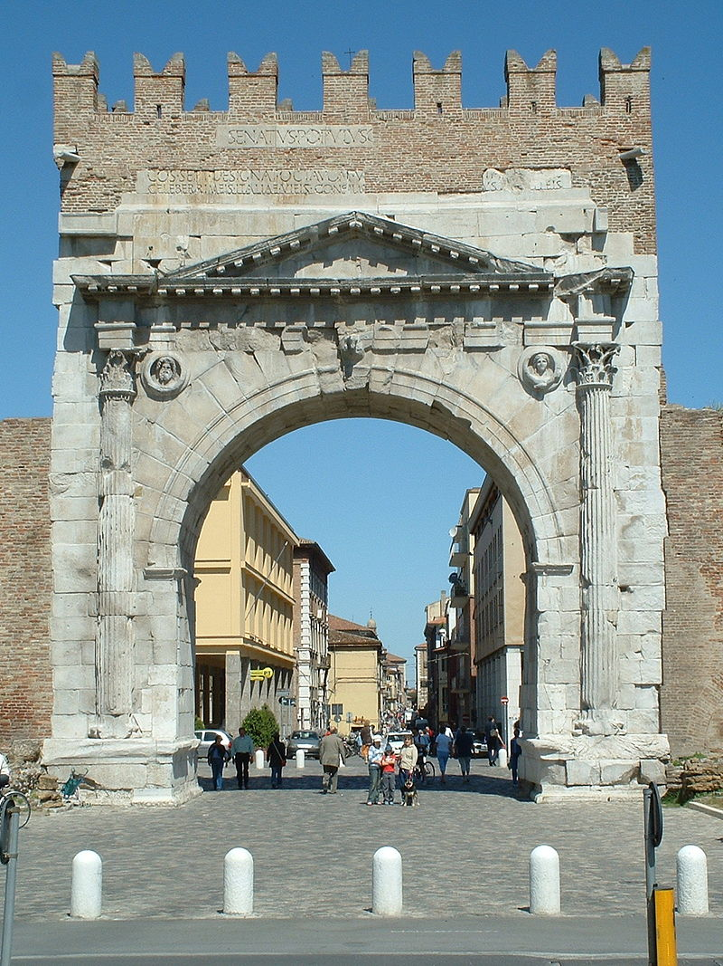
Arch of Augustus, Ariminum (Rimini)
https://commons.wikimedia.org/wiki/File:Arco_d%C2%B4Augusto_Rimini.JPG

Deinde omnēs vultū dēmissō ad raedās sē recēpērunt, cum Sextus longē ā tergō
Then all with-face downcast to wagons selves took-back while Sectus far-off from back
sequerētur, Cornēliā autem metū et frīgore 120 tremere nōn dēsineret.
was-following Cornelia moreover with-fear and cold tembling not stopped
Quōs cum aspexisset, Drūsilla terrōre ēlāta: "Quid nunc malī accidit?" inquit. "Cūr hās
Them when she-had-sighted Drusilla with-fear carried-away what now of-evil has-happened said why these
vestēs madidās videō?"
clothes wet I-see
Nēmō vōce Sextum prōdere voluit; sed Pūblius, quī frātrem trīstem procul sequī
Nobody with-voice Sextus to-betray wanted but Publius who brother sad in-distance to-be-following
animadverterat: "Suspicor," inquit, 125 "quid factum sit. Sextus noster, ut opīnor, dēnuō
had-noticed I-suspect said what happened Sextus our as I-think again
sorōrem lūdificāvit."
sister played-joke-on
Tum Cornēlius vultū torvō: "Satis in praesēns iam dictum est. Sed cum Arīminum
Then Cornelius with-face stern enough for the-present already said has-been but when to-Ariminum
pervēnerimus, tum haec rēs dīiūdicābitur. Interim in sōle vestēs madidae siccentur." 130
we-will-have-reached then this incident will-be-gone-into meanwhile in sun clothes wet let-be-dried
Quod cum factum esset, iterum profectī, sub vesperum ad caupōnem dēvertērunt.
This when done had-been again setting-off towards evening to inn they- went-aside
CAPUT XXXIII

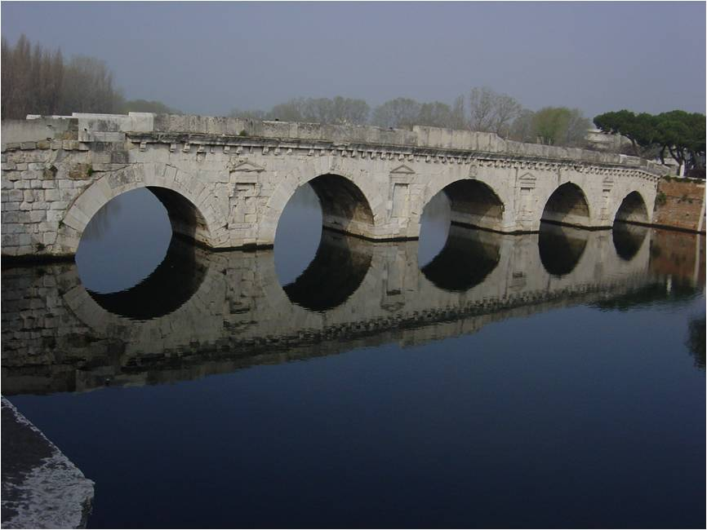
The Ponte Tiberio at the start of the Via Aemilia linking Ariminum (Rimini) with Placentia (Piacenza)
https://en.wikipedia.org/wiki/Via_Aemilia#/media/File:Rimini_-_Ponte_romano_-_Foto_Giovanni_Dall'Orto,_aprile_2004_01.jpg

Manē, cum raedae adductae essent, omnēs alacrēs cōnscendērunt. Sextus autem diū
In-the-morning when wagons brought had-been all energetically got-onboard Sextus however long-time
maestus sēcum sedēbat; nam ā patre vehementer castīgātus erat, eumque suae imprūdentiae
sad alone was-sitting for by father severely scolded had-been and-him of for-own thoughtlessness
maximē paenitēbat; nisi enim prīdiē Onēsimus et Stasimus praestō fuissent, Cornēlia
very-greatly regret-was-affecting if-not for previous-day Onesimus and Stasimus on-hand had-been Cornelia
fortasse in flūctibus periisset. 5
perhaps in waves would-have-perished
Postrēmō hilariōre vultū sē circumspicere coepit; cum autem locō idōneō viātōrēs
Finally with-more-cheerful face self look-around he-began when moreover at-place suitable travellers
cōnstitissent, ut cibus dēprōmerētur, in umbrā adhūc quiētus sedēbat, neque ōrāvit ut sibi
had-halted so-that food could-be-brought-out in shade still quiet he-sat and-not asked that to-him
licēret per agrōs vagārī. Ē contrāriō ā mātre petiit ut sibi aliquid nārrāret.
It-be-permitted through fields to-wander on contrary from mother he-sought that to-him something she-should-tell
Drūsilla, prīmō recūsāre cōnāta: "Hīs diēbus," inquit, 10 "pauca legō. Sed fortasse nōn
Drusilla at-first to-refuse tried these days she-said few-things I-read but perhaps not
audīvīstī dē itinere Orpheī, quī ad īnferōs dēscendit, ut inde uxōrem Eurydicēn redūceret.
you-have-heard about journey of-Orpheus who to underworld descended so-that thence wife Eurydice he-could-bring
"Haec nārrā, sīs, māter," inquit Cornēlia. "Ego quoque audīre volō."
These-things tell please mother said father I too to-here want
"Memoriae trāditum est," inquit Drūsilla, "Eurydicēn, dum 15 in herbā vagātur
To-memory handed-down it-has-been said Drusilla Eurydice while in grass she-wanders
secūra, dentem serpentis in pedem recēpisse; quō vulnere celeriter exanimāta est.
free-of-care tooth of-serpent in foot to-have received from-which injury quickely killed she-was
"Quam cum Orpheus diū dēplōrāsset, cōnstituit ipse dēscendere ad umbrās, sī forte
Her when Orpheus for-long=time had-mourned he-decided himself to-descend to shades in case
cantū suō dīs īnferīs persuādēre posset, ut Eurydicēn ad superōs redūcī paterentur. 20
by-singing his gods below to-persuade he-was-able that Eurydice to world-above to-be-brought-back they-allow
"Quārē sine morā profectus, per 'templa alta Orcī pallida lētō, nūbila tenebrīs loca'
So without delay having-set-off through temples lofty of-Orcus pale with-death gloomy with-darkness places
iter fēcit, ipsamque Prōserpinam impavidus et rēgem īnferōrum adiit.
journey he-made and-herself Proserpina fearlessly and king of-underworld approached
"Apud quōs lyrā personat, nervōsque ad verba movēns ōrat ut uxor sibi reddātur.
Among them on-lyre he-plays and-strings to-accompany words moving he-begs that wife to-him be-returned
Interim, dulcēdine cantūs captae, umbrae 25 undique flēbant. Quīn etiam Tantalus nōn diūtius
Meanwhile by-sweetness of-singing cativated shades in-all-directions were-weeping indeed even Tantalus not longer
aquam captāre cōnātus est, et Ixīōn vultū rīsit invītō.
water to-get-hold-of tried and Ixion with-face smiled unwilling
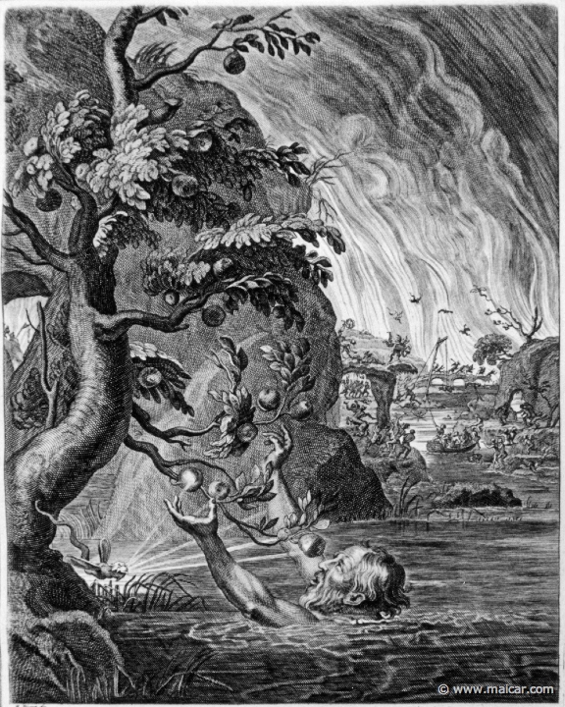
Tantalus as depicted by Bernard Picart (1673-1733)
http://www.maicar.com/GML/Tantalus1.html

"Hīs precibus resistere nec Prōserpina neque ipse Plūtō poterat, et Eurydicē vocāta est.
These pleas to-resist neither Proserpina nor himself Pluto was-able and Eurydice called was
Accessit uxor adhūc dē vulnere tarda; quam Orpheus laetus recēpit. Sed dīmissus est cum 30
Came-up wife still from would slow her Orpheus happy received but dismissed he-was with
mandātō ut abīret statim, nēve prius respiceret quam ē rēgnō īnferōrum esset ēgressus; aliter
instruction that he-leave at-once nor earlier look-back than from kingdom of-underworld he-had emerged otherwise
irritum dōnum futūrum.
void gift going-to-be
"Silentiō Orpheus et Eurydicē ascendērunt clīvum arduum, obscūrum, calīgīne ātrā
In-silence Orpheus and Eurydice ascended slope steep dark with-darkness black
dēnsum; nec procul āfuērunt ā margine ōrae superae, cum ille, veritus nē uxor dēficeret,
thick nor far they-were-away from edge of-shore upper when he fearing lest wife was-loosing-strength
amāns oculōs 35 retorsit.
Lovingly eyes turned-back
"Quō factō, illa statim relāpsa est; neque Orpheō, etsī Charontem ēnīxē ōrāvit, flūmen
With-which done she at-once fell back and-not to-Orpheus although Charon forcefully he-begged river
iterum trānsīre licuit, nec posteā uxōrem umquam aspexit."
again to-cross was-allowed nor afterwards wife ever he-saw
"Tū quoque, māter," inquit Cornēlia, "audītū trīstia nārrās. 40Vix lacrimās teneō, cum
You also mother said Cornelia to-hear things-sad tall scarcely tears I-hold [back] when
dē Orpheō miserō cōgitō."
about Orpheus wretched I-think
"At," inquit Sextus, "quis est ille Charōn, aut quō modō is Orphea prohibēre potuit
But asked Sextus who is that Charon or in-what way he Orpheus to-provent he-was-able
quōminus redīret, ut iterum uxōrem peteret?"
from return so-that again wife he-might-seek
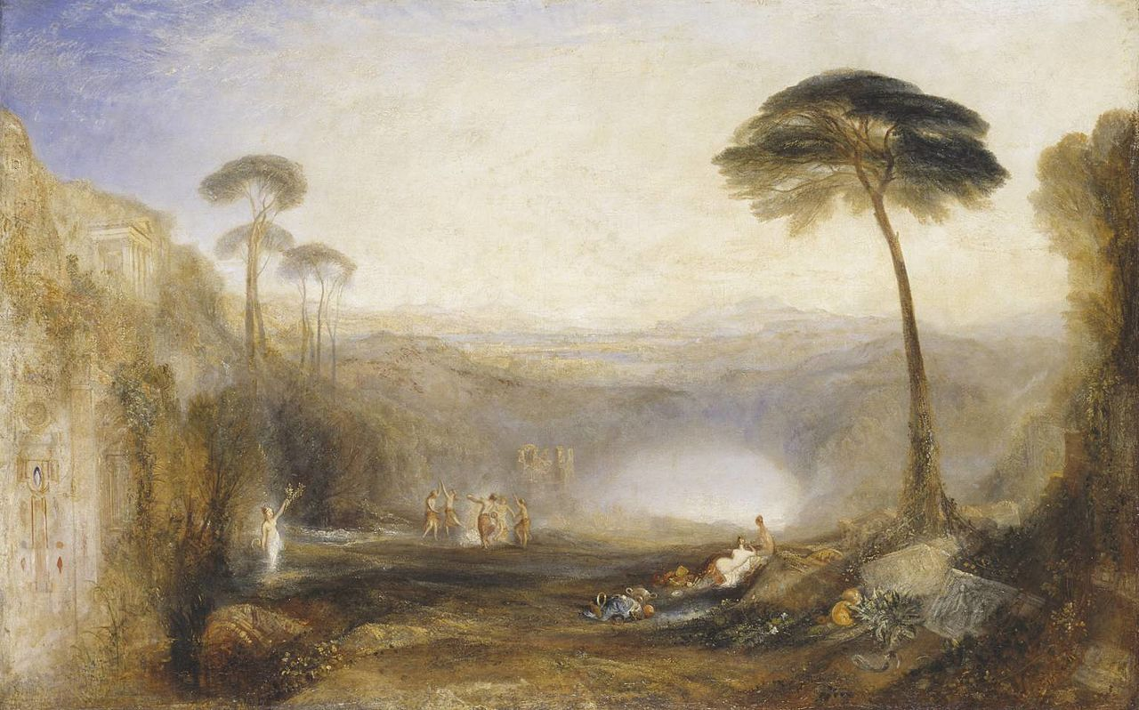
Turner’s 1834 painting of the Sibyl holding the Golden Bough by Lake Avernus
https://www.tate.org.uk/art/artworks/turner-the-golden-bough-n00371

Tum Pūblius: "Charōn erat portitor," inquit, "quī umbrās 45 cymbā trāns flūmen
Then Publius Charon was ferryman said who shades in-skiff across river
Acherontem vehēbat. Dē hīs rēbus multa dīcit poēta Vergilius, quī refert quō modō hērōs
Acheron used-to-carry about these thoings many-things says poet Virgil who related in-what way hero
quoque Aenēās ad īnferōs dēscenderit, ut ibi patrem Anchīsēn convenīret."
also Aeneas to underworld descended so-that there father Anchises he-could-meet
"Dē hōc amplius, sī vīs," inquit Sextus. "Libenter tē audiō." 50
About this more if you-will said Sextus Gladly you I-listen-to
"Aenēās, cum classem ad Italiam appulisset," inquit Pūblius, "Sibyllam statim adiit,
Aeneas when fleet to Italy he-had-brought said Publius Sibyl at-once went-to
quae ad īnferōs dux viae esset. Illa autem eī respondit:
who to underworld leader of-way might-be she then to-him replies

" ' Facilis dēscēnsus Avernō;
easy descent to-Avernus
55 Noctēs atque diēs patet ātrī iānua Dītis.
Nights and days lies-open of-dark door Dis
Sed revocāre gradum superāsque ēvādere ad aurās,
But to-retrace step and-above to-go-out to air
Hoc opus, hic labor est. '
This work this labour is

"Praetereā monuit paucōs admodum fuisse, quī umquam ad ōrās rediissent superās,
Besides she-warned few exceedingly there-to-have-been who ever to shores had-returned above
cum semel eō dēscendissent; sīn autem 60 ille perīculum tantum subīre parātus esset, in opācā
when omce there they-had-descended but-if however he danger so-great to-undergo ready was in shadowy
silvā inveniendum esse rāmum aureum, quī, ut mūnus acceptissimum, ad Prōserpinam
wood to-be-found to-be bough golden which as gift most-welcome to Proserpina
dēferrētur.
might-be-carried
"Aenēās, fortūna adiūtus, rāmum invēnit, et Sibyllā duce per spēluncam ātram
Aeneas by-fortune aided bough found and with-Sibyl [as]leader through cave dark
prōgressus iter īnferōrum brevī carpēbat. 65 Prīmō occurrunt speciēs horrendae, quās hērōs,
having-advanced journey of-underworld soon-was-on first there-meet-him apparitions terrible which hero
timōre commōtus, gladiō strictō transfīgere parābat. Sibylla autem docuit illās esse umbrās
by-fear moved with-sword drawn to-run-through was-preparing Sibyl however explained them to-be shades
tantum, quae nec laedere nec laedī possent.
only which neither to-harm nor to-be-harmed were-able
"Sīc ad rīpam Acherontis pervēnērunt. Qu cum appropinquantēs vīdisset Charōn,
Thus to bank of-Acheron they-reached them when approaching had-seen Charon

statim abīre iussit; nam sibi nefās esse 70 corpora vīvā trādūcere cymbā. Postquam autem
at-once to-go-away ordered for to-him wrong to-be bodies live to-take-across in-boat after however
rāmum aspexit aureum, sine morā Aenēān comitemque in cymbam recēpit.
bough he-sighted golden without delay Aeneas and-companion into boat he-received
"Illa, quae umbrās tantum portāre solēbat, sub pondere gemuit; Aenēās autem
It which shades only to-carry was-accustomed under weight groaned Aneeas however
incolumis ad rīpam pervēnit alteram et in Nemoribus Fortūnātōrum postrēmō repperit
safe to bank reached other and in Groves of-the-Blessed finally found
patrem.”
father
75 Sed iam equī recreātī sunt, ac Cornēlius omnēs in raedās cōnscendere iussit; nam
But now horses refreshed are and Cornelius all into wagons to-climb ordered for
spērābat ante vesperum Faventiam usque pervenīrī posse.
he-was-hoping before evening Faventia as-far-as there-to-be-arrival to-be-possible
Cum dēnuō iter carperent, Sextus: "Modo dīxistī, Pūblī," inquit, "Aenēān classem ad
When again way they-were-on Sextus just-now you-said Publius said Aeneas fleet to
Italiam appulisse. Unde, obsecrō, nāvēs solverat?" 80
Italy to-have-brought from-where please he had set sail
"Ā Siciliā tum vēnerat," inquit Pūblius; "sed anteā nāvēs solverat Carthāgine, quam
From-Sicily then he-had-come said Publius but before he had set sail from-Carthage which
urbem Dīdō condidit, cum crūdēlitāte frātris domō expulsa omnibus cum opibus trāns mare
city Dido founded when by-cuelty of-brother from-home expelled all with wealth across sea
fūgisset, ut locīs longinquīs cīvitātem novam īnstitueret."
she-had-fled so-that in-places distant state new she-could-set-up
"Opēsne eius magnae erant?" inquit Sextus. 85
Riches-? of-her great were asked Sextus.
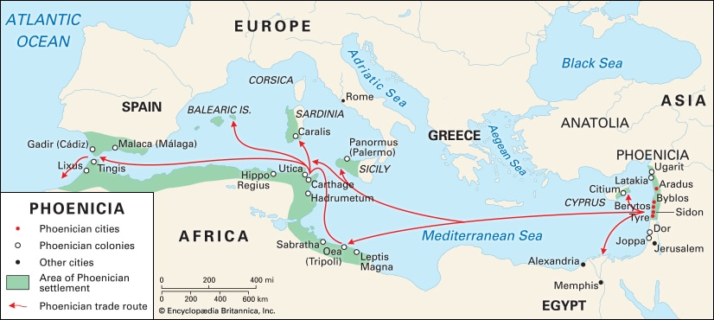
Phoenician colonies and trading routes
https://kids.britannica.com/students/assembly/view/125790

"Permagnae fuisse dīcuntur," inquit Pūblius. "Et multīs post saeculīs, imperātor Nerō,
Enormous to-have-been they-are-said said Publius and many after centuries emperor Nero
cum fiscum maximīs sūmptibus exhausisset et pecūniā egēret, in spem summam ērēctus est
when treasury by-greatest expenditures he-had-exhausted and money he-needed into hope highest raised was
ex indiciō cuiusdam equitis Rōmānī, quī prō certō nūntiābat thēsaurōs maximōs, quōs Dīdō
from indication of-a-certain knight Roman who as a-certainty announced treasures very-great which Dido
Tȳrō fugiēns sēcum extulisset,90 adhūc integrōs esse in Āfricā, in vāstissimīs cavernīs
From-tyre fleeing with-her had-taken still intact to-be in Africa in very-vast caverns
absconditōs, ac posse parvō labōre effodī. Posteā imperātor, cum haec spēs eum fefellisset,
concealed and to-be-able with-little labour to-be-dug-out afterwards emperor when this hope him had-deceived
rapīnīs intendit animum."
on-plundering focussed mind
"Hem!" inquit Cornēlia. "Istīus monstrī nōmen ipsum vix audīre sustineō."95
Hey said Cornelia of-that monster name itself sarecely to-hear I-bear
"Atquī quiddam est," inquit Pūblius, "quod dē eius familiā forsitan libenter audiās."
However something there-is said Publius which about his family perhaps gladly you-may-hear
"Perge porrō dīcere," inquit Sextus. "Ego quidem tē dē eō loquentem libenter audiō."
Continue further to-speak said Sextus I at-least you about him speaking gladly hear
"Nerō erat ē gente Domitiā," inquit Pūblius, "ē quā 100 duae familiae illūstrēs fuērunt,
Nero was from clan Domitian said Publiis from which two families famous there-were
Calvīnōrum et Ahēnobarbōrum; et ipse Lūcius Domitius Ahēnobarbus vocābātur, dōnec ab
[those]of-Calvini and Ahenobarbī and himself Lucius Domitius Ahenobarbus was-called until by

imperātōre Claudiō est adoptātus.
Emperor Claudius was adopted
"Memoriae trāditum est prīscīs temporibus cuidam L. Domītīō, 105rūre ad urbem
To-memory handed-down it-has-been in-former times to-a-certain Lucius Domitius from-country to city
redeuntī, in viā obviam factōs esse duōs iuvenēs augustiōre speciē, quī eum iubērent senātuī
returning on road in-way made to-have-been two youths with-quite-splendid appearance who him ordered to-senate
ac populō nūntiāre victōriam maximam ā Rōmānīs ad lacum Rēgillum modo partam esse.
and people to-announce victory very-great by Romans at Lake Regillus just-now won to-have-been
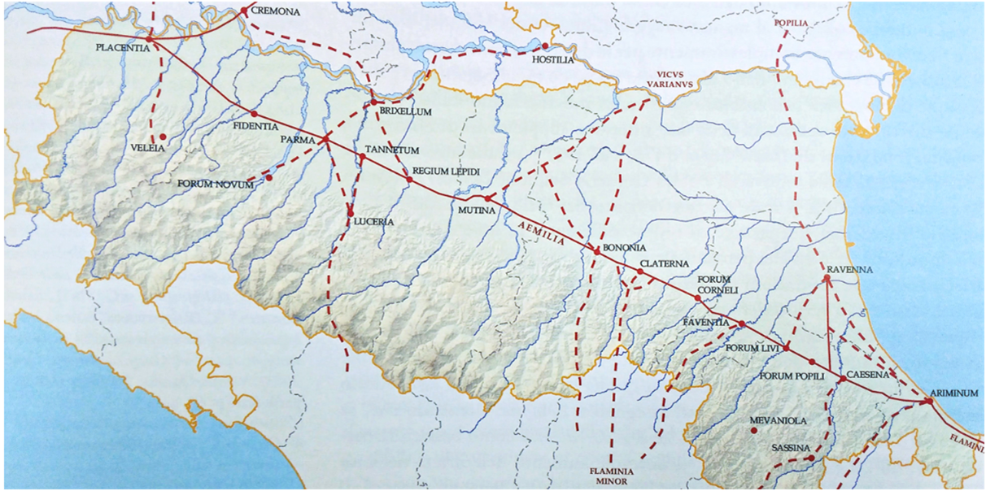
Map of the Via Aemilia, showing Faventia (Faenze) and Bononia(Bologna)
https://blog.travelemiliaromagna.com/via-emilia-history-and-origins-of-a-region-in-10-points

"Cum autem ille dubitāret utrum eīs fidem habēret necne, 110 iuvenēs, ut auctōritātem
When then he was-in-doubt whether in-them trust he-should-have or-not the-youths so-that authority
suam dīvīnam esse probārent, malās eius manibus suls permulsērunt; ac statim ē nigrā
own divine to-be they-might-prove cheeks his with-hands their stroked and at-once from black
hominis barba rutila atque aerī similis facta est; unde cognōmen 'Ahēnobarbus.' Quod īnsigne
man’s beard red and to-bronze similar became from-which surname `Bronzebeard’ this mark
adhūc manet; nam posteā ex illā familiā multī barbā rutilā fuērunt."
still remains for afterwards from that family many with-beard red there-were
115 "Hoc magis placet," inquit Cornēlia, "etsī mihi quidem vix crēdibile vidētur."
This more pleases said Cornelia although to-me indeed scarcely believable it-seems
Interim raedās equī libenter dūcēbant; ac hōra ferē ūndecimā ad oppidum Faventiam
meanwhile wagons horses willingly were-leading and at-hour about eleventh to town Faventia.
perventum est. Posterō diē viātōrēs contendērunt Bonōniam usque, ubi in hospitium amīcī
reached it-was on-next day travellers hurried Bononia up-to where to hospitality of-friend
dēvertērunt.
they-turned-aside
CAPUT XXXIV

Inde manē profectī, ante merīdiem pervēnērunt ad rīvum amoenum, ubi duās hōrās
From-there in-morning setting-out before noon theyarrived at stream pleasant where two hours
morātī sunt. Postquam gustāvērunt, Anna cum Lūciō in herbā cōnsēdit, ac līberī ab eā
they-delayed after they-ate Anna with Lucius on grass sat-down and children from her
petīvērunt ut aliquid sibi nārrāret.
aked that something to-them she-might-tell
5 Atque illa: "Ūnum tantum nunc recordārī possum," inquit, "neque id permagnum. Sed
And she one-thing only now remember I-can said and-not that very-major but
sī audīre vultis, ego incipiam."
if to-hear you-want I will-begin
"Nārrā, obsecrō," inquit Sextus. "Nam Pūblius aliquō sōlus abiit, cēterīque quiētī sē
Tell please said Sextus for Publius somewhere alone has-gone-off and-others to-rest selves
dedisse videntur."
to-have-given seem
"Fortasse," inquit Anna, "meministis mē ōlim quaedam 10 loquī dē iuvene pāstōre, quī
Perhaps said Anna you-remember me once some-things to-speak about young shepherd who
gigantem occīdit rēxque posteā factus est."
giant killed and-king afterwards was-made
"Ita vērō," inquit Cornēlia. "Plūra audīre volumus."
Yes indeed said Cornelia more to-hear we-want
Tum Anna: "Illī rēgī fuit fīlius, quem ūnicē amābat. Puer erat īnsignī pulchritūdine; sed
Then Anna To-that king was son whom exxeptionally he-loved boy was with-remarkable good-looks but
cum iam adultus esset, coniūrātiōnem in patrem fēcit, cum spērāret sē ipsum rēgem fore.15
when now adult he-was conspiracy against father he-made since he-hoped himself king to-be-going-to-be
"Hāc coniūrātiōne dētēctā, pater prīmō salūtem fugā petiit; sed postrēmō, cōpiīs coāctīs,
With-this conspiracy detected father first safetly by-flight sought but finally with-forces assembled
bellum cum fīlīō gerere invītus parāvit.
war with son to-wage unwillingly he-prepared
"Eō diē, quō exercitūs decertātūrī erant, omnēs rēgem ēnīxē ōrāvērunt nē sē ipsum
on-that day when armies going-to-meet-in-battle were all king earnestly begged that-not himself
perīcūlō obiceret. Quārē, cum 20 cēterī ad pugnam proficīscerentur, ipse ad oppidī portam
to-danger he-should-expose so when rest to fight were-setting-off he-himself at town’s gate

relictus est.
left was
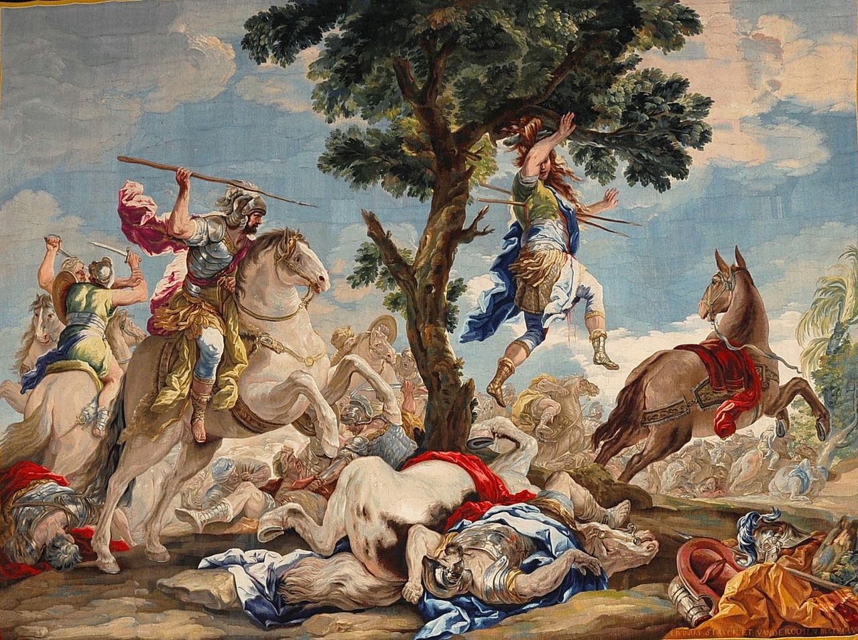
Death of Absalom – tapestry by Corrado Giaquinto (18th. cent.)
https://commons.wikimedia.org/w/index.php?curid=5268721

"Fīlium quamvīs perfidum pater tamen vehementer amābat. Quārē lēgātō suō abeuntī
Son although treacherous father nevertheless greatly loved so to-commander his departing
dīligenter praecēperat, nē quid iuvenī 25 ipsī nocērētur; et iam sollicitā mente ēventum
carefully he-had-given-instructions that-not any to-youth himself harm-be-done and now with-troubled mind result
exspectābat, dum speculātor ē mūrō attentē prōspicit.
he-was-awaiting whilst as-sentinel from wall attentively he-looked-out
"Ā rēgiīs copiīs magna victōria parta est; ac fīlius, asinō vectus, per silvam effugere
By-royal forces great victoy obtained was and son by-donkey carried through wood to-escape
cōnābātur. Capillō tamen, quī eī prōmissus erat, ramīs implicātō, asinus abiit, hominemque in
was-trying with-hair however which for-him long was in-branches caught donkey went-off and-man in
30 arbore pendentem relīquit.
tree hanging left
"Hōc cognitō, lēgātus rēgius, tribus lanceīs arreptīs, in silvam properāvit iuvenemque ter
With-this learned commander royal with-three lances snatched into forest hurried and-young-man thrice
per pectus trānsverberāvit. Tum comitēs, cum prius hominem exanimātum gladiīs aggressī
through chest pierced then companions when first man dead with-swords attacked
essent, dēmpsērunt corpus; quod in foveam abiectum saxīs multīs 35 mīlitēs obruērunt.
they-had took-away body which into pit dumped with-rocks many soldiers overwhelmed
"Interim rēx sollicitus nūntiōs pugnae spērābat; ubique speculātor clāmāvit cursōrem
Meanwhile king worried news of-battle was-hoping-for and-when sentinel shouted runner
procul cōnspicī posse, rēx, in summam exspectātiōnem ērēctus, vix hominis adventum
in-distance to-be-seen to-be-able king into greatest expectatiomn aroused scarcely man’s arrival
manēre potuit; cumque eī victōria magna nūntiāta esset, hoc tantum 40 rogābat: 'Estne iuvenis
wait-for he-could and-when to-him victory great announced had-been this only ke-kept-asking is-? youth
salvus?'
safe
"Cursor sē nescīre dīxit. Sed alter, quī celeriter subsecūtus erat, cum ab eō idem
Runner himself himself not-to-know said but a-second-one who quickly followed-up had when by him same-thing
quaesītum esset: 'Utinam,' inquit, 'ō rēx, omnibus inimīcīs tuīs ita esset, ut nunc est illī iuvenī!'
asked had-been would-that said o king for-all enemies you thus it-were as now it-is for-that youth
"Quod ubi audīvit, rēx summō maerōre adflīctus sē in sēcrētum 45 recēpit, cum
Which when he-heard king with-greatest sorry afflicted himself into seclusion took-back while
identidem lamentābilī vōce dēplōrāret: 'Ō fīlī cārē, utinam ego prō tē periissem, fīlī mī!'"
repeatedly in-sorrowful voice he-mourned o son dear would-that I instead-of you had-perished son my
"Nē tū quidem hodiē laeta loqueris, Anna," inquit Cornēlia. "Tālium iam satis est; et
Not you even today happy-things speak Anna said Cornelia of-suc-things now enough it-is and
mīror ubi Pūblius tam diū morētur."
I-wonder where Publius so long is-delaying
" 'Ecce tibi lupus in fābulā,' " inquit Sextus, cum digitō 50 mōnstrāret Pūblium, quī
Here’s for-you wolf in story said Sextus while with-finger he-pointed-out Publius who
lēniter accēdēbat.
Slowly was-approaching
Quī, simulac propius accessit: "Sibyllam," inquit, "modo vīdī. Nōnne vultis mēcum īre,
He as-soon-as nearer he-came-up Sibyl he-said just-now I-have-seen don’t you-want with-me to-go
ut eam cōnsultēmus?"
so-that her we-can-consult
"Nōs lūdificāre cōnāris," inquit Sextus; "et ego saltem ad īnferōs dēscendere minimē
Us to-make-fun-of you are-trying said Sextus and I at-least to Underworld to-descend not-at-all
cupiō."
want
"Veniātis, suādeō," inquit frāter. "Illa quidem certē digna 55 est, quae ā vōbīs aspiciātur."
Come I-urge said brother she indeed certainly worthy is who by you may-be-seen
Quibus verbīs inductī, Sextus et Cornēlia secūtī sunt; quōs Pūblius rēctā per agrōs dūxit
By-which words swayed Sextus and Cornelia followed them Pulius straight across fields led
ad parvam casam, quae haud procul cōnspicī poterat.
to small house which not far-off be-seen could
Quō cum perventum esset, anum dēcrepitā aetāte vīdērunt 60, quae rāmulōs āridōs
To-there when arrived it-had-been old-woman with-feeble age they-saw who twigs dry
legēbat.
was-gathering
"Em," inquit Pūblius rīdēns, "Sibyllam aspicite. Ego quidem nihil umquam similius
There said Publius smiling sibyl see I at-any-rate nothing ever more-like[her]
vīdī."
have-seen
Dum līberī, quī sēcum male āctum esse putābant, tamen videndī studiō circumspiciunt,
While children who with-selves badly done to-have-been thought still for-seeing with-enthusiasm looked-around
subitō ē casā ad eōrum aurīs adlāta est vōx horrenda: "Tōtam consūmpsī. Cedo alteram.65"
suddenly from house to their ears brought was voice alarming whole-of-her I’ve-eaten-up give-me another
Quā audītā, Cornēlia pallidō ōre: "Fugiāmus," inquit. "Male metuō nē intus sit
With-which heard Cornelia with-pale face let’s-run-away said badly I-fear lest inside may-be
mōnstrum eīs simile, quae Aenēae occurrērunt, cum ad īnferōs dēscenderet. Iam ūnam
monster to-those similar which Aeneas met when to Underworld he-was-descending already one
puellam vorāsse vidētur."
girl to-have-swallowed he-seems
Pūblius autem audācter ad iānuam prōcessit, et cēterōs ut 70 sequerentur hortātus est.
Publius however boldly to door advanced and others that they-should-follow urged
Tum autem iterum audīta est illa vōx: 'Cedo alteram,' ac Cornēliā perterrita iam fugitūra
Then however again heard was that voice give-me another and Cornelia terrified now about-to-run-away
erat, cum Pūblius, quī casam intrōspexerat, in cachinnōs effūsus: "Accēdite," inquit, "ut
was when Publius who house had-looked-inside into chuckles collapsing come-here said so
'mōnstrum' illud videātis."
monster that you-can-see
Quō audītō, Sextus et Cornēlia timidē et lēniter prōgressī 75, intus vīdērunt corvum, quī
With-this-heard Sextus and Cornelia timidly and slowly going-forwards inside saw raven which
placentās, quās mīles porrigēbat singulās, avidē vorābat, cum interdum 'Cedo alteram' raucā
cakes which soldier was-holding-out one-by-one eagerly was-devouring whilst meanwhile give-me another in-rough
vōce dīceret.
voice was-saying
Pūbliō et līberīs animadversīs, mīles placentās cēterās corvō prōiēcit, et: "Salvēte
With-Publius and children noticed soldier cakes the-other to-raven threw and greetings
omnēs," inquit. "Ego sum veterānus, 80 quī prō patriā pugnāns vulnera multa accepī; tum,
all said I am veteran who for fatherland fighting wounds many received then
bracchiō amputātō, domum remissus sum. Haec casa est mea; sī intrāre vultis, quō poterō
with-arm amputated home sent-back was this house is mine if to-enter you-wish as I-will-be-able
hospitiō vōs libenter accipiam."
with-hospitality you gladly I-will-welcome
Quārē omnēs ingressī sunt ac dīversīs locīs cōnsēdērunt. Sed 85 etiam tum Cornēlia
So all entered and in-different spots sat-down but even then Cornelia
ānxia corvum observābat; quī autem, placentīs intentus, nihil amplius locūtus est.
anxious raven was-observing who however on-cakes concentrated nothing more spoke
Tum mīlitī Pūblius: "Tū, nisi fallor," inquit, "saepe adfuistī, cum ācriter pugnārētur."
Then to-soldier Publius you unless I’m-mistaken said often were-present when fierecely fighting-was-going-on
"Vēra dīcis," inquit mīles. "Longinquās in ōrās penetrāvī, 90 et terrā marīque proeliīs
Truth you-say said soldier distnt to shores I-penetrated and on-land and-sea in-battles
multīs interfuī."
many I-was-present

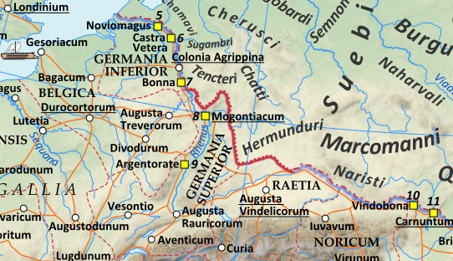
Rome’s north-western frontier
https://upload.wikimedia.org/wikipedia/commons/b/bb/Roman_Empire_125.png

"Nōnne vīs," inquit Pūblius, "dē hīs rēbus aliquid nobīs nārrāre?"
Don’t you-wish said Publius about these things something to-us to-tell
"Dē meīs rēbus gestīs semper invītus loquor," inquit veterānus. "Sed quīdam centuriō,
About my things done always unwilling I-speak said veteran but a-certain centurion
familiāris meus, facinora 95 ēgregia saepe ausus est, quae ego verbīs satis dignīs exprimere
relative my deeds outstanding often dared which I in-words enough fitting to-express
nūllō modō possum."
in-no way I-am-able
"Dē eō igitur dīc," inquit Pūblius, "sī dē tē ipsō nihil vīs loquī."
About him therefore speak said Publius if about you yourself nothing you-wish to-speak
At mīles: "Ōlim, cum lēgātus per expedītiōnem abesset, ille 100 centūriō in praesidiō
And soldier once when legate on expedition was-away that centurion in base
aeger relictus erat. Morbō tantopere vexābātur, ut diem iam quīntum cibō cārēret, cum
sick left had-been by-sicness so-much he-was-troubled that day now fifthe food he-was-going-without when
subitō in illa castra hostēs impetum ācerrimum fēcērunt.
suddenly into that camp enemy attack very-fierce made
"Tum ille, suae atque omnium salūtī diffīsus, cum inermis ē tabernāculō prōdiisset,
Then he about-own and of-all safety not-confident when unarmed out-of tent he-had-gone-forth
hostēs vidēbat maximē imminēre 105 remque summō in discrīmine esse.
enemy he-saw greatly to-be-threatening and-situation greatest in crisis to-be
"Arma igitur cēpit ā proximīs, atque ipsā in portā castrōrum fortissimē cōnstitit sōlus.
Weapons therefore he-took from those-nearest and itself in gate of-camp most-bravely took-stand alone
Hunc autem celeriter secūtī sunt centuriōnēs eius cohortis, quae eō tempore in statiōne
Him however quickly followed centurions of-that cohort which at-that time on guard
erat.
was
"Ita proelium est restitūtum. Iam autem, gravibus acceptīs 110 vulneribus, hominem
Thus battle was restored Now however serious received with-wounds man
animus relīquit, ac vix per manūs trāditūs servātus est.
consciousness left and scarcely through hands passed-on saved he-was
Hōc tamen spatiō interpositō, reliquī, mente iam cōnfirmāta, mūnītiōnēs virtūte tantā
With-this however interval interposed the-rest with-mind now strengthened fortifications with-courage so-great
dēfendērunt, ut hostēs, dēspērātā castrōrum expugnātiōne, trāns flūmen Rhēnum brevi sē
defended that enemy despaired-of of-camp storming across river Rhine soon themselves
reciperent." 115
took-back
"Optime factum!" inquit Pūblius. Tum ex ōstiō prōspiciēns: "Sed servum nostrum
Excellently done said Publius then from doeway looling-out but slave our
Onēsimum appropinquantem videō, et exīstimō statim nōbīs proficīscendum esse. Quārē
Onesimus approaching I-see and I-think at-once for-us necessary-to-set-off to-be so
et valē, senex, et hanc tibi accipe." Quō dictō, hominī gemmam parvam trādidit. 120
both farewell old-man and this for-yourself accept with-which said to-man gem small he-handed-over
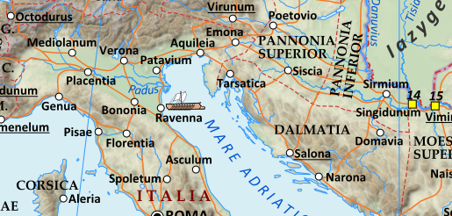
Pannonia and Dalmatia with frontiers of 125 A.D.
https://upload.wikimedia.org/wikipedia/commons/b/bb/Roman_Empire_125.png

"Cedo alteram," inquit corvus, quī iam placentās omnēs cōnsūmpserat.
Give-me another said raven who now cakes all had-consumed
Quō audītō, omnēs rīsērunt; et Pūblius, dum ad raedās sē recipiunt: "Verbīs huius
with-which heard all laughed and Publius while to wagons selves they-were-taking-back by-words of-this
corvī," inquit, "admoneor dē quōdam centuriōne, quī ōlim in Germāniā ōrdinem dūxit. 125
raven said I-am-reminded about a-certain centurion who once in Germany company commanded
"Eī per iocum mīlītēs cognōmen 'Cedo-alteram' indidērunt, quod, cum virgam in tergō
To-him as joke soldiers surname Give-me-another bestowed because whenever stick on back
mīlitis frēgerat, alteram clārā vōce ac rūrsus aliam poscēbat."
of-soldier had-broken another in-clear voice and again another used-to-demand

"Hahahae!" inquit Sextus. "Cognōmen aptum! Sed gaudeō mē in illō exercitū nōn
Ha ha ha said Sextus name fitting but I-am-glad myself in that army not
stīpendia fēcisse."
military-service to-have-done
130 Iam ad raedās perventum est; ubi Drūsilla, cum ēscenderet, lagunculam ē mānū
Now to wagons reached it-was where Drusilla when she-was-boarding little-bottle from hand
forte dīmīsit; quō cāsū frācta est. Itaque Annae illa: "Cedo alteram," inquit. Quō dictō, rīsus
by-chance dropped by-which fall broken it-was and-so to-Anna she give-me another said with-which said laughter
maximus exortus est; cumque matrī, tantae hilāritātis causam quaerentī, tōtam rem
very-great arose and-when to-mother of-so-great high-spirits cause asking whole story
exposuissent, līberī 135 posteā temperāre nōn potuērunt quīn interdum ex intervāllō haec
they-had-explaoined children afterwards stop-temselves not were-able from sometimes at interval these-things
omnia reminīscerentur cachinnōsque revocārent.
All were-recalling giggles-also they-renewed
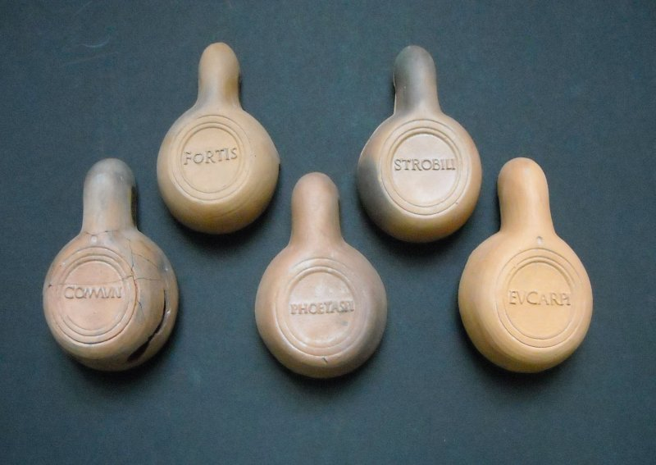
Mutina oil lamps with brand names
http://www.romanhideout.com/News/2008/20081127.asp

Sīc huius diēī iter tōtum fēlīciter cōnfectum est, atque sōlis occasū Mutinam
Thus of-this day journey whole happily completed was and of-sun at-setting Mutina
pervēnērunt. Parmae noctem ēgērunt proximam.
they reached at-Rama night they-spent next

The story is told by Suetonius, who explains that the fire had spread from a stove (Vitellius, 8). For details of Vitellius’s brief reign in 69, see chapters XXI and XXIII.
offendō (-ere, offendī, offēnsum) basically means to strike or dash against something.
Caesar landed in Africa in December 47 B.C. to pursue his remaining opponents in the civil war of 49-45. Suetonius is again the source of the anecdote and his actual wording is pōlāpsus .. in ēgressū nāvis versō ad melius ōmine: 'teneō tē,' inquit, 'Āfrica.' (Divus Iulius, 59).
Livia Drusilla (?59 B.C. – 29 A.D.), known also as Livia Augusta and Julia Augusta, married Octavian (later Augustus) in 39 B.C after her first husband, Tiberius Claudius Nero had agreed to divorce her. She had no children by Augustus but Tiberius, her son from her first marriage, succeeded Augustus in 14 A.D. and the following three emperors were her descendants through Tiberius’ brother, Drusus the Elder (see the chart on page 3 ). She was the great-grandmother of Caligula, grandmother of Claudius and great-great-grandmother of Nero. Rome’s first five emperors are therefore known as the Julio-Claudian dynasty. See https://en.wikipedia.org/wiki/Livia
i.e. near the city of Veii mentioned in the previous chapter
Literally `At the Hens’
The chart gives an accurate picture of the family inter-connections but the regnal years of Claudius and nNero were 41-54 and 54 to 68 A.D. respectively.
obviam is an adverb (literally `in the way’) used with the dative and a verb of motion with the meaning `to meet’.
The subjnctive is needed here to show that the relative clause is part of what Sextus himself said rather than information added by the writer.
The ablative of the supine is frequently used with adjectives in this way
cruentus, -a, um can sometimes just mean `blood red’ but normally refrs to actual blood or violences.
As explained at https://www.globalsecurity.org/military/world/spqr/money-1.htm, it is virtually impossible to state the equivalent of Roman monetary units in modern curencies because of changes in economic structure. However, on the basis of the price of gold (approx. US$1650 per ounce in March 2020), 30,000 sesterces would be around 150, 000 dollars. Under the early empire, a labourer’s daily wage was probably around 4 sesterces. Note the easily confusable terms sestertius, -ī m (sesterce) and sestertium, - ī n (thousand sesterces).
For the ubiquity of banditry in the Roman world, see Thomas Grünewald’s study, available at https://historicalunderbelly.files.wordpress.com/2012/12/thoma-grunewald-bandits-in-the-roman-empire-myth-and-reality-2004.pdf
Narnia, originally known as Nequinum, was a settlement of the Umbrians, whose language is part of the Osco-Umbrian group, regarded by some scholars as Italic like Latin but by others as a separate branch of Indo-European. Following the Roman conquest of the town in 299 B.C. it was made into a Latin colony and renamed after the nearby river Nar (Nār, Nāris; modern Nera). C.S. Lewis adopted the name for his imaginary kingdom after discovering it in Murray’s Small Classical Atlas (https://archive.org/details/murrayssmallclas00grun/page/n57/mode/2up For more details see https://en.wikipedia.org/wiki/Narni and, for other parallels between the real and the fictional Narnia, https://www.catholicnewsagency.com/news/narni-italys-inspiration-for-the-magical-realm-of-c-s-lewis-54887 These resemblances may, however, be coincidental and there is no evidence that Lewis himself ever visted the town. The Nera, a tributary of the Tiber, is one of the few rivers in Italy, apart from the Tiber itself and the Po, which flow all year round.
obvius fīo (fierī, factus sum) is another way of expressing `encounter’, `meet up with’
i.e. around 9 a.m. or between then and 10 a.m.
Assuming he was carrying the money in gold pieces (aureī), each of which were worth 100 sesterces, he would have needed to count out 300 coins
The Umbrian Nuceria (modern Nocera), whose name meant `New [town’] in the Osco-Umbrian language, came under Roman control around 300 B.C. The original settlement was in the valley but after this was destroyed, perhaps by Germanic invaders, in the early 5th century, the survivors shifted to the present hill-top site (see https://en.wikipedia.org/wiki/Nocera_Umbra). This town should not be confused with the Nuceria in Campania, many of whose citizens perished in a riot during a gladiator show at Pompeii in 59 A.D. (see Stage 8 of Cambridge Latin course).
videor (passive of videō) means both `I am seen’ and `I seem’
sī forte: literally ` if by chance’
From incidō (incidere, incidī). Distinguish from incīdō (incidere, incīdī, incīsum, `cut into’)
Literally `I will throw on’
Stasimus is punning with the words mālum, -ī n (evil thing) and māla, -ae f (cheek). Both have to be distinguished from mālum, -ī n (apple or similar-shaped fruit) and mālus, -ī m (apple tree, ship’s mast).
autem has little real meaning here and could actually be left out in the translation.
Literally `with running poured-out’
`into very-loud laughter were poured out’
Contraction of rediistī (perfect of redeō, redīre, rediī, reditum)
mōrōsus, -a, -um (peevish, capricious) should be distinguished from late Latin morōsus, -a, -um, `slow in coming.’
The short `o’ in the printed book is an error.
Ancient Sentinum was situated to the east of the Via Flaminia, about one kilometre south of the present-day town of Sassoferrato. The town appears to have collapsed as an organised community during the Gothic invasion in the late 4th or early 5th century, in which Rome itself was captured. See https://en.wikipedia.org/wiki/Sentinum
The battle of Sentinum was fought in 295 B.C. when the Romans were facing a coalition of the Samnites, Etruscans, Umbrians and Senones (Italian `Senoni’), the Gallic tribe then occupying the east coast south of Ariminum (Rimini), who had captured Rome itself in 390. After the Roman victory, made possible because the Umbrians and Etruscans were defending their own territory against diversionary attacks, the Samnites were abandoned by the other peoples and were themselves then finally brought under Roman control See https://en.wikipedia.org/wiki/Battle_of_Sentinum, https://www.livius.org/articles/place/sentinum/
This construction with fore ut and the subjunctive was normally preferred in indirect statements to the use of the `future passive infinitive’ (hostium sīc minūtum īrī impetum, Rōmānīs ..vīrēs paene integrās servātum īrī)
Publius Decius Mus’s father of the same name sacrificed himself in an identical manner at the Battle of Vesuvius in 340 B.C. when Romans and Samnites were allies in the Latin War of 340-338 against both the Latins themselves and the, Campanians, Volsci, Sidicini and Aurunci, peoples occupying the west coast of Italy from Latium to the Bay of Naples (see map on pg.19). Roman victory in 340 ensured her domination of Latium, as victory at Sentinum in 295 paved her path to supremacy in Italy.
Lictors carried fascēs, an axe in a bundle of rods, as a symbol of the consul’s power to punish.
Contraction of castigāvisse
The `Lacus Curtius’ (`Lake of Curtius’) was in historical times a small, duodecagonal basin, apparently all that was left of the marsh (and possibly once a real lake) that had existed before the Forum area was paved over in the seventh century B.C. As well as the devōtiō story, conventionally dated to 362 B.C, which he himself prefers, Livy mentions a rival ancient explanation linking the name to a to a Sabine leader, Mettius Curtius. This man supposedly became stuck in the marsh during the fighting after the Romans’ abduction of the Sabine maidens. The gēns Curtia were in fact of Sabine origin but both legends may be distorted memories of the area’s probable early function as a site for execution and human sacrifice. The emperor Galba was lynched by soldiers at this place in 69 A.D. The relief shown on pg. 21 is in the Capitoline Museum. See for a third legend and further details https://www.livius.org/articles/place/rome/rome-photos/rome-forum-romanum/lacus-curtius/
Cicero’s translation of Simonides’ Greek original: Ὦ ξεῖν', ἄγγειλον Λακεδαιμονίοις ὅτι τῇδε κείμεθα, τοῖς κείνων ῥήμασι πειθόμενοι. (`Tell them in Lacedaimon, passer-by, that here, obedient to their word, we lie.’) The verses are an elegiac couplet (i.e. a hexameter plus a pentameter; see note ?? to chapter 25). The epitaph commemorates the three hundred Spartans who held the narrow pass on the coast road at Thermopylae against the Persian invasion force in 480 B.C. and died fighting to the end after a Greek traitor showed the enemy a path through the hills to get behind them.
Subjunctive iniciant (from inciciō, inicere, iniēcī, iniēctum) in a relative clause of characteristic.
Julius Caesar sailed to Alexandria in Egypt in summer 48 B.C. in pursuit of Pompey, whose forces he had defeated at Pharsalus in western Greece, only to find that his rival had been murdered by King Ptolemy XIII who hoped thereby to win his support. Caesar had in fact planned to pardon Pompey and he subsequently intervened in support of the king’s sister, Cleopatra, who was engaged in a civil war against him. Caesar was out-numbered and was besieged in a section of the city for several months but finally, with help from Mithridates, the ally whom he summoned from Pergamum in Asia Minor, he defeated Ptolemy at the Battle of the Nile in February 47.
Impersonal passive of the intransitive verb labōrō.
Inns generally had a poor reputation in the Roman period and those with a wide enough circle of friends and acquaintances normally preferred to rely on their hospitality even if accommodation was available elsewhere.
The party would probably have crossed the Metaurus (modern Metauro) by the bridge at Calmazzo (`Ponte di Traiano’), five kilometres above Forum Sempronii (see map, AD ALPES III, p.54), and probably constructed by Trajan in 115. This was extensively restored in later centuries but destroyed in WWII.
Hasdrubal was left in command in Spain when Hannibal left for Italy in 218. In 209 he was defeated by Roman forces under Publius Cornelius Scipio (who was later ot defeat Hannibal himself) but retained most of his army intact and evaded the Romans to cross the Pyrennes to Gaul in winter 208. He waited till spring 207 to cross the Alps, using Hannibal’s route and, unlike him, finding the local tribesmen now co-operative. His letter to his brother, intercepted by the Romans, asked Hannibal to meet him in Umbria. See https://en.wikipedia.org/wiki/Hasdrubal_Barca
Venusia, birthplace of the poet Horace, was on the border between Apulia and Lucania near the site of Hannibal’s vitory at Cannae. Cornelius’s family visited the town in chapter XIV (AD ALPES II: 91).
The bridge on this site was constructed by Diocletian in 292 and rebuilt in 1782 and again in 1947, following its destruction in World War II. The road over it connected the Via Flaminia, which here ran north of the river, with the south bank.. For more details, see pp. 112-3 of M.H. Balance, `The Roman Bridges of the Via Flaminia’ Papers of the.British School at Rome, 19 (1951), pp. 78-117, https://www.jstor.org/stable/40310491, and https://en.wikipedia.org/wiki/Ponte_della_Concordia,_Fossombrone
The Battle of Trasimene (Lago Trasimeno on the Tuscany/Umbria border), in which Flaminius’s army was ambushed on the northern shore of the lake, was fought around 21 June 207.
Literally `If I will have been able’.
Odes IV:4, 69-72. The stanza is in Horace’s favourite Alcaic pattern, consisting of two Alcaic hendecasyllables (ᵒ - ᵕ - - - ᵕ ᵕ - ᵕ-), an iambic dimeter plus one syllable ( ᵒ - ᵕ - ᵒ - ᵕ - -) and an Alcaic decasyllable (- ᵕ ᵕ - ᵕ ᵕ - ᵕ - -).
Corresponding roughly to the hour from 3.00 to 4.00 p.m.
Fanum Fortunae (Fano) stands at the mouth of the Metaurus, where the Via Flaminia met the Adriatic coast. The upper storey of the Arch of Augustus (2 A.D.) was destroyed during a siege in 1463 (see https://en.wikipedia.org/wiki/Fano). The site of the Battle of the Metaurus, fought on 22 June 207, is unknown but was probably not far inland. Bernard Henderson’s extensive discussion, published in 1898, is reproduced at http://penelope.uchicago.edu/Thayer/E/Journals/EHR/13/Metaurus*.html
Literally `sum (or top) of things.
alveus (-ī m) can mean a basket, tray, hollow continer or channel.
The verb prōscrībō is best-known from the process of listing political opponents who could be freely killed and their property confiscated. This was notoriously done by the dictator Sulla in 82/81 B.C.and also by the triumvirs Octavian (Augustus), Mark Anthony and Lepidus in 43 B.C. before they left Rome in pursuit of the conspirators who had killed Julius Caesar. The Moses story is generally seen as a myth. (https://en.wikipedia.org/wiki/Moses#Historicity.) A similar motif is also found in a 7th century B.C. Assyrian text, supposedly from the autobiography of Sargon, who founded the Akkadian empire in Mesopotamia around 2300 B.C. (https://en.wikipedia.org/wiki/Sargon_of_Akkad): My mother, the high priestess, conceived; in secret she bore me. She set me in a basket of rushes, with bitumen she sealed my lid. She cast me into the river which rose over me.
praestō is here an adverb (at hand, stepping out) but the same word also functions as a verb (praestāre, praestitī, praestitum) meaning `surpass, stand out, fulfil, show). It survives in English in the magician’s `Hey presto!’ as he pulls the rabbit out of a hat.
Because of changes of course over the years and the name `Rubicon’ going out of use, it is not certain which present-day river Caesar crossed. However in 1933 the Fiumicino, a small river which enters the sea at Gatteo about 20 kilometres NW of Rimini (Ariminum),was officially renamed `Rubicone’, an identification strengthened by later research, and the town of Savignano al Romagna was also re-titled `Savignano al Rubicone.’ Until Octavian extended Italy’s boundary to the Alps in 42 B.C, the line between the Rubicon and the Arno in the west was the southern limit of Cisalpine Gaul, which together with Transalpine Gaul and Illyricum had been governed by Caesar since 58 B.C., Caesar chose war in 49 B.C because the senate wanted him to disarm and would not let him stand in absentia in the consular election. He wanted to step straight into the magistracy from his governorships and military command to retain immunity from the prosecution by his political opponents. See also https://en.wikipedia.org/wiki/Rubicon and (in Italian) https://it.wikipedia.org/wiki/Rubicone
Although poets lengthenend the first vowel of Italia to allow the word to be used in hexameters, the vowel was short in normal use.
Caesar’s appointment as dictātor perpetuus did not, of course,, come until after his later victory inthe civil war. Cornelius’s language in this paragraph accurately reflects the republican values still held by many upper-class Romans even though they acknwedge that emperors were a practical necessity.
Contraction of dubitāvisse (perfect infinitive of dubitō)
The account of the incident is taken almost verbatim from Suetonius (.69-26 A.D.), Divus Iulius, c.31-32. The Greek writer Plutarch (c.46-120 A.D.) does not mention the mysterious trumpet player but says in three places ( Moralia 206.7; Life of Caesar. 32.9; Life of Pompey 60) that Caesar’s words were Ἀνερρίφθω κύβος (`Let the die be cast’, in Latin `Iacta alea esto’) and he claims in the third passage that Caesar actually spoke them in Greek. The Greek phrase is also found in a play by Menander (c.342-290 B.C.), whose work served as a model for Roman playwrights, but it may have already been a common catch-phrase. There is a very full discussion of what Caesar said, of continuing support today for other rivers’ claim to be the true Rubicon. and also of the background to the civil war at https://www.latinitium.com/blog/iacta-alea-est
From Cicero’s letter of 25 April, 49 B.C.(Ad Familiares XIV.14), written from Minturnae (modern Minturno), about 125 kilometres south-east of Rome, on the border with Campania. He worried Caesar might allow his soldiers to loot the city or that food could run short.
Corfinium, remains of which lie near the modern town of Corfinio in the Abruzzo region of central Italy, was a fortified town on the eastern flank of the Appenines and originally the stronghold of the Paeligni tribe. Briefly renamed as `Italia’, it served in 90 -89 B.C. as the capital of the confederacy of Italian peoples that revolted against Rome after being denied full citizenship. It was the first place in Italy where Caesar met effective resistance but this ended after Pompey, who had in fact not wanted Domitius to make a stand there, made it clear he could not come to the rescue. Pompey’s forces in Italy greatly outnumbered Caesar’s but he had no confidence in their quality and fled to Greece to assemble stronger ones. Caesar pursued him to Brundisium but, without a fleet, could not immediately follow,
Gnaeus Julius Agricola (40-93 A.D.) was governor of Britain from 77 to 85. His career is known in detail from the biography by his son-in-law, the historian Tacitus. He encouraged the Romanisation of the British elite and defeated the Caledonian tribes in what is now Scotland at the Battle of Mons Graupius in 83 or 84. See https://en.wikipedia.org/wiki/Gnaeus_Julius_Agricola, and AGRICOLA.ppt available at https://linguae.weebly.com/ad-alpes.html Publius’s story is from Tacitus, Agricola, c.28,
The Usipi, also known as the Usipetes, were a tribe referred to as Germans in Roman sources but perhaps actually Celtic. Their location shifted over time along the right bank of the Rhine. Together with the Tencteri they attempted in winter 55 B.C. to seize territory on the left bank but were pushed back by Julius Caesar and a large number of them killed trying to cross back on a day when a truce had been declared. Though Caesar himself claimed the other side violated it first, Cato, a political opponent in Rome, demanded that he be handed over to the Germans to absolve the Roman state of guilt (see https://en.wikipedia.org/wiki/Usipetes). The Usipi mutiny in Britain probably took place in 82 A.D.
A maniple was originally a tactical devision of the Roman army, as organised between c.315 to 107 B.C., consisting of either 120 or 60 men. After the reforms instituted by Marius the manipular system was replaced by organisation into cohorts and centuries but maniples retained the vaguer meaning of `unit’ or `company’.
raptum is a supine (from rapiō, -ere, rapuī, raptum) expressing purpose with a verb of motion (ēgressī erant).
The Suebi were a confederation of different tribes, including the Marcomanni, Quadi, Hermunduri, Semnones and Lombards (Langobards) https://en.wikipedia.org/wiki/Suebi In the 6th century A.D. the Lombards invaded Italy. Establishing a kingdom in in what is now Lombardy, they ruled until Charlemagne’s conquests in the 8th century. The present-day Frisian dialects are the closest relatives of English within Germanic and one of them today has official recognition in the Dutch province of Friesland (see https://en.wikipedia.org/wiki/Frisian_languages).
ēmptōrum is here the genitive plural of ēmptor (buyer), not of the perfect particple of emō (emere, ēmī, ēmptum)
Literally `with foot deceiving [her]’
Ariminum (modern Rimini) on the Adriatic coast, founded by the Romans in 268 B.C., was the endpoint of the Via Flaminia, which entered the city through the Arch of Augustus. This is the oldest surviving Roman arch and was erected in 27 A.D. when the principate was established and Octavian tok the name Augustus. The structure was originally surmounted by a statue of Augustus himself and the battlements now topping it are medieval. See https://en.wikipedia.org/wiki/Rimini and https://en.wikipedia.org/wiki/Arch_of_Augustus_(Rimini) but note that the text of the dedicatory inscription given there is faulty,
Begun under Augustus the bridge was completed in 20 A.D. by his successor, Tiberius, and is still in use today by light vehicles, after surviving German attempts to blow it up during their retreat northwards in 1944. See https://en.wikipedia.org/wiki/Ponte_di_Tiberio_(Rimini)
Like several other impersonal verbs, paenitet takes the accusative of the person feeling the emotion and genitive of its cause or object.
In prose a prepositional phrase (in locō idoneō) is more usual than this plain ablative.
This is an indirect reflexive, referring back to the subject of the main clause (Sextus) not to the subject of the dependent clause (Drusilla).
The story of Orpheus is told in Book X, ll 1-85 of Ovid’s Metamorphoses and summarised in prose in chapter XXI of Latin via Ovid. A PowerPoint illustrating the chapter can be downloaded from the `Teaching aids for Latin via Ovid’ section of https://linguae.weebly.com/latin--greek.html
Literally `if by chance’
The words are from Cicero, Tusculanae disputationes,1.48, and he is often assumed to be quoting from Andromacha, a play by Ennius (c.239-169 B.c.). However, Cicero does not name his source and Varro (Lingua Latina, 7.6), who does make this attribution, quotes rather different words. See Brill’s Companion to Roman Tragedy,pp. 18-19, https://books.google.com.hk/books?id=x8VWCgAAQBAJ
Tantalus, the great-grandfather of Agamenon and Menalaus, stood in a pool whose waters receded whenever he bent down to drink, while the fruit hanging above him moved upwards whenever he tried to reach it. This was punishment for his having served his own son, Pelops, as a meal for the gods to test their omniscience (see https://en.wikipedia.org/wiki/Tantalus). Ixion revolved eternally on a wheel of fire after he attempted to seduce Hera (see https://www.ancient.eu/Ixion/)..
Acheron was the name both of a real river in western Greece and of one of the five, interconnected rivers of Hades (or Orcus), the others being the Styx, Lethe (`River of Forgetting’), Phlegethon (`River of Burning’) and Cocytus (`River of Lamentation’). Further details at https://www.thoughtco.com/five-rivers-of-the-greek-underworld-118889
Virgil, Aeneid, 6:126-8. Dis is another name for Pluto/Hades. Both Virgil and Ovid place the Sibyl near Cumae and Lake Avernus (Lago Averno) at the north end of the Bay of Naples but Servius, the 4th century Virgilian commentator, links the story of the golden bough with the cult of Diana Nemorensis and the fugitive slave priest by Lake Nemi in the Alban hills over 100 miles to the north (see chapter 23 above). No other ancient source mentions the bough in connection with the Nemi shrine so Virgil might have been drawing upon an entirely separate, purely Cumaean legend or on his own imagination for this motif. For a full discussion of the Nemi cult and the text of all the original sources see C. Bennett Pascal’, ‘Rex Nemorensis’, Numen 23:1, 23-39, https://www.jstor.org/stable/3269555. Aeneas’s meeting with the Sibyl is described in Book XIV of the Metamorphoises, and summarised in chapter XXI of Latin via Ovid, with PowerPoint at https://linguae.weebly.com/latin--greek.html
Virgil’s placing of Nemora Fortūnātōrum, i.e. Elysium (the abode of the especially favoured dead) in the underworld contrasts with other Greek and Latin authors, who refer to `Isles of the Blessed’ (Mακάρων Nῆσοι, Fortūnātōrum Īnsulae), supposedly somewhere in the Atlantic.
Faventia (Faenza), thirty miles SE of Bononia (Bologna) is now best-known for the type of tin-glazed pottery called in English `faenze’. Originally an Etruscan, then a Galllic settlement before becoming Roman, it was the site in 82 B.C. of an engagement in the civil war between the forces of Sulla and Marius that followed the former’s return from the war against Mithridates in the eastern Mediterranean. See https://en.wikipedia.org/wiki/Faenza
Literally `had untied his ships’
The details of the story of the Tyrian queen Dido (also known by the more semitic name `Elissa’) and her brother Pygmalion, as known from the differing accounts given by Virgil’s Gallo-Roman contemporary Pompeius Trogus and by Virgil himself, are not historical and the traditional date for her foundation of Carthage (814 B.C.) is four hundred years after the Trojan war. However, Elissa and Pygmalion may conceivably have been real persons and archaeological evidence from Carthage (in Punic Qart-Hadasht, `new city’), whose earliest remains date from about 760 B.C., supports a connection with Phoenician Tyre in what is now Lebanon. The Phoenicians had by this time developed an extensive network of trade routes and colonies in the Mediterranean, partly to fund tribute demands from their Assyrian overlords. See Richard Miles’s Carthage Must Be Destroyed and https://en.wikipedia.org/wiki/Dido
Anecdote from Suetonius, Nero, 21-22. Nero had spent lavishly on construction programmes after the Great Fire, including in particular his own Domus Aurea (`Golden House’). His fiscal problems led to the first debasement of the coinage under the empire.
Nero was the son of Gnaeus Domitius Ahenobarbus and the scheming and ambitious Agrippina the Younger, a great-granddaughter of Augustus. After Ahenobarbus’s death, Agrippina in 49 married Claudius, who adopted Nero the following year. For relationships within the Julio-Claudian dynasty, see c.28
obviam fīō, fierī, factum esse (with dative): meet (literally `become in the path of’)
Lake Regillus, drained at an unknown date, was near the modern town of Frascati, twelve miles SE of Rome. It was supposedly the site in c.496 B.C. of a legendary battle between the Romans and the Latin League, who the deposed Tarquinius Superbus had turned toafter the Etruscan king Lars Porsenna withdrew his support.The superhuman youths who met Domitius were the twin brothers of Helen of Troy, Castor and Pollux, who were believed to have also helped the Romans in the fighting.; see https://en.wikipedia.org/wiki/Regillus and https://en.wikipedia.org/wiki/Battle_of_Lake_Regillus , .
i.e. roughly between 4 and 5 p.m.
Originally an Etruscan city called Felsina, Bononia was later controlled by the Boii, a Gallic tribe, but became a Roman colony in 189 B.C., two years before the completion of the Via Aemilia, The meeting between Mark Anthony, Octavian and Lepidus in 43 B.C., which agreed the establishment of the Second Triumvirate, was probably held near here on an island in a river near here.
The perfect infinitive locūtam esse would be more usual here, if Anna is referring to a story she told on one particular occasion in the past (see chapter 5 for the story of David and Goliath). But if ōlim is taken to mean `sometimes’ (as it can be, though this usage is not refrred to in Nutting’s own vocabulary), loquī makes betters sense: `Do you remember that I sometimes talk..’
Distinguish ubique (`and when’) from ubīque (`everywhere’).
The story of King David and his son Absalom is taken from II Samuel. It is generally accepted that David was an actual Jewish leader around 1000 B.C. but he may have been chieftain of a smaller territory rather than of all of what later became the kingdoms of Israel and Judaea. See https://en.wikipedia.org/wiki/David
lupus in fābula (`Talk of the devil!’) was the Roman equivalent of一講曹操，曹操就到
anus, anūs (old woman) must be carefully distinguished from ānus, -ī , `ring’ and also `anus’. Probably because of the danger of confusion with the latter meaning, the diminutive ānulus was very frequently employed to refer to actual rings, though ānulus itself was also used by Cato the Elder to mean `anus’.
With an ambiguity that cannot be preserved in English, the Latin eam could refer either to a female (`her’), as Cornelia assumed, or to something inanimate but female in gender (`it’).
cedo, combining the emphatic/demonstrative particle ce (found also in hic, haec, hoc) and the verb root da (give) is an archaic imperative used when informally asking for something. Distinguish from cēdō (`I give way, retreat’)/
Rome’s northern frontier in 138 lay along the lower Rhine but beyond Bonn was a wooden pallisade enclosing the salient between the Rhine and the Danube. The boundary then followed the latter most of the way to the Black Sea except for the inclusion in the Empire till 275 of Dacia (roughly corresponding to modern Romania) on the northern bank. See the map on pg.57. The remains along the German līmes (boundary line), together with Hadrian’s Wall and the Antonine Wall in Britain are classified as a UNESCO World Heritage Site (see https://whc.unesco.org/en/list/430/)
Centurions regularly carried a wine branch (vītis) as a symbol of authority and as an instrument of corporal punishment. This centurion, Lucilius by name (Tacitus, Annals, Book 1, chap.23), was killed in a mutiny just after the death of Augustus by three legions stationed in Pannonia (not Germania), a region spanning parts of former Yugoslavia, Austria and Hungary. These soldiers had been involved in fierce fighting during a revolt in Pannonia and neighbouring Dalmatia in 6-9 A.D.when both were part of the province of Illyricum. Their complaints included, as well as harsh discipline, the low quality of the land they were granted on retirement. This was probably on marshy ground or a barely cultivable limestone plateau near the new colony of Emona (modern Ljubljana in Slovenia) J. J. Wilkes, `A Note on the Mutiny of the Pannonian Legions in A. D. 14,’ The Classical Quarterly, Vol. 13, No. 2 (Nov., 1963), pp. 268-271 (https://www.jstor.org/stable/637620). A video on the celebrations in Ljubljana in 2014/15 of the 2000th anniversary of Emona’s foundation see https://www.visitljubljana.com/en/visitors/explore/things-to-do/art-and-culture/article/roman-ljubljana/
Mutina (modern Modena) was, like several other towns in the region, originally an Etruscan, then a Gaulish settlement. It may have been abandoned by the Romans after Hannibal’s arrival but was refounded as a colony in 183 B.C., destroyed in a Ligurian revolt in 177 and then rebuilt. It long remained an important strategic centre in Cisalpine Gaul and was joined to Verona at the foot of the Alps by the via Claudia Augusta completed by the emperor Claudius in the 1at century A.D. In 43 it was the scene of a major battle in which the combined forces of the senate and Octavian fought those of Mark Anthony, who had been besieging Decimus Brutus, one of Caesar’s assassins, in the town. Mark Anthony was defeated but withdrew successfully and late in the year reached an agreement with Octavian to work together against the republicans. Mutina was also a major centre for the manufacture of oil lamps in the 1st and 2nd. centuries A.D., with many samples excavated there in 2008 (see http://www.romanhideout.com/News/2008/20081127.asp ).Two male skeletons buried hand-in-hand in the 4th and 6th cent.A.D. were found in 2009 (https://www.bbc.com/news/world-europe-49672855)..
Parma, now best known for its ham, was also probably originally an Etruscan town, Latin parma/parma (a small round shield) being an Etruscan loan word.was Etrusan for a round shield. It became a Roman colony in the same year os Mutina

