LIBER III

[1] Fīnītō igitur Pūnicō bellō, quod per XXIĪĪ annōs tractum est, Rōmānī iam clārissimā
Having-been-finished therefore Punic war which through 23 years extended was Romans now by-most-conspicuous
glōriā nōtī lēgātōs ad Ptolomaeum, Aegyptī rēgem, mīsērunt auxilia prōmittentēs, quia rēx
glory known envoys to Ptolemy of-Egypt king sent help promising because king
Syriae Antiochus bellum eī intulerat. Ille grātiās Rōmānīs ēgit, auxilia ā Rōmānīs nōn accēpit.
of-Syria Antiochus war on-him had-launched he thanks to-Romans gave help from Romans not accepted
Iam enim fuerat pugna trānsācta. Eōdem tempore potentissimus rēx Siciliae Hierō Rōmam
Already for had-been struggle concluded at-same time most-powerful king of-Sicily Hiero to-Rome
vēnit ad lūdōs spectandōs et ducenta mīlia modiōrum trīticī populō dōnum exhibuit.
came for games being-watched and two-hundred thousands pecks of-wheat to-people as-gift provided

[2] L. Cornēliō Lentulō Fulviō Flaccō cōnsulibus, quibus Hierō Rōmam vēnerat, etiam contrā
With Lucius Cornelius Lentulus [and] Fulvius Flaccus consuls under-whom Hiero eo-Rome had-come also against
Ligurēs intrā Ītaliam bellum gestum est et dē hīs triumphātum. Carthāginiēnsēs tamen
Ligurians within Italy war waged was and over them triumph-celebrated Carthaginians however
bellum reparāre temptābant, Sardiniēnsēs, quī ex condiciōne pācis Rōmānīs pārēre dēbēbant,
war to-renew were-trying Sardinians who under terms of-peace Romans to-obey had-to
ad rebellandum impellentēs. Vēnit tamen Rōmam lēgātiō Carthāginiēnsium et pācem
towards rebelling inciting there-came however to-Rome embassy Carthaginian and peace
impetrāvit.
it-obtained

[3] T. Mānliō Torquātō C. Atīliō Bulcō cōnsulibus dē Sardīs triumphātum est, et pāce omnibus
With Titus Manlius Torquatus Gaius Atilius Bulcus consuls over Sardinians triumph-celebrated was and with-peace in-all
locīs factā Rōmānī nūllum bellum habuērunt, quod hīs post Rōmam conditam semel tantum
places established Romans no war had which to-them after Rome founded once only
Numā Pompiliō rēgnante contigerat.
With-Numa Pompilius reigning had-happened

[4] L. Postumius Albīnus Cn. Fulvius Centumalus cōnsulēs bellum contrā Illyriōs gessērunt et
Lucius Postumoius Albinus and Gnaeus Fulvius Centumalus consuls war against Illyrians waged and
multīs cīvitātibus captīs etiam rēgēs in dēditiōnem accēpērunt. Ac tum prīmum ex Illyriīs
with-many cities captured also kings into surrender received and then for-first-time over Illyrians
triumphātum est.
triumph-celebrated was
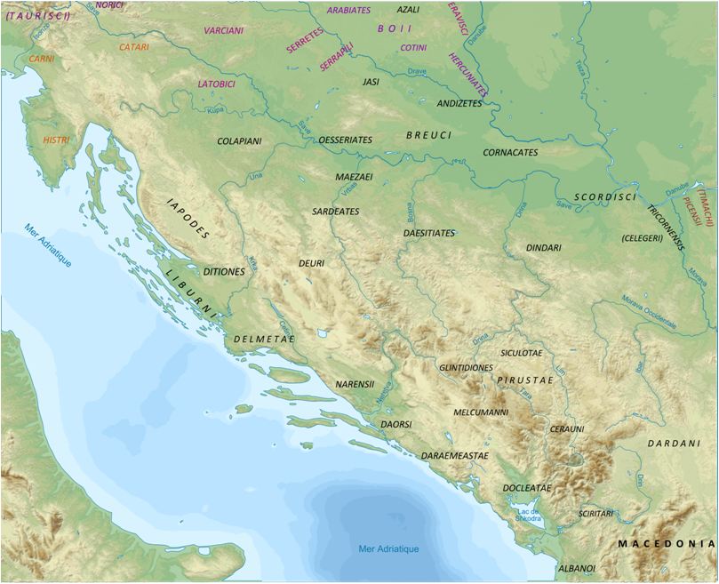
Illyrian tribes along the Adriatic coast
By Hxseek at English Wikipedia, CC BY 3.0, https://commons.wikimedia.org/w/index.php?curid=6636363

[5] L. Aemiliō cōnsule ingentēs Gallōrum cōpiae Alpēs trānsiērunt. Sed prō Rōmānīs tōta
With Lucius Aemilius consul huge of-Gauls forces Alps crossed but for -Romans all
Ītalia cōnsēnsit, trāditumque est ā Fabiō historicō, quī eī bellō interfuit, DCCC mīlia
Italy was-united and—handed-down it-was by Fabius historian who in-that war took-part 800 thousands
hominum parāta ad id bellum fuisse. Sed rēs per cōnsulem tantum prōsperē gesta est. XL
of-men prepared for that war to-have-been but thing by consul alone successfully managed was 40
mīlia hostium interfecta sunt et triumphus Aemiliō dēcrētus.
thousands of-men kille were aand triumph for-Aemilius decreed

[6] Aliquot deinde annīs post contrā Gallōs intrā Ītaliam pugnātum est, fīnītumque bellum
Some then years later against Gauls within Italy fought it-was and-finished war
M. Claudiō Mārcellō et Cn. Cornēliō Scīpiōne cōnsulibus. Tum Mārcellus cum parvā manū
with-Marcus Claudius Marcellus and Gnaeus Cornelius Scipio consuls then Marcellus with small band
equitum dīmicāvit et rēgem Gallōrum, Viridomarum nōmine, manū suā occīdit. Posteā cum
of-cavalry fought and king of-Gauls Viridomarus by-name by-hand own he-killed afterwards with
collēgā ingentēs cōpiās Gallōrum perēmit, Mediolānum expugnāvit, grandem praedam
colleague huge forces of-Gauls he-destroyed Mediolanum took-by-storm vast booty
Rōmam pertulit. Ac triumphāns Mārcellus spolia Gallī stīpitī inposita umerīs suīs vēxit.
to-Rome brought snd holding-tiumph Marcellus spoils of-the-Gaul on-stake placed on-shoulders his carried

[7] M. Minuciō Rūfō P. Cornēliō cōnsulibus Histrīs bellum inlātum est, quia latrōcinātī
With Marcus Minuciud Rufus Publius Cornelio consuls on-Histri war made was because raided
nāvibus Rōmānōrum fuerant, quae frūmenta exhibēbant, perdomitīque sunt omnēs. Eōdem
ships of-Romans they-had which corn were-providing and-subdued were all in-same

annō bellum Pūnicum secundum Rōmānīs inlātum est per Hannibalem, Carthāginiēnsium
year war Punic second upon-Romans brought was by Hannibal of-Carthaginias
ducem, quī Saguntum, Hispāniae cīvitātem Rōmānīs amīcam, obpugnāre adgressūs est,
general who Saguntum of-Spain state to-Romans friendly to-brsiege advanced
annum agēns vīcēsimum aetātis, cōpiīs congregātīs CL milium. Huic Rōmānī per lēgātōs
year doing twentieth of-age with-forces assembled of-150 thousand to-whom Romans through envoys
dēnūntiāvērunt, ut bellō abstinēret. Is lēgātōs admittere nōluit. Rōmānī etiam Carthāginem
demanded that from-war he-should-abstain he enoys to-receive was-unwilling Romans also to-Carthage
mīsērunt, ut mandārētur Hannibalī, nē bellum contrā sociōs populī Rōmānī gereret. Dūra
sent that order-be-give to-Hannibal that-not war aginst allies of-people Roman he-should-wage harsh
respōnsa ā Carthāginiēnsibus data sunt. Saguntīnī intereā famē vīctī sunt, captīque ab
replies by Carthaginians given were Saguntians meanwhile by-hunger beaten were and-captured by
Hannibale ultimīs poenīs adficiuntur.
Hannibal to-ultimate punishments are subjected
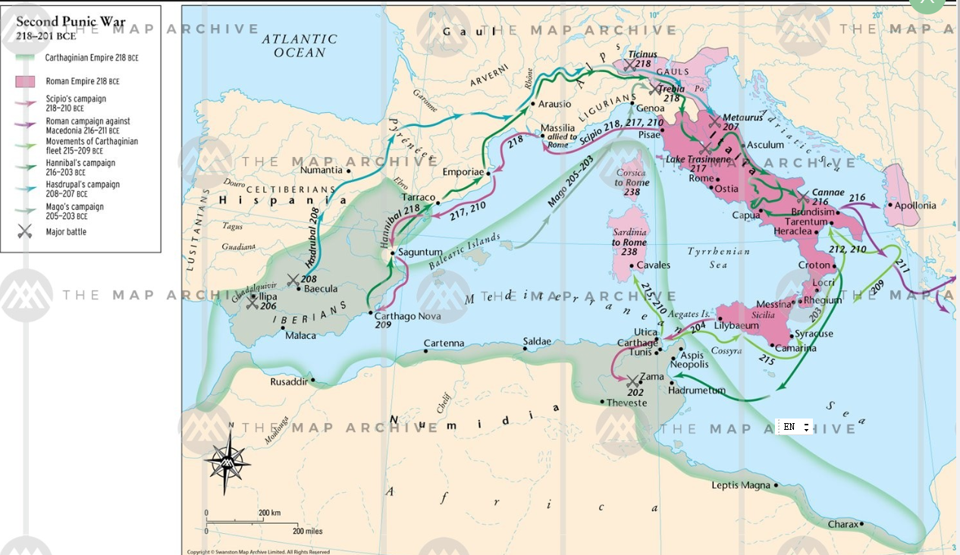
Campaigns of the 2nd. Punic War (218 – 201 B.C.)
https://www.themaparchive.com/second-punic-war-218201-bce.html

[8] Tum P. Cornēlius Scīpiō cum exercitū in Hispāniam profectus est, Ti. Semprōnius in
Then Publius Cornelius Scipio with army for Spain set out Tiberius Sempronius for
Siciliam, bellum Carthāginiēnsibus indictum est. Hannibal relictō in Hispāniā frātre
Sicily war against-Carthaginians declared was Hannibal having-been-left in Spain brother
Hasdrubale Pȳrēnaeum trānsiit. Alpēs, adhūc eā parte inviās, sibi patefēcit. Trāditur ad Ītaliam
Hasdrubal Pyrenees crossed Alps till-then in-that-part trackless to-himself laid-open he-is-reported to Italy
LXXX mīlia peditum, X mīlia equitum, septem et XXX elephantōs addūxisse. Intereā multī
80 thousand of-infantry 10 thousands of-cavalry seven and 30 elephants to-have-brought meanwhile many
Ligurēs et Gallī Hannibalī sē coniūnxērunt. Semprōnius Gracchus cognitō ad Ītaliam
Ligurians and Gauls to-Hannibal themselves joined Sempronius Gracchis having-been-learned-of in Italy
Hannibalis adventū ex Siciliā exercitum Arīminum trāiēcit.
Hannibal’s arrival from Sicily army to-Rimini transferred
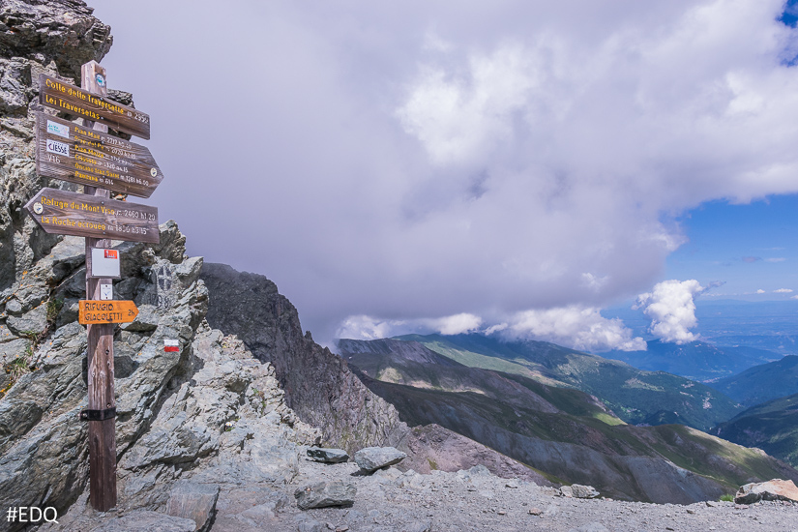
View of Italy from the Col de la Traversette, most southerly of Hannibal’s possible routes
https://www.envie-de-queyras.com/guide/col-de-la-traversette

[9] P. Cornēlius Scīpiō Hannibalī prīmus occurrit. Commissō proeliō, fugātīs suīs
Publius Cornelius Scipio Hannibal first met having-been-started-battle having-been-routed his-men
ipse vulnerātus in castra rediit. Semprōnius Gracchus et ipse cōnflīgit apud Trebiam amnem.
himself wounded into camp returned Sempronius Gracchus also himself fought at Trebia river
Is quoque vincitur.Hannibalī multī sē in Ītaliā dēdidērunt. Inde ad Tusciam veniēns Hannibal
He also is-defeated to-Hannibal many selves in Italy surrendered then to Tuscany coming Hannibal
Flāminiō cōnsulī occurrit. Ipsum Flāminium interēmit; Rōmānōrum XXV mīlia caesa sunt,
Flaminius consul encountered himself Flaminius he-killed of-Romans 25 thousand killed were
cēterī dīffūgērunt. Missus adversus Hannibalem posteā ā Rōmānīs Q. Fabius Maximus. Is
rest scattered sent against Hannibal afterwards by Romans Quintus Fabius Maximus He
eum differendō pugnam ab impetū frēgit, mox inventā occāsiōne vīcit.
him by-postponing battle from momentum broke soon with-found opportunity defeated

[10] Quīngentēsimō et quadrāgēsimō annō ā conditā urbe L. Aemilius Paulus P. Terentius
In-th-five-hundredth and fortieth year from founded city Lucius Aemilius Paulus Publius Terentius
Varrō contrā Hannibalem mittuntur Fabiōque succēdunt, quī abiēns ambō cōnsulēs monuit, ut
Varro against Hannibal are-sent and-Fabius succeed who departing both consuls warned that
Hannibalem, callidum et inpatientem ducem, nōn aliter vincerent, quam proelium differendō.
Hannibal clever and impatient general not otherwise they-would-defeat than battle by-postponing
Vērum cum inpatientiā Varrōnis cōnsulis contrādīcente alterō cōnsule [id est Aemiliō Paulō]
Indeed when through- impatience of-Varro consul expressing-disagreement other consul that is Aemilius Paulus
apud vīcum, quī Cannae appellātur in Āpūliā, pugnātum esset, ambō cōnsulēs ab Hannibale
at village which Cannae is-called in Apulia fighting there-was both consuls by Hannibal
vincuntur. In eā pugnā tria mīlia Āfrōrum pereunt; magna pars dē exercitū Hannibalis
are-defeated in that battle three thousands of-Africans perish great part from army of-Hannibal
sauciātur. Nūllō tamen proeliō Pūnicō bellō Rōmānī gravius acceptī sunt. Periit enim in eō
is-wounded in-no however battle in-Punuic war Romans more-gravely suffered perished for in it
cōnsul Aemilius Paulus, cōnsulārēs aut praetōriī XX, senātōrēs captī aut occīsī XXX, nōbilēs
consul Aemilius Paulus ex-consuls or ex-praetors 20 senators captureds or killed 30 noble
virī CCC, mīlitum XL mīlia, equitum IIĪ mīlia et quīngentī. In quibus malīs nēmō tamen
men 300 of-soldiers 40 thousands of-cavalry 3 thousands and five-hundred amidst these evils none however
Rōmānōrum pācis mentiōnem habēre dignātus est. Servī, quod numquam ante,
of-Romans of-peace mention to-make thought fit slaves something-that never before [had happened]
manūmissī et mīlitēs factī sunt.
freed and soildiers made
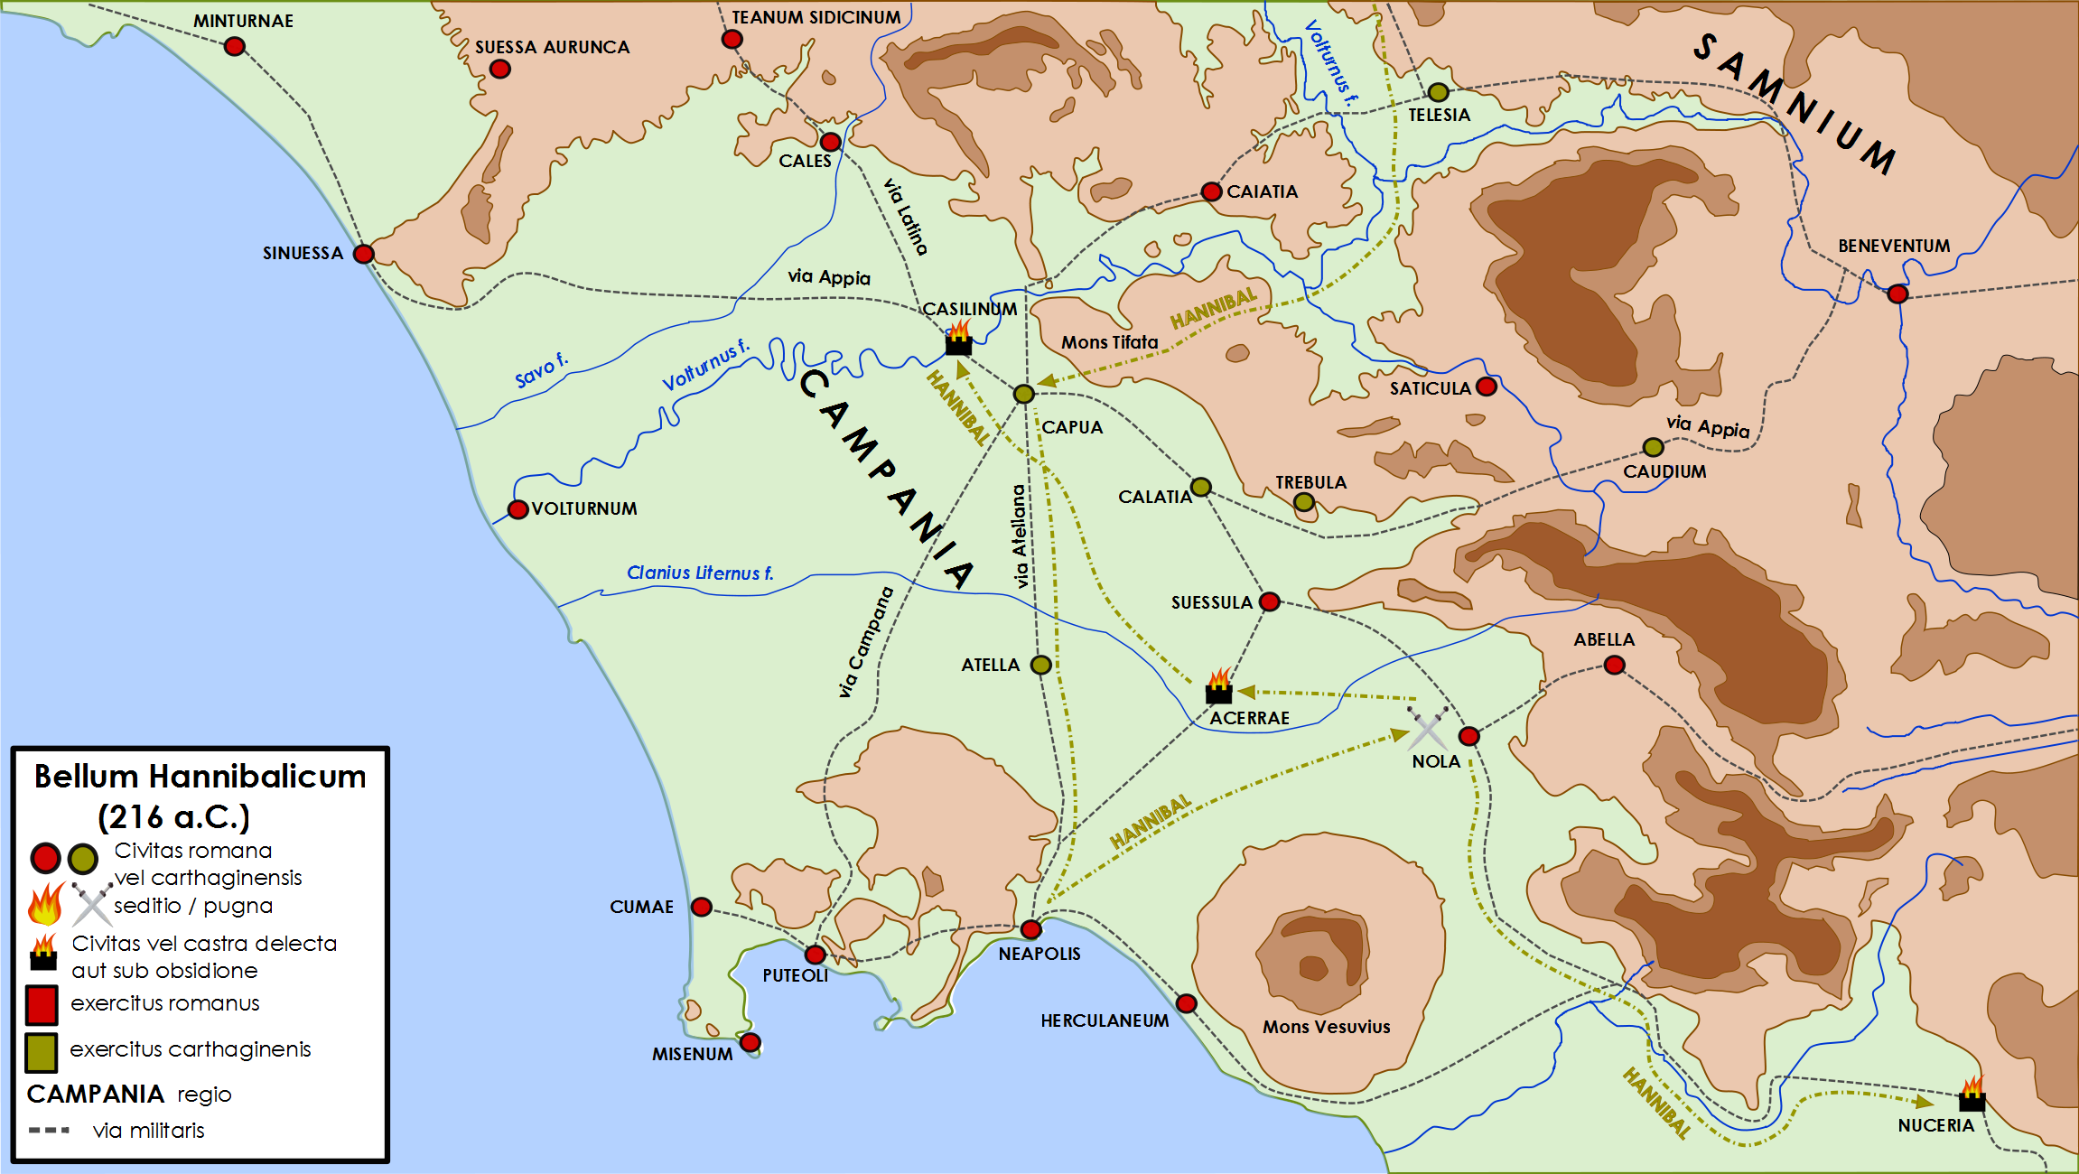
Campania, showing locations of Capua, Nola and Casilinum
https://commons.wikimedia.org/wiki/File:Campania_bellum_Hannibalicum_216_aC.png

[11] Post eam pugnam multae Ītaliae cīvitātēs, quae Rōmānīs pāruerant, sē ad Hannibalem
After that battle many of-Italy cities which to-Romans had-been-subject selves to Hannibal
trānstulērunt. Hannibal Rōmānīs obtulit, ut captīvōs redimerent, respōnsumque est ā senātū
transferred Hannibal to-Romans offered that prisoners they-ransom and-response-made was by senate
eōs cīvēs nōn esse necessāriōs, quī cum armātī essent, capī potuissent. Ille omnēs posteā
those citizens not to-be needed who although armed they-were to-be-captured had-been-able He all afterwards
variīs suppliciīs interfēcit et trēs modiōs ānulōrum aureōrum Carthāginem mīsit, quōs ex
with-various punishments killed and three modi[27litres] of-rings gold to-Carthage sent which from
manibus equitum Rōmānōrum, senātōrum et mīlitum dētrāxerat. Intereā in Hispāniā, ubi
hands of-knights Roman of-senators and of-soldiers he-had wrenched-off meanwhile in Spain where
frāter Hannibalis Hasdrubal remānserat cum magnō exercitū, ut eam tōtam Āfrīs subigeret,
brother of-Hannibal Hasdrubal had-remained with large army so-that it all to-Africans he-could-subject
ā duōbus Scīpiōnibus, Rōmānīs ducibus, vincitur. Perdit in pugnā XXXV mīlia hominum;
by two Scipios Roman generals is-defeated he-poses in battle 35 thousands of-men of
ex hīs capiuntur X mīlia, occīduntur XXV mīlia. Mittuntur eī ā Carthāginiēnsibus ad
these are-captures 10 thousands are-killed 25 thousands are-sent to-him by Carthaginians for
reparandās vīrēs XIĪ mīlia peditum, IV mīlia equitum, XX elephantī.
being-replenished strength 12 thousands of-infantry 4 thousands of-cavalry 20 elephants

[12] Annō quārtō postquam ad Ītaliam Hannibal vēnit, M. Claudius Mārcellus cōnsul apud
In-year fourth after to Italy Hannibal came Marcus Claudius Marcellus consul at
Nōlam, cīvitātem Campāniae, contrā Hannibalem bene pugnāvit. Hannibal multās cīvitātēs
Nola city of-Campania against Hannibal well fought Hannibal many cities
Rōmānōrum per Āpūliam, Calabriam, Brittiōs occupāvit. Quō tempore etiam rēx
of-Romans throughout Apulia Calabria and Bruttium occupied at-this time also king
Macedoniae Philippus ad eum lēgātōs mīsit, prōmittēns auxilia contrā Rōmānōs sub hāc
Of- Macedonia Philip to him envoys sent prmising help against Romans under this
condiciōne, ut dēlētīs Rōmānīs ipse quoque contrā Graecōs ab Hannibale auxilia
Condition that having-been-destroyed Romans himself also against Greeks from Hannibal help
acciperet. Captīs igitur lēgātīs Philippī et rē cognitā Rōmānī in Macedoniam M. Valerium
should-receive having-been-captured envoys of-Philip and thing learned Roman into Macedonia Marcus Valerius
Laevīnum īre iussērunt, in Sardiniam T. Mānlium Torquātum prōcōnsulem. Nam etiam ea
Laevinus to-go ordered into Sardina Titus Manlius Torquatus proconsul for also it
sollicitāta ab Hannibale, Rōmānōs dēseruerat.
incited by Hannibal Romans had-deserted

[13] Ita ūnō tempore quattuor locīs pugnābātur: in Ītaliā contrā Hannibalem, in Hispāniīs
Thus at-one time four in-places there-was-fighting in Italy against Hannibal in Spain
contrā frātrem eius Hasdrubalem, in Macedoniā contrā Philippum, in Sardiniā contrā Sardōs
against brother his Hasdrubal in Macedonia against Philip in Sardinia against the-Sardinians
et alterum Hasdrubalem Carthāginiēnsem. Is ā T. Mānliō prōcōnsule, quī ad Sardiniam missus
and another Hasdrubal Carthaginian He by Titus Manlius proconsul who to Sardinia sent
fuerat, vīvus est captus, occīsa cum eō duodecim mīlia, captī mīlle quīngentī, et ā Rōmānīs
had-been alive was captured killed with him twelve thousand captured thousand five-hundred and by Romans
Sardinia subācta. Mānlius victor captīvōs et Hasdrubalem Rōmam reportāvit. Intereā etiam
Sardinia subjugated Manlius victor captives and Hasdrubal to-Rome brought-back meanwhile also
Philippus ā Laevīnō in Macedoniā vincitur et in Hispāniā ab Scīpiōnibus Hasdrubal et Māgō,
Philip by Laevinus in Macedonia is-defeated and in Spain by Scipios Hasdrubal and Mago
tertius frāter Hannibalis.
third brother of-Hannibal
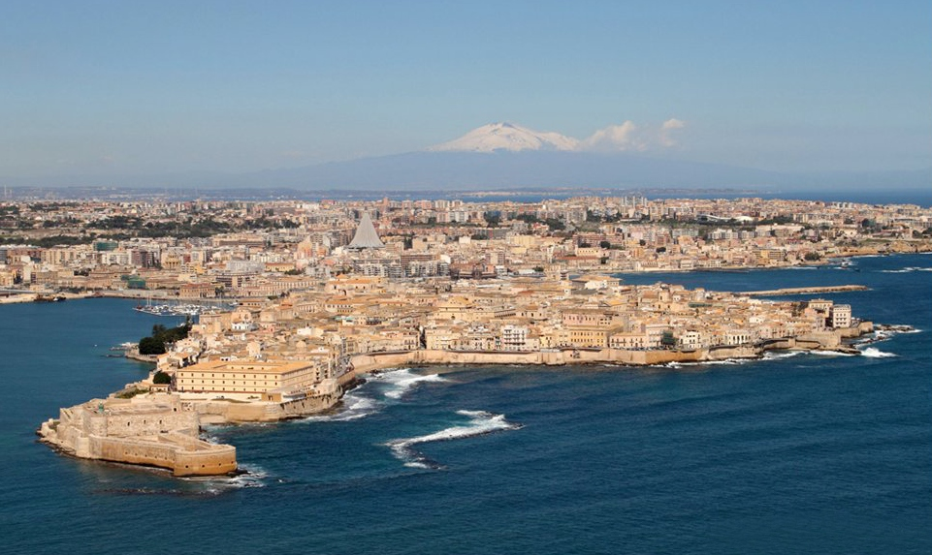
Syracuse today with Mt Etna in the background
By cc-by-2.0, Attribution, https://commons.wikimedia.org/w/index.php?curid=23148161

[14] Decimō annō postquam Hannibal in Ītaliam vēnerat, P. Sulpiciō Cn. Fulviō cōnsulibus,
In-tenth year after Hannibal to Italy had-come with Publius Sulpicius Cornelius Fulvius consuls
Hannibal usque ad quārtum mīliārium urbis accessit, equitēs eius usque ad portam. Mox
Hannibal up to fourth milestone of-city approached cavalry his up to gate soon
cōnsulum cum exercitū venientium metū Hannibal ad Campāniam sē recēpit. In Hispāniā ā
of-consuls with army coming from-fear Hannibal to Campania sewlf took-back in Spain by
frātre eius Hasdrubale ambō Scīpiōnēs, quī per multōs annōs victōrēs fuerant, interficiuntur,
brother his Hasdrubal both Scipios who over many years victors had-been are-killed
exercitus tamen integer mānsit; cāsū enim magis erant quam virtūte dēceptī. Quō tempore
army however intact remained by-chancew for more had-been than by-courage out-smarted at-this time
etiam ā cōnsule Mārcellō Siciliae magna pars capta est, quam tenēre Āfrī coeperant, et
also by consul Marcellus of-Sicily great part captured was which to-hold Africans had-begun and
nōbilissima urbs Syrācūsāna; praeda ingēns Rōmam perlāta est. Laevīnus in Macedoniā
most-noble city Syracusan loot enormous to-Rome brought was Laevinus in Macedonia with
cum Philippō et multīs Graeciae populīs et rēge Asiae Attalō amīcitiam fēcit, et ad Siciliam
with Philip and-many of-Greece people and king of-Asia friendship made and to Sicily
profectus Hannōnem quendam, Āfrōrum ducem, apud Agrigentum cīvitātem cum ipsō oppidō
setting-out Hanno certain of-Africans general at Arigentun city with itself town
cēpit eumque Rōmam cum captīvīs nōbilibus mīsit. XL cīvitātēs in dēditiōnem accēpit, XXVĪ
captured and-him to-Rome with captives noble sent 40 cities into surrender received 26
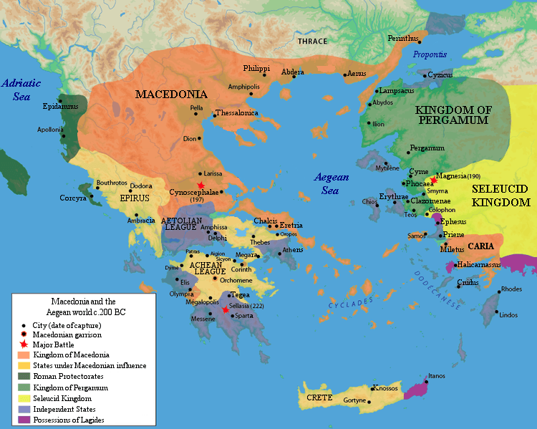
Macedonia and states around the Aegean
https://www.ancient.eu/image/4575/achaean-league-c-200-bce/

expugnāvit. Ita omnis Sicilia recepta et Macedonia frācta; ingentī glōriā Rōmam regressus stormed thus all Sicily recovered and-Macedonia shattered with-great glory to-Rome he returned
est. Hannibal in Ītaliā Cn. Fulvium cōnsulem subitō adgressus cum octo mīlibus hominum
[ ] Hannibal in Italy Gnaeus Fulvius consul suddenly attacking with eight thousands of-men
interfēcit.
killed

[15] Intereā ad Hispāniās, ubi occīsīs duōbus Scīpiōnibus nūllus Rōmānus dux erat,
Meanwhile to Spain where having-been-killed two Scipios no Roman general there-was
P. Cornēlius Scīpiō mittitur, fīlius P. Scīpiōnis, quī ibīdem bellum gesserat, annōs nātūs
Publius Cornelius Scipio is-sent son of-Pullius Scipio who in-same-place war had-waged years aged
quattuor et vīgintī, vir Rōmānōrum omnium et suā aetāte et posteriōre tempore ferē prīmus.
four and twenty man of-Romans all both in-own era and later time almost first
Is Carthāginem Hispāniae capit, in quā omne aurum, argentum et bellī apparātum Āfrī
He Carthage of-Spain captures in which all gold silver and of-war equipment Africans
habēbant, nōbilissimōs quoque obsidēs, quōs ab Hispānīs accēperant. Māgōnem etiam,
had very high-born also hostages who from the-Spanish they-had-received Mago also
frātrem Hannibalis, ibīdem capit, quem Rōmam cum aliīs mittit. Rōmae ingēns laetitia post
brother of-Hannibal there captures whom to-Rome with others he-sends at-Rome huge joy after
hunc nūntium fuit. Scīpiō Hispānōrum obsidēs parentibus reddidit; quārē omnēs ferē
this news there-was Scipio of-Spanish hostages to-parents returned therefore all-people almost
Hispāniae ūnō animō ad eum trānsiērunt. Post quae Hasdrubalem, Hannibalis frātrem, victum
of-Spain with-one mind to him went-over after these-things Hasdrubal Hannnibal’s brother defeated
fugat et praedam maximam capit.
he puts-to-flight and loot very-much he-captures
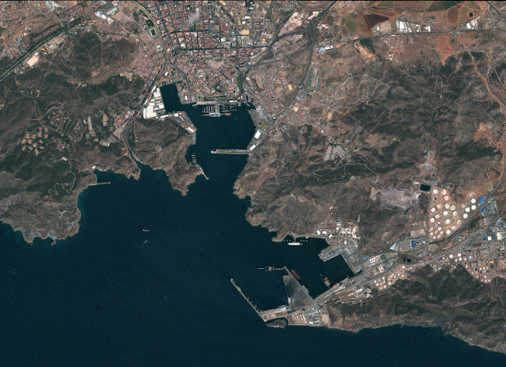
The harbour of Cartagena (Carthāgō Nova)
Google maps – Autoridad Portuaria de Cartagena

[16] Intereā in Ītaliā cōnsul Q. Fabius Maximus Tarentum recēpit, in quā ingentēs cōpiae
Meanwhile in Italy consul Quintus Fabius Maximus Taremntum revovered in which huge forces
Hannibalis erant. Ibi etiam ducem Hannibalis Carthalōnem occīdit, XXV mīlia hominum
of-Hannibal there-were there also general of-Hannibal Carthalo he-killed 25 thousand of-persons
captīvōrum vēndidit, praedam mīlitibus dispertīvit, pecūniam hominum vēnditōrum ad fiscum
captives he-sold loot to-soldiers he-distributed money from-people sold to treasury
retulit. Tum multae cīvitātēs Rōmānōrum, quae ad Hannibalem trānsierant prius, rūrsus sē
he-brought-back then many cities of-Romans which to Hannibal had-gone-over before again selves
Fabiō Maximō dēdidērunt. Īnsequentī annō Scīpiō in Hispāniā ēgregiās rēs ēgit et per sē et
to-Fabius Maximus surrendered in-following year Scipio in Spain outstanding things did both through him and
per frātrem suum L. Scīpiōnem; LXX cīvitātēs recēpērunt. In Ītaliā tamen male pugnātum
through brother his Lucius Scipio 70 cities they-recovered in Italy however badly fought
est. Nam Claudius Mārcellus cōnsul ab Hannibale occīsus est.
it-was. For Claudius Marcellus consul by Hannibal killed was
[17] Tertiō annō postquam Scīpiō ad Hispāniās profectus fuerat, rūrsus rēs inclitās gerit.
In-third year after Scipio for Spain set-out had again things glorious he-does
Rēgem Hispāniārum magnō proeliō victum in amīcitiam accēpit et prīmus omnium ā vīctō
king of-Spains in-great battle defeated into friendship he-receives and first of-all from the-defeated
obsidēs nōn poposcit.
hostages not he-demanded

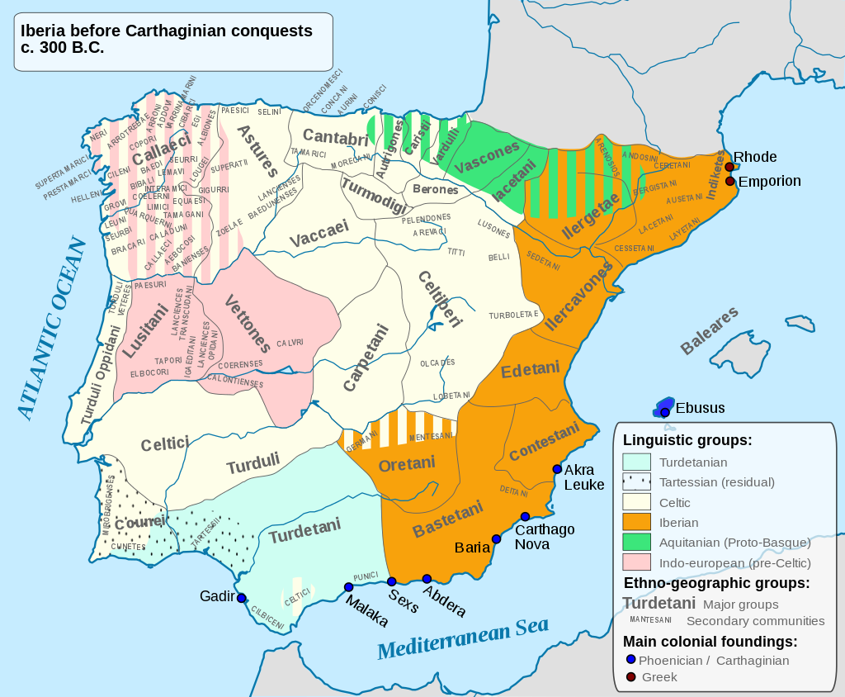
Indigenous ethnic groups in Spain showing the territory of the Turdetani
https://en.wikipedia.org/wiki/Turdetani

[18] Dēspērāns Hannibal Hispāniās contrā Scīpiōnem diūtius posse retinēre, frātrem suum
Abandoning-hope Hannibal Spain against Scipio longer to-be-able to-hold brother his
Hasdrubalem ad Ītaliam cum omnibus cōpiīs ēvocāvit. Is veniēns eōdem itinere, quō etiam
Hasdrubal to Italy with all forces summoned he coming by-same route by-which also
Hannibal vēnerat, ā cōnsulibus Ap. Claudiō Nerōne et M. Līviō Salīnātōre apud Sēnam,
Hannibal had-come by consuls Appius Claudoius Nero and Marcus Livius Salinator at Sena
Pīcēnī cīvitātem, in īnsidiās conpositās incidit. Strēnuē tamen pugnāns occīsus est; ingentēs
of-Picenum city into ambush laid fell vigorously however fighting killed he-was great
eius cōpiae captae aut interfectae sunt, magnum pondus aurī atque argentī Rōmam relātum
of-him forces captured or killed were great weight of-gold and of-silver to-Rome brought-back
est. Post haec Hannibal diffīdere iam dē bellī coepit ēventū. Rōmānīs ingēns animus
was after this Hannibal to-lack-confidence now about of-war began outcome to-Romans great encouragement
accessit; itaque et ipsī ēvocāvērunt ex Hispāniā P. Cornēlium Scīpiōnem. Is Rōmam cum
came and-so also they summoned from Spain Publius Cornelius Scipio he to-Rome with
ingentī glōriā vēnit.
Huge glory came

[19] Q. Caeciliō L. Valeriō cōnsulibus omnēs cīvitātēs, quae in Brittiīs ab Hannibale
With Quintus Caecilius Lucius Valerius consuls all cities which in Bruttium by Hannibal
tenēbantur, Rōmānīs sē trādidērunt.
were-held to-Romans selves handed-over
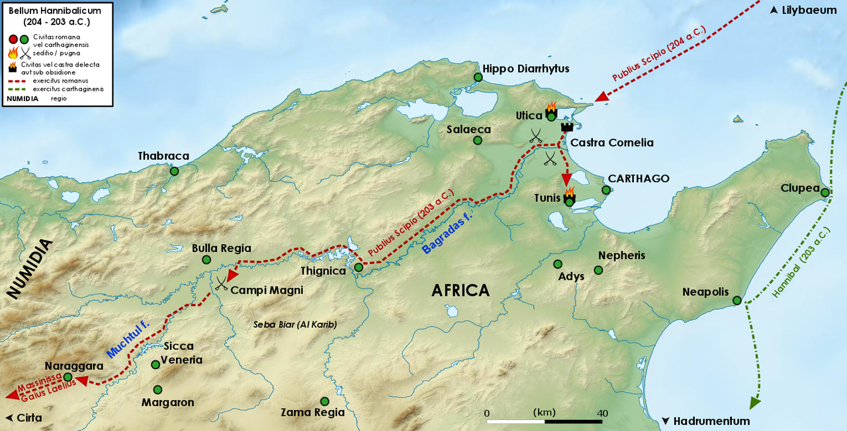
Scipio’s campaigns in Africa, 204-203 B.C.
https://commons.wikimedia.org/wiki/File:Campagna_africana_di_Scipione_204-203_aC.png

[20] Annō quārtō decimō posteāquam in Ītaliam Hannibal vēnerat, Scīpiō, quī multa bene in
In-year fourth tenth after into Italy Hannibal had-come Scipio who many-things well in
Hispāniā ēgerat, cōnsul est factus et in Āfricam missus. Cui virō dīvīnum quiddam inesse
Spain has-done consul was made and into Africa sent in-this man divine something to-reside
exīstimābātur, adeō ut putārētur etiam cum nūminibus habēre sermōnem. Is in Āfricā contrā
was-reckoned so-much that he-was-thought even with deities to-have conversation he in Africa against
Hannōnem, ducem Āfrōrum, pugnat; exercitum eius interficit. Secundō proeliō castra capit
Hanno general of-Africans fights army of-him kills in-second battle camp captures
cum quattuor mīlibus et quīngentīs mīlitibus, XĪ mīlibus occīsīs. Syphācem, Numidiae rēgem,
with four thousand and five-hundred soldiers 11 thousands killed Syphax of-Numidia king
quī sē Āfrīs coniūnxerat, capit et castra eius invādit. Syphāx cum nōbilissimīs
who self to-Africans had-joined captures and camp his enters Syphax with most-noble
Numidīs et īnfīnītīs spoliīs Rōmam ā Scīpiōne mittitur. Quā rē audītā omnis ferē Ītalia
Numidians and unlimited spoils to-Rome by Scipio is-sent With-this thing heard all almost Italy
Hannibalem dēserit. Ipse ā Carthāginiēnsibus redīre in Āfricam iubētur, quam Scīpiō vastābat.
Hannibal deserts He-himself by Carthaginians to-return to Africa is-ordered which Scipio was-laying-waste

[21] Ita annō septimō decimō ab Hannibale Ītalia līberāta est. Lēgātī Carthāginiēnsium
Thus in-year seventh tenth from Hannibal Italy freed was envoys of-Carthaginians
pācem ā Scīpiōne petīvērunt; ab eō ad senātum Rōmam missī sunt. Quadrāgintā et quīnque
peace from Scipio sought by him to senate to-Rome sent were for-forty and five
diēbus hīs indūtiae datae sunt, quousque īre Rōmam et regredī possent; et trīgintā mīlia pondō
days to-them truce given was until go to-Rome and return they-could and thirty thousands pounds
argentī ab hīs accepta sunt. Senātus ex arbitriō Scīpiōnis pācem iussit cum Carthāginiēnsibus
of-silver from them received were senate according-to judgment of-Scipio peace ordered with Carthaginians
fierī. Scīpiō hīs condiciōnibus dedit: nē amplius quam trīgintā nāvēs habērent, ut
to-be-made Scipio on-these conditions [peace]offered that-not more than thirty ships they-should-have that
quīngenta milia pondō argentī darent, captīvōs et perfugās redderent.
Five-hundred thousands pounds of-silver they-should-give captives and fugitives they-should-return
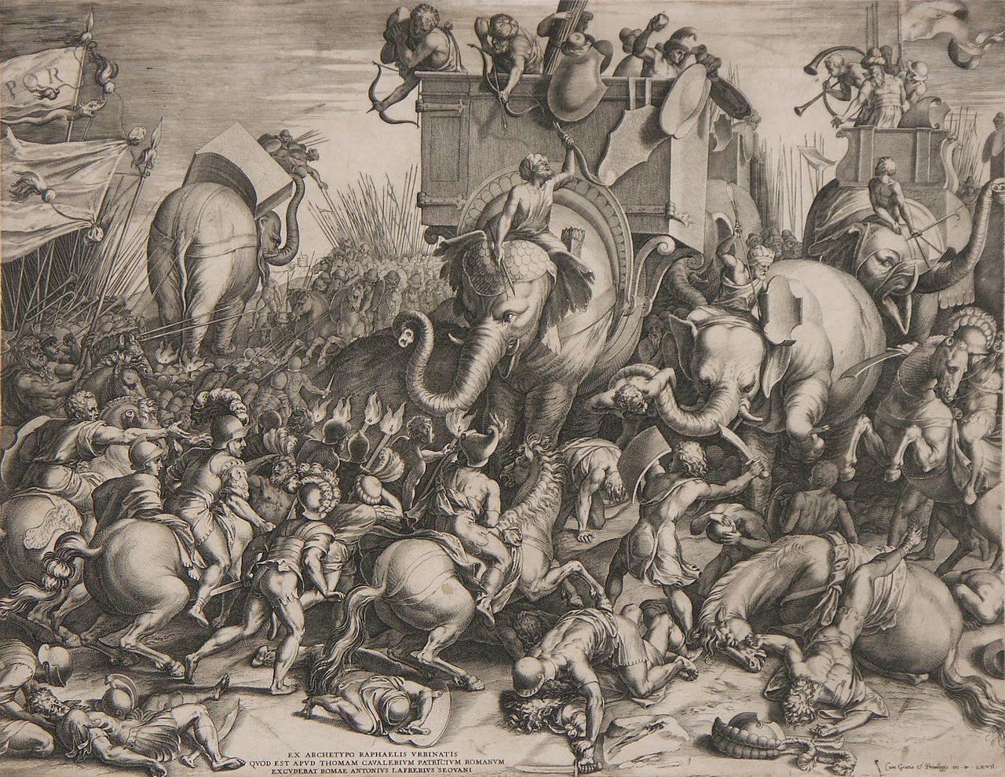
The Battle of Zama (202 B.C) as imagined by Cornelius Cort in 1567
https://en.wikipedia.org/wiki/Battle_of_Zama#/media/File:Slaget_ved_Zama_-_Cornelis_Cort,_1567.jpg

[22] Interim Hannibale veniente ad Āfricam pāx turbāta est, multa hostīlia ab Āfrīs facta sunt.
Meanwhile with-Hannibal coming to Africa peace disturbed was many hostile-things by Africans done were
Lēgātī tamen eōrum ex urbe venientēs ā Rōmānīs captī sunt, sed iubente Scīpiōne dīmissī.
Envoys however of-them from city coming by Romans captured were but with-ordering Scipio released
Hannibal quoque frequentibus proeliīs victus ā Scīpiōne petit etiam ipse pācem. Cum ventum
Hannibal also in-frequent battles defeated by Scipio sought also himself peace when came
esset ad colloquium, īsdem condiciōnibus data est, quibus prius, additīs quīngentīs mīlibus
it-had-been to conference on-same conditions [peace] offered was on-which before added to-five-hundred thousands
pondō argentī centum mīlibus lībrārum propter novam perfidiam. Carthāginiēnsibus
pounds of-silver hundred thousand of-pounds because-of new treachery Carthaginians
condiciōnēs displicuērunt iussēruntque Hannibalem pugnāre. Īnfertur ā Scīpiōne et Masinissā,
conditions displeased and-they-ordered Hannibal to-fight is-waged by Scipio and Masinissa
aliō rēge Numidārum, quī amīcitiam cum Scīpiōne fēcerat, Carthāginī bellum. Hannibal trēs
another king of-Numidians who friendship with Scipio had-made against-Carthage war Hannibal three

explōrātōrēs ad Scīpiōnis castra mīsit, quōs captōs Scīpiō circumdūcī per castra iussit
scouts to Scipio’s camp sent whom captured Scipio to-be-led-round through camp ordered
ostendīque hīs tōtum exercitum, mox etiam prandium darī dīmittīque, ut renūntiārent
and-to-be-shown to-these whole army soon also luncheon to-be-given and-to-be-released so they-could-report
Hannibalī quae apud Rōmānōs vīdissent.
to-Hannibal what among Romans they-had-seen

[23] Intereā proelium ab utrōque duce īnstrūctum est, quāle vix ūllā memoriā fuit, cum
eanwhile battle[-formation] by each leader drawn-up was such-as scarcely in-any memory was since
perītissimī virī cōpiās suās ad bellum ēdūcerent. Scīpiō victor recēdit paene ipsō Hannibale
very-skilled men forces their to war were-leading-out Scipio victor came-away almost with-himself Hannibal
captō, quī prīmum cum multīs equitibus, deinde cum vīgintī, postrēmō cum quattuor ēvāsit.
captured who first with many horsemen then with twenty finally with four escaped
Inventa in castrīs Hannibalis argentī pondō vīgintī mīlia, aurī octōgintā, cētera supellectilis
Found in camp of-Hannibal of-silver pound twenty thousand of-gold eighty other items
cōpiōsa. Post id certāmen pāx cum Carthāginiēnsibus facta est. Scīpiō Rōmam rediit, ingentī
in-abundance after that battle peace with Carthaginians made was Scipio to-Rome returned with-huge
glōriā triumphāvit atque Āfricānus ex eō appellārī coeptus est. Fīnem accēpit secundum
glory triumphed and Africanus from that [time] to-be-called began end received second
Pūnicum bellum post annum nōnum decimum, quam coeperat.
Punic war after year nineteenth that it-had-begun
LIBER IV

[1] Trānsāctō Pūnicō bellō secūtum est Macedonicum contrā Philippum rēgem quīngentēsimō
Having-been-completed Punic war followed Macedonian-one against Philip king in-five-hundredth
quīnquāgēsimō et prīmō annō ab urbe conditā.
fiftieth and first year from city founded
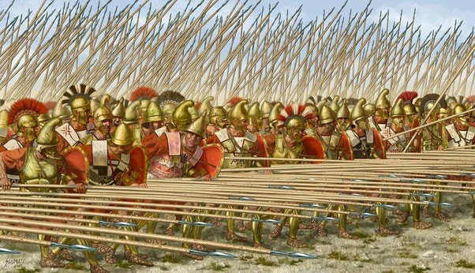
The Macedonian phalanx
https://www.quora.com/Why-was-the-Macedonian-phalanx-so-effective

[2] T. Quīntius Flāminīnus adversum Philippum missus rem prōsperē gessit. Pāx eī data est
Titus Quintius Flaminius against Philip sent affar successfully managed peace given was
hīs lēgibus: nē Graeciae cīvitātibus, quās Rōmānī contrā eum dēfenderant, bellum īnferret,
on-these conditions that-not of-Grreece on-cities which Romans against him had-defended war he-make
ut captīvōs et trānsfugās redderet, quīnquāgintā sōlās nāvēs habēret, reliquās Rōmānīs
that captives and fugitives he -return fifty alone ships he-have rest to-Romans
dēderet, per annōs decem quaterna mīlia pondō argentī praestāret et obsidem daret fīlium
he-s-surrender for years ten four-each thousands in-weight of-silver he-should-provide and as-hostage give son
suum Dēmētrium. T. Quīntius etiam Lacedaemoniīs intulit bellum. Ducem eōrum Nabidem
his Demetrius Titus Quintius also on-Spartans made war leader of-them Nabis
vīcit et quibus voluit condiciōnibus in fidem accēpit. Ingentī glōriā trimphāvit; dūxit ante
he-conquered and on-which he-wanted conditions into alliance received with-huge glory he-held-triumph he-led before
currum nōbilissimōs obsidēs, Dēmētrium, Philippī fīlium, et Armenēn Nabidis.
Chariot most-noble hostages Demetrius of-Philip son and Armenes [son]of-Nabis
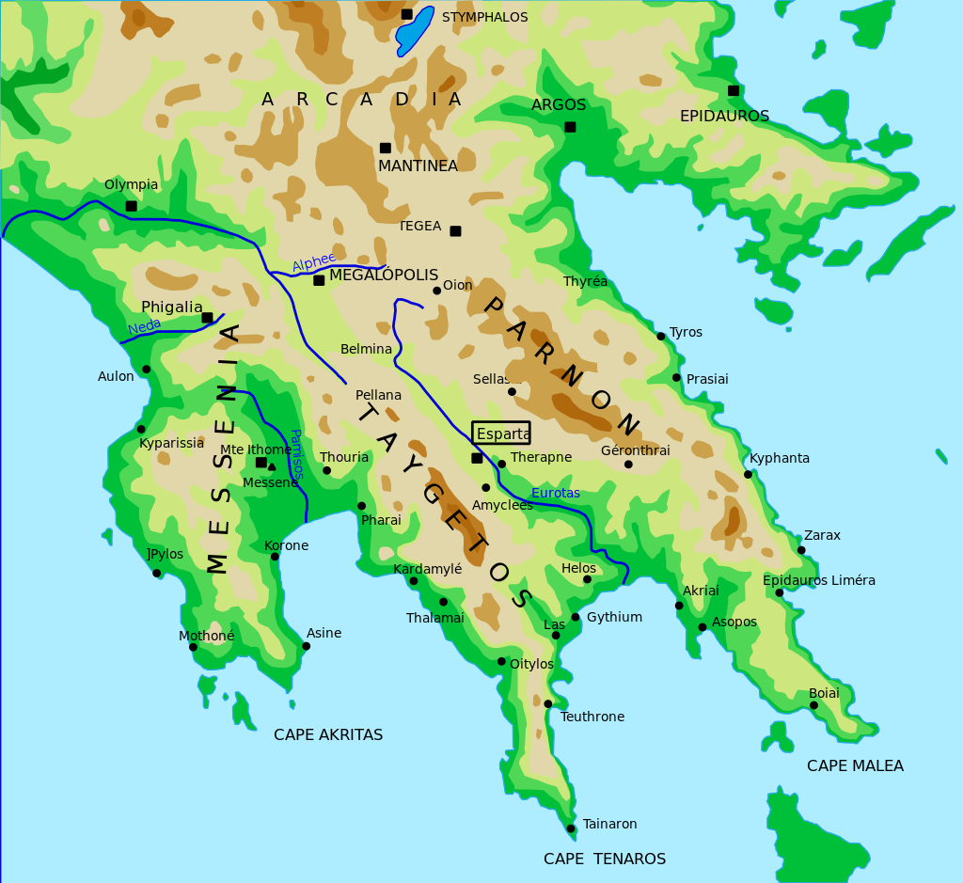
Argos and the Laconian Coast
https://en.wikipedia.org/wiki/War_against_Nabis#/media/File:SouthernPeloponessus.svg

[3] Trānsāctō bellō Macedonicō secūtum est Syriacum contrā Antiochum rēgem P. Cornēliō
Having-been-completed war Macedonian followed Syrian [one] against Antiochus king with-Publius Cornelius
Scīpiōne M. Acīliō Glabriōne cōnsulibus.Huic Antiochō Hannibal sē iūnxerat, Carthāginem,
Scipio Marcus Acilius Glabrio consuls to-this Antiochus Hannibal self had-joined Carthage
patriam suam, metū, nē Rōmānīs trāderētur, relinquēns. M. Acīlius Glabriō in Achāiā bene
country his from-fear lest to-Roman he-be-handed-over leaving Marcus Acilius Glabrio om Achaia well
pugnāvit. Castra rēgis Antiochī nocturnā pugnā capta sunt, ipse fugātus. Philippō, quia contrā
fought camp of-king Atiochus in-night battle captured was -himself put-to-flight to-Philip because against
Antiochum Rōmānīs fuisset auxiliō, fīlius Dēmētrius redditus est.
Antiochus to-romans had-been of-help son Demetrius returned was
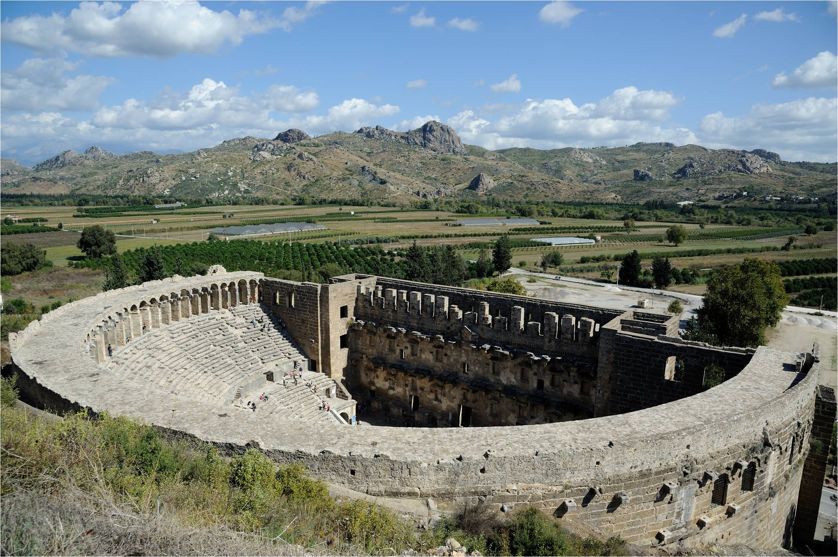
The Roman theatre later built at Aspendos, scene of Hannibal’s naval defeat in 190
https://upload.wikimedia.org/wikipedia/commons/6/60/Aspendos_Amphitheatre.jpg

[4] L. Cornēliō Scīpiōne et C. Laeliō cōnsulibus Scīpiō Āfricānus frātrī suō L. Cornēliō
With Lucius Cornelius Scipio and Gaius Laelius consuls Scipio Africanus to-brother his Lucius Cornelius
Scīpiōnī cōnsulī lēgātus datus contrā Antiochum profectus est. Hannibal, quī cum Antiochō
Scipio consul as-legate given against Antiochus set out Hannibal who with Antiochus
erat, nāvālī proeliō victus est. Ipse posteā Antiochus circā Sipylum apud Magnēsiam, Asiae
was in-naval battle defeated was Himself afterwards Antiochus near Sipylus at Magnesis of-Asia
cīvitātem, ā cōnsule Cornēliō Scīpiōne ingentī proeliō fūsus est. Auxiliō fuit Rōmānīs in eā
city by consul Cornelius Scipio in-huge battle routed was of-help was to-Romans in this

pugnā Eumenēs, Attalī rēgis frāter, quī Eumēniam in Phrygiā condidit. Quīnquāgintā mīlia
battle Eumenes of-Attalus king brother who Eumenia in Phrygia founded fifty thousands
peditum, tria equitum eō certāmine ex parte rēgis occīsa sunt. Tum rēx pācem petit. Īsdem
of-infantry three of-cavalry in-that fight from side of-king killed were then king pace sought on-same
condiciōnibus data est ā senātū, quamquam victō, quibus ante offerēbātur: ut ex
conditions given it-was by sanate although to-defeated-man as-those-on-which before it-was-offered that from
Eurōpā et Asiā recēderet atque intrā Taurum sē continēret, decem mīlia talentōrum et vīgintī
Europe and Asia he-withdraw and within Taurus self keep ten thousands of-talents and twenty
obsidēs praebēret, Hannibalem, concitātōrem bellī, dēderet. Eumenī rēgī dōnātae sunt ā
hostages he-provide Hannibal instigator of-war he-give-up to-Eumenes king awarded were by
senātū omnēs Asiae cīvitātēs, quās Antiochus bellō perdiderat, et Rhodiīs, quī auxilium
senate all of-Asia cities which Antiochus in-war had-lost and to-Rhodians who help
Rōmānīs contrā rēgem Antiochum tulerant, multae urbēs concessae sunt. Scīpiō Rōmam
To-Romans gainst king Antiochus had-brought many cities granted were Scipio to-Rome
rediit, ingentī glōriā triumphāvit. Nōmen et ipse ad imitātiōnem frātris Asiāgenis accēpit, quia
returned with-huge glory triumphed name also himself in imitation of-brother Asiāgenis he-received as
Asiam vīcerat, sīcuti frāter ipsīus propter Āfricam domitam Āfricānus appellābātur.
Asia he-had-conquered as brother of-self because-of Africa subdued Africanus was-called

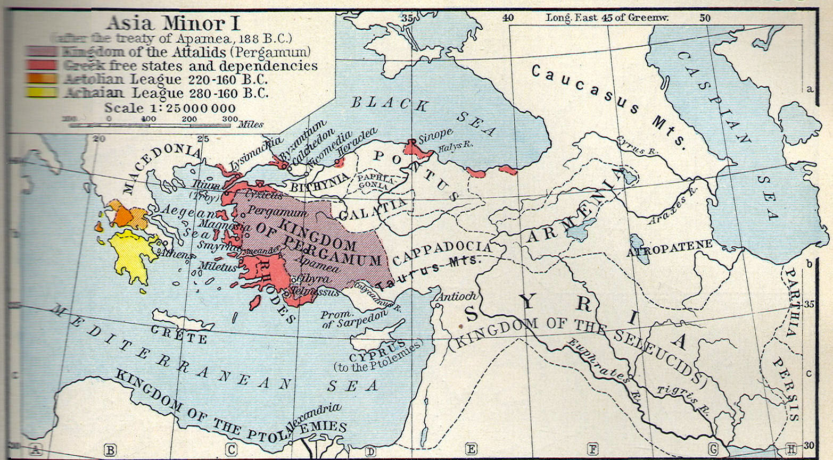
Asia Minor after the defeat of Antiochus III
https://www.heritage-history.com/site/data/map-dir/shepherd/shep033a.jpg

[5] Sp. Postumiō Albīnō Q. Marciō Philippō cōnsulibus M. Fulvius dē Aetōlīs triumphāvit.
With Spurius Postumius Albinus Quintus Marcius Philippus consuls Marcus Fulvius over Aetolians celebrated
Hannibal, quī victō Antiochō, nē Rōmānīs trāderētur, ad Prūsiam, Bīthȳniae rēgem,
Hannibal who having-been-defeated Antiochus lest to-Romans he-be-handed to Prusias of-Bithynia king
fūgerat, repetītus etiam ab eō est per T. Quīntium Flāminīnum. Et, cum trādendus Rōmānīs
had-fled demanded-back also from him was by Titus Quintius Flamininus and since to-be-handed to-Romans
esset, venēnum bibit et apud Libyssam in fīnibus Nīcomēdēnsium sepultus est.
he-was poison he-drank and at Libyssa on territory of-the-Nicomedians buried he-was
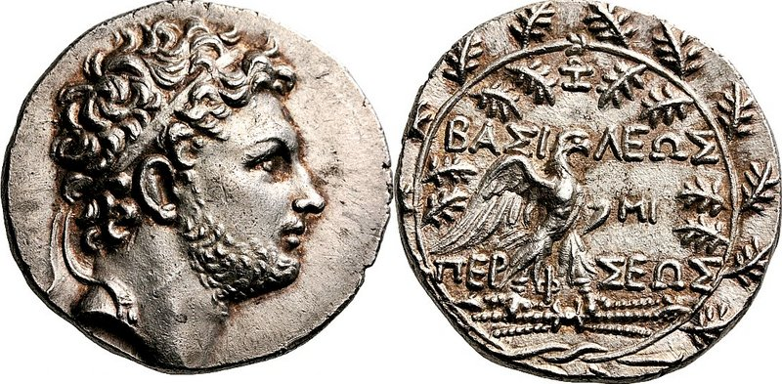
Coin of Perseus of Macedon (Classical Nunismatics Group)
https://commons.wikimedia.org/wiki/File:Perseus_of_Macedonia_Tetradrachm_90060057.jpg

[6] Philippō, rēge Macedoniae, mortuō, quī et adversum Rōmānōs bellum gesserat et posteā
With-Philip king of-Macedonia dead who both against Romans war had-waged and later
Rōmānīs contrā Antiochum auxilium tulerat, fīlius eius Perseus in Macedoniā rebellāvit
To-Romans against Antiochus help had-given son his Perseus in Macedonia rebelled
ingentibus cōpiīs ad bellum parātīs. Nam adiūtōrēs habēbat Cotyn, Thrāciae rēgem, et rēgem
with-huge forces for war prepared for helpers he-had Cotys of-Thrace king and king
Illyricī, Gentium nōmine. Rōmānīs autem in auxiliō erant Eumenēs, Asiae rēx, Ariarātus
Of-Illyria gentius by-name to-Romans on-other-hand of help were Eumenes of-Asia king Ariartus
Cappadociae, Antiochus Syriae, Ptolomaeus Aegyptī, Masinissa Numidiae. Prūsiās autem
Of-Cappadocia Antiochus of-Syria Ptolemy of-Egypt Masinissa of-Numidia Prusia moreover
Bīthȳniae, quamquam sorōrem Perseī uxōrem habēret, utrīsque sē aequum praebuit. Dux
Of-Bithynia although sister of-Perseus as-wife he-had to-both himself impartial showed as-leader
Rōmānōrum P. Licinius cōnsul contrā eum missus est et ā rēge gravī proeliō victus. Neque
of-Romans Publius Licinius consul against him sent was and by king in—major battle defeated and-not
tamen Rōmānī, quamquam superātī, rēgī petentī pācem praestāre voluērunt, nisi hīs
however Romans although defeated to-king seeking peace to-provide were-willing unless on-these
condiciōnibus: ut sē et suōs senātuī et populō Rōmānō dēderet. Mox missus contrā eum L.
conditions that self and his-people to-senate and people Roman he- surrender soon sent against him Lucius
Aemilius Paulus cōnsul et in Illyricum C. Anicius praetor contrā Gentium. Sed Gentius facile
Aemilius Paulus consul and into Illyria Gaius Anicius praetor against Gentius But Gentius easily
ūnō proeliō victus mox sē dēdidit. Māter eius et uxor et duo fīliī, frāter quoque simul in
in-one battle defeated soon self surrendered mother his and wife and two sons brother also at-same-time into
potestātem Rōmānōrum vēnērunt. Ita bellō intrā XXX diēs perfectō ante cognitum est
power of-Romans came thus with-war within 30 days completed early learned it-was
Gentium victum, quam coeptum bellum nūntiārētur.
Gentius conquered than begun was it-was-announced

[7] Cum Perseō autem Aemilius Paulus cōnsul IĪĪ Nōnās Septembrēsdīmicāvit vīcitque eum
With Perseus on-other-hand Aemilius Paulus consul on 3 September fought and-defeated him
vīgintī mīlibus peditum eius occīsīs. Equitātus cum rēge integer fūgit. Rōmānōrum centum
with-twenty thousands of-infantry his killed cavalry with king intact fled of-Romans hundred
mīlitēs āmissī sunt. Urbēs Macedoniae omnēs, quās rēx tenuerat, Rōmānīs sē dēdidērunt; ipse
soldiers lost were cities of-Macedonia all which king had-held to-Romans selves surrendered himself
rēx, cum dēsererētur ab amīcīs, vēnit in Paulī potestātem. Sed honōrem eī Aemilius Paulus
king since he-was-deserted by friends came into Paulus’s power but honour to-him Aemilius Paulus
cōnsul nōn quasi victō habuit. Nam et volentem ad pedēs sibi cadere nōn permīsit et iuxtā sē
consul not as to--defeated-man gave for both him willing at feet for-him to-fall not allowed and next-to self
in sellā conlocāvit. Macedonibus et Illyriīs hae lēgēs ā Rōmānīs datae: ut līberī essent et
on chair placed to-Macedonians and Illyrians these conditions by Romans given that free they-should-be and
dīmidium eōrum tribūtōrum praestārent, quae rēgibus praestitissent, ut appārēret, populum
half of-those taxes should-pay which to-kings they-had-paid so-that it-might-appear people
Rōmānum prō aequitāte magis quam avāritiā dīmicāre. Itaque in conventū īnfīnītōrum
Roman for fairness more than greed to-fight and-so in assembly of-countless
populōrum Paulus hoc prōnūntiāvit et lēgātiōnēs multārum gentium, quae ad eum vēnerant,
peoples Paulus this announced and delegations of-many nations which to him had-come
magnificentissimē convīviō pāvit, dīcēns eiusdem hominis esse dēbēre et bellō vincere et
most-magnificently with-banquet fed saying of-same person be it-should both in-war to-conquer and
in convīviī apparātū ēlegantem esse.
in of-banquet provision elegant to-be
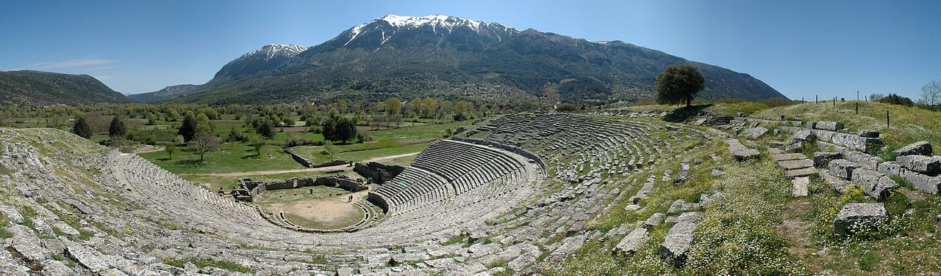
The amphitheatre constructed by Pyrrhus at Dodona
https://en.wikipedia.org/wiki/Epirus#/media/File:D70-0404-dodona.jpg

[8] Mox septuāgintā cīvitātēs Ēpīrī, quae rebellābant, cēpit, praedam mīlitibus distribuit.
Soon seventy states of-Epirus which were-rebelling he-captured loot to-soldiers distributed
Rōmam ingentī pompā rediit in nāvī Perseī, quae inūsitātae magnitūdinis fuisse trāditur,
To-Rome with-great splendour he-returned in ship of-Perseus which of-unusual size to-have-been is-reported
adeō ut sēdecim ōrdinēs dīcātur habuisse rēmōrum.Triumphāvit autem magnificentissimē
so-much-so that sixteen rows it-is-said to-have-had of-oars he-celebrated-triumph moreover most-magnificently
in currū aureō cum duōbus fīliīs utrōque latere adstantibus.Ductī sunt ante currum duo rēgis
in chariot golden with two sons on-each side standing led were before chariot two of-king
fīliī et ipse Perseus, XLV annōs nātus. Post eum etiam Anicius dē Illyriīs triumphāvit. Gentius
sons and himself Perseus 45 years old after him also Anicius over Illyrians celebrated-triumph Gentius
cum frātre et fīliīs ante currum ductus est. Ad hoc spectāculum rēgēs multārum gentium
with father and sons before chariot led was to this spectacle kings of-many nations
Rōmam vēnērunt, inter aliōs vēnit etiam Attalus atque Eumenēs, Asiae rēgēs, et Prūsiās
to-Rome came among others came also Attalus and Eumenes of-Asia ,kings and Prusias
Bīthȳniae. Magnō honōre exceptī sunt et permittente senātū dōna, quae attulerant, in Capitōliō
of-Bithynia with-great honour received they-were and permitting senate gifts which they-had-brought on Capitoline
posuērunt. Prūsiās etiam fīlium suum Nīcomēdēn senātuī commendāvit.
they-placed Prusias also son his Nicomedes to-senate commended

[9] Īnsequentī annō L. Memmius in Lūsitāniā bene pugnāvit. Mārcellus posteā cōnsul rēs
In-the-following year Lucius Memmius in Lusitania well fought Marcellus afterwards consul affairs
ibīdem prōsperās gessit.
in-same-place successful did

[10] Tertium deinde bellum contrā Carthāginem suscipitur, sexcentēsimō et alterō ab urbe
Third then war against Carthage is-undertaken in-six-hundredth and second from city
conditā annō, L. Mānliō Cēnsōrīnō et M. Mānīliō cōnsulibus, annō quīnquāgēsimō prīmō
founded year with-Lucius Manlius Censorinus and Marcus Manilius consuls in-year fiftieth first
postquam secundum Pūnicum trānsāctum erat. Hī profectī Carthāginem oppugnāvērunt.
after second Punic[war] completed had-been they having-set-out Carthage attacked
Contrā eōs Hasdrubal, dux Carthāginiēnsium, dīmicābat. Famea, dux alius, equitātuī
Against them Hasdrubal leader of-Carthaginians was-fighting Famea leader other for-cavalry

Carthāginiēnsium praeerat. Scīpiō tunc, Scīpiōnis Āfricānī nepōs, tribūnus ibi mīlitābat.
Of-carthaginians was-in-charge Scipio then of-Scipio Africanus grandson as-tribune there was-serving
Huius apud omnēs ingēns metus et reverentia erat. Nam et parātissimus ad dīmicandum et
Of-him amongst all great awe and respect there-was for both most-prepared for fighting and
cōnsultissimus habēbātur. Itaque per eum multa ā cōnsulibus prōsperē gesta sunt, neque
most-experienced was-considered and-so through him many-things by consuls successfully done were and-not
quicquam magis vel Hasdrubal vel Fameā vītābant, quam contrā eam Rōmānōrum partem
anything more either Hasdrubal or Fames used-to-avoid than against that of-Romans part
committere, ubi Scīpiō dīmicāret.
to-join-battle where Scipio was-fighting

[11] Per idem tempus Masinissa, rēx Numidārum, per annōs sexāgintā ferē amīcus populī
At same time Masinissa king of-Numjidians for years sixty almost friend of-people
Rōmānī, annō vītae nōnāgēsimō septimō mortuus quadrāgintā quattuor fīliīs relictīs
Roman in-year of-life ninetieth seventh dead with-forty four sone left
Scīpiōnem dīvīsōrem rēgnī inter fīliōs suōs esse iussit.
Scipio divider of-kingdom among sons his to-be told
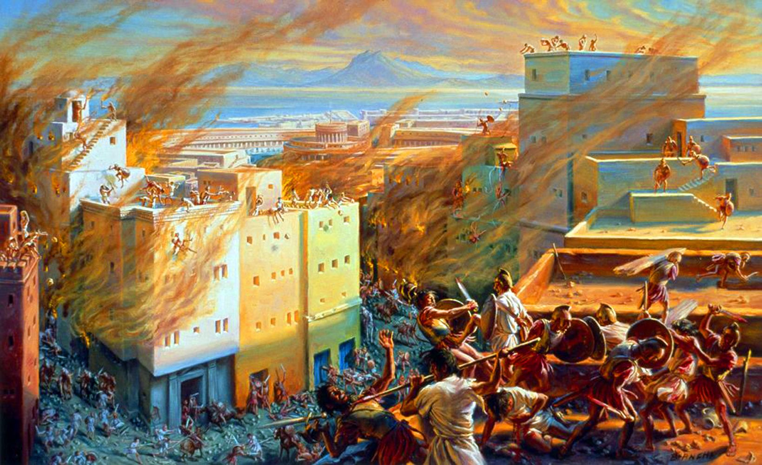
Destruction of Carthage, 146 B.C.
http://hannibalofcarthage.net/destruction-of-carthage.php
[12] Cum igitur clārum Scīpiōnis nōmen esset, iuvenis adhūc cōnsul est factus et contrā
Since therefore famous of-Scipio name was young-man still consul was made and against
Carthāginem missus. Is eam cēpit ac dīruit. Spolia ibi inventa, quae variārum cīvitātum
Carthage sent he it captured and destroyed spoils there found which of-various cities
excidiīs Carthāgō collēgerat, et ōrnāmenta urbium cīvitātibus Siciliae, Ītaliae, Āfricae
by-destruction Carthage had-collected and the-ornaments civic to-cities of-Sicily of-Italy of-Africa
reddidit, quae sua recognōscēbant. Ita Carthāgō septingentēsimō annō, quam condita erat,
he-restored which as-own they-recognised thus Carthage in-seven-hundredth year after founded it-had-been
dēlēta est. Scīpiō nōmen, quod avus eius accēperat, meruit, scīlicet ut propter virtūtem
destroyed was Scipio name which grandfather his had-received deserved i.e that on-account-of prowess
etiam ipse Āfricānus iūnior vocārētur.
also he Africansus junior be-called

[13] Interim in Macedoniā quīdam Pseudo-Philippus arma mōvit et Rōmānum praetōrem P.
Meanwhile in Macedonia a-certain Pseudo-Philip arms took-up and Roman praetor Publius
Iuventium contrā sē missum ad interniciōnem vīcit. Post eum Q. Caecilius Metellus dux ā
Iuventius against him sent to utter-ruin defeated after him Quintus Caecilius Metelles general by
Rōmānīs contrā Pseudophilippum missus est et XXV mīlibus eius occīsīs Macedoniam
Romans against Pesudo-Philip sent was and with-25 thousands of-him killed Macedonia
recēpit, ipsum etiam Pseudophilippum in potestātem suam redēgit.
recovered himself also the-Pesudo-Philip into control own brought

[14] Corinthiīs quoque bellum indictum est, nōbilissimae Graeciae cīvitātī, propter iniūriam
On-Corinthians also war declared was most-noble of-Greece city for unjust-treatment

lēgātōrum Rōmānōrum. Hanc Mummius cōnsul cēpit et dīruit. Trēs igitur Rōmae simul
of-envoys Roman this Mummius consul captured and destroyed three therefore at-Rome at-same-time
celeberrimī triumphī fuērunt: Āfricānī ex Āfricā, ante cuius currum ductus est Hasdrubal,
most-illustrious triumphs there-were of-Africanus from Africa before whose chariot led was Hasdrubal
Metellī ex Macedoniā, cuius currum praecessit Andriscus, idem quī et Pseudophilippus,
of-Metellus from Macedonia whose chariot preceded Andriscus same-man who also Pseudo-Philip [was-called]
Mummiī ex Corinthō, ante quem signa aēnea et pictae tabulae et alia urbis clārissimae
of-Mummius from Corinth before whom statues bronze and painted boards and other of-city most-famous
ōrnāmenta praelāta sunt.
ornaments carried were
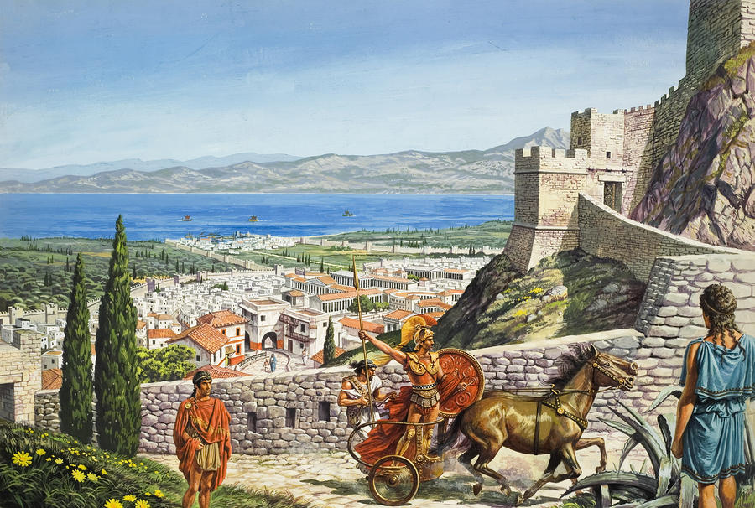
Corinth seen from the citadel of Acrocorinthus as imagined by Roger Payne
https://paintingandframe.com/prints/roger_payne_ancient_corinth-5152.html

[15] Iterum in Macedoniā Pseudopersēs, quī sē Perseī fīlium esse dīcēbat, collēctīs servitiīs
Again in Macedonia a-Pseudo-Perses who himself of-Perseus son to-be way-saying being-collected slaves
rebellāvit et, cum sēdecim mīlia armātōrum habēret, ā Tremellīō quaestōre superātus est.
rebelled and when sixteen thousands of-armed-men he-had by Tremellius quaestor defeated was
[16] Eōdem tempore Metellus in Celtibēriā apud Hispānōs rēs ēgregiās gessit. Successit eī
At-the-same time Metellus in Celtiberia among Spanish things amazing did succeded him
Q. Pompēius. Nec multō post Q. quoque Caepiō ad idem bellum missus est, quod quīdam
Quintus Pompeius and-not much later Quintus also Caepio to same war sent was which a-certain
Viriāthus contrā Rōmānōs in Lūsitāniā gerēbat. Quō metū Viriāthus ā suīs interfectus est, cu
Viriathus against Romans in Luasitania was-waging from-which fear Viriathus by own-men killed was
cum quattuordecim annīs Hispāniās adversus Rōmānōs mōvisset. Pāstor prīmō fuit, mox
when fourteen years the-Spains against Romans he-had-mobilised shepherd at-first he-was soon
latrōnum dux, postrēmō tantōs ad bellum populōs concitāvit, ut adsertor contrā Rōmānōs
of-bandits leader finally such-great to war peoples he-roused that restorer against Romans
Hispāniae putārētur. Et cum interfectōrēs eius praemium ā Caepiōne cōnsule peterent,
of-Spain he-was-thought and when killers of-him reward from Caepio consul sought
respōnsum est numquam Rōmānīs placuisse imperātōrēs ā suīs mīlitibus interficī.
answer was never to-Romans to-have-pleased generals by own soldiers to-be-killed
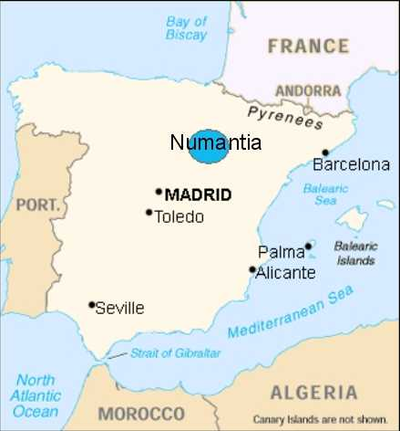
Location of Numantia, centre of Celtiberian resistance
https://100falcons.wordpress.com/2014/07/25/numancia-or-dont-mess-with-rome/

[17] Q. Pompēius deinde cōnsul, ā Numantīnīs, quae Hispāniae cīvitās fuit opulentissima,
Quintus Pompeius then consul by people-of-Numantia which of-Spain city was wealthiest
superātus, pācem ignōbilem fēcit. Post eum C. Hostīlius Mancīnus cōnsul iterum cum
defeated peace ignoble made after him Gaius Hostilius Mancinus consul again with
Numantīnīs pācem fēcit īnfāmem, quam populus et senātus iussit īnfringī atque ipsum
Numantinians peace made disgraceful which people and senate ordered to-be-broken and himself
Mancīnum hostibus trādī, ut in illō, quem auctōrem foederis habēbant, iniūriam solūtī
Mancinus to-enely to-be-handed-over so-that on-him whom aither of-treaty they-considered injury of-abrogated
foederis vindicārent. Post tantam igitur ignōminiam, quā ā Numantīnīs bis Rōmānī
treaty they-could-avenge after so-great therefore disgrace in-which by Numantinians twice Roman exercitūs fuerant subiugātī, P. Scīpiō Āfricānus secundō cōnsul factus et ad Numantiam
armies had-been beaten Publius Scipio Africanus second-time consul made and to Numantia
missus est. Is prīmum mīlitem vitiōsum et ignāvum exercendō magis quam pūniendō sine
sent was he first soldiery dissolute and cowardly by-training more than by-punishing without
aliquā acerbitāte corrēxit, tum multās Hispāniae cīvitātēs partim cēpit, partim in dēditiōnem
any harshness rehabilitated then many of-spain cities in-some-cases he-captured in-others into surrender
accēpit, postrēmō ipsam Numantiam diū obsessam famē cōnfēcit et ā solō ēvertit,
he-received finally itself Numania long-time besieged by-starvation he-finished-off and from ground overturned
reliquam prōvinciam in fidem accēpit.
rest-of province into allegiance he-received
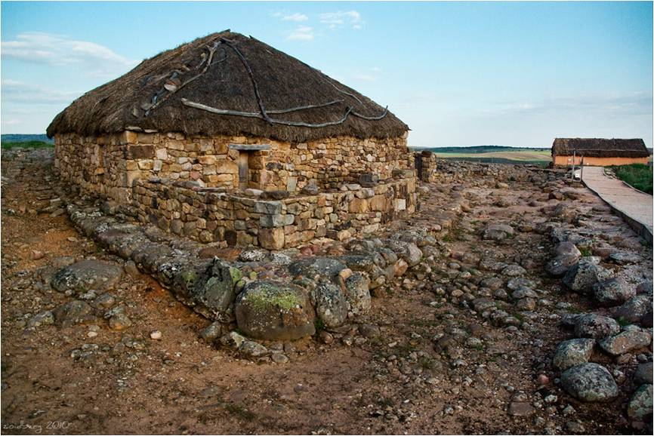
Reconstruction of a Celtiberian house at Numantia
https://upload.wikimedia.org/wikipedia/commons/f/f9/Numancia_%285%29.jpg
[18] Eōdem tempore Attalus, rēx Asiae, frāter Eumenis, mortuus est hērēdemque populum
At-same time Attalus king of-Asia brother of-Eumenes died and-heir people
Rōmānum relīquit. Ita imperiō Rōmānō per testāmentum Asia accessit.
Roman left thus to empire Roman through a-will Asia joined.

[19] Mox etiam D. Iūnius Brūtus dē Callaecīs et Lūsitānīs magnā glōriā triumphāvit et P.
Soon also Decimus Junius Brutus over Gallicians and Lusitanians with-great glory celebrated-triumph
Scīpiō Āfricānus dē Numantīnīs secundum triumphum ēgit quārtō decimō annō postquam
Scipio Africanus over Numantinians second triumph held in-fouth tenth year after
priōrem dē Āfricā ēgerat.
earlier-one over Africa he-had-held

[20] Mōtum interim in Asiā bellum est ab Aristonīcō, Eumenīs fīliō, quī ex concubīnā
Launched meanwhile in Asia war was by Aristonicus of-Eumenes son who from concubine
susceptus fuerat. Hic Eumenēs frāter Attalī fuerat. Adversus eum missus P. Licinius Crassus
born had-been this Eumenes brother of-Attalus had-been against him sent Publius Licinius Crassus
īnfīnīta rēgum habuit auxilia. Nam et Bīthȳniae rēx Nīcomēdēs Rōmānōs iūvit et Mithridātēs
unlimited of-kings had help for and of-Bithynia king Nicomedes Romans helped and Mithridates
Ponticus, cum quō bellum posteā gravissimum fuit, et Ariarāthēs Cappadōx et Pylaemenēs
of-Pontus with whom war after very-major there-was and Ariaarthes of-Cappadocia and Pylaemenes
Paphlagon. Victus est tamen Crassus et in proeliō interfectus est. Caput ipsīus Aristonīcō
of-Paphlogonia defeated was however Crassus and in battle killed was head of-him to-Aristonicus
oblātum est, corpus Smyrnae sepultum. Posteā Perperna, cōnsul Rōmānus, quī successor
offered was body at-Smyrna buried afterwards Perperna consul Roman who as-successor
Crassō veniēbat, audītā bellī fortūnā ad Asiam celerāvit et aciē vīctum Aristonīcum apud
to-Crassus was-coming being-heard of-war fortune to Asia hastened and in-battle defeated Aristonicus at
Stratonīcēn cīvitātem, quō cōnfūgerat, famē ad dēditiōnem conpulit. Aristonīcus iussū
Stratonicea city to-which he-had-fled by-starvation into surrender forced Aristonicus by-order
senātūs Rōmae in carcere strangulātus est. Triumphārī enim dē eō nōn poterat, quia
of-senate in-Rome in prison strangled was triumph-celebrated for over him not was-able because
Peperna ad Pergamum Rōmam rediēns diem obierat.
Peperna at Pergamum to-Rome returning [final]day had-met

[21] L. Caeciliō Metellō et T. Quīntiō Flāminīnō cōnsulibus Carthāgō in Āfricā iussū senātūs
With-Lucius Caecilius Metellus and Titus Quintius Flaminius consuls Carthage in Africa by-order of-senate
reparāta est, quae nunc manet, annīs duōbus et vīgintī postquam ā Scīpiōne fuerat ēversa.
re-established was which now remains years two and twenty after by Scipio it-had-been overthrown
Dēductī eō sunt cīvēs Rōmānī.
Brought to-there were citizens Roman

22] Annō sexcentēsimō vīcēsimō septimō ab urbe conditā C. Cassius Longīnus et Sex.
In-year six-hundredth twentieth seventh from city founded Gaius Cassius Longinus and Sextus
Domitius Calvīnus cōnsulēs Gallīs trānsalpīnīs bellum intulērunt et Arvernōrum tunc
Domitius Calvinus consuls on-Gauls across-Alps war made and of-Arverni then
nōbilissimae cīvitātī atque eōrum dūcī Bituītō īnfīnītamque multitūdinem iuxtā Rhodanum
noblest city and of-them leader Bituitus and-boundless multitude next-to Rhone
fluvium interfēcērunt. Praeda ex torquibus Gallōrum ingēns Rōmam perlāta est. Bituītus sē
river killed loot from necklaces of-Gauls huge to-Rome brought was Bituitus self
Domitiō dēdit atque ab eō Rōmam dēductus est, magnāque glōria cōnsulēs ambō
to-Domitius surrendered and from-there to-Rome brought was and with-great glory consuls both
triumphāvērunt.
triumphed

[23] M. Porciō Catōne et Q. Marciō Rēge cōnsulibus, sexcentēsimō trīcēsimō et tertiō annō ab
With Marcus Porcius Cato amd Quintus Marcius Rex consuls in-six-hundredth thirtieth and third year from
urbe conditā Narbōne in Galliā colōnia dēducta est annōque post ā L. Caeciliō Metellō et
city founded at-Narbo in Gaul colony established was and-a-year later by Lucius Caecilius Metellus and Q. Mūciō Scaevolā cōnsulibus dē Dalmatiā triumphātum est.
Mucius Scaevola consuls over Dalmatia triumph-held was
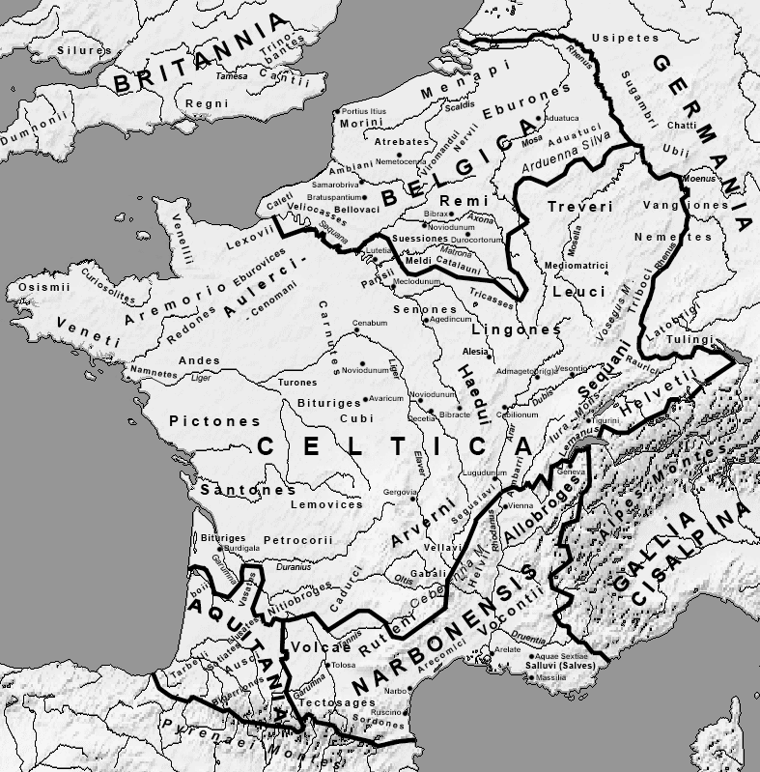
Regions of Gaul in 1st century B.C.
https://commons.wikimedia.org/wiki/File:Map_Gallia_Tribes_Towns.png
[24] Ab urbe conditā annō sexcentēsimō trīcēsimō quīntō C. Catō cōnsul Scordiscīs intulit
From city founded in-year six-hundredth thirtieth fifth Gaius cato consul on-Scordisci made
bellum ignōminiōsēque pugnāvit.
war disgracefully fought
[25] C. Caeciliō Metellō et Cn. Carbōne cōnsulibus duo Metellī frātrēs eōdem diē, alterum ex
With-Gaius Caecilius Metellus and Gnaeus Carbo consuls two Metelli brothers on-same say one over
Sardiniā, alterum ex Thrāciā, triumphum ēgērunt, nūntiātumque Rōmae est Cimbrōs ē
Sardinia other over Thrace triumph celebrated and-announced at-Rome it-was Cimbri from Gaul
Galliā in Ītaliam trānsīsse.
Gaul into Italy to-have-crossed

[26] P. Scīpiōne Nāsīcā et L. Calpurniō Bēstiā cōnsulibus Iugurthae, Numidārum rēgī, bellum
With Publius Scipio Nasica and Lucius Calpurnoius Bestia consuls against-Jugurtha of-Numidians king war
inlātum est, quod Adherbālem et Hiempsālem, Micipsae fīliōs, frātrēs suōs, rēgēs et populī
made was because Adherbal and Hiempsal of-Mickipsae sons brothershis-own kings and of-people
Rōmānī amīcōs, interēmisset. Missus adversus eum cōnsul Calpurnius Bēstia, corruptus rēgis
Roman friends he-had-killed sent against him consul Calpurnius bestia corrupted king’s
pecūniā, pācem cum eō flāgitiōsissimam fēcit, quae ā senātū improbāta est. Posteā contrā
by-money peace with him most-disgraceful made which by senate repudiated was afterwards against
eundem īnsequentī annō Sp. Postumius Albīnus profectus est. Is quoque per frātrem
same-man in-following year Spurius Postumius Albinus set out he also through brother
ignōminiōsē contrā Numidās pugnāvit.
disgracefully against Numidians fought

[27] Tertiō missus est Q. Caecilius Metellus cōnsul. Is exercitum ā priōribus ducibus
Thirdly, sent was Quintus Caecilius Metelllus consul he army by previous leaders
corruptum ingentī sevēritāte et moderātiōne corrēctum, cum nihil in quemquam cruentum
corrupted with-great strictness and restraint corrected when nothing against anyone cruel
faceret, ad disciplīnam Rōmānam redūxit. Iugurtham variīs proeliīs vīcit, elephantōs eius
he-did to discipline Roman returned Jugurtha in-various battles he-defeated elephants his
occīdit vel cēpit, multās cīvitātēs ipsīus in dēditiōnem cēpit. Et cum iam fīnem bellō positūrus
killed or captured many cities of-him into surrender took and when already end to-war about-to-put
esset, successum est eī ā C. Mariō. Is Iugurtham et Bocchum, Maurītāniae rēgem, quī
he-was succeded it-was to-him by Gaius Marius he Jugurtha and Bocchus of-Mauritania king who
auxilium Iugurthae ferre coeperat, pariter superāvit. Aliquanta et ipse oppida Numidiae cēpit
help to-Jugurtha to-bring had-begun equally defeated some also himself towns of-Numidia he-took
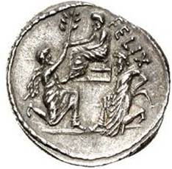
Coin issued by Sulla shows Bocchus kneeling to him in submision whilst Jugurtha, his hands bound as a prisoner, kneels in the background
https://en.wikipedia.org/wiki/Jugurthine_War#/media/File:Sulla_Coin2.jpg

bellōque terminum posuit captō Iugurthā per quaestōrem suum Cornēlium Sullam, ingentem
amd-to-war end put having-been Jugurtha by quaestor his Cornelius Sulla great
virum, trādente Bocchō Iugurtham quī prō eō ante pugnāverat. Ā M. Iūniō Sīlānō, collēga.
man handing-over Bocchus Jugurtha quo for him previously had-fought by Marcus Junius Silanus colleague
Q. Metellī, Cimbrī in Galliā vīctī sunt, et ā Minuciō Rūfō in Macedoniā Scordiscī et Triballī,
of-Quintus Metellus Cimbri in Gaul conquered were and by Minucius Rufus in Macedonia Scordisci and Triballi
et ā Servīliō Caepiōne in Hispāniā Lūsitānī subāctī. Āctī sunt et duo triumphī dē Iugurthā,
and by Servilius Caepio in Spain Lusitanians subdued held were also two triumphs over Jugurtha
prīmus per Metellum, secundus per Marium. Ante currum tamen Mariī Iugurtha cum duōbus
first by Metellus second by Marius before chariot however of-Marius Jugurtha with two
fīliīs ductus est catēnātus et mox iussū cōnsulis in carcere strangulātus est.
sons led was chained and soon by-order of-consul in prison strangled was

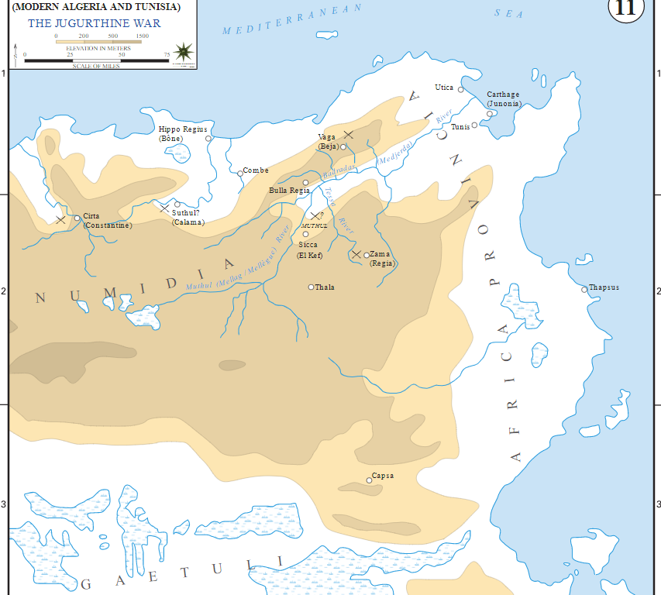

Numidia during the Jugurthine war (112-105 B.C.)
Frank Martini, United States Military Aademy
https://en.wikipedia.org/wiki/Jugurthine_War#/media/File:Jugurthine_war_Numidia-en.svg

The Third Syrian War (246-241), also known as the Laodicean War, was actually fought between Ptolemy III and Antiochus II’s son, Seleucus II. Backed by his mother, Laodice, Seleucus was proclaimed king on his father’s death despite the counter-claim by Antiochus’s second wife, Berenice, Ptolemy’s sister, that Antiochus had on his deathbed named her own five-year old son as heir. Ptolemy began the war after Laodice’s supporters had killed Berenice’s son and he was able to gain control of the Syrian coast as far as Seleucia Pieria on the Orontes river, which is just inside modern Turkey, The Ptolemaic and Seleucid dynasties had been founded by generals of Alexander the Great who divided his empire between them. See also https://www.livius.org/articles/concept/syrian-war-3/
A peck is about 8 litres.
Hiero, who ruled the south-east corner of the island from Syracuse, was a staunch Roman ally from 263 until his death in 215.
Lucius Cornelius Lentulus Caudinus and Quintus Fulvius Flaccus were consuls in 237. The Ligurians, who occupied territory in NE Italy and SW France, were heavily influenced by the Celts but may have been a distinct ethnic group. They attacked Ariminum (Rimini) with support from the Gallic Boii but the two groups turned on each other as the Romans approached. Despite the Roman victory that year, intermittent fighting with the Ligurians continued till 230.
Eutropius turns the truth on its head The Romans were in fact invited in 240 to take over Sardinia by mercenaries who had revolted against their Carthaginian employers and, though initially declining, they accepted a renewed invitation in 238 and annexed the island in 237.. The Carthaginians, faced also with war against their mercenaries in Africa, had to accept the loss of both Sardinia itself and Corsica, whose surrender had been demanded by Regulus in 256 but which had been left under Carthaginian control by the peace treaty. They also had to pay an additional indemnity,
The cessation of all wars was marked in 235 by the closing of the gates of the Temple of Janus in the forum. `Bulcus’ is a mistake for `Bulbus’.
In 229 B.C. the consuls fought against Teuta, widow of the chieftain who had united the Illyrian tribes along the eastern coast of the Adriatic, after she had refused to stop piracy against Roman and allied shipping. The Illyrians, who occupied former Yugoslavia and northern Albania, were culturally Indo-European but it is uncertain whether they had any sense of shared ethnicity, See https://en.wikipedia.org/wiki/Illyrians
Quintus Fabius Pictor, probably born around 270 B.C, is the first Roman historian whose name is known to us. His account, which has not survived, was written in Greek and probably in an annalistic format, starting with Aeneas’s arrival in Italy. He was still active in public life at the start of the 2nd. Punic war. See https://en.wikipedia.org/wiki/Quintus_Fabius_Pictor
Not only Lucius Aemilius Papus but also his fellow consul for 225, Gaius Atilius Regulus was involved in the decisive battle at Telamon (modern Talamone) on the Etruscan coast. Regulus, who had returned hastily from Sardinia, was killed in the fighting. For a detailed account see https://en.wikipedia.org/wiki/Battle_of_Telamon
The key battle was fought in 222 at Clastidium (the modern village of Casteggio) about 30 miles west of Placentia (Piacenza) in the Po Valley against the Gallic Insubres and mercenaries from the Gasaetae tribe from across the Alps, who had also fought at Telamon. Marcellus was the last Roman commander to earn the spolia optima, i.e arms etc. won by single-handedly killing the enemy commander. Mediolānum is modern Milan.
This war was fought against 221 B.C. against the ruler of the island of Pharos off the Dalmatian coast, a Roman ally who had recommenced raids on shipping. Pharos (modern Hvar) was a Greek colony but the (H)Istrians were probably an Illyrian people. They have given their name to the peninsula of Istria at the head of the Adriatic (see map on pg,2) but their area may have extended further south at this time. Istria is now largely in Croatia, with the area around Trieste belonging to Italy and another small area to Slovenia
Eutropius puts the events of three years into one. Hannibal took command of Carthaginian forces in Spain in 221, when he was already 25. Saguntum was well south of the River Ebro, which Carthage had agreed to accept as the northern limit of their expansion but the Romans accepted its appeal for an alliance and in 220-19 ordered Hannibal not to interfere in the Saguntians’ dispute with a tribe under Carthaginian control. After Hannibal’s capture in 219 of the city, whose inhabitants he enslaved, and Carthage’s refusal to hand him over, Rome declared war in March 218. See Bird for further details,,
Hovering over the map on the website produces enlarged images of different areas. Note that the boundary of Carthaginian possessions in 218 B.C. should be south, not north of Corsica and Sardinia
Hannibal reached Italy in autumn 2018. All figures for Hannibal’s forces are unreliable but Polybius (III.56) states only 20,000 infantry and 6,000 cavalry survived the march. Many Ligurians and Gauls joined him out of resentment of Rome’s recent expansion into the Po Valley.
Hannibal’s exact route across the Alps in 218 B.C,. has been endlessly debated. There is a technical discussion at https://pdfs.semanticscholar.org/6546/6b792b3f5b8367554236700d563c577b7483.pdf, arguing that he came over the Col de la Traversette as remains of rock falls there match the historian Polybius’s description of a landslip that impeded his advance (see Livy’s account, dependent on Polybius, in livy_interlinear__ii_.doc, available at . https://linguae.weebly.com/livy.html) The same researchers also claim to have found remains from the droppings of Hannibals’s pack animals; see the discussion at https://www.smithsonianmag.com/history/how-hannibal-crossed-the-alps-180963671/, which is more reader-friendly and also mentions arguments for a more northerly route across the Col du Clapier.
For details of the Roman defeats in the Po valley in the cavalry engagement at the Ticinus and at the Trebia in 218 see the notes on Ad Alpes, chapter 36 (at https://linguae.weebly.com/ad-alpes.html). Eutropius implies that Sempronius fought Hannibal alone at Trebia but, although accounts of the battle are confused, at least some of Scipio’s army were also involved.
For the ambush of the Roman army at Lake Trasimene in 217 see Ad Alpes chapter31.
Quintus Fabius Maximus Cunctator (`The Delayer’) was appointed dictator after Trasimene, helped recover Clusium (modern Chiusi) in Etruria in 214 and then retook Tarentum (Taranto) on the south coast in 209
540 A.U.C is 214 B.C. but the battle, which Varro insisted on fighting against Paulus’s wishes, took place in 216. See Ad Alpes, chapter 17 for further details.
Literally `were treated’.
Most of southern Italy went over to Hannibal, including most notably the city of Capua in Campania. Crucially, however, the Latin allies remained loyal.
Publius Cornelius Scipio, the consul of 218, and his brother Gnaeus Cornelius Scipio Calvus (`The Bald’). Both brothers were on their way to Spain 218 when Publius had to attempt to intercept Hannibal in Gaul and then return to oppose him in Italy. Gnaeus carried on to Spain, taking Tarraco (modern Tarragona) in the north-east, establishing Roman control of the area north of the Ebro and defeating Hannibal’s brother Hasdrubal in a naval battle near the mouth of the river. Publius joined him in 217 and they defeated Hasdrubal on land. The reinforcements that then had to be sent from Carthage had previously been intended to support Hannibal in Italy.
Marcellus, winner of the spolia optima when consul in 222, served briefly as a replacement consul in 215, then again as regular consul in 214.He successfully defended Nola from three attacks by Hannibal in 216, 215 and 214. In 215 he recovered Casilinum, which had been captured by Hannibal in winter 216-5. See also https://en.wikipedia.org/wiki/Marcus_Claudius_Marcellus
Apulia was a broad section of SE Italy.`Bruttium’ (the land of the Bruttii/Brittii) and `Calabria’ both referred to the SW peninsula stretching towards Sicily.
The Carthaginians sent troops to Sardinia in 215 to support the local revolt against the Romans, for whom the island was a major grain supplier.
Laevinus defeated Philip at Apollonia, a Greek city on the coast of what is now Albania in 214, relieving the city, which the king had been besieging, and making him burn his fleet. The ruins of Apollonia are about 11 miles from the modern city of Fier. The Scipios’ new victories in Spain were won in 212.
Gnaeus Fulvius Centumalus Maximus and Publius Sulpicius Galba Maximus were consuls in 211, which was actually Hannibal’s 8th year in Italy, In that year, Hannibal, failing to break the Roman siege of Capua,, marched on Rome but had to withdraw when part of the besieging troops were diverted to help defend the capital. Capua itself surrendered some months later and its territory was confiscated.
After the arrival of substantial new forces from Carthage, both brothers were killed in separate engagements in 211. The Romans were, however, able to maintain their hold on the area north of the Ebro. See Bird (p.88) for further details.
Syracuse, which had gone over to Carthage after Hiero’s death in 215, was besieged from 213 to 211. For the city’s capture and the killing of its great engineer, Archimedes, see the detailed narrative in Norman Davies, Europe –a History, pp.139-47. Davies regards the Roman victory as a crucial turning point in the 2nd. Punic War and in the development of European civilization.
Eutropius again telescopes events of different years. Laevinus, the victor of Apollonia three years before, made alliances with the Aetolian league of western Greece and with Attalus I of Pergamum, a kingdom often referred to as `Asia’. He secured the surrender of Agrigentum, a city on the southern coast of Western Sicily in 210, after which the rest of the island submitted to the Romans.. Philip of Macedonia only agreed a peace treaty in 205 after coming under threat from another Roman commander,
Gnaeus Fulvius, presumably the consul of 211 now serving as pro-consul, was defeated and killed in 210, when hoping to recover the town of Herdonia in Apulia, This was Hannibal’s last victory of the war, See also Livy XXVII.1 and https://en.wikipedia.org/wiki/Battle_of_Herdonia_(210_BC)
The plural Hispāniae is used here because the Romans divided the Iberian peninsula into different provinces. Their number was increased over time but the five set up by Diocletian in 293 (see the map at https://en.wikipedia.org/wiki/Timeline_of_Hispania#/media/File:Iberia_293.svg) were probably the ones Eutropius knew. For further details on the history of Spain under Roman rule see John Richardson’s The Romans in Spain
P. Cornelius Scipio, given the additional name `Africanus’ after his defeat of Hannibal at Zama in 202, arrived in Spain in 210.
This settlement, modern Cartagena. was originally called Mastia. Chosen as their main base by the Carthaginians for its excellent natural harbour, it was named by them Qart Hadasht (`New Town’) after their own capital. Scipio renamed it Carthāgō Nova (literally `New New Town’) after capturing it in 209. See https://en.wikipedia.org/wiki/Cartagena,_Spain#Ancient_history
There seems to be some confusion here as Hannibal’s brother, Mago Barca, continued serving as a Carthaginian general in Spain until after Scipio’s final victory there in 206. He subsequently carried out an invasion of Italy in 205 but was prevented by the Romans from linking up with Hannibal and, like him, was recalled to Carthage in 203. The town of Mahon in the Balearic Islands, from which the word `mayonnaise’ derives, was allegedly founded by him
Scipio defeated Hasdrubal in 208 at the battle of Baecula in Andalusia (southern Spain), for which see https://en.wikipedia.org/wiki/Battle_of_Baecula , but he still had most of his army and led it along Hannibal’s earlier route to try to join his brother in Italy.
Tarentum was re-taken in 208.
i.e cities which had been in Roman possession, not which had Roman inhabitants.
A rather irregular use of the reflexive pronoun as Scipio is not the subject of the verb in its clause (recēpērunt, presumably referring to the Romans in general)
Marcellus, who had slain a Gallic chieftain at Clastidium in 222 and captured Syracuse in 211, was serving as consul for the 5th time in 208 when he was ambushed by Hannibal’s Numidian cavalry near Tarentum. His fellow consul died in the same incident.
Although `the third year after Scipio’s arrival’ should be 208 or (not counting 210) 207, the reference is presumably to the defeat of the remaining Carthaginian forces at Ilipa near modern Seville in 206, and to Attenes, a chieftain of the Turdetani in the far-south of Spain, going over to the Roman side. Scipio himself visited North Africa to confirm an alliance with the Numidian chieftain, Syphax He was also joined by Masinissa, a rival Numidian prince, who had hitherto fought for Carthage.
Sena Gallica (modern Senigallla) on the Adriatic coast in Umbria. Hasdrubal, leading an army of about 30,000, was defeated on the River Metaurus near here in 207 after an intercepted letter to his brother revealed his plans.
Scipio returned to Rome in 206 and was consul in 205..
L.Valerius Philo and Q. Caecilius Metellus were consuls in 206 B.C. Hannibal had withdrawn into Bruttium (the extreme south-west of Italy) after his brother’s death. The Romans hurled Hasdrubal’s severed head into Hannibal’s camp, though Hannibaal had allowed Marcellus a proper funeral in 208 and sent his ashes in a casket to his son (see https://en.wikipedia.org/wiki/Marcus_Claudius_Marcellus)
Hannibal had reached Italy in 218 and Scipio invaded Africa in 204. This move was opposed by many senators, including Quintus Fabius Maximus, but strongly supported by the people. Not allowed adequate troops by the senate, Scipio enlisted the disgraced survivors of Cannae in Sicily, which (like Britain for later Romans and Hong Kong for 19th century Britons) was seen as a punishment posting.
After landing with 35,000 men about 35 kilometres NW of Carthage, Scipio captured several towns and defeated a Carthaginian cavalry force. He intended to take the city of Utica but had to withdraw when large forces under Hasdrubal and the Numidian chieftain Syphax, approached; the latter had switched allegiance from Rome to Carthage partly because of the charms of Hasdrubal’s daughter, Sophonisba, who was now his wife. Scipio spent the winter of 204-203 in `Castra Cornelia’, a fortified camp set up on a peninsula SE of Utica (see map). He opened peace negotiations with the Carthaginians as a ploy, but in the spring launched a surprise attack, setting fire to the enemy’s camps and destroying their forces (see https://en.wikipedia.org/wiki/Battle_of_Utica_(203_BC). The Carthaginians raised fresh troops but Hasdrubal and Syphax were defeated decisively in the `Battle of the Plains’ at Campi Magni in the Bagradas Valley. Masinissa and Scipio’s lieutenant Laenius pursued Syphax, defeating him again near Cirta (https://en.wikipedia.org/wiki/Battle_of_the_Great_Plains)
The town of Cirta surrendered when Syphax was displayed as a prisoner before its walls. Masinissa, decided to marry Sophonisba, to whom he had once been engaged, to save her from Roman vengeance. However, Scipio finally demanded that she be surrendered to appear in his triumph in Rome and Masinissa provided her with poison to commit suicide,
The preposition ā/ab in a sentence with a passive verb normally means `by’ but the sense here is obviously `from’. Eutropius wrongly places Hannibal’s departure from Italy in 201 rather than 203
pondō (derived from pondus, ponderis n, weight, pound) was strictly speaking an adverb meaning `in weight’ . A Roman pondus (or libra, from which the English abbreviation `lb’ was approximately 330 grams as against 450 to a modern British pound.
The battle was fought at Zama in 202.
The peace agreement was reached in 201 B.C., the 19th year of the war if it is assumed to have begun with the attack on Saguntum in 219.
As Rome was supposedly founded in 753 B.C. this date corresponds to 203. The war, however, actually begun in the consulship of P. Sulpicius Galba and C. Aurelius Cotta in 200. Roman intervention had been requested by Pergamum and Rhodes who were resisting Philip’s attempt to conquer territory in Asia Minor and also by the Athenians. See map on page 10.
Titus Quinctius Flamininus (the spelling `Quīntius’ was a later simplification) was elected consul in 198 and after prolongation of his command defeated Philip at the battle of Cynoscephalae (`Dog’s Heads’) in Thessaly in 197, reaching a peace agreement with him in 196. The Macedonians’ long spears made their phalanx very difficult to defeat in a frontal assault but the Romans seem to have prevailed through flank attacks and because their own formations were more manoeuvrable on hilly ground. See https://en.wikipedia.org/wiki/Battle_of_Cynoscephalae for further details.
i.e. presumably 4,000 pounds of silver annually. Other sources give different figures.
Flamininus and a Greek coalition, including Macedonia, defeated Nabis in 195, ending Spartan control of Argos in the NE Peloponnese and of the coastal states of Laconia further south. For details of this conflict, known as the Laconian War, see https://en.wikipedia.org/wiki/War_against_Nabise.
Publius Cornelius Scipio Nasica, a cousin of Scipio Africanus, and Marcus Cornelius Glabrio were consuls in 191 B.C. Antiochus III of Syria had in 204 signed a secret agreement with Philip V of Macedon to attack the possessions of the infant King Ptolemy VI and during the 2nd Macedonian War had decisively defeated Ptolemy’s forces. After Rome’s defeat of Philip, Antiochus moved against the Ptolemaic possessions in Asia Minor which Philip had earlier hoped to annex, prompting the cities of Smyrna and Lampascus to appeal for Roman protection. Antoichus landed in mainland Greece in 192, invited by the Aetolian League, a confederacy of tribes and cities north of the Gulf of Corinth, who had first allied with Rome in 212 and then again in the 2nd. Macedonian War, but now felt Rome was seeking to dominate rather than liberate Greece. In 191 Glabrio defeated Antiochus and destroyed his army at Thermopylae, site of the famous battle between Greeks and the invading Persians in 480.
Designed by a Greek architect in 155 A.D, this is the best preserved of all ancient theatres.
L. Cornelius Scipio (later `Asiaticus’ or `Asiagenis’ (Ἀσιαγενής)) and Laelius were consuls in 190
Hannibal took refuge at Antiochus’ court in 195 B.C. after his political enemies in Carthage had told the Romans (perhaps untruthfully) that he was already negotiating with the king, who was in dispute with Rome. Hannibal was commanding part of Antiochus’s fleet in 190 when he was defeated by Rome’s Lydian Rhodian allies off Aspendos, a city near the southern coast of Asia Minor. The Romans shortly afterwards obtained full control of the sea by defeating Antiochus’s main fleet at Myonnesus, a promontory and city near Ephesus on the western coast.
After his defeat at Magnesia near Ephesus in 189 Antiochus was compelled to accept the loss of Thrace and almost all of Asia Minor,
For Antiochus III’s empire before his defeat by Rome and her allies see the map in chapter 20 of Ad Alpes.
Albinus and Philippus were consuls in 186. Nobilis, consul for 189, began his campaign against the Aetolians that year and held his triumph in December 187.
Flamininus, the victor in the 2nd. Macedonian War, had also been sent in 192 to negotiate with Antiochus III before the outbreak of war. According to Plutarch, after his mission to capture Hannibal resulted in the latter’ death, he was criticised by some senators for cruelty against a man who was no longer a threat.
After the battle of Magnesia Hannibal took refuge first in Crete and then with King Prusias of Bithynia. For the stories of how he used snakes when fighting a naval battle on behalf of Prusias against Eumenes of Pergamum and how he kept his money safe from the Cretans, see chapters 1 and 3 of Ad Alpēs. Hannibal lived for some years in Nicomedia (modern İzmit), a city on the Black Sea coast which was later the capital of the Roman province of Bithynia and, briefly in the 4th century AD., the eastern capital of the whole empire (see https://en.wikipedia.org/wiki/Nicomedia). His funeral mound at nearby Libyssa, where he committed suicide in 183/2, long remained a local landmark.
Perseus, Philip’s son by a concubine, succeeded his father in 179, having earlier engineered the death of Demetrius, the legitimate heir and a former hostage in Rome. The Romans, encouraged by Eumenes, were suspicious of him from the start and declared war in 171, alleging he had attacked chieftains in Illyria under their protection. See https://en.wikipedia.org/wiki/Perseus_of_Macedon
For Masinissa’s role in the 2nd. Punic War, see footnote 41 above.
Publius Licinius Crassus, consul in 171, was defeated at the Battle of Callinicus in Thessaly.
Aemilus and Anicius were in office in 168,
The Battle of Pydna, a town on the eastern coast of Macedon, was generally supposed in antiquity to have been fought on 4 September (II Nōnās ) but the lunar eclipse said to have occurred that day was actually on 21 June. The inadequate system of intecalations meant that the Roman calendar was frequently out of line with the true date,
Although Perseus was treated honourably at the start he was later taken as a prisoner to Rome and eventually killed after taking part in Aemilius Paulus’s triumph. Macedonia was initially organised into four separate republics but, after the rebellion of Andriscus (see c.13 below), made into a Roman province in 146 B.C. See https://en.wikipedia.org/wiki/Perseus_of_Macedon
i.e. to be a characteristic
The inhabitants of Epirus in NW Greece, south of Illyria, had not always been accepted as fully Greek but the region had some cultural prestige as it contained the oracle of Dodona, which ranked second only to the one at Deplhi. Epirus emerged as a united kingdom in 370 B.C. and King Alexander of Epirus, invaded Italy in 334 or 333, anticipating Pyrrhus’s better-known campaigns 50 years later, but was defeated by the southern Italian tribes. The end of the Aeacid dynasty in 232 weakened Epirus, and facilitated the regional ascendancy of the Illyrian queen, Teuta (see page 2 above), but Epirus retained a looser unity as the Epirot League. After Aemilius’s victory in 167 secured Roman control over the core area of Molossia, which had sided with Perseus, 150.000 inhabitants were enslaved (see https://en.wikipedia.org/wiki/Epirus)
As Bird explains, the ship would not have had sixteen banks of oars but either two or three banks on with a total of sixteen men pulling them.
Aemilius’s triumph, celebrated over three days, was the most splendid seen up to his time. The sons accompanying him were Q.Fabius Maximus and P.Cornelius Scipio Aemilianus (later also Africanus) who had both been adopted into other families. Aemilius. known after his victory at Pydna as Macedonicus, was himself the son of the consul who was killed at Cannae in 216.
The name Lusitania was later used for the state of Portugal although the boundaries of the territory occupied by the ancient Lusitani did not coincide with those of the modern state
Memmius’s victories in Spain and North Africa came in 153, more than ten years after the triumphs of Aemilius Paullus and Anicius and a year after a Roman defeat in western Spain by the Lusitanians, a non-Celtic but Indo-European-speaking tribe. Fulvius Nobilior, consul for 153, was defeated by the Celtiberians, a Celtic people, at Numantia in northern Spain either that year or in 152 but M.Claudius Marcellus, consul for the third time in 152 and probably the grandson of the Marcellus who fought in the 2nd. Punic War, negotiated a peace settlement after capturing the Celtiberian town of Occilis.
Eutropius correctly gives the names of the consuls for 149 B.C. when the war began. On the Varronian system 602 A.U.C, would be 152 but Bird points out that Livy’s chronology, which Eutropius is probably following, puts Rome’s foundation of the city in 751 or 750 rather than 753 B.C.. By inclusive reckoning, 149 is 53 ather than 51 years after the end of the Second Punic War in 201.
Publius Cornelius Scipio Aemilianus was the youngest son of Aemilius Macedonicus but had been adopted by the son of the Scipio who defeated Hannnibal at Zama. He had literary interests and was a friend of the historian Polybius, who was brought to Rome as a Greek hostage in 167.
The subjunctive dīmicāret is presumably used as this clause is given as a consideration in the Carthaginians’ minds. Hazzard states that the consuls themselves were grossly incompetent and only saved from disaster by Scipio’s sound advice.
Masinissa, who died in 148, had been encouraged by the Romans to encroach on Carthaginian territory and they themselves then declared war on the city when the Carthaginians tried to resist.
Literally `of cities’. Urbs and cīvitās were by Eutropius’ time essentially synonyms, though cīvitās also has the wider meaning of `state’.
Carthage was destroyed in 146 so Eutropius implies a foundation date of 846 (or 845 on inclusive reckoning). The traditional date for its founding is 814 but the earliest dated archaeological remains are from c.760 (see Miles Carthage Must Be Destroyed, p.61.) The city’s destruction had long been the demand of a faction headed by Cato the Elder, though he probably did not actually use the famous phrase Delenda est Carthāgo, which is only attested since the Renaissance. The Carthaginians realised that they had minimal chance of successful resistance but held out for three years because the Romans had demanded that they abandon their city and build a new one ten miles inland. When the Romans finally broke through the walls and began systematic destruction, most of its inhabitants surrendered and 50,000 were enslaved. The family of Hasdrubal held out the longest but Hasdrubal himself finally went out to fall at Scipio’s feet his wife cursed him from the rooftop and then hurled both her children and herself into the burning building. A detailed description of the events is given by the Greek historian Appian, probably relying on Polybius who witnessed the siege alongside Scipio. Appian explicitly attributes to Polybius the claim that Scipio wept as Carthage was destroyed, fearing that the same fate would one day befall Rome itself,
The man who claimed to be Philip, son of Perseus was actually a Cretan soldier from the Syrian army who invaded Macedonia with help from the rulers of Thrace. After his victory over P.Iuventius Thana in 148 B.C. he was defeated by Q.Caecilius Metellus and executed after the latter’s triumph in Rome. See Bird, pp.91-2 for further details.
Corinth was destroyed in 146 at the end of Rome’s war against the Achaean League, of which the city was a part. The League, whose territory had at one time included the whole Peloponnese, had in 148 attacked Laconia after the Romans had allowed Sparta and some other cities to secede. Told by a Roman envoy in Corinth in 147 that it was to be dissolved, the League in 146 invaded central Greece but was defeated by Metellus and then by Memmius, consul for that year.
Persēs was an alternative spelling of Perseus and the `fales Perses’ revolted in 142. For the significance of the successive Macedonian revolts see R. Kallet-Marx’s Hegemony to Empire.
In 143-2, Quintus Caecilius Metellus Macedonicus, who had fought against Andriscus and then the Achaeans, was generally successful against the Celtiberians but did not attack the key stronghold of Numantia. See map on page 13 for tribal territories and, for an account of the whole conflict. https://penelope.uchicago.edu/~grout/encyclopaedia_romana/hispania/celtiberianwar.html
Idem bellum is slightly misleading because the rest of the chapter focuses on the campaign in the far west of the Iberian peninsula, which was largely separate from the struggle further east in Celtiberia
quō metū is equivalent to cuius metū (`from fear of whom’)
Caepio, as consul in 140 got the senate to repudiate a compromise agreement reached with Viriathus in 141 after his defeat of several Roman commanders. He then actually himself arranged the assassination, which led to the Lusitanians’ capitulation in 139,
Pompeius, consul in 141, agreed peace terms in 140 when his own camp was under siege but then denied he had done so. Another Roman commander, Marcus Popillius Laenas, was defeated by the Numantians shortly afterwards.
Mancinus, who was defeated in 137, was delivered bound and naked to the Numantians but, according to Appian, our major source for the wars in Spain, they refused to accept him. Tiberius Gracchus, who had negotiated the agreement on Mancinus’s behalf and who is best-known for his later land reform proposals, escaped punishment thanks to the intervention of Scipio Aemilianus.
Ā solō ēvertit is the functional equivalent of `razed to the ground’.
Aemilianus was consul for 134. His measures to restore discipline included the expulsion from the camp of 2,000 prostitutes. There is a detailed account of the siege, which ended in 133, at https://www.academia.edu/987374/The_siege_of_Numantia_how_Scipio_Aemilianus_conquered_the_bravest_of_all_cities Many inhabitants committed suicide rather than face enslavement and their resistance is still a matter of national pride in Spain today.
`Asia’ here refers to the kingdom of Pergamum and to the new Roman province which comprised the major part of its territory, the remainder going to Cappadocia and to Pontus. Tiberius Gracchus, tribune of the plebs in 133, proposed unsuccessfully that Aattalus’s treasury be used to finance his scheme to provide land to landless Roman citizens. The reform programmes of Tiberius and his brother Gaius (tribune in 123 and 122), which both met violent resistance and cost both men their lives, were a major turning point in Roman history but ignored by Eutropius, probably because he disapproved of their populism (see Bird’s introduction, p.xxvii). Attalus III (reigned 138-133) was actually the son of Eumenes II (197-150) and the nephew of Eumenes’ brother, Attalus II (150-138). Pergamum had consistently supported Rome since the latter’s first conflict with Macedonia and had been granted extensive additional territory at the end of the war with Antiochus of Syria (see map on pg. 21 for its boundaries). Attalus III, who had no legitimate heirs of his own, appears to have gifted the kingdom to the Romans to avoid bloodshed in the belief that they would take it in any case. He intended to exclude the Greek cities from the bequest, leaving them free, but the Romans ignored this nicety. For a summary of Pergamene history, see https://en.wikipedia.org/wiki/Pergamon
Brutus’s campaigns in Gallicia and Lusitania took place in 137-134. Scipio Aemilianus’s triumph for Numidia was celebrated in 133, fourteen years by inclusive reckoning after the celebration in 146 of his victory over Carthage.
A city on the Aegean coast between Pergamum (viz. the kingdom’s capital) and Ephesus.
Stratonicea was a city on the Carian coast in SW Anatolia.
The defeat of Crassus (consul in 131) and victory of Peperna (consul in 130) both probably took place in 130. It is uncertain whether Aristonicus, who called himself Eumenes III, was actually the son of Eumenes II and thus brother of Attalus III. Promising freedom to both slaves and serfs, he was well supported in the countryside but apparently opposed by most of the Greek cities. His associates included the Stoic philosopher Gaius Blossius of Cumae, a former mentor of Tiberius Gracchus, who advocated the Utopian project of establishing `Heliopolis’ (`City of the Sun’) in which slavery would not exist. See https://en.wikipedia.org/wiki/Eumenes_III and, for the argument that Aristonicus and Blossius were not as radical as some imagine, Thomas Africa, `Aristonicus, Blossius and the City of the Sun’. International Review of Social History, 6(1) (1961): 110-124 Robin Levin’s essay on slavery in the ancient world and in 19th century America contrasts Blossius’s apparent rejection of slavery as such with the general acceptance of the institution among even the more humane thinkers in the classical world.
Gaius Gracchus, the reformist tribune who died in civil strife in 121, established the colony of Junonia near Carthage in 122, the year after Metellus and Flamininus’s consulship. A new city on the actual site of Carthage was only established under Augustus a century later.
Longinus and Calvinus were consuls in 124, so 627 A.U.C. is correct if Eutropius was using the Livian date of 751 for Rome’s foundation and exclusive reckoning. The Averni were defeated by Q. Fabius Maximus (consul in 121) and a Roman province organised in the coastal region corresponding roughly to modern Provence and Languedoc and initially called called provincia nostra or Gallia Trānsalpīna. The Romans’ initial interest in the region had been to protect their communications with Spain and they had made an early alliance with the Greek colony of Massilia (Marseilles) which was often at odds with neighbouring Gallic tribes.
Cato and Rex were consuls in 118 when Narbo (moderb Narbonne) was founded on the coast as a colony for Roman veterans. The province was subsequently renamed Gallia Narbonensis.
Metellus fought against the Dalmatians as consul for 119 and celebrated his triumph in 117.
Cato’s consulship and defeat by the Scordisci, a tribe with mixed Celtic, Thracian and Illyrian origins centred on what is now Serbia, was in 114, not 116 as Eutropius’s dating implies.
Gaius Caecilius Metellus, son of Quintus Caecilius Metellus Macedonicus, fought the Thracians as consul in 113. His brother Marcus, consul in 115, subdued a revolt in Sardina in 114. The brothers’ joint triumph was celebrated in 113.
The Cimbri and their allies the Teutones had migrated south from Jutland (see map in Book V) and in 113 invaded the territory of the Taurisci, a tribein Noricum (now southern Austria and northern Slovenia) who were allied to Rome. The Germans started to withdrew as demanded by consul Gnaeus Papirius Carbo, backed by a 30,000-strong army, but Carbo, despite promising them safe passage, tried to ambush them at Noreia (near modern Ljubljana) and, when his plan was discovered, suffered a massive defeat. Although they were expected now to attack Italy the tribesmen headed into Gaul. Carbo, impeached in Rome, committed suicide. See https://en.wikipedia.org/wiki/Battle_of_Noreia
On Micipsa’s death in 118, Jugurtha, his adopted son, and his two natural sons each received part of the kingdom but Jugurtha had Hiempsal murdered and expelled Adhurbal. The Romans insisted on his return and the division of Numidia between the two men but Jugurtha in 112 killed Adhurbal after besieging him in Cirta (modern Constantine), where his troops also massacred a number of Italians. In 111 Bestia, sent against Jugurtha as consul, reached a compromise settlement, whether as the result of bribery or simple military difficulties. Jugurtha himself was given safe conduct to Rome to give evidence against Bestia and others but retuned home after the arrangement was vetoed by a tribune, Whilst in the city he had arranged the murder there of his cousin Massiva and on leaving he supposedly remarked that it was `a city for sale and soon to perish if it found a buyer’ (urbem venalem et mature perituram, si emptorem invenerit, Sallust, Bellum Iugurthinum, 35).
Albinus consul in 110 campaigned for some months but then retuned hime leaving command to his brother Aulus, under whom a Roman army was defeated and forced to go under the yoke.
This Metellus, consul in 109, was the son of the Lucius who was consul in 123 and is mentioned in chapters 21 and 23
Both Metellus and Marius, who had served as his legatre(deputy) before winning the consulship for 107, wonsome successes but failed to defeat Jugurtha decisively. In 105, Lucius Cornelius Sulla, Marius’s deputy, got Bocchus, King of Mauritania to betray Jugurtha, his son-in-law, in return for territory in western Numidia and Jugurtha was taken to Rome, paraded in Marius’s triumph on 1 January 104 and later either strangled in prison or died of starvation. Marius was accused by his enemies of having taken Metellus’s place as Roman commander by spreading false accusations of incompetence against him. Marius and Sulla went on to become leaders respectively of the `populist’ and `aristocratic’ factions in Rome and Eutropius’s praise of Sulla shows his own bias.
Other sources make it clear that in 109 Marcus Junius Silanus was actually defeated by the Cimbri at an unknown point on the border of Transalpine Gaul. The Triballi, a Thracian tribe with some Celtic and Illyrian influence were defeated together with the Scordisci the same year by Minucius, whi had been consul in 110. Quintus Servilius Caepio, was praetor in 109 and celebrated his triumph over the Lusitanians in 107.

