QUESTIONS ARISING FROM 57TH MEETING -26/8/15

We read chapters 24 to 29 of Fabulae Faciles, which cover the 4th, 5th and 6th labours of Hercules (the Erymanthian Boar, the Augean Stables and the Stymphalian birds). Because we had twelve members attending (the largest number since the inaugural meeting in December 2010), we broke up into two groups, led by Anastasia and John, for the reading and comprehension questions. Everyone was reminded that, although handouts with the chapters needed for each meeting are always provided on the day, it is best to prepare with the latest (2015) version of Steadman’s on-line edition, which can be downloaded free of charge from http://geoffreysteadman.com/ritchies-fabulae-faciles/
The Latin text with interlinear translation (hercules1, 2 and 3) can be downloaded from the `linguae’ site at http://linguae.weebly.com/latin--greek.html

As usual we also discussed terms for some of the things consumed, including citrum, -ī n (lemon), pānis Persicus (naan - actually the ordinary Persian word for bread), brassica Pompēiāna (cauliflower) and orȳza (rice). The last word, first attested in English in the 13th century, certainly derives via French form the Latin, which in turn derives ultimately from Sanskrit vrihi, perhaps via old Persian brizi. In Roman times the grain was not a staple food but an expensive import used for medicinal purposes: a kind of rice pudding was given to settle a sick stomach, much as congee is sometimes used today. Mention was also made again of the words for different kinds of meat. These all consisted originally of the word carō (carnis, f) plus the adjective formed from the name of the relevant animal, e,g. carō porcīna (< porcus), pork. Usually this was abbreviated by omitting carō, thus giving bubula (beef), gallinācea (chicken), ovilla (mutton) etc. There is some dialogue on food on the Circulus page in the sections Vīta cottidiāna and Dē Rē Culīnāriā (http://linguae.weebly.com/circulus-latinus-honcongensis.html )

In a discussion of language evolution, Andy mentioned that Tocharian, a group of three closely related Indo-European languages preserved in documents of the 6th to 8th century in the Tarim Basin in Xinjiang (新疆) province, added additional cases to those it inherited .from Proto-Indo-European. This system is presented in detail in the Wikipedia article on Tocharian at https://en.wikipedia.org/wiki/Tocharian_languages The cases retained from the parent language were nominative, vocative, accusative (known in Tocharian grammar as `oblique’) and genitive, while suffixes were added to the oblique form to produce the new instrumental, perlative, comitative, allative, ablative, locative and causative cases. The system resembles in some ways that of modern Hindi, in which many nouns have an oblique case used with postpositions. The Hindi postpositions are written as independent words but the closely corresponding Nepali postpositions are invariable suffixes as in Tocharian (e.g. Hindi ghoḍe mẽ, Nepali ghoḍāmā Tocharian B yakwene = English on the horse)

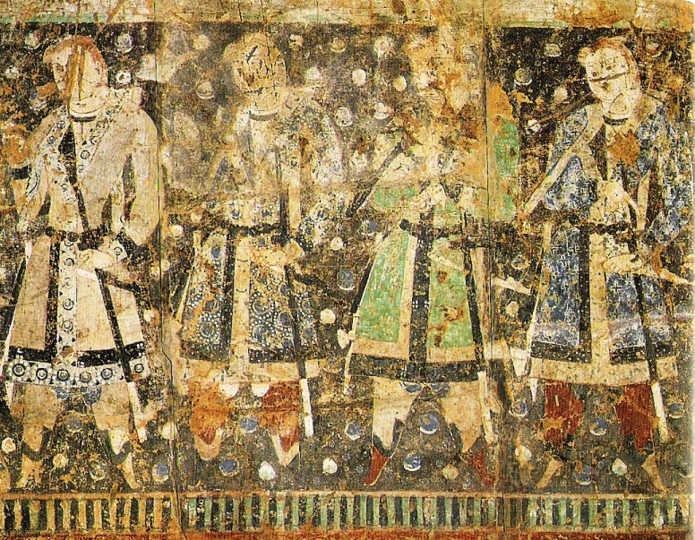
6th century Tocharian fresco

Many of the Tocharian documents discovered at the beginning of the 20th century by Auriel Stein are translations of Sanskrit Buddhist works. After the region was conquered by the Uyghurs in the 9th century, Tocharian itself was supplanted by the Uyghurs’s Turkic language and Buddhism by Islam but the present-day non-Han population is probably descended from a mixture of the earlier inhabitants and the invaders.
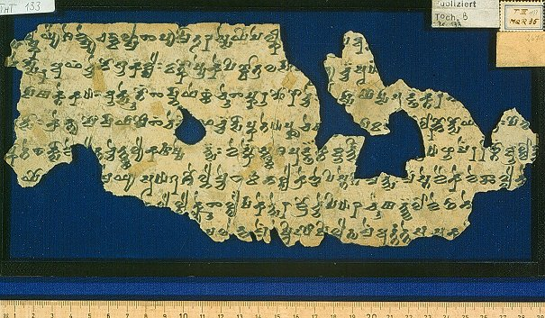
Tocharian script (derived, like most South and South-East Asian alphabets, from the Indian Brahmi script)

We touched on the fact that many Cantonese do not like (spicy) hot food and also the difficulty that many people in this part of China, in common with some in SE Asia, have in metabolizing alcohol. John vaguely recalled that it had been suggested that there was a stronger genetic similarity between northern Chinese (famous for their use of alcohol!) and gweilo than between northern and southern Chinese. Whether or not that is true, there is some reason for believing that this part of the Middle Kingdom spoke mostly Tai languages before the Han Chinese moved south and that many Cantonese have some of the earlier inhabitants’ DNA in them.

We also discussed the word fascēs, which could refer to bundles of wood or straw but most famously meant the bundles of rods carried by their attendants (lictōrēs) in a magistrate’s procession. Chris thought that these could only contain an axe if the magistrate had been hailed as imperātor by his troops. In fact, if we can accept Wikipedia’s account at https://en.wikipedia.org/wiki/Fasces, senior magistrates were all entitled to the axe, which symbolized their power to inflict capital punishment but they had to abandon it when within the city’s pomerium or sacred boundary, because in Rome itself the Roman people held power over life and death. The only magistrate entitled to retain the axe inside the city was a dictātor, an office which under the Republic was held only for a short period in emergencies and came with the right to inflict the death penalty even within the city. There is evidence, though, that this rule was sometimes broken..

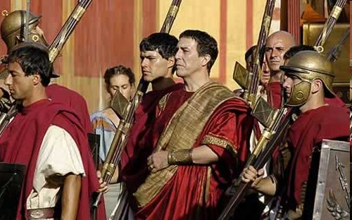
A consul in procession with fasces-bearing lictors (from the PBS TV series `Rome’)

Another word that came up for discussion was cowboy, for which the Morgan’s neo-Latin dictionary (available at
https://archive.org/details/TheLexiconAnglumEtLatinumByDavidMorgan) offers the classical word armentārius (herdsman).

Also briefly discussed were the present disturbances in Nepal, in which a number of people have lost their lives. John explained that there has been a long-running argument on whether the units in a proposed federal structure should be
designed to allow particular ethnic minorities to enjoy a plurality within them. On 8 August the government issued a draft which did not do this but left the Parbatiyas - the traditionally Nepali-speaking hill castes - as the strongest group in every province. Opposition to this was particularly strong in the tarai plains at the foot of the hills, where there is resentment over hill domination and also tension between the earlier inhabitants and hill people who have settled in the lowlands after the eradication of malaria in the 1950s. More information on the dispute is available on John’s site at http://linguae.weebly.com/nepali.html (scroll down to `Federal Nepal’) and a list of recommended books is in the section `Background reading on Nepali history and society’ lower down. A 2500-word summary of Nepal’s history over the last fifty years is at http://linguae.weebly.com/nepal-1964-2014.html

Mention was made of the Indian-Bangladesh enclaves - pockets of Indian territory within Bangladesh and vice-versa, which existed until an exchange t this year (see https://en.wikipedia.org/wiki/India%E2%80%93Bangladesh_enclaves). John was asked whether there was a similar situation on the Nepal-India border and he explained that there was not, but that Nepal has constantly complained of encroachments on its territory at different points. In Europe, there is a partial parallel to the India-Bangladesh situation in the territory of Kaliningrad/Königsberg, a Russian enclave situated between Poland and Lithuania.

During the summer Tanya and John’s families had been in Italy, visiting in particular Pompeii, Herculaneum and the summit of Vesuvius. Herculaneum, a smaller site which attracts fewer visitors than Pompeii, was a resort for the wealthy and provided with sewers. It therefore did not need the `stepping stones’ found at many points on Pompeii’s streets, which kept pedestrians out of the waste material often flowing by! Another contrast is that the remains of Herculaneum are below the present ground level whereas Pompeii looms up above the approaching visitor. A selection of photos will be placed on a new page on the `linguae’ site but this will probably not be ready before the end of September.

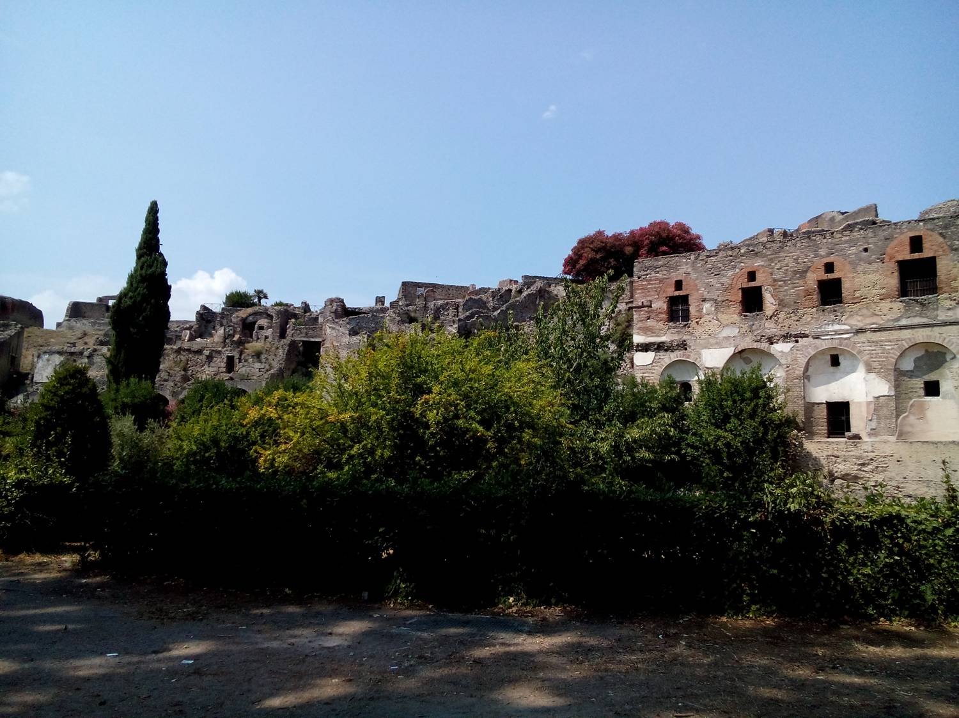
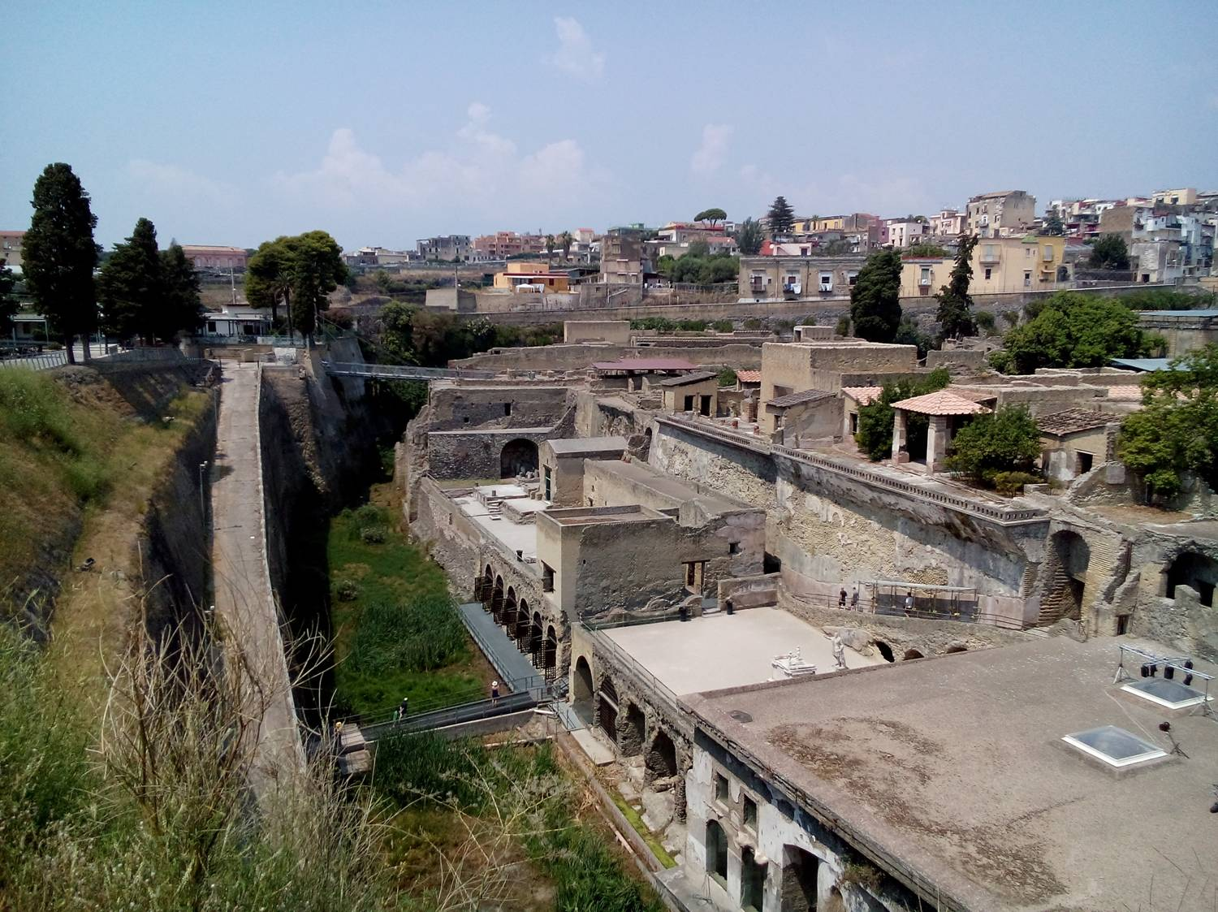

Pompeii Herculaneum

Finally, in discussion of Internet aids to memorization, mention was made of the Anki flashcard site. At the moment John’s own flashcards sets are all on www.cram.com. This in not so easy to search as the sadly defunct Wordchamp platform, but cards can be rapidly located via the links on http://linguae.weebly.com/flashcards.html

24. 4th LABOR: THE ERYMANTHIAN BOAR
Tum vērō iussus est Herculēs aprum quendam capere quī illō tempore agrōs Erymanthiōs vāstābat et incolās huius regiōnis magnopere terrēbat. Herculēs rem suscēpit et in Arcadiam profectus est. Postquam in silvam paulum prōgressus est, aprō occurrit. Ille autem simul atque Herculem vīdit, statim refūgit; et timōre perterritus in altam fossam sē proiēcit. Herculēs igitur laqueum quem attulerat iniēcit, et summā cum difficultāte aprum ē fossā extrāxit. Ille etsī fortiter repugnābat, nūllō modō sē liberāre potuit; et ab Hercule ad Eurystheum vīvus relātus est.

25. HERCULES AT THE CENTAUR'S CAVE
Dē quartō labōre, quem suprā narrāvimus, haec etiam trāduntur. Herculēs dum iter in Arcadiam facit, ad eam regiōnem vēnit quam centaurī incolēbant. Cum nox iam appeteret, ad spēluncam dēvertit in quā centaurus quīdam, nōmine Pholus, habitābat. Ille Herculem benignē excēpit et cēnam parāvit. At Herculēs postquam cenāvit, vīnum ā Pholō postulāvit. Erat autem in speluncā magna amphora vīnō optimō replēta, quam centaurī ibi dēposuerant. Pholus igitur hoc vīnum dare nōlēbat, quod reliquōs centaurōs timēbat; nūllum tamen vīnum praeter hoc in speluncā habēbat. "Hoc vīnum," inquit, "mihi commissum est. Sī igitur hoc dabō, centaurī mē interficient." Herculēs tamen eum irrīsit, et ipse pōculum vīnī dē amphorā hausit.

26. THE FIGHT WITH THE CENTAURS
Simul atque amphora aperta est, odor iūcundissimus undique diffūsus est; vīnum enim suāvissimum erat. Centaurī nōtum odorem sēnsērunt et omnēs ad locum convēnērunt. Ubi ad spēluncam pervēnērunt, magnopere īrātī erant quod Herculem bibentem vīdērunt. Tum arma rapuērunt et Pholum interficere volēbant. Herculēs tamen in aditū spēluncae cōnstitit et impetum eōrum fortissimē sustinēbat. Facēs ārdentēs in eōs coniēcit; multōs etiam sagittīs suīs vulnerāvit. Hae autem sagittae eaedem erant quae sanguine Hydrae ōlim imbūtae erant. Omnēs igitur quōs ille sagittīs vulnerāverat venēnō statim absūmptī sunt; reliquī autem ubi hoc vīdērunt, terga vertērunt et fugā salūtem petiērunt.

27. THE FATE OF PHOLUS
Postquam reliquī fūgērunt, Pholus ex spēluncā ēgressus est, et corpora spectābat eōrum quī sagittīs interfectī erant. Magnopere autem mīrātus est quod tam levī vulnere exanimāti erant, et causam eius reī quaerēbat.
Adiit igitur locum ubi cadāver cuiusdam centaurī iacēbat, et sagittam ē vulnere trāxit. Haec tamen sīve cāsū sīve cōnsiliō deōrum ē manibus eius lapsa est, et pedem leviter vulnerāvit. Ille extemplō dolōrem gravem per
omnia membra sēnsit, et post breve tempus vī venēnī exanimātus est. Mox Herculēs, quī reliquōs centaurōs secūtus erat, ad spēluncam rediit, et magnō cum dolōre Pholum mortuum vīdit. Multīs cum lacrimīs corpus amicī ad sepultūram dedit; tum, postquam alterum pōculum vīnī exhausit, somnō sē dedit.

28. 5th LABOR: THE AUGEAN STABLES
Deinde Eurystheus Herculī hunc labōrem graviōrem impōsuit. Augēās quīdam, qui illō tempore rēgnum in Ēlide obtinēbat, tria mīlia boüm habēbat. Hī in stabulō ingentis magnitūdinis inclūdēbantur. Stabulum autem inluviē ac squālōre erat obsitum, neque enim ad hoc tempus umquam purgātum erat. Hoc Herculēs intrā spatium ūnīus diēī purgāre iussus est. Ille, etsī rēs erat multae operae, negōtium suscēpit. Prīmum magnō labōre fossam duodēvīgintī pedum dūxit, per quam flūminis aquam dē montibus ad mūrum stabulī perdūxit. Tum postquam mūrum perrūpit, aquam in stabulum immīsit et tālī modō contrā opīniōnem omnium opus cōnfēcit.

29. 6th LABOR: THE STYMPHALIAN BIRDS
Post paucōs diēs Herculēs ad oppidum Stymphālum iter fēcit; imperāverat enim eī Eurystheus ut avēs Stymphalidēs necāret. Hae avēs rostra aēnea habēbant et carne hominum vēscēbantur. Ille postquam ad locum pervēnit, lacum vīdit; in hōc autem lacū, quī nōn procul erat ab oppidō, avēs habitābant. Nūlla tamen dabātur appropinquandī facultās; lacus enim nōn ex aquā sed ē līmō cōnstitit. Herculēs igitur neque pedibus neque lintre prōgredī potuit. Ille cum magnam partem diēī frustrā cōnsumpsisset, hōc cōnātū dēstitit et ad Volcānum sē contulit, ut auxilium ab eō peteret. Volcānus (quī ab fabrīs maximē colēbātur) crepundia quae ipse ex aere fabricātus erat Herculī dedit. Hīs Herculēs tam acrem crepitum fēcit ut avēs perterritae āvolārent. Ille autem, dum āvolant, magnum numerum eārum sagittīs trānsfīxit.
QUESTIONS ARISING FROM 58th MEETING - 30/9/15

Before eating everyone had to reply in Latin to the questions Ubi nātus/nāta es? (Where were you born?) and Quō mūnere fungeris (What’s your job?). Places of origin included Austrālia, Britannia, Latvia, Honcongum and Sīna Continentālis (mainland China). Andy, who is from northern Guangdong, pointed out that the plural form Sīnae was more common in Latin. John explained that, though this was true, when he had himself first taught Latin outside his old secondary school, Pater Ludovīcus Aestās (Fr. Louis Ha Kei Lung), the course director and Hong Kong’s leading Latinist, had decreed that the singular be used, presumably so Beijing won’t think we are rejecting the one China policy! As well as Sīnae/Sīna, usually thought to derive ultimately from the dynastic name Qin (秦), another early Latin term was Sēres (-um, m.pl.), `silk people’, presumably deriving from sī (絲,). For further discussion of these words and details of early contact between Europe and China along the Silk Road, see the Powerpoint presentation SINA LATINA, available for download at http://linguae.weebly.com/sina-latina.html

Occupations represented amongst us included professor iūrisprūdentiae/lēgum ēmeritus (or professor….rude dōnātus, referring to the wooden stick received by a gladiator when honourably discharged), discipulus medicīnae (medical student), mēchanicus programmāticus (software engineer), subredāctor āctōrum diurnōrum (newspaper sub-editor), investigātor pecūniārius (or simply argentārius) rude dōnātus (retired financial analyst or retired banker), magistra linguārum Francogallicae Theodiscaeque ēmerita (retired French and German teacher), magistra linguae Anglicae (English teacher), magistra artium graphicārum (art teacher), magistra linguae Anglicae (English teacher), historicus (historian) and magister Latīnitātis (Latin teacher). For civil servant we have in the past used officiālis, which was used in that sense in late classical times, normally of more junior employees. An alternatives might be accēnsus ( -ī m), the perfect participle of the verb accēnseō (enroll, add to the list) or, perhaps better as a term covering higher as well as lower ranks, minister pūblicus (`public servant’). Pat ended his career as district officer for Shatin, which might be rendered administrātor regiōnalis Satinēnsis.

Food ordered included rice (orȳza), water spinach (spinacia aquātica) and curried beef (bubula in iūre acrī), washed down as usual with vīnum rubrum/sanguineum and/or thea. It was again noted that we have not discovered the word used by early Jesuit missionaries for `chop-stick’ so have to continue use clavula (-ae f) which really means `twig.’

We read chapters 3-35 of the story of Hercules from Fabulae Faciles, translating into English or asking and replying to comprehension questions in Latin.. See the text printed below.

Pat, who had recently returned from several months mostly in Europe, had also visited Uzbekistan, seeing Samarkand and other points along the Silk Road (via Sērica). He spoke highly of the country’s natural beauty and of the government’s restoration programme for historical monuments, though noting the dictatorial nature of the regime.

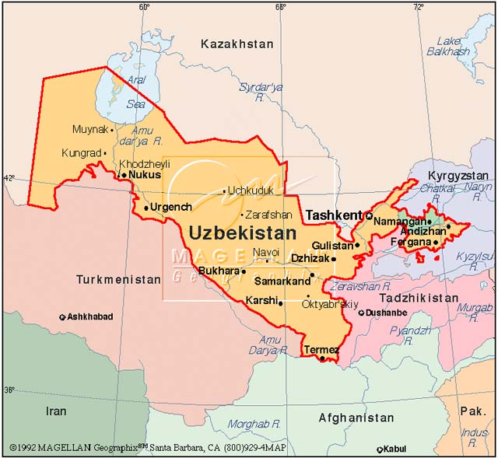

Uzbekistan might be Latinized as Uzbekistānia but much of the modern state and of neighbouring Tadzhikstan, which are now both Turkic-speaking, were in pre-Islamic times part of a region called Sogdia or Sogdiāna, whose inhabitants spoke a language closely related to Iranian. The name itself may derive from an Indo-European root meaning `archer’. Sogdia formed part of the Persian Empire but had probably became independent around 400 B.C., seventy years before its conquest by Alexander the Great. It remained part of the Hellenistic kingdom of Bactria till around 150 B.C. when the region was overrun by Scythians and other nomads from the north. Sogdia was never a single, united kingdom but Samarkand, now Uzbekistan’s capital, emerged as the principal commercial centre and Sogdians long dominated much of the trade along the Silk Road whilst they were also instrumental in the transmission of religions such as Buddhism, Zoroastarianism and Manichaeism through Central Asia. The Arab conquest of Samarkand in 719 A.D. put pressure on its people to convert to Islam and the participation of many Sogdians in the An Lushan rebellion of 755-763 led many of them to conceal their Sogdian heritage and become assimilated as Chinese, Turks etc. after the Tang dynasty regained control. Samarkand nevertheless retained its commercial importance, and its role was particularly significant during the Yuen (Mongol) dynasty, when contact with Europe along the Silk Road was deepened.


For further information see the accounts at http://io9.com/sogdia-the-lost-empire-that-ruled-the-silk-road-1553078058
and https://en.wikipedia.org/wiki/Sogdia The battle between Han troops and a Hun army in 36 B.C., in which some historians believe Roman legionaries, former prisoners of the Parthians, took part and which is referred to in the Wikipedia article, probably took place in Kazakhstan rather than Uzbekistan. The disputed evidence for a Roman presence is presented in slide 3 of the SINA LATINA Powerpoint already referred to. For a detailed account of Alexander the Great’s seizure of a Sogdian stronghold, see http://www.livius.org/aj-al/alexander/alexander_t54.html

John had recently returned from his annual trip to Nepal and explained that most of the buildings in the capital, Kathmandu, had suffered only minor damage in April’s earthquake but that prominent temples had collapsed in the historic centre of the town and other buildings, including the old royal palace, had been badly affected. The Kathmandu Valley had been peaceful during his two weeks there but he had had to spend an extra day at a friend’s bungalow in the hills east of the Valley because activists opposed to the new constitution promulgated on 20 September had threatened to attack vehicles on the road and taxis and buses stopped operating on roads outside the main towns.

There has been much greater unrest in the tarai plains to the south, resulting in around 40 deaths by the time of the promulgation. The Madhesis, people who share culture and language with Indians south of the border rather than with the hill people’s further north, are angry because they have not received the degree of autonomy they wanted and also because of restrictions on their citizenship rights. At the moment there is a semi-blockade of Nepal in place, with a drastic reduction in the amount of oil and other supplies normally sent in from India, though it is disputed how far this is the result of Madhesi protestors blocking the roads on the Nepal side of the border and how much of a conscious decision by the Indian government to put pressure on Kathmandu. More information is available in the `Federal Nepal’ section of http://linguae.weebly.com/nepali.html

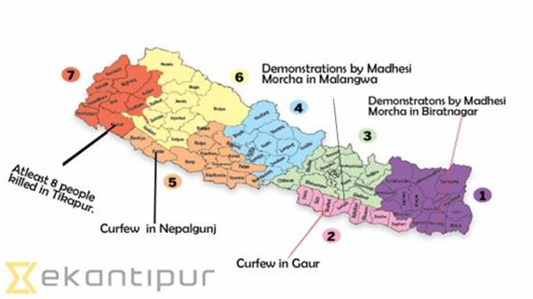
APPENDIX: EXTRACT FROM FĀBULAE FACILĒS

30. 7th LABOR: THE CRETAN BULL
Tum Eurystheus Herculī imperāvit ut taurum quendam ferōcissimum ex īnsulā Crētā vīvum referret. Ille igitur nāvem cōnscendit, et cum ventus idōneus esset, statim solvit. Cum tamen insulae iam appropinquāret, tanta tempestās subitō coörta est ut nāvis cursum tenēre non posset. Tantus autem timor animōs nautārum occupāvit ut paene omnem spem salūtis dēpōnerent. Herculēs tamen, etsī navigandī imperītus erat, haudquāquam territus est.
Post breve tempus summa tranquillitās cōnsecūta est, et nautae, quī sē ex timōre iam recēperant, nāvem incolumem ad terram appulērunt. Herculēs ē nāvī ēgressus est, et cum ad rēgem Crētae vēnisset, causam veniendī docuit. Deinde, postquam omnia parāta sunt, ad eam regiōnem contendit quam taurus vāstābat. Mox taurum vīdit, et quamquam rēs erat magnī perīculī, cornua eius prehendit. Tum, cum ingentī lābōre mōnstrum ad nāvem trāxisset, cum praedā in Graeciam rediit.

31. 8th LABOR: MAN-EATING HORSES OF DIOMEDE
Postquam ex īnsulā Crētā rediit, Herculēs ab Eurystheō in Thrāciam missus est, ut equōs Diomēdis redūceret. Hī equī carne hominum vēscēbantur; Diomēdēs autem, vir crūdēlissimus, illīs obiciēbat peregrīnōs omnēs quī in eam regiōnem vēnerant. Herculēs igitur magnā celeritāte in Thrāciam contendit et ab Diomēde postulāvit ut equī sibi trāderentur. Cum tamen ille hoc facere nōllet, Herculēs īrā commōtus rēgem interfēcit et cadāver eius equīs obicī iussit.
Ita mīra rerum commūtātiō facta est; is enim quī anteā multōs cum cruciātū necāverat ipse eōdem suppliciō necātus est. Cum haec nuntiāta essent, omnēs quī eam regiōnem incolēbant maximā laetitiā affectī sunt et Herculī meritam grātiam referēbant. Nōn modo maximīs honōribus et praemiīs eum decorāvērunt sed orābant etiam ut rēgnum ipse susciperet. Ille tamen hoc facere nōlēbat, et cum ad mare rediisset, nāvem occupāvit. Ubi omnia ad navigandum parāta sunt, equōs in nāvī collocāvit; deinde, cum idōneam tempestātem nactus esset, sine morā ē portū solvit, et paulō post equōs in lītus Argolicum exposuit.

32. 9th LABOR: THE GIRDLE OF HIPPOLYTE
Gēns Amāzonum dicitur omnīnō ex mulieribus cōnstitisse. Hae summam scientiam reī mīlitāris habēbant, et tantam virtūtem adhibēbant ut cum virīs proelium committere audērent. Hippolytē, Amāzonum rēgīna, balteum habuit celeberrimum quem Mars eī
dederat. Admētā autem, Eurystheī fīlia, fāmam dē hōc balteō accēperat et eum possidēre vehementer cupiēbat. Eurystheus igitur Herculī mandāvit ut cōpiās cōgeret et bellum Amāzonibus īnferret. Ille nuntiōs in omnēs partēs dīmīsit, et cum magna ultitudō
convēnisset, eōs dēlēgit quī maximum ūsum in rē mīlitārī habēbant.

33. THE GIRDLE IS REFUSED
Hīs virīs Herculēs persuāsit, postquam causam itineris exposuit, ut sēcum iter facerent. Tum cum eīs quibus persuāserat nāvem cōnscendit, et cum ventus idōneus esset, post paucōs diēs ad ōstium flūminis Thermōdontis appulit. Postquam in fīnēs Amāzonum vēnit, nūntium ad Hippolytam mīsit, quī causam veniendī docēret et balteum posceret. Ipsa Hippolytē balteum trādere volēbat, quod dē Herculis virtūte fāmam accēperat; reliquae tamen Amāzonēs eī persuāsērunt ut negāret. At Herculēs, cum haec nuntiāta essent, bellī fortūnam temptāre cōnstituit.Proximō igitur diē cum cōpiās ēdūxisset, locum idōneum dēlēgit et hostēs ad pugnam ēvocāvit. Amāzonēs quoque cōpiās suās ex castrīs ēdūxērunt et nōn magnō intervāllō ab Hercule aciem īnstrūxērunt.

34. THE BATTLE
Palūs erat nōn magna inter duōs exercitūs; neutrī tamen initium trānseundī facere volēbant. Tandem Herculēs signum dedit, et ubi palūdem trānsiit, proelium commīsit.
Amāzonēs impetum virōrum fortissimē sustinuērunt, et contrā opīniōnem omnium tantam virtūtem praestitērunt ut multōs eōrum occīderint, multōs etiam in fugam coniēcerint. Virī enim novō genere pugnae perturbābantur nec magnam virtūtem praestābant. Herculēs autem cum haec vidēret, de suīs fortūnīs dēspērāre coepit. Mīlitēs igitur vehementer cohortātus est ut prīstinae virtūtis memoriam retinērent neu tantum dēdecus admitterent, hostiumque impetum fortiter sustinērent; quibus verbīs animōs omnium ita ērēxit ut multī etiam quī vulneribus confectī essent proelium sine morā redintegrārent.

35. THE DEFEAT OF THE AMAZONS
Diū et ācriter pugnātum est; tandem tamen ad sōlis occāsum tanta commūtātiō rērum facta est ut mulierēs terga verterent et fugā salūtem peterent. Multae autem vulneribus dēfēssae dum fugiunt captae sunt, in quō numerō ipsa erat Hippolytē. Herculēs summam clēmentiam praestitit, et postquam balteum accēpit, lībertātem omnibus captīvīs dedit. Tum vērō sociōs ad mare redūxit, et quod nōn multum aestātis supererat, in Graeciam proficīscī mātūrāvit. Nāvem igitur cōnscendit, et tempestātem idōneam nactus statim solvit; antequam tamen in Graeciam pervēnit, ad urbem Trōiam
nāvem appellere cōnstituit, frūmentum enim quod sēcum habēbat iam dēficere coeperat.

QUESTIONS ARISING FROM 59th MEETING – 16/10/15

Food ordered at the Basmati restaurant included carium gallīnāceum or iūs acre gallīnacuem (chicken curry), angīna (lamb), iūs lentium butyrātum (dal makhani) and melongēna (aubergine). Dal makhani, in origin a Panjabi dish, is not actually made from true lentils (lentēs) but a mixture of so-called `black lentils’ or `black gram’ (vigna (-ae, f) mungo) and red kidney beans (phaseōlī vulgārēs). The aubergine (茄子.botanical name: solānum melongēna). which is related to both the potato (sōlānum tuberōsum) and the tomato (lycopersicum), seems to have been domesticated independently in East and South Asia and to have been brought into Europe by the Arabs in the early Midle Ages. Its Sanskrit name vātiṅgaṇa (वातिङ्गण), itself borrowed from a Dravidian original, has become baigan (बैंगन )in Hindi and bhantaa (भन्टा) in Nepali. The Sanskrit became in Persian bādinjān, which was transformed in Byzantine Greek into μελιτζάνα melitzána under the influence of the Greek μελανο- 'black'. This in turn was adopted into Latin as melongēna. The Arabs also borrowed the Persian word and this, prefixed by the article `al’, gave Catalan alberginia, whence the French and British English names. The Italians changed the Latin into melanzana, and re-interpreted this as mela insana, whence an obsolete English name for the vegetable – mad-apple. The Americans boringly broke the chain by calling it just `egg plant’. Finally, the Indian English name brinjal is a back-formation from the Portuguese berinjela! For more details see https://en.wikipedia.org/wiki/Eggplant#Names_and_etymology


The food was washed down as usual with vīnum rubrum (or sanguineum) but Don, unusually, abstained, explaining that he’d spent the day at a symposium that had been true to that word’s origins – the Greek means `drinking party.’ We also noted that `I order food’ could be either cibum poscō (poscere, poposcī) or cibum imperō (-āre, -āvī, -ātum). The latter word, perhaps with too much of a politico-military flavor for restaurant use, is used with the dative of the person being ordered to do something but accusative of the item demanded, e.g. Caesar Britannīs obsidēs imperāvit, Caesar demanded hostages from the Britons.

We read and answered questions on chapters 36-42 of Fābulae Facilēs (see below), covering Hercules’ adventures from the rescue of King Laomedon’s daughter from the sea monster to the theft of his cattle by the ogre Cacus near the future site of Rome. The narrative includes Hercules’ battle with the Ligurians (Ligurēs), a fierce people who gave their name to Liguria in NW Italy but who once inhabited also a large area in what is now south-eastern France and beyond (see http://ligures-ambrones.tumblr.com/history ) .

Steadman writes both Lāomedōn and Laōmedōn , the former being the correct form; in Greek, in contrast to Latin, it was common for a long vowel to come immediately before a short one. He also has parēre instead of the correct pārēre (to obey). The long stem vowel here should be carefully noted to help distinguish the verb from parāre (to prepare) and parīre (to bring forth). The principal parts are: parō, parāre, parāvī, parātum v. pāreō, pārēre, pāruī v. pariō, parere, peperī, paritum/partum.

Don noted in the passage the distinction between the common pecus, pecoris n, herd, flock and pecus, pecudis f, farm animal; John could not remember encountering the latter before. Trouble was also given by the perfect participle nactus from the 3rd conjugation deponent verb nancīscor, (obtain). There is a set of electronic flashcards for practising 27 common deponent verbs at http://www.cram.com/flashcards/deponent-verbs-3451081 and a longer list (DEPONENT VERBS.doc) can be downloaded from http://linguae.weebly.com/latin--greek.html.

Two other vocabulary items of interest were cōgō (< co+agō), cōgere, coēgī, coāctum, used here in its basic sense of `collect together’ rather than the commoner derived one of `compel’ and obtulērunt, from offerō, offerre, obtulī, oblātum. The latter is a prime candidate for a handout entitled `VERBS BEHAVING BADLY’, which John hopes to produce shortly.

John mentioned the satirical essay `Dē vērā religiōne’ on the cult of the Flying Spaghetti Monster (Mōnstrum Pastae Vermiculātae Volucre) http://www.pugna-in-saltu-teutoburgiensi-facta.de/fsm.html The author, gifted but demented German classicist Thomas Fuchs, sets out in Latin (possibly with some creative touches of his own) the `creed’ of the `Church of the Flying Spaghetti Monster ‘, a parody religion created in the US in reaction to evangelicals’ push to have creationism taught alongside evolution in school science classes. For the American `religion’ see the account at https://en.wikipedia.org/wiki/Flying_Spaghetti_Monster

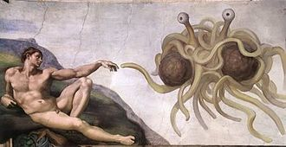
We talked briefly about a Royal Asiatic society trip some time ago along the Silk Road and John mentioned the Sogdians who featured in last month’s discussion (see page 6 above). An Lushan’s failed revolt against the Tang dynasty, which led to the Sogdians’ disappearance as a distinct ethnic group, is said to have caused the death of 36 million people, a total, which, if scaled up to allow for the difference in world population, would make it an even more destructive event than World War II. This claim is advanced by American psychologist Stephen Pinker in his celebrated book The Better Angels of Our Nature: a History of Violence and Humanity (p.235) but he acknowledges in a note that historians are divided on whether the figure in the old Chinese sources is credible. For an overview of Pinker’s thesis of a persistent trend towards a less violent world and the criticisms advanced against it see https://en.wikipedia.org/wiki/The_Better_Angels_of_Our_Nature

Zhang Wei mentioned the starkness of the gap between rich and poor in the Philippines and also that in Manila the rich were concentrated in the Makati district of Manila. This is also the city’s main financial district.

Don asked whether Nepal’s new prime minister, Khadga Prasad Sharma Oli, was the first communist to hold that post. He is in fact the fifth, since Man Mohan Adhikari and Madhav Kumar Nepal, both, like Oli, members of the Communist Party of Nepal (Unified Marxist-Leninist), led governments before the abolition of the monarchy and Maoists Pushpa Kamal Dahal (`Prachanda’) and Baburam Dahal did so afterwards. Oli’s UML is a more moderate grouping than the Unified Cmmunist Party of Nepal (Maoist) and has operated as a parliamentary party from the end of the palace-dominated`Panchayat’ system in 1990 whereas the Maoists pulled out of the system in 1994 and only returned after the 2006 agreement which formally ended their `People’s War.’ However, the UML is in part a continuation of the `Jhapeli group’ , including Oli himself, which staged an abortive revolt in 1970 and the Maoists, weakened by several splits, are part of the coalition government which Oli now leads. Also included in the coalition is Hindu traditionalist and erstwhile royalist National Democratic Party- Nepal and the Madhesi Janadhikar Forum (Democratic), one of the regionalist parties representing the people of the tarai. Protestors in this region against the new constitution are currently still blocking the transport of goods to the Kathmandu Valley with the undeclared backing of India.
APPENDIX: EXTRACT FROM FĀBULAE FACILĒS (WITH CORRECTIONS)

36. LAOMEDON AND THE SEA-MONSTER
Lāomedōn quīdam illō tempore rēgnum Trōiae obtinēbat. Ad hunc Neptūnus et Apollo annō superiōre vēnerant, et cum Trōia nōndum moenia habēret, ad hoc opus auxilium obtulerant. Postquam tamen hōrum auxiliō moenia cōnfecta sunt, nōlēbat Lāomedōn praemium quod prōposuerat persolvere. Neptūnus igitur et Apollo ob hanc causam īrātī mōnstrum quoddam mīsērunt speciē horribilī, quod cotīdie ē marī veniēbat et hominēs pecudēsque vorābat. Trōiānī autem timōre perterritī in urbe continēbantur, et pecora omnia ex agrīs intrā mūrōs compulerant. Lāomedōn hīs rēbus commōtus ōrāculum cōnsuluit, ac deus eī praecēpit ut fīliam Hēsiōnēn mōnstrō obiceret.

37. THE RESCUE OF HESIONE
Lāomedōn, cum hoc respōnsum renūntiātum esset, magnum dolōrem percēpit; sed tamen, ut cīvēs suōs tantō perīculō līberāret, ōrāculō pārēre constituit et diem sacrificiō dīxit. Sed sīve cāsū sīve cōnsiliō deōrum Herculēs tempore opportūnissimō Trōiam attigit; ipsō enim temporis pūnctō quō puella catēnīs vīncta ad lītus dēdūcēbātur ille nāvem appulit. Herculēs ē nāvī ēgressus dē rēbus quae gerēbantur certior factus est; tum īrā commōtus ad rēgem sē contulit et auxilium suum obtulit. Cum rēx libenter eī concessisset ut, sī posset, puellam līberāret, Herculēs mōnstrum interfēcit; et puellam, quae iam omnem spem salūtis dēposuerat, incolumem ad patrem redūxit. Lāomedōn magnō cum gaudiō fīliam suam accēpit,
et Herculī prō tantō beneficiō meritam grātiam rettulit.

38. 10th LABOR: THE OXEN OF GERYON
Tum vērō missus est Herculēs ad īnsulam Erythēam, ut bovēs Gēryōnis arcesseret. Rēs erat summae difficultātis, quod bovēs ā quōdam Eurytiōne et ā cane bicipite custōdiēbantur. Ipse autem Gēryon speciem horribilem praebēbat; tria enim corpora inter sē coniūncta habēbat. Herculēs tamen etsī intellegēbat quantum perīculum esset, negōtium suscēpit; ac postquam per multās terrās iter fēcit, ad eam partem Libyae pervēnit quae Eurōpae proxima est. Ibi in utrōque lītore fretī quod Eurōpam ā Libyā dīvidit columnās cōnstituit, quae posteā Herculis Columnae appellābantur.

39. THE GOLDEN SHIP
Dum hīc morātur, Herculēs magnum incommodum ex calōre sōlis accipiēbat; tandem igitur īrā commōtus arcum suum intendit et sōlem sagittīs petiit. Sōl tamen audāciam virī tantum admīrātus est ut lintrem auream eī dederit. Herculēs hoc dōnum libentissimē accēpit, nūllam enim nāvem in hīs regiōnibus invenīre potuerat. Tum lintrem dēdūxit, et ventum nactus idōneum post breve tempus ad īnsulam pervēnit. Ubi ex incolīs cognōvit quō in locō bovēs essent, in eam partem statim profectus est et ā rēge Gēryōne postulāvit ut bovēs sibi trāderentur. Cum tamen ille hoc facere nōllet, Herculēs et rēgem ipsum et Eurytiōnem, quī erat ingentī magnitūdine corporis, interfēcit.

40. A MIRACULOUS HAIL-STORM
Tum Herculēs bovēs per Hispāniam et Liguriam compellere cōnstituit; postquam igitur omnia parāta sunt, bovēs ex īnsulā ad continentem transportāvit. Ligurēs autem, gēns bellicōsissima, dum ille per fīnēs eōrum iter facit, magnās cōpiās coēgērunt atque eum longius prōgredī prohibēbant. Herculēs magnam difficultātem habēbat, barbarī enim in locīs superiōribus cōnstiterant et saxa tēlaque in eum coniciēbant. Ille quidem paene omnem spem salūtis dēposuerat, sed tempore opportūnissimō Iuppiter imbrem lapidum ingentium ē caelō dēmīsit. Hī tantā vī cecidērunt ut magnum numerum Ligurum occīderint; ipse tamen Herculēs (ut in tālibus rēbus accidere cōnsuēvit) nihil incommodī cēpit.

41. THE PASSAGE OF THE ALPS
Postquam Ligurēs hōc modō superātī sunt, Herculēs quam celerrimē prōgressus est et post paucōs diēs ad Alpēs pervēnit. Necesse erat hās transīre, ut in Ītaliam bovēs ageret; rēs tamen summae erat difficultātis. Hī enim montēs, quī ulteriōrem ā citeriōre Galliam dīvidunt, nive perennī sunt tectī; quam ob causam neque frūmentum neque pābulum in hīs regiōnibus invenīrī potest. Herculēs igitur antequam ascendere coepit, magnam cōpiam frūmentī et pābulī comparāvit et hōc commeātū bovēs onerāvit. Postquam in hīs rēbus trēs diēs cōnsūmpserat, quartō diē profectus est, et contrā omnium opīniōnem bovēs incolumēs in Ītaliam trādūxit.

42. CACUS STEALS THE OXEN
Brevī tempore ad flūmen Tiberim vēnit. Tum tamen nūlla erat urbs in eō locō, Rōma enim nōndum condita erat. Herculēs itinere fessus cōnstituit ibi paucōs diēs morārī, ut sē ex labōribus recreāret. Haud procul ā valle ubi bovēs pascēbantur spēlunca erat, in quā Cācus, horribile mōnstrum, tum habitābat. Hic speciem terribilem praebēbat, nōn modo quod ingentī magnitūdine corporis erat, sed quod ignem ex ōre exspīrābat. Cācus autem dē adventū Herculis fāmam accēperat; noctū igitur vēnit, et dum Herculēs dormit, quattuor pulcherrimōrum boüm abripuit. Hōs caudīs in spēluncam trāxit, nē Herculēs ē vestīgiīs cognōscere posset quō in locō cēlātī essent.
QUESTIONS ARISING FROM 60th MEETING – 20/11/15

As usual we spent some time discussing the terms for various dishes. Char siu (叉燒 - `fork roast’), Cantonese-style marinated and grilled pork, is porcīna (furculā) assa, while chicken with lemon should be (carō) gallīnācea cum citreō (John had originally suggested cum limōne but limō, limōnis f is actually lime. ). Another dish was broccoli (brassica Italica) with pomelo skin and, while skin or rind is obviously cutis, we were unsure about the name of the fruit itself. Native to southeast Asia and unknown in Europe in Roman time, it was probably introduced to Britan in the 17th century as its original Englsih name was shaddock, after the East India Company captain who took it to Jamaica in 1696 (see https://en.wikipedia.org/wiki/Pomelo ). Pat suggested pomelō, pomelōnis, which sounds properly classical, though an alternative would be the scientific name, citrus maxima. For `egg white’, classical Latin had both album ovī and albūmentum ovī. We finally mentioned collȳrā for noodles

Pat is planning to bring out a book next year on the magistrates of New Peace County (新安縣), the administrative region that once included both Hong Kong and present-day Shenzhen, focusing particularly on the 17th century. The county seat was Namtau (南頭), which is now a rather run-down district of Shenzhen. It was at one time an important centre for coastal defence and surrounded by strong walls, of which only a little remains. The old gate house is shown below and for more details see https://en.wikipedia.org/wiki/Nantou_Subdistrict

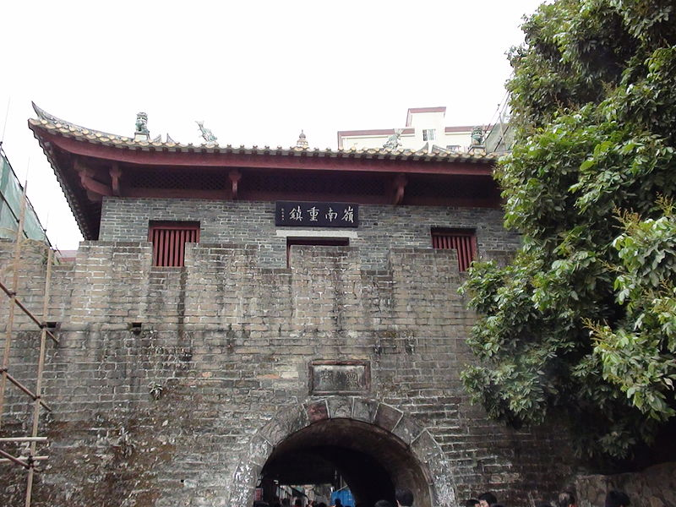
Most of the county was affected by the `Great Clearance’ of 1661-1691, when the Ching government ordered the evacuation of areas within 50 kilometres of the coast in order to deprive pirates and Ming loyalists (sometimes the categories overlapped) of resources. Southern China as a whole was also affected by the struggle by the Manchu Qing dynasty to impose its authority on the whole empire. Three Han Chinese generals, two of whom had served the Manchus since the 1630s and the third, Wu Sangui, switched sides after the peasant rebels seized Beijing, put down Ming resistance in the region and became virtual rulers of the south, earning the title `the Three Feudatories’in Western historiography. In 1673 Wu and the sons of his two colleagues rebelled against the Qing, one of the sons, who controlled Guangdong, imprisoning his ailing father, who wanted to remain loyal to the Beijing government. The rebellion was suppressed only with great difficulty in fighting which continued until 1681.During all these disturbances the town of Namtau itself was besieged five or six times and the population of the county declined from 33, 000 to 7,000.

Even before their invasion of China. The Manchus had been to some extent Sinified and the process accelerated once they estavblished control. They did also maintaion their own tungusic language but after the fall of the dynasty in 1911 numbers of speakers dropped drastically and Tony believes only a handful still speak Manchu.

We touched briefly on an earlier invasion of China, that of the Mongols in the 13th century which caused very heavy casualties, the Wikipaedia article (https://en.wikipedia.org/wiki/Mongol_invasion_of_China) putting the losses suffered by the Song and their civilian population at 10 million. Tony later supplied a link on the Mongols’ invasion of Persia (https://www.quora.com/What-do-Iranian-people-think-about-Mongols-who-killed-90-of-their-population-in-history),
which suggested the total population may have been reduced from 2,500.000 to 250,000. However, as was pointed out in the previous meeting’s discussion of the An Lushan revolt.tt is necessary to remember that such estimates are not always reliable.

John was also planning a publication for 2016 but this would be simply a revised edition of his 1983 book, Jang Bahadur in Europe: the First Nepalese Mission to the West. Jang Bahadur Kunwar Rana, was appointed prime minister of Nepal in 1846 after the killing of many of his rivals, and his family were hereditary prime ministers of the country up to 1951 with a similar relationship to the Shah kings as that of the shoguns to the pre-Meiji emperors of Japan. Jang’s visit to London and Paris in 1850 caught the popular imagination and the book combines a translation and commentary on the account written in Nepali by one of his colleagues with extracts from contemporary British and French newspaper reports. Some information on the visit is available on the Internet at http://linguae.weebly.com/nepali.html (near the bottom of the page) and a portrait of Jang painted during his visit, which for many years hung above the desk of the British Foreign Secretary and is now in the reading room of the India Office Records section of the British Library, is shown below:
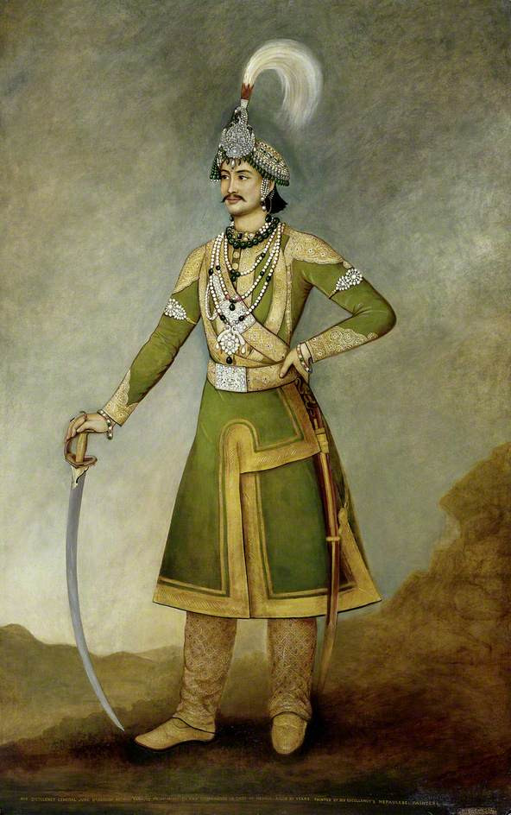
We read a transcript of the first of a series of language proficiency interviews conducted by the late Professor David Morgan with Latin students at various levels. David Morgan, a gifted and highly popular academic originally worked as a lawyer but switched fields to teach French language and literature at Furman University in South Carolina whilst concentrating mianly on neo-Latin literature as his field of research. The neo-Latin wordlist he compiled, intended as preliminary work for a full dictionary (https://archive.org/details/TheLexiconAnglumEtLatinumByDavidMorgan), is the best resource available on the web for those wanting to use the language to communicate about modern as well as ancient subjects.

The conversation with `Christophorus’, a beginner, includes the term castra aestīva for summer camp, āeronāvis (which would more commonly be understood as airship) for aeroplane, and hebdomada for week, for which John prefers the probably less common septimāna because of its similarity to derivatives in the Romance languages. The transcript (which includes a couple of places where the words are not clear) is on-line together with a link to the video at the bottom of http://linguae.weebly.com/in-conclavi-scholari.html

We also read chapters 43-48 of Fābulae Facilēs, covering Hercules’ recovery of the cattle stolen by Cacus and his gaining possession of the golden apples of the Hesperides. Ritchie’s text makes these women the daughters of the giant Atlas but therir father is more commonly thought to have been Hersperus, the evening stat and brother of Atlas. We wondere whether the the name Hesperides (which also referre to a group of islands in the Atlantic) ) was connected with Hebrides, the modern name for the islands off the west coast of Scotland. The answer is probably not as the earliest recorded name for the latter is Ebudes (in Pliny the Elder’s encylopaedia compiled in the 1st century A.D.) and this is thought to be Celtic, perhaps the name of a tribe with the roots epos (horse) in it (see . https://en.wikipedia.org/wiki/Hebrides#Etymology) By the 3rd century the Latin name had become Hebudes and the modern `Hebrides’ may simply have resulted from a printing error!

The word used in Ritchie for apple is pōmum, which in fact can apply to any type of fruit or nut. The commonest Latin word for apple was mālum, which also applied to any fleshy fruit with a kernel. The word pīrum refe rs specifically to the pear. Mālum and malum (`evil’) are among several pairs of words distinguished only by vowel length and they are included in a famous pair of contrasting sentences:

Meā, uxor, sūs māla ēst (Move, wife, the pig is eating the apples)
Mea uxor sūs mala est (My wife is an evil pig)

The verb haereō, meaning `stick’, `stick to one’s position’, is used in the extract to describe the initial reluctance of the Hesperides to surrender the apples and Don pointed out that haesitō (`hesitate’) is the frequentative of this verb. Frequentatives are first conjugation verbs formed by the addition of –(i)t- to a simple verb stem and in principle denoting repeated or regular action. In practice the pairs of verbs thus generated may be used simply as synonyms (e.g. canō v. cantō, both meaning `sing’) or develop different senses (e.g. habeō (`have’) v. habitō (`live in’, `have as one’s home’), or saliō (`leap’) v. saltō (`dance)’

We discussed briefly the origin of the word `chop’ (seal, impression made by a seal, 印章), which was discovered later to be from the Hindi chaap (छाप) meaning `print’ or `impression’. Pidgin English chop-chop (quickly, get a move on!) is probably from the Cantonese 急 (`urgent’). We also noted the forms of the `defective’ noun vīs, which in the singular is normally found only in the nominative, accusative (vim) and ablative (vī). The plural vīrēs, with forms for all cases, means `strength.’ The older among us could remember the use of `Vim’ as the name for a brand of scouring power in the U.K.

Finally, it was suggested that the Spanish patio derives from patet (`lies open’). Etymonline (www.etymonline,com) admits this as a possibility but thinks it is more likely connected with an old Provence word pati, meaning `communal pasture’, derived from Latin pactum (agreement).

After some members had left, there was mention of Tanya’s friend Michael Dunn, who has done research on the endangered Chukchi language of Siberia. He is also a historical linguist who is among those using Bayesian mathematical methods to model the evolution of language families and estimate the time at which the common ancestor was spoken. He and his colleagues have recently published an article claiming to establish that proto-IE originated in Anatolia around 8,000 years ago rather than 5 or 6,000 years ago on the Pontic steppes. See Remco Bouckaert et al. Science 2012;337:957-960, http://www.sciencemag.org/content/337/6097/957.full. The methodology is, however, highly controversial and a no-holds-barred attack on it by Roher Blench can be downloaded from the `Indo-European’ section of http://linguae.weebly.com

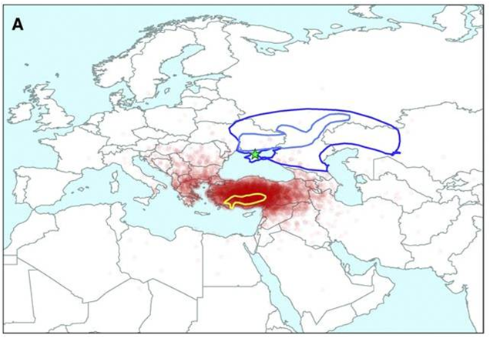
Map illustrating the rival theories of the location of the Indo-European homeland (Remco Bouckaert et al.)
APPENDIX: EXTRACT FROM FĀBULAE FACILĒS (WITH CORRECTIONS)

43. HERCULES DISCOVERS THE THEFT
Posterō diē simul atque ē somnō excitātus est, Herculēs furtum animadvertit et bovēs āmissōs omnibus locīs quaerēbat. Hōs tamen nūsquam reperīre poterat, nōn modo quod locī nātūram ignorābat, sed quod vestīgiīs falsīs deceptus est. Tandem cum magnam partem diēī frūstrā cōnsūmpsisset, cum reliquīs bōbus prōgredī cōnstituit. At dum proficīscī parat, ūnus ē bōbus quōs sēcum habuit mūgīre coepit. Subitō eī quī in spēluncā inclusī erant mugītum reddidērunt, et hōc modō Herculem certiōrem fēcerunt quō in locō cēlātī essent. Ille vehementer īrātus ad spēluncam quam celerrimē sē contulit, ut praedam reciperet. At Cācus saxum ingēns ita
dēiēcerat ut aditus spēluncae omnīnō obstruerētur.

44. HERCULES AND CACUS
Herculēs cum nūllum alium introitum reperīre posset, hoc saxum āmovēre cōnātus est, sed propter eius magnitūdinem rēs erat difficillima. Diū frūstrā lābōrābat neque quicquam efficere poterat; tandem tamen magnō cōnātū saxum āmōvit et spēluncam patefēcit. Ibi āmissōs bovēs magnō cum gaudiō cōnspexit; sed Cācum ipsum vix cernere potuit, quod spēlunca replēta erat fūmō quem ille mōre suō ēvomēbat. Herculēs inūsitātā speciē turbātus breve tempus haesitābat; mox tamen in spēluncam irrūpit et collum mōnstrī bracchiīs complexus est. Ille etsī multum repugnāvit, nūllō modō sē līberāre potuit, et cum nūlla facultās respīrandī darētur, mox exanimātus est.

45. 11th LABOR: GOLDEN APPLES OF THE HESPERIDES
Eurystheus postquam bovēs Gēryōnis accēpit, lābōrem ūndecimum Herculī imposuit, graviōrem quam quōs suprā nārrāvimus. Mandāvit enim eī ut aurea pōma ex hortō Hesperidum auferret. Hesperidēs autem nymphae erant quaedam fōrmā praestantissimā, quae in terrā longinquā habitābant, et quibus aurea quaedam pōma ā Iūnōne commissa erant. Multī hominēs, aurī cupiditāte inductī, haec pōma auferre iam anteā cōnātī erant. Rēs tamen difficillima erat, namque hortus in quō pōma erant mūrō ingentī undique circumdatus erat; praetereā dracō quīdam cui centum erant capita portam hortī dīligenter custōdiēbat. Opus igitur quod Eurystheus Herculī imperāverat erat summae difficultātis, nōn modo ob causās quās memorāvimus, sed etiam quod Herculēs omnīnō ignorābat quō in locō hortus ille situs esset.

46. HERCULES ASKS AID OF ATLAS
Herculēs, quamquam quiētem vehementer cupiēbat, tamen Eurystheō pārēre cōnstituit, et simul ac iussa eius accēpit, proficīscī mātūrāvit. Ā multīs mercātōribus quaesīverat quō in locō Hesperidēs habitārent, nihil tamen certum reperīre potuerat. Frūstrā per multās terrās iter fēcit et multa perīcula subiit; tandem, cum in hīs itineribus tōtum annum cōnsūmpsisset, ad extrēmam partem orbis terrārum, quae proxima est Ōceanō, pervēnit. Hīc stābat vir quīdam, nōmine Ātlās, ingentī magnitūdine corporis, quī caelum (ita trāditum est) umerīs suīs sustinēbat, nē in terram dēcideret. Herculēs tantās vīrēs magnopere mirātus statim in colloquium cum Atlante vēnit, et cum causam itineris docuisset, auxilium ab eō petiit.

47. HERCULES BEARS UP THE HEAVENS
Atlās autem Herculī maximē prōdesse potuit; ille enim cum ipse esset pater Hesperidum, certō scīvit quō in locō esset hortus. Postquam igitur audīvit quam ob causam Herculēs vēnisset, "Ipse," inquit, "ad hortum ībō et fīliābus meīs persuādēbō ut pōma suā sponte trādant." Herculēs cum haec audīret, magnopere gāvīsus est; vim enim adhibēre nōluit, sī rēs aliter fierī posset. Cōnstituit igitur oblātum auxilium accipere. Atlās tamen postulāvit ut, dum ipse abesset, Herculēs caelum umerīs sustinēret. Hoc autem negōtium Herculēs libenter suscēpit, et quamquam rēs erat summī lābōris, tōtum pondus caelī continuōs complūrēs diēs sōlus sustinēbat.

48. THE RETURN OF ATLAS
Ātlās intereā abierat et ad hortum Hesperidum, quī pauca mīlia passuum aberat, sē quam celerrimē contulerat. Eō cum vēnisset, causam veniendī exposuit et fīliās suās vehementer hortātus est ut pōma trāderent. Illae diū haerēbant; nōlēbant enim hoc facere, quod ab ipsā Iūnōne (ita ut ante dictum est) hoc mūnus accēpissent. Ātlās tamen aliquando eīs persuāsit ut sibi pārērent, et pōma ad Herculem rettulit. Herculēs intereā cum plūrēs diēs exspectāvisset neque ūllam fāmam dē reditū Ātlantis accēpisset, hāc morā graviter commōtus est. Tandem quīntō diē Atlantem vīdit redeuntem, et mox magnō cum gaudiō pōma accēpit; tum, postquam grātiās prō tantō beneficiō ēgit, ad Graeciam proficīscī mātūrāvit.

QUESTIONS ARISING FROM 61st MEETING – 18/12/2015

Food consumed included pānis tenuis (papadom) orȳza (rice), gallīnācea cum iūre ācrī (chicken curry) and iūs ē lentibus (daal). We noted that the Latin for Bon appétit! Is bene sapiat! from sapiō, sapere, sapīvī/sapiī/sapuī (taste (of)).

Kelvin had just finished taking his exams (probātiōnēs suscipere), whilst Tan was gallantly attending the gathering despite suffering from a cold (gravēdīne labōrāre). Chris, rivaling Aeneas in pietās and without fear of jetlag (ietlagia, or, for purists, dēbilitās pyraulicinētica), had just got back from a weekend trip to South Africa where his father had been celebrating his 64th. birthday. This anniversary was of particular significance because his father was an enthusiastic fan of the Beatles and their famous line `Will you still love me when I’m 64?’

There was a brief discussion of the phrase nōs moritūrī tē salūtāmus (We who are about to die salute you!), which was probably NOT regularly said by gladiators before they started to fight. A statement of this kind is mentioned just once in Latin literature, the historian Suetonius recording how on onr occasion condemned criminals, ordered to fight in a mock naval battle (naumāchia), addressed the emperor Claudius with the words `Ave imperātor, moritūrī tē salūtant’ to which he replied `Aut nōn’ (or not). Taking this as a reprieve, the men initially refused to fight until prevailed on by a mixture of threats and promises. There is nothing in this account to suggest that the words were a standard formula (see the full discussion at https://en.wikipedia.org/wiki/Ave_Imperator,_morituri_te_salutant )

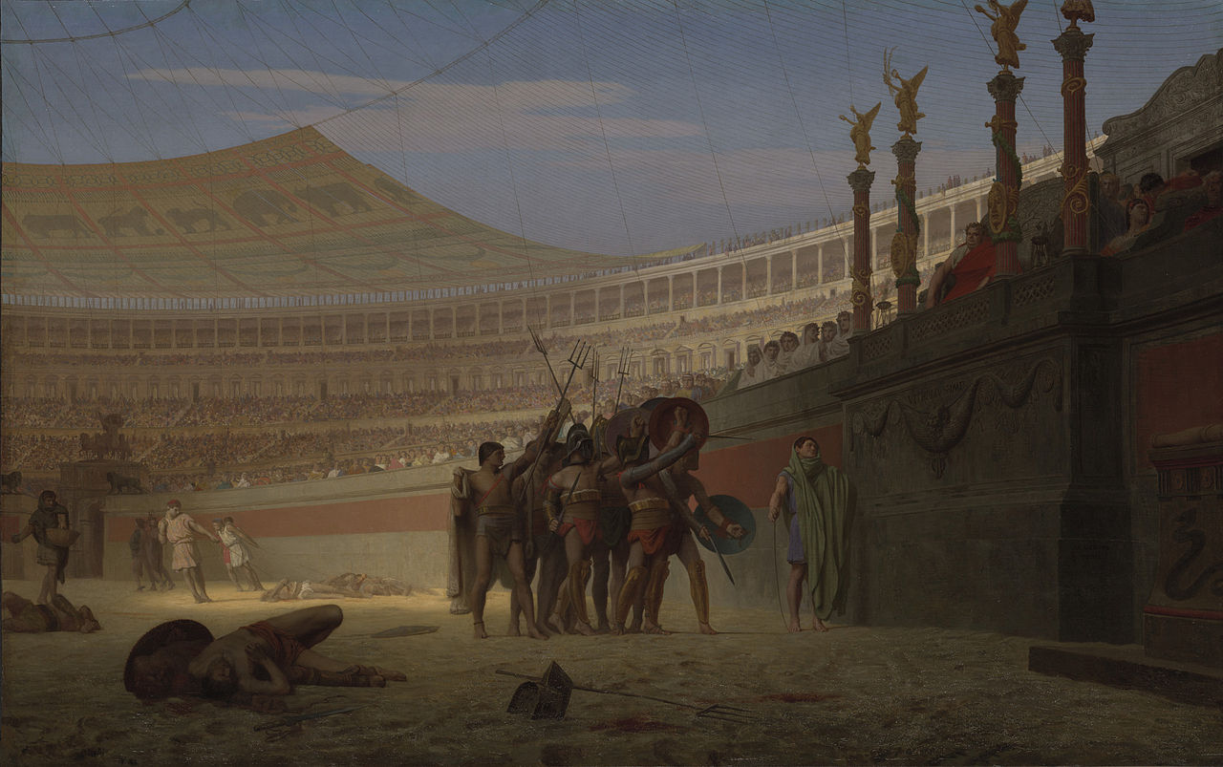
`Ave Caesar Morituri te Salutant’ by Jean-Léon Gérôme (1859), depicting gladiators greeting Vitellius

In honour of the medical student amongst us we pondered how to say in Latin `We who are about to kill our patients’ and hit upon either nōs aegrōs interfectūrī or nōs sānāndōs necātūrī.

Chris mentioned the various versions of simple songs dressed up in Latinate verbiage, such as `Three Sightless Rodents’:

Three sightless rodents, three sightless rodents,
Observe how they navigate, observe how they navigate.
They all pursued the agriculturalist's spouse,
Who severed their posterior appendages with a culinary object.
Have you ever observed such a phenomenon in your existence
As three sightless rodents.

John explained that there some eccentrics cultivated `Anglish’, a version of the English language as it might have been if the habit of importing Latin and French words instead ofcompounding native roots had not started after the Norman Conquest. Their efforts can be viewed at http://anglish.wikia.com/wiki/Main_leaf. John also told his old story about a 19th century professor who hated the Romance element in English so much that he always referred to the `unthoroughfaresomenesss of stuff’ instead of `the impenetrability of matter.’ It was eventually pointed out to him that `stuff’, although seeming Germanic enough, was actually derived from the Romance root stoppa (material, furniture) whereupon he promptly had a heart-attack and yielded up his spirit to the old Teutonic gods. In fact the ultimate origins of the word are obscure, one theory being that the stoppa itself came from the Old High Germanic stopfôn, though that in turn derived from Latin stuppāre (to plug up). The Oxford English Dictionary mentions this explanation but is skeptical about it as it would be unusual for a German loanword to spread into all the Romance languages and the presumed shift in meaning would be a drastic one.

Still on the Teutonic front, Chris mentioned the well-known German spring song Alle Vögel sind schon da, which
invokes different species of bird to bless the year, but quoted a parody version with the line `Amsel, Drossel, Fink und Meise scheißen auf die Bahnhofsgleise` (`Blackbird, thrush, finch and titmouse shit on the station tracks’) - Merula, turdus, fringila et parus orbitas ferroviāriās cacant

We read chapters 49-53 of Fābulae Facilēs (see below), in which Hercules completes the last of his Twelve Labours and returns to his native Thebes. This includes a reference toTartarus, the place of punishment for the wicked. John mentioned three of its best-known occupants – Tantalus, forever reaching out for grapes and water which receded from him, Ixion on his wheel and Sisyphus perpetually rolling his stone to the top of a hill. Illustrations are provided in the Powerpoint for Orpheus and Eurydice that can be downloaded from http://linguae.weebly.com/latin--greek.html (search on the page for orpheus_et_eurydice).

Finally, we looked at the plainchant setting of Rudolph the Rednosed Reindeer, of which Chris gave a very creditable rendition. The text of this and other Christmas songs are given below and you can also listen to a performance on You-Tube (TūTubulum) see https://www.youtube.com/watch?v=BwkH1SAwphY.

APPENDIX I: EXTRACT FROM FĀBULAE FACILĒS (WITH CORRECTIONS)

49. 12th LABOR: CERBERUS THE THREE-HEADED DOG
Postquam aurea pōma ad Eurystheum relāta sunt, ūnus modō relinquēbātur ē duodecim lābōribus quōs Pythia Herculī praecēperat. Eurystheus autem cum Herculem magnopere timēret, eum in aliquem locum mittere volēbat unde numquam redīre posset. Negōtium igitur eī dedit ut canem Cerberum ex Orcō in lūcem traheret. Hoc opus omnium difficillimum erat, nēmō enim umquam ex Orcō redierat. Praetereā Cerberus iste mōnstrum erat horribilī speciē, cui tria erant capita serpentibus saevīs cīncta. Antequam tamen dē hōc lābōre nārrāmus, non aliēnum vidētur, quoniam dē Orcō mentiōnem fēcimus, pauca dē eā regiōne prōpōnere.

50. CHARON'S FERRY
Dē Orcō, quī īdem Hādēs appellābātur, haec trāduntur. Ut quisque dē vītā dēcesserat, mānēs eius ad Orcum, sēdem mortuōrum, ā deō Mercuriō dēdūcēbantur. Huius regiōnis, quae sub terrā fuisse dīcitur, rēx erat Plūtō, cui uxor erat Prōserpina, Iovis et Cereris fīlia. Mānēs igitur ā Mercuriō dēductī prīmum ad rīpam veniēbant Stygis flūminis, quō rēgnum Plūtōnis continētur. Hoc trānsīre necesse erat antequam in Orcum venīre possent. Cum tamen in hōc flūmine nūllus pōns factus esset, mānēs trānsvehēbantur ā Charonte quōdam, quī cum parvā scaphā ad rīpam exspectābat. Charōn prō hōc officiō mercēdem postulābat, neque quemquam, nisi hoc praemium prius dedisset, trānsvehere volēbat. Quam ob causam mōs erat apud antiquōs nummum in ōre mortuī pōnere eō cōnsiliō, ut, cum ad Stygem vēnisset, pretium trāiēctūs solvere posset. Eī autem quī post mortem in terrā nōn sepultī erant Stygem trānsīre nōn potuērunt, sed in rīpā per centum annōs errāre coāctī sunt; tum dēmum Orcum intrāre licēbat.

51. THE REALM OF PLUTO
Ut autem mānēs Stygem hōc modō trānsierant, ad alterum veniēbant flūmen, quod Lēthē appellābātur. Ex hōc flūmine aquam bibere cōgēbantur; quod cum fēcissent, rēs omnēs in vītā gestās ē memoriā dēponēbant. Dēnīque ad sēdem ipsīus Plūtōnis veniēbant, cuius introitus ā cane Cerberō custōdiēbātur. Ibi Plūtō nigrō vestītū indūtus cum uxōre Prōserpinā in soliō sēdēbat. Stābant etiam nōn procul ab eō locō tria alia solia, in quibus sēdēbant Mīnōs, Rhadamanthus, Aeacusque, iūdicēs apud īnferōs. Hī mortuīs iūs dīcēbant et praemia poenāsque cōnstituēbant. Bonī enim in Campōs Elysiōs, sēdem beātōrum, veniēbant; improbī autem in Tartarum mittēbantur ac multīs et variīs suppliciīs ibi excruciābantur.

52. HERCULES CROSSES THE STYX
Herculēs postquam imperia Eurystheī accēpit, in Lacōniam ad Taenarum statim sē contulit; ibi enim spēlunca erat ingentī magnitūdine, per quam, ut trādēbātur, hominēs ad Orcum dēscendēbant. Eō cum vēnisset, ex incolīs quaesīvit quō in loco spēlunca illa sita esset; quod cum cognōvisset, sine morā dēscendere cōnstituit. Nec tamen sōlus hoc iter faciēbat, Mercurius enim et Minerva sē eī sociōs adiūnxerant. Ubi ad rīpam Stygis vēnit, Herculēs scapham Charontis cōnscendit, ut ad ulteriōrem rīpam trānsīret. Cum tamen Herculēs vir esset ingentī magnitūdine corporis, Charōn solvere nōlēbat; magnopere enim verēbātur nē scapha sua tantō pondere onerāta in mediō flūmine mergerētur. Tandem tamen, minīs Herculis territus, Charōn scapham solvit, et eum incolumem ad ulteriōrem rīpam perdūxit.

53. THE LAST LABOR IS ACCOMPLISHED
Postquam flūmen Stygem hōc modō trānsiit, Herculēs in sēdem ipsīus Plūtōnis vēnit; et postquam causam veniendī docuit, ab eō petīvit ut Cerberum auferre sibi licēret. Plūtō, quī dē Hercule fāmam accēperat, eum benignē excēpit, et facultātem quam ille petēbat libenter dedit. Postulāvit tamen ut Herculēs ipse, cum imperāta Eurystheī fēcisset, Cerberum in Orcum rūrsus redūceret. Herculēs hoc pollicitus est, et Cerberum, quem nōn sine magnō perīculō manibus prehenderat, summō cum lābōre ex Orcō in lūcem et ad urbem Eurystheī trāxit. Eō cum vēnisset, tantus timor animum Eurystheī occupāvit ut ex ātriō statim refūgerit; cum autem paulum sē ex timōre recēpisset, multīs cum lacrimīs obsecrāvit Herculem ut mōnstrum sine morā in Orcum redūceret. Sīc contrā omnium opīniōnem duodecim illī lābōrēs quōs Pythia praecēperat intrā duodecim annōs confectī sunt; quae cum ita essent, Herculēs servitūte tandem līberātus magnō cum gaudiō
Thēbās rediit.

APPENDIX II: CARMINA FESTĪVA

http://gaudium-mundo.blogspot.hk/2005/12/reno-erat-rudolphus-plain-chant-version.html
Text with long vowels marked according to Restored (i.e. classical) Pronunciation. `Videās’ (`you were to see’ has been substituted for the ungrammatical `vidēbat’ (`he/she was seeing’) in the version given with the music.
Rēnō erat Rudolphus. Nāsum rubrum habēbat Sī quandō videās, hunc candēre tū dīcās. Omnēs tarandrī aliī semper hunc dērīdēbant; cum miserō Rudolphō in lūdīs nōn lūdēbant. Sanctus Nicholas dīxit nocte nebulae: `Ō Rudolphe, nocte hāc vīsne traham dūcere?’ Tum rēnōnēs clāmābant, `Rudolphe, dēlectus es? Cum nāsō rubrō clārō nōtus eris posterīs.’ Alleluia
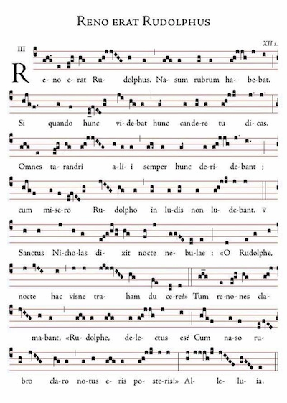
Adeste, fideles, laeti triumphantes; Be present, faithful-ones, joyful triumphant
Venite, venite in Bethlehem; Come, come, into Bethlehem
Natum videte Regem angelorum. Born see King of angels
Venite adoremus. Come, let-us-adore
Venite adoremus. Come let-us-adore
Venite adoremus Dominum. Come let-us-adore the-Lord
En grege relicto, humiles ad cunas See with-flock abandoned humble to cradle
vocati pastores adproperant: called shepherds hasten
et nos ovanti gradu festinemus. and we with-rejoicing step let-us-make-haste
Venite adoremus.
Venite adoremus.
Venite adoremus Dominum.
Adeste, fideles, laeti triumphantes;
Venite, venite in Bethlehem;
Natum videte Regem angelorum.
Venite adoremus.
Venite adoremus.
Venite adoremus Dominum.

Veni, veni Emmanuel! Come, come Emanuel
Captivum solve Israel, Captive set-free Israel
qui gemit in exsilio, who groans in exile
privatus Dei Filio. deprived-of God’s Son
CHORUS
Gaude, gaude; Emmanuel Rejoice, rejoice, Emmanuel
nascetur pro te, Israel. will-be-born for you, Israel
Veni, O Jesse virgula! Come, O Jesse's branch
Ex hostis tuos ungula, out-of enemy’s claw your-people *
de specu tuos tartari from cave of-hell your-people *
educ et antro barathri. lead-out and from-cavern of-abyss
CHORUS
Veni, veni O Oriens! Come, come O Rising-one
Solare nos adveniens, Comfort us arriving
noctis depelle nebulas night’s clouds drive-off *
dirasque noctis tenebras. and-terrible of-night darkness
CHORUS
Veni, Clavis Davidica! Come, Key of David
Regna reclude caelica! Kingdoms unlock heavenly
Fac iter tutum superum Make journey safe to-heaven
et claude vias inferum. And close ways to-hell
CHORUS
Veni, veni Adonai! Come, come Adonaus
Qui populo in Sinai Who to-people in Sinai
legem dedisti vertice, law gave from-on-high
in Maiestate gloriae. in majesty of-glory
CHORUS

Ecce versiō altera carminis de Rudolphō illo quod Latinsta quīdam sodālibus Gregis Latīnē Loquentium ostendit:

Rudolfō rennō rubrināsō
Erant nārēs nitidissimae
Quās sī quandō conspicerēs
Dīcerēs exsplendēscere.
Omnēs rennī rīsu cēterī
Cum eō cavillārī solēbant,
Neque umquam miserum Rudolfum
Sīvērunt lūdīs suīs lascīvīre
Tum quādam nebulōsā vesperā
Sanctus advēnit eī dictātum:
Rudolfe nāsō splendidō,
Quīn hāc nocte traham duceres?
Tunc ita rennī eum dīlēxērunt
ut laetī omnēs exclāmārint:
Rudolfe renne rubrināse,
Memorāberis in tabulīs

VOCABULARY NOTES
rennus, -ī m seems to be a recent coinage for `reindeer’. The usual Latin equivalents are tarandrus, -ī m (used by Pliny the Elder) and rēnō, rēnōnis m (in Caesar), though the latter probably only meant reindeer skin (as a garment) in classical Latin. The scientific name for the species is Rangifer tarandrus and rangifer, -ferī m is found in 16th century Latin as is cervus iugālis

exclāmārint is a contraction of the perfect subjunctive exclāmāverint

The plainchant version of `Rudolph the Red-nosed Reindeer’ can also be heard (with the Latin text as subtitles) on YouTube: https://www.youtube.com/watch?v=BwkH1SAwphY
QUESTIONS ARISING FROM 62nd. MEETING – 29/1/16

We discussed as usual the names for various items on the table. Pea shoots should probably be virgae pīsorum while for, bean curd (豆腐) we had previously come up with cāseus ē fabīs cōnfectus (`cheese made from beans’), cāseus fabārum or daufum, -ī . It was pointed out that cheese, unlike bean-curd, was produced by a process involving fermentation and so probably the straightforward transliteration of the Cantonese pronunciation, daufum, is best. One member suggested lacertae (lizards) for thin strips of fish in batter but the more prosaic laciniae piscium should probably be adopted. There seems to be no Latin word for batter as Smith-Hall just offers a definition: farīna lacte, ōvīs aliīsque rēbus commixta. We should perhaps coin a noun batterium and verb batterō,

One of us had to avoid anything containing gluten, for which the Morgan-Owens lexicon suggests either glūten, -inis n or the less common variant glūtinum, -ī n, both of which also mean glue. Circulus practice, perhaps rather confusingly has been to use glūten exclusively for glue, and glūtinum exclusively for gluten.

We also had jellyfish (海蜇) strips, which, as we noted in the November 2014 meeting, John’s daughter has always called `rubber bands’ (limbi cummeī , from limbus (-ī m), `belt’, `band’, `girdle’, and cummeus, -a, -um `gummy, connected with gum’). In 2014 we settled on urtīca marīna, literally `sea nettle’, found in Pliny the Elder and other authors and paralleling the modern English name `Pacific sea nettle’ for the species Chrysaora fuscescens shown in the picture below. However, both Smith-Hall and the Pocket Oxford dictionary translate jellyfish as pulmō, pulmōnis m or halipleumōn, halipleumonis m This animal is also referred to by Pliny and translated into the obsolete English word `sea-lungs’, used both as a singular and a plural. This marine animal is now referred to as a `comb-jelly’ and belongs

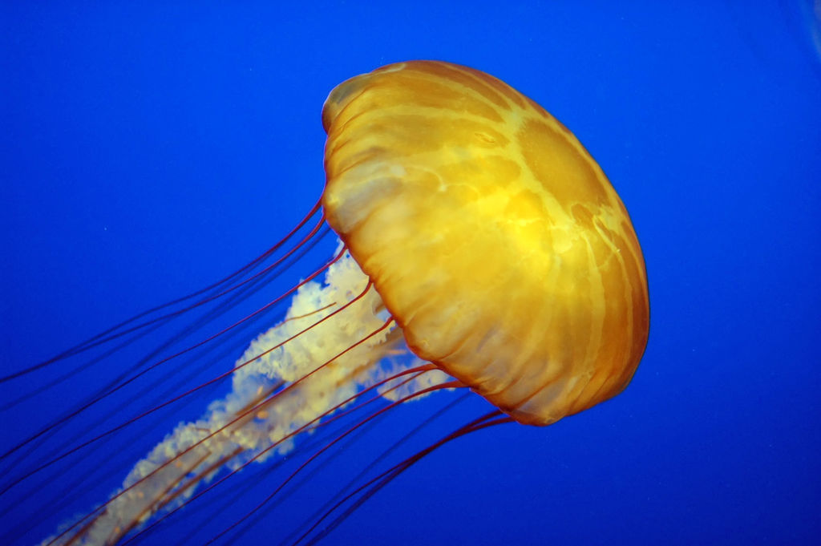
to the phylum Ctenophora as opposed to jellyfish proper which are members of the phylum Cnidaria (see http://the-earth-story.com/post/105339905127/ctenophora-took-the-road-less-traveled-there-are and the picture below) The Greek word for sea-lungs/comb-jelly, halipleumon was used by the 4th century B.C.Greek explorer Pytheas of Massilia (Marseilles) to convey the appearance of the mixture of air and sea which he claimed was found in northern waters – perhaps a reference to the mixture of water, slush and ice, often covered in fog, at the edge of expanses of drift ice (see https://en.wikipedia.org/wiki/Pytheas)

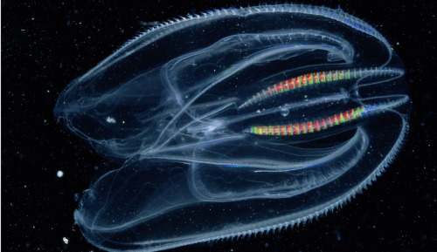
John was eating in a Chinese restaurant for the second time that day, having attended a Departmental Reunion Dinner (團年飯) to mark the end of the Chinese Year. The Latin phrase for this should probably be Cēna Annua Readūnātiōnis (the last word is not classical but used by the Christian writer Tertullian of reunion after the resurrection).

Mention was made of evidence for the presence of a Jewish community in the Northern Song dynasty capital of Kaifeng, which still survives today (see https://en.wikipedia.org/wiki/Kaifeng_Jews). There is considerable doubt, however, about the belief amongst Southern Indian Christians that the apostle Thomas reached the west coast of India and even more so about the story that he then went on to China and Japan (see http://www.newworldencyclopedia.org/entry/Saint_Thomas_(the_Apostle))

There was brief discussion of the vocabularies of different languages and John mentioned the claim that there were 40,000 characters in the largest of the Qing dynasties. Zhang Wei, whose wife has been for many years involved in the computer coding of all characters, thought the total was higher. He also mentioned the recent completion of a 4-volume Chinese-English dictionary and the recent 100th anniversary of a famous Chinese-Japanese dictionary.

We read the final chapters of the story of Hercules from Fābulae Facilēs (see annex), leading on to speculation about a possible connection between Nessus, the centaur who tried to abduct Hercules’s wife Deianira, and the Loch Ness Monster, but this was thought very unlikely. The Scottish ness may be the Gaelic nis (`now)’ or, less likely, from old Norse or Anglo-Saxon words for a headland (see http://www.nessriver.co.uk/pages/nessriver/nessName.html). Don pointed out that in the myth as re-told by Steadman the shirt which Deianira sent to her hisband was supposed to be white, in which case its dipping in blood would have been obvious. We wondered whether centaurs’ blood was not actually red! We also noted the expression `the shirt of Nessus’, referring to a situation from which there is no escape.

On the general theme of monsters, Tanya mentioned a Filipino one which supposedly stuck its tongue down chimneys to such embryos from their mothers’ wombs. This led on to mention of the recent claim that many traditional fairy tales go back much further than previously supposed (see http://www.telegraph.co.uk/news/science/science-news/6142964/Fairy-tales-have-ancient-origin.html )

We also read the first three chapters in Steadman’s other reader, Fābulae ab Urbe Condita, which retells the legends concerning early Roman history (also in the annex). These extracts included the story of the abandonment of Romulus and Remus as babies on the river bank and Don pointed out that the word river itself derives from rīpa (bank). Tanya mentioned the Australian term rip for a dangerous current in the sea that swimmers had to avoid. John thought that the Latin word aggredior, though the origin of our word aggression, meant attack in the purely tactical sense, with no implication of who was in the wrong. Also noted was the etymological connection between pyra (funeral pyre) and the word fire itself. Zhang Wei drew attention to Steadman’s note pointing out that praeda (normally translated `booty’) could also mean specifically `cattle’ and this would what the farmers under Romulus and Remus recovered from the robbers (latrōnēs)..
ANNEX

FĀBULAE FACILĒS 54-56

54. THE CENTAUR NESSUS
Posteā Herculēs multa alia praeclāra perfēcit, quae nunc perscrībere longum est. Tandem iam aetāte prōvectus Dēianīram, Oeneī fīliam, in mātrimōnium dūxit; post tamen trēs annōs accidit
ut puerum quendam, cui nōmen erat Eunomus, cāsū occīderit. Cum autem mōs esset, ut sī quis hominem cāsū occīdisset, in exsilium īret, Herculēs cum uxōre suā ē fīnibus eius cīvitātis exīre mātūrāvit. Dum tamen iter faciunt, ad flūmen quoddam pervēnērunt in quō nūllus pōns erat; et dum quaerunt quōnam modō flūmen trānseant, accurrit centaurus Nessus, quī viātōribus auxilium obtulit. Herculēs igitur uxōrem suam in tergum Nessī imposuit; tum ipse flūmen trānāvit. Nessus autem paulum in aquam prōgressus ad rīpam subitō revertēbātur et Dēianīram auferre cōnābātur. Quod cum animadvertisset Herculēs, īrā graviter commōtus arcum intendit et pectus Nessī sagittā trānsfīxit.
.
55. THE POISONED ROBE
Nessus igitur sagittā Herculis trānsfīxus moriēns humī iacēbat; at nē occāsiōnem suī ulcīscendī dīmitteret, ita locūtus est: “Tū, Dēianīra, verba morientis audī. Sī amōrem marītī tuī cōnservāre
vīs, hunc sanguinem, quī nunc ē pectore meō effunditur, sume ac repōne; tum, sī umquam in suspiciōnem tibi vēnerit, vestem marītī hōc sanguine inficiēs.” Haec locūtus, Nessus animam efflāvit; Dēianīra autem nihil malī suspicāta imperāta fēcit. Paulō post Herculēs bellum contrā Eurytum, rēgem Oechaliae, suscēpit; et cum rēgem ipsum cum fīliīs interfēcisset, Iolēn eius fīliam captīvam sēcum redūxit. Antequam tamen domum vēnit, nāvem ad Cēnaeum promuntūrium appulit, et in terram ēgressus āram cōnstituit, ut Iovī sacrificāret. Dum tamen sacrificium parat, Licham comitem suum domum mīsit, quī vestem albam referret; mōs enim erat apud antīquōs, dum sacrificia facerent, albam vestem gerere. At Dēianīra verita nē Herculēs amōrem ergā Iolēn habēret, vestem priusquam Lichae dedit, sanguine Nessī infēcit.

56. THE DEATH OF HERCULES
Herculēs nihil malī suspicāns vestem quam Lichās attulerat statim induit; paulō post tamen dolōrem per omnia membra sēnsit, et quae causa esset eius reī magnopere mīrābātur. Dolōre paene exanimātus, vestem dētrahere cōnātus est; illa tamen in corpore haesit, neque ūllō modō abscindī potuit. Tum dēmum Herculēs, quasi furōre impulsus, in montem Octam sē contulit, et in rogum, quem summā celeritāte exstrūxit, sē imposuit. Hoc cum fēcisset, eōs quī circumstābant ōrāvit ut rogum quam celerrimē succenderent. Omnēs diū recūsābant; tandem tamen pāstor quīdam, ad misericordiam inductus, ignem subdidit. Tum, dum omnia fūmō obscurantur, Herculēs, dēnsā nūbe velātus ā Iove, in Olympum abreptus est.

FĀBULAE AB URBE CONDITA (Extract with corrections)

1a. Aeneas
Ōlim in Asiā erat urbs antīqua, quae Troia appellāta est. Eam urbem Graecī decem annōs obsēdērunt tandemque cēpērunt. Priamō rēge fīliīsque interfectīs, urbem dēlēvērunt. Sed Aenēās,
quī inter clārissimōs dēfensōrēs urbis fuerat, cum paucīs comitibus ex urbe effūgit; cum profugōs ex omnibus partibus coēgisset, in Ītaliam migrāre constituit.
Post septem annōs vēnit in eam partem Italiae ubi erat urbs Laurentum. Ibi cum Troiānī praedam ex agrīs agerent, Latīnus rēx Aborīginēsque, quī ea loca tenēbant, agrōs dēfendere parāvērunt.
Sed Latīnus, postquam in colloquiō orīginem multitūdinis ducisque
[1b. Aeneas]
cognōvit, pācem cum Aenēā fēcit atque posteā eī Lāvīniam fīliam in mātrimōnium dedit. Troiānī urbem condidērunt, quam Aenēās ab nōmine uxōris Lāvīnium appellāvit. Deinde Turnus, rēx
Rutulōrum, cui Lāvīnia ante adventum Aenēae dēspōnsa erat, bellō Latīnum Troiānōsque aggressus est. Victī sunt Rutulī, sed victōrēs ducem Latīnum āmīsērunt. Inde Turnus auxilium petiit ab Etrūscīs, quī tōtam Italiam fāmā nōminis suī implēverant; illī metuentēs novam urbem multitūdine et opibus crescentem laetī auxilium tulērunt. Aenēās in tantō discrīmine, ut Aborīginēs Troiānōsque sub eōdem iūre atque nōmine habēret,
[1c. Aeneas]
Latīnōs utramque gentem appellāvit. Cum adversus Etrūscōs sē moenibus dēfendere posset, tamen in aciem copiās ēdūxit. Etrūscī victī sunt; victōrēs tamen ducem ut anteā āmīsērunt; post pugnam enim Aenēam reperīre nōn potuērunt; multī igitur eum ad deōs trānsīsse crēdidērunt.

2. The Founding of Alba Longa
Lāvīnia inde rēgnāvit, quoad Ascānius, Aenēae fīlius, adolēvit. Tum ille propter abundantem Lāvīniī multitūdinem mātrī urbem relīquit; ipse novam aliam urbem sub Albānō monte condidit, quae Alba Longa appellāta est. Multī rēgēs post Ascānium imperium Albānum gessērunt. Quīdam ex hīs, cui nōmen Proca erat, duōs fīliōs, Numitōrem atque Amūlium, habuit. Numitōrī, quī māior erat, rēgnum relīquit. Pulsō tamen frātre, Amūlius rēgnāvit. Fīlium frātris necāvit; fīliam Rhēam Silviam per speciem honōris sacerdōtem Vestae lēgit.

3a. Romulus and Remus
Ex hāc fīliā nātī sunt duo filiī, Rōmulus et Remus. Pater eōrum, ut fāma est, Mars deus erat. Sed nec deī nec hominēs mātrem et puerōs ā crudelitāte rēgiā defendērunt. Sacerdōs in custōdiam data
est; puerōs rex in Tiberim inīcī iussit. Forte Tiberis abundāverat, neque eī quī puerōs ferēbant adīre ad altam aquam poterant. Itaque puerōs in alveō posuērunt atque in tenuī aquā reliquērunt.
Sed alveus in siccō sēdit. Deinde lupa sitiēns, sīc enim est trāditum, ex montibus quī circā sunt ad puerōrum vāgītum cursum flexit. Faustulus, pāstor rēgius, eam invēnit puerōs nūtrientem. Ab
eō atque Lārentiā uxōre puerī ēducātī sunt. Cum prīmum
3b. Romulus and Remus
adolēvērunt, venārī coepērunt et in latrōnēs praedā onustōs impetus facere pāstōribusque praedam dīvidere. Dum quoddam lūdicrum celebrātur, latrōnēs īrātī ob praedam āmissam impetum in Rōmulum et Remum fēcērunt; captum Remum rēgī Amūliō trādidērunt. Puerōs praedam ex agrīs
Numitōris ēgisse incūsābant. Sīc ad supplicium Numitōrī Remus dēditur. Ab initiō Faustulus crēdiderat puerōs iussū rēgis expositōs apud sē ēducārī. Tum perīculō Remī mōtus rem Rōmulō aperit. Forte Numitor quoque audīverat frātrēs geminōs esse; tum comparāns et
3c. Romulus and Remus
aetātem eōrum et nōbilem animum Remī nepōtem agnōvit. Rōmulus cum manū pāstōrum in rēgem Amūlium impetum facit; Remus, aliā parātā manū, adiuvat. Ita rēx interfectus est. Imperium Albānum Numitōrī avō ab iuvenibus restitūtum est. Deinde Rōmulus et Remus in eīs locīs ubi expositī ubique ēducātī erant urbem condere constituērunt.

The present tense is often used with `dum’ although the reference is to past time.

