QUESTIONS ARISING FROM 102nd MEETING – 28/6/19

Food ordered included okrum arōmaticum (bhindi masala, `lady’s fingers’, okra with spices), cicera arōmatica (chana masala, chickpeas with spices), melongēna contūsa (baigan bharta, mashed aubergine/eggplant), spināchia cum caseō (palak paneer, spinach with cheese) carnēs assae mixtae (mixed grill), iogurtum cum holeribus contūsīs (raita, yohurt with chopped vegetables), pānis tenuis (papadom), pānis Persicus (nan), orӯza (plain rice), orӯza pilavēnsis cum holeribus (vegetable pilau, i.e rice cooked with vegetables in broth) and, of course, vīnum rubrum/sanguineum, pōtiō iogurtīna (lassi) and nux Indica (coconut)

`Okra’ could also be Latinized as ocra, -ae f or with its rather clumsy botanical name Abelmoschus esculentus. The vegetable’s distribution is from tropical to warm-temperate regions, including in Hong Kong, while Ethiopia, South Asia and West Africa have all been suggested as its place of origin (see https://en.wikipedia.org/wiki/Okra).

Eugene demonstrated some of his continuing work on the speech synthesis of Latin text, for which he is now developing colour coding. There are some examples of his results at
https://linguae.weebly.com/latin-speech-engines.html John was impressed but pointed out that using the system to get new texts read aloud required sophisticated computer skills and wondered if it would be possible to develop an `idiot-friendly’ dialogue box where we could simply paste in the words to generate the right sounds. Eugene thought this would be technically very difficult to do on our own, There is, though a facility of this kind provided by the Acapela site (see illustration below), which allows 300 characters can be processed at a time in the free version. Only modern languages are available, but these include Greek, so Homer, the New Testament etc. can be processed as long as you don’t mind the modern pronunciation.


The Acapela speech synthesizer https://acapela-box.com/AcaBox/index.php

Malcolm mentioned Göbekli Tepe in SE Turkey (https://en.wikipedia.org/wiki/G%C3%B6bekli_Tepe), a Stone Age structure possibly dating from around 9000 B.C. – 6.000 years before the Pyramids and Stonehenge. He will be visiting the site himself this summer

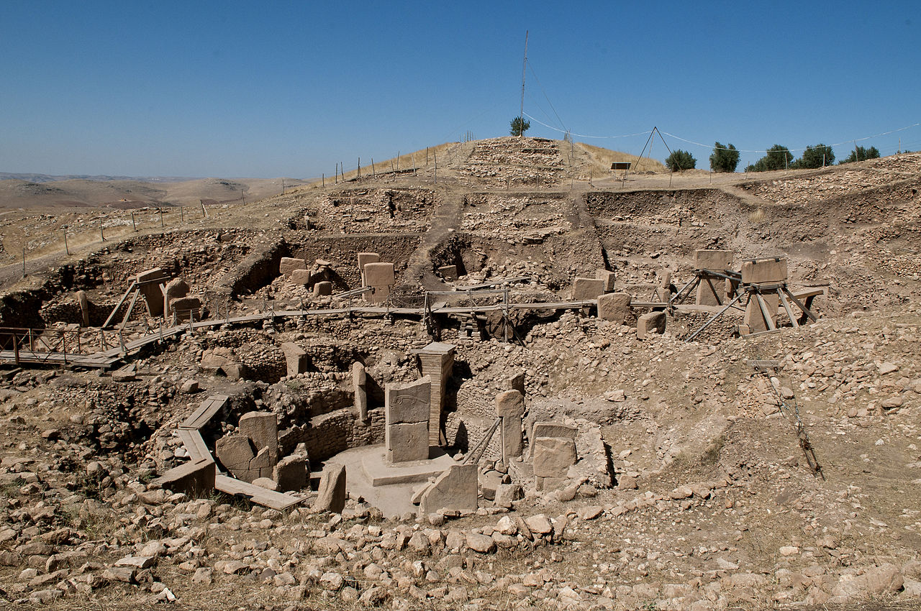
Göbekli Tepe
https://en.wikipedia.org/wiki/G%C3%B6bekli_Tepe#/media/File:G%C3%B6bekli_Tepe,_Urfa.jpg

We read lines 177-231 of Aenedi IV and Tanya asked about a possible connection between the verb condō and English conduit. In fact the latter derives from condūcō ( -dūcere, -dūxī, -ductum), `lead together’, `hire’. Words from condō (condere, condidī, conditum, `place together, found, build, hide, bury’) include recondite and (via the variant verb condīre, `place in spices’, `pickle’) condiment. The family of verbs in –dō, -didī, -ditum derive ultimately from the PIE root *dhe (place, put) and, despite what John told his students until recently, not from dō, dare, dedī, datum (give), which developed from the PIE root with the same meaning, *do- The perfect participle conditus –a, -um is used in the phrase Ab Urbe Conditā (`from the city founded’, i.e. `from the foundation of the city’). Abbreviated to A.U.C. this was used in a system of dating events from a base line of 753 B.C., the supposed year of Rome’s foundation (see https://linguae.weebly.com/roman-calendar.html)


Buddha Eyes
https://www.ancient-symbols.com/buddhist-symbols.html

Someone asked if there was an etymological link between the Latin fāma (fame, reputation, rumour) and Greek φημί (phēmi, I say) and both in fact serive from PIE *bha- (speak, say). The Roman personification of rumour (Fāma with initial capital in modern printed texts) is described by Virgil as possessing eyes beneath all of the feathers that cover its body and Zhang Wei wondered whether there could be a link between this symbolism and the `Buddha Eyes’ or `Wisdom Eyes’ depicted on the sides of Buddhist monuments, Although in both cases there is an underlying idea of nothing escaping notice, a direct connection is unlikely as the Buddha’s vision was seen as a positive force,

Malcolm again recommended Jessye Norman’s performance of `Dido’s Lament’, the mournful aria from Purcell’s Dido and Aeneas, which can be found at https://youtu.be/eRyec66Jp2c

John reported that he had finally got round to writing a suitably respectful letter to Professor Mary Beard, the UK’s leading historian of Rome, for a ruling on an argument between Malcolm and a friend over whether the Roman Empire reached its maximum extent under Trajan (98-117) or Septimius Severus (193 to 211) . John himself had thought we probably lacked the precise information to settle the question and Dame Mary’s rapid reply took the same line: `I think you are right. We can’t know for sure .. and it depends on how we define the borders. So there are different ideas. M’

John, who was preparing a lecture on earthquakes in Nepal (PowerPoint now available at the bottom of https://linguae.weebly.com/nepali.html ), mentioned the claim by James Palmer in his The Death of Mao: The Tangshan Earthquake and the Birth of the New China (London: Faber & Faber, 2012) that revulsion at the callous attitude of the `Gang of Four’ towards the victims of the July 1976 Tangshang earthquake had been a factor in their downfall shortly after Mao’s death the following month. Both Zhang Wei, who had been living in Beijing at the time and felt the earthquake, and Malcolm were sceptical about this. However, Zhang Wei later attended the lecture at the Hong Kong Anthropological Society and suggested that Mao’s death, which undoubtedly triggered the political changes, could have been hastened by the disaster. Mao himself, though an atheist, was superstitious and susceptible to the old Chinese belief about rulers being in some way at fault when natural disasters occurred.

Malcolm referred to Mao’s record of causing more deaths than Stalin and Hitler combined and he recommended Weijian Shan’s Out of the Gobi; My Story of China and America for the disaster caused by the Great Leap Forward. Both Malcolm and I had heard of but not yet seen Julia Lovell’s Maoism – a global history, which looked at the influence of Mao’s theories and example outside China and included a chapter on Nepal.

AENEID IV 177-231
[fāma] ingrediturque solō et caput inter nūbila condit.
and-walks-upon the-ground and heas among clouds buries
illam Terra parēns īrā inrītāta deōrum
her earth prent by-anger provoked at-the-gods
extrēmam, ut perhibent, Coeō Enceladōque sorōrem
last as they-relate for Coeus and-Encelasus sister
prōgenuit pedibus celerem et pernīcibus ālīs, 180
gave-birth-to on-feet swift and with-desturctive wings
mōnstrum horrendum, ingēns, cui quot sunt corpore plūmae,
horrible monster huge to-whom as-many-as are on-body feathers
tot vigilēs oculī subter (mīrābile dictū),
so-many watchful eyes underneath strange to-say
tot linguae, totidem ōra sonant, tot subrigit aurīs.
So-many tongues same-number-of mouths make-sound so-many she-pricks-up ears
nocte volat caelī mediō terraeque per umbram
by-night she-flies of-heaven in-middle and-of-earth through shadow
strīdēns, nec dulcī dēclīnat lūmina somnō; 185
hissing an-not in-sweer shuts eyes sleep
lūce sedet cūstōs aut summī culmine tēctī
in-daylight sits as-sentinel either of-top on-roof of-building
turribus aut altīs, et magnās territat urbēs,
on-towers or high and great terrifies cities
tam fictī prāvīque tenāx quam nūntia vērī.
As-much of-falsehood and-of-evil tenacious as announcer of-truth
haec tum multiplicī populōs sermōne replēbat
she then with-manifold peoples speech was-filling
gaudēns, et pariter facta atque īnfecta canēbat: 190
joyfully and equally facts and ficrions was-singing
vēnisse Aenēān Troiānō sanguine crētum,
to-have-come Aeneas from-Trojan blood born
cui sē pulchra virō dignētur iungere Dīdō;
to-which herself beautiful sees-fit to-join Dido
nunc hiemem inter sē luxū, quam longa, fovēre
now winter among themselves in-sensuality as long [as it lasted] were-keeping-warm
rēgnōrum immemorēs turpīque cupīdine captōs.
of-kinfdoms forgetful and-by-disgraceful lust captured
haec passim dea foeda virum diffundit in ōra. 195
these-things everywhere goddess vile of-men scatters into mouths
prōtinus ad rēgem cursus dētorquet Iarbān
immediately to king path she-turns Iarbas
incenditque animum dictīs atque aggerat īrās.
and-inflames [his]mind with-words and builds-up [his]anger
Hic Hammōnesatus raptā Garamantide nymphā
This-man from-Hammon born by-ravished Garamantian nymph
templa Iovī centum lātīs immānia rēgnīs,
temples to-Juppiter hundered in-broad vast realms
centum ārās posuit vigilemque sacrāverat ignem, 200
hundred altars placed and-watchful had-consecrated fire
excubiās dīvum aeternās, pecudumque cruōre
sentinel of-gods eternal and-of-herds with-blood
pingue solum et variīs flōrentia līmina sertīs.
rich the-ground with-various resplendent thresholds garlands
isque āmēns animī et rūmōre accēnsus amārō
and-he maddened in-soul and by-rumous indlamed bitter
dīcitur ante ārās media inter nūmina dīvum
is-said before altars in-middle between divine-powers of-gods
multa Iovem manibus supplex ōrāsse supīnīs: 205
many-things (from) Juppiter with-hands as-a-supplianr to-have-begged turned-upwards
'Iuppiter omnipotēns, cui nunc Maurūsia pictīs
Juppiter all-mighty to-whom now Mauretanian -embroidered
gēns epulāta torīs Lēnaeum lībat honōrem,
race feasting couches of-wine offers the-honour
aspicis haec? an tē, genitor, cum fulmina torquēs
do-you-see-this or you father whe thunder-bolts you-hurl
nēquīquam horrēmus, caecīque in nūbibus ignēs
in-vain are-wein-awe-of and-blindly in the-clouds lightnng
terrificant animōs et inānia murmura miscent? 210
terrifies minds and meaningless roaring stir-up
fēmina, quae nostrīs errāns in fīnibus urbem
woman who our wondering in territories city
exiguam pretiō posuit, cui lītus arandum
small for-a-price established to-whom stretch-of-shore shore for-ploughing
cuique locī lēgēs dedimus, cōnūbia nostra
and-to-whom of-place l aws we-gave [offer-of] marriage our
reppulit ac dominum Aenēān in rēgna recēpit.
repulsed and [as] lord Aeneas into kingdom received
et nunc ille Paris cum sēmivirō comitātū, 215
and now that Paris with of-half-men retinue
Maeoniā mentum mitrā crīnemque madentem
With-Maeonian chin turban and-hair reeking [of perfume]
subnexus, raptō potītur: nōs mūnera templīs
tied-up what-was-deized posseses we gifts to-temples
quippe tuīs ferimus fāmamque fovēmus inānem.'
Of-course your bring and-reputation we-cherish empty
Tālibus ōrantem dictīs ārāsque tenentem
with-such [him] praying words and-altars holding
audiit Omnipotēns, oculōsque ad moenia torsit 220
heard All-mighty-one and-eyes to walls turned
rēgia et oblītōs fāmae meliōris amantīs.
of-palace and forgetful of-reputation better lovers
tum sīc Mercurium adloquitur ac tālia mandat:
then thus Mercury he-addresses and such gives-orders
'vāde age, nāte, vocā Zephyrōs et lābere pennīs
Go now son call west-winds and glide on-wings
Dardaniumque ducem, Tyriā Karthāgine quī nunc
And-Trojan leader in-Tyrian Carthage who now
exspectat fātīsque datās nōn respicit urbēs, 225
waits and- by-fate given not has-regard-for cities
adloquere et celerīs dēfer mea dicta per aurās.
speak-to and swift carry-down my words through air
nōn illum nōbīs genetrīx pulcherrima tālem
not him to-us mother most-beautiful such
prōmīsit Grāiumque ideō bis vindicat armīs;
promised and-of-Greeks for-this-reason twice defended from-arms
sed fore quī gravidam imperiīs bellōque frementem
but to-be-going-to-be one-who pregnant-with empire and-in-war raging
Ītaliam regeret, genus altō ā sanguine Teucrī 230
Italy would-rule race noble from blood of-Teucer
prōderet, ac tōtum sub lēgēs mitteret orbem.
propagare and whole under laws should-send world

QUESTIONS ARISING FROM 102nd MEETING – 12/7/19

Food ordered included cicera arōmatica (chana masala, chickpeas with spices), melongēna contūsa (baigan bharta, mashed aubergine/eggplant), carnēs assae mixtae (mixed grill), iogurtum cum holeribus contūsīs (raita, yohurt with chopped vegetables), batātae cum brassicā Pompēiānā (alu gobi, potatoes with cauliflower), squillae arōmaticae (prawns with spices), caseus fervēns (sizzling paneer (cheese)),pānis Persicus (nan), orӯza (plain rice), and vīnum rubrum/sanguineum

We read chapter 15 of Henry Nutting’s Ad Alpēs: a Tale of Roman Life, originally published in 1923 and recently re-issued recently by Daniel Pettersson (see his Latinitium site to order a copy). The text of the 1927 edition, with interlinear translation and illustrations, is being added progressively to
https://linguae.weebly.com/ad-alpes.html and has now reached chapter 17. The plain text and translation of chapter 15 have also been placed below. Within a frame narrative of a family travelling from Ephesus in Asia Minor to the Alps, via Brundisium and Rome, the book includes a plethora of stories from Roman history, Greek mythology and the Old Testament,

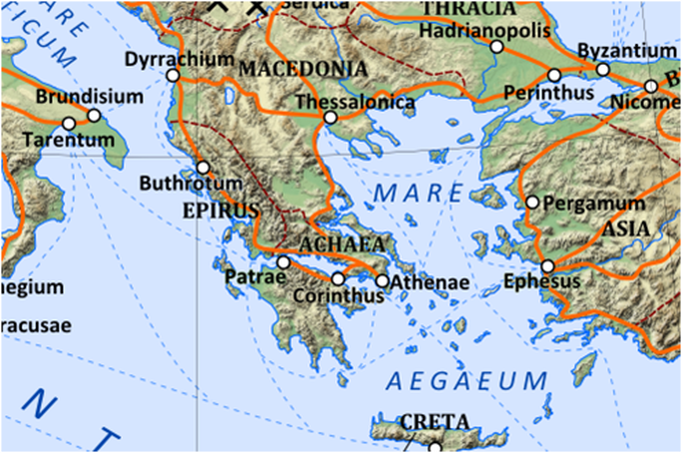
The first stage of the family’s journey in Ad Alpēs

As the chapter is set in an Italian inn, we also looked at the tombstone inscription which a real innkeeper designed for himself and his partner and which has been discussed and translated by Mary Beard. The couple called themselves Lucius Calidius Eroticus and Fannia Voluptas, names which Dame Mary renders as `Mr Hot Sex’ and `Madame Gorgeous’

In the story itself, a peddlar and the family’s rascally slave Stasimus quarrel with each other and both use the term nūgātor,which derives from nūgae (jokes, trifles) and for which Lewis & Short offers a wide range of translations: jester, joker, babbler, trifler, silly person braggart, swaggerer. John suggested `bullshitter’ as a good equivalent in modern, colloquial English.This led us to a brief discussion of other Roman insults, many of which, were, of course, obscene. There is a selection of such terms at http://www.obscure.org/obscene-latin/vocabulary.html and John has a longer list which. The standard reference for this topic is, as noted in earlier meetings, James Adam’s comprehensive account, available for download at https://monoskop.org/images/7/79/Adams_JN_The_Latin_Sexual_Vocabulary.pdf We also noted Stasimus’s use of the words Discēde in maximam malam crucem (literally `Go off to a very big bad cross’), a slight variation on a phrase used by the playwright Plautus, In everyday speech, probably abī in malam rem or abī in malam crucem were more common. When discussing British politics, John generally employs Abeant Brexitōrēs in malam rem, idiomatically `To hell with the Brexiteers’. A recent pro-Europe demonstration featured Boris futue tē ipsum, directed at the UK’s esteemed prime minister.

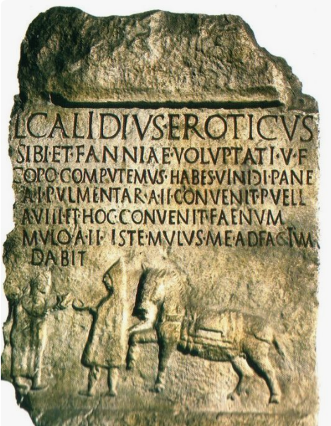
`Mr Hot Sex’s’ inscription from Isernia in Southern Italy
(transcription and partial translation below)

Someone asked if there was any difference between the verbs properō and festīnō It transpires that Cato the Elder (234-149 B.C.) asserted that there was:: aliud est properāre, aliud festīnāre. Quī ūnum quid matūre trānsigit, is properat: qui multa simul incipit neque perficit, is festīnat (`Properāre is one thing, festīnāre another (` Properāre means to accomplish one thing in good time, festīnāre is to start many things at once and not finish them’). However, the 2nd. century A.D. writer Aulus Gellius, whose miscellany Noctēs Atticae (`Attic Nights) (16, 14, 2), preserves the saying, claims that they were in fact used interchangeably.

We also asked whether the verb gustō, which most of us learned as `taste’, can also mean `eat’, which is how it appeared to be used in the chapter. It turns out that gustō means basically `eat just a little’, so it covers both `taste’ in the English sense as well as `eat a light meal’, The Romans normally ate a large meal in the evening (cēna), whilst ientāculum (`breakfast’) and prandium were not at all substantial, so Nutting can correctly use gustō of the family having a bite to eat before setting off in the morning. Similarly the noun gustātio means literally `a tasting’ but it was also used of a light first dish as part of a larger meal.

Someone also asked whether ēheu and heu were synonyms. Both were in fact used as exclamations of pain or grief, the shorter word being apparently more common.

There was a brief discussion of the controversial ding right policy under which male indigenous villagers were entitled to build a `small house’ without paying the usual hefty fees involved. Although linked to supposed practice before Britian acquired the lease on the New Territories in 1898, the present system dates back to legislation passed in 1972. In may this year, a court decided that the practice was constitutional if applied to privately owned land but not for public land. Both supporters and opponents of the system are dissatisfied with the compromise and the situation is complicated because the organization representing the indigenous inhabitants of the New Territories, the Heung Yee Kok, has been assiduously cosying up to the authorities in Beijing since the 1980s. The details are explained in an article at https://www.scmp.com/news/hong-kong/law-and-crime/article/3008261/battle-over-hong-kongs-controversial-small-house


`Small houses’ in the New Territories
https://www.hongkongfp.com/2016/01/21/explainer-hong-kongs-divisive-small-house-policy/

There was also brief discussion of the notions of ethnicity and nationality in China. An article published in the economist in 2016 argues that most Chinese virtually equate Han ethnicity with Chinese nationality, creating possible problems both because of the exclusionary consequence for non-Han within China and because of the implicit claim that the Chinese diaspora remain Chinese in a political sense, see `Who is Chinese? The upper Han’ https://www.economist.com/briefing/2016/11/19/the-upper-han. The article may be behind a pay-wall but John can provide a copy on request.

Finally, Valerie confirmed thart the only British Latin GCSE equivalent that can be taken in Hong Kong is the Cambridge IGCSE. She also said that Eton and Winchester have now discontinued the policy of having their top sets take the more difficult IGCSE exam rather than OCR. The former’s syllabus covers a wider grammatical range and the extracts from original Latin literature to be studied are longer.

AD ALPĒS: CHAPTER XV

Māne abīre dēstināverant; cum autem gustāssent, Anna maesta nūntiāvit Lūcium tam adsiduē
In-morning to-leave -they-had-planned when however they-had-eaten Anna sadly announced Lucius so unceasingly
flēre, ut plānē morbō labōrāre vidērētur. Quō audītō, Drūsilla: "Heu," inquit; "semper
to-weep that plainly from-sickness to-suffer he-seemed with-this heard Drusilla Oh-no said always
metuēbam nē quid malī illī parvulō miserō accideret, cum tam raptim terrā marīque iter
I-feared lest anything of-bad to-that little-one poor might-happen since so rapidly by-land and-sea journey
facerēmus. Quid nunc faciendum est?"
we-were-making what now to-be-done is
Interim accesserat caupō avārus; quī, ubi haec audīvit, cum hospitēs tam locuplētēs
Meanwhile had-approached inn-keeper greedy who when these-things he-heard since guests so rich
quam diūtissimē apud sē retinēre vellet: "Etiam dī significāre videntur," inquit, "hodiē vōbīs
as long-as-possible with him to-keep he-wished even gods to-give-sign seem he-said today for-you
nōn abeundum esse. Nam modo in viā aliquem fīcōs vēndentem audīvī, quī identidem
not needing-to-go-away to-be for just-now in street someone figs selling I-heard who repeatedly
'cauneās' clāmāret."
mind-you-don’t--go was shouting
"Quō modo istud ad rem pertinet?" inquit Cornēlius.
In-what way that to thing is-connected aske Cornelius
"Ōmen manifēstum est," inquit caupō. "Nam etsī homō haud distinctē prōnūntiābat,
Omen obvious is said innkeeper for although man not clearly was-pronouncing
idem fit quasi 'cavē nē eās' dīxisset. Mēlius erit igitur, sī hinc hodiē nōn proficīscēminī."
same-thing becomes as-if beware lest you-go he-had-said better it-will-be therefore if from-here today not you-will-set-out
"Istīus modī rēs minimī faciō," inquit Cornēlius; "et properāmus."
Of-that kind things nor-at-all I-value said Cornelius and we-are-in-a-hurry
At Drūsilla: "Paulisper, obsecrō, hīc morēmur. Medicum saltem adhibērī volō,
But Drusilla a-little-while please here let-us-stay doctor at-least to-be-called-in I-want
priusquam abeāmus."
before we-leave
"Fīat," inquit Cornēlius. Tum caupōnī: "Medicus statim arcessātur ; et cūrā ut optimus
So-be-it said Cornelius then to-innkeeper doctor at-once let-be-summoned and make-sure that best
ille sit."
he is
"Licet," inquit caupō; "nam haud procul habitat medicus, quō melior etiam Rōmae
That’s fine said innkeeper for not far-off lives doctor than-whom better-one even in-Rome
vix invenīrī potest."
scarcely be-found can
"Bene hercle nūntīās," inquit Cornēlius. "Perge modo."
Well by-heaven you-give-news said Cornelius carry-on just
Interim Anna ad Lūcium redierat, ac cēterī, morae impatientēs, in triclīniō sedēbant
Meanwhile Anna to Lucius had-returned and the-others of-delay impatient in dining-room were-sitting
medicum exspectantēs, quī brevī advēnit. Et Cornēlius: "Salvē, medice," inquit. "Fīlius meus
doctor eaiting-for who soon arrived and Cornelius Food-morning doctor said son my
parvulus minus bene sē habet. Rōmam iter facimus. Celeriter eum sānārī volō."
Little less well himself has to-Rome journey we-are-making quickly him to-be-cured I-want
"Id quidem perfacile est," inquit medicus. "Omnia ego facere possum. Modo crūs
That indeed perfectly-easy is said doctor all-things I to-do am-able just-now leg
frāctum Aesculāpiō obligavī, et bracchium Apollinī. Quīn etiam mortuōs ex īnferīs excitāre
broken for-Aesculapius I-bound-up and arm for-Apollo Ineed even the-dead from inderworld to-rouse
soleō."
I-am-accustomed
At Cornēlius: "Crēdō. Sed nunc expōne quid nobīs faciendum sit."
But Cornelius [said’] I-believe[you] but now explain ehat by-us to-be-done is
Dum haec fīunt, Anna arcessīta adiit, in gremiō Lūcium fovēns. Quō vīsō, medicus:
While these-things are-happening Anna sent-for arrived in lap Lucius keeping-warm with-him seen doctor
"Fac ut eius pedēs appāreant," inquit. Quōs cum pertractāsset, "Aquā gelidā," inquit, "pedēs
Make [that] his feet appear said which when he-had thoroughly-handled with-water ice-cold he-said feet
lavātō."
wash
"Tē obsecrō, medice," inquit Drūsilla. "Febris modo in eum incidit. Male metuō nē
You I-beg doctor said Drusilla fever just-now on him has-come badly I-fear lest
gravēdō sequātur, sī aquā gelidā pedēs perfūsī erunt."
a-cold may-follow if in-water cold feet bathed will-have-been
"Sīc faciendum est," inquit medicus, "sī fīlium salvum optās. Ac interim fac ut hoc
Thus to-be-done is said doctor if so safe you-wish and meanwhile make that this
medicāmentum tertiā quāque hōrā abundē hauriat."
medicine third every hour in-large-quantity he drinks-up
Quae cum dīceret, ex amphorā medicāmentum ātrum, picī simile, in pateram effundēbat.
Which while he-was-saying from amphora drug black to-pitch similar into bowl he-was-pouring
"Haec omnia," inquit, "sī ad praescrīptum fīent, crās puer aut sānātus aut mortuus erit. Tum
These all he-said if as prescribed will-be-done tomorrow boy either cured or dead will-be then
redībō. Iam valēte." Quō dictō, domum sē recēpit.
I-will-return now goodbye with-which said home himself he-took
Tum Cornēlius īrātus caupōnī: "Quid vīs, sceleste?" inquit. "Audēsne hominem tam
Then Cornelius angrily to-innkeeper what do-you-want rogue asked fo-you-dare man so
stultum et ineptum prō medicō arcessere? Crēdisne mē hōc venēnō meum fīlium
foolish and incompetent as-doctor to-send-for do-you-believe me with-this poison my son
interfectūrum esse?" Quae cum dīxisset, medicāmentum per fenestram apertam abiēcit,
oing-to-kill to-be which when he-had-said medicine through window open he-threw-away
Annamque iussit Lūcium abdūcere, sī forte quiētō somnō eī melius foret.
And-Anna he-orderd Lucius to-take-away in-case by-chance with-quiet sleep for-him better it-would-be
Caupō vultū maestō discessit, etsī vērō gaudēbat hospitēs abīre nōndum audēre. Cum illī
Innkeeper with-face sad went-off even-though indeed he-was-glad guests to-leave not-yet to-dare when they
intus sollicitī exspectārent, subitō per fenestrās apertās audīta est vōx Stasimī, quī in āreā
inside anxiously were-waiting suddenly through windows open heard is voice of-Stasimus who in yard
īnstitōrī vagō occurrerat. Inter quōs altercātiō eius modī orta est:
hawker itinerant had-come-across between whom quarrel of-this sort arose
Stasimus. Quis tū es homō, quī tam audācter hās aedēs adīs?
What you are man who so boldly this house approach
Inst. Multās mercēs lepidās et mīrandās ego hīc in saccō ferō. Cīvem nōbilem hūc herī
Many wares charming and wonderful I here in bag am-carrying citizen noble here yesterday
advēnisse audiō. Esne tū eius servus?
To-have-arrived I-hear are you his slave
Stasimus. Ita vērō. Cuius tū servus es?
Yes indeed whose you slave are
Inst. Apage tē, nūgātor. Mēne prō servō habēre audēs? Quīn ego rēgibus antīquīs ortus
Away-with you bullshitter me for slave to-take you-dare in-fact I from-kings ancient descended
sum.
am
Stasimus. Facile crēdō tē ortum rēge—fūrum.
Easily I-believe you [to-be] descended from-king of-thieves
Inst. Quid ais, furcifer? Mēne fūrem esse īnsimulās?
What are-you-saying scoundrel me thief to-be are-you-insinuating
Stasimus. Haud īnsimulō, quod certō sciō.
Not I-insinuate what for-certain I-know
Inst. Cave malum. Huius modī verba ā servīs ego nūllō modō audīre soleō.
Beware-of trouble of-this kind words from slaves I in-no way to-hear I-am-accustomed
Stasimus. At verbera sentīre solēs, cum dominus tē pendentem paene ad necem
But blows to-feel you-are-accustomed when master you strung-up almost to death
caedit.
lashes
Inst. Aisne, carnifex? Hōsne pugnōs vidēs? Tē in somnum longissimum collocābunt,
Do-you-say-so wretch these fists do-you-see you into sleep very-long they-will-put
nisi tibi cavēs.
unless for-yourself you-are-careful
Stasimus. Amīcē pollicēris; nam hās noctēs trēs pervigilāvī, atque aliquem quaerō,
In-friendly-way you-promise for these nights three I-have-been-awake and someone I’m-looking-for
quī faciat ut dormiam.
who can-make that I-sleep
Inst. Verbum adde ūnum, mastīgia, et tē ad terram colaphīs adflīgō.
Word ass one villain and you to ground with-blows I-knock
Stasimus. Tange modo, cūstōs carceris. Oculōs tibi effodiam, sī propius accesseris.
Touch[me] just guard of-prison eyes for-you I’ll –gouge-ou t if closer you-will-have-come

Vīsne pugnāre?
Do-you-want to-fight
Inst. Caupōnem forās ēvocābō. Heus, caupō, exī et istum nūgātōrem hinc abige.
Innkeeper outside I-will-call Hey innkeeper come-out and that bullshitter from-here drive-away
Stasimus. Abī, dormītātor. Fue! alium olēs. Tē āmovē; discēde in maximam malam
Go-away idler Aiyaa of-garlic you-smell yourself move-away leave from the-largest evil
crucem!
cross
Tum autem ex aedibus celeriter ēgressus Pūblius: "Quid fit, Stasime?" inquit.
Then however from house quickly having-emerged Publius what is-going-on Stasimus said
"Nōnne scīs Lūcium dormīre, et omnia hīc tranquilla esse oportēre? Cūr audēs tantās
Don’t you-know Lucius to-be-sleeping and all here uiet to-be to-need whi do-you-dare such-great
turbās concitāre?"
disturbances to-stir-up
"Hoc omnīnō oblītus sum," inquit Stasimus, "propter hunc scelestum, quī modo parentēs
This altogether I-forgot said Stasimus because-of this rogue who just-now parents
suōs interfēcit domumque expīlāvit, atque hūc quoque fūrātum venīre ausus est. Abī, nūgātor,
own has-killed and-home looted and here also to-steal to-come dared has Go-away bull-shitter

discēde."
leave
At Pūblius: "Tacē, inquam. Sī hodiē clāmōrem iterum tollēs, maximō malō tuō
But Publius quiet I-say if today moise again you-make for-very-great trouble your
faciēs."
you-will-do [it]
Paying the bill at an inn in Isernia (Southern Italy)
L. CALIDIUS EROTICUS
SIBI ET FANNIAE VOLUPTATI V.F.
COPO COMPUTEMUS HABES VINI)I PANE[M]
A.I PULMENTAR.A.II CONVENIT PUELL[A]
A.VIII ET HOC CONVENIT FAENUM
MULO A.II ISTE MULUS ME ADFACTUM
DABIT

Tum īnstitor Pūbliō: "Tē ōrō, adulēscēns," inquit, "ut mihi liceat mercēs meās mulieribus
Then peddlar to-Publius I beg-you young-man said that to-me it-be-permitted wares my to-the-women
ostendere. Certō sciō, sī semel aspexerint, eās multa emere parātās fore."
To-show for-certain I-know if once they-will have-seen them many-things to-buy prepared to-be-going-to-be
"Mater mea iam haud occupata est,"inquit Publius. "Quārē mē sequere, ac mercēs
Mother my now not busy is said Publius so me follow and wares
ostende. Tū interim, Stasime, intempēstīvās facētiās tuās alia in loca aufer." Quō dictō, aedēs
show you meanwhile Stasimus badly-timed jokes your other in places take with-which said house
intrāvit, ubi Drūsilla et Cornēlia libentissimē īnspexērunt rēs mīrandās, quās īnstitor ē saccō
he-entered where Drusilla and ornelia very-willingly looked—at the-things marvellous which peddlar from bag
suō prōmēbat.
his was-pulling-out
Vix erat ille dīmissus, cum Anna nūntiāvit Lūcium placidē quiēvisse, ac eī iam
Scarcely had he been-dismissed when Anna announced Lucius peacefully to-have-rested and for-him now
multō melius esse. Quod cum cognitum esset, omnēs gaudēbant; ac Cornēlius Onēsimum
much better to-be which when learned had-been all were-rejoicing and Cornelius Onesimus
statim mīsit, ut caupōnem vocāret.
At-once sent so-that innkeeper he-could-call
Iste scīlicet haud libenter audīvit Lūciō melius factum esse. Sed ratiōnem cōnficere
That-man obviously not happily heard for-Lucius better made to-have-been but bill to-make
coāctus est ; ac paulō post, pecūniā solūta, viātōrēs iterum in raedīs sedēbant, atque equī
forced he-was and a-little later with-money paid travellers again in wagons were-sitting and horses
alacrēs viā strātā vehicula celeriter rapuērunt.
Eagerly on-way paved vehicles quickly whisked-away
QUESTIONS ARISING FROM 103rd MEETING – 20/9/19

We discussed our activities duting the fēriaes aestīvae, using the Latin prompts given below. Zhang Wei had been in Alaska, which he explained is actually quite warm in the summer months, with temperatures in Anchorage up to around 30 degrees. However his attempt at a country stroll was curtailed when, just afte he locked his car door, he was told that abear cub had been sighted just ahead. As the mother bear would presumably be not too far off, Zhang and family got back in the car and made a safe retreat.
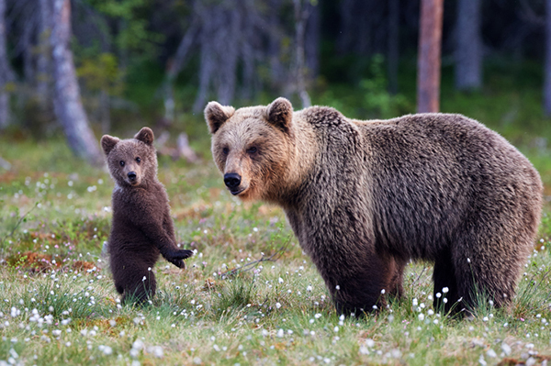
Alaskan bear cub with its mother
https://www.alaskatourjobs.com/blog/outdoor-activities/5-best-places-view-bears-alaska/

Tan and her family had been in Australia, including a hiking trip in Tasmania, home to both the wel-known `Tasmanian devil’ and also the quoll, a marsupial speices that none of the rest of us had ever heard of. Both species are listed as threatened but the status of the Tasmanian devil is worse and it is now found in the wild only on Tasmania, its numbers drastically reduced in recent years by devil facial tumour disease.
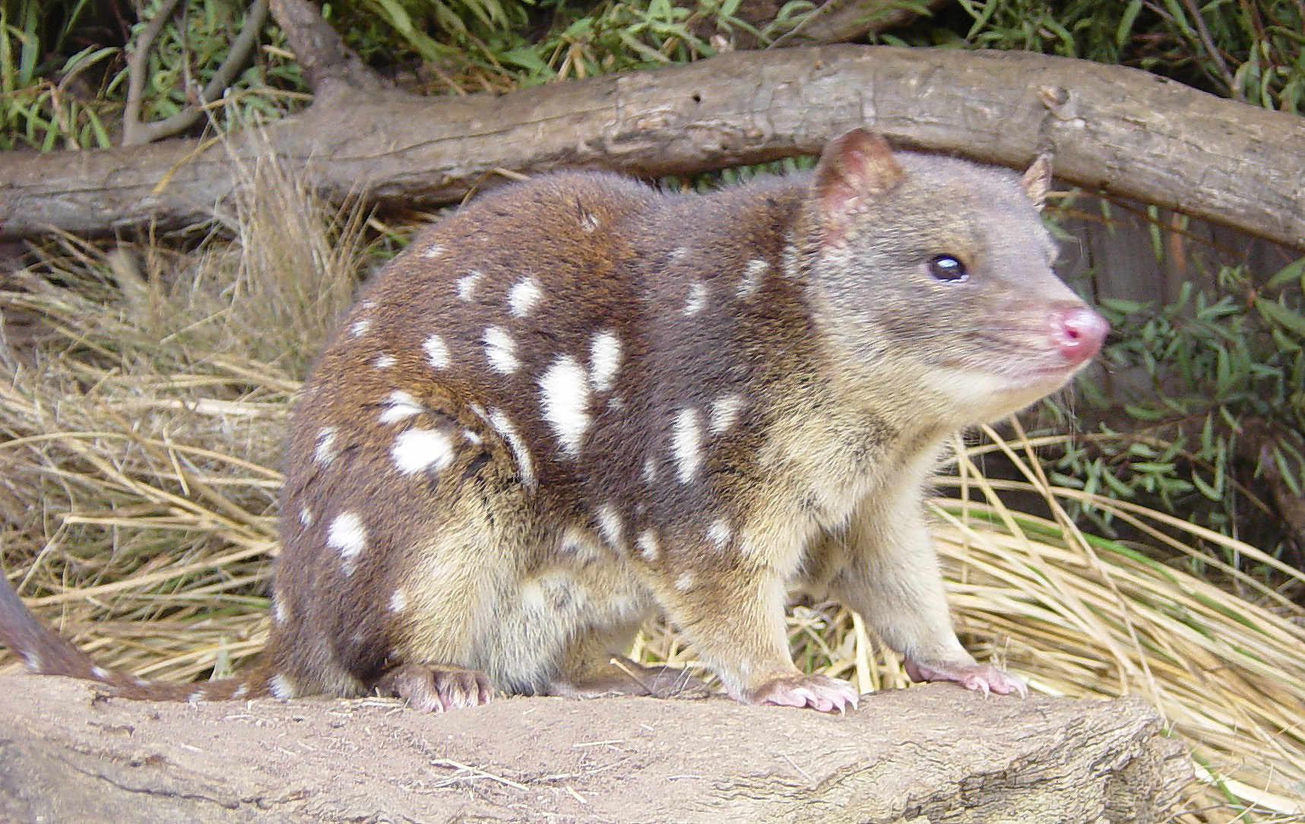
A quoll photographed at a rescue centre
https://en.wikipedia.org/wiki/Quoll
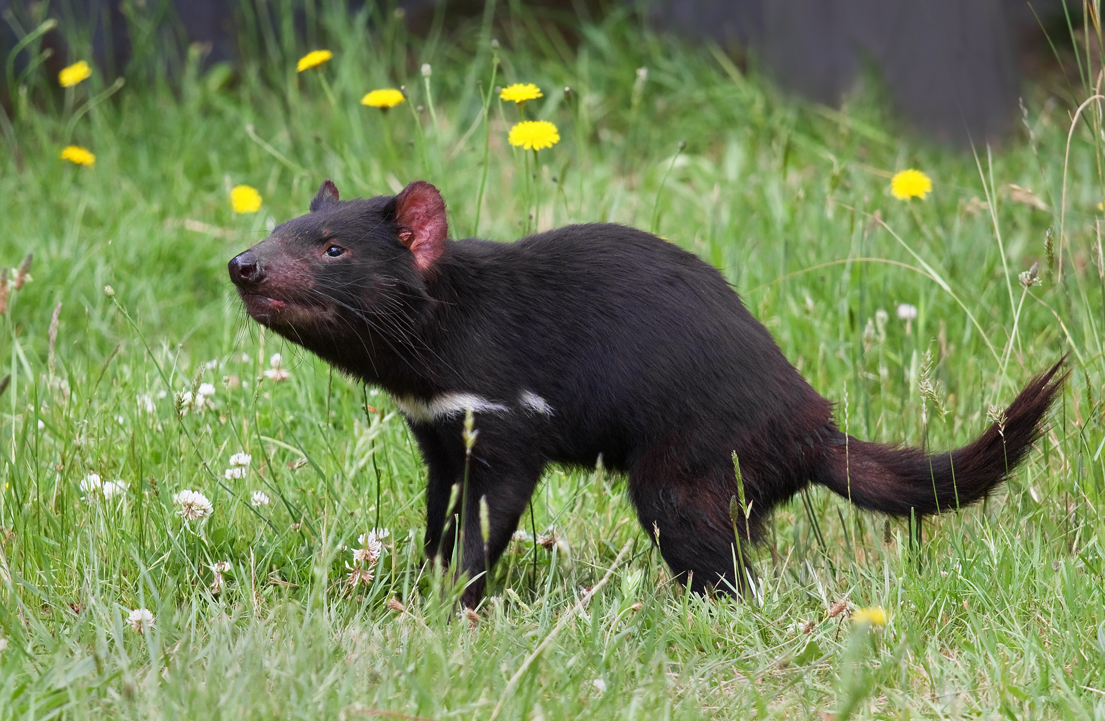
https://en.wikipedia.org/wiki/Tasmanian_devil

Following his usual trip to Nepal, John had been touring in Greece with his family, visiting Athens, Delphi. Corinth and Nauplion, and finishing with four nights on the island of Lemnos in the NE Aegean. His family were particularly impressed by the splendid setting of Delphi and the romantic castle ruins above Nauplion and Lemnos’s capital. Myrina. From 1833 to 1834, Nauplio was the first capital of the modern Greek state before King Otto decided to move the government to Athens, Lemnos boasts the remains of what is believed to be the oldest urban settlement in Europe as well as many fine beaches. The island was headquarters for the allied forces in the Gallipoli campaign of 1915 and also the site for the surrender of Turkish forces in the Aegean theatre.

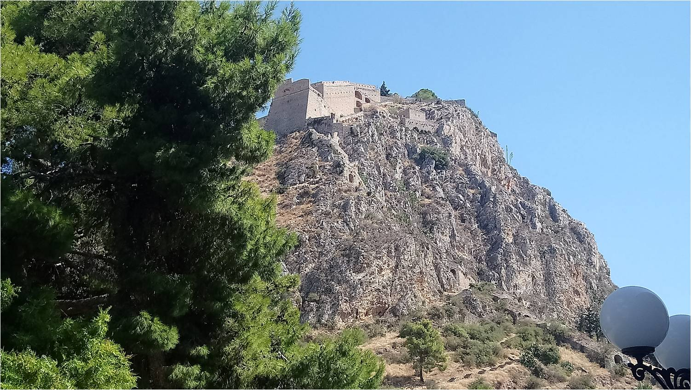
The Palamidi fortesss at Nauplion

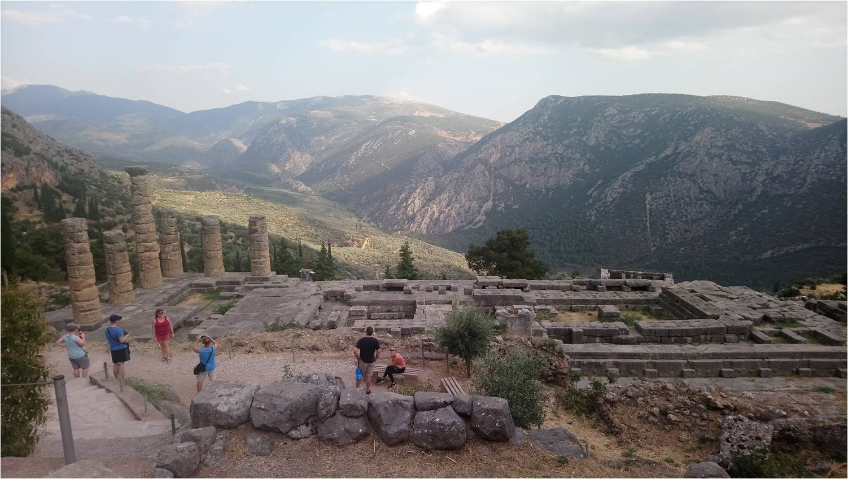
Temple of Apollo at Delphi

We read chapter 17 of Nutting’s Ad Alpēs (see text below), which covered among othere topics the sword of Damocles and the Battle of Cannae. We noted the controversy over whether Hannibal would have been able to capture Rome itself if he had taken Maharbal’s advice to march on the city immediately after his stunning victory in 216 B.C. Nutting’s phrase for `would have been able to capture the city itself is urbem ipsam occupāre potuit, where an English speakere would have expected potuisset (pluperfect subjunctive).

The Damocles anecdote as related by Cicero involves good-looking young boys to wait on him at dinner and one of us wondered whether Cicero was having a dig at Greek homosexual tendencies. John thought this was unlikely since Romans did not think it wrong for an adult male to have a sexual relationship with a boy, stigma only attaching to an adult who was the passive partner in such a relationship. The situation was in some way parallel to that existing in some parts of Afghanistan today..

The 19th century artist who illustrated the Damocles story chose to change the attendants to females (see the illustration below), whether because of unease over any suggestion of homosexuality or because young women better fitted his idea of a life of princely luxury and indulgence.

This topic led Tanya to remember that her eight-year-old daughter, to whom she is currently reading Lord of the Rings, proclaimed it was a `gay novel’ because female chacters played so small a role in it. Tanya herself was sceptical about that but believed there was a gay relationship between Mole and Ratty in Wind and the Willows. John suggested that male camaraderie of characters in these classics (and of many of the authors themselves in real life) did not necessarily involve homosexuality. In the case of Tolkien and Lord of the Rings there is an additional complication as some believe that the model for Gandalf was actually the author’s aunt, Jane Neave – see Tolkien’s Gedling 1914, co-authored by John’s old schoolmate, Andrew Morton (https://www.amazon.co.uk/Tolkiens-Gedling-1914-Andrew-Morton/dp/185858423X).

We briefly discussed the Latin verbs for `play’ a musical instrument: canere/cantāre (literally `to sing’) for plucking strings or blowing into a pipe or trumpet and pulsāre (`to strike’) for percussion instruments.. There is sometimes a dispute over whether a modern piano should be placed in the percussion or string category but most people would definitely use clāvic(h)ordiō canere/cantāre. In Spanish the verb tocar. derived from Vulgar Latin* toccāre (to strike) means both `to touch’ and `to
play (an instrument)’, whilst tañer, from tangere and thus originally meaningt `touch’, now means only `to play’. It is uncertain at what time toccāre came into colloquial Latin but as the word is itelf thought to have been of Germanic origin it was most likely in late antiquity or early medieval times. There remains the possibility that ordinary Romans in the classical period might have used instrumentum tangere for `to play an instrument.’ John bemoaned his own inability to `sing’ in either the vocal or instrumental sense and recalled how his one attempt at a karaoke performance (during a school open day) had resulted in the room rapidly emptying.

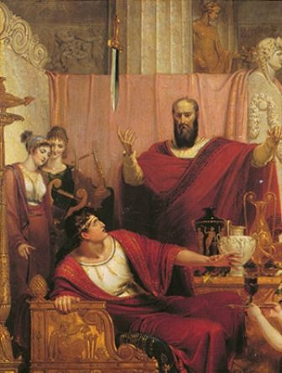
The Sword of Damocles (Richard Westall, 1812)
https://en.wikipedia.org/wiki/Damocles

There was also mention of Chinese sayings and ways of remembering them. The equivalent of Latin lupus in fābulā (`wolf in the story’) and `Speak of the devil!’ is 一講曹操, 曹操就到 (yat gong Chou Chou, Cho Chou jau dou! - `As soon as you say `Chou Chou’, Chou Chou arrives’), referring to the Macchiavellian ruler in the Three Kingdoms period. John always remembers this one because just after he’d been taught it on a Cantonese course at CUHK, he was climbing the hill to the Mall area and came up behind one of his instructors whilst she was complaining about how many times he had written the Romanisation of the character 印 (yan) with a tone 1 (high-falling) mark instead of the correct tone 3 (mid-level). John announced his presence by quoting the proverb, thus ensuring that both this and the right pronunciation of印 are securely lodged in his memory. He also recalled the phrase 千古罪人 (chin yan jeui yan, `sinner for a thousand ages’, `eternal villain’, furcifer aeternus), which Lu Ping of the Hong Kong and Macau Affairs Office applied to Chris Patten over his electoral reform proposals. John subsequently used it from time to time on the blackboard when listing students who had not handed in their assignments.

Finally, Tanya explained the banding system for Hong Kong schools, students being divided into three bands on the basis of their results in their last year in primary school. Parents of Band 1 students get first choice of secondary schools. Band 3 students, who end up together in the lease prestigious schools, include not only those who have always struggled academically but also very bright students who cracked up under the pressure of the system..

QUAESTIŌNĒS ADS FĒRIĀS PERTINENTĒS

Quid in fēriīs aestīvīs fēcistī? Ex Honcongō discessistī?
What did you do in the summer holidays? Did you leave Hong Kong?

Ad Britanniam/Austrāliam/Graeciam/Eurōpam īvī
I went to Britain/Australia.Greece/Europe

In lītōre requiēscēbam et in marī natābam
I rested on the beach and swam in the sea

In montibus/Rūrī ambulāvī
I walked in the mountains / countryside

Templa, mūsaea, castella et templa antīqua vīsitāvī
I visited museums, castles and old temples

Honcongī mānsī et tumultūs vītāre temptāvī
I stayed in Hong Kong and tried to avoid the pirates

Ut semper, labōrābam!
As usual, I kept on working

AD ALPĒS - CHAPTER XVII

Posterō diē viātōrēs, ubi gustāvērunt, iter lēniter faciébant, cum pater Sextō: “Quā dē rē
On-next day travellers when they-ate journey slowly were-making when father to-Sextus what about thing
Onēsimus vōbīscum locūtus est,” inquit, “cum nocte proximā ad eum abistis?”
Onesimus with-you spoke? said when night last to him you-went-off
“Dē duōbus mūribus dīxit,” inquit Sextus. “Mūs rūsticus, quī ab alterō ad urbem
About two mice he-spoke said Sextus mouse country who by the-other to city
invītātus erat, ut ibi molliter vīveret, amīcum in domum hominis locuplētis secūtus est. Cum
invited had-been so-that there luxuriously he-could-live friend into home of-man rich he-followed when
autem mūrēs cēnae sümptuōsae reliquiīs ibi sē oblectārent, subitō cum canibus intrāvit
however mice of-dinner splendid with-remains there themselves were-delighting suddenly with dogs entered
aedium dominus. Tum metū paene exanimātus mūs rūsticus per fenestram ēvāsit, ac
of-house master then from-fear almost made-to-faint mouse country through window escaped and
libentissimē rūs ad vīctum tenuem iterum sē recēpit.”
very-gladly to-country to diet meagre again himself took-back
“Eī, ut vidētur, accidit idem, quod Dāmoclī factum est,” inquit Pūblius.
To-him as it-seems happened same-thing which to-Damocles done was said Publius
At Sextus: “Quis, obsecrō, fuit iste Dāmoclès? Hoc nōmen anteā numquam audīvī.”
But Sextus who I-beg was that Damocles this name before never I-have-heard
“Tyrannī Dionȳsī adsentātor erat,” inquit Pūblius; “atque ōlim, cum illīus cōpiās, opès,
Of-tyrant Dionysius flatterer he-was said Publius and once when his resources wealth
maiestāem rērumquē abundantiam in sermōne commemorāsset, ac negāret umquam
dignity and-of-possessions abundance in conversation had-mentioned and was-denying ever
beātiōrem quemquam fuisse, tum eī Dionȳsius: “Vīsne igitur,' inquit, “quoniam tē haec vītā
happy anyone to-have-been then to-him Dionysius do-you-wish therefore he-said since you this life
dēlectat, meam fortūnam ipse experīrī?'
delights my fortune yourself to-experience
“Ubi Dāmoclēs sē cupere dīxit, tyrannus hominem in lectō splendidō collocārī iussit,
When Damocles himself to-want said the-tyrant the-man on couch splended to-be-placed ordered
mēnsamque argentō aurōque caelātō ōrnāvit. Deinde puerīs eximiā fōrmā imperāvit, ut
and-table with-silver and-gold engraved adorned then boys of-oustanding beauty he-ordered that
adessent, et Dāmoclī studiōsē ministrārent. Aderant unguenta, corōnae, incendēbantur
they-be-present and `to-Damocles enthusiastically minister there-were-present perfumes garlands was-being-burnt
odōrēs, mēnsaeque epulīs lūculentīs exstruēbantur.
Incenses and-tables with-feasts exellent were-loaded
“Dāmoclēs iam scīlicet sibi fortūnātus vīsus est. Sed subitō tyrannus iussit gladium
Damocles now of-course to-himsewlf fortunate seemed but suddenly tyrant ordered sword
fulgentem saetâ equīnä aptum ē lacūnārī ita dēmittī, ut capitī Dāmoclis impendēret. Quārē ille
gleaming by-hair of-horse suspended from ceiling so to-be-lowered that over-head of-Damocles it-hung therefore he
miser nōn diūtius puerōs aspiciēbat pulchrōs, nec manum in mēnsam porrigébat. Postrēmō
wretched not (any)longer boys was-looking-at handsome nor hand onto table was-stretching-out finally
vērō tyrannum ēnīxē ōrāvit, ut sibi abīre licēret, quod iam “beātus' esse nōllet.”
indeed tyrant earnestly he-begged

“Hahahae!” inquit Sextus. “Homō salsus profectō erat ille tyrannus. Dē eō plūra audīre
Ha-ha-ha said Sextus Man witty certainly was that tyrant about him more to-hear
cupiō.”
I-want
“Alia dē eō commemorāta,” inquit Cornēlius, “nūllō modō aequē iūcunda sunt. Cum
Other-things about him related said Cornelius in-no way equally pleasant are since
enim metueret nē quis clam sē adorīrētur, vītam suam cūrä maximâ custódiébat; quam ob
for he-feared lest anyone secretly him might-attack life his-own with-care greatest he-used-to-guard which because-of
rem causā incognitā capitis damnāvit omnēs, quōs vīvere sibi perīculōsum esse putāret.”
thing with-trial not-held to-death he-condemned all whom to-live to-himself dangerous to-be he-thought
“Quam crūdēliter factum!” inquit Cornēlia. “Ille mihi vidétur dignus quī compārētur
How- cruelly done said Cornelia he to-me seems worthy to-be-compared
cum istō Nerōne, dē quō nūper audīvimus.''
With that Nero about recently we-heard
“Eī cum Nerōne alia fuit similitūdō,” inquit, pater. “Nam nōn modo erat crūdēlissimus,
To-him with Nero other was similarity said father for not only was-he very-cruel
sed etiam sē poētam eximium esse exīstimābat; quārē tragoediās suās in Achaiam mittēbat,
but also himself poet excellent to-be he-reckoned consequently tragedies his to Achaia used-to-send
cum certāmina ibi habēbantur. Et eī, quamquam versūs eius pessimī erant, ōlim corōna dēlāta
when contests there were-being-held to-him although verses his very-bad were once crown awarded
est.''
was
“Prō certōne compertum est,” inquit Sextus, “eius scrīpta tam absurda fuisse?
For certain-? found was said Sextus his writings so absurd to-have-been
” Ac Cornēlius: “Sine dubiō pessima fuērunt. Saepe enim domī quoque carmina sua
And Cornelius without doubt very-bad they-were often for at-home also poems his
recitābat; cumque adsentātōrēs omnēs in plausūs maximōs sē effundēbant, poēta Philoxenus,
he-used-to-recite and-when sycophants all into applause loudest themselves were-pouring poet Philoxenus
quī illīs temporibus apud eum morābātur, semper sedēbat tacitus, aut etiam in cachinnōs
who in-those times with him was-staying always used-to-sit silent or even into laughter
ērumpêbat. Quem igitur tyrannus īrātus postrēmō in lautumiās abdūcī iussit.
burst-out him therefore tyrant angered finally into stone-quarries to-be-taken-away ordered
“Sed nihilōminus vērus iūdex erat poēta. Nam ē lautumiīs dēmum reductus, cum versüs
But nevertheless true judge was the-poet for from quarries at-last brought-back when verses
novōs tyrannī audīre cōgerētur, suā sponte surrēxit et recēdēbat. Hōc animadversō, Dionȳsius:
new of-tyrant to-hear was-being-forced of-own accord he-got-up and started-to-leave with-this noticed Dionysius

“Quō abīs, Philoxene?' At ille: “Ad lautumiās redeō,' inquit.”
Where-to are-you-off Philoxenus but he to quarries I’m returning said
“Ille vērō poēta,” inquit, Pūblius, “homō erat, nōn modo salsus, sed etiam audāx.”
That indeed poet said Publius man was not only witty but also bold
At Cornēlius: “Aequē praeclārum est respōnsum philosophī Diogenis. Cui holera
But Cornelius equally famous is the-reply of-the-philosopher Diogenes to-hm vegetables
lavantī cum dīxisset Aristippus: `Sī Dionȳsiō adsentārī vellēs, ista nōn ederēs,'
washing when had-said Aristipus if Dionysius to-flatter you-were-willing those not you-would-be-eating
ille: `Immō,' inquit, “sī tū ista edere vellēs, Dionȳsiō tē adsentārī nōn opus esset.'”
He in-fact said if you those to-eat were-willing Dionysius you to-flatter not need there-would-be

“Verba philosophō digna!” inquit Pūblius. “Sed quae sunt istae lautumiae, dē quibus tū
Words for-a—philosopher worthy said Publius but what are those quarries about which you
modō mentiōnem fēcistī?”
just-now mention made
Tum Cornēlius: “Cavernae sunt ingentês, ex rūpibus cavātae, quibus prō carcere
Then Cornelius caves they-are huge out-of cliffs carved which as prison
tyrannus ūtēbātur.” (Etiam hodiē ūna ex illīs lautumiīs 'Dionȳsī auris' appellātur, quod
the-tyrant used even today one of those quarries `Dionysius’ Ear’ is-called because
memoriae trāditum est eam ita fōrmātam esse, ut resonandō vōcēs omnēs ūnum in locum
to-memory handed-down it-has-been it so formed to-have-been that by-echoing voices all one into place
adferret; ibique cōnsistentem Dionȳsium solitum esse clam eā audīre, quae miserī
it-brought and-there halting Dionysius accustomed to-have-been secretly those-things to-hear which wretched-ones
intus inclūsī dē ipsō incautī loquerentur.)
within shut-up about himself carelessly were-saying
“Mihi mīrandum vidētur,” inquit, Pūblius, “eius cīvês tot annōs crūdēlitātem tantam
To-me amazing it-seems said Publius his citizens so-many years cruelty such-great
ferre potuisse. Sed dē eō iam satis dictum est; mihi Hannibalis calliditās magis placet.
to-bear to-have-been-able but about him already enough said has-been me Hannibal’s cleverness more pleases
Nōnne hīs in regiōnibus dux ille ōlim cum Rōmānīs manum cōnseruit?''
Surely these in regions general that once with Romans battle joined
“Ita vērō,” inquit pater. “Nam haud procul hinc facta est pugna illa Cannēnsīs, inter
Yes-indeed said father for not far from-here fought was battle that of-Cannae between
paucās clādēs populī Rōmānī memorābilis. Hōc proeliō nostrī circiter quīnquāgintā mīlia
the-few disasters of-people Roman memorable in-this battle our-man around fifty thousand
periērunt, ac paulum āfuit quīn illa diēs fīnem bellō adferret.”
Perished and little it-was-away that-not that-day end to-war brought
“Plūra nārrā, sīs,” inquit Sextus. “Dē proeliīs semper perlibenter audiō, maximē cum
More tell please said Sextus about battles always very-happi,ly I-hear escecially when
Hannibal hostēs dūcit.”
Hannibal the-enemy is-leading
“Alternīs diébus,'' inquit pater, “imperābant cōnsulēs, quōrum alter statim
On-alternate days said father were-in-command the-consuls of-whom one at-once
dēcertāre volēbat, alterī vērō bellum prōdūcī melius vidēbātur. Ōlim, cum apud cōnsulem
to-hav-edecisve-fight wanted to-other indeed war to-be-prolonged better it-seemed once when with consul
Varrōnem imperium esset, ad manum cum Poenīs cōnserendam exercitus ēductus est.
Varro command was to battle with Carthaginians being-joined army led-out was
“Quārē Paulus, cónsul alter, quamquam dīversā suāserat, tamen in castrīs morārī tantō in
Therefore Paulus consul other although differently he-had-urged still in camp to-stay so-great in
discrīmine rērum nōlēbat, ac perinvītus secūtus est; quī, prīmō statim proeliō fundā graviter
crisis of-situation was-unwilling and very-reluctantly followed he in-first at-once clash by-sling-shot gravely
vulnerātus, suō cornū tamen hostibus diū fortissimē resistēbat.
wounded on-own wing however enemy for-long-time most-bravely continued resisting
“Postrēmō autem Rōmānōs, quōs ārdor pugnandī incautōs longius prōvēxerat, equités
Finally but Romans whom eagerness for-fighting heedless quite-far had-carried-forward cavalry
hostium subitō ā tergō adortī sunt. Hinc erat initium fugae, ac Cn. Lentulus, tribūnus
of-enemy suddenly from-rear attacked from-thids-point was beginning of-flight and Gnaeus Lentulus tribune mīlitum, cum Paulum sanguine respersum in saxó sedentem vīdisset, eī equum suum
of-soldiers when Paulus with-blood spattered on rock sitting he-had-seen to-him horse his-own
trādere volēbat. At ille: 'Abī,' inquit, “et senātuī nūntiā ut urbem mūniat. Ego satis vīxī;
to-hand-over wanted but he go-off said and to-senate announce that city it-should-fortify I (long)enough have-lived
hīc morī certum est.'
here to-die certain is

“Hannibal fortasse, sī properāre voluisset, urbem ipsam occupāre potuit; atque, ut id
Hannnibal perhaps if to-hurry he-had-been-willing city itself to-occupy was-able and that it
cōnārētur, Maharbal vehementer suāsit. Sed Hannibal, hāc tantā victōriā ēlātus, dēliberandī
he-should-try Maharbal strongly urged but Hannibal by-this so-great victory elated for-considering
tempus poposcit. Quārē Maharbal: “Vincēre scīs, Hannibal,' inquit; “victōriā ūtī nescīs.'''
time asked-for so Maharbal to-win you-know-how Hannibal said victory to-to-us you-don’t-know-how
At iam Drūsilla: “Ego et Cornēlia,” inquit, “carmina proelīīs praepōnimus. Nōnne
B ut now Drusilla I and Cornelia said poems to-battles prefer aren’t
versūs ūllōs recordārī potes, Pūblī?”
verses any to-remember you-able Publius
“Cum modō dē Dāmocle loquerēmur,” inquit ille, “mihi in mentem vēnit verbōrum
Since just-now about Damocles we-were-talking said he to-me into mind has-come words
Horātī Flaccī:
of-Horatius Flaccus
“`Dēstrictus ēnsis cui super impīā
Unsheathed sword for-whom above wicked
Cervīce pendet, nōn Siculae dapēs
Neck hangs not Sicilian feasts
Dulcem ēlabōrābunt sapōrem,
Sweet will-produce flavour
Nōn āvium citharaeque cantūs
Not of-birds and-of-cithara singing
Somnum redūcent.'''
Sleep will-bring-back
Dum hōc modō inter sê loquuntur, diēs abiit; ac paulō ante sōlis occāsum libenter
While in-this way among themselves they-were-talking day-departed and a-little before of-sun setting gladly

oppidum Beneventum haud procul aspexērunt.
Town Beneventum not far-off they-sighted
QUESTIONS ARISING FROM 104th MEETING 18/10/19

The meeting had to finish a little earlier than usual because of the on-going protests and the closure of MTR stations at 10 o’clock. This reminded us of Cinderella who had to flee the ball before her carriage reverted to vegetable form. The Fairy Godmother’s Latin warning would have been Discēde antequam raeda in cucurbitam mūtētur! (`Leave before your wagon changes into a pumpkin!) . This also brings to mind the catchphrase raeda est in fossa (`The wagon is in the ditch!’) used in the Quomododicitur podcasts (http://quomododicitur.com) when the need is felt to abandon a particular topic or halt discussion completely. These podcasts, uploaded at least once a month, involve unscripted Latin discussion and the format is described in English by Latin teacher and polymath Luke Ranieri in his video at https://www.youtube.com/watch?v=eGDrlpaImCk


Picture offered for discussion with Episode 150 of Quomododicitur (October 2019)
http://quomododicitur.com/2019/10/21/qdp-ep-150-de-imagine-satis-ridicula/#comments

At the start of the evening, food ordered included gallīnācea cum iūre lentium (chicken daal), spināchia cum cāseō (saag paneer), okrum (okra, `ladies’ fingers), piscis Madrasiānus (fish Madras), carō concīsa cum pīsīs (keema muttor, mincemeat with peas), pisā cum brassicā Pompēiāna (muttor gobi, peas with cauliflower), acētāria (salad), iūs lentium butyrātum (daal makhani) and, of course, orӯza (plain rice) and vīnum rubrum/sanguineum. The problems in translating `mincemeat’ into Latin and the origin of the term brassica Pompēiāna were discussed at length in our meetings in December 2018 (https://linguae.weebly.com/conventus-dec-2018.html) and October 2018 (https://linguae.weebly.com/conventus-oct-2018.html ) respectively.

Eugene brought along his Loeb edition of Marcus Terentius Varro’s Dē Linguā Latīnā , a work which he bought 20 years ago in the hope of finding a Latin grammar written in Latin. Varro’s work is not actually a grammar in the conventional sense but a compilation of observations on etymology, morphology and syntax. Latin words and their history, rather similar, in Eugene’s opinion, to a guidebook highlighting interesting sights in a city. Varro, who lived from 116 – to 27 B.C, was a prolific writer, and, as Pat pointed out, a forerunner of the better-known polymath, Pliny the Elder, but most of his work has not survved other than in fragments quoted by later writers. We do however have the complete text of his treatise on agriculture, and also much of six books out of the twenty-five which originally made up his treatise on his native language.

Among the issuesVarro discusses is the existence of an alternative, rustic pronunciation of words like the name Caecilius, which could be represented by spelling them with `e’ rather than `ae’. This phenomenon, observable from the 2nd. century BC onwards, is taken by most scholars as evidence for a shift in the pronunciation of `ae’ from a diphthong similar to English `I’ to a simple vowel, which by medieval times was written as `e’ – hence spellings like English `edifice’ from Classical Latin aedificium etc.

The passage in question, which concludes with a quote from the 2nd. cent. A,D. satirist, Lucilius, reads: In pluribus verbis A ante E alii ponunt, alii non, ut quod partim dicunt scaeptrum, partim sceptrum, alii Plauti Faeneratricem, alii Feneratricem; sic faenisicia ac fenisicia, ac rustici pappum Mesium, non Maesium, a quo Lucilius scribit: “Cecilius pretor ne rusticus fiat.” (Varro VII.V)

According to Wolfgang de Melo, Oxford’s Professor of Classical Philology, who John was in touch with on this issue a couple of years ago, the monothongisation of `ae’ was completed in Rome itself by the end of the 1st century A.D. Tacitus and Pliny, therefore, would have pronounced `ae’ as `e’, in line with Pat, Eugene, the Catholic Church and many classicists in northern Europe as well as in Italy. However, Professor de Melo argues that it is more practical for scholars to adopt one pronunciation for Latin in general rather than different ones for different authors, and so John, like most Latinists in Britain and the USA (and Fr Ha at Chinese University), will continue to use the diphthongal pronunciation of Cicero’s time, whatever author he is reading.

De Mello’s own edition of De Lingua Latina, with Latin text, English translation and extensive commentary, was published earlier this year and details are available at https://global.oup.com/academic/product/varro-de-lingua-latina-9780199659739. As it sells for ₤250, most of us will wait till it is available in a local library. Meanwhile, more on Varro’s career and a list of his lost works is available free of charge at https://en.wikipedia.org/wiki/Marcus_Terentius_Varro.

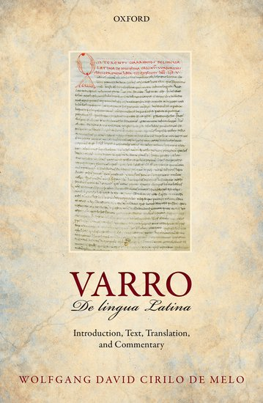
For anyone interested in the way in which Latin varied in different regions and between different classes, the standard texts are by James Adams: The regional diversification of Latin, 600 B.C. – A.D.200 (https://www.amazon.com/Regional-Diversification-Latin-200-BC/dp/1107684587) and
Social variation and the Latin language (https://www.amazon.co.uk/Social-Variation-Latin-Language-Adams/dp/131662949X). Adams is also author of The Latin Sexual Vocabulary, which has been mentioned in Circulus meetings before and which is available at https://monoskop.org/images/7/79/Adams_JN_The_Latin_Sexual_Vocabulary.pdf

The Romans’ own approach to teaching their language is explored in Eleanor Dicey’s Learning Latin the Ancient Way ( https://www.amazon.com/Learning-Latin-Ancient-Way-Textbooks/dp/1107474574), of which John has a copy he can lend on request. The core of their method was the use of bilingual dialogues and narratives and Dicey gives a large number of these, with the Greek translation normally found in the originals replaced by English. More recently, the author has also brought out an introductory textbook of her own incorporating some of the ancient and medieval didactic material: Learn Latin from the Romans: A Complete Introductory Course Using Textbooks from the Roman Empire (https://www.amazon.com/Learn-Latin-Romans-Introductory-Textbooks/dp/1316506193/)

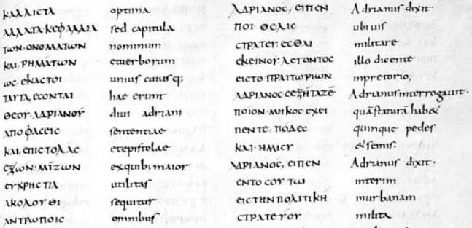From `The Judgements of Hadrian’ in a 9th century manuscript in Leiden University library

In the above extract (discussed on pages 64-69 in Dicey), the emperor Hadrian is interrogating a man who wants to join the army. The first sentence in the right-hand columns, with modern punctuation added, reads: Ἀδριανὸς εῖπεν, «ποι θέλις στρατεύεσθαι;» - Adriānus dīxit “Ubi vis mīlitāre?”
(Hadrian said, “Where do you want to serve?”). Note the spellingt pretorio for classical praetorio in the fourth column but the retention of the older spelling in epistolae in the second.

Confusion in spelling conventions is in facrt a major source of our knowledge of sound changes and another type of error is hypercorrection – in republican time, for example, the Greek loan word σκηνή (skēnē) was regularly spelled scaena, even though there was no diphthong in the original. People were evidently aware that the new, `mistaken’ `e’ pronunciation was reflected in mis-spellings and wrongly assumed that scena should be corrected to scaena. In the 2017 correspondence, de Μello noted this phenomenon perating in English also. He had himself heard kitchen pronounced as kitching’, presumably because people were aware the pronunciation runnin was a mistake for running and some speakers assumed a similar error here.

There was also mention again of the equivalents for `play’ a musical instrument, and after the meeting both Eugene and John looked up various examples. It appears that pulsāre (`strike’) plus the accusative was sometimes also used of stringed instruments, and that ūtī `(use’), personāre (`to sound through and through’, ``to fill with sound’) and resonāre (to resound, echo), used with the ablative, were also found. The verb psallere (`play upon a stringed instrument’), either on its own or with an ablative, is particularly common in the Bible but also occurs in classical authors like Sallust or Aulus Gellius. Particularly as there is in any case a dispute over whether piano should be classed as a string or percussion instrument, we could therefore in neo-Latin say clāvichordium pulsāre (similar to the medival Latin orgānum pulsāre). Though John will probably stick with clāvichordiō cantāre.

We read chapter 19 of Ad Alpēs (see the text below), much of which was about elephants, including Hannibal’s supposed use of rafts to get his across the Rhone during his advance to the Alps. Pat pointed out that there had been a distinct North African elephant species, smaller than the present-day African elephant. According to one article on the web, the last North African elephant was shot by a hunter in 1920 (https://www.smithsonianmag.com/science-nature/the-truth-about-lions-11558237/)

We also looked at the correspondence between John and Jesse (`Magister’) Craft about a small error in one of the latters excellent Minecraft Latin videos: `Odyssea Magistri Craft – 3 (Mare Nostrum)’. This is available at https://www.youtube.com/watch?v=TJ1MF7XR2c4 and past of a large collection in which viewers can choose either Latin or English subtitle. The mistake was the use of accusative mē instead of the correct dative mihi in the sentences Mēne dās pānem and Mēne dās aquam? Jesse promptly corrected mene in the subtitles to mīne (a contraction of mihine). This is not too dissimilar to mēne, which has for the moment to remain in the soundtrack as correction there would entail a complete re-recording.
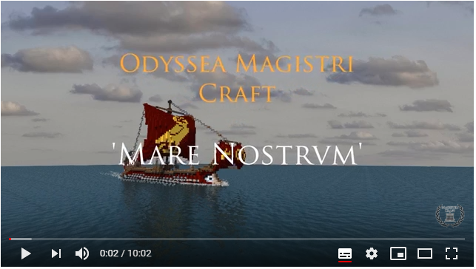
As luck would have it, John later realized that in the email pointing out Jesse’s error he had made several slips of his own and members were invited to identify these as well as explaining the original mistake (see the text of the emails below).

We also discussed the treatment of non-Latin names and the alternative methods of Latinizing them or treating them as indeclinable nouns. Following Biblical precedent, Sam could remain Samuel in every case, or don full Roman dress as Samuel, Samuēlis. Yet another suggestion was that he might cal himself Eduardus (`Teddy’) in memory of the Latvian Order of the Bearslayer, an honour which was bestowed on various Latvians and foreigners between 1919 and 1928. This was more properly known as the Order of Lāčplēsis, the hero of the Latvian national epic (see for further details)
https://en.wikipedia.org/wiki/Order_of_L%C4%81%C4%8Dpl%C4%93sis)

Still on the topic of names, we referred again to the sexist custom under which Roman women were normally called simply by their clan name, in contrast to the praenōmen, nōmen and cognōmen borne by upper-class Roman males – this `Gaius Julius Caesar’, in contrast to his daughter’s plain `Julia’. There is a good account at https://alison-morton.com/2014/08/18/whats-in-a-roman-name/, where author Alison Morton explains that in early times women did in fact have more complex names but by the end of the republic were using just the clan ones. If there was more than one daughter in a household, an ordinal number or an adjective from the family cognomen could be used (e.g. Iūlia Tertia), whilst a wife retained her natal name so would be readily distinguishable from everyone else in the marital home.

We noted the use of in Ad Alpes of Appia via for the trunk road linking Rome and Brundisium. Normal usage would be via Appia in Latin, in line with the tendency for adjectives of quality (as against size or quantity) to follow thir nouns. However, this rule was not invariable so Nutting did not actually make a mistake. In English, of course, the name has to be `Appian Way’.

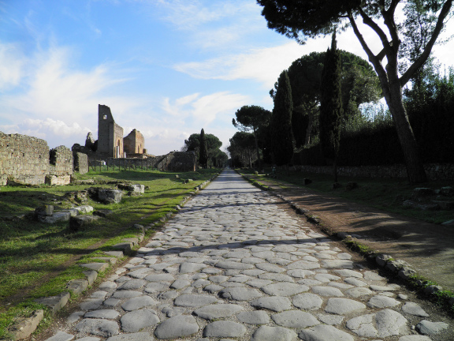
The Appian Way near the Villa di Quintili just south of Rome
https://followinghadrian.com/2013/06/21/wandering-along-the-appian-way-images-from-milestone-i-to-vi/

Finally, Zhang Wei told us about the exhibition of Leonardo Da Vinci manuscripts at City U which will be on until 15 December. Details at https://www.cityu.edu.hk/ceg/exhibitions/daVinci

AD ALPES - CHAPTER XVIII

Māne aliquantum morae factum est, quod ūnus ex equīs claudus esse vidēbātur, aliusque
In-the-morning something of-delay made was because one out-of horses lame to-be seemed and-another
quaerendus erat. Interim Cornēlius cum fīliīs per oppidum vagābātur, ac pater puerīs multa
needing-to-be-sought was meanwhile Cornelius with sons through town was-wandering and father to-boys many-things
nārrāvit dē proeliō ibi commissō, quō Pyrrhus rēx ā Māniō Curiō superātus est.
told about battle there fought in-which Pyrrhus king by Manius Curius defeated was
Cum postrēmō Appiā viā veherentur, Sextō Cornēlia: “Quid, obsecrō, vīdistī,” inquit,
When finally on-Appian Way they-were-travelling to-Sextus Cornelia what please did-you-see said
“dum per oppidum ambulābās?”
while through town you-were-walking
“Nihil mīrandum vīdimus,” inquit Sextus. “Sed quaedam audīvī dē rēge Pyrrhō et
Nothing out-of-the-ordinary we-saw said Sextus but certain-things I-heard about king Pyrrhus and
elephantīs, quōs ille prīmus in Ītaliam trādūxit, quīque vulgō 'bovēs Lūcae' appellābantur,
elephants which he first into Italy brought-across and-which commonly cattle Lucanian were-called
quod eōrum genus ignōtum erat ac bēstiae prīmum in Lūcāniā vīsae sunt.''
Because their species unknown was and the-beasts first in Lucania seen were
At Cornēlia: “Vellem ego quoque tum adfuissem. Nam dē omnis generis ferīs
But Cornelia wish I also then I-had-been-present for about of-every kind wild-animals
libentissimē audiō.”
most-gladly I-hear
“Dē elephantīs,” inquit, Pūblius, “nōn omnia tum commemorāta sunt. Ōlim fābulam
Abouit elephants said Publius non all-things then related were once story
lēgī, quae fortasse vōbīs iūcunda vidēbitur: “In proeliō, quod ad Thapsum commissum est,
I-read which perhaps to-you pleasant will-seem in battle which at Thapsus fought was
virtūs cuiusdam mīlitis legiōnis quīntae maximē ēnituit. Nam cum in sinistrō cornū elephantus
courage of—a-certain soldier of-legion 5th very-greatly was-conspicuous for when on left wing elephant
vulnerātus et dolōre incitātus in lixam inermem impetum fēcisset hominemque sub pede
wounded and by-pain goaded on camp-follower unarmed attack had-made and-man under foot
prēmeret et necāret, mīles ille sustinēre nōn potuit, quīn sē armātum bēstiae offerret.
Was-pressing and killing soldier that to-refrain not was-able from himself armed to-beast presenting
“Quem postquam elephantus ad sē tēlō īnfēstō venīre ānimadvertit, lixā relictō,
him after elephant towards self with-weapon hostile to-come noticed with-campfollower released
mīlitem circumdedit proboscide, atque altē sustulit. Ille interim cōnstanter sē gessit, ac
soldier surrounded with-trunk and high lifted-up he meanwhile unwaveringly self conducted and
proboscidem, quantum vīribus poterat, gladiō caedébat; nec fīnis fuit, priusquam elephantus,
trunk as-much-as with-strength he-could with-sword continued-cutting nor end was before elephant
dolōre adductus, abiectō mīlite, maximō cum strīdōre ad reliquās bēstiās sē recēpit.”
by-pain driven thrown-aside soldier loudest with shriek to other beasts self took-back
“Mīles ille,” inquit Sextus, “profectō fortissimus erat, quī tantō perīculō sē committeret.
Soldier that said Sextus undoubtedly very-brave was who to-such-great danger self exposed
Nam vīrēs multitūdinis hominum vix cum rōbore ūnīus elephantī sunt comparandae.''
For strength of-crowd of-men scarcely with power of-one elephant is comparable
“Rēs ita sē habet,” inquit, Cornēlius; “atquī interdum elephantī â mīlitibus singulīs
Thing thus itself has said Cornelius and-yet sometimes elephants by soldiers individual
occīsī sunt. Velut dīcitur Hannibal, cum captīvōs Rōmānōs quondam inter sē dīmicāre
killed have-been for-example is-said Hannibal when captives Roman once among selves to-fight
coēgisset, ūnum, quī supererat, elephantō obiēcisse, lībertātem hominī pollicitus, sī bēstiam
he-had-forced one who had-survived to-elephant to-have-exposed freedom to-man having-promised if beast
occīdisset.
he-killed
“Rōmānus sōlus in harēnam prōgressus, magnō Poenōrum dolōre elephantum cōnfēcit,
Roman alone into arena having-advanced to-great of-Carthaginians sorrow elephant finished-off
ac līberātus est. Sed Hannibal, ut apud Plīnium est, bēstiās fāmā huius dīmicātiōnis in
and freed was but Hannibal as in Pliny it-is beasts by-report of-this fight into
cōntemptum Rōmānīs ventūrās esse ratus, equitēs mīsit, quī victōrem abeuntem
contempt among-Romans going-to-come to-be having-thought cavalry sent who victor departing
sequerentur atque occīderent.”
could-follow and kill
“Mihi vix crēdibile vidētur,” inquit, Pūblius, “Hannibalem ita fidem fallere voluisse;
To-me scarcely believable it-seems said Publius Hannibal thus promise to-break to-have-wanted

nam ego eum, etsī Poenus erat, hostem generōsum fuisse semper putāvī.”
for I him although Carthaginian he-was enemy generous to-have-been always have-thought
At Cornēlius: “Fortasse id, quod modo dīxī, falsō trāditum est.” Tum ad Sextum et
But Cornelius perhaps that which just-now I-said falsely handed-down has-been then to Sextus and
Cornêliam conversus: “Vōsnē līberī scītis, quō modō Hannibal elephantōs suōs flūmen
Cornelia having-turned do-you children know in-what way Hannibal elephants his river
Rhodanum trādūxerit?”
Rhône got-across
“Nescīmus,” inquit Cornēlia. “Nōnne vīs hoc quoque nōbīs nārrāre?”
We-don’t-know said Cornelia Don’t you-wish this also to-us to-tell
Tum pater: “Sunt quī trādant elephantōs nandō ad alteram rīpam trānsīsse; sed magis
Then father there-are those-who pass-on elephants by-swimming to other bank to-have-crossed but more
cōnstat ratibus eōs trānsvectōs esse.
is-consensus on-rafts them brought-over to-have-been
“Mīlitēs ratem pedēs ducentōs longam in flūmen porrēctam terrā iniectā ita
Sooldiers raft feet two-hundred long into river stretched-out with-earth thrown-on in-such-way
cōnstrāvērunt, ut pontis speciem habēret; tum altera ratis centum pedum, ad trānseundum
covered that of-bridge appearance it-had then another raft hundred of-feet for going-across

apta, huic coniūncta est. Elephantī prīmī, per stabilem ratem quasi per pontem āctī, in
fit to-this joined was elephants the-first across stable raft as-if over bridge driven into
minōrem sine timōre prōgressī sunt.
smaller-one without fear advanced
“Tum subitō vincula sunt solūta, ac ratis minor aliquot nāvibus āctuāriīs celeriter ad
Then suddenly cables were untied and raft smaller some by-boats swift quickly to
rīpam alteram rapiēbātur. Ibi prīmīs expositīs, elephantī aliī deinde repetītī sunt et
bank other began-to-be-whisked-away there with-first-ones unloaded elephants other then gone-back-for were and
trāductī.
taken-across
“Nihil sānē timēbant bēstiae, dum velut per continentem pontem agēbantur. Cum ratis
of-nothing indeed were-afraid beasts while as-if over a-solid bridge they-were-drivan when raft
minor ab alterā solverētur, tum prīmus erat terror; atque, extrēmīs ab aquā cēdentibus,
smaller from other was-untied then first was fear and with-those-on-edge from water drwing-back
trepidātiōnis tantum ēdēbant, ut in flūmen exciderent quīdam. Hī autem, pondere suō stabilēs,
of-panic so-much they-produced that into river fell-off some these however by-weight own stabilised
vada pedibus quaerēbant, ac postrēmō incolumês in rīpam ulteriōrem ēvāsērunt.”
shallows on-foot began-seeking and finally safely onto bank further they-emerged
“Vērumnē est,” inquit, Pūblius, “elephantōs mūrēs aut ōdisse aut timēre?”
True-? It-is said Publius elephants mice either to-hate or fear
“Ita vērō,” inquit Cornēlius. “In Indiā autem et Āfricā sunt mōnstra, quae nōn sine causā
Thus indeed said Cornelius in India moreover and Africa are monsters which not without cause
ab eīs metuuntur; nam ibi nāscuntur serpentēs tantae magnitūdinis, ut facile elephantōs
by them are-feared for there are-born serpents of-such-great size that easily elephants
orbibus suīs obligent. Interdum et elephantus et serpēns simul pereunt, cum elephantus
in-coils their they-bind sometimes both elephant and serpent at-same-time perish since elephant
corruēns pondere suō serpentem ēlīdat.'?
collpasing with-weight its-own serpent crushes
“Väh!” inquit Cornēlia. “Rem audītū quam foedam!”
Waah said Corneli thing to-hear how disgusting
At Pūblius: “Ego quidem mihi videor recordārī ā quibusdam prō certō scrīptum esse
But Publius I indeed to-myself seem to-recall by certain—people as certain written to-have-been
serpentēs in Indiā tantam ad magnitūdinem pervenīre, ut solidōs hauriant cervōs taurōsque.
serpents in India such-great to size to- reach that whole they-swallow deer and-bulls
Atque omnibus nōtum est, bellō prīmō Pūnicō ad flūmen Bagradam ā Rēgulō imperātōre
And to-all known it-is in-war first Punic at river Bagradas by Regulus general
serpentem centum vīgintī pedēs longam ballistīs expugnātam esse.”
serpent hundred twenty feet long with-siege-engines overcome to-have-been

“Dēsine, obsecrō,” inquit, Cornēlia. “Sī tālia nārrātūrus es, ego hāc in raedā nōn diūtius
Stop I-beg saidd Cornelia if such-things going-to-tell you-are I this in wagon not longer
morābor.”
will-stay
“Quiētō es animó,” inquit frāter; “nam fīnem iam fēcī.” Tum Cornēliō: “Quod ad
With-quiet be mind said bro9ther for end already I-have-made then to-Cornelius which to
oppidum, pater, iam tendimus?”
town father now we-are-heading
Ac Cornēlius: “Caudium brevī adībimus; et spērō hodiē nōs etiam Capuam usque iter
And Cornelius Caudium soon we-will-reach and I-hope today us also Capua as-far-as journey
facere posse.”
to-make to-be-able
“Nōnne Samnītēs,” inquit, Pūblius, “clādem maximam in hīs regiōnibus populō
Didn’t Samnites said Publius disaster very-great in these regions on-people
Rōmānō, ōlim intulērunt?” “Rēctē quaeris,” inquit Cornēlius; “nam haud longē absunt
Roman once inflict rightly you-ask said Cornelius for not far are-away
Furculae Caudīnae, ubi exercitus Rōmānus sub iugum īre coāctus est.''
Forks Caudine where army Roman under yoke to-go forced was
“Quid est, quod ā tē audiō?” inquit Sextus. “An nostrī militēs umquam tantā
What is-it that from you I-hear said Sextus [Qu] our soldiers ever by-so-great
ignōminiā adfectī sunt?”
humiliation affected were
“Vellem id vērē negārī posse,” inquit, pater. “Sed cōnfitendum est nōn tum sōlum tāle
I-would-like it truly to-be-denied to-be-able said father but necessary-to-confess it-is not then only such
dēdecus admissum esse. Velut apud Horātium Flaccum, ille Rēgulus, dē quō modo audīvistis,
disgrace suffered to-have-been for-example in Horace Flaccus that Regulus about whom just-now you-heard
cum ex Āfricā Rōmam revertisset:
when from Africa to-Rome he-had-returned
“’Signa ego Pūnicīs
Standards I to-Punic
Adfixa dēlūbrīs et arma,
Fixed temples and weapons
Mīlitibus sine caede,' dīxit,
From-soldiers without slaughter said
‘Ēreptā vīdī; vīdī ego cīvium
Snatched-away I-have-seen I-have-seen of-citizens
Retorta tergō bracchia līberō.'”
Tied-behind back arms free

“Haec certē foedissima sunt,” inquit Sextus; “sed, sī tibi nōn est molestum, dē proeliō
These-things certainly very-digraceful are said Sextus but if to-you not is troublesome about bttle
audiāmus, quod in hīs locīs commissum est.”
let-us-hear which in these places fought was
At Cornēlius: “Quādam in convalle undique angustiīs et collibus clausā, Rōmānī, in
But Cornelius a-certain in valley on-all-sides by-defiles and hills enclosed Romans in
īnsidiās dēlātī, omnibus ex partibus ab hostibus circumventī sunt. Quārē, cum nē in virtūte
ambush brought all from sides by enemies surrounded were thus since not in courage
quidem spēs ūlla salūtis esset, nostrī summam ad dēspērātiōnem pervênêrunt. Tum hostēs sē
even hope any of-safety was our-men gretest to desperation reached then enemy
Rōmānōs, sub iugum missōs, cum singulīs vestīmentīs incolumēs abīre passūrōs pollicitī sunt.
Romans under yoke sent with one-each garment safe to-leave going-to-allow promised
“Condiciōne acceptā, prīmī prōgrediēbantur cōnsulēs sēminūdī, deinde cēterī, cum
With-condition accepted first began-moving-forward consuls half-naked then the-rest while
interim circumstābant hostēs exprōbrantēs atque ēlūdentés. Quīn etiam gladiī sunt dēstrictī, ac
meanwhile were-standing-round enemy mocking and jeering indeed also swords were drawn and
Rōmānī aut vulnerātī aut occīsī sunt, quōrum vultūs victōrēs offenderant.
Romans either wounded or killed were whose expressions victors had-offended
“Nostrī, cum omnēs sub iugum missī essent, etsī ante noctem Capuam pervenīre
Our -men when all uder yoke sent had-beeen although before night Capua to-reach
poterant, dē fidê sociōrum incertī, oppidum adīre nōn ausī sunt, ac prope viam passim humī
were-able about loyalty of-allies uncertain town to-approavh not dared and near road everywhere on-ground
corpora prōstrāvērunt. Quod ubi Capuam dēlātum est, oppidānī, commeātū benignē missō,
bodies had-laid-down which-thing when to-Capua was-reported townsmen with-supplies kindly sent
summā cōmitātē Rōmānōs hospitiō recēpērunt.
with-greatest friendliness Romans with-hospitality received
“Interim Rōmae maestitia summa erat; quō cum cōnsulēs vīctī redīssent, senātū vocātō,
Meanwhile at-Rome sorrow greatest was there when consuls defeated had-returned with-senate called
dēcrētum est ut Samnītibus nūntiārētur irritam esse pācem ā cōnsulibus cōnfirmātam, quod
decreed it-was that to-Samnites it-be-announced void to-be peace by consuls confirmed because
iniussū populī facta esset. Nē quis autem dīcere posset Rōmānōs fidem fefellisse, senātus
without-order of-people made had-been lest anyone however say could Romans promise broke senate
praetereā dēcrēvit ut cōnsulēs, quī suō arbitriō pācem fēcerant, vīnctī hostibus trāderentur.”
besides decreed that sonsuls who by-own decision peace had-made bound to-enemy should-be-handed
“Nōnne cōnsulēs id recūsāvērunt?” inquit Sextus. “Nam tālēs captīvōs omnī cruciātū
Didn’t consuls that refuse said Sextus for such prisoners with-every torture
necāre putō hostibus licuisse.”
to-kill I-think to-enemy to-have-been-permitted
At pater: “Immō alter ex cōnsulibus id ipse vehementer suāsit, rem pūblicam ita omnī
But father on-the-contrary one out-of consuls this himself forcefully urged state thus from-all
religiōne līberātam ratus, sī eī, quī pācem illam fēcerant, hostibus dēditi essent.
religious-obligation freed having-thought if those who peace that had-made to-enemy surrendered had-been
“Itaque cōnsulēs sine morā magistrātū sē abdicāvērunt, ac Caudium sunt dēductī;
And-so consuls without delay from-magistracy themselves removed and to-Caudium were taken
cumque ad portam urbis perventum esset, veste dētractā manūs eīs post tergum retortae sunt.
and-when to gate of-city reached had-been with-clothing pulled-off hands for-them behind back tied were
“Ubi ad tribūnal imperātōris hostium vēnērunt Rōmānī, atque ante eum stābant
When to tribunal of-commander of-enemy came Romans and before him were-standing
cōnsulēs vīnctī, ille īrā incēnsus negāvit rem ita compōnī posse, omnēsque Rōmam dīmīsit.
consuls tied-up he with-anger inflamed denied matter thus to-be-settled to-be-able and-all to-Rome sent-off
Iūris haud perītus, scīlicet sēcum male āctum esse exīstimāvit; et paulō post bellum ācriter
in-law not expert to-be-sure with-himself badly done to-have-been he-reckoned and a-little later war fiercely
renovātum est.”
renewed was
Ut haec dicta sunt, Stasimus in oppidum Caudium praemissus est, ut quaereret
When these-things said were Stasimus into town Caudium sent-ahead was so he-could-seek
dēversōrium, ubi viātōrēs edendō vīrēs reficerent, priusquam Capuam inciperent iter tendere
inn where travellers by-eating strength could-replenish before to-Capua they-started journey to-make

To Jesse Craft 7/9/19 ò

Salve, Jesse

Mense Iunio de quibusdam erroribus minimi moment in pelliculis tuis optimis inter nos communicabamus. Heri cum discipulo tertiam partem operis tui c.t, `Odyssea 3’ spectans, animadverti duas sententias quas puto esse corrigendas. Nonne pro `Mene aquam/panem das’ dicendum est `Mihine aquam/panem das?’ Vel `Mihi aquam/panem da, quaeso’?

Textus epistulae quam astate misi iam amissus est, itaque non sum certus me horum sententiarum mentionem non fecisse. Si me memoria senilis revere fefalilt, veniam posco.

Optime vale

From Jesse 7/9/19

Eheu! Est dedecori mihi. Gratias plurimas tibi ago quod hoc, vel, haec invenisti. Nescio quomodo possibile sit quia ego et Lucius Ranieri hanc partem et perlegimus et recitavimus sed nullum corrigendum vidimus! Bene se habet quia nunc statim muto librum et postea subtitulos pelliculae. Gratias iterum tibi ago!
Response: Libenter! Ego quoque valde miror tot errores in scriptis meis inveniri,

___ nōmen / prōnōmen cāsū nominātīvō / accūsātīvō / genitīvō / datīvō .ablātīvō esse dēbet
The noun / pronoun_______ should be in the nominative / accusative …

Prō X scrībendum erat Y
Instead of X, Y should have been written

Answers:
1.`mē’ prōnōmen cāsū datīvō esse dēbet
2.. Prō `moment’ scribendum erat `momenti’
3. Prō `asatate’ scribendum erat `aestate’
4. Prō `revere fefalilt’ scribendum erat `revera fefallit’
QUESTIONS ARISING FROM 105th MEETING 22/11/19

Whilst ordering food we briefly discussed the history of chilli, which Rene thought might have originated in India rather than his native Mexico. Later fact-checking confirmed that Mexico is indeed the source (see https://en.wikipedia.org/wiki/Chili_pepper) and the only real dispute is whether the plant was first brought to Asia by the Portuguese via Goa or the Spanish via the Philippines, but it seems to be agreed that Portuguese missionaries brought it to Japan in 1542, from where it entered Korea.

Despite its ubiquitous use in Indian cuisine, chilli is thus a relatively recent import, as are potatoes, carrots, peas, cauliflower and tomatoes, as well as naan, which originated in Central Asia and whose name is simply the Persian word for bread. The contrast between modern Indian food and the strictly traditional dishes served in southern India at shraddha meals eaten in honour of a family’s ancestors is explored at http://www.bbc.com/travel/story/20190609-the-surprising-truth-about-indian-food

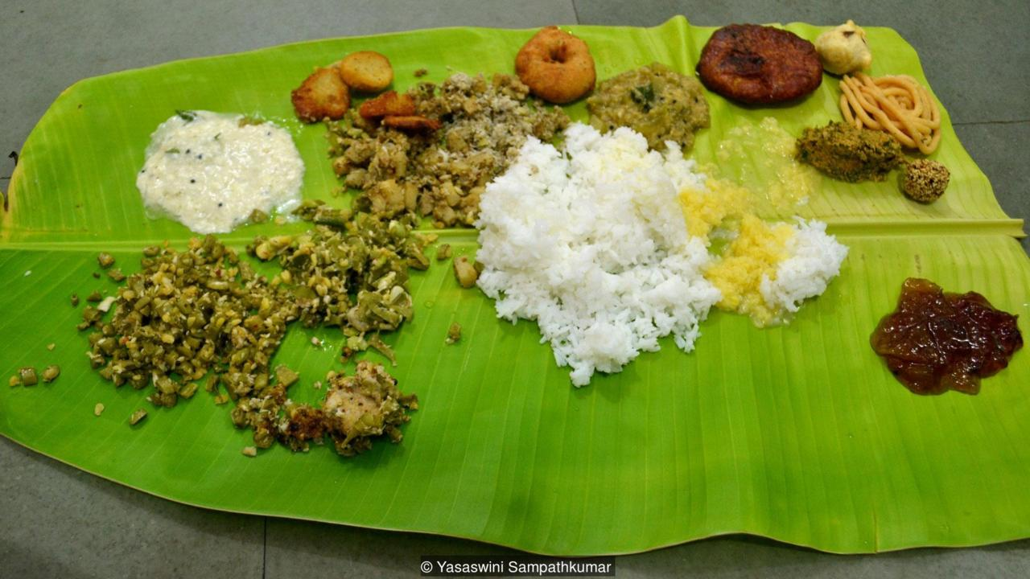

An authentic Indian meal

Before the arrival of chilli Asians did, of course have other ways of spicing up their dishes, using peppers native to the region, such as black pepper. This still grows wild in Hong Kong, though, as Pat and Don pointed out when this topic was discussed before, the character 胡 (= imported) in the name for pepper (胡椒 (Cantonese wu jiu, Putonghua hu jiao)) shows it was regarded as non-indigenous over China as a whole. Black pepper appears to have been indigenous to more southerly regions within Asia.

Locating references to chilli in the record of our earlier meetings was made more difficult, because of the different spellings in use. `Chilli’ is the standard spelling in the UK and `chili’ in the USA, although in the latter case `chile’ is an acceptable variant in America. The word itself comes from the Nahuatll language spoken by the Aztecs and the ealiest transcriptions of the word is `chilli’, as in British orthography. The ealiest spelling in English is`chille’ (1662). For a full discussion see the article at
https://www.grammarphobia.com/blog/2013/09/chili-chile-or-chilli.html

We discussed a picture from the Quomodoloquitur site (see below) in which a creature with a horse’s head and a man’s body looks through a fence at a normal horse. In a comment posted on the site (http://quomododicitur.com/2019/10/21/qdp-ep-150-de-imagine-satis-ridicula/#comments). `Patavinus’ suggested that the hybrid was in fact the adult Pinocchio, who, when a boy, had been turned into a donkey with a friend after they had run away from school to the Land of Toys. In the original story. Pinocchio had eventually been turned from a donkey into a puppet again and then finally to a real boy, thanks to the intervention of the Blue Fairy. Patavinus thinks that in later life he and his friend ran off to Las Vegas and began patronizing street walkers, whereupon as a punishment the Blue Fairy, now married to Pinocchio, turned them into horses. Pinocchio, whose transformation has just begun, looks in horror at his friend in fully equine state.

An alternative explanation was suggested by Tanya who thought the hybrid was actually a horse having a bad dream in which after eating psychedelic mushrooms he starts turning into a semi-human, yet he is still able to look back through time and sees himself before he made his terrible mistake.

Yet another explanation was offered by sam, who thought the creature might be a centaur with his body parts reversed.

On the language front, we wondered about Patavinus’s use of faga for `fairy’, as we couldn’t find the word in any dictionary. John thought that nympha was the closest Latin equivalent, and this word is suggested, along with nūmen and dīva in the Morgan-Owens lexicon (http://neolatinlexicon.org), whilst Smith-Hall thinks nūmen the best general equivalent. The problem with nūmen, however, is that it can cover any supranatural agency, including the major gods.

The word fairy itself derives ultimately from hypothetical Vulgar Latin fāta, -ae f. `fate’ or `goddess of fate’, which appears to have been a reinterpretation of the neuter plural fāta (from fātum, -ī n, fate). The word arrived in English around 1300 as a borrowing of Old French faerie (`land of fairies, magic, witchcraft’) with the meaning of an individual fairy developing later. Towards the end of the 14th century, Old French fae (Modern French fée) was itself borrowed as the now archaic fay (preserved in `Morgan the Fay’ of Arthurian legend).

We read part of chapter 19 of Ad Alpēs, which mainly covers the eruption of Vesuvius as described by Pliny the Younger in two of his most famous letters but reached only as far as the point where Pliny the Elder and his companions, deciding they were better off outside than waiting indors for the roof to collapse, equipped themselves with pillows to protect their heads from falling pumice stones and torches to find their way in the darkness ( lūminibus viam explōrāre necesse erat, pg. 111, l.60 in the Latinitium edition; pg. 54 in my ad_alpes_ii__interlinear_.doc)

The original letters were read in the March 2014 meeting of the Circulus, when we discussed the treatment of the story in the 2014 film `Pompeii’. Text and translation of the Pliny letters themselves and of two modern letters on the film are available in vesuvius_transl_.doc, which can be downloaded from https://linguae.weebly.com/pliny.html There is an extremely detailed presentation of Pliny’s text, with description of the manuscript tradition, translation, full explanation of the physical background, and stylistic analysis at https://quemdixerechaos.com/2012/11/19/translatingplinypt1/ and linked pages.

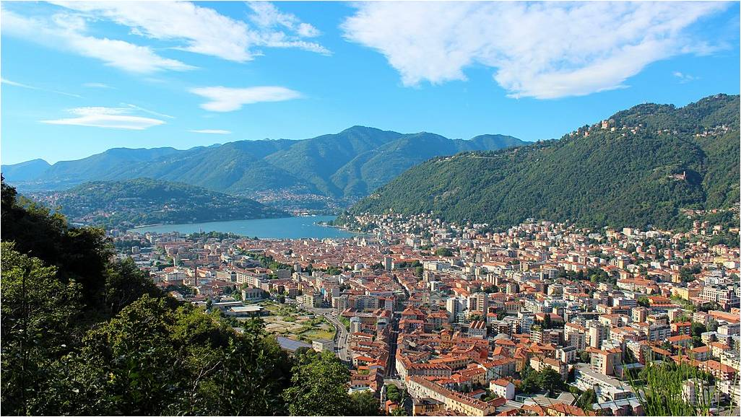
Como (ancient Comum), Pliny's birthplace on Lake Como in northern Italy
https://en.wikipedia.org/wiki/Como#/media/File:Como_and_it's_lake.jpg

We briefly discussed the setting of the Ad Alpēs stories, told by members of the family of Publius Cornelius, who is returning to Italy on the orders of the new emperor, Antonius Pius, in 138, after five years as a provincial administrator in Asia Minor. `Publius’ is his praenōmen (personal name) and `Cornelius’ his nōmen (clan name) and he evidently lacks the cognōmen (family surname) that most upper class Romans would have possessed at this time. He is accompanied by his wife, Drusilla, sons Publius (16-years) and Sextus (12-years), daughter Cornelia (10-years) and infant son Lucius. Also in the party are Onesimus (a middle-aged slave acting as Cornelius’s business manager), Stasimus (a young and mischievous slave) and Anna, the Jewish nanny looking after Lucius.

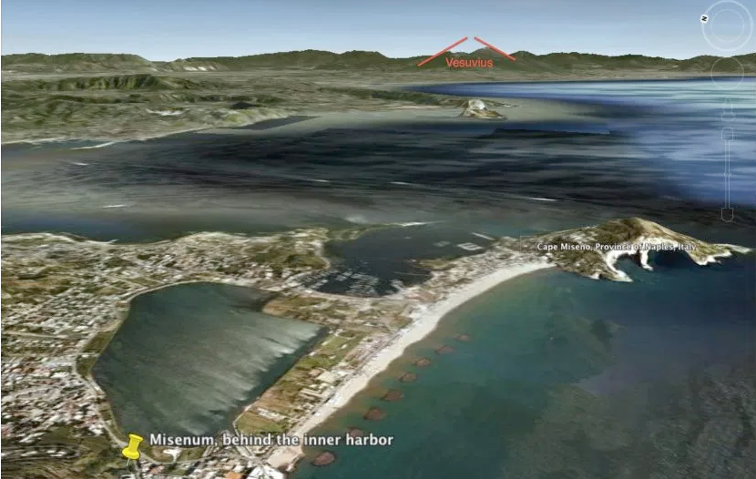
Looking south-east across the Bay of Naples from Misenum towards Vesuvius
https://quemdixerechaos.com/2013/01/01/translatingplinypt6/misenum2vesuviusgooglee3/

Language points that arose whilst reading included the technical terms prōducta (`extended’) and correpta (`compressed’), for long and short vowels respectively. We also noted the two different words for `uncle’ – patruus for father’s brother and avunculus for mother’s brother, the latter being Pliny the Younger’s original relation to the Elder, who subsequently also adopted him. Many cultures, including those of China and South Asia make a similar distinction and there may be a tendency for the maternal uncle (Cantonese kau5fu6,舅父) to be regarded as a `soft touch’ in contrast to the parternal one, who shares to a degree the father’s disciplinary responsibilities. This would mesh with the meaning of `avuncular’ in English and also to an extent with the sometimes pejorative connotations of mama (मामा), the Nepali word for a maternal uncle.

John initially thought there might be a grammatical mistake on page 110 (l.30-31) in the words ōrābat ut sē discrīminī ēriperet as he himself would have preferred ē discrīmine (`get her out of danger’). However subsequent checking in the Lewis & Short dictionary revealed that the plain dative is also allowed, i.e aliquem alicui as well as aliquem ex aliquō ēripere

We noted the wide range of meaning of sinus (-ūs, m), which basically tefers to anything curved in shape, and can mean `bay’, `bosom’ or `lap’. Tan also mentioned her favourite etymological fact, vix.the common derivation of shit and science from proto-Indo-European *skei (cut, split). The underlying semantic link in the first case is through the ide of something becoming separated from the body, and in the second presumably to the metaphorical segmentation of reality in analysing it.

We touched again on the thorny question of coining new Latin words, something vital if we want to discuss modern topics in Latin as well as studying the older texts. There is no ultimate authority for neo-Latin vocabulary but the Lexicon Morgianum (also known as the Morgan-Owens Lexicon), available at http://neolatinlexicon.org/, is the best reference source. This which can be supplemented by books like John Traupman’s Conversational Latin and Robert Maier’s Latein Deutsch Visuelles Wörterbuch. The reliance of the last-mentioned work on illustrations makes it useful even for those who do not read German, though the small print may be a barrier for some of us. An incomplete list of words found useful in past Circulus discussions, CIRCULUS VOCABULARY, plus more specific lists covering Indian food and household objects compiled by Eugene, can be downloaded from the Circulus web page (https://linguae.weebly.com/circulus-latinus-honcongensis.html), just above the location map for the Basmati restaurant. There is a discussion of other reference materials lower down the page

When the standard resources fail us and we need to devise new words or expressions ourselves, it is very much a matter of taste, though we do need to abide by the normal rules of Latin phonology and orthography. Thus in umbrivir (`ghost-man’, i.e. gweilo) the middle vowel has to be `i’ because an original short `a’ is normally replaced by `i’ in word compounds. However, everyone is free to use either this word or Pat’s preferred alternative, vir daemoniacus (`devilish man’).

There are, of course, a number of gweilo who still object to the name itself, and, as John has often pointed out, the cure for this condition is to buy of lend them a copy of Gweilo: a Memoir of a Hong Kong Childhood, Martin Booth’s magical recreation of Hong Kong in the 1950s, seen through the eyes of a 7-year-old British boy.



We learned that our new member. Rene, speaks French, Italian and German as well as his native Spanish. He also picked up a little Hindi when working in Gujarat in western India and is now learning Japanese in Causeway Bay, just down the road from Dante, where John, the sole northern barbarian on the staff, teaches Latin. John struggles to get his tongue round any non-English sounds, and it is convenient that the native speakers of Latin are all dead, thus sparing him great embarrassment. The general standard of spoken Latin nowadays is so low, even among professional Latinists, that even minimal fluency makes you look good: inter caecōs luscus rēx (`in the kingdom of the blind, the one-eyed man is king’)

DĒ PICTŪRĀ MĪRĀBIlĪ

Picture offered for discussion with Episode 150 of Quomododicitur (October 2019)
http://quomododicitur.com/2019/10/21/qdp-ep-150-de-imagine-satis-ridicula/#comments

Quid in pictūrā censēs fierī? What do you rthink is going on in the picture?

Quid cēnsēs anteā factum? What do you think happened before?

capite equī With the head of a horse

corpore equī With the body of a man

in________ mūtātus est has been changed into _______

AD ALPĒS CAPUT XIX

Cum hōram ūnam Caudiī morātī essent, raedīs iterum profectī sunt. Dumque per rūra
When hour one at Caudium stayed they-had in-wagons again th ey set out and-while through countryside amoena celeriter vehuntur, Cornēlia: “Vidētisnē,” inquit, “cacūmen montis illīus, quī nūbibus
charming quickly they-are-conveyed Cornelia do-you-see said summit of-mountain that which with-clouds
miscērī vidētur?” Quibus verbīs mōnstrāvit montem ingentem, quī ad occidentem plānē
to-be-mixed seems with-which words he-showed mountain huge which to west clearly
aspicī poterat.
be-seen could
Et pater: “Hic,” inquit, “est mōns ille Vesuvius, quī semel atque iterum agrōs et urbēs
And father this he-said is mountain that-famous Vesuvius which once and again fields and cities
fīnitimās magnā clāde obruit.”
neighbouring in-great disaster overwhelmed
“Dē istīs rēbus,” inquit Sextus, “ego numquam audīvī. Dē hīs amplius, sī vīs.”
About those things said Sextus I never have-heard about them more if you-will
“Ē nātūrā locī,” inquit pater, “facile appāret etiam antīquitus clādēs maximās ibi
From-nature of-place said fother easily it-appears even in-olden-time disasters very-great there
exstitisse; sed patrum memoriā facta est nōtissima illa calamitās, dē quā Plīnius loquitur in
to-have-occurred but of-fathers in-mmory happened most-famous that disaster about which Pliny speaks in
litterīs, quās ad Tacitum, familiārem suum, scrīpsit. Fortasse Pūblius, sī hās lēgit, vōbīs
letters which to Tacitus close-friend his wrote perhaps Pulblius if these he-has-read to-you
nārrābit quid ibi invēnerit.”
Will-tell what there he-found
Quā cohortātiōne inductus Pūblius: “Plīniō erat avunculus eiusdem nōminis, quī tum
By-which encouragement swayed Pulius to-Pliny was uncle of-same name who then
erat praefectus classī, quae Misēnī agēbat. Ille Plīnius maior opus magnum cōnficiēbat, cui
was commander for-fleet which at-Misenun operated That Pliny the-elder work great was-completing for-which
est nōmen “Nātūrālis Historia'; ac summō studiō exquīrēbat omnia, quae mīranda et
is name Natural history and with-greatest enthusiasm was-investigating all-things which wonderous and
vīsū aut audītū digna vidébantur.
seeing or hearing worth seemed
“Itaque ōlim, cum subitó eī nūntiātum esset in caelō appārēre nūbem īnsolitâ
And-so once when suddenly to-him announced had-been in sky to-appear cloud with-unusual
magnitūdine et specié, ex aedibus ēgressus ēscendit locum, unde commodissimè mirāculum
size and appearance out-of house having-gone climbed-to place from-which most-conveniently wonder
illud cōnspicī poterat.
That be-observed could
“Ibi cognōvit fūmum, immēnsae nūbī similem, orīrī ex monte, quī procul in adversō
There he-found smoke to-immense cloud similar to-be-arising from mountain which far-off on opposite
lītore stābat. Quārē statim Liburnicam parārī iussit, ut sinum trānsīre et rem tam mīrābilem
shore stood therefore at-once light-galley to-be-prepared he-ordered so-that bay to-cross and thing so amazing
propius nōscere posset.
from-closer investigate he-could
“Sed iam advēnit tabellārius, litterās adferēns cuiusdam mulieris, quae in vīllā Vesuviō
But now arrived courier letter bringing of-certain woman who in villa Vesuvius
subiacente morābātur. Immīnente perīculō perterrita, illa Plīnium ōrābat ut sê discrīminī
lying-under was-staying byimminent danger terrified she Pliny was-begging that her from crisis
ēriperet; nam nisi nāvibus nūllam fugae esse spem. Ille igitur cōnsilium mūtāvit et
might-rescue for except by-ship no of-flight to-be hope he therefore plan changed and
quadrirēmēs aliquot dēdūxit, ut auxilium ferret omnibus, quī ex illō locō effugere vellent.
quadriremes several launhed so-that help he-could-bring to-all who from that place to-escape wanted
“Tum rēctum cursum in perīculum tenuit, cum interim summā dīligentiā observâbat
Then direct course into danger he-maintained when . meanwhile with-greatest diligence he-was-observing
omnia, quae memorātū digna erant. Mox cinis in nāvēs incidere coepit; cum autem
all-things which remembering worth were soon ash onto ships to-fall began when however
monēret gubernātor ut Mīsēnum redīret, ille vērō: “Fortēs,' inquit, “Fortūna adiuvat,' ac
was-advising helmsman that to-Misenum he-should-return he indeed the-brave said fortune helps and
rēctā in perīculum contendit.”
straight into danger hurried
“Ille certê intrepidus erat,” inquit Sextus. “Quem exitum rēs habuit?”
He certainly fearless was said Sextus what ending thing had
At, Pūblius: “Brevī audiēs,” inquit: “Ubi ad lītus nāvēs appulsae sunt, Plīnius in terram
But Publius soon you-wil-hear haid when to shore ships brought had-been Pliny onto land
ēgressus hominēsque trepidantīs cōnsōlātus, sē in balneum dēferrī iussit, ut suā sēcūritāte
having-disembarked and-people in-fear having-consoled himself into bath to-be-carried ordered so-that by-own tranquility
timōrem cēterōrum lēnīret; ac paulō post, cum noctū flammae ex monte relūcērent, dictitābat
fear of-others he-might-alleviate and a-little later when at-night flames from mountain were-glowing he-kept-saying
ab agricolīs ignēs relictōs esse vīllāsque dēsertās ardēre.
by farmers fires left to-have-bdeen and-villas deserted to-be--burning
“Interim flūctūs magnōs in lītus ventus tam adversus volvēbat, ut inde nūllō modō nāvēs
Meanwhile waves great onto shore wind so unfavourable was-rolling that then in-no way ships
solvī possent. Quārē Plīnius quiētī sē dēdit; cumque aliī ānxiā mente vigilārent, ille
set-sail could therefore Pliny to-rest himself gave and-while others with-anxious mind kept-awake he
somnō artissimō quiēscēbat. Postrēmō autem ārea, pūmicibus opplēta, tam altē surrēxerat, ut,
in-sleep deepest was-resting finally however yard in-pumice-stones covered so high had-risen that
sī diūtius intus morārētur, ē cubiculō exīre eī omnīnō nōn licēret.
if longer inside he-stayed from room to-come-out for-him completely not would-be-possible
“Quārē ab amīcīs ex somnō excitātus sē cēterīs reddidit. Tum in commūne cōnsultant
Therefore by friends from sleep awakened himself to-the-rest restored then in common they-consider
utrum in tēctīs maneant, an in apertō vagentur; nam tēcta crēbrīs ac vāstīs tremōribus
whether in buildings they-should-remain or in open roam for buildings from-frequent and great tremors
nūtābant, in apertō autem lapidum cāsus metuēbātur.
were-swaying in open however of-stones fall was-feared
“Tandem exīre cōnstituērunt, et cervīcālia capitibus imposita sunt, quae contrā
At-last to-go-out they-decided and pillows on-heads placed were which against
incidentēs lapidēs mūnīmentō essent. Iam alibī erat diēs, sed illīc nox omnibus noctibus
falling stones protection could-be now elsewhere was day but there night than-all nights
nigrior et dēnsior; quārē lūminibus viam explōrāre necesse erat.
Blacker and more-inpenetrable so with-lights way to-scout-out necessary was
QUESTIONS ARISING FROM 106th MEETING – 20/12/19

Food ordered at the Basmati included iūs lentium butyrātum (daal makhani), batātae cum brassicā Pompēiānā (alu gobi), cicera aromatica (chana masala), carnes assae mixtae (assorted roast meat), melanogēna (eggplant), and cucurbita amāra (karella, bitter gourd), with pānis Persicus (nan), both rēgulāris (plain) and cum āliō (with garlic), and orӯza (plain boiled rice). This was washed down with the usual aqua and/or vīnum rubrum.

We read the remainder of chapter 19 and the first part of chapter 20 (up to the words omnēs rūrsus conticuērunt) from Ad Alpes, which will be found below.

Eugene brought along his copy of Elementa Linguae et Gramaticae Latinae, a reference grammar supplemented by specifically ecclesiastical material and compiled by Cetus Pavanetto, an expert Latinist now in his 80s. Eugene had bought this on the internet but when John later searched for it –on-line it was not available on Amazon or Bookdepository and, although it can be brought from Saleson publications’ own site (https://www.editricelas.it/libreria/libri/) they apparently do not deliver outside Italy.

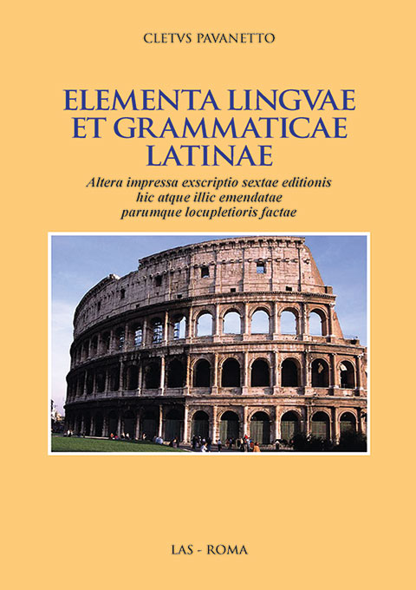

People in Hong Kong (including a colleague of John’s at the school where he first taught) sometimes claim that the Chinese language has no grammar but this is only true if by `grammar’ you just nean inflections of words. There are in fact quite complex rules of word order, so that wan m dou (I can’t find) is correct Cantonese but not *m wan dou or *wan dou m! The system for classical Chinese is, of course, rather different from that in the modern language/

This led on to discussions of general influences on Chinese culture and history. John referred briefly to having read somwhere that genetically there might be more similarities between northern Chinese and gweilo than between the northerners and southern Chinese. Subsequent investigation suggested that this was not reallyso, even if many southerners lack the alcohol-processing gene which gweilo and northerners generally possess. There is nevertheless a definite genetic contrast between the northern and southern southern Han. One article suggested that southerners derive their maternal DNA about half and half from northen Han and from earlier inhabitants of the south (presumably Tai and Austronesian groups) whilst on the paternal side the northern element is predominant (see Yong-Bin Zhao et al.` Ancient DNA Reveals That the Genetic Structure of the Northern Han Chinese Was Shaped Prior to 3,000 Years Ago’, https://journals.plos.org/plosone/article?id=10.1371/journal.pone.0125676). Zhao and his colleagues are mainly concerned to argue that there has not been much genetic alteration among northern Han over the last three millennia but, of course, that population was originally formed from diverse elements, one of which was probably the`Ancient North Eurasian’ population which also contributed to the DNA of early European hunter-gatherers (see Razib Khan, `The Great Genetic Map And History Of China’
https://www.gnxp.com/WordPress/2017/08/01/the-great-genetic-map-of-china/). In any case, on the `Out of Africa’ model which is accepted by almost all mainstream historians and geneticists, though sometimes still challenged on ethnocentric grounds in China and elsewhere, all the different groups ultimately go back to a single stream.

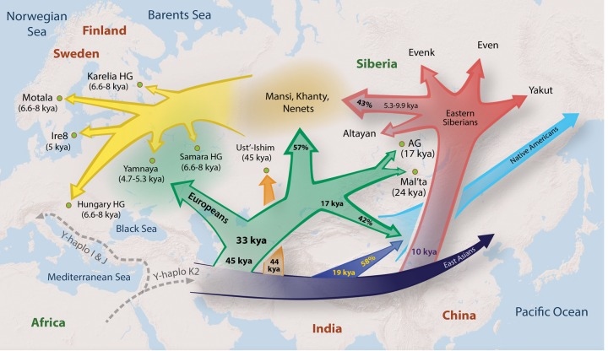
From Emily Wong et al. `Reconstructing genetic history of Siberian and Northeastern European populations’ - https://www.ncbi.nlm.nih.gov/pmc/articles/PMC5204334/

There is no doubt that, even without much recent genetic admixture, northern China was under constant political and cultural pressure from `barbarians’ to their north and west and Zhang Wei pointed out that Buddhism made its entrance into China during a chaotic period with northern tribes penetrating into the heartland. We discussed the arrival of Buddhism in our December 2018 meeting and noted then that this was mainly due to the Kushans whose empire in rthe 2nd. century A.D. stretched from northern India into the Tarim basin. Their ethnic origins are uncertain but Chinese tradition is that they originally were part of a tribal confederacy that in the 2nd century B.C. migrated west from Gansu because of pressure from the Xiongnu ((匈奴). The latter are often equated with the Huns who terrorised Europe some centuries later but this, too, is uncertain.

Whatever the reasons, there remain strong contrasts between northern and southern China and this has led to stereotyping. Wikipedia (https://en.wikipedia.org/wiki/Northern_and_southern_China) offers two illustrative quotations:

`The people of the North are strong; they must not copy the fancy diets of the Southerners, who are physically frail, live in a different environment, and have different stomachs and bowels.’
— the Kangxi Emperor, Tingxun Geyan (《庭訓格言》)

`According to my observation, Northerners are sincere and honest; Southerners are skilled and quick-minded. These are their respective virtues. Yet sincerity and honesty lead to stupidity, whereas skillfulness and quick-mindedness lead to duplicity.’
— Lu Xun, Complete works of Lu Xun (《魯迅全集》), pp. 493–495.

Tan mentioned that the introductory chapter of Pat’s book, Forgotten Heroes: San On County and its Magistrates in the Late Ming and Early Qing, (with partial preview at http://cityupress.edu.hk/Template/Shared/previewSample/9789629373061_preview.pdf) describes the massacre in 1197-1200 of the population of Lantau, who at that time were non-Han tribesmen forced to work as state bond-slaves in the salt fields but continually rising in revolt. Pat explains that shortly before this time the Kowloon peninsula, previously an exclusion zone to reduce smuggling from the salt fields, was opened for Han settlement. The fate of the original inhabitants of Lanatau, and the genetic composition of the southern Han today, suggest that many indigenous males across the region were physically eliminated or at least lost out in the competition with the Han incomers for female partners.

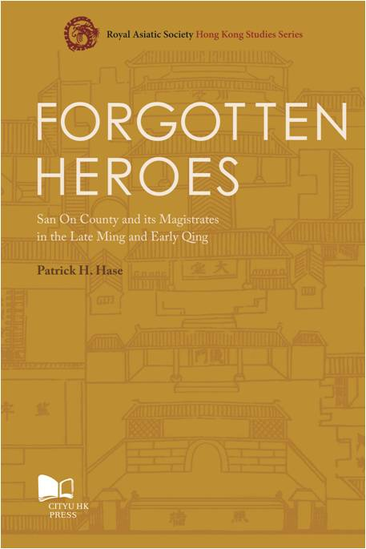

Don is still in Europe but shortly after the meeting posted on facebook a YouTube video outlining a theory that would put the origins of Chinese civilisation in Egypt! The video (https://www.youtube.com/watch?v=HNrFeAY8qO4) is a rather scrappy presentation of the case made by a geochemistry professor at Hefei University of Science and Technology, Sun Weidong. The arguments cited – a description of a river in Sima Qian’s account of the topography of the Xia realm which appears to match the Nile better than any Chinese river and the discovery ofsubmerged pyramids in the Sea of Japan – seem very weak. Sun Weidong’s original arguments may be stronger, but most of the more coherent account of them offered by Ricardo Lewis is behind a paywall (see https://foreignpolicy.com/2016/09/02/did-chinese-civilization-come-from-ancient-egypt-archeological-debate-at-heart-of-china-national-identity/ )

At the end of the YouTube video there is brief mention of a theory first advanced by Chinese scholars in their own language and discussed extensively in English academic writing since at least 1975, most notably in Mike Xu’s 1996 book, Origin of the Olmec Civilization (see https://en.wikipedia.org/wiki/Olmec_alternative_origin_speculations#Epigraphic_evidence)
The claim is that in around 1200, at the end of the Shang period, refugees from China landed in the New World and founded, or greatly influenced this culture which flourished in northern Mexico, Yu’s principal argument is the alleged similarity of symbols on some Olmec objects with Shang dynasty Chinese characters. However, this idea is not accepted by most specialists om Mesoamerica and Zhang He has shown that the alleged similarity in writing systems is down to chance resemblance (see his 2017 Sino-Platonic paper at http://sino-platonic.org/complete/spp273_olmec_chinese_writing.pdf)

Tanya mentioned the origin myth of the Korean people, according to which their first king, Dangun, was the grandson of the divine Hwanin, Lord of Heaven. Hwanin’s son. Hwanung, left heaven to live on earth where he established the `City of God’ on Mt. Baekdu in the north of Korea, He was approached by a tiger and a bear, both of whom wanted to become human. He instructed them to remain in a cave for a hundred days, eating only garlic and mugwort. The tiger gave up after just twenty days but the bear stuck it out and was transformed into a woman who became Hwanung’s wife and Dangun’s mother. For more details, see https://en.wikipedia.org/wiki/Dangun

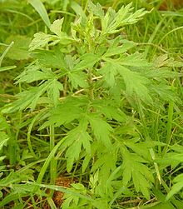
Chinese mugwort (native to much of north-east Eurasia)

This prompted a brief discussion of Hangul, the phonetic Korean writing system introduced in the mid-15th century by King Sejong in order to make it easier for ordinary people to become literate. Prior to this, writing had normally been done in classical Chinese, though there also existed some older Korean phonetic systems. There was resistance maong the educated elite to the new script and many of them maintained a preference for writing in Chinese down to the 20th century. It remains possible to incorporate some Chinese characters in Hangul text but, in contrast to the Japanese system, this is not essential. More details at https://en.wikipedia.org/wiki/Hangul

We also talked about garlic, a plant which originated in central Asia, with 80% of the world’s total supply now being produced in China (https://en.wikipedia.org/wiki/Garlic). In Rome ālium (sometimes spelled allium, was widely used by the por but was also believed to have medicinal qualities.In reading non-macroned texts, care must be taken not to confuse the word with the adjective alius, -a, -um (other)
AD ALPES

CAPUT XIX (contd,)
“Placuit iterum lītus adīre, sī forte iam ventus nāvēs solvere sineret; sed ibi omnia
It-was-decided again shore to-go-to in-case by-chance now wind ships to-set-sail allowed but there all-things
adhūc adversa erant. Tum subitō flammae et odor sulpuris aliōs in fugam vertêrunt; Plīnius
still unfavourable were then suddenly flames and smell of-sulphur others to flight turned Pliny
autem, quī interim in harēnā recubuerat, prīmō surrēxit, sed statim concidit, ac ibīdem
however who meanwhile on sand had-lain-down first rose but at-once collapsed and on-spo
mortuus est, spīritū cālīgine crassiōre obstrūctō.”
died with-breathing by by-fumes more-concentrated obstructed
“Quid cēterīs factum est?” inquit, Cornēlia.
What to-rest happened asked Cornelia
“Illī quidem,” inquit Pūblius, “incolumēs ēvāsērunt. Quī, cum prīmum lūx diēī iterum
They indeed said Publius safely escaped They when first light of-day again
reddita est, eōdem reversī, eius corpus inlaesum invēnērunt; quīn etiam illīus habitus
restored-was to-samke-place returned his body un-harmed found indeed even his posture
quiēscentī quam mortuō similior erat.”
to-one-resting than to-one-dead more-similar was
At Sextus: “Ubi interim erat ille Plīnius, quī litterās scrīpsit?”
But Sextur where meanwhile was the Pliny who letter wrote
“Hic,” inquit pater, “Misēnī cum mātre relictus, prīmō aliquid temporis studiīs dat; nam
He said father at-Misenum with mother left first some of-time to-studies gives for
tum duodēvicēsimum annum agēbat. Tum sequitur balneum, cēna, somnusque inquiētus et
then 18th year he-was-in then follws the-bath dinner and-sleep disturbed and
brevis; nam mōtūs terrae noctū tam validī exstitērunt, ut omnia plānē ēvertī vidērentur.
short for movements of-earth at-night so strong occurred that all-things clearly to-be-being-destroyed seemed
“Quārē Plīnius et māter, ex aedibus ēgressī, in āreā cōnsēdērunt; ubi iuvenis ultrō librum
So Pliny and mother out-of house having-gone in yard sat-down where the-youth actually book
Titī Līvī poposcit, et quasi ōtiōsus legēbat. Sed etiam in āreā erat magnus et certus ruīnae
of-Titus Livius asked-for and as-if at-leisure began-reading but even in yard was great and certain of-disaster
metus, quod tēcta proxima tremōribus maximīs quatiēbantur.
fear because buildings nearest by –tremors enormous were-being-shaken
“Prīmā lūce dēmum oppidō excēdere vīsum est; sed vehicula, quae prōdūcī
At-first light finally from-town to-depart seemed [good] but vehicles which to-be-brought-out
iusserant, etsī in plānissimō campō, in contrāriās partēs agēbantur, ac nē lapidibus
they-had-ordered although on very-flat plain in different directions were-being-pushed and not by-stones
quidem fulta in eōdem vēstigiō quiēscēbant.
even wedged in same rut they-remained-still
“Iam nūbēs in terram dēscendērunt, omniaque tenebrīs obscūrāta sunt. Tum māter fīlium
Now clouds onto earth descended and-all-things by-darkness obscured were then mother son
vehementer hortārī coepit, ut, quō modō posset, sē servāret; sē enim ipsam, annīs ac
forcefully to-urge began that by-what means he-could himself he-should-save [self] for herself with-years and
corpore gravem, bene moritūram, sī fīliō causa mortis nōn fuisset.
with=body heavy well gong-to-die if for-son cause of-death not she-had-been
“Ille autem, manum eius amplexus, addere gradum coēgit. Brevī autem cinis
He however hand of-her having-taken to—increase pace compelled soon however ash
cadēbat dēnsior; ac dē viā dēflectere necesse erat, nē turbā hominum perterritōrum in
was-falling more-densely and from road to-turn-aside necessary was lest by-crowd of-people terrified in
tenebrīs obtererentur. Ibi cōnsēdērunt, cum interim ululātus fēminārum, īnfantium
darkness they-be-trampled-under-foot there they-sat-down whilst meanwhile wailing of-women of-infants
vāgītūs, clāmōrēsque virōrum omnibus ex partibus audīrentur. Nam aliī parentês, aliī
crying and-shouts of-men all from directions were-heard for some their-parents others
līberōs, aliī coniugēs vōcibus quaerēbant.
their-children others their-spouses with-voices were-seeking
“Iam cadēbat cinis tam multus et gravis, ut identidem surgere eumque excutere
Now was-falling ash so much and [so-]heavy that repeatedly to-get-up and-it to-shake-off
cōgerentur; opertī aliter essent, et pondere ēlīsī. Sed postrēmō cālīgō tenuāta in
were-forced buried otherwise they-would-have-been and by-weight crushed but finally fog thinned-out into
fūmum discessit; sōl etiam effulsit, lūridus tamen, quālis esse solet, cum dēficit.
Smoke departed sun also shone-out murky however such-as to-be it-is-accustomed when it-is-in-eclipse
“Plīnius et māter, Mīsēnum reversī, noctem suspēnsam atque inquiētam ēgērunt; nam
Pliny and mother to-Misenum having-returned night anxious and restless spent for
etiam tum tremōrēs terrae cōntinuābantur. Sed inde abīre nōluērunt, priusquam dē salūte
even then tremors of-earth were-continuing but then to-leave they-were-unwilling before about safety
avunculī nūntius certus pervenīret.”
of-uncle news reliable could-arrive
“Multīne hominēs hāc clāde periērunt?” inquit Sextus. “Plūrimī vērō,” inquit pater;
Did-many people in-this disaster perish asked Sextus Very-many indeed said father
“quīn etiam, ut modo dīxī, oppida tōta obruta sunt.”
Indeed also as just I-said towns whole overwhelmed were
Dum haec nārrantur, viātōrēs celeriter Capuam versus vehēbantur, et propinquīs iam
Whilst these-things were-being-told travellers quickly Capua towards were-being-carried and near already
tenebrīs in oppidum pervēnērunt. darkness in town they-arrived

CAPUT XX

Cum posterō diē iterum profectī essent, Cornēlius: “Haud procul abest locus,” inquit, “ubi
When next day again set-off they-had Cornelus not far is-away place said where
Hannibal sollertiā magnā imperātōrem nostrum ēlūsit. Sed dē hīs rébus tū dīc, Pūblī; nam
Hannibal with-skill great general our escaped-from but about these things you say Publius for
exīstimō tē apud Cornēlium Nepōtem haec nūper lēgisse.”
I-reckon you in Cornelius Nepos them recently to-have-read
Tum Pūblius: “Rōmānīs Cannēnsī pugnā dēvictīs, Hannibal urbēs complūrēs
Then Publius with-Romans of-Cannae in-battle defeated Hannibal cities several
occupāvit et postrēmō nūllō resistente Rōmam profectus, in propinquīs urbī montibus
seized and finally with-nobody resisting to-Rome having-set-off in near to-city hills
cōnsēdit. Cumque aliquot diēs ibi castra habuisset et Capuam reverterētur, in agrō
took-up-position and-when some days there camp he-had-kept and to-Capua was-returning in Field
Falernō eī occurrit Q. Fabius Maximus, dictātor Rōmānus, dē quō dīcit poēta quīdam:
“ ‘Ūnus homō nōbīs cūnctandō restituit rem.'
One man for-us ny-delaying restored the-situation
“Hannibal locī angustiīs clausus, Fabium tamen callīdissīmē ēlūsit. Nam noctū bovês,
Hannibal of-place by-narrowness shut-in Fabius nevertheless very-cleverly eluded for at-night oxen
rāmīs in cornibus dēligātīs atque incēnsīs, omnēs in partēs vagātum ēmīsit.
with-branches on horns tied and set-alight all in directions to-wander he-sent-out
“Quī procul vīsī tantum terrōrem exercituī Rōmānōrum iniēcērunt, ut extrā vāllum
These in-distance seen so-much terror in-army of-Romans instilled that outside rampart
ēgredī nēmō audēret; omnēs enim exīstimābant īnsidiās ab hostibus comparārī. Interim
to-go nobody dared all for reckoned a-trap by enemy to-be-being-set meanwhile
Hannibal nūllō prohibente cōpiās suās ê locō perīculōsō ēdūcēbat.”
Hannibal with-nobody preventing troops his from place dangerous was-leading-out
“Nōnne Hannibal umquam proeliō superātus est?” inquit Sextus. “Mihi vidētur ille
Didn’t Hannibal ever in-battle defeated get asked Sextus to-me seems he
semper aut sollertiā aut virtūte suā superāsse.''
Always either by-cleverness or courage his-own to-have-won
“Cum hoc idem bellum iam vīgintī ferē annōs gestum esset,'' inquit Cornēlius,
When this same war already twenty almost years waged had been said Cornelius
“Hannibal, in Āfricam redīre coāctus, Zamae tantā clāde victus est, ut Carthāginiēnsēs sē
Hannibal to Africa to-return compelled at-Zama in-so-great disaster defeated was that Carthaginians themselves
Rōmānīs dēdere cōgerentur.''
To-Romans to-surrender were-compelled
“Quid postrēmō Hannibale ipsō factum est?” inquit Cornēlia.
What finally with-Hannibal himself done was asked Cornelia
“Fortasse,'' inquit pater, “iam audīvistis eum post clādem acceptam diū cōnsiliō et operā
Perhaps said father already you-have-heared him after disaster suffered long-time with-advice and work
patriam suam adiūvisse, tum autem clam domō abīre coāctum esse, quod suspicārētur
country his to-have-helped then then however secretly from-home to-depart forced to-have-been because he-suspected
sē brevī Rōmam obsidem arcessītum īrī.
Himself soon to Rome as-hostage summoned to-going-to-be
“Prīmō ad rēgem Antiochum dēvertit, cui persuāsit ut bellum Rōmānīs īnferret;
First to king Antiochus he-fled whom he-peruaded that war on-Romans he-might-make
deinde, Antiochō vīctō, Crētam vectus est; unde postrēmō in Pontum ad rēgem Prūsiam sē
then with-Antiochus defeated to-Crete he-sailed from-there finally into Pontus to king Prusias himself
contulit.
he-took
“Ibi cum cognōvisset Rōmānōs mīsisse lēgātōs, quī ā Prūsiā postulārent , ut sibi in
There when he-had-learned the-Romans to-have-sent envys who from Prusias were-to-demans that to-them into
custōdiam ipse trāderētur, suā sponte venēnum sūmpsit, quod semper sēcum habēre
custody he-himself be-handed-over by-own will poison he-took which always with-him to-have
solēbat.”
he-was-accustomed
“Cum mentiō venēnī facta sit,” inquit Pūblius, “mihi recordārī videor ōlim aliquem
Since mention of-poison made has-been said Publius to-myself to-recall I-seem once someone
venēnō rēgem Pyrrhum interficere cōnātum esse. Sed certō sciō nostrōs numquam tantō
by-poison king Pyeehus to-kill tried to-have but for-certain I-know our-people never so-great
scelere sē contāmināvisse.”
crime themselves to-have-disgraced
“Rēctē dīcis,” inquit Cornēlius; “nam Rōmānīs nōn est mōs venēnō bella gerere. Sed
Rightly you-say said Cornelius for of-Romans not is custom with-poison wars to-wage but
quīdam Tīmocharēs, rēgis ipsīus familiāris, ad C. Fābricium cōnsulem vēnit ac pollicitus est
a-certain Timochares ofking himself close-friend to Gaius Fabricius consu; came and promised
sē rēgem, sī praemium satis magnum prōpōnerētur, venēnō brevī sublātūrum; quod facile
himself king if reward enough big was-offered by-poison soon to-do-away-with which easy
factū fore dīxit, quoniam fīlius suus in convīviō pōcula rēgī ministrāret.
“Hāc rē Rōmam ad senātum dēlātā, lēgātī statim missī sunt, quī Pyrrhum certiōrem
With-this-thing to-Rome to senate reported envoys at-once sent were who Pyrrhus informed
facerent quantō in perīculō versārētur, eumque hortārentur ut īnsidiās cavēret domesticās. Sīc
could-make how-much in danger he-stood and-him could-urge that plots he-should beware of domestic thus
cōnservātus, rēx grātiam maximam populō Rōmānō habuisse trāditur, omnēsque captīvōs,
saved king gratitude greatest to-people Roman to-have-had is-reported and-all prioners
quōs tum habēret, sine mercēde ultrō reddidisse.”
whom then he-had without ransom of-own-accord to-have-returned

“Ut ad Hannibalem redeam,” inquit Pūblius, “nōnne ille aliquid facētē dīxit dē cōpiīs
That to Hannibal I-may-return said Publius surely he something witty said about forces
Antiochī, cum ad illum rēgem sē contulisset, postquam domō fugere coāctus est?”
of-Antiochus when to to that king himself he-had-brought after from-home to-flee forced he-was
“Maximē vērō,'' inquit pater. “Rēgēs barbarī inānī speciē mīlitum et fulgōre armōrum
Very true said father kings barbarian in-empty appearance of-soldiers resplendence of-armour
vehementer dēlectārī solent; täliāque saepe plūrīs faciunt quam rōbur et fortitūdinem.
greatly to-delight are-accustomed and-such-things often more they-value than strength and courage
“Quārē, ut Hannibal ad Antiochum pervênit, rēx glōriāns, cum cōpiās suās argentō
Therefore when Hannibal to Antiochus reached king boasting when troops his in-silver
aurōque splendidās īnstrūxisset, Hannibālī: `Nōnne putās,' inquit, `satis esse Rōmānīs
and-gold shining had-drawn-up to-Hannibal Don’t you-think he-said enuogh to-be for-the-Romans
haec omnia?' At ille: `Satīs esse crēdō Rōmānīs haec omnia, etiamsī avārissimī sint.’”
These all but he [replied] enough to-be I-believe for-Romans these all even-if very-greedy they-are
“Dignē respōnsum!” inquit Sextus. “Etsī mihi mīrandum vidētur Hannibalem
Fittingly answered said Sextus even-though to-me surprising it-seems Hannibal
voluisse tam apertē dēspicere cōpiās rēgis, quem ad bellum in Rōmānōs excitāre cuperet.”
To-have-wanted so openly to-denigrate forces of-king whom to war against Romans to-arouse he-wanted
Quae cum dicta essent, paulisper omnēs tacentēs sedēbant, dum equī raedās celeriter viā
Which when said had-been for-short-time all silent kept-sitting whilst horses wagons quickly on-way
strātā dūcunt. Tum Cornēlia: “Certīs intervāllīs,” inquit, “per viam lapidēs collocātōs iam
paved pull then Cornelia at-fixed intervals said along road stones placed now
diū animadvertō. Cūr ita positī sunt, pater?”
for-long-time I’ve-been-noticing why thus placed they-have-been father
At ille: “Haec sunt mīliāria,” inquit, “in quibus īnscrīptum est quam longē ā Rōmā
Then he these are milestones said on which inscribed has-been how far from Rome
distent. Ibi in forō est aureum mīliārium, quod quasi centrum imperiī Rōmānī habētur.”
they-are-distant there in forum is golden milestone which as-if centre of-empire Roman is-considered
“Sōlāne in viā Appiā,” inquit, Sextus, “mīliāria posita sunt?”
Only-? on Way Appian said Sextus milestones placed have-been
“Omnibus in viīs maiōribus Ītaliae inveniuntur,” inquit pater. Quō dictō, omnēs rūrsus
All on roads major of-Italy they-are-found said father with-which said all again
conticuērunt
fell-silent
QUESTIONS ARISING FROM 107th MEETING – 22/1/20 AND NEW YEAR PARTY – 28/2/20

Food ordered included cicera aromatica (chana masala), iūs aromaticum lentium (daal tarka), batātae cum brassicā Pompeiānā (aloo gobi), caseus fervēns (sizzling paneer (cheese)), melongēna contūsa (baingan bharta, mashed eggplant), carō ruber (rogan josh), spīnācia cum caseō, (saag paneer), okrum arōmaticum (bhindi masala, `lady’s fingers’, okra with spices), with samosae holeribus fartae (vegetable samosas) for starters and accompanied by the usual pānis Persicus (naan) and orӯza (rice), plus, of course, vīnum rubrum/sanguineum.

Latinising rogan josh (a Kashmiri-style lamb curry) is difficult because the etymology of the original name is obscure. It may derive from roughan, Persian and Urdu for `ghee’ (clarified butter, i.e. butter fat with water and milk solids removed) and juš or josh, meaning to stew or braise, in which case it might be termed carō in gio cocta. Alternatively, rogan means `red’ (from Urdu roghan ( روغن‎), `brown’ or `red’, or from Kashmiri roghan, "red") and the second word is gošt (`meat’), giving us carō ruber. More details at https://en.wikipedia.org/wiki/Rogan_josh

Zhang Wei had brought along the Chinese edition of Francoise Waquet’s Latin ou l’empire d’un signe, which examines the role of the language in European culture from the 16th to the 20th century – essentially from the time when it began to lose its role as the main means of actual communication at a pan-European level. Waquet’s main conclusion, which made her unpopular amongst some classical scholars, was that Latin’s retention of a central position long after it had been displaced first by French and then by English as a lingua franca was because it became a marker of membership of a social elite. This idea echoes a remark made by an anonymous Frenchman and often attributed to American Supreme Court Justice Oliver Wendell Holmes (1841-1935), who in fact just quoted it in a letter to a friend. The Frenchman was supposedly asked if a gentleman must know Latin and Greek and replied `No, but he must have forgotten them’ (see https://twitter.com/jdsnel/status/928713995414069250)

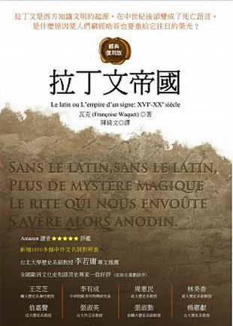

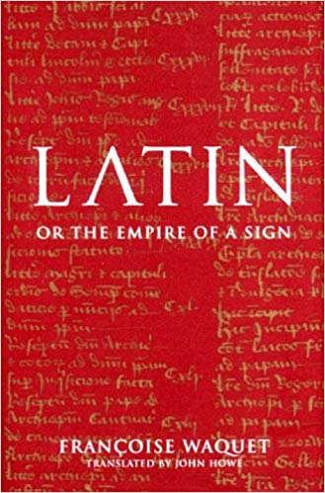

Eugene showed us his copy of Cleto (Cletus) Pavanetto’s Graecae litterae institutiones – pars prima. He had previously written to John that this and three other works by the same author, including Elementa linguae et grammaticae Latinae, which he had shown us in the December meeting, were still available from www.amazon.it The other texts were Graecae litterae institutiones – pars altera and.
Romanorum Litterae et Opera Aetatis Nostrae Gentes Erudiunt. Pavanetto’s textbooks are unusual in that both the Latin and Greek ones have all the explanations in Latin.

Eugene had also explained that the earliest surviving writer on Latin grammar, Varro, a contemporary of Caesar and Cicero, had named five of the six cases on the Greek model: casus nōminandī or nōminātīvus, pātricus or pātrius (i.e. genitive), dandī (i.e. dative), accusandī or accūsātīvus, vocandī. Greek had no ablative case, so Varro simply used casus sextus (`sixth case’) for this,

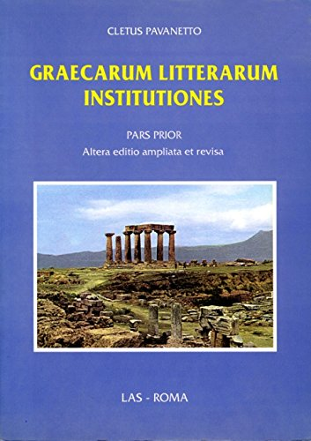

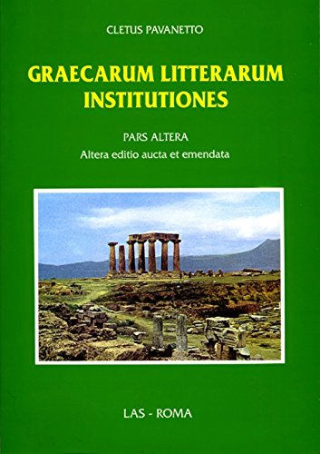

The word vocātīvus was not employed before Aulus Gellius (c.125 till after 180. A.D.), while the terms genitīvus, datīvus and ablātīvus were not in use before the time of Quintilian (c.35-100 A.D.). In the writings of Donatus (4th cent.A.D.) we find the order nominātīvus, genitīvus, datīvus, accūsātīvus, vocātīvus and ablātīvus and the system of declining a noun together with the adjective/pronoun hic, which functioned rather like a definite article (vix. hic dominus, huius dominī etc.) This had the advantage of disambiguating forms like dominō which were shared by two or more cases. Later grammarians followed suit, except that the vocative (which was often omitted as it was usually identical with the nominative) was usually put after instead of before the ablative. In Britain, this ancient order was deliberately changed in the 19th century by Charles Kennedy, whose Latin Primer put the vocative after the nominative and the accusative next. The new system had the advantage of normally placing identical forms together and is still followed in British textbooks today. Other countries, including the USA, have retained the original Roman order.
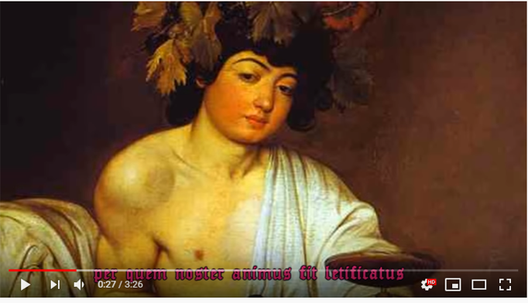
Bacchus, bene venies!
Both in the meeting on 22 January and at our New Year gathering at Keon and Tanya’s on 28 January, we sang verses from the well-known drinking song from the Carmina Burana, `Bachus, bene venies!’ The briefer version used on the 22nd, is pasted below, followed by the longer version used on the 28th, which also has musical notation. The latter, however, also has a couple of typos and for a full, corrected version, with translation added, see the embedded videos and accompanying lyrics at https://linguae.weebly.com/corvus-corax.html

On the 28th, Tan, who has a special interest in memory techniques used by pre-modern societies, mentioned that in the Middle Ages, things needing to be remembered were deliberately associated with morally bad objects or ideas to make them less forgettable! On the theme of associations, she also recalled a French ash-tray inscribed je fume, tu fumes nous fûmes - `I smoke, you smoke, we existed’. All three verb forms are pronounced identically but the last, which is in the simple past tense (`passé historique’) only employed in writing, is not from the verb fumer (`to smoke’) but from être (to be) and can be the equivalent of `we’re dead!’

At the Basmati meeting we finished chapter 20 and read the whole of chapter 21 of Ad Alpēs (see text below). This prompted discussion of the exclamation pāpae used by Sextus, the younger brother in the family, after hearing the story of Midas and the Golden Touch. It was suggested that John’s translation with Cantonese waah was inappropriate as the latter was always positive, whilst pāpae often indicated simple surprise, as here, rather than positive approval. Chapter XXI, in a section referring to the emperor Nero,also covered the practice of flooding arenas to stage a mock sea-battle (naumachia) as entertainment and Sam thought Nero could be seem as anticipating the development of Ocean Park in Hong Kong. We also noted the practical problem of ensuring the water did not drain away!

The same chapter also alluded to tightrope-walking elephants. These can be found nowadays in Thailand, but with the animal walking on two parallel wires rather than one.
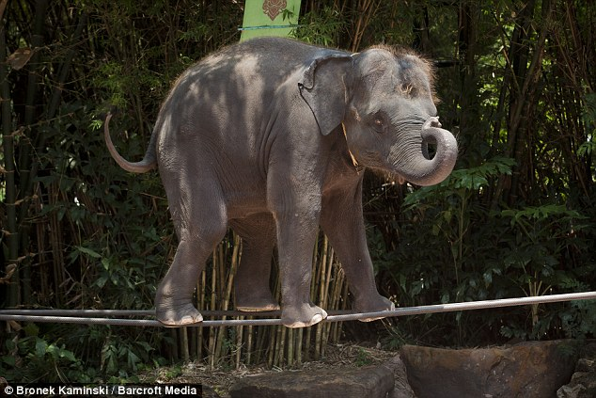
Roman entertainment recreated in Thailand
https://www.dailymail.co.uk/news/article-1326182/Circus-cruelty-Adult-elephants-forced-walk-metal-tightropes-Thailand-tourist-attraction.html

In the second Midas story related by Drusilla, Apollo gives the king donkey’s ears as a punishment for preferring Pan’s music to Apollo’s own. Both the king and Pan himself in fact got off lightly because when the satyr (goat-man) Marsyas dared to suggest he was a better musician than Apollo, the god proceeded to flay him alive!

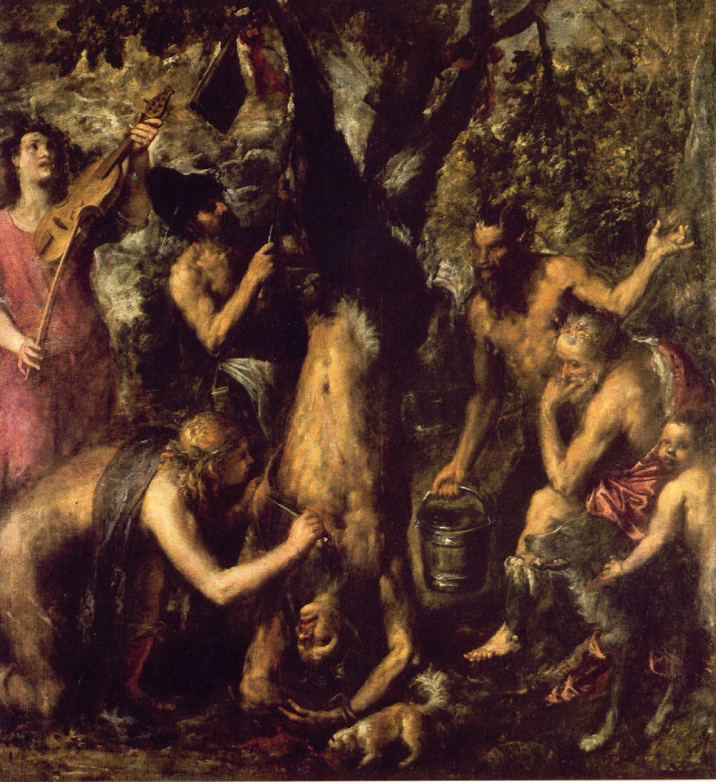
Apollo skinning Marsyas
http://farmersletters.blogspot.com/2011/10/titian-flaying-of-marsyas-1575.html

BACCHE BENE VENIES (as sung on 22/1/20)

Bacche, bene veniēs
grātus et optātus
per quem noster animus
fit laetificātus
Istud vīnum, bonum vīnum
vīnum generōsum
reddit virum curiālem
probum, animōsum
Iste cyphus concāvus
dē bonō merō profluus
sī quis bibit saepius
Satur fit et ēbrius
Istud etc.
BACCHE BENE VENIES (as sung on 28/1/20)
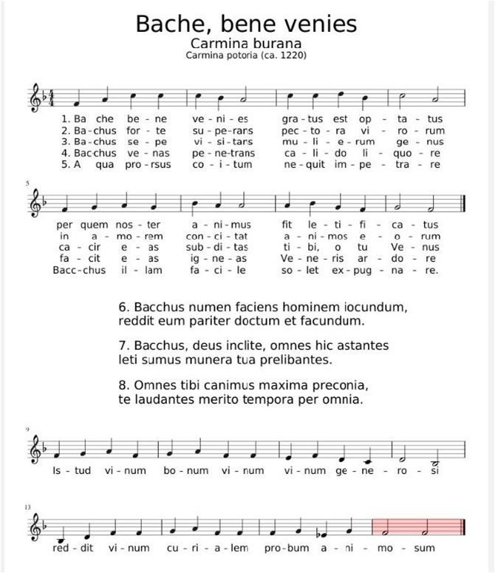
Note that in the refrain at the bottom, the last word in the first line should be `ge-ne-ro-sum’ and the seond in the second line `vir-rum’

AD ALPES - CHAPTER XX (contd,)

Interim sōl ārdēns in caelō fulgébat; ac postrēmō equī aestū labōrāre coepêrunt. Quārē,
Meanwhile sun burning in sky was-gleaming and finally horses from-heat to-suffer began So
cum iam ventum esset, ad locum ubi haud procul ā viā complūrēs arborēs altae umbram
since now come it-had-been to place where not far from road several trees tall shade
grātissimam praebébant, raedās cōnsistere Cornēlius iussit.
most-pleasing provided wagons to-halt Cornelius ordered
Hīc līberī, dum equī reficiuntur, aliquamdiū cum Lūciō libenter lūsērunt, quem Anna,
Here the-children while horses were-refreshed for-some-time with Lucius gladly played whom Anna
palliolō substrātō, humī posuerat. Tum Drūsillae Cornēlia: “Iam diū factum est, māter,”
with-a-little-cloak laid-beneath on-ground had-played then to-Drusilla Cornelia Now long-time done it-has-been mother
inquit, “cum tū nōbīs nūllam fābulam nārrāvistī. Dē bellīs pater et Pūblius semper
said when you to-us no story have told about wars father and Publius always
loquuntur. Nōnne tū vīs aliquid laetius nārrāre?''
speak don’t you want something more-cheerful to-tell
At māter: “Metuō nē haud multa sciam, quae vōs audīre velītis. Sed fortasse numquam
Then mother I-fear lest not much I-know which you to-hear would-want but perhaps never
audīvistis quō modö Atalanta in mātrimōnium data sit.”
You-have-heard in-what way Atalanta in marriage given was
“Id quidem nōn audīvimus,” inquit Cornēlia. “Nārrā, sīs.”
That indeed not we-have-heard said Cornelia Tell please
Tum Drūsilla: “Atalanta erat rēgia virgō, quae cursū virōs superāre solébat; eam autem,
Then Drusilla Atalanta was royal maiden who at-running men to-beat was-accustomed her also
cum pulcherrima esset, omnēs iuvenēs in mātrimōnium dūcere cupiêbant. Illa vērō, etsī
since very-beautiful she-was all young-men into marriage to-lead wanted she indeed although
nūbere nōlēbat, celeritāte tamen suā frēta prōmīsit sê eī nüptūram, quī sē
to-marry she-did-not-want on-speed however her-own relying promised herself him, to-be-going-to marry who her
cursū superāsset.
in-running had-beaten
“Lēx autem certáminis erat, ut competītor victus occīderētur. Quā lēge dūrā haud
Condition however of-contest was that competitor defeated should-be-killed by-which condition harsh not
dēterriti, multī, pulchritūdine virgīnīs captī, in certāmen dēscendēbant; ac vīctī poenās
deterred many by-beauty of-maiden captivated to competition came-down and the –defeated penalty
dēdērunt.
paid
“Postrēmō quīdam iuvenis, Hippomenēs nōmine, quī haec omnia procul aspexerat,
Finally a-certain youth Hipomenes by-name who these-things all from-afar had-observed
amōre incēnsus, in certāmen dēscendit. Quī cum in mediō stadiō cōnstitisset, virginī: “Cūr
by-love set-on-fire to contest came-down He when in middle of-stadium had-halted to-maiden why
facilem titulum tardīs superandīs quaeris?” inquit. “Tē mēcum cōnfer. Ego sum Neptūnī
easy title by-slow-ones being-beaten do-you-seek asked yourself with-me compare I am Neptune’s
nepōs; ac, sī vincar, tū nōmen magnum et memorābile habēbis.”
grandson and if I win, you name great and memorable will-have
Hōc audītō, virgō, mollī vultū iuvenis mōta, paulisper dubitat, an superāre velit, et
With-this heard the-maiden by-soft face of-youth moves a-short-while douts whether to-win she-wants and
Hippomenam ā certāmine dēterrēre cōnātur. Ille autem in sententiā persevērat; ac rēx et
Hippomenes from contest to-deter tries He however in opnion perserveres and king and
populus cursum solitum poscunt.
people race usual demand
“Tum Hippomenēs clam invocat Venerem, quae forte aderat manū ferēns tria māla aurea
Then Hippomenes secretly calls-upon Venus who by-chance was-present carrying three apples golden
quae modo in agrō sibi dēdicātō ex arbore flāvā dēcerpserat. Haec māla, nūllō cernente, dea
which just-before in field to-herself dedicated from tree yello she-had-plucked These apples with-nobody seing goddess
iuvenī dēdit, docuitque quī ūsus esset in illīs.
to-young-man gave and-taught what use was in them
“Simulac signum tubā datum est, virgō et iuvenis ventō celerius per harēnam prōvolant.
As-soon-as signal by-trumpet given has-been maiden and young-man than-wind faster across sand fly
Illa facile superior erat; sed Hippomenēs, ā tergō relictus, subitō dē tribus mālīs ūnum
She quickly ahead was but Hipomenes at back left suddenly from three apples one
prōiēcit. Virgō cōnstitit ac cupidē sustulit aurum. Interim iuvenis praeterit, et resonant
threw-forward maiden stopped and eagerly picked-up the-gold meanwhile youth went-past and echo
spectācula plausū.
rows-of-seat with-applause
“Atalanta tamen celeriter moram corrēxit, et iuvenem iterum post tergum relīquit. Mālō
Atalanta however quickly delay corrected and youngman again behind [her]-back left with-apple
alterō prōiectō, virgō rūrsus cōnstitit, atque iterum cōnsecūta est. Tum Hippomenēs summā
second thrown-forward maiden again stopped and again followed then Hippomenes greatest
vī mālum tertium longē ā cursū proiēcit; puella dubitat, tum aurum petīvit. Sīc virgō, morā
with-force apple third far from course hurled-forward girl hesitatexs then gold went-after thus maiden by-delay
et mālōrum pondere impedīta, praeterita est, atque Hippomenēs victor praemium cēpit.”
and of-apples weight hindered passed was and Hippomenes as-victor prize took
“Euax!” inquit, Cornēlia. . “Tālia mē dēlectant.''
Hooray said Cornelia such-things me delight
Mox omnia ad proficīscendum parāta erant; et tantō alacrius equī iam prōgressī sunt, ut
Soon all-things for setting-off ready were and so-much more- readily horses now advanced that
hōrā octāvā ad oppidum Sinuessam pervenirētur; ubi viātōrēs libenter ē raedīs
At-hour eighth at town Sinuessa it-was=arrived where the-travellers happily from wagons
dēscendērunt.
got-down
Drūsilla cum servīs statim sē recēpit in dēversōrium; cēterī autem per oppidum paulisper
Drusilla with slaves at-once herself took-back back to inn others however through town a-short-while
ambulāre mālēbant. Sed sub cēnae tempus omnēs ad tēcta rediērunt
to-walk preferred but towards of-dinner time all to building returned.

CHAPTER XXI
Māne, dum viā Appiā celeriter vehuntur, Cornēliō Sextus: “Nudius tertius, pater,” inquit,
In-the-morning whilst on-via Appia quickly they-are-conveyed to-Cornelius Sextus day-before-yesterday father said
“cum Capuae essēmus, aliquem audīvī dīcentem urbem illam ōlim gladiātōribus
when at-Capua we-were someone I-heard saying city that once for-gladiators
celeberrimam fuisse. Quō modō hoc factum est?''
very-famous to-have-been in-what way this happened
Tum pater: “Diū Capuae habēbātur lūdus, ubi gladiātōrēs exercērentur; quī, cum eō
Then father for-long-time at-Capua was-kept school where gladiators were trained who when in-that
genere pugnandī bene īnstitūtī essent, Rōmam missī sunt, ut ibi in harēnā populī dēlectātiōnis
type of-fighting well instructed had-been to-Rome sent were so-that there in arena people’s enjoyment
grātiā operam ēderent. Neque enim est ūllum genus spectāculī quod plērīsque magis placeat.”
for-sake-of effort might-make neither for is any kind of-show which to-most more pleases
“Mihi quidem,” inquit, Drūsilla, “omnia eius modī crūdēlissīma videntur, et magis
To-me indeed said Drusilla all-things of-this kind very-cruel seem and more
bēluis digna quam hominibus.”
for-beasts worthy than for-men
“Semper fuērunt, nōnnūllī,” inquit, Cornēlius, “quī tēcum sentīrent. Ac Cicerō ipse
Always there-were some said Cornelius who with-you agreed and Cicero himself
quōdam locō tālia spectācula hīs verbīs improbat: “Quae potest hominī esse polītō dēlectātiō,
in-a-certain passage such shows with-these words criticizes what can for-man be cultured enjoyment
cum aut homō imbēcillus ā valentissimā bēstiā laniātur, aut praeclāra bēstia vēnābulō
when either man weak by very-strong wild-animal is-torn-apart or splendid beasrt by-hunting-spear
trānsverberātur?”
is-pierced
“Atque īdem aliō locō scrīpsit, sē cum eīs sentīre, quibus gladiātōrum spectācula
And the-same-man in-another place wrote himself with those to-side to-whom of-grladiators shows
inhūmāna vidērentur;—etsī exīstimat antīquitus aliter rem sē habuisse, cum capītīs
inhumane seemed although he-reckons in-antiquity otherwise matter itself to-have-had when to-death
damnātī inter sē dēpugnārent.”
condemned among themselves fought-it-ought
“Dē hōc amplius, sī vīs, pater,” inquit, Sextus; “nam dē huius modī certāminibus
About this more if you-will father said Sextus for about of-this type contests
numquam audīvī.”
never I-have-heard
Ac pater: “Eīs temporibus, dē quibus dīcit Cicerō, interdum capitis damnātīs
And father in-those times of which speaks Cicero sometimes to-death to-those-condemned
data est facultās optandī utrum statim mōrerentur, an aliquamdiū operam in harēnā eā
given was opportunity of-chosing whether at-once they- died or for-some-time service in arena with-this
condiciōne ēderent, ut, sī pōst certum tempus adhūc superstitēs essent, tum līberī
provision they-performed that if-after certain time still surviving they-were then free
dīmitterentur.. Cum hominēs ita inter sē dēlībertāte pugnārent, Cicerō certāmen honestius
they-would-be-set when men thus among themselves for freedom fought Cicero contest more-honourable
nec mōribus cīvitātis tam perniciōsum putābat.''
and-not to-morals of-stat so destructive thought
“Nōnne aliquid simile ab Hannibale factum est,” inquit, Pūblius, “cum bellum Italiae
Surely something similar by Hannibal done was said Publius when war into-Italy
īnferēns Alpēs trānsīret?”
carrying Alps he-was-crossing
“Rēctē dīcis,” inquit, Cornēlius. “Cum enim iam ad summōs montēs pervēnisset et brevī
Rightly you-say said Cornelius when for already at summit-of mountains he-had-arrived and soon
in Italiam dēscēnsūrus esset, mīlitēs suōs nōn sōlum verbīs sed etiam rēbus cohortandōs
into Italy going-to-descend was soldiers his not only with-words but also through-actions needing-to-be-encou
ratus, ad spectāculum eius modī eōs convocāvit:
having-thought to spectacle of-this sort them he summmoned
“Captīvōs montānōs in mediō vīnctōs cōnstituit, armīsque ante pedēs eōrum
Prisoners from-mountains in-middle bound he-placed and-with-weapons before feet their
prōiectīs, interpretem interrogāre iussit, num quis ferrō dēcertāre vellet, sī victor
thrown-forward interpreter to-ask he-ordered whether anyone with-sword fight-to-the-end wished if victor
lībertātem arma equumque acciperet.
freedom weapons and-horse would-receive
“Montānī omnēs ad ūnum cupidē ferrum pugnamque popōscērunt. Quārē sorte ēlēctī
Mountain-people to a-man eagerly sword and-fight demanded therefore by-lot chosen
sunt, quī dēpugnārent. Interim aspiciēbant Hannibalis militēs; quōrum mentēs maximê sunt
were those-who would-fight-it-out meanwhile were-watching Hannibal’s soldiers whose minds greatly were
cōnfirmātae, cum vidērent quam laetī in certāmen dēscenderent barbarī, quamque libenter
strengthened when they-saw how happily into contest entered barbarians and-how gladly

mortem ipsam oppeterent.”
death itself they-met
“Hoc quoque crūdēle mihi vidētur,” inquit, Cornēlia. “Nūllane sunt spectācula, quae
This also cruel to-me seems said Cornelia no there-are shows which
hominēs morī nōn cōgant?”
people to-die not force
“Maximē vērō,” inquit, pater. “Saepe populī dēlectātiōnis causā variae rēs īnsolitae et
Very-much indeed said father often people’s enjoyment for-sake-of various things unsual and
mīrandae indūcuntur. Velut, Galba ille, quī posteā imperātor factus est, novum spectāculī
to-be-amazed-at are-put-on for-example Galba the-famous who afterwards emperor became new of-spectacle
genus, elephantōs fūnambulōs, ēdidit. Et ōlim nōtissimus eques Rōmānus, elephantō
kind elephants tightrope-walking put-on and once very-well-known knight Roman on-elephant
vectus per fūnem dēcurrit.”
carried along rope rode-down
“Vellem tum adfuissem,” inquit, Cornēlia. “Tālia saltem perlibenter vīdissem. Erantne
I-would-like then I-had-been-present said Cornelia such-things at-least very-gladly I-would-have-seen were-there
alia eōrum similia?”
other-things to-them similar
At pater: “Nōmen Daedalī, crēdō, saepe audīvistī. Meministīne quid eius fīliō factum
then father name of-Daedalus I-believe often you-have-heard do-you-remember what his to-son done
sit?”
was
“Meminī vērō,” inquit, Cornēlia. “Daedalus ālās fēcit, quibus fīlius per āera magnum
I-remember indeed said Cornelia Daedalus wings made on-which son through air vast
volāret. Īcarus autem ad sōlem propius accessit; cuius ārdōre, cērā mollītā, ālae solūtae sunt,
could-fly Icarus however to sun nearer approached whose by-heat with-wax softened wings unfastened were
ac puer infēlix in mare praecipitātus est.”
and boy unfortunate into sea sent-headlong was
Tum pater: “Imperātor Nerō ōlim in amphitheātrō idem temptārī voluit,” inquit. “Sed
Then father Emperor Nero once in amphitheatre same-thing to-try wanted said but
'Īcarus' prīmō statim cōnātū décidit atque imperātōrem ipsum sanguine suō respersit.”
`Icarus’ at-first immediately attempt fell and emperor himself with-blood his spattered
“Paene Rōmānī nōminis mē pudet,” inquit Cornēlia, “cum tālia audiō. Imperātōrem
Almost of-Roman name on-me comes-shame said Cornelia when such- things I-hear emperor
quam crūdēlem, quī hominēs tam perīculōsa temptāre coēgerit!”
what-a cruel who people such dangerous-things to-attempt forced
“Aliud multō inhūmānius fēcit Caligula,” inquit, pater. “Ille enim, cum ad cibum
Another much more-inhumane-thing did Caligula said father he for when for food
ferārum mūnerī praeparātārum pecudēs cārius comparārentur, ex capitis damnātīs dīcitur
of-wild-animals for-show prepared cattle quite-expensively were-obtained from to-death those-condemned is-said
hominēs ēlēgisse, quibus ferae vēscerentur.”
men to-have-selected on-whom wild-animals might-be-fed
“Quāle mōnstrum hominis!” inquit, Drūsilla, “sī vērō homō omnīnō appellandus est.”
What-a monster of-a-man said Drusilla if indeed man at-all to-be-called he-is
“Naumachiam quoque Nerō exhibuit,” inquit Cornēlius, “in lacū marīnā aquā replētō,
Sae-battle also Nero put-on said Cornelius in lake with-sea water filled
ubi etiam bēluae nābant; atque ā Claudiō spectāculum simile ēditum est.
where even beasts were-swimming and by Claudius show similar put-on was
“Hic autem, cum prōpugnātōrēs (ut solent gladiātōrēs) conclāmāssent: “Avē,
He however when fighters as are-accustomed gladiators had-shouted-together Hail
imperātor, moritürī tê salūtant,' diū dubitābat, an eōs inter sē pugnāre iubēret;
emperor those-about-to-die you salute for-long-time was-in-doubt whether them among themselves to-fight he-should-order
postrēmō vērō ad pugnam compulit, signō proeliī ā Tritōne datō, quī māchinā ē mediō lacū
finally indeed to fight he-forced with-signal of-battle by Triton given who on-a-machine from middle-of lake
ēmerserat.
had-emerged
“Sed iam illīs dē rēbus satis diū locūtī sumus. Fortasse tū, Drūsilla, lībēris aliquid
But now these about things enough long spoken we-have perhaps you Drusilla to-children something
iūcundius nārrābis.”
pleasanter will-tell
Illa prīmō abnuit; nam dicēbat, sē nūper minimum temporis lēctiōnī dedisse; cum autem
She at-first refused for said herself recently very-little time to-reading to-have-given when however
Sextus et Cornêlia, blandius ōrārent: “Adhūc puella,” inquit, “saepe dē rēge Midā fābulam
Sextus and Cornelia coaxingly kept-begging [when] still a-girl she-said often about king Midas story
audīvī. Hanc, sī vultis, vōbīs fortasse nārrāre possum.”
I-heard this if you-wish to-you perhaps tell I-can
“Nārrā, sīs,” inquit Cornēlia. “Nōs ad audiendum parātī sumus.”
Tell please said Cornelia we for listening prepared are
Tum māter: “Ōlim Midās, Phrygum rēx, grātiam maximam ā deō Bacchō iniit, quod
Then mother once midas of-Phrygians king favour very-great with god Bacchus got-into because
Silēnum āmissum ad eum redūxerat. Quārē deus rēgī facultātem dedit, optandī quid prō
Silenus lost to him had-brought-back therefore god to-king opportunity gave of-choosing what for
praemiō accipere vellet. Atque ille stultus: “Effice,' inquit, “ut omnia, quae corpore,
reward to-receive he-wanted and he foolishly Bring-it-about said that all-things which with-body
contigerō in aurum flāvum vertantur.'''
I--will-have-touched into gold yellow are-turned
“Haud stultus mihi rēx fuisse vidētur,” inquit Sextus; “nam istō modō dīvitiās maximās
Not foolish to-me king to-have-been seems said Sextus for in-that way riches very-great
facillimē comparāre potuit.”
very-easily obtain could
“Ipsī quoque,” inquit, māter, “rēs prīmō ita sē habēre vidēbātur. Cum autem cibum
Himself also said mother thing at-first thus itself to-have seemed when however food
capere vellet, et ministrī mēnsās dapibus optimīs exstrūxissent, tum haec quoque omnia rēgis
to-take he-wanted and servants tables with-feast excellent had-loaded then these also all king’s
tāctū aurea facta sunt; quī, dīves et miser, quid faceret, nōn habēbat.''
at-touch golden made were he rich and wretched what he-could-do not had
“Mortālem infēlīcem!” inquit Cornēlia. “Quō modō ex tantīs malīs sē expedīvit?”
Mortal unfortunate said Cornelia in-what wayfrom such-great evils himself he-freed
Tum māter: “Ad caelum bracchia tollēns: `Dā veniam, pater Bacche,' inquit; 'peccāvī.
Then mother to sky arms raising give pardon father Bacchus he-said I have sinned
Sed miserēre, precor, mēque ex hōc malō ēripe.'
But forgive I-beh and-me from this eveil pull-out
“Quō audītō, deus mītis revocāvit mūnus, et Midae imperāvit ut quōdam in fonte
With-this heard god gentle recalled gift and to-Midas gave-order that certain in spring
lavārētur. Quod cum factum esset, vīs aurea ex corpore rēgis in aquam cessit; ac trāditum est
he-should-barther which when done had-been force golden from body of-king into water passed and handed-down it-has-been
in harēnā flūminis, quod inde oritur, grāna aurea etiam hodiē reperīrī posse.”
in sand of-river which from-ther rises grains golden even today to-be-found to-be-able
“Pāpae!” inquit Sextus. “Hoc vērum esse vix crēdere possum.”
Waah said Sextus This true to-be scarcely to-believe I-am-able
At māter: “Idem dīcēs, cum vōbīs aliud nārrāverō, quod posteā huic rēgī
Then mother same-thing you-will-say when to-you something-else I-will-have-told which afterwards to-this king
accidit:
happened
“Nam deus Pān, dum nymphīs tenerīs carmina fistulā mōdulātur, glōriārī ausus est sē
For god Pan whilst to-nymphs tender songs on-pan-pipe plays to-boast dared himself
Apollinem ipsum cantū superāre posse. Quārē illī duo ad certāmen sub Tmōlō iūdice
Apollo himself in-playing to-surpass to-be-able so those two to contest under Tmolus [as]judge
vēnērunt; quō in certāmine Pān facile victus est.
came which in contest Pan easily beaten was
“Tmōlī iūdicium omnibus placuit; Midās sōlus dissentiēbat. Quam ob rem prō tantā
Tmolus’s judgement all pleased Midas alone disagreed which because-of thing for such-great
stultitiā Apollō aurēs rēgis in spatium trāxit, eāsque in speciem asinī aurium mūtāvit. Itaque
stupidity Apollo ears of-king into length dragged and-them into appearance of-ass’s ears changed and-so
Midās, ut hoc vitium turpe tegeret, semper posteā caput tiārā vēlāre coāctus est.''
Midas so-that this fault disgraceful he-could-conceal always afterwards head with-turban to-cover forced was
Dum haec dīcuntur, nūbēs in caelō cōgēbantur, brevīque imber frīgidus cōnsecūtus est.
While these-things are.being-said clouds in sky were-gathering and-soon rain-storm cold followed
Viātōrēs, in vīllā quādam duās hōrās morātī, multō ante noctem tamen potuērunt Fundōs
The-travellers in villa a-certain two hours afterp delaying much before night still were-able Fundi through
pervenīre; ubi ad dēversōrium sine morā sē contulērunt.
to-reach where to inn without delay themselves they-took

QUESTIONS ARISING FROM 108th MEETING

Go to end of sectiomn on Chritaimns – imntro to discussion of Regulus (summo in homnorte habebantguir)

Pat had been the first to arrtive and talked with manager about the financial situation of Basmati – last month takings only 438,000 against expenses of 200, 000 Our final bil was 1,731 – nine present, don not eating. Charged 5 drinkers 100 each, 160 for 8 people for food. Don just contributed 50 for wine. But ended up with a tip included – despite theortically the total being $1730

Pat was commmissioned to write histotry of the tai po Catholic parish – never put on sale, copies present to those interested by the parish- Eugene has seen it on-line:
https://taipo.catholic.org.hk/zh/wp-content/uploads/sites/2/2019/01/堂區資料-大埔傳敎150周年特刋.pdf
Catholic archives well-kept but difficult to use as soo many different languages – including raimondi’s easy Italian but others Italian very litereary and fifficult to understand.During WWII 1870-1900 documents eaten by termites.
Pat was not aware of Louis Ha’s thesis https://www.cp1897.com.hk/product_info.php?BookId=9789620436024

I mention Raimondi’s fights with the french and his disparaging view of chineses capabilities.
Pat mentions a young priest from Tai po mission who drowned in a storm when tryinh to cross tolo harbour. The only account is Raimondi’s Italian one.

Pat on Man clan’s origins – claim descent from yopunger brother of famopus patriot Man Tin Cheung, who, before battle against Mongols which hw knew he was going to lose, gave silver to younger brother, told him to go to a remote area. He took family members, settled on mosquito Island (on West side of the Delata) where had to drain a marsh and became experts in reclamation. Later move to marshy areas along the Shenzhen river,

Appi(i) Forum - Pat wants Appi second, Louis suggests Appio; may.be appianum (is forum appio on the map on p.26 of AD ALPES III
Refer also to the -i v. Ii issue and its chronology

Orbis terrārum – falo9imng off rthe edge of the disc – 43 A.D. Alexander’s army in India
Accuratius < ad + cyra
Idem v. īdem
Supplicium – torture (Pat on medieval meamning_), -punishment – capital punishment (kneeling to be beheaded? Traupmann)
Rēctē v. rītus, -ūs m English right Sanskrit Rita
Depositum / amalaversiomn
How were hetairia banned if Mysteries allowed to ocntinue? Link to Greek hetaira) (cortesan)
Valerie to get details of special no-limit Zoom for China/HK

Sam mentions Korean invention of cemntal heating – holocaust-like remains discovered from 500 B.c. 3000 B.c. evidence for combined coking and heating syste.
http://www.antiquealive.com/Blogs/Ondol_Korean_Home_Heating_System.html - puts it only as startting in the 2nd century and reaching ful development in the 13th.
https://en.wikipedia.org/wiki/Ondol - evidence of system as early as 5000 B.C.

Earth is said to have given birth to Rumour and the other Giants in anger at the gods for destroying the Titans, who had also been Earth’s offspring. Virgil, like many others, confuses the two categories as Coeus was in fact a Titan and Enceladus a Giant, who supposedly, like Typhoeus, was buried under Mt. Etna in Sicily. See notes at http://dcc.dickinson.edu/vergil-aeneid/vergil-aeneid-iv-173-197
i.e. in between geaven and earth
Accusative and infinitive construction giving the content of the rumours.
Iarbas was the king of a neighbouring tribe and, by Pompeius Trogus’ account (see the details at https://linguae.weebly.com/conventus-apr-2019.html ), it was actually to avoid marriage to him that Dido had committed suicide,
hic is the nominative singular masculine of hic, haec, hoc and thus has a short vowel (in contrast to hīc, `here’) but before a word behinning with `h’ or a vowel the final `c’ is pronounced double, making the syllable long,
Hammon (or Ammon) was a ram-headed Libyan god equated with Jupiter. It is uncertain whether he should be connected with the Phoenician and Carthaginian god Ba’al Hammon, who the Greeks and Romans generally identified with Chronos/Saturn, See https://www.livius.org/articles/place/ammon-siwa/ammon-deity/
The Garamantes were a nomadic tribe – or collection of tribes – living in the Sahara to the south of Carthaginian and Numidian territory (see https://www.livius.org/articles/place/garamantes/ in what is now SW Libya. Some scholars believe they dominated a much larger area (see map)
The use of the pluperfect sacrāverat in line 20 suggests that the ever-burning fires were established before the temples were constructed. As pecudumque…līmina sertīs refer more naturally to the temples, pingue solum and līmina are then best taken as nominatives with the verb understood (`The floor is rich…’)
Probanly a locative, even though in prose only names of cities and dmall islands, plus, humus (hround), rūs (`countyside’) and domus (`home’) have this case.
`amidst the divind presences’ would be an idiomatic translation
Abbreviation of ōrāvisse from ōrō (1), which takes a double accusarive.
Mauretania in ancient times stretched from what is now central Algeria west to the Atlanti cand south to the Atlas Mountains. The name of the modern stte of Mauritania, situated on the Atlantiv coast further south is derived from it but situated on different territory,
Lenaeus is another name for Bacchus, god of wine. Gods were frequently honoured by pouring winr onto the ground or onto their altar,
murmur, murmoris n could refer to a low-pitched rumbling as well as to a low-volume, unclear sound.
Iarbas’s expression is tantamount to `conditions of tenure’
Maeōnia was an old name for Lydia, the kingdom which once covered much of Western Anatolia. A mitra, the word from which `mitre’ (bishop’s head-dress) derives was a headband, turban or bonnet, the wearing of which (or of any headgear other than a helmet in battle) was regarded as effeminate by the Romans. Iarbas equates the union of Aeneas and Didi with Paris’s abduction of Helen from Sparta.
raptō is neuter ablative singular with lītore or rēgnō understood.
One suggested idiomatic translation: `hug to our hearts an empty name.’
The plural here is probably just used for singular, as very often in poetry, and so refers only to the future Rome. It is just possible that it is meant to include the earlier foundations of Lavinia (by Aeneas and himself) and of Alba Longa (by his son Iulus/Ascanius)
The reference is to Venus saving her son from the Greek Diomedes earlier in the war and then protecting him when Troy fell.
Pharr suggsest that referet, prōderet and mitteret
Teucer was the first king of Troy.
This phrase might possibly refer to a supposed `civilising mission’ but more likely simply to the act of bringing others under one’s own jurisdiction,
The hawker was actually offering dried figs from Caunos in Asia Minor but the accusative cauneās (with noun fīcōs understood) sounded the same as the pronunciation in rapid speech of cavē nē eās. In his De Divinatione (2.84), Cicero records that Crassus, when about to embark on his ill-fated expedition against the Parthians (54 B.C.), had heard a hawker saying this word and that some people argued it was an omen he should have heeded.
i.e. `How is that relevant?’
i.e. `is not so well’
occurrro (-ere, occurrī, occursum), literally `run into’, is regularly used with the dative for accidentally meeting people
As this is an interrogative adjuctive qualifying homō, quī rather than quis would be nore normal,
furcifer is literally `gallows carrier’, a reference to the practice of making condemned criminals carry the instrument of their own execution.
Literally `cuts.’ The whip regularly broke the victim’s skin.
carnifex, the regular word for `executioner’, is literally `meat-maker’.
abī in malam crucem (`get yourself hung’, `go to hell’) was a common insult
https://www.eagle-network.eu/story/roman-inns-are-not-for-free/ An innkeeper in the 2nd. century A.D. had this tongue-in-cheek gravestone made for himself and his wife. Dame Mary Beard playfully suggests `Mr Hot Sex’ and `Madame Gorgeous’ as English equivalents for the couple’s names (Lucius Calidius Eroticus and Fannia Voluptas). Her free translation of the dialogue: - -- Innkeeper! Let’s work out the bill! – You’ve had a sextarius [one pint] of wine, and bread: one as. Relish, two asses. – Okay. – The girl, eight asses. – That’s okay too. – Hay for the mule, two asses. – That bloody mule will be the ruin of me.
ubi is literally `when’ but āfter’ would be a more idiomatic translation here.
Very comon word order for the combination of preposition with noun and interrogative adjective, as in quam ob causam?(for what reason?) etc.
Dionysius II, who ruled Syracuse in Scily from 367 to 357 B.C. and from 346 to 344. The story of Damocles is knpwn only from a passage in Cicero (Tusculānae Disptātiōnēs, 5.61), whose ultimate source was probably the Sicilian historian Timaeus (c. 345 – c. 250 B.C.). See https://en.wikipedia.org/wiki/Damocles
Contracted form of the pluperfect subjunctive commemorāvisset.
The painter Richard Westall (p.32) changed the sex of the attendants.
Literally `scents were being burned’
capitis: literally ōf head’, stanging here for `capital punishment’
Quī comparētur: literally, `who might be compared’
Achaia(or Achaea) was originally the name for the northern part of the Pelolponnese (i.e Greece south of the Isthmus of Corinth) and Achaioi was used by Homer as an ethnonym for Greeks in general. After Greece was brought fully under Roman control in 146 B.C. Achaea was the name of the province comprising most of modern Greece, the sense in which the word is used in this book.
Perhaps Philoxenus of Leucas (an island off the NW coast of Greece), 425-350 B.C.
Prisoners in Syracuse werere regularly kept in the quarries to carry out forced labour.
Diogenes the Cynic (412 or 404 to 323 B.C)., the philosopher famous for living in a barrel and for telling Alexander the great to stand out of the way of his sunshine (see https://en.wikipedia.org/wiki/Diogenes ).
manum cōnseruit: literally, `joined hand’.
facta est: literally `was made’.
paulum āfuit quīn plus the subjunctive conveys the idea that an outcome was only just avoided. Rome came close to losing the war altogether after this defeat in 216 B.C.
The military tribunes formed a comander’s staff and must be distinguished from the tribūnī plēbis who were magistrates elected to represent the common people.The abbreviation for the praenomen `Gnaeus’ has a `C’ because it was devised before the introduction of the letter `G’ ..
Maharbal was in charge of Hannibal’s cavalry and also his second-in-command. Hannibal may, however, have been right to hesistate because he had no siege engines.
Placing ego first in this kind of phrase was normal in Latin. To avioid having to explain this every time, the rule is deliberately broken in Circulus Latinus emails and ego placed last in accordance with English usage. When the 16th century statesman Cardinal Wolsey used the phrasee ego et rēx meus (`I and my king’) he was grammatically correct but probably annoyed Henry VIII, who never liked to be upstaged!
The use of the genitive pural verbōrum is a little strange here. Either the reader is supposed to supply mentally the nominative memoria, or the writer considers in mentem vēnit as equivalent to the verb meminī (I remember), which frequently does take the genitive. Horace’s full name was Quīntus Horātius Flaccus.
Horace, Odes III, 1: lines 17-21. This is written in Alcaic stanzas, each of four lines, with the pattern – – u – – : – u u – u – / – – u – – : – u u – u – / – – u – – – u – – /– u u – u u – u – – .The quotation includes two words from the start of the next stanza. There is an attempt, perhaps not very successful, to reproduce the original rhythm in the translation at https://www.poetryintranslation.com/PITBR/Latin/HoraceOdesBkIII.php
dum is normally followed by a present tense, even when the main clause is in a past tense.
Beneventum (modern Benevento) is a city on the Appian Way about 30 miles north-east of Naples
King Pyrrhus of Epirus in western Greece intervened in Italy in 280 B.C. at the request of the Greek city of Tarentum. He defeated the Romans in two major battles but lost so many men that he had to withdraw to Sicily. After his position there also became untenable he sailed back to Italy. The Battle of Beneventum in 275 B.C against Manius Curius Denatus may have been a tactical draw rather than a defeat but lack of resources forced his return home. See https://en.wikipedia.org/wiki/Pyrrhic_War
Literally `to-be-wondered-at’ (gerundive from mīror, mīrārī, mīrātus sum). The gerundive is the one part of a deponent verb which is passive in meaning as well as form.
Thapsus (modern Ras Dimas) is situated on the Tunisian coast SE of Carthage and was the site of Caeasr’s defeat of Republican forces in 46 B.C. after which, Cato the Younger, best-known of his remaining opponents, committed suicide. See https://en.wikipedia.org/wiki/Battle_of_Thapsus and the map in the Digital Atlas of the Roman Empire ( http://dare.ht.lu.se/places/21595.html). The 5th Legion distinguished itself by withstanding an elephant charge at the start of the battle and afterwards wore an elephant badge in commemoration.
sustinēre nōn potuit, quīn..offeret: literally `was unable to endure that he should not offer himself..
Plural verb in agreement with vīrēs, -ium
Standard idiom for `that is the case’.
Pluperfect subjunctive (literaly `had killed’) is used here representing the future perfect in direct speech.
Pliny the Elder, Naturalis Historia, VIII:18
fidem fallere is literally `to deceive trust’
Although Livy believed this account of the use of rafts, which he found in the Greek historian Polybius, he also mentioned an alternative version according to which an elephant driver goaded one of the animals into following him into the river and the rest then followed by herd instinct, all then swimming across, aided by a favourable current.. Both stories are plausible because elephants are in fact naturally good swimmers but do also become uneasy if they realise they are on a floating platform. The story of simply swimming across is, however, more likely because, with reports of a Roman army advancing up the Rhône towards him, Hannibal is unlikely to have had time for elaborate raft construction. In addition, if elephants did have to be transported in this way foliage had to be put around the edges to prevent them realising they are surrounded by water .Tthough the Carthaginians, with ample experience of elephants would have known this, Polybius and Livy represent them as only covering the rafts with earth. It is possible, therefore, that Polybius transferred the raft story fron another setting because he accepted Aristotle’s erroneous belief that elephants could not swim well; Polybius supposed accordingly that the animals which fell overboard walked along the bed of the rive using their trunks as snorkels. See S. O'Bryhim, `Hannibal's Elephants and the Crossing of the Rhône’ Classical Quarterly 41 (1):121-125 (1991), available at https://www.jstor.org/stable/639029
During the First Punic War (264-241 B.C.), which ended with Rome wresting control of Sicily from Carthage, Marcus Attilius Regulus invaded Africa, capturing many towns and defeating the Carthaginians at Adys in 256 B.C.. They sued for peace but Regulus’s proposed terms were so harsh that they decided to fight on. The Carthaginians then defeated and captured Regulus at the Bagradas River (see map on page 45). The giant snake incident took place just before the battle and is described in many ancient sources, which include the claim that the animal’s skin was shipped back to Rome and kept in a temple until it was lost in 133 B.C. The most detailed account by a historian is probably the one in Orosius’s Historia contra Paganos, composed in the early 5th century A.D. He may have relied on the lost 18th book of Livy and the considerable details provided of the snake’s anatomy suggests that, though exaggerated, the story is based on a real encounter with a python. These are not now found north of the Sahara but may have had a wider range in antiquity. See the discussions by Joshua Hall (`Regulus and the Bagradas dragon’, Ancient History Magazine, June 2018, https://www.ancientworldmagazine.com/articles/regulus-bagradas-dragon/) and Richard B. Stothers ( `Ancient Scientific Basis of the “Great Serpent” from Historical Evidence`’ Isis Vol. 95, No. 2 (June 2004), pp. 220-238 https://www.jstor.org/stable/10.1086/426195 )
An is sometimes used as a marker at the start of a question though more often used with the meaning `or’ between two alternatives (e.g. Esne Graecus an Rōmānus?).
From Odes III.5 in which Horace praises Regulus for preferring a painful death to dishonour, The quotation combines the last two and a half lines of one Alcaic stanza with the first two of the next, so the pattern is – u u – u – / – – u – – – u – – /– u u – u u – u – –/ – – u – – : – u u – u – / – – u – – : – u u – u –/ The translation at https://www.poetryintranslation.com/PITBR/Latin/HoraceOdesBkIII.php attempts to reproduce the meter and a musical performance of the whole poem can be heard at https://www.youtube.com/watch?v=aawIx7nTtiU Roman legend maintained that Regulus was sent back to Rome by the Carthaginians after promising to try to negotiate a peace agreement and to come back if he failed. Instead he supposedly urged his countrymen to continue the war, then returned to Carthage and death under torture to avoid Rome’s being punished by the gods for violating a solemn promise. In fact Regulus probably died shortly after his capture at Bagradas, either from natural causes or more likely by crucifixion. See Gaius Stern’s discussion at https://www.academia.edu/25815545/The_Tortured_Tale_of_Marcus_Atilius_Regulus_the_Roman_Hero_that_Never_Was
See page 49 for this style of ritual humiliation of a defeated enemy as imagined by a 19th century painter.
The geographer Strabo (63 B.C. – 24 A.D.).noted that the ash-like soil at the summit of the mountain and rocks that appeared burned by fire showed it had once been an active volcano (Geographica, 5.4.8, http://www.pompeiana.org/Resources/Ancient/Strabo%20Geography%205.4.8.htm). However, in 79 A.D. it had been dormant for 700 years and there was no memory of previous disasters.
Pliny the Younger (61-c.113 A.D.) wrote two letters to the historian Tacitus on this topic: VI.16 on the experiences of his uncle, Pliny the Elder (23-79) and VI.20 on those of his mother and himself at Misenum. The younger Pliny was both nephew and adopted son of the older. The complete text of the two letters, with interlinear translation, is at https://linguae.weebly.com/ad-alpes.html For text with translation and full commentary see https://quemdixerechaos.com/2012/11/19/translatingplinypt1/
A Liburnica (or Liburna) derived its name from the Liburnians, an Illyrian people on the coast of what is now Croatia, renowned as seafarers and at one time as pirates. After the Romans adopted the design they modified it, with two banks of oars instead of the original one, but it remained lighter and swifter than a conventional bireme. See https://en.wikipedia.org/wiki/Liburna
Although biremes and triremes had two and three banks of oars, it is now thought that the terms quadrireme, quinquereme etc. referred to the number of rowers, with a quadrireme having two banks of oars but with two men on each oar (see https://en.wikipedia.org/wiki/Hellenistic-era_warships)
incidō, -cidere, -cidī, -cāsum (fall into/onto, occur) should be carefully distinguished from incīdō, -cīdere, -cīdī, -cīsum (cut into/through).
Literally, `to be untied’
Pliny the Elder, who was probably over-weight, may have died from asthma or possibly have suffered a heart-attack
The plural litterae is used for a single written message so it is unclear if the reference is to one or more messages.
Literally `was doing his 18th year’.
Titus Livius (Livy), who was probably born between 64 and 59 B.C. and died between 12 and 17 A.D. wrote a history of Rome Ab Urbe Conditā (`From the foundation of the City) in 142 books, out of which only 1-10 and 21-45 survive almost complete. Each book would have filled a single papyrus roll.
sē and ipsam go together, the first being the reflexive pronoun (subject of the accusative-and-infinitive clause in indirect statement) and the second added for emphasis (`that she herself would die…’). Reinforcement of the reflexive pronoun this way was seen in a poster carried in a recent anti-Brexit demonstration in London: `BORIS FUTUE TE IPSUM. It is uncertain whether the demonstrators wanted to add emphasis, or wrongly believed that ipsum was required to make the pronoun tē reflexive
amplector, -lectī, -lexus sum usually means `embrace’ but here that the son enfolded the mother’s hand in his own,
Literally `to add step’
Pompeii’s population in 79 A.D. is estimated at between 12,000 and 15,000 (https://en.wikipedia.org/wiki/Pompeii ), whilst the other settlements in the affected area will have had fewer inhabitants. The rural population on the fertile slopes of the mountain will have been considerable and Strabo (se note 96 above) writes that the whole area around the Bay of Naples was so densely settrled that it gave `the appearance of a single city.’ What proportion of the inhabitants managed to escape before the final, most destructive phase of the eruption is unknown,
propinquīs..tenebrīs: ablative absolute (`with darkness near’)
Cornelius Nepos (c.110 – 25 B.C.), a friend of Cicero and of the poet Catullus, was a biographer and historian, whose only surviving work is Excellentium Imperātōrum Vītae (`Lives of Outstanding Commanders’), also known as Liber de Excellentibus Ducibus Exterārum Gentium (`A Book on Outstanding leaders of foreign Nations’) and originally one out of sixteen books comprising his Dē Virīs Illustribus (`On Famous Men’). The work includes lives of Hannibal and of his father Hamilcar. See https://en.wikipedia.org/wiki/Cornelius_Nepos
The incident Publius describes actually took place in 217 B.C, before the Battle of Cannae in 216 and in the aftermath of an earlier Roman defeat at Trasimene in northern Italy..
The city of Capua defected to Hannibal after Cannae but in 217 was still allied to Rome
The Falernian Field was a fertile plain in northern Campania on the right bank of the Volturno River. The Romans controlled all the bridges and passes out of the area, leaving Hannibal with the apparent choice of running out of supplies or fighting an enemy in a stronger position. According to Plutarch, Hannibal entered the trap because his guides misunderstood where he wanted to go.
`One man restored the situation for us by delaying’. A line in praise of Fabius from the Annales, a verse history of Rome down to 184 B.C. by Quintus Ennius (c.239 – c. 169 B.C.), the first Latin poet to write in hexameters. It is re-used by Virgil in the Aeneid (VI: 846) with quī substituted for homō.
The supine of vagor (vagārī, vagātum), used with a verb of motion to express purpose.
The actual events were rather more complicated. Fabius had stationed 4000 of his men guarding the main pass itself whilst he remained in a separate camp with the main army on higher ground. Hannibal sent the oxen up to a ridge between his own camp and the pass and the Roman soldiers stationed at the pass, on seeing the lights in the darkness, moved uphill themselves, either through panic (Livy’s account in Book 22, chapter 17) or, according to Polybius (3.94), intending to engage the enemy. They did in fact come into contact with Carthaginian soldiers accompanying the oxen but, after an initial skirmish, both sides kept apart. In the meantime Hannibal moved with the bulk of his troops and his booty through the now unguarded pass. At dawn he sent reinforcements to the ridge, and the Romans who had moved from the pass were defeated. Fabius, unsure in the darkness of what was happening and fearing a trap of some kind, had remained throughout in camp.
superāsse: contaction of perfect infinitive superāvisse
The Second Punic War began in 218, the Battle of Zama was in 202 and peace agreed in 201.
Note the distinction between quid Hannibale factum est? (`What was done with Hannibal) and quid ab Hannibale factum est? (`What was done by Hannibal?’)
Antiochus III ruled the Seleucid Empire, one of the Hellenistic successor states to Alexander the Great ‘s short-lived empire, from 222-187 B.C. Hannibal took refuge at his court in 195 B.C. after his political enemies in Carthage had told the Romans (perhaps untruthfully) that he was already negotiating with the king, who was in dispute with Rome. Antiochus invaded mainland Greece in 192 but, following Hannibal’s defeat in a seabattle in 190, he was himself defeated on land at Magnesia in Lydia in 189 and compelled to accept the loss of Thrace and western Asia Minor,
Prusias I (c.243 – 182 B.C.)was actually king of Bithynia, a state to the west of Pontus on the south shotre of the Black Sea but in the 1st century B.C., afer the final defeat of Rome’s great enemy, Mithridates of Pontus, the two kingdoms were merged into a single Roman province of Bithynia et Pontus. Hannibal’s suicide to avoid Prusias’s handing him over to the Romans was in 183 B.C.
For Phyrrhus’s campaigns against Rome in southern Italy, see chapter 18 above.
Ablative of the supine, which is often combined with adjectives inn this way (cf mīrum dictū, `strange to say’)
The Appian Way, whose construction was begun in 312 B.. by Appius Claudius Caecus was the most celebrated of Roman roads,. It is the subject of a short documentary on YouTube (https://www.youtube.com/watch?time_continue=40&v=LkIMjtfAj1s) and there is an illustrated account of a hike along the six miles nearest to Rome at https://followinghadrian.com/2013/06/21/wandering-along-the-appian-way-images-from-milestone-i-to-vi/
The present tense is normally used with dum, even when the verb in the main clause is in a past tense
i.e. `you haven’t told us a story for a long time’
Drusilla omits the unhappy ending in Ovid’s version of the myth: because Hippomenes neglected to thank Venus for her help, she induced the couple to make love in the sanctuary of the mother goddess Cybele, who punished the sacrilege by turning them into lions. For translations of the different versions in classical authors, see https://www.theoi.com/Heroine/Atalanta.html
Sinuessa, about ten miles north of the Volturno River, was at the point where the Appian Way turned inland to cross the mountains.
The phrase nudius tertius derives from of nunc diēs tertius (`now [it is] the third day’ ) and means ` two days ago, the day before yesterday’ rather than `three days ago’, because of Roman inclusive reckoning
The verb sentīrent, like placeat three lines above, is subjunctive in a relative clause of characteristic (`There were always the kind of people to agree with you..’)
A quotation from Cicero’s letter to his friend Marius (Ad Familiares, 7,1,3).
`The situation to have been different’
Probably members of the Allobroges tribe who lived in what is now south-eastern France and part of Switzerland and had resisted Hanniabal’s advance through their territory.
From context, the noun mīlitēs is clearly nominative and subject of the sentence but, as the accusative plural is identical in form, placing the word at the end of the sentence is a little strange.
Servus Sulpicius Galba (3 B.C. – 69 A.D.) lead a revolt against Nero 68 and was emperor for seven months from June 68 to January 69 A.D. when he was assassinated by the praetorian guards who proclaimed his rival Otho emperor. Before the end of this `Year of the Four Emperors’, Otho himself was in turn overthrown by Vitellius and Vitellius by Vespasian. Galba’s introduction of elephant tightrope walking was made when, as praetor, he presided over the Floralia games held annually on 27 April
The Equites (Knights) were a social class ranking juust below the senators and had originally been citizens wealthy enough to own a horse and equipment and therefore employed as cavalry. They later lost this function but continued as a largely hereditary group, often invovlved in finance.
Literally `of them’. The adjective similis could take the genitive as well as the dative case,
coēgerit is perfect subjunctive in a relative clause of characteristic: `What a cruel emperor to make people…’
In fact it is now believed that gladiators did not regularly say this and that words spoken to Claudius were a one-off. The anecdote is told by Suetonius in his biography of Claudius (c.21): `When he had replied `Or not’ to the fighters shouting `Hail emperor, those about to die salute you’, this was understood as a reprieve and nobody was wiling to fight. For a long time he hesitated, wondering whether to destroy them with fire and sword. Finally, he leaped from his seat and running in different directions around the lake with unseemly indecisiveness, he compelled them to fight partly by threats and partly by exhortation.’ It should also be noted thart those ordered to fight to the death in this manner were usually ordinary condemned criminals, not trained gladiators.
Son of Neptune and Amphitrite, normally portrayed as a merman (with a fish’s tail in place of legs) and carrying a conch
The old satyr Silenus, whose role is prominent in Ovid but omitted from the shorter retelling in Latin via Ovid, was a satyr (a creature originally envisaged as a man-horse but later as a man-goat hybrid) and mentor to Bacchus. He was found wandering, drunk in the forest but then befriended by Midas. Aristotle’s version of the `golden touch’ story has Midas actually dying of starvation. The origin of the second Midas story may have been the use of donkey’s ears as an emblem of royalty in the Bronze Age kingdom of Mira in western Anatolia (see https://en.wikipedia.org/wiki/Midas)
Tmolus was a legendary king of Lydia and later the god of the mountain of that name (now Bozdağ) which overlooks Sardis in Lydia, now in Turkey’s Manisa province.
A town on the Appian Way halfway between Rome and Naples, now known as Fondi,

