2014 (3) ISSN 2277 – 2464

FPRC Journal

______________________________________
(a Quarterly research journal devoted to studies on Indian Foreign Policy) __________________________________________

Focus : India-Nepal Relations
Responses, Articles

________________________________________
Foreign Policy Research Centre
NEW DELHI (INDIA)
________________________________________

Nepal-India Relations: Territorial/Border Issue
with Specific Reference to Mahakali River

Dwarika Nath Dhungel and Santa Bahadur Pun

Dwarika Nath Dhungel, with PhD in Social Sciences, is a former Secretary of the Government of Nepal. He is a senior researcher, Social Sciences and social activist having several publications to his credit.
Santa Bahadur Pun, an engineer, is a former Officer on Special Duty at the Ministry of Water Resources/Nepal Government and also an ex-Managing Director of Nepal Electricity Authority.

______________________________

- Context
Following the 1814-1816 Anglo-Nepal war, Article 5 of the Treaty of Segowlie (henceforth Sugauli) , forced ‘The Rajah of Nipal renounces for himself, his heirs and successors all claims to or connexion with the countries lying to the west of the River Kali and engages never to have any concern with those countries or the inhabitants thereof.’ Thus the Gorkha Kingdom, extending from Teesta in the east to Sutlej in the west, was downsized to the present day boundaries between the Rivers Mechi and Mahakali (See sketch of Greater Nepal). In order to ‘gratify the Rajah in a point he has much at heart’, the same Sugauli Treaty restored ‘the whole Terai lands lying between the Rivers Coosah(Kosi) and Gunduck …. except the disputed lands in the Zillahs of Tirhoot and Sarun…..restore the Terai lying between the Rivers Gunduk and Rapti, that is to say, from the River Gunduk to the western limits of the Zillah of Goruckpore, together with Bootwal and Shiraj…‘.Then in 1860 ‘in recognition of the eminent services rendered’ during the mutiny of the Native army of Bengal in 1857, the British Government bestowed to the 'Maharajah of Nipal in full sovereignty the whole of the lowlands between the River Kali and Raptee and the whole of the lowlands lying between the River Raptee and the District of Gorukpore ….’ To be noted in this context also, for the ‘eminent’ services rendered by Nepal during the First World War (1914-1918), the British government did discuss with Nepal about ceding back certain territories in the Terai between Someshwar range and Gandak river. Due to objections from the nationalist Indian leaders, this ceding of territory was abandoned for ‘an annual present of ten lakhs of Rupees to be paid in perpetuity'. After that, there has been no major alteration on the Indo-Nepal border.

With the British departure from India in 1947, Prime Minister Jawaharlal Nehru tended to perceive Nepal’s high Himalayas as India’s northern sentinel. So when a Sino-Nepalese border clash erupted in 1959 at Mustang, Nehru immediately proclaimed that an attack on Nepal would be considered an attack on India. However, the astute Prime Minister BP Koirala swiftly rebutted Nehru by stating that Nepal, as a sovereign independent nation, was quite competent to handle this border issue by herself. In fact, the first Sino-Nepalese border agreement was signed on March 21, 1960 on the basis of which the border between the two countries was demarcated and a border protocol was signed on October 5, 1961

Of the 1,880 kilometer long Indo-Nepal border, 1,240 km forms the land boundary and the remaining 640 km is the river boundary (Department of Survey, GoN).This 1,880 km Indo-Nepal boundary has encountered various types of problems: many minor, some serious and a few outstanding for an unduly long period. Pushpita Das states that ‘Till recently, persons and groups in Nepal have alleged that there are as many as 54 disputed areas with approximately 60,000 hectares encroached by India.’

In fact, the following glimpses of the 2013 Bisheswor Prasad Koirala Foundation (BPKF)-funded Nepal-India Open Border Report give the flavor of the problems facing Nepal and India:

- Our research also realised that there are a couple of areas in Nepal-India border which are on dispute. .......Our team has observed that the places like Pashupatinagar in Ilam, Jogbani in Morang, Alau and Inarwa (Janaki Tole in Nepali side) in Parsa, Balara (Basvitta in Indian side) and Arnah (Sujawa in Indian side) in Sarlahi where there is no clear and maintained Das Gaja. It was surprising that both the Indian Custom and Immigration offices in Pashupatinagar border are either in the No man's land [Dasgaja] or in Nepal's territory. Just behind the offices, there are a couple of personal houses which were constructed in the middle of Dasgaja area. Interestingly, there is a house with two gates; one is on Indian side and another on Nepal side. If somebody inter (enter) into the house from one country, he can be in another country just by using another door of the house. Similar situation was found in Jogbani gate of Nepal-India border.
- It can be noticed that there has had been no major border conflict between Nepal and India since the Treaty of Sugauli [1816], though some occasional complaints have been made by Nepal. Even today, some disputed territories exist, but they are not as serious as some try to make.
- On the top of all, Kalapani in the Far West [in reference to the source of the Mahakali River] and Susta in Nawalparasi have been always in lime light in Nepal-India border relations. Kalapani is the most disputed area of Nepal-India border which lies in Kalapani-Li[l]mpiadhura area of Darchula district.
With those excerpts from the 2013 Nepal-India Open Border report, this article confines itself only to the Indo-Nepal territorial disputes on the western front. As Nepal's western border stipulated by the 1816 Sugauli treaty is the Kali River, the dispute basically hinges on the origin of the Kali River itself. Three schools of thought are being floated around on the origin of the Kali River: i) that the Kali originates from Limpiyadhura (5,532 meter) ii) that it originates from Lipulek (5,089 meter) and iii) that it originates from the Kali Tal east of Kalapani in Lipulek (4,571 meter). Along with this Kali origin issue, there is a small piece of land at Brahmadev Mandi (in Nepal’s Kanchanpur district) on the left bank of the Mahakali River that has not been returned by India despite the agreement from the British times. These are the two territorial disputes that the article discusses on the basis of historical facts, maps, documents and the hydrological factors of the river.

2. Controversy over the Origin of River Kali (Mahakali)
2.1 ) 1814-1816 Anglo-Nepal War, 1816 Sugauli Treaty and Nepal's Western Boundary

Historian cum diplomat Rishikesh Shah writes:
By the beginning of the 19th century, the expansion of the Gorkhas in the hills was running parallel to that of the British in the northern and eastern of India, and they had evolved a common land frontier extending along a distance, of at least 700 miles. Nowhere else in Asia the frontiers had ever been demarcated and the problem of frontiers was at its worst in India during those uncertain times when the British advances from Bengal were creating a stir in the entire region …
The Gorkhali kingdom throughout its whole length adjoined territories either administered or protected by the East India Company's Government. The Gorkha expansion towards the west synchronized with the extension of its northern frontiers by the British company…
Between 1808 and 1814 several disputes arose between Nepal and British India all along their common border-on the frontier of Purnea in the east, on those of the frontiers of Gorakhpur and Saran to the south of central Nepal and on the frontiers of Bareilly in the west. But the most serious differences were those regarding the borders of Gorakhpur and Saran where the Butwal and Syuraj incidents and the Gorkhas' capture of 22 Saran villages triggered the war of 1814-1816 between Nepal and British India…

This 1814-1816 Anglo-Nepal war came to an end when a treaty was ‘done at Segowlie’[ Sugauli] on December 2, 1815 but approved and accepted by the Rajah of Nipal only on December 8, 1816. As a result of this treaty, Nepal ignominiously lost 'one-third of its territory, mainly on the west and on the south' (Shah 1996).
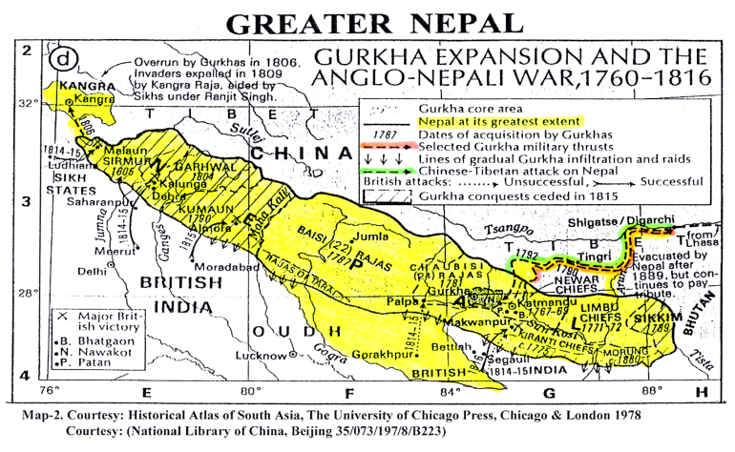
Source: Buddhi Narayan Shrestha

2.2) Kali River during the East India Company era [1816-1857]
In 1837, twenty one years after the Sugauli treaty, JB Tassin drew the Anglo-Persian map of India, which has been published from Calcutta. In this map, the Kali River, flowing down from the Limpiyadhura range, has been indicated as Nepal’s Western boundary stipulated by the Sugauli treaty. Furthermore, the Map of 1856 drawn by the Office of the Surveyor General of India also indicates the Western boundary of Nepal along the Kali River (mentioned as Kalee) originating from Limpiyadhura (Limpiya range). With regard to the knowledge of the Government of Nepal about the preparation of this 1856 map, the hand written explanatory note No 3 in the map indicates that the map was seen and approved by Prime Minister Junga Bahadur Rana to be sent to the British Resident at Kathmandu. This note indicates that the Government of Nepal and the East India Company Government were in communication with each other while preparing the map of the Kumaon region.

It is abundantly clear from this 1856 Government of India map that the Kali/Mahakali River originates from Limpiyadhura. Thus, all territories to the east of the Kali/Mahakali River belong to Nepal. There is an interesting correspondence between the Chief Secretary, Government of India and Commissioner of Kumaon just after the December 1816 Sugauli Treaty. The Zamindars of Byas Praganna petitioned the Kumaon Commissioner on 8th March 1817 that ‘We are now informed that the villages situated east of Kalee are now [to] be attached to the Pargunnah of Dotee [Nepal]. There are only two villages so situated, Tinkar and Changroo, the remaining six villages of the Pergunnah namely Boodhe[Budhi], Gurbhuyan[Garbyang], Goonjee, Nabhee, okutee[Nihal…?], Kuthee[Kuti], however, derive the support of their inhabitants almost entirely from the produce of land situated on that side of the land …..’ The correspondence appears to indicate that, while the Zamindars resided on the west side of Kali in British India, their tenants lived on the east of the Kali River in Nepal. The Zamindars, thus, losing their valuable revenues immediately petitioned the Kumaon Commissioner. The Acting Chief Secretary directed his Kumaon Commissioner that ‘The letter and spirit of the Treaty of Peace give to the Nepalese Government to the undoubted right to all lands situated to the eastwards of the Kali…….it is extremely undesirable to manifest any reluctance to give prompt and full effect to those stipulations of the Treaty…….’ (see Annexes 1 and 1.1 ).

Survey of India, 1856
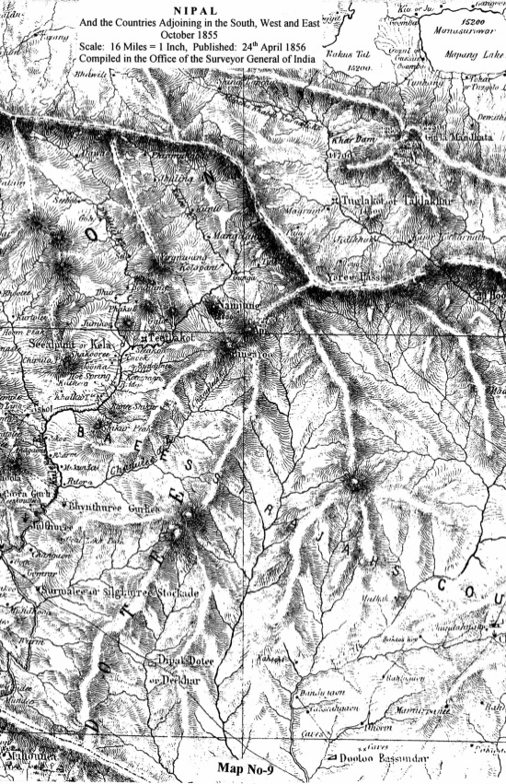
Source: Buddhi Narayan Shrestha

2.3) Kali River during the British India era [1857-1947]
After 1856 there have also been a number of map publications showing the origin of the Kali/Mahakali River. All post 1857 maps produced by the Government of British- India refrained from showing Limpiyadhura as the origin of the Kali/Mahakali River. The map of the District of Almora prepared by the Survey of India during the periods of 1865-69 and 1871-77 is a glaring example. Contradicting its own 1856 map, the Survey of India re-named the river originating from Limpiyadhura as Kuti Yangdi (Kali Nadi in local dialect) and named the river originating from the Lipulekh as Kali River. Also the border between Nepal and India is shown in this map following the watershed ridge starting from a little south of Kalapani to Omparbat (west of Tinker) in the Lipu range. This is clearly in contravention of the Sugauli Treaty's concept of Kali River as the border. Besides, Nepal was never consulted during these surveys and the Government of British India published these erroneous maps unilaterally. According to Buddhi Narayan Shrestha, former Director General of Department of Survey of Nepal, this was blatant 'cartographic aggression' as it was clearly against the spirit and wordings of the 1816 Sugauli Treaty.

One of the theories as to why the 'fair-minded' British resorted to such cartographic aggression is that Great Britain was deeply suspicious of the activities of the Russian Czar in Central Asia and particularly in Afghanistan. To protect her North-West Frontier, Britain engaged in the Second Afghan War in 1878 subduing the Afghans at the Battle of Kandahar in September 1880. Britain had already noted the ageless Kailash-Manosarovar pilgrimage route through the Lipulekh Pass as strategically important. Being a nation of traders, they had also not failed to note the importance of Lipulekh Pass as the Indo-Tibet trade route. The Survey of India thus resorted to this cartographic aggression. In fact, the 1904 guns of Younghusband Expedition to Lhasa forced the Tibetan government to open up three trade routes to Tibet. One of them was Gartok in Western Tibet.

District Almora: 1865-69 and 1871-77 ( Sheet 2 and 4) Scale: 1"=2 miles or 1: 126,720 ( Surveyed in different periods, Survey of India)
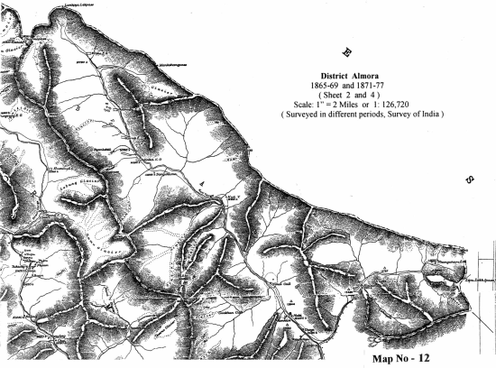
Source : Buddhi Narayan Shrestha

Survey of India map, 1879
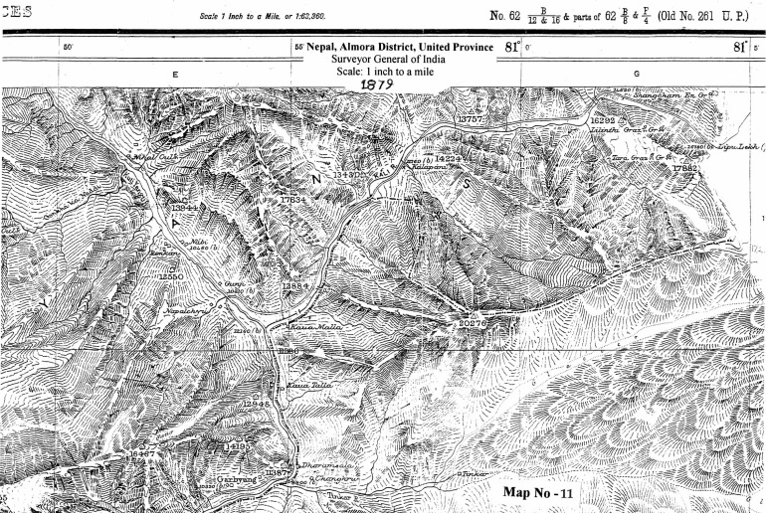
Source : Buddhi Narayan Shrestha
2.4 ) Sarada Banbasa Barrage of 1920:
In 1910 Nepal gave permission to the Government of India ‘for the survey of the Sarda (Mahakali) river channel in connection with the Sarda–Ganges–Jamna Feeder Project from Baramdeo Mandi to a point one mile below Banbassa ferry’ – the Scheme known as the Sarda Kichha Feeder Project. The British objective was to utilize the waters of the Sarada (Mahakali) river for irrigating the huge fertile lands in United Province (Uttar Pradesh). The shrewd British had the headworks of this project ‘situated entirely in British Territory at Solani Goth.’ However, Nature has her own intricate ways of working. The 1916 letter of British Resident, J Manners Smith, to Prime Minister Chandra Shumshere indicated that, due to the big flood of 1910, the ‘whole winter supply (of Sarada river) is now in the Nepal side.’ Hence the Government of India was forced to request Nepal to ‘kindly consent’ to the occupation of a ‘strip of land on the east side of the river which is now Nepal territory.’ This request gave birth to the 1920 Sarada Treaty. For some inexplicable reason, the origin of the Kali River and Limpiyadhura escaped the meticulous Chandra Shumshere while signing this Sarada treaty. Some analysts believe that if Chandra Shumshere had raised the issue of Limpiyadhura as the Kali River origin and thus Nepal's western boundary, the then British Government would not have disagreed with him. This is because Chandra Shumshere had provided 200,000 Gurkhas during that Great War of 1914-18.

2.5) Excess land during Exchange of Lands with Nepal for Sarada/Banbasa Project:
The accompanying letter of the Deputy Secretary of the Government of Public Works Department in UP dated July 1946 is self-explanatory about the transfer of 36.68 acres of land at Brahmadev Mandi to Nepal. The letter explains that during the swapping of lands, due to computational error, 31.47 acres of land plus another 5.21 acres acquired for guide bund construction were required to be returned to Nepal ( Annex 2). However, on the return of this excess 36.68 acres of land to Nepal, Indian ambassador KV Rajan on September 21, 1996 (a day after the Mahakali treaty ratification) replied.
‘It seems a matter that goes back to 1920 before India became independent. It seems as if after the actual land was measured … was likely in excess of what was supposed to be the case now. This is a very small, very technical matter. I have no doubt at all that the two countries will be able to resolve this….. to the total satisfaction of Nepal in the very near future.’

2.6 )Kali/Sarada/Mahakali in Republic of India era [1947- onwards ]:
After independence, the young Republic India went into a frenzy of building ‘temples of resurgent India’, massive water resources projects like Bhakra Nangal, Damodar Valley Corporation projects and the Kosi and Gandak projects in Nepal. Hence, the short but nasty Sino-Indian border clash of October 20 – November 20 1962 at NEFA and Ladakh was not only humiliating but an eye-opener for India. That humiliation was a blessing in disguise for States on the Sino-Indian border as the Indian government scrambled all its scarce resources to build roads, airports, communication, army barracks etc. all along the entire Sino-Indian border. As part of that security beefing up, Nepal became a hapless victim. India in 1963 intruded into the strategically important Kalapani in Nepal’s then Baitadi (now Darchula) district. India hastily posted her special police and the just raised para-military Indo-Tibetan Border Police Force (ITBPF) in Nepalese territory. In December 1960, King Mahendra had summarily thrown out and imprisoned Prime Minister BP Koirala. Had BP Koirala been the Prime Minister, some analysts swear that Pandit Nehru would have thought twice before violating Nepal's territorial integrity. At that point in time, King Mahendra was caught on the wrong foot. Besides facing the ire of Pandit Nehru for daring to open the Kodari Rajmarga to Tibet, the King was having skirmishes with the 'Nepalese exiles' along the entire Indo-Nepal border.

Interestingly, just prior to India’s intrusion into Nepal’s Kalapani, the country-wide Nepal census of 1961 was undertaken. A veteran Nepalese journalist Bhairab Risal was the census officer in charge of the Mahakali zone under which the present new district of Darchula fell. Risal categorically remembers taking the census of the villages of Gunji, Nabhi and Kuti in the beginning of July 1961. All these villages are on the left bank (eastern side) of the river locally known as Kuti Yangdi (Kali Nadi). This categorically confirms that the origin of the Kali River is Limpiyadhura and the territories to the east of Kuti Yangdi belong to Nepal. Despite the cartographic aggression by British India, there was no physical aggression of the territory. It is believed that physical aggression of Nepalese territory by India, as indicated above, occurred only after the October/November 1962 Sino-Indian border clash, most probably in May/June of 1963 after the snowmelt. Furthermore, Dr. Dwarika Nath Dhungel (one of the paper contributors) was during his government service the Chief District Officer of Darchula district. While touring his district in July 1981, he remembers being clearly told by the local residents of the villages of Gunji and Chhangro in the Byas Praganna that the Kali River originates from Limpiyadhura. As Chief District Officer of Darchula, he had reported this to his parent Home Ministry in Kathmandu.
2.7)Origin of Kali River in the 1996 Mahakali Treaty Ratification:
In order to replace the aging 1928 built Sarada Banbasa barrage, India started to unilaterally construct the Tanakpur barrage in early 1980s. Despite Nepal’s protests, India argued that the Tanakpur barrage with its entire associated afflux bunds were being built wholly within Indian territories and there were no adverse impacts to Nepal. But the Mahakali River, not dissimilar to that of 1910 during the British era, started to seriously gnaw the left bank upstream of the Tanakpur barrage. This forced Prime Minister Chandra Shekar on May 17, 1991 to request Nepal’s cooperation in exactly the same fashion as the British in 1916. Prime Minister GP Koirala through the controversial 1991 Tanakpur MOU permitted India to use 11.9 ha (2.9 ha in Jimuwa village plus 9 ha pondage area)ha of Nepalese lands so that India’s left afflux bund could be continued upstream and tied to the higher Nepalese lands. To solve this controversial Tanakpur issue, the Communist Party of Nepal–United Marxist Leninist (CPN-UML) came up with a marvelous concept, encapsulating it as 'Sarada barrage of yesterday, Tanakpur barrage of today and Pancheshwar project of tomorrow'. Thus was born the 1996 Treaty on The Integrated Development of the Mahakali River including Sarada Barrage, Tanakpur Barrage and Pancheshwar Project.

It is this Integrated Mahakali River Treaty that opened up to the public the Mahakali River origin stating skillfully ‘recognizing that the Mahakali River is a boundary river on major stretches between the two countries’. To the query of the major opposition party, CPN-UML, the government responded that the ‘boundary river on major stretches between the two countries’ and ‘basically a border river’ meant the same – having the same consequence. To another query of CPN-UML as to which is the main branch of Mahakali River, the government deftly replied that the main branch is the Kali River. CPN-UML, agreeing to Kali River being the main branch, finally hit the nail on the head by asking which is the Kali River itself and where does it originate from. The government then finally let the cat out of the bag by conceding that the origin of the Kali River from Kalapani Tal (lake) as shown by India on the Nepal-India border is categorically NOT the Kali River origin. Then on September 11, 1996, Prime Minister Sher Bahadur Deuba, through a letter to CPN-UML General Secretary Madhav Kumar Nepal, informed that the governments of Nepal and India had already decided to dispatch a Joint Survey Team (JST) in the coming winter [of 1996]. Based on the Sugauli Treaty and other maps and documents, this Team would demarcate the border in a scientific manner. After this demarcation, Prime Minister Deuba stated that his government will allow no foreign military or police personnel within the Nepalese territory.

Nearly two decades have lapsed since the ratification of the 1996 Mahakali Treaty. The term of the Joint Committee of Experts (JTE) of the Joint Survey Team has expired in 2007. Yet, the two governments still agree to disagree on the origin of the Kali River. India to this date continues to station its Indo-Tibetan Border Police Force (ITBPF) at Kalapani (see map). From 1982 onwards during the Annual Kailash Mansarovar Yatra, ‘ITBPF provides communication, security and medical cover to the yatries from Gunji to Lipulekh Pass and back to Gunji in co-ordination with Ministry of External Affairs (MEA) and Kumaon Mandal vikas Nigam.’

3. Resolving the Origin of Kali/Mahakali River

It is desirable on the part of both India and Nepal to resolve this contentious issue of the origin of Kali/Mahakali River on the basis of historical facts and international practices. While the 1816 Sugauli Treaty stipulates Kali River as Nepal's western boundary, one needs to abide by international practices to determine which exactly is the Kali River at the uppermost reach. Knowledgeable hydrologists state there are four principle hydrological parameters followed internationally to determine the main river. They are: i) the average discharge of the river i.e the volume of water flow ii) the length of the river iii) the catchment area of the river and iv) the numbering of river. In other words, the river having the longer length, bigger catchment area and larger discharge is automatically the main river. Following this international practice, Dr. Jagat Kumar Bhusal, a hydrologist, has categorically stated (The Rising Nepal, September 4, 1998) that the origin of Kali/Mahakali river is from Limpiyadhura. Kuti Yangdi (Kali Nadi) is the name of the Kali/Mahakali River at its uppermost reach.

Map of the Upper Basin of the Mahakali River
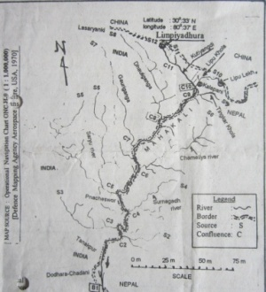
Source: The Rising Nepal, September 4, 1998
Both JB Tassin in 1837 and the Surveyor General of India in 1856 have indicated Kuti Yangdi as the uppermost reach of Kali River. This was the same principle applied by Dr. Campbell in 1838 to investigate Sikkim’s claim over Nepal’s Antu ridge, located in the eastern part of Nepal. As the Antu hill had two rivers on its eastern and western side, Sikkim claimed Antu with the argument that the border River Mechi was the one on the western side. However, Dr. Campbell, following the above mentioned principle, identified the river on the eastern side of Antu to be the main Mechi River (Shrestha 2003). This is a glaring precedent that could be replicated in the dispute over whether the Kali River originates from Lipulekh or Limpiyadhura.

Conclusion: Need to Resolve the Kali River Origin

To conclude, the following are the summary of the above arguments on the dispute over the origin of the River Kali:

- The 1816 Sugauli Treaty barred Nepal from ‘….. all claims to or connexion with the countries lying to the west of the River Kali….’
- The letter of the Acting Chief Secretary of the Government of India in March 1817 to the Commissioner of Kumaon ruled that the six villages (Budhi, Garbyang, Gunji, Nabi, Rokuti[Nihal ?] and Kuti) in the east of the Kali River categorically belonged to Nepal.
- The 1856 Map by the Surveyor General of the Government of India categorically identifies the river originating from the Limpiyadhura range as the Kalee (Kali) River.
- But the Survey of India prepared Map of Almora (surveyed in different periods 1865-’69 and 1871-’77) started to name the Lipu rivulet originating from Lipulekh as the Kali River. The map showed the river originating from Limpiyadhura as Kuti Yangdi. The same map similarly indicated the border of Nepal, not along the so called Kali River to the Lipulekh Pass as stipulated by the Sugauli treaty, but for strategic purposes diverted south then east following the watershed ridge to Omparbat.
- The control of the ageless Lipulekh Pass to Kailash/Manosarovar as the trade route to western Tibet was uppermost in British rulers’ minds. As this was only a ‘cartographic aggression’, for the Rana rulers of Nepal ignorance was bliss.
- The census of the ‘Nepalese inhabitants’ living east of the Kuti Yangdi River was undertaken by the Government of Nepal in July 1961. India had no problems with that.
- But the Sino-Indian border clash of October 1962 led to India’s ‘physical aggression’ of Nepalese territories east of Kuti Yangdi in early 1963.

Based on historical treaty, maps, documents and international practices, it is hoped that the two governments of Nepal and India settle this dispute over the origin of Kali/Mahakali River as soon as possible. Both the countries are keen to exploit the huge water resources potential of Nepal for mutual benefit. But with 372 square kilometers of Nepalese territory (310 sq. km in Limpiyadhura and 62 sq. km in Lipulekh/Kalapani) encroached by India, an atmosphere of mutual trust and faith can never develop. And this is detrimental to the interests of both the countries.

References :
Books and Reports
- Baral, Lok Raj and Uddhab Pyakurel ( 2013), India-Nepal Open Border – A Field-based Study on Problems and Prospects- A Report by submitted to the B P Koirala Foundation India-Nepal Foundation, Embassy of India, Kathmandu, Nepal Repo
- Compilation and Analysis of South Asian Treaties, Agreements on Water Resources (2003) – A report prepared by Association for Research and Management Services (ARMS)Pvt. Ltd for International Center for Integrated Mountain Development (ICIMOD), Kathmandu, Nepal
- Documents related to the Treaty on Integrated Development of the Mahakali River including Sarada barrage, Tanakpur barrage and Pancheshwor Authority, Government Press, (October/November 1996) Kathmandu, Nepal
- Kaul, B M ( 1967). The Untold Story, Allied Publishers' Pvt. Ltd, New Delhi, India
- Shah, Rishikesh (1996). Modern Nepal: A Political History- Volume I (1769 -1855), Manohar Publishers and Distributors, 2/6 Ansari Road, Dariyaganj, New Delhi, India.
- Shrestha, Buddhi Narayan (2013) Sima Sangram (Border Dispute), Ratna Sagar Publishers and Distributors, Kathmandu, Nepal
- -- Border Management of Nepal ( 2003), Bhumi Chitra Co. Pvt. Ltd. Kathamndu, Nepal
- --Demarcation of the International Boundaries of Nepal (2013) in Haim Srebro (Ed.) International Boundary Making (FIG Commission 1 Professional Standards and Practice), International Federation of Surveyors (FIG), Copenhagen, Denmark
- Smelling, John (2005). The Sacred Mountain, Travellers and Pilgrims at Mt. Kailash in Western Tibet, Motilal Banarsidass Publishers, New Delhi. India
- Upretti, Prem Raj (1984). A Small Nation in the Vortex of International Conflicts. Pugo Mi Publishers, Kathmandu, Nepal
- Landon, Perceval (2007). Nepal Volume I and II. Rupa and Company, New Delhi, India
Articles
- Bhusal Jagat Kumar (1998). The Origin of Mahakali River, The Rising Nepal, September 4, 1998
- Das, Pushpita (2008). Towards a Regulated Indo-Nepal Border, Strategic Analysis, Vol. 32, No. 5, Institute for Defence Studies and Analyses, September 2008, New Delhi, India
- Khatri, Ganesh ( Srawan 2055[July-August 1998]) Kasto Chha Bharatiya Jyadati Kalapanima, Mulayankan Magazine, Vol. 59, Kathmandu, Nepal
- Kuna ho Bastabik Kalinadi (Cover Story), Mulayankan Magazine: Vol. 17:70, Aswain2056 eptember/October 1999], Kathmandu, Nepal
- Lumsali, Rishiraj (Srawan 2055BS[July-August 1998]), Kutiyangdinai Kali Nadi ho, Mulayankan Magazine, Vol. 59, Kathmandu, Nepal
- Sharma, Sudhir ( Srawan 2055 BS [July-August 1998] ), Kalapani Kina Ra Kasari Bharatle Michheko Chhaa, Mulayankan Magazine, Vol. 59, Kathmandu, Nepal
Website : www.itbpolice.nic.in

Annexes
Annex 1
Petition of the Zamidars of Pergannah- Byas to Acting Commissioner, Kumaon, 8th March, 1817
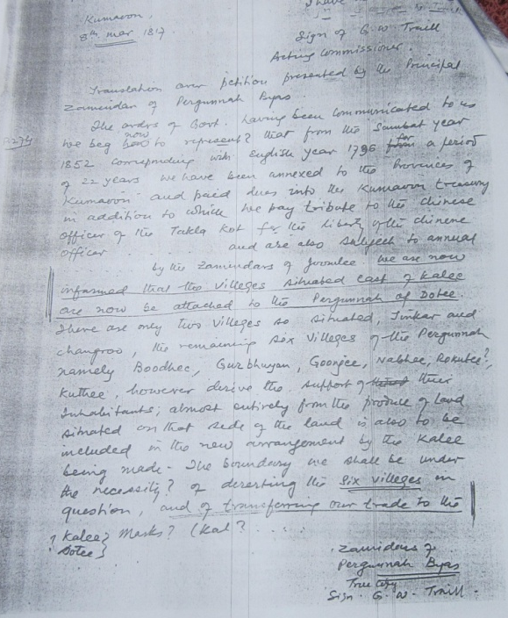
Source: Through Various sources
Annex 1.1
Reply of Acting Chief Secretary to the Government of India, J Adam regarding the Petition of Pergunnah, Byas to Acting Commissioner G W Traill, Kumaon, 22nd March 1817

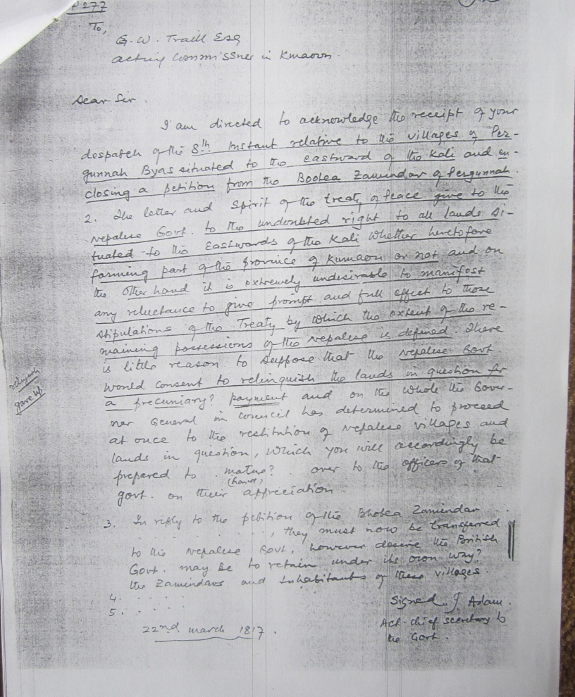
Source: Through Various sources
Annex 2.
Letter of Government of Public Works, UP India on Return of Land to Nepal
in Connexion with the Sarada Kitcha Project, July 23, 1946

Letter No 733 W/XXIII/1687-1939 dated 23.7.46
from
K.N. Kathpalia, Esquire, ISE,
Deputy Secretary
Government Public Works Department, UP
to
the Secretary
Government of India, External Affairs Department
New Delhi
and copy to the Minister, Nepal

Subject: Exchange of Land with Nepal in connexion with Sarada Kitcha Project

Sir,
I am directed to refer to your letter No. 857-CA /46 dated February 14, 1946 in which this Government was referred to the letter No 922 dated January 24, 1946 from His Majesty’s Government Minister, Nepal and asked for further comments of the Provincial Government.

2. I am to say that the area of the land shown at “B” in the sketch map forwarded with this Government’s letter No. 1408W/168W-1937, dated November 23, 1944 which the Nepal Government have accepted for transfer to them, is 36.68 acres.
This area was offered by Government for transfer to Nepal to rectify the error of 31.47 acres in the computation of land caused during the survey of 1934 and in exchange for 5.21 acres of Nepal land (shown at “A” on the sketch map in which about 80 feet of the existing right Down stream Guide Bund projects at present. The demolition of this Bund along with the low boulder bund in plot “C” would be most undesirable from the point of view of the protection of the Chaure-pani…against attack by the Sarada river.

3. I am therefore to request that if the Government of India have no objection, the Nepal Government may kindly be moved to receive an Engineer representative of this province to explain this Government difficulties to them with a view to persuade them to reconsider their decision regarding the exchange of 5.21 acres of land in plot “A” and 116.32 acres in plot “C” for an equal area of in plot “B” and “D” as proposed in paragraph 6 of this Government’s letter No. 1408/ 163W-1939 dated November 25, 1944.
4. I am to add that, if the Nepal Government are not agreeable to this proposal,
they may kindly be requested to let this Government have the area in question on a long term lease on term mutually agreed upon.

Sources: Ministry of Foreign Affairs and Ministry of Water Resources, Government of Nepal.
*****************

The authors wish to acknowledge the valuable inputs provided by the following persons in the preparation of this paper: Mr. Amrit Rai, Joint Secretary/Ministry of Foreign Affairs/Government of Nepal, Mr. Nagendra Jha, Director-General/Survey Department/Government of Nepal, Mr. Madhu Sudan Adhikari, Deputy Director-General/Survey Department, Mr. Krishna Sapkota, Chief Surveyor/Survey Department and Krishna Shyam Shrestha Surveyor/Survey Department. The authors would also want to acknowledge and thank Mr. Buddhi Narayan Shrestha, former Director-General, Survey Department, Government of Nepal for sharing his views on the subject and permitting us to use his maps for this paper. We would also like to thank many others who provided inputs for this paper. This Treaty, though ‘done at Segowlie’ on December 2, 1815, was approved and accepted by the Rajah of Nipal only on December 8, 1816 (BS Poush 4, 1873).
Kanchanpur, Kailali, Banke and Bardiya districts aptly termed Naya Muluk in Nepal.
Upretti, Prem R. 1984. A Small Nation in the Vortex of International Conflicts. Pugo Mi. Kathmandu. This meant moving the boundary pillar southwards to Champaran and ceding Nepal the possessions of the Rajah of Bettiah and Ram Nagar.
Landon, Perceval. 2007 Nepal Volume I and II. London. In fact, Landon mentions ‘Viceroy’s explanation that money is offered only because it is impossible to repeat the retrocession of territory which expressed the gratitude of the Indian Government for the services of Nepal during the Mutiny of 1857 to 1858.’
Shrestha, Buddhi Narayan (2013) Sima Sangram (Border Dispute), Ratna Sagar Publishers and Distributors, Kathmandu, Nepal
Pushpita Das, “Towards a Regulated India-Nepal border”, Strategic Analysis, Vol. 32, No. 5, September 2008, New Delhi, India
India-Nepal Open Border – A Field-based Study on Problems and Prospects Report by Lok Raj Baral and Uddhab Pyakurel submitted to BP Koirala India-Nepal Foundation, Embassy of India, Kathmandu, Nepal 2013 Report Submitted
Shah, Rishikesh (1996). Modern Nepal: A Political History. Volume I (1769 -1855), Manohar Publishers and Distributors, 2/6 Ansari Road, Dariyaganj, New Delhi, India.
Shrestha, Buddhi Narayan (2013) Sima Sangram (Border Dispute), Ratna Sagar Publishers and Distributors, Kathmandu, Nepal
'The British encounter with Kailas and its environs stemmed from altogether more hardheaded motives. They wanted to know what was going on in the territories immediately adjacent to their prized Indian possessions; they were very interested too in the possibility of opening up trading connections;…..' The Sacred Mountain by John Snelling, 2006. Motilal Banarsidass, New Delhi.
As per the treaty, Nepal Government would transfer necessary land for the construction and maintenance of canal works which is provisionally estimated at 4000 acres and would receive land equal in area from the British Government. The land to be taken from Nepalese territory will, after demarcation be measured and then land equal in area to it will be given to Nepal by the said Government. Also The Nepal Government will have a right for a supply of 460 cusecs of water and, provided the surplus is available, for a supply of upto 1000 cusecs when cultivation grows at any future time from the Sarda canal head work during the Kharif i.e. from 15th May to 15th October, and of 150 cusecs during Rabi i.e. from the 15th October to 15th May, the canal head being in the latter period alternately closed and opened for 10 days at a time running 300 cusecs whenever the canal is open. Nepal was able to make use of this water only when the Mahakali irrigation system (both first and second phases of the project with a command area of 11,600 hectares [ha] of land in Kanchanpur district) was built with World Bank assistance and completed in 1997/98 (Source: Compilation and Analysis of South Asian Treaties, Agreements on Water Resources (2003)–A report prepared by Association for Research and Management Services Pvt. Ltd for International Center for Integrated Mountain Development (ICIMOD), Kathmandu, Nepal)
From publication in Nepali of the Ministry of Water Resources, His Majesty’s Government of Nepal dated Kartik 29, 2053 (Nov. 14, 1996) on the Treaty between His Majesty’s Government of Nepal and the Government of India concerning the Integrated Development of the Mahakali River including Sarada Barrage, Tanakpur Barrage and Pancheshwar Project.
Lt. General B M Kaul in his book The Untold Story ( 1967), Allied Publishers' Pvt. Ltd. gives the following approximate causalities of the Indian Army in NEFA and Ladakh during that 1962 Sino-Indian clash: NEFA [ killed- 1,150, wounded-500 and missing 1,600] and Ladakh [ killed-230, wounded-50 and missing-60]. In total 3,590 [ NEFA-3,250 and Ladakh-340].
During that time, the Rana system of administrative division was still intact, using such terms like Thum, Praganna, Garkha etc. The villages of Gunji, Nabhi and Kuti fell under the Byas Garkha. At that time there were only 35 districts (32 districts outside of Kathmandu and three districts of Kathmandu valley) in Nepal and the present Darchula fell under the Batadi administrative division. It was only in early 1960's that 75 districts were created.
The 87 year old journalist spritely Bhairab Risal is still around and remembers visiting that area towards the third week of Asar 2018. He stands by the census he carried out on the villages east of Kuti Yangdi (Kali River) in 1961.
This was the government formed after the Supreme Court reinstated the Parliament that Prime Minister Man Mohan Adhikari had dissolved. It was a coalition government of Nepali Congress (NC), Rashtriya Prajatantra Party (RPP) and the Sadbhavana Party. The Prime Minister was Sher Bahadur Deuba (NC), the Water Resources Minister Pashupati SJB Rana (RPP) and Foreign Minister Prakash Chandra Lohani (RPP).
Just before the Parliament’s ratification of the Mahakali Treaty on September 20, 1996.
www.itbpolice.nic.in

