QUESTIONS ARISING FROM 41st MEETING – 11/4/14

As normal at an Indian restaurant (though we discovered this particular one is operated by Nepalis!) we talked about the proportion of highly-spiced and mild dishes to be ordered, leading on to mention of the notoriously bland nature of a lot of British food. The Latin adjective blandus, -a, -um has the basic meaning of flattering and, although the Pocket Oxford Dictionary suggests it could also be the equivalent of English bland, the more detailed entry in Lewis & Short’s lexicon shows that the secondary meanings were pleasant, agreeable etc. rather than the word’s English derivative.
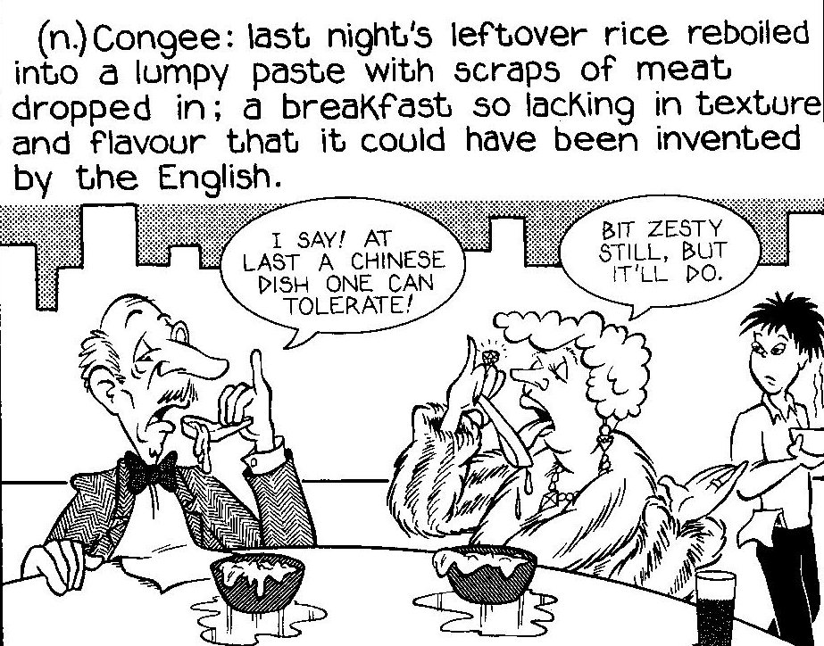

Searching his dictionary for words to describe food or wine without positive qualities, Stefan came up with imbelicus (specifically in the phrase vīnum imbelicum), vapidus (more in the sense of spiritless, flat, spoiled), sapōre carēns (lacking flavour), ineptus (really referring to speech or behaviour rather than food or drink), infacetus (used normally of coarse or rude behaviour) and insulsus. The latter means literally `unsalted’ and, although most frequently applied to people who are tasteless, silly or awkward, it could also refer to food. This last adjective is applied to the Britons by the leading Roman character in the 1980s British comedy series `Chelmsford 123’ in a stretch of Latin dialogue that can be viewed on Youtube with transcript on the `linguae ‘ site (http://linguae.weebly.com/latin--greek.html

There was a brief mention of the modern Romance languages and one member was surprised that Romanian, spoken in an area of eastern European country only briefly part of the Roman Empire, was among them. This question was discussed recently at another meeting (see QUESTIONS ARISING (II), page 57).

We also discussed Roman authors suitable for reading after completing a basic course in Latin. Caesar’s style is very straightforward and his De Bello Gallico (`On the Gallic War’) used to be a mainstay of the secondary school Latin curriculum. Partly as a result of a reaction against empire-building and militarism, he suffered a decline in popularity but has now been re-instated as a major component of the USA Latin AP examination (roughly the equivalent of A-level or IB). Stefan pointed out that he was relevant to discussions of the concept of a just war (iūstum bellum), since a major part of his purpose was to justify the wars he conducted on his own initiative against the Helvetii and other tribes. The selection of Caesar extracts on the American high school syllabus for 2013-14, with commentary and vocabulary, is available free at http://geoffreysteadman.com/college-caesar/

Clement, an admirer of Cicero, asked which of the orator’s works was best to start with and Stefan recommended the speeches In Verrem, which were written for his prosecution of the corrupt and oppressive governor of Sicily, C. Cornelius Verres, and established Cicero’s own reputation in Rome. Extracts, with commentary, form the first section of Wheelock’s Latin Reader, designed to follow on from the well-known course book. The surname Verres is also a common noun meaning `swine’ or `wild-boar’ and Stefan thought that Cicero’s punning phrase iūs verrīnum, which could be translated as `Verres’ law’ also meant `pig swill’ rather than (as John had previously thought) `boar soup’ . Lewis & Short does, however, translate the expression as `pork-broth.’

Relatively easy reading is also provided by translations of children’s classics, including Winnie Ille Pu, Harrius Potter et Lapis Philosophi (this is also available in classical Greek), Harrius Potter et Camera Secretorum, Hobbitus Ille and several volumes in the Astérix series. The best choice for a beginner, however, is probably the Fabulae Faciles anthology of stories from the Greek myths mentioned in several other meetings and downloadable from http://geoffreysteadman.com/ritchies-fabulae-faciles/ in Steadman’s user-friendly edition. He gives a short, basic vocabulary consisting or words that occur 15 or more times in the text and readers are asked first to learn this. All other words are glossed opposite the text itself and explanations of all difficult constructions also provided.

Another collection of similar stories, which John has not yet seen but which has been highly recommended on the web is Luigi Miraglia’s Fabulae Surae, the Sura in the title being a character in Hans Orberg’s direct method course Lingua Latina per Se Illustrata. The vocabulary and grammar covered (with a particular emphasis on the subjunctive) ties in with the contents of chapters 26 to 34 of Orberg’s first volume, Familia Romana, and can be used after completing Orberg’s own collection of dialogues, Colloquia Personarum, or simply as an independent reader for any intermediate student of Latin (see http://www.amazon.com/Fabulae-Syrae-Lingua-Latina-Miraglia/dp/1585104280/).

We discussed briefly various derogatory or informal expressions, including Cantonese yai (曳, naughty, improbus) and chi sin (黐線, īnsānus), Clement pointing out that the latter was used between equals and the former only by superiors to or about inferiors. Mention was also made of yeung gwaiji (洋鬼子, diabolus aliēnus), an expression which came into the language in the Qing period but which is now obsolete, in contrast to the universally recognised gwailou (鬼佬. literally `ghost fellow/dude’, umbrivir or vir daemoniacus).

This led on to a discussion of hierarchy in Chinese society, Clement arguing that the central bureaucracy only reached down to the level of municipalities and control at village level relied on the Confucian value system which had survived right through until the Cultural Revolution. As an illustration of the strength of Confucian attitudes regarding the family, he cited an incident about a hundred years ago in which both the head of a municipality and the provincial governor felt obliged to resign because a young man in the area under them had struck his own mother during a dispute over his gambling away family money. The unfilial son was exiled to Mongolia.

Clement also suggested that there was a recurring pattern throughout Chinese history with each dynasty going through a `violence’ phase when physical coercion was directed against their internal enemies, then a `power’ phase when they were accepted as rulers within China and tried to extend their political control over regions beyond China. He seemed to think that China was now heading again for an expansionist phase but John suggested that, despite a threatening posture over control of the neighbouring seas, China was likely to gain further economic influence rather than exercise direct politico-military control.

There was also some discussion of the Qing (Manchu) dynasty, which some Chinese have seen as an alien disruption of Chinese civilisation; in the account of Chiang Kai-shek (中正)’s family history in his memorial museum in Taipei an ancestor is praised for his refusal to serve `the alien court.’ Clement had read that the Qing had ordered the burning of 0.5 million books, and, while later investigation suggests this was an over-estimate, Qianlong (emperor from 1736 to 1796 ), who oversaw the copying of a massive collection of major works of Chinese literature (3,697 works selected out of over 10,000 considered for inclusion) also suppressed 2.320 books deemed subversive. His reign saw the execution of a man who had published criticism of the dictionary compiled under Kangxi (the second Qing emperor) and revealed the secret names of the emperors (see John Fairbank, China: A New History, p.158-59.) Ruthless censorship was not, however, a Qing monopoly, for the most famous book-burning in Chinese history was conducted by the first emperor, Qin Shi-huang

The belief that the Qing were not true guardians of Chinese tradition led some in Japan, which gave refuge to Ming loyalists, to see themselves as the real heirs to the Confucian heritage and this formed part of the ideological justification for Japan’s bid for control of China in the 20th century. Clement argued that the actual effect of this intervention was to lay the foundation for modern Chinese nationalism

We touched briefly on the Hong Kong plague outbreak of 1894, the subject of many of the exhibits in the Museum of Medical Science on Hong Kong Island. The plague had spread to the territory from southern China and then travelled round the world claiming up to 22 million victims. The official Hong Kong death toll was just 2,600 but this covered only those who died in hospitals and excluded in particular the large numbers of fatalities amongst around 100,0000 Chinese who left the colony to return to their home villages.. Clement mentioned Alexandre Yersin, the French bacteriologist who is credited for first isolating the plague bacillus, which in 1954 was officially named after him: Yersinia pestis. Yersin arrived in Hong Kong during the outbreak on his own initiative and was not initially able to secure co-operation from the colonial authorities, who had themselves invited two Japanese bacteriologists to investigate. One of the Japanese, Kitasato Shibashaburo, in fact observed the bacillus under the microscope and published his discovery ahead of Yersin but he did not provide a fully detailed description, nor succeed in isolating Yersinia pestis fully. Today Yersin is commemorated by a bust in the grounds of the Medical Sciences Museum but John does not remember seeing any reference to Kitisato when he visited the museum recently. The picture below illustrates the disinfection of homes of plague victims and removal of furniture for burning, measures which caused considerable tension between the authorities and the Chinese population. The political and scientific controversies are discussed in Myron Echenberg’s Plague Ports (available on-line in Google Books (see
http://books.google.com.hk/books?id=qw1M_3amPcQC&pgn10s&hl and in a recent article by Hong Kong historian Lee Pui-tak (http://hub.hku.hk/bitstream/10722/185180/1/Content.pdf?accept=1).

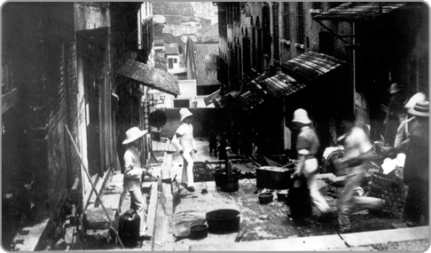

Stefan asked about materials to help in preparation for the IGCSE Latin set texts. John has detailed notes both on the extracts from Aeneid II and on the Nepos, Livy and Seneca selections. He is happy to send these as email attachments to friends who need them but they are not available for download from his IGCSE web page - http://linguae.weebly.com/igcse-latin.html The web site does, however, include Powerpoint presentations on the authors and their work as well as general information on the examinations.

Finally, a macroned-text of a sample dialogue from the new textbook for oral Latin, Vox Populī was distributed and John and Stefan commented on some of its non-classical features, including the use of the participle dēlectāns to translate `interesting.’ It was agreed, however, that it was an interesting attempt to enliven presentation of the language. The pdf with translation and grammar notes is available at http://www.voxromana.org/images/voxpopuli_chapter6.pdf and a recording at http://www.voxromana.org/Media/06.mp3 John has still to finish colour-coding of the accented syllables on the macroned-text and the document will be sent to everyone on the Cicrulus list again when this work is finished.

QUESTIONS ARISING FROM 42nd MEETING – 23/5/14

Following the astounding announcement that both the City Chinese and the gweilou-style restaurant on the floor above had run out of wine, a Latvian relief expedition (Mavis and Aletia) arrived with a bottle, occasioning rehearsal of the Latvian for `thank you’ (paldies), with Latin grātiās maximās naturally accompanying and Welsh diolch yn fawr thrown in for good measure. Up to that moment we had had to make do with beer (cervisia) which one of the party could not share because of the gluten (glūtenum) it contains. The Romans themselves were definitely vīnum drinkers, leaving cervisia (a loanword from Gallic) to the northern barbarians, who were also notorious for the consumption of milk (lac, lactis n) by adults.

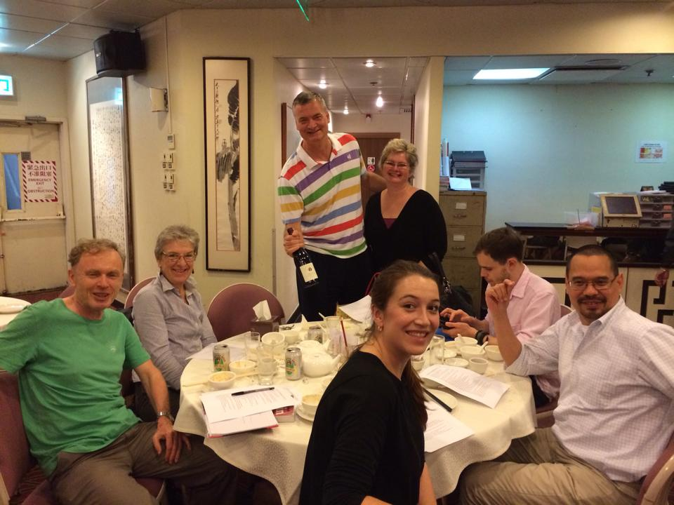

We read together the chapter from the Vox Populī course briefly discussed last month. As noted then, some of its features struck us as rather unclassical features including the verb mōtivāre (for motivate) and Rōmānēnsis, -is f for novel. The latter word does, however, seem to be quite well established in neo-Latin usage, although normally in the phrase fābula Rōmānēnsis or Historia Rōmānēnsis (the latter is used by Leinbitz). Stefan argued that there ought to be a classical word for works such as Apuleius’s Metamorphoses (also known as The Golden Ass) and in fact Apuleius himself announces at the beginning of the book sermone isto Milesio varias fabulas conseram (`let me join together stories in that Milesian style’). The reference is to the Μιλησιακά (`Milesian Tales’) of the 2nd. century B.C. Greek author Aristides of Miletus, which were translated into Latin in the 1st century B.C. by Lucius Cornelius Sisenna under the title Fābulae Mīlēsiae (see http://en.wikipedia.org/wiki/Milesian_tale) but, despite great popularity in the ancient world, have not survived.. Aristides book, like The Golden Ass or the Satyricon of Petronius, was a collection of stories combined within an over-arching narrative and the title later became a generic term for any similar work. Most Latinists now prefer to use fābula Mīlēsia as the term for `novel’ (see, for example, David Morgan’s neo-Latin word list (http://millie.furman.edu/morgan/adumbratio.htm), s.v.), though the singular originally referred to an individual sub-plot rather than the collection as a whole. In addition, Aristides’ own Fābulae Mīlēsiae were erotic stories, in line with the city of Miletus’s reputation for permissiveness, so one could argue if the phrase is entirely appropriate as a label for a novel of any kind. Smith-Hall’s English-Latin dictionary (largely confining itself to classical expressions and available on-line at http://www.archive.org/stream/copiouscriticale00smit#page/n7/mode/2up) offers historia commenticia but this should is probably best translated as `fiction’.

For background information on ancient Greek and Roman novels, Gareth Schmeling, The Novel in the Ancient World (1996), http://books.google.com.hk/books?id=1498GeN0W3EC and Heinz Hoffman Latin Fiction; the Latin novel in context (2004). http://books.google.com.hk/books?id=6cpr5tsEEn8C
Apuleius’s work, which tells the adventures of Lucius (also the author’s own praenōmen) who is magically changed into an ass but is finally restored to human shape by the goddess Isis, is the only ancient novel to have survived intact. An adapted extract (Sagae Thessāliae, `The Witches of Thessaly’) is included in the Cambridge Anthology and is amongst the prescribed passages for the 2014 OCR GCSE examination in the UK. More details, and links to the Latin text and English translation of the whole book are available on the Cambridge website (http://www.cambridgescp.com/Upage.php?p=cla^prose1^p_stage7400 ). This in addition lets you read the extract on-line with the usual hyper-linked glosses (click on `Explore the Story’)

We also read Queen Elizabeth’s 1597 rebuke to the Polish ambassador, the text and translation of which has already been circulated and is now on the web at http://linguae.weebly.com/regina-et-legatus.html The Latin has been marked up for vowel length and stress in line with classical rules, but Elizabeth’s own pronunciation will certainly have been deviated from that. The different ways in which the language was pronounced in different parts of Europe was a major barrier to efficient communication, as Elizabeth’s uncle, Prince Arthur, had discovered in 1501, when he and his newly-arrived bride, Catherine of Aragon, were unable to understand each other’s spoken Latin, despite having successfully corresponded with each other in it for a considerable time previously. However, the Polish ambassador’s own spoken Latin must have been close enough to the English one for the queen to have understood the gist, unless we suppose that he had handed over a written version before he began his speech. The whole episode was a public relations triumph for the queen whose prestige had diminished towards the end of her reign as people looked north to her designated successor, James VI of Scotland (now known better as James I of England). It should be remembered, however, that the text as we have it must have been written down from memory by one of those present and may not reproduce the queen’s words exactly.

Catherine and Arthur’s correspondence has not been published but may have been more of a formal exercise at their tutors’ direction rather than a true meeting of minds. The Latin letters of her half-brother Edward included in The Literary Remains of King Edward VI, available on-line at
http://books.google.co.uk/books?id=WUEuAAAAIAAJ&pg=PA28#v=onepage&q&f=false certainly make very staid reading.

Robert Bolt’s A Man for all Seasons, a fictionalized account of the clash between Elizabeth’s father Henry and Sir Thomas Moore, portrays Henry himself as a rather halting speaker of Latin in contrast to Moore’s scholarly daughter, Margaret. This scene from the film, with transcript and translation of the Latin, can be viewed at http://linguae.weebly.com/latin--greek.html (use the in-page search function to find `Margaret Moore’)

Tanya pointed out that Elizabeth herself had also tried her hand at English poetry, whilst a prisoner of her sister Mary at Woodstock House in Oxfordshire, she inscribed these verses with a diamond on a window::

Much suspected by me,
Nothing proved can be,
Quoth Elizabeth prisoner.

A full collection of her is available on-line at http://tudorhistory.org/poetry/elizabeth.html, including a longer Woodstock poem, this time done in charcoal on a shutter:

Oh, Fortune! how thy restlesse wavering state
Hath fraught with cares my troubled witt!
Witnes this present prisonn, whither fate
Could beare me, and the joys I quitt.
Thou causedest the guiltie to be losed
From bandes, wherein are innocents inclosed:
Causing the guiltles to be straite reserved,
And freeing those that death had well deserved:
But by her envy can be nothing wrought.
So God send to my Foes all they have thought
As the most fluent reader of Chinese present, Mike was in charge of ordering the food and it transpired that he and John had both been students in CUHK’s Chinese Language Centre in 1996-97. Before starting on Cantonese, Mike was already fluent in English, Tagalog and Spanish and this early multi-lingualism, plus the importance of intonation in Tagalog, made the Cantonese tones easier for him than for many. The Cantonese section of the Centre is now no longer operating and only Putonghua is regularly taught there. The issue of the status of Cantonese in Hong Kong has caused a lot of controversy recently and some relevant material is available on the `Chinese Languages’ site (http://chineselanguages.weebly.com/ ) John’s now rather dated essay on this topic, `The future of Cantonese: Current Trends’ (Hong Kong Journal of Applied Linguistics, vol. 4, no. 1, pp.43 -60) is available on-line at http://hkjo.lib.hku.hk/archive/files/4f2b75239ff867ce521ae391d01eacb9.pdf and his diary study of his own attempt at learning Cantonese, `The Other Side of the Hill’, can be downloaded from Chinese Languages.

Tanya, who is also a Cantonese speaker, recommended Chineasy (http://chineasy.org/ ) the site run by London-based Taiwanese businesswoman ShaoLan, for help in learning characters because of the imaginative ways in which these are presented as part of a picture:

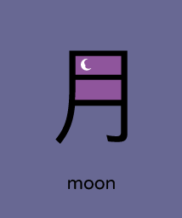

Mike suggested that chopstick should perhaps be rendered clavula Sīnica rather than simply clavula, which we have previously been using and which, strictly speaking, means twig. We also noted that insurance, the field that Rhiannon works in, should be assēcūrātiō (–ōnis f)

Finally, there was brief discussion of obscene expressions in Cantonese – often only differentiated from perfectly innocuous words by tone shifts non-native-speakers have difficulty perceiving. The fullest collection of `bad language’ is probably Christopher Hutton and Kingsley Bolton’s Dictionary of Cantonese Slang, whilst some of the most basic items are listed in Robert Bauer’s Modern Cantonese Phonology (p.312-13). John can provide a copy of the latter with the transcriptions converted into the Yale system. For equivalent Latin expressions, the standard authority is James Adams, The Latin Sexual Vocabulary (see http://books.google.com.hk/books?id=GDP9VHGbF1AC&dqlt for a partial preview) and, for those who can cope with explanations in Latin, there is Rambach’s 1833 Thesaurus Eroticus Linguae Latinae, whose full text is at https://archive.org/details/thesauruserotic00rambgoog
QUESTIONS ARISING FROM 43rd MEETING
The restaurant was busier than our previous visit and we had some trouble attracting the waiter’s attention. This led to discussion of the Latin for wave (the hand). One suggestion was (manū) nutō but the verb means specifically nod the head and, though it also means stagger or totter (referring to the whole body, or, in a famous simile in Book II of the Aeneid, to a tree swaying before it topples to the ground) it does not seem to have been used of hand movements. Another possibility might be manum vibrō (cf gladium vibrō, wave or brandish a sword) but a subsequent search of the Latin Library corpus (www.thelatinlibrary.com) yielded no example of this collocation. The Smith-Hall English-Latin dictionary (http://www.archive.org/stream/copiouscriticale00smit#page/938/mode/2up0 gives the phrase manūs iactō (-āre, -āvī, -ātum) from Juvenal but the context is someone throwing up his hands in a gesture of applause. Smith-Hall also has manum rotō (-āre, -āvī, -ātum) for moving the hand in a circle. For ordinary waving, perhaps manūs agitō (-āre, -āvī, -ātum), on the analogy of Ovid’s hastam agitō, would work or, if the purpose is to give a message, manū indicāre (to indicate with the hand) plus accusative and infinitive.

The general noise level in the restaurant was also a problem: Tantus clāmor est ut etiam Anglicē inter nōs sermōnem serere difficile est (It’s so noisy that even speaking together in English is difficult!). John had originally suggested sermōnēs disserere for hold a conversation but disserō (unlike serō (-ere, serui, seritum) sew or bind together) is used intransitively to mean discuss, converse.

We went over some basic vocabulary for items on the table, including cultellus (-ī m) knife, furcula (-ae f) fork, cochlear (cochleāris, n) spoon. vīnum (-ī n) wine, and lagoena (-ae f) bottle. We also mentioned clavula (-ae f), literally twig but used also for chopstick and cervisia (-ae f) beer. We had forgotten the phrase costa agnīna tandūria which we hit upon for `tandoori lamb chop’ some while back (see QUESTIONS ARISING (II), p.57-8, where angīna is a typo, inviting confusion with angina, choking, strangulation, c.f. the medical term angina pectoris)

We went quickly over William of Poitiers account of the Battle of Hastings (14 October 1066), which was probably written two or three years after the event and is the only detailed report to have survived. The author was chaplain to William the Conqueror and, as he had trained as a knight before becoming a priest, was in a good position to write military history. Particularly interesting are the details of how the English lost the battle by repeatedly abandoning their strong defensive position to charge down the hill after the retreating Normans and also the statement that all of the English, whether or not they felt a personal allegiance to King Harold, `were coming to the aid of their country, which they wanted to defend.against foreigners, even though unjustly’ (patriae praestābant quam contra extraneōs, tametsī nōn justē, defensāre volēbant). Coming from a supporter of Duke William, this is conclusive evidence of a strong sense of common nationhood on the English side, something lacking at this time in Normandy, let alone in France as a whole. Despite making the admission that the English did not want a Norman as their king, Wiiliam of Poitiers is still able to argue that justice was on the Normans’ side because in the Middle Ages popular feeling was regarded as irrelevant to the issue of political legitimacy: England was a piece of property which `belonged’ to Duke William and the English were morally obliged to accept him as their overlord whether they liked the idea or not.

We discussed briefly whether people in the various parts of France, even if lacking a strong sense of common political identity, nevertheless felt they had something in common culturally or whether, in view of the very divergent dialects they spoke, thought of themselves simply as members of Latin Christendom. Certainly once in England the Normans will have been keenly aware of the linguistic divide between themselves and the English, and King Willliam issued edicts to `my subjects, French and English.’ In addition, John Armstrong’s Nations before Nationalism describes how the emergence of the notion of France as a distinct entity was encouraged by the papacy as a counterweight to the Holy Roman Emperor. However, Eugen Weber’s Peasants into Frenchmen; the Modernization of Rural France, 1870-1914, shows how even in the late 19th century it took extensive social engineering to subordinate local to national identity. Of course, in the English case as well we cannot be sure how strong the sense of Englishness was in the 11th century for those right at the bottom of the social hierarchy.

There is an account of the political background to the conflict, which was a three-way one between William, Harold and Harold Hardrada of Norway, in a powerpoint downloadable from http://linguae.weebly.com/english.html (scroll down to the Battle of Hastings’’ section). This also has a number of illustrations from the Bayeux Tapestry which tells the story of the conflict in pictures with simple Latin captions:
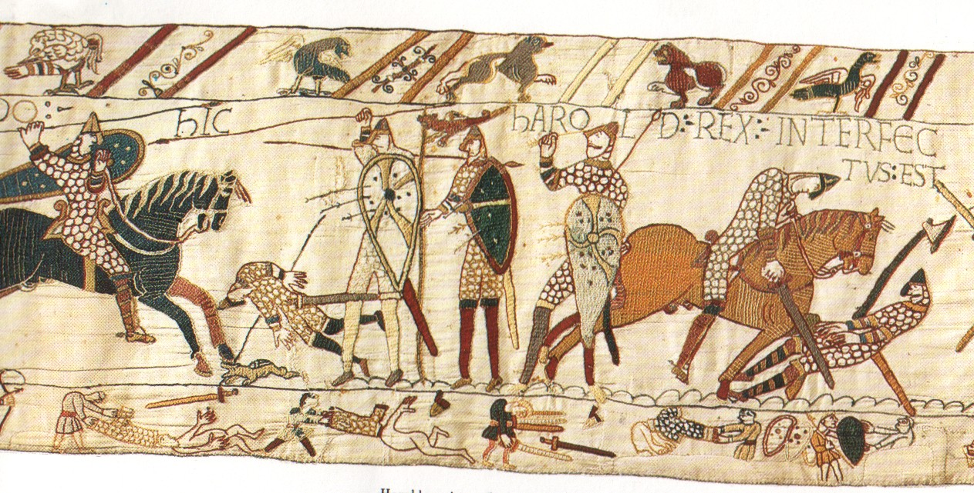
`Hic Haroldus rēx interfectus est’ (Here King Harold has been killed)

The PowerPoint also deals with the long-term linguistic consequences of the Norman Conquest, with French initially the preferred language of the ruling elite and retaining an important role down to the early 15th century, well after English had become the first language of rulers as well as ruled. In 1300, this fact was bemoaned by Robert of Gloucester (who was himself writing in French): `unless a man knows French he is thought little of. But humble men keep to English and their own speech still. I reckon there are no countries in the whole world that do not keep to their own speech, except England only.' Although English re-asserted itself as the language used for all public purposes in England, one or two fossilized phrases remain (e.g. the formula La reine le veult (medieval French for `The queen wishes it’) pronounced after an Act of Parliament has received the royal assent) and, much more importantly, the flood of Latin and French words admitted into the language after the 11th century have made it very different from Old English (Anglo-Saxon).

During the period of European colonialism English itself was to assume an important role in territories were it was not the vernacular. Lewis remarked on the fact that English is now used less widely in Hong Kong than in most ex-British colonies. Countries where it has retained a greater role are generally those where linguistic and ethnic diversity makes a link language necessary. In India, for example, Hindi is sufficiently similar to the regional languages of the north to make it acceptable for inter-regional communication but educated speakers of the Dravidian languages of the south prefer to continue using English.

Lewis is a speaker of Japanese, with his interest (like that of many in Hong Kong) first aroused by enthusiasm for Japinese anima. We rehearsed other basic phrases such as loquerisne Iaponicē? (do you speak Japanese?), fēcistīne iter in Iaponiam (have you been to Japan) and habēsne amīcōs Iaponēnsēs Honcongī? (Do you have Japanese friends in Hong Kong?).

John also mentioned his own experience learning Cantonese at the Chinese Language Centre in CUHK (Ūniversitās Sīnica Hōncongēnsis) when the department was run by 苗太(Miu Tai), wife and former tutor of senior civil servant苗學禮 (Tony Miller, Antōnius Molendīnārius)). Unfortunately the Cantonese section at the centre has fallen victim to `mainlandization’ (continentālificātiō) and foreigners there now learn only Putonghua (sermō normālis).

Finally, Lewis talked about his job in transport planning (commeātus excogitandus) including work on a new road link between Central and Wanchai (Centrālis) and Wanchai (Sinus Parvus or perhaps Sinulus) which will go through an undersea tunnel (cunīculus, -ī m, an interesting word which also means `rabbit’!)
QUESTIONS ARISING FROM 44th MEETING – 18/7/14

We spent some time discussing the Latinizations of various place-names, especially the home districts of the members present:

For Hongkong itself, the Circulus has always used Honcongum, although `ng’ in Latin always represents two consonant sounds (as in finger rather than in singer). The alternative (used, for example, by Terentius Tunberg, a leading American advocate of living Latin) is Honconum, but this is pronounced `Hongkonum’, with an alveolar /n/ instead of the velar nasal /ŋ/ which both Cantonese and English versions of the name end with. Egger’s Lexicon Nōminum Locōrum offers the rather ugly Hongcongum, or (based on Putonghua Xiang Gang) Siamkiamum

With Kowloon, we use the literal translation of九龍 but here, too, there is room for argument as we could write either Novemdracōnēs or, with assimilation at the word boundary, Novendracōnēs.

Tseung Kwan O (將軍澳) could perhaps be Sinus Imperātōris or Sinus Imperiālis (`General’s Bay’), though one member suggested that the Chinese character澳 really meant `body of calm water’ in which case Tranquillitās Imperātōris might be justified, even though tranquillitās refers to the abstract state rather than to a calm object.

Although we decided a long time back on a similarly literal Magnus Portus (`Big Anchorage/Port’) for Tai Po (大埔) David prefers the adjectival form Taepoēnsis, -e (based on a noun Taepoum, -ī n and, though Mexicānus by birth, describes himself as corde Taepoēnsis (or perhaps intrinsecus Taepoēnsis?), `a Taipoan at heart.’ The spelling ae is best for the Cantonese/English diphthong ai, as the latter combination in Latin would more naturally represent a long ā followed by consonantal ī.

The `Chung’ in Tung Chung, which John took as `bay’, means `creek’ in Cantonese (the character 涌 occasionally means `rapid water’ but is then pronounced `yung’) and the full name means `east of the creek’ (Rivulōriēns, –entis f?) Transliteration is difficult as the sounds represented by ch and ng do not exist in Latin but perhaps Tungsiungum or Tungsiunum would do

For Lantau, we toyed some years back with Magnīnsulamōns (a literal translation of大嶼山, `Big Island Mountain’) but preferred the less unwieldy Lantāvia, -ae f.

For Macau, De Christiana Expeditione (1617), an account based on Matthaeo Ricci’s reports and available on-line at http://books.google.com.au/books?id=iLsWAAAAQAAJ, uses Amacaum with derived adjective Amacaensis, explaining on page 155 that `In ea peninsula idolum erat, quae hodieque visitur, cui nomen erat Ama; inde locus Amacao, ac si Amae Sinus dicas, appellatur’ (`on that peninsula there was an idol, still to be seen today, whose name as Ama; the place is for this reason called Amacao, meaning `Ama’s Bay.’) The reference is to the 1488.
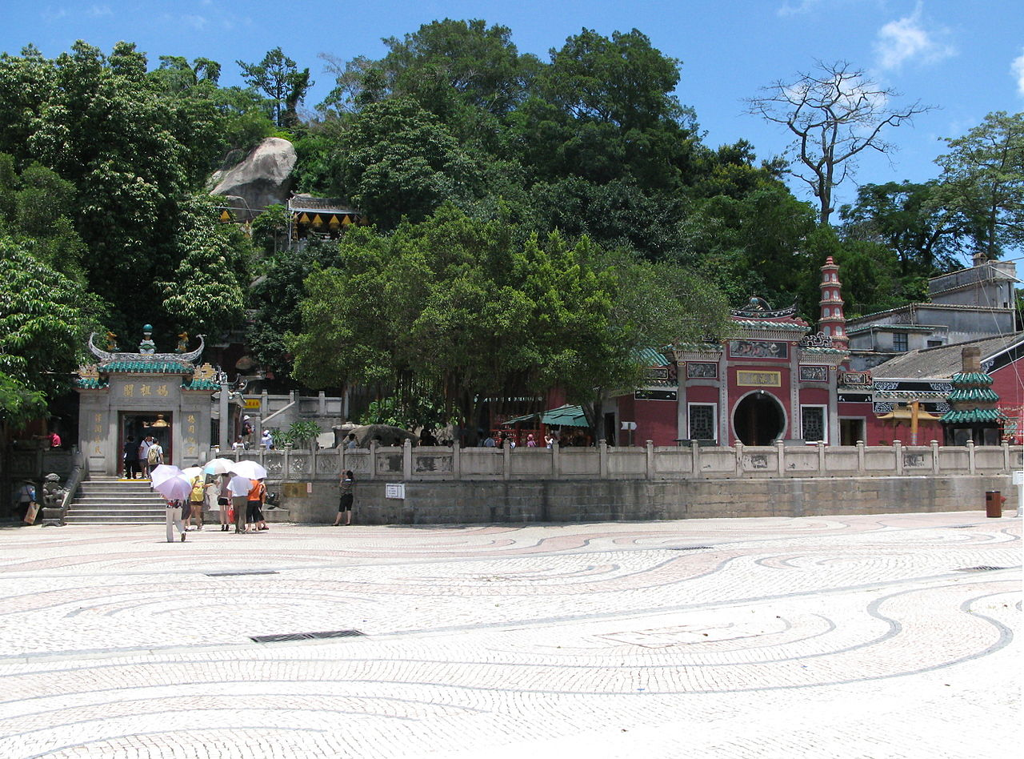
temple of Matsu (Tin Hau) which is known in Cantonese as `Ma Gak Miu’ (媽閣廟 – Mother’s Pavilion Temple) and generally recognized as the source of the place-name (see picture above and http://en.wikipedia.org/wiki/Names_of_Macau). Presumably local inhabitants used the ubiquitous prefix `a’ and added the word `o’ (澳, `bay’) to tell the first Portuguese arrivals they were in `A-Ma-Gak-O’ . To refer to Macau in Latin today we could thus chose between Amacaum (or Amacāum to achieve the classical relationship between syllable length and stress in the penultimate syllable), Amae Sinus (-ūs m), Ōmūnum (from the Cantonese pronunciation of the modern Chinese name澳門) or settle for Macāvia, -ae f, which is currently listed in the `Circulus Vocabulary’

Literally translating the English would give Rupēs Leōnis or (if an adjective is preferred to a noun in the genitive) Rupēs Leōnīna but, although rupēs can be used for a crag or rocky cliff, it’s probably best to translate the Chinese獅子山 (`Lion Mountain’) and use Mōns Leōnis /Mōns Leōnīnus).` The well-known song title獅子山下 (Si Ji Shan Ha, `Under Lion Rock’) would thus be Sub Monte Leōnis/Leonīnō

David passed round a copy of the 2011 re-issue of Clive Carruthers’ 1964 Latin version of Alice in Wonderland. The new edition was brought out by the efforts of Michael Everson and Johan Winge, the latter being well-known by his work on Latin pronunciation (see http://web.comhem.se/alatius/latin/). They have contributed a new introduction, discussing among other things the difficulties in translating phrases such as `the Cheshire cat’ (fēlēs Cestriāna). The also explain the typographical conventions they used, which were decided after a survey of 250 classical scholars:

Hōc in librō offertur lēctōrī nova ēditiō fābulae "Alicia in Terrā Mīrābilī" in Latīnum annō 1964ō ā Clive Harcourt Carruthers conversae. Differt ā prīmā ēditiōne duābus praecipuīs rēbus: cum quod discrīmen nunc servātur inter "i" litteram vōcālem et "j" litteram vim cōnsonantis habentem, tum quod omnēs vōcālēs longae sunt līneolīs superscrīptīs ōrnātae. Omnium vōcālium longitūdinēs dīligenter exquīsītae sunt, etiam in syllabīs positiōne longīs. In pauciōribus syllabīs, quārum vōcālium longitūdinēs aut nunc incertae sunt, aut manifestē etiam antīquīs temporibus vacillābant, vōcālēs sine līneolīs scrīptae sunt. Glōssārium Latīnō-Anglicum in ultimō librō magnopere auctum est. Praeter ferē vīgintī Neolatīna vocābula locūtiōnēsque, ut in prīmā ēditiōne, hoc novum glōssārium etiam complectitur plūs ducenta vocābula antīqua tīrōnibus inūsitātiōria. Spērāmus fore ut glōssāriō auctō multō plūrēs lēctōrēs sine aliōrum lexicōrum ūsū ex hōc librō magnam capiant voluptatem.

In this book we present a new edition of Clive Harcourt Carruthers' 1964 translation of "Alice's Adventures in Wonderland" into Latin. It differs from Carruthers' original text chiefly in two ways: a regular distinction between the vowel "i" and the consonant "j" has been made, and long vowels are marked with macrons consistently throughout. All vowels have been carefully investigated, including the vowels in syllables long by position. In a few isolated cases where the classical vowel lengths are in dispute, or where usage evidently vacillated, the vowels have been left unmarked. The Latin-English glossary at the end has been greatly enlarged. Instead of treating only a few Neo-Latin words and phrases peculiar to this book, the extended glossary now also covers over two hundred less common classical words. It is our hope that this will enable a much larger group of our readers to enjoy Carruthers' translation without having to resort to external dictionaries.

Buying the book probably works out cheaper from the Book Depository, which does not charge postage: (http://www.amazon.com/Alicia-Terra-Mirabili-Latin-Edition/dp/1904808697
However, Amazon is useful for the extensive preview provided on their site:
http://www.bookdepository.co.uk/Alicia-Terra-Mirabili-Lewis-Carroll/9781904808695

Carruther’s work is one of a substantial number of Latin translations of literary classics and children’s books (see http://en.wikipedia.org/wiki/List_of_Latin_translations_of_modern_literature) While the Alice in Wonderland translation is highly regarded, there are howlers in some other works. See, for example, Winge’s review of Hobbitus Ille: http://www.amazon.com/Hobbitus-Ille-J-R-Tolkien-ebook/dp/B008TGOD1E/



`Lewis Carroll’ was the pen name of an Oxford don, Charles Dodgson, who told the first version of his story to Alice Liddell, daughter of the Dean of Christ Church College and vice-chancellor of the University, on a boating trio in 1862. Mimi, a pharmacist who studied at Christ Church, told us that the real Alice in later life fell in love with Leopold, a German prince. There was no question at that time of his marrying a commoner but they kept in touch and each of them named one of their children after the other. For those who read Chinese, reflections and reminiscences on UK life and culture in general are provided in Mimi’s regular回眸英倫 column in 信報 (Hong Kong Economic Times).

After the meting, Mimi provided two photographs of Christ Church locations, one of the door through which Alice is supposed to have entered Through the Looking Glass and the other of the tree in which the famous Cheshire Cat (and his grin) appeared. There is more on this topic in Mimi’s article in the 9 February 2013 issue of信報, which can still be read via this link.:
http://generation40s.wordpress.com/2013/08/19/%E6%84%9B%E9%BA%97%E7%B5%B2%E9%9A%94%E4%BB%A3%E6%83%85%E7%B7%A3/
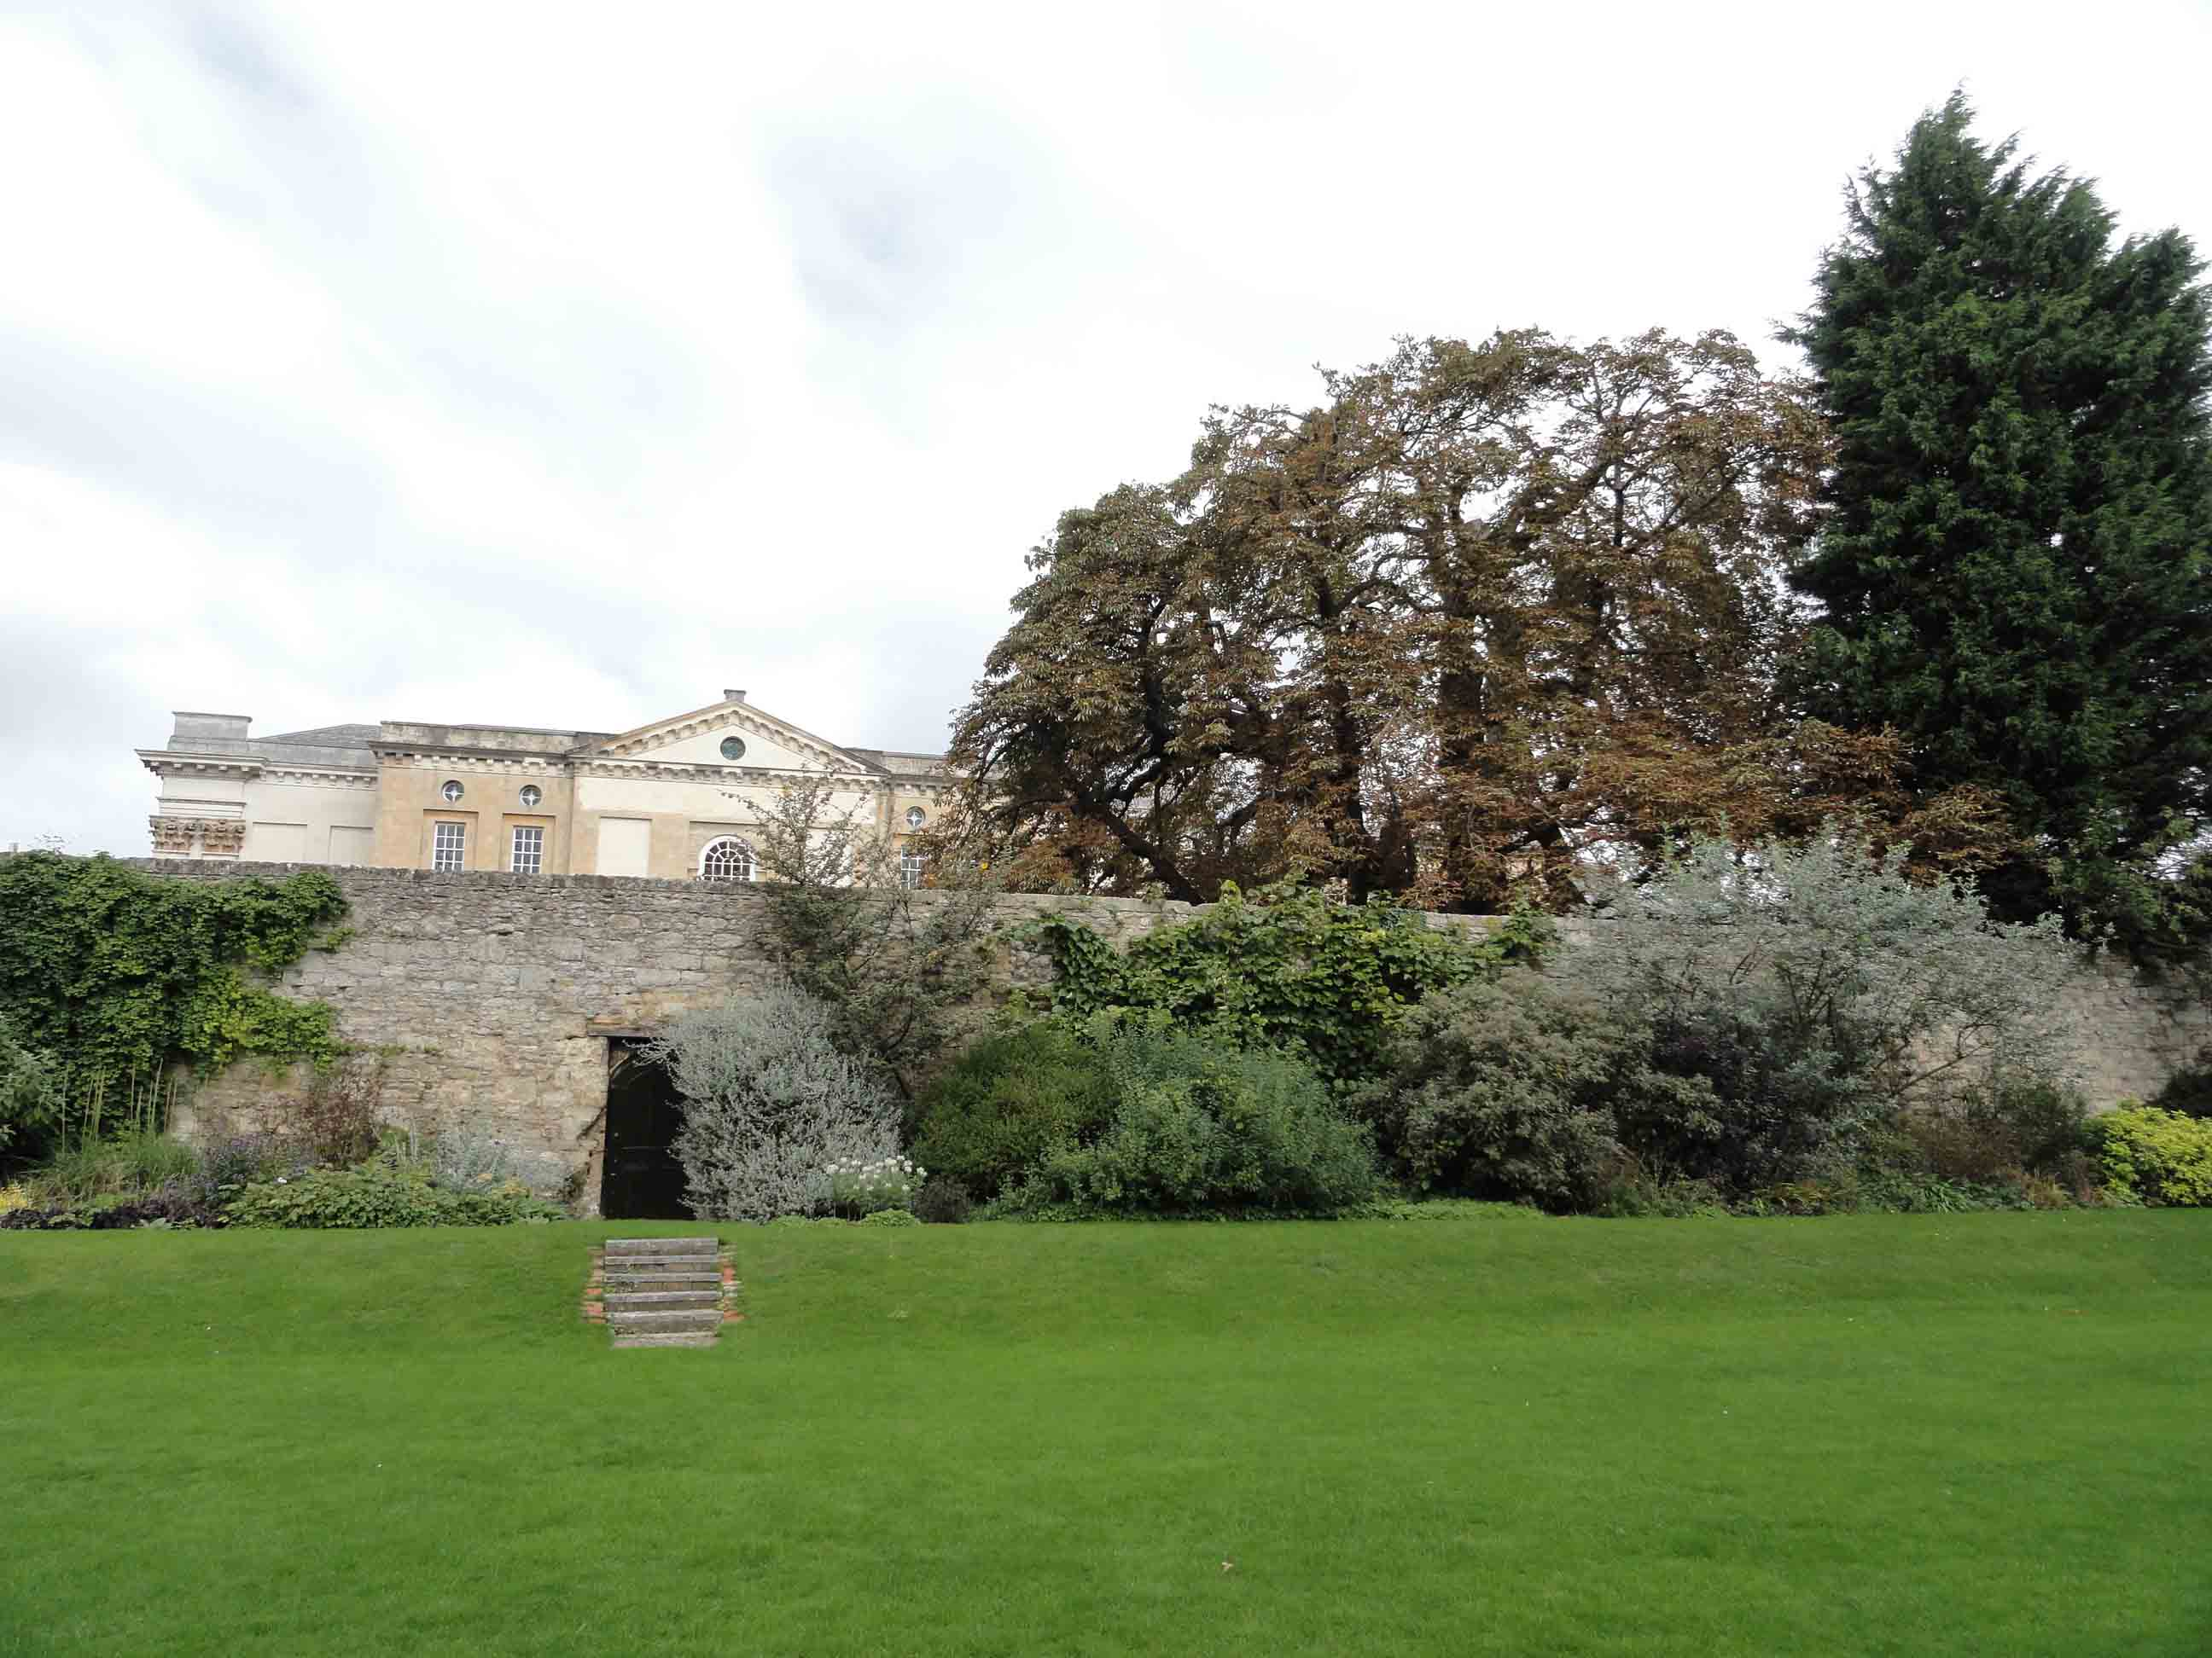
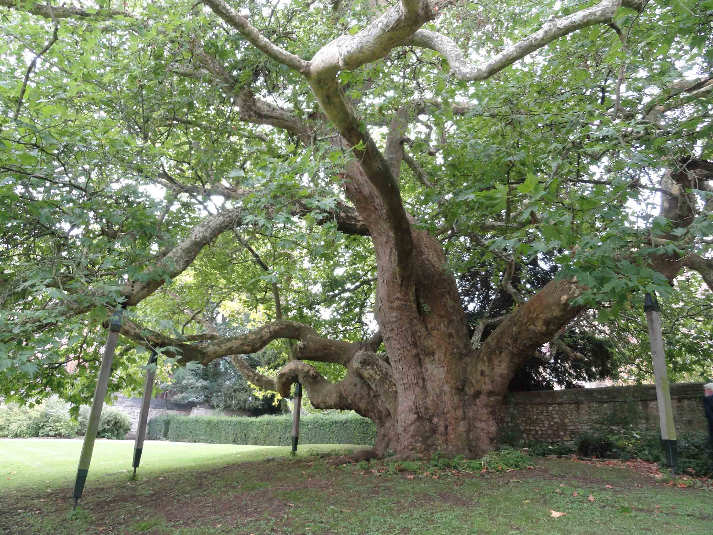
David asked about the quality of Pope Francis’s spoken Latin, but the others had not yet heard this. In contrast, Benedict XVI’s Latin resignation statement was broadcast world-wide (a transcript and link to a recording is available at http://linguae.weebly.com/latinitas-pontificalis.html). John said that Benedict’s speech on that occasion was in place a bit rushed and indistinct but that his overall command of the language was probably better than that of his successor as he was older and had longer experience of using Latin in church administration. Listening subsequently to Francis’s proclamation of the canonisation of Popes John XXIII and John-Paul II (now available on Youtube at https://www.youtube.com/watch?v=PZO8E8iEyX0) , he does perhaps seem less comfortable in the language though it is difficult to be sure from the reading of prepared texts.

Particularly because two new members were present, we again discussed basic terms for dining and tableware. We use clavula (-ae f) (`little twig’) for chopsticks, so起筷 (hei fai, `raise your chopsticks’) is clavulās tollite! Chopsticks used for serving food are clavulae pūblicae (translating Chinese公筷, gung fai). `Glass’ is pōculum (-ī n) so `Raise your glasses is ` pōcula tollite!’ `Cheers!’ is prōsit! (subjunctive from the verb prōsum, prōdesse, prōfuī, be advantageous), a word which, shortened into `Prost!’ is still in use in Germany and elsewhere. `Drain a glass’ is pōculum haurio (haurīre, hausī, haustum); the expanded from of the verb, exhauriō, gives the English derivative exhaust. The Latin for spoon is cochlear, coc(h)leāris n, originally a curved instrument for extracting a snail from its shell but the meaning was later widened. `Hot’ is calidus, -a, -um when referring to temperature and probably acer, acris, acre for spicy food. There is a problem with words for crockery because the Romans seem often to have used the same word for both bowl and plate (see the `Circulus Vocabulary’). David Morgan’s neo-Latin dictionary recommends acētābulum (-ī n), which seems originally to have applied to any small, cup-shaped vessel, or catilllus cavus (`hollow catillus’) for a small bowl, and paropsis (paropsidis f), catīnus cāvus or lanx (lancis f) cava for a large one. A possible solution for present-day communication is to use patella (-ae f) and catillus (-ī m) for an individual’s plate and bowl respectively and patera (-ae f) and catīnus,(-ī m) for the larger plate and dish in which food is served in a Chinese restaurant.

We also went over words for various languages. The full forms of these are normally phrases consisting of the noun lingua (tongue, language) plus an adjective, though, depending on context, the adjective alone is sometimes used as a noun. For example, lingua Sīnica (Chinese), Anglica (English), Lūsitānica (Portuguese). If we want to distinguish dialect and language (a distinction which is arguably political more than linguistic -`A dialect is a language with an army and a navy’), we can use sermō, sermōnis or the neo-Latin word dialectus (-ī m) for the former and reserve lingua for the latter. We have normally referred to Cantonese as sermō Cantonēnsis and Putonghua as sermō normālis (`standard speech’). For `in Latin’ etc. an adverb in –ē is normally used. E.g. loquerisne Latīnē, `Do you speak Latin?’

Someone asked about the relationship of Catalan (lingua Catalāna for Catalan separatists and sermō Catalānus for Spanish unionists?) to Spanish (the standard, Castilian variety which is Spain’s national language). It is, as one would expect from its geographical position, intermediate between Spanish and French. David also added that European and South American Spanish were so different that he sometimes needed help from sub-titles when watching films made in Spain. John recalls once relying on the Chinese sub-title for one remark in an American film but this was down to the noise the other members of the audience were making rather than the inherent comprehensibility of the phrase involved.

David and Wei talked about the Latin news broadcasts from Helsinki and Bremen, Wei thinking that the latter was a little bit clearer but David that it depended on individual news readers. The Helsinki bulletins can be listened to on-line and transcripts read at http://ohjelmaopas.yle.fi/1-1931339 but to download the recordings to your own computer you need to go to http://areena.yle.fi/radio/1931339 . The Bremen broadcasts are available at http://www.radiobremen.de/podcasts/latein/latein114.html
David also recommended the S,P,Q.R iPad and iphone application which includes a corpus of Latin texts, dictionary, parser etc. Detail are available at http://www.romansgohome.com/spqr

We also briefly discussed again the Latinization of Hebrew names from the Bible. These were sometimes given Greek/Latin endings and sometimes treated as indeclinable nouns and a single form used for all the cases. An alternative method was to add endings from one of the native Latin declensions. Thus `Adam’ is treated as an indeclinable noun in the vulgate but other authors added 2nd or 1st. declension endings (e.g. genitive Adae or Adamī)

We spent a few minutes looking at the RES GRAMMATICAE handout on the discussion of Latin grammar in Latin. John realised he had made an error in the first section, where pronoun should be translated as prōnōmen, not praenōmen The latter refers to the personal forenames that male roman citizens were normally given, e,g, Gāius in Gāius Iūlius Caesar. Roman praepositiō became preposition in English because in medieval times the Latin word itself was often written with an `e’ to reflect the changed pronunciation of what had originally been a diphthong similar to the `ie’ in die. This change also explains spellings like edifice (<aedificium) and celestial (<caelestis)

Another pronunciation question discussed was the digraph `rh’. This is used in words borrowed from Greek, where it represented an aspirated or voiceless `r’, which an English speaker can approximate by attempting to say `h’ and `r’ simultaneously. A similar procedure is needed to produce the voiceless `l’ written `ll’ in Welsh Llandudno etc. However, it’s unlikely the Romans themselves pronounced `rh’ any differently from plain `r’!

Finally, the ever useful phrase Mē stultum! (`Silly me!’) was explained and the translations Sī ego tū essem, hoc facerem and Sī ego tū fuissem, hoc fēcissem were provided for `If I were you, I would do this’ and `If I had been you, I would have done this.’ Latin uses the imperfect for contrary-to-fact conditionals referring to present time and pluperfect subjunctive for past counter-factuals.

QUESTIONS ARISING FROM 45th MEETING – 29/8/14

Wei explained that he had enjoyed following another summer course in reading medieval Latin provided by Swarthmore College http://www.swarthmore.edu/classics and devoted this year to Saint Jerome’s `Life of Malchus’ (a Syrian monk who was enslaved and forced to marry but remained faithful to his vow of chastity) and on the anonymous Navigatio Sancti Brendani, an account produced around 900 A.D. of the supposed maritime adventures of St. Brendan (c,484 to 577) The details of Brendan’s voyage into the Atlantic are mostly sheer fantasy but the story might just conceivably have been based on an actual journey to Greenland and Newfoundland The texts and commentary used this year, and also of last year’s text, Gesta Francorum, are still available at https://sites.google.com/a/swarthmore.edu/medieval-latin-summer-2013-the-gesta-francorum/home/latin-texts-of-the-gesta-francorum and there is a recording of one of the on-line lessons (conducted interactively with eight participants) at:
https://plus.google.com/u/0/communities/106839324668039713380?cfem=1

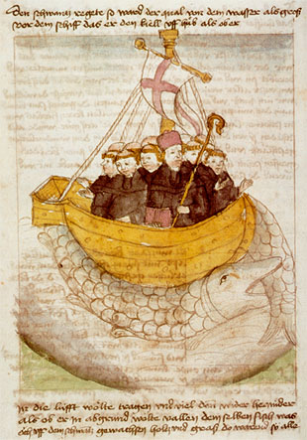

We also discussed briefly the SPQR application (mentioned in a bulletin you all received in February), which costs about HK$40 and includes a corpus of the works of 17 commonly studied authors (a word that should be translated as scrīptōrēs rather than auctōrēs, the latter term referring rather to the originator of doctrines etc.), dictionary, parser and other tools. For more details see http://www.romansgohome.com/

Stefan had brought along his copy of Latin For Beginners (Usbourne), which is a lavishly illustrated guide to basic conversation in Latin aimed at teenagers and part of a series also including French, Italian, German, Italian and Welsh,. John recalled first seeing this in the Hong Kong Book Centre around 1990 and thinking how weird it was to treat Latin just like a modern language, though, of course, he was soon converted to the idea himself! Alec recommended Jesuit author Stephen Wilby’s 1892 Guide to Latin Conversation, downloadable as a pdf from SkyDrive by following the link
http://bit.ly/cnf4Ud A more elementary compilation is How to Speak Latin (http://bit.ly/do6vXr)
There was also mention of the Latin proverb Absentem laedit cum ēbriō quī litigat (He who argues with a drunken man is attacking an absent opponent).

We touched on the Hindi cinema, which mostly produces action movies/romances punctuated by elaborate song-and-dance routines and seen only in the South Asian counties and their diasporas. Some films, however, became international hits, including, most recently, `The Lunchbox’ and, two or three years ago, `Three Idiots’. Still on the entertainment front, Stefan recommended YouTube videos featuring `Achmed the Dead Terrorist’ and Nigerian scammers tricked into recreating the Monty Python `Dead Parrot’ sketch. These may, however, be difficult to view on some computers until you figure out how to disable `Safe Mode’!

The centre-piece of the meal was the restaurant’s speciality dish, tandoori leg of lamb – crūs angīnum tandūrium, with salad (acetāria, -ōrum n.pl.), rice (orỹza) and nan (pānis Persicus)., washed down as usual with red wine (vīnum rubrum or vīnum sanguineum). Tan mentioned her providing colleagues at school with mulled wine at Christmas time – vīnum coctum/candescēns There was some general discussion of wine drinking culture, including Stefan’s warning that a sophisticated drinker would never mix the contents of two bottles of the same wine, let along two different types. Wei told us that the cultivation of grapes for wine production had reached China during the Tang period.

A lot of time was spent going through the text of `Robīnus Hood’ – the video produced by Eduardo Engelsing’s students at the University of West Washington (text and translation at http://linguae.weebly.com/latin--greek.html). Stefan spotted a mistake in John’s transcription – the final `e’ in the adverb male should be short (unlike the case with most adverbs formed from adjectives). It was also agreed that an instrumental ablative couldn’t really be used with a noun for a person and so it should be Robīnum per siccārium interficere (`to kill Robin through an assassin’) rather than siccāriō interficere (`to kill with an assassin’). Other mistakes in Engelsing’s text include using fūrāta as passive perfect participle (`stolen things’) when the verb is a deponent (fūror) and the perfect participle therefore active in meaning (`having stolen’). There are other places in the text where there may be grammatical errors or where the words are inaudible. John had received a reply from Engelsing to an e-mail but not the requested transcript or explanation of inaudible/unintelligible phrases (marked in red on John’s site). Finally, quem delectātiōnem should have been quam dēlectātiōnem because while quem can be used for both genders as an interrogative pronoun, separate forms for masculine and feminine are normally used when it functions as an interrogative adjective.



QUESTIONS ARISING FROM 46th MEETING – 26/9/14

The City Chinese restaurant did not look very different from before its temporary closure but is under new management and so its licence to serve alcohol has not yet come through. Aware of this, John had brought in a clandestine bottle (lagoena, -ae f) and corkscrew (extrāculum, -ī n) of his own. lagoena (also spelt lagēna, lagoena or lagōna) is from Greek λάγυνος (lagūnos) and originally may have meant an earthenware flask or flagon with a handle but could be made of other materials and (according to Morgan’s neo-Latin lexicon) the word `is the best general term, and is appropriate for ordinary wine and beer bottles.’ Bulk transportation of wine in the ancient world was in a large container with pointed end called an amphora (-ae f). Food consumed with the wine included bitter gourd (cucurbita (-ae f) amāra) and fried rice (orӯza (-ae f) frīcta). We were unsure of the origin of the squash/pumpkin/gourd family but checking afterwards revealed the whole genus originated in America so its growth and consumption in China and elsewhere is post-1500 (see http://en.wikipedia.org/wiki/Cucurbita). We did recall in discussion that apples probably originated in the Tian Xian/Tin Shan (`Heavenly Mountains – Montēs Caelestēs) of western China.

Pat was still suffering (labōrābat or affligēbātur) from jet lag (dēbilitās (-ātis f) aërospātiālis or, more simply, ietlagia (-ae f) after his return from the U.K. (Rēgnum ( -ī n) Ūnītum) but still needing to work intensively on his book on the magistrates of New Peace County (新安縣), an administrative unit set up under the Ming dynasty in 1573 and including all of the present territory of Hong Kong. A study of the last (1819) edition of the official gazetteer for the county was published by Peter Ng and Hugh Baker some years ago (see the preview at http://books.google.com.hk/books?id=CTi-AQAAQBAJ) but Pat’s work makes use of the 1688 edition, and includes material on the periods both before and after the 1661-1669 evacuation of the coastal area ordered by the Qing dynasty as a measure against pirates. The language of the gazetteer is very difficult and some of it beyond the translation students at HKU who have been helping him..

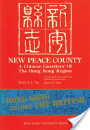

Discussion of Chinese history brought mention of Ray Huang’s 1587, a year of No Significance: the Ming Dynasty in Decline, which focuses on personalities at the court of Emperor Wan-li and the signs already visible of impending collapse (see the reviews at http://www.amazon.co.uk/1587-Year-No-Significance-Dynasty/dp/0300028849/) Mention was also made of the general state of Hong Kong before the British and Pat put the total population before 1841 at 150,000. The first British census of Hong Kong island (May 1841)found 4,350 permanent residents (plus around 2000 fishermen living on their boats, 800 merchants temporarily in the bazaar and 300 labourers from Kowloon. See Frank Walsh’s History of Hong Kong (pg. 137)

We looked at the original text of the Declaration at Arbroath, a letter sent by the Scottish nobility to the Pope seeking recognition of Robert the Bruce as their rightful king and of Scotland’s status as an independent kingdom. The text itself is included in the attachment (MONUMENTA CALEDONICA), which is also available now as a page on our website:. http://linguae.weebly.com/monumenta-caledonica.html Mention was made of the irony that, though the document stressed the antiquity of the Scottish people and their monarchy, some of the signatories (like Robert Bruce himself) were Normans whose families had moved into the country quite recently. The document also refers to the Scots supposed origin in Scythia (an area corresponding roughly to Europe east of Germany) and migrating over the Tyrrhenian (< Etruscan) Sea, i.e the waters between west coast of Italy, Corsica, Sardinia, Sicily and North Africa.)

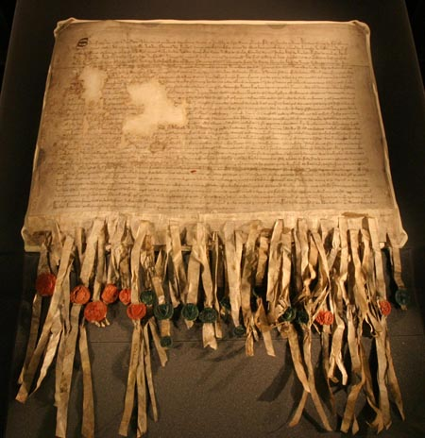
The Declaration of Arbroath with seals of signatories attached

We also read a section from 18th century Jesuit scholar Giulio Cesare Cordara’s account of the Jacobite rebellion of 1745, when Prince Charles Edward Stuart, grandson of the exiled king James II, tried to reclaim the throne from the Hanoverian King George II. Raising a small army in Scotland, the prince moved south into England, reaching as far south as Derby. There, although the Jacobites had won every engagement with government troops, his advisors decided that, as there had been no rising in their favour in England nor intervention from France, and since they were outnumbered by the gathering government forces, they must retreat to Scotland. They were pursued by government forces and decisively defeated at Culloden near Inverness (just off the north-east corner of the map in the attachment) in April 1746. The prince escaped in disguise and eventually boarded a French vessel on the west coast; the well-known `Skye Boat Song’ commemorates one stage in his journey (performance on YouTube at https://www.youtube.com/watch?v=ensGKMOD4cM

Cordara refers to the English calling the Hebrides (Latin Ebrudae) the Western Isles (Insulae Westernae) and Tanya wondered about a connection to the kingdom of Westeros in Game of Thrones. The common link is probably that they are both derived independently from West

There was some discussion of the recently held Scottish referendum (`Nuntii Latin`’ uses plēbiscītum, (-ī n), originally a decree passed by the plebeian assembly, which, after the end of the `Struggle of the Orders’ between patricians and plebeians, had the full force of law at Rome; Morgan recommends populī scītum).The Scottish vote decided that Scotland would remain part of the United Kingdom and we touched briefly on the history of the union itself. After centuries of intermittent warfare between England and Scotland, and also frequent intermarriage between the royal families, the Scottish scholar John Major (who taught the Protestant reformer John Knox) may have been the first to advocate a peaceful merger. In the last years of the life of the `Virgin Queen’ Elizabeth I of England , her advisors negotiated for James VI of Scotland (who was descended from Elizabeth’s aunt, Margaret Tudor) to inherit the throne as James I of England. On his accession in 1603 he was the ruler of both kingdoms (not just the symbolic head of state as Queen Elizabeth is today in the UK and many other commonwealth countries) but the kingdoms themselves remained separate, each with their own parliament. For a modern analogy, imagine Obama as president of both the USA and Canada but laws still having to be passed for the former by Congress in Washington and for the latter by Parliament in Ottawa. James himself devised the title `Great Britain’ for the two kingdoms together and would have liked a full merger, but nothing changed legally until the Act of Union in 1707 formally established `The United Kingdom of Great Britain’ (Ireland, though under British control remained a separate legal entity until a further Act of Union in 1801 changed the name to `United Kingdom of Great Britain and Ireland’.)

Public opinion in Scotland was against the 1707 measure but the parliament in Edinburgh accepted it and voted to dissolve itself because otherwise the country would have been shut out from English markets and financial assistance. The union also came after the civil wars of the 17th century and the expulsion of the last Stuart king, James II, in 1688, who was a Catholic in a by-now staunchly Protestant England. Continuing tensions made it possible for Prince Charles to gain support in Scotland, even from some Protestants, but, when it was clear he was going to lose, there was a rush to join the winning side and by the time the opposing armies met at Culloden there were more Highlanders in arms against than for him. Nevertheless, since the core of his support had been in the Gaelic-speaking Highlands, there followed ruthless reprisals and repression the region’s culture, including even a ban on the wearing of the kilt. Over time, as the British Empire grew and parts of Southern Scotland became an industrial powerhouse, the country as a whole accepted inclusion in the United Kingdom, but a sense of a separate Scottish identity remained strong, helped by the fact that the Act of Union had guaranteed the retention of Scotland’s separate legal system and church system. With the post-world War II decline in Britain’s status in the world, Scottish nationalism as a political force began to grow and the Scottish Nationalist Party is currently the largest party in the Scottish assembly set up in 1999.

We also touched on the languages spoken in Scotland, Wales and in Catalonia (NE Spain), where, as in Scotland, there has been a strong movement for independence, but, unlike in the UK, no agreement between central and regional government on holding a referendum. The vast majority of people in Scotland speak English with varying regional characteristics but write in standard British English. A small number of people are trying to promote writing in `Scots’ or `Lollans’ (`language of the Lowlands’), which was emerging as a literary standard before the 18th century union with England and used for Robert Burns’ poetry (see some other samples at http://www.billykay.co.uk/Pages/ScotsTheMitherTongue2.asp) . The name Scotland itself derives from the Scoti, Gaels from Ireland who raided the west coast of Britain in the later years of Roman rule and later established a kingdom in the West of Scotland, later extending their rule over the whole of the territory now called after them (a similar process led to Franks, originally a Germanic tribe, conquering and giving their name to modern France). Down to the 18th century the Highlands and Islands of Scotland were largely Gaelic speaking but hostility to Gaelic culture in both Edinburgh and London, the `Highland clearances’ in which tenants were evicted to convert land to sheep pastures, and the normal tendency for people to switch to a language of greater economic opportunity, steadily reduced the number of speakers. The language now has protected status but is spoken by under 60,000 people (about 1% of Scotland’s population). The language remains very similar to Irish and the two are mutually comprehensible at a basic level.

In contrast, Welsh has about 500,000 (a fifth of the population of Wales) and enjoys full official status, with television programmes, road signs, train service announcements etc. in both Welsh and English. The language is also on the curriculum of all state schools in Wales. Like Gaelic/Irish, Welsh is a Celtic language and it is a continuation of the old Brythonic language spoken throughout England, Wales and Southern Scotland until its displacement in most places by English or (less often) Gaelic. It used to be thought that Anglo-Saxon invaders completely displaced the Celtic inhabitants over what later became England, driving them into the far west or exterminating them, but a considerable number of Celtic speakers were assimilated into Anglo-Saxon society, and, though the geneticists are still arguing over exact percentages, it is possible that the majority of the ancestors of the present-day English were Celtic speakers (and that these themselves had once spoken a pre-Celtic language). For more information, see
http://www.nytimes.com/2007/03/06/science/06brits.html?_r=3&th&emc=th&oref=slogin& and http://www.arthuriana.co.uk/historical.htm Assimilation will partly have been driven by legal penalties on those who continued to speak Celtic and Pat pointed out that Anglo-Saxon prejudices were illustrated by the legend of St. Godric, an East Anglian monk who was troubled by demons, their demonic nature being made clear to him by the fact that they spoke Welsh!

The Catalan language, intermediate between standard Spanish (Castilian) and French was spoken over an extended area north and south of the eastern Pyrenees and is the native language of around half of the present population of the Catalan autonomous region in NE Spain. The Catalan areas north of the Pyrenees were ceded to France in 1659 but before that parts of southern France were often included in political units centred in Spain. The kingdom ruled in the late 7th century by the Gothic king Wamba covered all of Spain and Provence as far east as Nîmes (see the French-language links on Olivier Rimbault’s site at http://www.via-neolatina.fr/historica/wamba.html and for a brief account in Latin and English, scroll down (or use the in-page search function) for the words `Gallia Narbonensis’ on http://linguae.weebly.com/circulus-latinus-honcongensis.html )

We also spoke about the increasing interest on the mainland in the study of Latin and of European ancient history. Don, who is Hong Kong representative in the `Union Mundial Pro Interlingua’, later handed over this article from the Union’s newsletter Panorama (Maio-Junio 2014). Interlingua is an artificial language based primarily on common features of Romance languages. Hopefully, many readers will have no great difficulty in following it:

Latino e Greco plus popular in China
Per Thomas Breinstrup

CHINA – Le duo linguas classic del cultura occidental, latino e greco ancian, experientia un sorta de renascentia in Asia del Est.
Universitates Chinese experientia un crescente interesse pro studier le duo linguas que intertanto es in periculo de dispareer totalmente del scheda de education in multe paises occidental. Milles de studiantes apprende latino e greco ancian, e un del centros de gravitate es le Universitate Sun Yat-sen in le urbe sud-chinese Guangzhou, ubi un equipa de 30 studiantes in le estate 2013 finiva un studio de quatro annos con focalization al education classic occidental.
Durante le prime anno illes studiava latino sex horas per septimana, durante le secunde greco ancian durante sex horas septimanal, Pois on continuava per leger autores classic como Herodot e Platon, scribe le septimanal danese Weekendavisen.
Le Universitate de Beijing ha justo establite su centro pro studios classic Occidental, e altere universitates ha commenciate emplear academicos specialisante in le antiquitate classic. In 2010 comenciava apparer Le Magazin Chinese pro Studios Classic.
Le interesse crescente ha duo causas: un desiro de obtener le mesme nivello como studiantes in le West e un desiro de studier grande questiones ideologic.

There is also Latinitas Sinica, a department within the National Research Centre of Oversea Sinology, which focuses on Latin writing about China; see http://en.wikipedia.org/wiki/Latinitas_Sinica and, for the contents (in Chinese) of the first issue of their house journal, 拉丁语言文化研究 (Journal of Latin Language and Culture) http://www.sinologybeijing.net/cn/detail/12682 There is also a selection of materials on this topic on our own website: http://linguae.weebly.com/sina-latina.html

Tanya and Fiona also mentioned an Indian princess who supposedly married a king in Korea in the 2nd. century B.C. The king involved was King Suro of Geumgwan Gaya in SE Korea and his wife, Heo Hwang-ok, was from `Ayota’, identified with Ayodhya in northern India. For details, see http://en.wikipedia.org/wiki/Suro_of_Geumgwan_Gaya We noted that, whatever the truth of this story, there was considerable contact between ancient India and NE Asia, including Buddhist missionaries, and the order of the Japanese Hiragana script clearly resembles that of India’s Devanagari syllabary.

Finally, we noted the unhappy fate of an Indian news reader more familiar with Roman numerals than Chinese surnames. He was sacked after referring to Chinese president Xi Jin-ping as `Mr. Eleven’.

QUESTIONS ARISING FROM 47th MEETING – 31/10/14

We spent some time as usual on the Latin for items consumed, which included Chilean red wine (vīnum rubrum (or sanguineum) Chiliēnse, saagwala chicken (gallīnācea cum spināchiā), mutton butter masala (angīna butyrāta et arōmatica). We also had alu gobi, ie. potato and cauliflower. The first of these is solanum (-ī n) tuberōsum (the scientific name) or pōmum (-ī n) terrestre (c.f French pomme de terre) or even (as attested in the 16th and 17th centuries just after the plant was introduced into Europe) simply batāta). For cauliflower, Pliny the Elder uses brassica (cabbage) Pompeiāna. We also had bhanta (eggplant, aubergine, melanogēna), plain mutton curry (angīna cum iūre ācrī – from iūs ācre (iūris ācris n), literally `pungent soup), rice (orỹza) and naan (pānis Persicus, pānis Persicī m – as naan is simply the ordinary Persian word for bread.)

The Portuguese word for bread, pão (< Latin accusative pānem) sounds very similar to the Chinese character包, originally meaning `to wrap’ but now also used in the sense of `(bread) roll’ and as the second syllable of the standard Chinese for `bread’, 麵包 (Cantonese: mihn bàau, Putonghua: miànbāo. Wei thought that the Chinese usage was a phonetic borrowing from Portuguese into Cantonese and this seems plausible but a quick search on Google yields nothing to confirm or refute the idea.

Well in advance of actually paying for the meal, we discussed the Latin for `bill’, which apparently is not additiō (the word from which French addition derives) but, according to John Traupman’s Conversational Latin, rātiō (=ōnis f) dēbitī

We had two handouts, one of them a piece of Harrius Potter fan fiction by US Latin teacher Claudia Kirschner, which is available at http://voxromana.org/latin-fiction/ amd entitled `Fausta Lemurālia Longbottom’/ `Happy Halloween Mr Longbottom. We discussed the translation of Halloween two years ago (see the Dē Lemurālibus antīquīs hodiernīsque section in the dialogues at http://linguae.weebly.com/circulus-latinus-honcongensis.html ). The nearest Roman equivalent was the Lemūrālia, held on three days in May, when the head of the household was supposed to banish evil ghosts (Lemurēs) by walking backwards through his home throwing beans (fabae, -ārum f) over his shoulder! The modern term `Halloween’ derives from `All Hallows’ Eve’ (vigilia Omnium Sanctōrum), the night before the Feast of all Saints, though the celebrations incorporate elements from pagan festivals, such as the Celtic Samhain (see http://www.bbc.com/news/uk-england-29742774 and http://archive.archaeology.org/online/features/halloween/).

Claudia Kirschner is also author of the oral Latin course Vox Populi which has been discussed before and can be ordered (for US$11) from http://voxromana.org/. A sample chapter can be downloaded free-of-charge from the same site.

Most of the time was spent discussing the other handout, the dialogue on the current `Occupy Central’ (Centrālis Occupanda) protests, which has now also been placed on the Circulus page:. http://linguae.weebly.com/circulus-latinus-honcongensis.html Don has been very active on Facebook (Liber Prosopogrāphicus) criticizing the movement, which he argued was actually likely to postpone by ten or fifteen years the introduction of a fully democratic system because of the alarm created in Beijing. John agreed that the movement was tactically unwise but took a stronger line than Don against the paranoia in the Chinese leadership over the issue. Wei spoke about a friend from the mainland who had gone down to look at the Occupy sites and found a great contrast with the purely negative picture provided by state media on the mainland. In contrast, it’s very noticeable that RTHK, though a publicly funded broadcaster, is very careful to give Occupy activists time to state their case.

Don said that the composition of the nominating committee had not yet been fixed, even though it would quite likely be similar to the existing one. He also suggested that C.Y.Leung’s recent reported comments on the need for the poorer half of the population’s votes to carry less weight than the elite’s might have been a result of his own difficulties expressing himself in English. His words as reported on the Financial Times website (one of the newspapers’ whose journalists did the interview) were: “If it’s entirely a numbers game – numeric representation – then obviously you’d be talking to half the people in Hong Kong [that] earn less than US$1,800 a month...You would end up with that kind of politics and policies.”

We also talked a bit about the access to information available to ordinary Chinese. It was agreed that the well-educated, who know the technical tricks to get round the `Great Firewall’ blocking many sites and topics on the Internet, do have a good idea of alternative viewpoints to the official one as do Chinese who travel abroad. Wei thought, though, that the mass of the population still didn’t have any alternative to the official `Marxist-Leninist’ perspective drummed into them from early years. Wei also suggested that Xi Jin Ping had, since taking over the presidency, been tilting a little to the Left in comparison to his predecessors.

Don had just been at a conference at Hong Kong Univeristy on democracy and authoritarianism in East Asia and reported the general consensus that neither political system could be said to be better, per se, for economic development. The key variable was not the degree of political freedom but the quality of governance.

It was noted that Gordon Mathews, an anthropology professor at CUHK, has recently been getting a lot of publicity in the local Chinese press, particularly because of the success of his book on Chung King Mansions (see http://www.amazon.com/Ghetto-Center-World-Chungking-Mansions/dp/0226510204). Gordon, for long a leading light of the Hong Kong Anthropological Society, is currently spending a lot of time at the `Occupy Central’ encampments, though it’s unclear how far this is for ethnographic reasons and how far to give active support. For details of HKAS’s monthly talks for November-January see http://linguae.weebly.com/hkas.html. These events are open to the public with no admission charge and the option to attend a self-paying dinner with the speaker afterwards. .

We also discussed language use in the Himalayas, as Wei mentioned a friend who had got the impression at a conference that Tibetans could readily understand Nepali. John explained that it was unlikely many people from Tibet proper would have any competence in Nepali, which is an Indo-European language closely related to Hindi, while Tibetan is, of course, a Sino-Tibetan language and thus in an entirely different family. There are, however, a number of groups very similar culturally to Tibetans living along Nepal’s northern border and also a number of Tibetan refugees still remaining in the Kathmandu Valley and elsewhere and such persons would usually know Nepali, which also serves as a lingua franca in the eastern Himalayas generally, including Sikkim (now part of India) and Bhutan. Nepal itself (Nepālum, -ī n) is an ethnic mosaic as a result of successive migrations from both north and south (see map below and http://linguae.weebly.com/nepali.html) Most of Hong Kong’s own Nepali community belong to groups which once spoke Tibet—Burman languages, quite closely related either to Tibetan or to the languages of Yunnan, but they have now largely switched to Nepali.
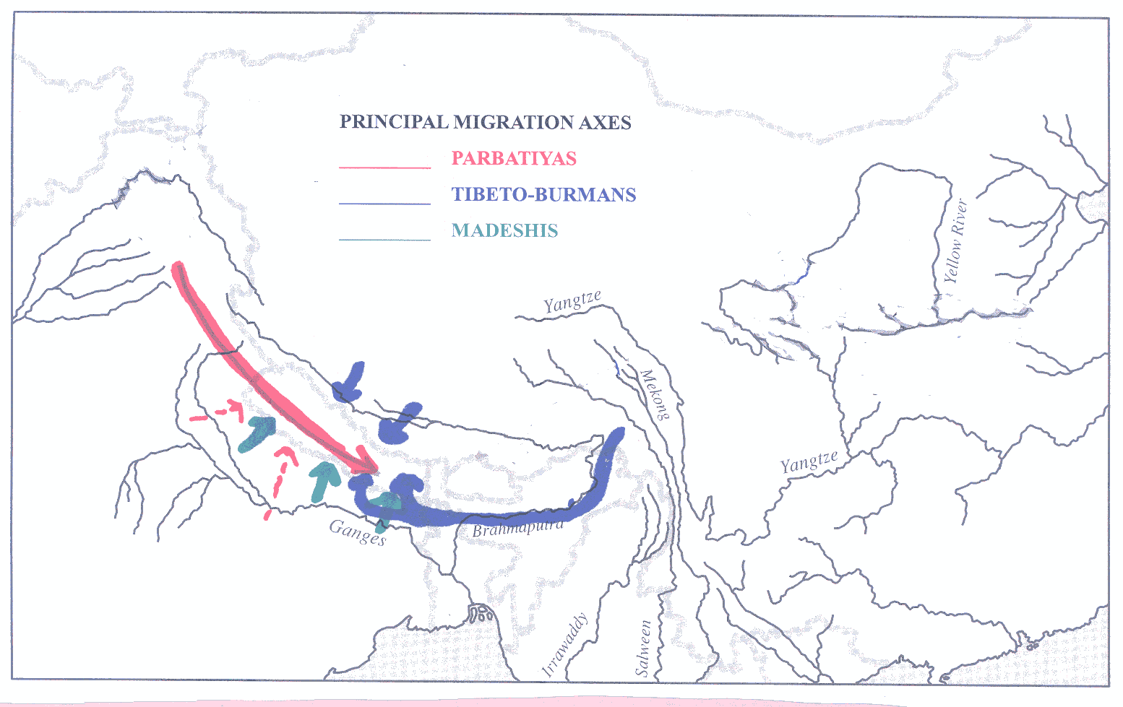
Wei, who visited Nepal earlier this year, reported that the behaviour of some Chinese tourists had created an image problem in Nepal. John said that in general Nepalis gave the Chinese the benefit of the doubt, regarding them as a useful counter-weight to the Indians, who have the predominant economic and political influence on their country.

We noted that in India, Nepal’s southern neighbour. Hindi, which is officially the national language, is not such a natural choice as Mandarin/Putonghua is for China. A substantial majority of the Chinese population speak dialects quite close to Mandarin, but an analogous situation is only found in northern India. In the south, there are a group of regional languages not only unrelated to Hindi and belonging to the Dravidian rather than the Indo-European family. After Indian independence, the speakers of these languages successfully resisted the imposition of Hindi at regional level, and this is one of the reasons that English still plays an important role within India. John mentioned the internationally successful Indian film Three Idiots, where the humour in one scene depends on the fact that a student from the south does not understand the formal Hindi speech he is required to deliver at a college function.

Both Hindi and Nepali draw on Sanskrit, the classical language of India, for much of the vocabulary used in formal writing. However, in both countries English terms are often preferred in daily conversation. In Nepal, for example, the loanword pulīs (< English police) is much more likely to be used than the formal, Sanskrit term praharī (प्रहरी).

We also talked about attitudes to homosexuality in different societies. In ancient Rome, the stigma attached not to homosexuality as such but to being the passive partner (pathicus) in intercourse. Julius Caesar spent most of his life denying the rumour that he had been his role in a supposed relationship with the King of Bithynia during his 80-78 B.C. stay in Asia Minor. Wei noted that in various societies there was greater tolerance of homosexual relationships between a man and a young boy rather than between two adult men and he commented on the prevalence of this kind of relationship among the Taliban as depicted in The Kite Runner.. He thought, though, that in China, widespread tolerance of homosexual relationships had been a feature only of the Qing dynasty. One criticism of the best-known English-language work on this topic (Passions of the Cut Sleeve; the Male Homosexual Tradition in China, see http://www.amazon.com/Passions-Cut-Sleeve-Homosexual-Tradition/dp/0520078691 ) is indeed that the author relies too much on slight, anecdotal evidence from earlier dynasties, but the earliest Jesuit missionaries, who were in the country in the final years of the Ming, did note (very censoriously!) the prevalence in China of `the vice of sodomy.’.

This topic led to mention of Sir Edward Trelawny-Backhouse, a friend of Oscar Wilde, who left Britain to spend many years in Beijing and wrote a recently published exposé of the sexual behaviour of the Manchu elite and claimed that he himself, apart from various homosexual liaisons, to have been in a physical relationship with Empress-dowager Cixi (慈禧). Although it is generally believed that some of his material is pure fantasy, he does seem at least to have a good knowledge of gossip in and about high society in Beijing on the eve of the 1911 revolution. There is a good discussion at http://www.telegraph.co.uk/news/worldnews/asia/china/8421904/The-salacious-sex-lives-of-the-Qing-Dynasty.html and his account, left in the possession of his Swiss doctor, is available on Amazon:
http://www.amazon.com/Decadence-Mandchoue-Memoirs-Trelawny-Backhouse/dp/9881944511
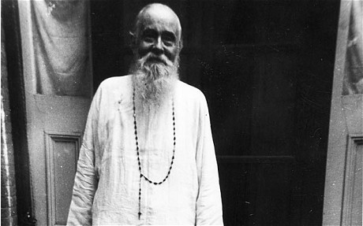

Finally, Latinizations suggested for `Singapore’ included Singapura (-ae f) (used by `Nuntii Latini’ and Leonopolis (-is f), `Lion city’ from the literal meaning of the Sanskrit.
QUESTIONS ARISING FROM 48th MEETING – 28/11/14

We had the usual search for Latin terms for the items we consumed. These included brassica Italica (broccoli), which has apparently been a favourite vegetable in Italy since the 6th century B.C. (see http://en.wikipedia.org/wiki/Broccoli) and which now has the botanical name brassica oleracea. The Italian word broccoli itself is a diminutive of brocco (`stalk’ or `sprout’). Pork is, of course, [carō] porcīna (-ae, f), with the sweet and sour variety (gulo yuk, (咕嚕肉) also known informally as gweilo yuk (鬼佬肉) as it is the Chinese dish best known by many westerners) translating as porcīna dulcis et acida. We also had jellyfish (海蜇) strips, which John’s daughter has always called `rubber bands’ (limbi cummeī , from limbus (-ī m), `belt’, `band’, `girdle’, and cummeus, -a, -um `gummy, connected with gum’). Rubber proper was not known till the 18th century but cummis, cummis f, or the indeclinable form gummī are used for it in neo-Latin. The correct term for jellyfish is actually urtīca marīna, literally `sea nettle’, found in Pliny the Elder and other authors and paralleling the modern English name `Pacific sea nettle’ for the species Chrysaora fuscescens shown in the picture below.
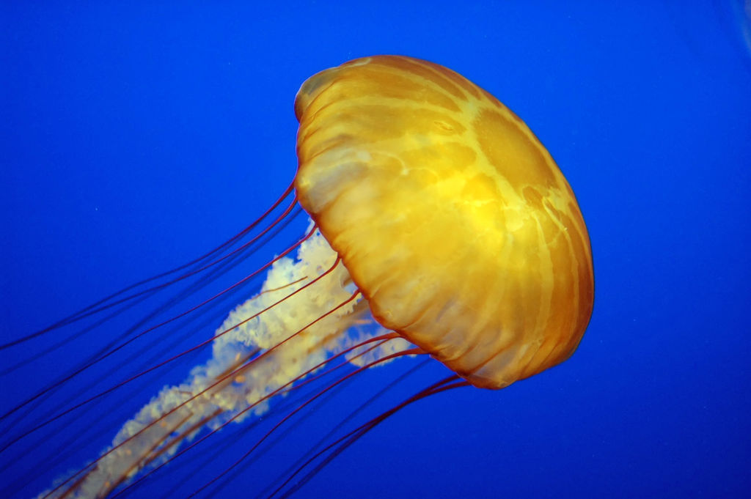
As the City Chinese restaurant under its new management is still waiting to receive its license to sell alcohol, we were again obloged to bring our own bottle (lagoena, -ae f) together with a corkscrew (extrāculum, -ī n). The restaurant was, however, able to furnish us with glasses (pōculum, -ī n) to drink from.

Mention or one member known for frequently saying he will attend meetings and then changing his mind prompted mention of the term piker, which is used in New Zealand and Australia of people who back out of commitments. In other dialects of English, however, it means rather someone who is mean with his money.

We also talked about some of the children Tanya teaches who have managed to go through years of schooling with very little to shoe for it. In contrast to the old HKCE, modeled on British GCSEs, which not all students stayed on to take, the new Hong Kong Diploma of Secondary Education DSE has to be taken by everyone and around 10% of each year’s candidates end up with near-zero marks.

The handout for the meeting was an article on Hong Kong’s `Umbrella Movement’ in the on-line Latin newspaper Ephemeris (http://ephemeris.alcuinus.net/) together with discussion of it in letters sent to the Grex Latine Loquentium email forum, including a sketch of Hong Kong history provided by John in response to the many errors in the Ephemeris piece, The full Latin text of the handout is available at http://linguae.weebly.com/historia-honcongensis.html and a translation (at the moment including only the article itself) is being provided at http://linguae.weebly.com/historia-honcongensis-trans.html

It was also mentioned that at least one student was interested doing a project on Roman cooking and resources for this briefly discussed. The most important ancient source is the collection of recipes compiled by Marcus Gavius Apicius (c. 400 A.D.?). There are links to text and translation and also one teacher’s instructions for students researching the topic at https://delicious.com/Velptonius/Apicius and a recent reference book is Andrew Dalby’s Food in the Ancient World from A to Z, which can be previewed on Google books at:
http://books.google.com.hk/books?id=FtIXAe2qYDgC&redir_esc=y

Finally, Tanya had brought needle and thread and volunteered to let her own hair be stitched together by Chris to demonstrate the way in which we now believe the elaborate hair-styles of Roman ladies were produced. Details of the research on which the current theory is based are available at http://online.wsj.com/news/articles/SB10001424127887324900204578286272195339456 (a recent article in an American newpaper) and http://www.bbc.co.uk/news/magazine-22630813 (a BBC video in which Janet Stevens, the hairdresser who first advanced the current theory explains her work.) The first three pictures below are from the first of these links and the last the small-scale-demonstration on Tania’s head:

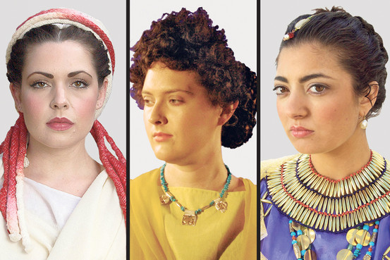
Models wear historic hairstyles, including the 'Vestal Virgin' style, left, and one favored by Cleopatra, right.Janet Stephens

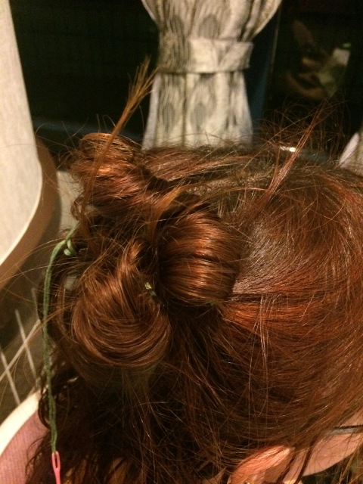
Chris’s demonstration on Tanya’s head
QUESTIONS ARISING FROM 49TH MEETING – 26/12/2014

Food was expertly prepared by Tanya and included as appetizer (gustātiō, -ōnis f) a dish of nachos (nachus, -ī m? nachō, nachōnis m ?). This might also be described as a snack, for which Traupman (Conversational Latin) suggests merenda, -ae f but the dictionary shows this was more the equivalent of lunch or afternoon tea. Subsequent delving on the Internet revealed that nachos derive their name from, Mexican restaurant manager Ignacio `Nacho’ Anaya, who supposedly devised the dish to feed a group of hungry American military wives in 1943. (see http://en.wikipedia.org/wiki/Nachos)

The highlight of the meal was a leg of lamb (crūs (crūris n) agnīnum; lamb without specification of the cut would be carō (carnis f) agnīna, i.e. lamb meat, and carō (meat, flesh) would normally be omitted. It was accompanied by spiced-yogurt roast cauliflower head (brassica Pompeiāna cum iogurtō arōmatibusque tosta?) A more classical alternative to iogurtum is lac (lactis, n) fermentātum Dessert was baked apples (māla cocta) and we drank mulled wine (vīnum coctum) throughout the proceedings

Christmas was marked by singing Adeste Fidēlēs and Venī, venī, Emmanuel(see texts and translation at http://linguae.weebly.com/carmina-nativitatis.html), just managing to keep in tune, but we merely listened to the plain chant version of Rēno erat Rudolphus (`Rudolph the Red-nosed Reindeer’) on the internet (http://gaudium-mundo.blogspot.hk/2005/12/reno-erat-rudolphus-plain-chant-version.html)
The text with long vowels marked according to Restored (i.e. classical) Pronunciation is as follows, with videās (`you were to see’) has been substituted for the ungrammatical vidēbat (`he/she was seeing’) in the version given on the site:

Rēnō erat Rudolphus. Nāsum rubrum habēbat Sī quandō videās, hunc candēre tū dīcās. Omnēs tarandrī aliī semper hunc dērīdēbant; cum miserō Rudolphō in lūdīs nōn lūdēbant. Sanctus Nicholas dīxit nocte nebulae: `Ō Rudolphe, nocte hāc vīsne traham dūcere?’ Tum rēnōnēs clāmābant, `Rudolphe, dēlectus es? Cum nāsō rubrō clārō nōtus eris posterīs.’ Alleluia

It’s likely that rēnō really meant only the reindeer skin used as a garment and that in classical Latin only tarandrus (a word used by Pliny the Elder) meant the living animal. In any case, rēnō does possibly derive from the German root rein which is seen in English reindeer. The word rangifer (rangiferī m) is found in late Latin, apparently an adaptation of the Finnish raingo. The moderin scientific name for the species is Rangifer tarandrus

We also read Gospel accounts of the Nativity, and a report from Finnish Radio’s Nuntii Latini on the Travelodge Hotel chain’s gimmick of offering a free room for one night between Christmas Eve and the Feast of the Epiphany (6 January) to any married couple whose names were Mary and Joseph. The texts are given below (without macrons) and a translation of Luke and Matthew can be found if needed at http://www.sacred-texts.com/bib/poly/

Evangelium secundum Lucam, 2:1-21
1 Factum est autem in diebus illis exiit edictum a Caesare Augusto ut describeretur universus orbis. 2 Haec descriptio prima facta est praeside Syriae Cyrino. 3 Et ibant omnes ut profiterentur, singuli in suam civitatem. 4 Ascendit autem et Ioseph a Galilaea de civitate Nazareth in Iudaeam civitatem David, quae vocatur Bethleem, eo quod esset de domo et familia David, 5 ut profiteretur cum Maria desponsata sibi, uxore praegnate 6 Factum est autem cum essent ibi, impleti sunt dies ut pareret, 7 et peperit filium suum primogenitum et pannis eum involvit et reclinavit eum in praesepio, quia non erat eis locus in diversorio.
8 Et pastores erant in regione eadem vigilantes et custodientes vigilias noctis supra gregem suum. 9 Et ecce angelus Domini stetit iuxta illos, et claritas Dei circumfulsit illos, et timuerunt timore magno. 10 Et dixit illis angelus: "Nolite timere; ecce enim evangelizo vobis gaudium magnum, quod erit omni populo, 11quia natus est vobis hodie Salvator, qui est Christus Dominus in civitate David. 12 Et hoc vobis signum: invenietis infantem pannis involutum et positum in praesepio". 13 Et subito facta est cum angelo multitudo militiae caelestis laudantium Deum et dicentium: 14 "Gloria in altissimis Deo, et in terra pax in hominibus bonae voluntatis". 15 Et factum est ut discesserunt ab eis angeli in caelum, pastores loquebantur ad invicem: "Transeamus usque Bethleem et videamus hoc verbum quod factum est, quod fecit Dominus et ostendit nobis". 16 Et venerunt festinantes et invenerunt Mariam et Ioseph et infantem positum in praesepio. 17Videntes autem cognoverunt de verbo quod dictum erat illis de puero hoc. 18 Et omnes qui audierunt mirati sunt et de his, quae dicta erant a pastoribus ad ipsos.19 Maria autem conservabat omnia verba haec conferens in corde suo. 20 Et reversi sunt pastores glorificantes et laudantes Deum in omnibus, quae audierant et viderant, sicut dictum est ad illos.

Evangelium secundum Matthaeum, 2:1-18
Cum autem natus esset Iesus in Bethlehem Iudaeae in diebus Herodis regis, ecce Magi ab oriente venerunt Hierosolymam 2 dicentes: "Ubi est, qui natus est, rex Iudaeorum? Vidimus enim stellam eius in oriente et venimus adorare eum". 3 Audiens autem Herodes rex turbatus est et omnis Hierosolyma cum illo; 4 et congregans omnes principes sacerdotum et scribas populi, sciscitabatur ab eis ubi Christus nasceretur. 5 At illi dixerunt ei: "In Bethlehem Iudaeae. Sic enim scriptum est per prophetam: 6 "Et tu, Bethlehem terra Iudae, nequaquam minima es in principibus Iudae; ex te enim exiet dux, qui reget populum meum Israel".
7 Tunc Herodes, clam vocatis Magis, diligenter didicit ab eis tempus stellae, quae apparuit eis; 8 et mittens illos in Bethlehem dixit: "Ite et interrogate diligenter de puero; et cum inveneritis, renuntiate mihi, ut et ego veniens adorem eum". 9 Qui cum audissent regem, abierunt. Et ecce stella, quam viderant in oriente, antecedebat eos, usque dum veniens staret supra, ubi erat puer. 10 Videntes autem stellam gavisi sunt gaudio magno valde. 11 Et intrantes domum viderunt puerum cum Maria matre eius, et procidentes adoraverunt eum; et apertis thesauris suis, obtulerunt ei munera, aurum et tus et myrrham. 12 Et responso accepto in somnis, ne redirent ad Herodem, per aliam viam reversi sunt in regionem suam.
13 Qui cum recessissent, ecce angelus Domini apparet in somnis Ioseph dicens: "Surge et accipe puerum et matrem eius et fuge in Aegyptum et esto ibi, usque dum dicam tibi; futurum est enim ut Herodes quaerat puerum ad perdendum eum". 14 Qui consurgens accepit puerum et matrem eius nocte et recessit in Aegyptum 15 et erat ibi usque ad obitum Herodis, ut adimpleretur, quod dictum est a Domino per prophetam dicentem: "Ex Aegypto vocavi filium meum".
16 Tunc Herodes videns quoniam illusus esset a Magis, iratus est valde et mittens occidit omnes pueros, qui erant in Bethlehem et in omnibus finibus eius, a bimatu et infra, secundum tempus, quod exquisierat a Magis. 17 Tunc adimpletum est, quod dictum est per Ieremiam prophetam dicentem:
18 "Vox in Rama audita est,
ploratus et ululatus multus:
Rachel plorans filios suos,
et noluit consolari, quia non sunt".

Est Iosepho et Mariae locus in deversorio
28.12.2007, klo 08.59
In evangelio secundum Lucam de nativitate Christi in Bethlehem haec narrantur: "Factum est autem, cum essent ibi, impleti sunt dies, ut (Maria) pareret. Et peperit filium suum primogenitum et pannis eum involvit et reclinavit eum in praesepio, quia non erat eis locus in deversorio".
Hodie res melius succedunt quam praeside Syriae Quirino, nam societas deversoriorum Travelodge nuntiavit se coniugibus, quibus nomina essent Iosephus et Maria, in deversoriis suis Britannicis, Irlandicis Hispanicisque cubiculum gratuitum ad unam noctem inter vigiliam Nativitatis Domini et Epiphaniam daturam esse.

It was pointed out that Luke’s census story is unlikely to be historical both because a census of `the whole world’ (universus orbis) would certainly have been reported in other sources and because it would have been pointless (as well as a logistical nightmare) to require people across the Roman Empire all to return to their ancestral home. The record we have of a Roman census taken about one hundred years later in Egypt suggests that people were simply required to be in their normal place of residence at the stipulated time. Presumably the Gospel story was devised to reconcile the known-fact of Christ coming from Galilee in northern Israel with Old Testament prophecies suggesting the Messiah would come from Bethlehem, a village near Jerusalem in the south. For a full-length discussion of this issue see http://www.webpages.uidaho.edu/ngier/census.htm

Another problem with the traditional story is that while St Jerome’s Latin word deversōrium definitley means inn, the Greek word he was translating, kaluma, actually meant something like lodging or billet and the author of the Gospel might actually have envisaged Mary and Jospeh not having enough space in the room in a relative’s house where guests were normally put up and so sleeping on the groundfloor where animals where kept but which was also part of the household’s own living space.

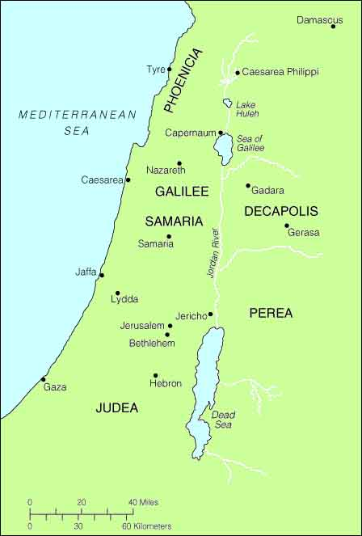

We were initially unsure of the length of the vowels in the name Hērōdēs but Jane thought, in view of the likely connection with the Greek hērōs (`hero’) they should all be long and this was confirmed from the dictionary later on.

There was a brief discussion of the letter `Y’, which originally in ancient Greek repreented a rounded high front vowel like the French one in tu or the Cantonese sound in 書 (syū). The Romans (like modern English speakers) had no such sound in their own language and lesser educated pople came ot promnuonc it as ī (removing the rounding), hence the name for the letter in Latin was ī graeca (> French i grec. However, Tanya pointed out that in some loan words the Greek vowel was replaced by u (e.g. purpura (purple) <πορφυρα (porphura)). The sound of `y’ in English you was of course represented in classical Latin by `I’ and in medieval Latin (and in modern printed editions of classical Latin texts up till early in the 20th century) by `J’.

We talked a little about the syllabus at Oxford where Jane is currently studying and she mentined that some translation from English into Latin is required. John recalls that in his day (1968-1972) prose composition was optional though until shortly before that it had been a core element of Classics courses everywhere. This led Joseph to ask about Latin exams that could be taken in Hong Kong. John produced a short account of these some time back and this has now been updated and added as a downloadable file on http://linguae.weebly.com/latin--greek.html
QUESTIONS ARISING FROM 50TH MEETING – 30/1/2015

We briefly discussed theories of nationalism including Ernest Gellner’s functional account linking it to the need of an industrialised society for a realtively homogenised workforce. John was sceptical about this, arguing that linguistic and also religious factors were involved much earlier in the spread of a sense of community over a wide population and that Gellner, a Briton of Czech-Jewish descent, had come up with a theory that did not makes sense of British, Czech or Jewish history. Mention was also made of the papacy’s role in the promotion of a sense of national or proto-national identity in France, Poland and elsewhere in Eastern Europe via the affording of a kind of sacral status to these territorial units. This was a deliberate strategy to counteract the imperial claims of the Holy Roman Empire which was seen by the popes as a rival for influnce in Europe. These ideas are discussed in John Armstrong’s book Nations Before Nationalism Chapel Hill: University of North California Press, 1982.

Mention was made of a theory recently advanced by Hong Kong-based Italian jeans manufacturer, novelist and historian Angelo Paratico that the Leonardo da Vinci’s model for the Mona Lisa was a Chinese slave who had been brought to Italy. Follwing Sigmund Freud’s suggestion, Angelo also believes that the woman was Leonard’s own mother. The Chinese Mona lisa hypothesis has so far met with a sceptical reception - see
http://www.telegraph.co.uk/culture/art/art-news/11269723/Was-the-Mona-Lisa-a-Chinese-slave.html
Angelo, whose wife teaches Italain at the Dante Alighieri centre in Causeway Bay, was previously best-known for his champioing of the 17th century scholar Giotolamo’s revisionist view of the emperor Nero as a benevolent emperor loved by the common people and resented only by the senatorial aristocracy. A facsimile of Cardono’s book (Encomium Neronis) can be seen at http://www.e-rara.ch/cgj/content/pageview/1634385 and details of Angelo’s English translation Nero: an Exemplary Life', are presented at http://beyondthirtynine.com/nero-an-exemplary-life/ , from where the Latin text can also be downloaded.

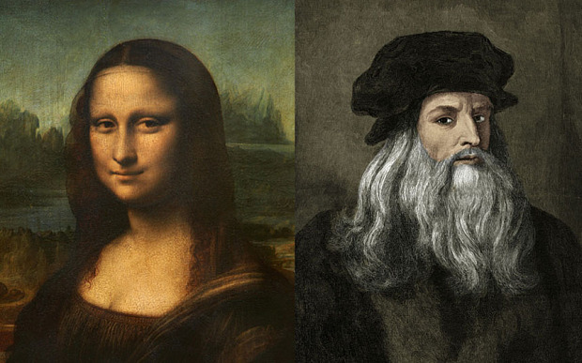
Painting and painter

As usual we also discussed the appropriate Latin names for the dishes consumed, including melanogēna, -ae f (eggplant/aubergine), agnīna in iūre acrī (lamb curry) and gallinācea cum spināchiā (saagwala chicken). For raita, perhaps iogurtum (-ī n) arōmaticum would do. We confirmed from the dictionary that the names for various types of meat (a feminine adjective such as porcīna, būbula, agnīna with carō (meat, flesh) understood are classical rather than medieval.

Tan mentioned her son’s habit of referring to Chinese people as `jou sans’ – from the Cantonese morning greeting早晨. This led to mention of the early name for Korea, Joseon, which was written朝鮮 in Chinese and is now 조선 in Hangul, which is still used as an official name for the country in North Korea.

We finally read a passage on houses and flats adapted from Robert Patrick and John Piazza’s Colloquia Cottidiana (http://www.johnpiazza.net/colloquia_cottidiana_draft_1.pdf), with a chapter from John Traupman’s Conversational Latin as supplementary material (see
http://books.google.com.hk/books?id=UOcRPumgVTsC&dq) The passage from Patrick and Piazza, two enthusiastic proponents of oral Latin in the American school system is marred by incncisteent use of domus as a general word for `home’ and as a particular type of dwelling place but made a good basis for discussion and is given here with an expanded vocabulary:

DĒ DOMŌ
Ubi habitās? Habitāsne in aedificiō? Aedificium est habitātiō, sed hominēs habitant in habitātiōnibus et
aedificiīs dīversīs. Sunt quī habitant in domīs. ‘Domus’ est ūnum nōmen habitātiōnis inter alia nōmina.
Alia sunt: casa, vīlla, diaeta, fundus, et cētera. Domus conclāvia habet. Casa est domus parva, in quā
sunt pauca conclāvia. Conclāve est pars domūs, et domus dīviditur in conclāvia varia. Vīlla est domus
maior, sed nōn est in urbe. Vīlla est domus rūstica. Habitāsne in īnsulā? Non īnsula in marī, sed
in aedificiō nominē ‘īnsula’! Īnsula est aedificium magnum, in quō multae familiae habitant. Domus
in insulā est diaeta. In regiōnibus urbānīs, multī hominēs in diaetīs habitant, sed in regiōnibus
suburbānīs, plūrēs hominēs in casīs habitant. Alii hominēs habitant in domunculīs subrotātīs, praecipuē
in regiōnibus rusticīs. Domuncula subrotāta est domus parva et mōbilis, quae rotās habet. Etiam in
regiōnibus rūsticīs sunt fundī. Fundus est domus ubī habitant agricolae. Agricolae terram colunt.
Quae sunt partēs, vel conclāvia, domūs? Partēs sunt: mediānum, cubiculum, cēnaculum,
balneum, et culīna. Quid agunt hominēs in culinā? Coquunt, id est, cibum parant. In mediānō, hominēs
solent sedēre et loquī cum familiā et amīcīs, vel tēlevīsōrium spectāre. Cubiculum est pars in quā
hominēs dormiunt. In cēnāculō, hominēs cēnant, id est, cibōs comedunt. In balneō, hominēs sē lavant
et sellā pertūsā ūtuntur. Sella pertūsā est rēs sordida! In domō meā, sunt tria cubicula et duo balnea.
Quid de domō tuā? Domus mea est parva, in quā sunt unum cubiculum et unum balneum. Cubiculum
meum nōn est proprium meum, quod frāter meus quoque dormit in cubiculō. Est cubiculum nostrum!

Vocābula
aedificium, -ī n. building
agricola, -ae m. farmer (syn: colōnus, ī m.)
balneum, -ī n. bathroom (syn lātrīna, -ae f.)
balneolum, -ī n pluvium shower
cēna, -ae f. dinner, supper
cēnāculum, ī n. dining room (syn: cenātiō, -ōnis f.; trīclīnium, ī n.)
cēnō, -āre (1) to eat dinner
cibus, -ī m. food
comedō, -ere (3) to eat (syn edō, -ere (3);
conclāve, is n. room
cubiculum, -ī n. bedroom
culīna, -ae f. kitchen (syn: coquīna, -ae f.)
diaeta, -ae f. apartment
domuncula, -ae f. little house (diminuitive of domus)
domus, -ūs f. house (syn: habitātiō, -ōnis f.; villa, -ae f. casa, -ae f.; aedēs, -ium f.plr.)
fundus, -ī m. farm, farmland (syn: praedium, -ī n.; rūs, rūris n.)
ientāculum, -i n. breakfast
īnsula, -ae f. apartment building
librārium, -ī n bookcase
lectus, -ī m bed, couch
maeniānum, -ī n balcony
mediānum, -ī n. living room
mēnsa, -ae f table
nōminē from nōmen, meaning “of the name”
pedeplāna, -ōrum n ground-floor
prandeo, -ēre (2) to eat lunch
prandium, -ī n. lunch
proprius, -a, -um (adj.) particular, one’s own.
pluteus, -ī m bookshelf
sella, -ae f seat, chair
sella pertūsa f. toilet
soleō, -ēre (2) to be accustomed to
solium, -ī n bathtub
sordidus, -a, -um (adj.) dirty, filthy
supellex, supellectilis n furniture,
tablīnum, -ī n. office, study (syn: studiolum, ī n.)
tabulātum, -ī n storey
tēlevīsōrium, -ī n television (set)

Responde Latine:

In quā habitātiōne habitas?

Est domus tua magna an parva?

Quot cubicula sunt in domō tuā?

Quot balnea sunt?

Habitasne in urbe? In regione suburbanā? In regione rūsticā?

Quod supellex in diaetā/casā habēs?

Habēsne hortum?

Habēsne maeniānum?

Quot tabulāta habet aedificium tuum?

In quō tabulātō habitās?

Quomodō dīcitur Anglicē `domuncula subrotāta’?

QUESTIONS ARISING FROM 51st MEETING – 23/2/15

We used the document CORPUS HUMĀNUM (the full version can be downloaded from http://linguae.weebly.com/latin--greek.html, search within the page for corpus_humanum) to follow simple commands like manūs in capite pōnite! (Put your hands on your head!) or nāsum tangite! (Touch your nose). In addition to the vocabulary on the sheet, Don used the verb tegō (tegere, tēxī, tēctum, cover), not to be confused with texō (texere, texuī, textum, weave). The word for backside was requested but John could only recall fundamentum, a general word for bottom (the best word is in fact culus, more or less equivalent to English arse). This word is included in his TABOO VOCABULARY list which can be supplied on request. The spelling umerus (shoulder) was queried, since humerus is used in modern derivatives, but Lewis and Short’s dictionary (http://www.athirdway.com/glossa) describes the latter spelling as a manuscript error. By the 1st century B.C., ordinary Romans had generally ceased to pronounce `h’ so this led to confusion over spelling, with the letter sometimes wrongly omitted and sometimes added where it was not etymologically justified. We also noted the derivation of chef/chief from caput (head) and how supercilium (eyebrow) explains the English adjective supercilious.

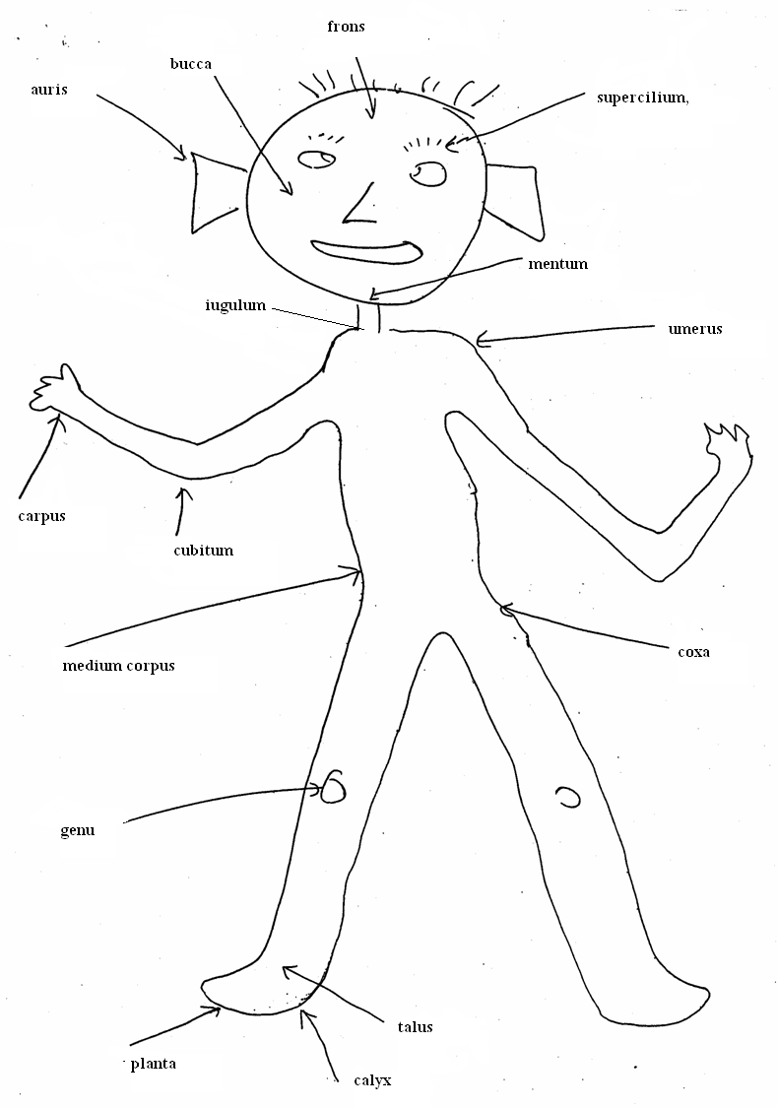

Whilst on anatomical subjects, mention was also made of the verbs futuo (futuere, futuī, futūtum) equivalent (and probably etymologically linked) to English f**k and of cacō (cacāre, cacāvī, cacātum), delicately translatable as defecate or defecate upon. The derived compound concavō was, allegedly, amongst the last words of the emperor Claudius in 54 B.C.: Eheu, mē, putō, concavī (Oh no, I think I sh*t myself!). It was suggested that there might be a connection with the Greek kakos (`bad’) but the link seems to be rather with Greek kopros (`faeces’). The adjective kakos, Latinized as Cacus (`Bad Man’), is the name of an orgre who supposedly lived near the future site of Rome until killed by Hercules. The English faeces is in origin a euphemism, the Latin faeces having originally referred to the sediment that settled at the bottom of a wine bottle! The regular Latin word was merda, which lives on in French and other Romance languages. For these and other indelicate expressions, see http://en.wikipedia.org/wiki/Latin_profanity and also James Adam’s The Latin Sexual Vocabulary (preview at http://books.google.com.hk/books?id=GDP9VHGbF1AC&dqlt)

The food, expertly prepared by Tanya and family, included collӯra (noodles/pasta), agnīna assa (roast lamb), acetāria (-ium n.pl, salad), solana (-ōrum, n.pl.) tuberōsa (potatoes) and meringa in crūstā cocta (meringue pie), washed down with vīnum rubrum and album. We mentioned that the Romans used the same words for both bowls and plates but Circulus practice is to use patella or patina for the latter and catillus (-ī m) and crāter (crāteris m) for small and large bowls respectively. More straightforward are furcula (-ae f, fork), culter (cultrī, m., knife) and cochlear (-āris n, spoon) whilst clavula (-ae f, twig) is pressed into service for chopstick. For Bon appétit one can say libenter cēna/cēnāte/comede/cmedite (Dine/Eat with pleasure!) or Bene [tibi/vōbīs] sapiat (May it taste good [to you]). The verb sapiō, sapere, sapīvī usually means taste of. As usual, we made extensive use of pocula tollite (raise your glasses) and prōsit (literally `may it be advantageous’, still used in the short form prost as the Central European equivalent of `Cheers!’).

Discussion of tollite reminded Pat of the story of Dick Whittington, the 14th century mayor of London, who as a young man was about to leave the city but turned back after hearing the bells of St. Mary-le-Bow church seeming to tell him `Turn again, Whittington!’ Pat believes that in the original story Dick imagined hearing the Latin words tolle, surge (Take up your pack and rise!) but investigation found no trace of this version on the Internet. The phrase surge, tolle (arise and pick up [your bed]) is, however, found in the Vulgate amongst the words of Jesus to a man he cured of paralysis.

Mention was made of the ancient Roman belief (shared until recently in Chinese culture) that milk was not a suitable food for adults. For this reason it was once thought that McDonald’s cheeseburgers would never become popular in China! It was suggested that this old belief might be linked to a high degree of lactose intolerance amongst East Asians. It appears, though, that condensed milk has long been acceptable in Chinsese society. The use of any form of milk with tea (thea, -ae f) probably originated in India.

We noted that the noun bellum, ( -ī n), classical Latin for war, is identical to the neuter forms of the adjective bellus, -a, -um (beautiful) and Pat explained that this was the reason why the modern Romance languages all adopted a Germanic word for the former. This is confirmed by the entry on www.etymonline.com , which adds the following:

war (n.)
late Old English wyrre, werre "large-scale military conflict," from Old North French werre "war" (Old French guerre "difficulty, dispute; hostility; fight, combat, war;" Modern French guerre), from Frankish *werra, from Proto-Germanic *werz-a- (cognates: Old Saxon werran, Old High German werran, German verwirren "to confuse, perplex"), from PIE *wers- (1) "to confuse, mix up". Cognates suggest the original sense was "to bring into confusion."
Spanish, Portuguese, and Italian guerra also are from Germanic… There was no common Germanic word for "war" at the dawn of historical times. Old English had many poetic words for "war" (wig, guð, heaðo, hild, all common in personal names), but the usual one to translate Latin bellum was gewin "struggle, strife" (related to win (v.)).

Another word discussed was Iuppiter, really a title (`Father of the Gods’) rather than a name, with the second element from pater and Iov/Iup originally from diov-, derived (like deus) from Proto-Indo-European *dewos (`god’). This is in turn connected to the root *dyeu- (`gleam’, `shine’)), presumably because the gods were linked to the sun or to lighning.

Jin, a guest of Tanya’s who was a caricaturist (gryllographus, -ī m) born in Malaysia, mentioned that his father had among the Communist guerillas fighting the British during the Malayan `Emergency’ but had been captured and repeatedly tortured during two years in prison. The guerillas had been particularly afraid of the Gurkha troops on the British side who were much better than native Brits at moving silently through the jungle. Pat believed that the Gurkhas’ value to the British army lay principally in their tendency to go beserk in the heat of combat and act with complete disregard of their own safety. He also believed that many of the ethnic groups in Nepal and further west in the Panjab and Afghanistan had a particular aptitude for fighting. It should be added, however, that modern scholarship sees the `martial races’ theory as very much a kind of stereotyping, though one which often came to be internalized by these groups themselves. For a discussion, see Lionel Caplan’s book Warrior Gentlemen: Gurkhas’ in the Western Imagination (http://www.amazon.com/Warrior-Gentlemen-Gurkhas-Western-Imagination/dp/1571818529)
Since 2009, former Gurkha soldiers and their families have been eligible to settle in Britain as a result of a long campaign involving both Gurkha activists and public figures such as Joanna Lumley. Another guest at the meeting, himself a former soldier, said that this change in the law would in fact spell the end of the Britgade of Gurkhas as they were now as expensive as native British soldiers. An interesting essay on the Nepali community in Britain (now about 100,000 strong) and how Nepal’s caste system has been maintained there is downloadable from https://www.academia.edu/11049684/Cast_e_in_Bone_The_Perpetuation_of_Social_Hierarchy_among_Nepalis_in_Britain and there are a number of news reports on Hong Kong’s Nepali community (perhaps now 25,000) at http://linguae.weebly.com/nepalis-in-hong-kong.html

Although Hong Kong was the base for the Brigade of Gurkhas from the 1970s until 1997, historically it was troops from India that made up the main non-European part of the Hong Kong garrison. Pat referred to the Viceroy of India at one point withdrawing the Indian regiment on loan to Hong Kong and the subsequent establishment in 1896 or 1897 of the Hong Kong Regiment, which recuited from the sub-continent but paid more than the Indian army and thus attracted the best recruits. The British authorities in India complained about this and in 1902 it was agreed to revert to the original arrangement of stationing a regiment from the Indian Army in Hong Kong. The Hong Kong Regiment continued in existence but no longer recruited from the sub-continent.

There was discussion of the term gweilo (鬼佬), which was originally pejorative and earned anyone who used it in legal proceedings an automatic fine for contempt of court but is now cheerfully used by many gweilo themselves. It was explained that the Circulus had two, rival translations of the word, Pat’s vir daemoniacus (viri daemoniacī ,`devilish man’) and John’s umbrivir (umbrivirī, `ghost man’).

We also discussed the rather strange characterization of the Chinese as `yellow’, given the fact that their actual complexions varied greatly in colour, with many (particularly females) actually whiter than the average gweilo. Pat said that the word originally used by early European vistors should be translated as `sallow’, referring to Chinese faces supposedly not changing greatly with different emotions. Chinese skin color does make it more difficult for them to absorb enough sunlight for vitamin D production and sun-ray treatment is used much more often in HK hospitals for Chinese rather than gweilo babies.

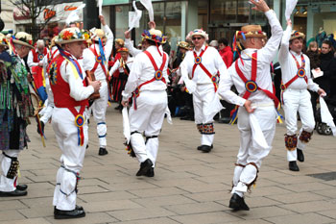

One of our guests, another John, was a Morris dancer (saltātor Mauricus) and he explained that the name derived from `Moorish.’ Nobody is sure why this traditional English activity came to be called this but he himself liked the theory that it was because North Africans washed up on British shores after the wreck of the Spanish Armada in 1588 turned to dancing to make a living as they had little English. He also thought that earlier, during the Wars of the Roses (the conflict between the Yorkist and Lancastrian factions in England that ended with Henry VII’s defeat of Richard III a Bosworth in 1485), many country people took up dancing as an occupation because this exempted them from being pressed into service with the army of either side. He mentioned the work of Cecil Sharpe in 1890-1910 in collecting folk music in England and encouraging a revival of Morris dancing and also that the Moorish connection was supported by the tradition (now largely discontinued) for Morris dancers on the Welsh Borders to blacken thir faces for performances.

Dictionaries support the Moorish/Morris link but the use of the name certainly predates the Spanish Armada since the first occurrence of the phrase recorded in the Oxford English Dictionary is in 1458, over a century earlier. It is embedded in the Latin text of the will of one Alice Wetenhale, preserved in the Public Record Office: Lego Caterine filie mee..iij ciphos argenti sculptos cum moreys daunce cum unico cooperculo ad eosdem (I bequeath to my daughter Catherine three silver cups engraved with [scenes of] Morris dancing together with one lid for the same). There is a good introduction to Morris dancing and its history at http://www.dailyinfo.co.uk/reviews/feature/4933/Morris_dancing, which suggests the name came into use as a result of a fascination with Moorish/Arab culture which developed during the Reconquista of the Iberian peninsula in the decades before the fall of Granada, capital of the Arabic kingdom of Andalusia, in 1492.

Paul, another new member, who is a solicitor, told us that in about 40% of cases before the courts, the parties involved chose to represent themselves because of the growing expense of legal fees, especially for barristers. Whilst cheaper, this also has the result of making proceedings much longer. Still on legal matters, someone else referred to a report that there had been some consideration on the mainland of introducing juries into their own legal system.


Some of the older members (joined by another participant who added a histrionic touch) posed with New Year greetings to be sent to Kristina (strictly, as Don pointed out, that should have been Christina in a Latin text!), who was a regular attender at meetings till returning to Australia. TIBI ANNUM CAPRĪNUM FĒLĪCEM FAUSTUMQUE EXOPTĀMUS translates as We wish you a Happy and Auspicious Year of the Goat. It seems that `Goat’, rather than `Ram’ or `Sheep’ is the best translation of 羊 in this context (see http://chineselanguages.weebly.com/goat-versus-sheep.html ).

John mentioned that the usual translations for take a photo (e.g. imāginēs lūce exprimere, phōtogrāphicē reddere), like a lot of neo-Latin phrases, were too much like paraphrases and suggested imāginem capere instead

Mention was also made of Don’s linguistic prowess and of his postion as Hong Kong representative for the World Union for Interlingua (Union Mundial por Inerlingua).. It was explained that Interlingua is a constructed language for international communication based largely on the Romance languages (see the sample and further details at http://linguae.weebly.com/)

We also remembered the Railway Tavern (Taberna Ferroviāria), the venue of the Circulus’s first meeting in December 2010. We have not used it since because the noise level made it difficult to communicate, especially in Latin. Pat recommended (though not for Latin meetings!) the King’s Belly (Venter Rēgis) in Tai Po (Magnus Portus)

We did not have time to make extensive use of the handout on Roman and Chinese spring festivals but noted that the Roman year had once begun in the spring. The annual tenure of the consuls, joint chief magistrates who gave their names to the year, started on 15 March until 153 B.C and thereafter on 1 January, though it is possible that a January-December year was already in use then for other purposes (compare the use in many countries of an April-March financial year alongside the normal calendar one). Further details are on http://linguae.weebly.com/circulus-latinus-honcongensis.html (search within the page for `Chinese New Year’) in the usual form of Latin dialogue with parallel English translation. A translation of Ovid’s Fasti, a major source on Roman festivals and associated myths is available at http://www.theoi.com/Text/OvidFasti1.html and there is information on the fountain of Anna Perenna, originally a Goddess of the New Year, recently excavated in Rome at
http://archeoroma.beniculturali.it/en/archaeological-site/fountain-anna-perenna There is more information on the goddess at http://en.wikipedia.org/wiki/Anna_Perenna , on the Roman calendar at
http://en.wikipedia.org/wiki/Roman_calendar#Years and on Roman festivals in general at
http://histmyst.org/festivals.html
QUESTIONS ARISING FROM 52nd MEETING – 18/3/15

We practiced some basic conversation with the help of a handout adapted from the beginning of the dialogues section on the Circulus site (http://linguae.weebly.com/circulus-latinus-honcongensis.html) and this has been reproduced below. Links to other conversational resources are also available on the site, and Wei brought along one we had not come across before, Georg Capallanus’s Latin Can Be fun: Facetiae Latinae, originally with German translations of the dialogues but now available in an English version prepared by Peter Needham, who translated the first two Harry Potter books into Latin (Harrius Potter et Lapis Philosophi and Harrius Potter et Camera Secretorum). This looks interesting but unfortunately has an unmacroned Latin text.

Job titles we needed in discussion included professor iūrisprūdentiae rudī dōnātus (retired professor of law), investigātor suī iūris or investigātor indēpendēns (independent researcher), diurnārius (journalist), ēditor (used in neo-Latin for English editor though originally really meaning publisher). The phrase rudī dōnātus (`presented with a wooden stick’) originally referring to the ceremony by which successful gladiators were allowed to quit their profession, is now used of retired people in general. The conventional translation of rudis (rudis, f) as `wooden sword’ is not strictly accurate in this context as the Latin word was used both of the wooden sword used in military and gladiatorial training and of sticks in general, including the rod presented to the retiring gladiator.

Dishes ordered included costae dulcēs acidaeque (sweet and sour spare ribs), frustum piscis frīctum cum fungō (fried fish fillet with fungus). Other dishes contained rāpum. -ī (turnip – the word could be used as an insult for an individual and also for a knort in the roots of a tree) and cāseus fabārum (`bean cheese’) or simply daufum, -ī (tofu -豆腐).

John mentioned his Latin insults (inspired by a phrase in the Cambridge Latin Course) for various sectors of the HK population, viz.pessimus umbrivir/continentālis/Honcongēnsis for damn gweilo/mainlander/Honkie (死鬼佬/大陸人/港人) but it was pointed out that港人 was too formal. A suitably derogatory alternative would be 港燦, a term devided on the mainland in retaliation fo the long-standing use by Honkongers of 阿燦 for mainlanders. 燦 (chàahn, literally `bright’) was originally the name of a far from bright mainland immigrant in a Hong Kong TV series mocking the supposed lack of sophistication of the newscomerns. The appropriate Chinese phrases would then be
死鬼佬/阿燦/港燦.

We also briefly discussed language typology, with Andy suggesting that languages with subject-object-verb (SOV) word order (like classical Latin) worked better with inflected endings. The statistical picture is rather complex as Joan Bybe’s investigation of verb morphology (Morphology: A Study of the Relation between Meaning and Form (p.46-7) – available at https://books.google.com.hk/books?id=DaO-VC81JmQC ) suggests that languages with object preceding the verb can have any degree of inflection but that ones where the verb comes before the object either have a complex set of verbal inflection or none at all

Although the Latin system of verbal inflexion survives in a modified form in the modern Romance languages, the case system for nouns was reduced in colloquial speech by late antiquity was to just two cases – nominative and accusative (labeled cas sujet and cas régime in Old French) and the accusative form then normally winning out, so that, for example, the modern Spanish liberdad (freedom) derives from lībertātem, not lībertās.

Among Germanic languages, English underwent a collapse of both the noun and verb systems, with just –s, -ing and –ed normally surviving in verbs, the plural and possessive terminations in nouns. In both the Romance and English cases, simplification seems to have been driven by large-scale use of the languages by second-language speakers, whose speech tends to be `pidginised; to some degree. In contrast, extremely complex inflectional systems often survive in languages rarely learned by outsiders, such as those of the eastern Himalayas and the Caucasus.

Andy belived that languages that do undergo simplification, moving from an inflecting state like that of Latin to an isolating one like that of Chinese and many other East Asian languages, may later become agglutinating (with an elabaorate sytem of suffixes or postpositions as in Turkish) and then eventually inflectional again, as the suffixes are modified and differentiated. There is certainly historical evidence for the fusing of separate words to produce new inflected forms, the classic example being the future tense in romance languages (e.g. French il aimera (`he will love’) from the late periphrastic Latin future form ille amāre habet)

Tony, who taught law for many years at Baptist University, argued that the lack of precision in the Chinese language (e.g. the absence of tenses or of an elaborate system of modals) made it less suitable for expressing legal distinctions. There was also a problem of vocabulary with traditional Chinese, which, for example, lacked an exact equivalent of English offer. He suggested that the failure of Chinese technology ands science to develop to the same extent as in Western Europe was partly the result of linguistic factors. This remains a hotly debated hypothesis.

It was also suggested that the grammaticalisation of Chinese 的 (originally meaning `target’ but now a possessive marker) and了 was pioneered by early Jesuit missionaries who needed to import greeter precision into their writing. Bobo also pointed out that the later incorporation of many new terms from Japanese was simply the result of Japan having started to modernize earlier than China.

We briefly touched on deeper connections between Chinese and other languages and John mentioned George van Driem’s argument that Chinese, rather than constituting an independent branch of the Sino-Tibetan language family, was in fact itself a member of the Bodic (Tibetan) division of Tibet-Burman. This `demotion’ of Chinese within the Sino-Tibetan family has not been generally accepted but is difficult to disprove since, as with most language families other than Indo-european, we lack early enough written records of most of the languages involved. Van Driem’s views on Sino-Tibetan, and much else besides, are set out in his mammoth Languages of the Himalayas, which is summarized in John’s review article downloadable from http://linguae.weebly.com/nepali.html (use the internal search function to find `Driem’ on the rather long page!).
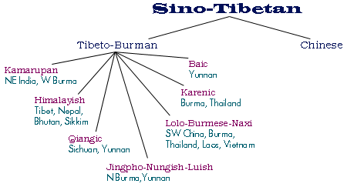

One version of the hotly-disputed Sino-Tibetan `family tree’ (http://stedt.berkeley.edu/about-st)

There waas also a brief discussion on the origins of the name `China’ and early contacts between China and Europe via the `Silk Road.’ The earliest name for China used in Europe seems to have been the Greek Sēres (σηρες), which was borrowed into Latin and meant `the silk people’ (c.f. Latin sēricum. –ī n, silk), probably deriving ultimately from Chinese絲. The name Sinae, which might derive, via Sanskrit and Persian, from the Chinese dynastic name qin, or from zina, the indigenous name of the Yelang confederation in Yunnan, is first found in Latin in the work of the geographer Ptolemy at the beginning of the 2nd. century A.D., though he seems to regard the Sinae as a separate people living south of the Seres. There is the complication that Sanskrit china is found in texts traditionally dated before the 3rd, century B.C. emergence of both the Qin dynasty and the Yelang polity but the dating of Hindu texts is notoriously insecure. The same caveat applies to the use of the word sinim in chapter 49 of the Hebrew Book of Isaiah, which might be as early as the 6th century B.C but could have been composed much later and, in any case, the words might refer to the Persians (as assumed in the Septuagint Greek translation of the Hebrew) or some other people rather than to the Chinese. .For more discussion see the materials at http://linguae.weebly.com/sina-latina.html and http://en.wikipedia.org/wiki/Names_of_China#Sinae

It is uncertain when the trade in silk between China and the Roman Empire, conducted via intermediaries, actually began but it was at its height in the 2nd. Century A.D, when only two states (Parthia and the Kushan empire), both of which were commercially minded, sparated the Chinese and the Romans and conditions alon the route were generally peaceful. Julius Caesar is may have possessed silk cutains in the 1st century B.C. but any trade at this time will have been on a much smaller scale.

Bobo also mentioned links between the Arabs and China in the the 8th century at a time when the former were contuing their dramatic expansion begun under the prophet Mohammed. The standard treatment of this topic (written largely from a Tibetan perspective) is Christopher Beckwith’s The Tibetan Empire in Central Asia: A History of the Struggle for Great Power among Tibetans, Turks, Arabs, and Chinese during the Early Middle Ages (Princeton University Press 1987), conveniently summarized in a review at http://dannyreviews.com/h/Tibetan_Empire.html The map shows the expansion of Tang dynasty control into Sinjiang and a large area of central Asia, which they lost principally bcasue of An Lushan’s rebellion rather than their defeat by an Arab army at Talas in 751 A.D. (see http://en.wikipedia.org/wiki/Battle_of_Talas)

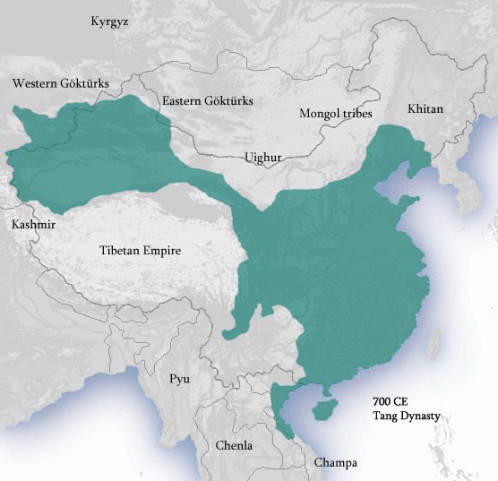

Finally, mention was also made of the use of mitochondrial and Y-chromosome DNA to work out the relations between homo spiens and clasely-related species – Neanderthals and Denisovans and (just perhaps Homo Floresiensis – tthough in the latter case the experts can’t agre whether we have a development from an early hominid or a genetic regression of members of our on species who were stranded on the island – see http://phys.org/news/2014-10-ten-years-scientists-debating-homo.html.

Appendix: Conversation Handout:

IŪNCTŪRAE SIMPLICĒS
Fundamentālia

Iterum dīc, quaesō Say again, please.
Lentē quaesō Slowly, please
Maiōre vōcē, quaesō Louder, please
Scrībe, quaesō Write it down, please
Nōn intellegō I don’t understand
Intellegisne/Intellegitisne? Do you understand?
Nōn intellēxī I didn’t understand?
Intellēxistīne/Intellēxistisne? Did you understand or Have you understood?
Quōmodo dīcitur _____Latīnē/Anglicē How do you say _______ in Latin/English
Quid hoc vocātur? What’s this called?
Ita (est), Etiam Yes
Minimē Not at all
Mihi ignosce Sorry

In taberna

Requīrisne vīnum ? Do you want some wine?
Sōlum theam requīrō I only want tea
Aliquidne requīris? Do you want anything?
Cibum poscāmus! Let’s order the food!
Ubi est latrīna? Where’s the toilet
Ibi in fīne illīus andrōnis? At the end of that corridor
Ratiōnem postulā! Ask for the bill!

Salvē/salvēte Hello
Quid/Quod est tibi nōmen ? What’s your name
Mihi nōmen (Anglicum/Sīnicum/Latīnum) My (English/Chinese/Latin) name is _________
est_______
Quid agis? How are you
Bene/Mediocriter/Atrōciter mē habeō I’m fine
Valē/valēte Goodbye

QUAESTIONĒS ET RESPŌNSA

Ubi nātus/nāta es? Where were you born?
In Sīnā/Britanniā/Canadā/ Americā I was born in China/Britain/Canada/America
Francogalliā / Germāniā /Corēā France /Germany/Korea/Australia
Austrāliā nātus/nāta sum
Cuius es cīvitātis ? What’s your nationality?
Britannus/a sum I’m British
Candiānus /a Americānus/a Canadian American
Francogāllus/a Germānus/a French German
Sīnēnsis Coreānus/a Chinese Korean
Austrāliānus/a Australian
Quot annōs nātus/nāta es? How old are you?
------ annōs nātus/nāta sum I’m ____ years old
Habēsne fīliōs vel fīliās? Do you have any sons or daughters?
Habeō nūllum/ūnum fīlium sed/et nūllam/ I have no/one son and/but no/one daughter
ūnam fīliam
Habeō duōs fīliōs/duās fīliās I have two sons/daughters
Quō mūnere fungeris? What’s your job?
Esne advocātus/a? Are you a lawyer?
Sum argentārius/a - grammaticus/a I’m a banker language teacher professor/profestrix - medicus/a professor doctor
diurnārius/a - advocātus/a journalist lawyer
magister/magistra sacerdos – teacher priest
historicus/a scrīptor/scrīptrix - historian writer
mercātor/mercātrix - officiālis businessman/-woman civil servant
Ubi habitās? Where do you live?
In īnsulā Honcongī / Novemdracōnibus/ On Hong Kong Island/in Kowloon/in the New
In Terrīs Novīs habit Territories
Antequam Honcongum vēnistī, ubi habitābās? Before you came to HK, where did you live?
Nottinghāmiae/Londīnī/Berolīnī/ I /lived in Nottingham/London/Berlin/Paris/
Lutetiae/in Sīnā continentālī habitābam in mainland China
Cur linguam Latīnam didicistī? Why did you learn Latin?
Nōndum didicī I haven’t learned yet!
Quia cultūra atque historia antīquae mē Because ancient culture and history attract me
alliciunt
Quia mē linguae tenent/alliciunt. Because languages interest/attract me
Quia in schola mea coācti sumus Because we were forced to learn Latin in school
linguam Latīnam discere .
Cur linguam Latīnam didicistī? Why did you learn Latin?
Nōndum didicī I haven’t learned yet!
Quia cultūra atque historia antīquae mē Because ancient culture and history attract me
alliciunt
Quia mē linguae tenent/alliciunt. Because languages interest/attract me
Quia in schola mea coācti sumus Because we were forced to learn Latin in school
linguam Latīnam discere .
Quībus aliīs linguis loqueris? What other languages do you speak?
Francogallicē, Germānicē, Sīnicē (sermōnē French, German, Chinese (Cantonese or
Cantonēnsī vel normālī), Iaponīcē, Putonghua) Japanese, Korean, Polish,
Coreānicē, Polonicē, Hispanicē, Graecē Spanish, Greek
QUESTIONS ARISING 53rd meeting – 29/4/15

We read and asked and answered simple questions in Latin on the first five chapters of the story of Perseus from Fabulae Faciles (see text below), the reader first published by Francis Ritchie in 1884 and containing also the stories of Hercules, Jason and the Argonauts and Ulysses. The work was subsequently re-published in slightly revised form by other authors and Zhang Wei showed us one such version which he had come across in a second-hand bookshop in South Africa,. The book is also available on the Internet, the most user-friendly version being that of Geoffrey Steadman, which can be downloaded free of charge from http://geoffreysteadman.com/ritchies-fabulae-faciles/ . Steadman provides a list of all words occurring more than 15 times in the text and asks readers to learn these first. Pages facing the Latin text itself include all words not in the list together with grammatical notes. Readers are assumed to know already the five declensions, the pronouns and the active and passive tenses of verbs but the subjunctive is not introduced until half way through the story of Hercules and indirect speech and ablative absolutes are only met with in Jason and the Argonauts.

Although the help Steadman provides should enable those with a basic knowledge of the language to read it, even near-beginners can use the the stories of Perseus and Hercules in the versions with interlinear translation downloadable from http://linguae.weebly.com/latin--greek.html

We were unsure if Ritchie’s phrase quiētem capere (to take rest) was idiomatic Latin but later investigation revealed it is used by Caesar in his famous account of the elks of the Hyrcanian forest in Germany, which he supposed slept leaning agianst trees: ad [arborēs] sē applicant atque ita paulum modo reclīnatae quietem capiunt (Dē Bellō Gallicō, Bk VI, chap 27). The use of vertere in for `turn into’ also turns out to be perfectly standard.

Most of the language in the chapters was easily recognizable but there was a query about tālāria (-ium, n.pl). This is in orign an adjective derived from tālus, -ī m, ankle, but is used specifically to refer to the winged shoes or sandals used by Mercury and Perseus. Pat was also puzzled by the use of anguis for snake as this word is etymologically connected to English eel. Ritchie’s usage is again in fact standard and it is the derivative anguilla which means fresh-water eel in Latin.

We were joined by Tan’s mother, Austra, an accomplished linguist who read out some of the Latin text accurately despite not having studied the language before. She is Latvian and spent the first five years of her life in a displaced persons camp after WWII before moving to Australia. Her father had been involved in the demarcation of the border between Latvia and the Soviet Union after Latvian independence and he and her mother gave her a very negative impression of Russia which she confirmed for herself by travelling thorough the country in a hired car in the 1960s. She was able to avoid being accompanied by an official `minder’ by demonstrating her competence in Russian, learned precisely for that purpose.

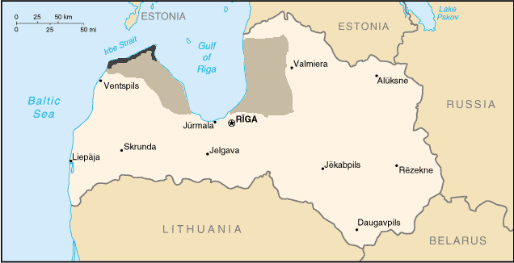
We spent some time discussing Baltic geography and linguistics, including the the Livonian language and region. The Livonians, originally speakers of a language related to Finnish and Estonian and thus

non-Indo-European, used to occupy a region west and east of the Gulf or Riga (see the map above, taken from http://en.wikipedia.org/wiki/Livonian_language on 10/5/15). The last native speaker of Livonian is generally now said to have died in 2013 but some people dispute this and attempts to cultivate and preserve the language continue. The area were Livonian was last spoken natively is shown by the black strip on the map.

After the conquest and forced Christianisation of the Livonians by the Germanic Brothers of the Sword, the name `Livonia’ was used for a wider territory comprising southern Estonia and northern Latvia.. This was for over three centuries independent as the `Livonian Confederation’ but in the late 16th century was incorporated into the Polish-Lithuanian Commonwealth, whose borders and main sub-divisions are shown on the map below: the Duchy of Livonia is in grey, the Grand Duchy of Lithuania in plum, the `Crown of the Kingdom of Poland’ in red and the region between Poland and Lithuania was the Duchy of Prussia, which incorporated the present-day Russian enclave of Kalingrad and was a Polish fief. Pat explained that the Russians insisted on retaining Kalingrad/Koenigsburg, despite its undoubted Polish connections, because of its significance as a WWII battle ground

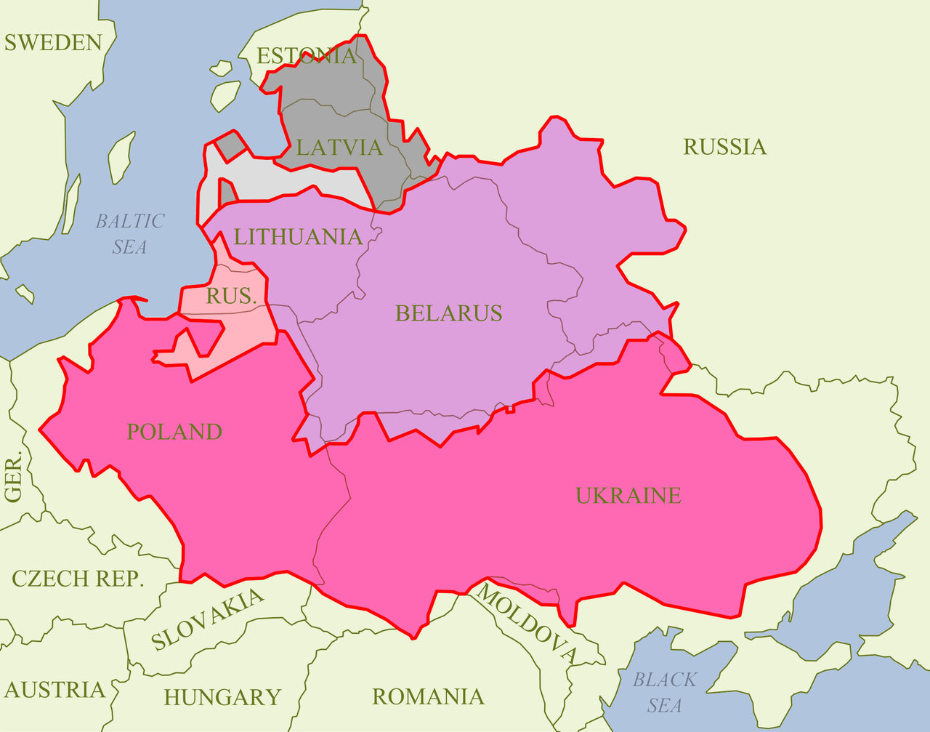
http://en.wikipedia.org/wiki/Livonia#/media/File:Rzeczpospolita2nar.png (accessed 10/5/15)

Pat argued that the name `Lithuania’ was derived from `Livonia’, a suggestion which we discussed in October 2013 (see QUESTIONS ARISING (II), p.43) and which John is skeptical about as the Latin Litua for Lithuania is found as early as 1009 A.D. and must be a derivative of a Slavicised form of Lithuanian Lietuva (see http://en.wikipedia.org/wiki/Name_of_Lithuania)

We also talked briefly about the region of Courland, situated in western Latvia between Livonia and Lthuania and originally inhabited by the Curonians, who were also forcibly converted in the early 13th century. The Duchy of Courland and Semigallia (stretching from the Baltic to the border of present-day Belarus) was a semi-independent part of Poland from 1561 to 1795, when it was incorporated into the Russian Empire (see http://en.wikipedia.org/wiki/Courland, from which the map below, with the approxximate borders of the duchy shown in yellow, has been taken)

HISTORIC DIVISIONS OF LATVIA

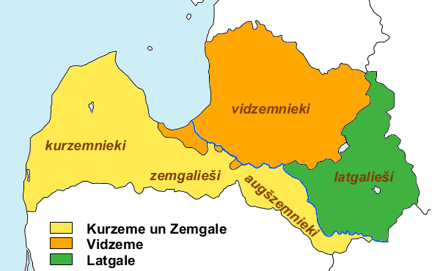
http://en.wikipedia.org/wiki/Courland

We also touched on the elaborate declension system of Lithuania, and the clear resemblance to Latin, Greek and Sanskrit (see table at http://linguae.weebly.com/circulus-latinus-honcongensis.html ). Austra explained that although it is Latvian which has preserved the major collection of ancient Baltic oral poetry, the present-day Latvian language is less inflected than Lithuanian. This is because Latvian has been in continuous widespread use throughout its history and therefore subject to progressive simplification, whereas Lithuanian was displaced for many purposed by languages of administration such as German, Polish or Russian and so remains more conservative.
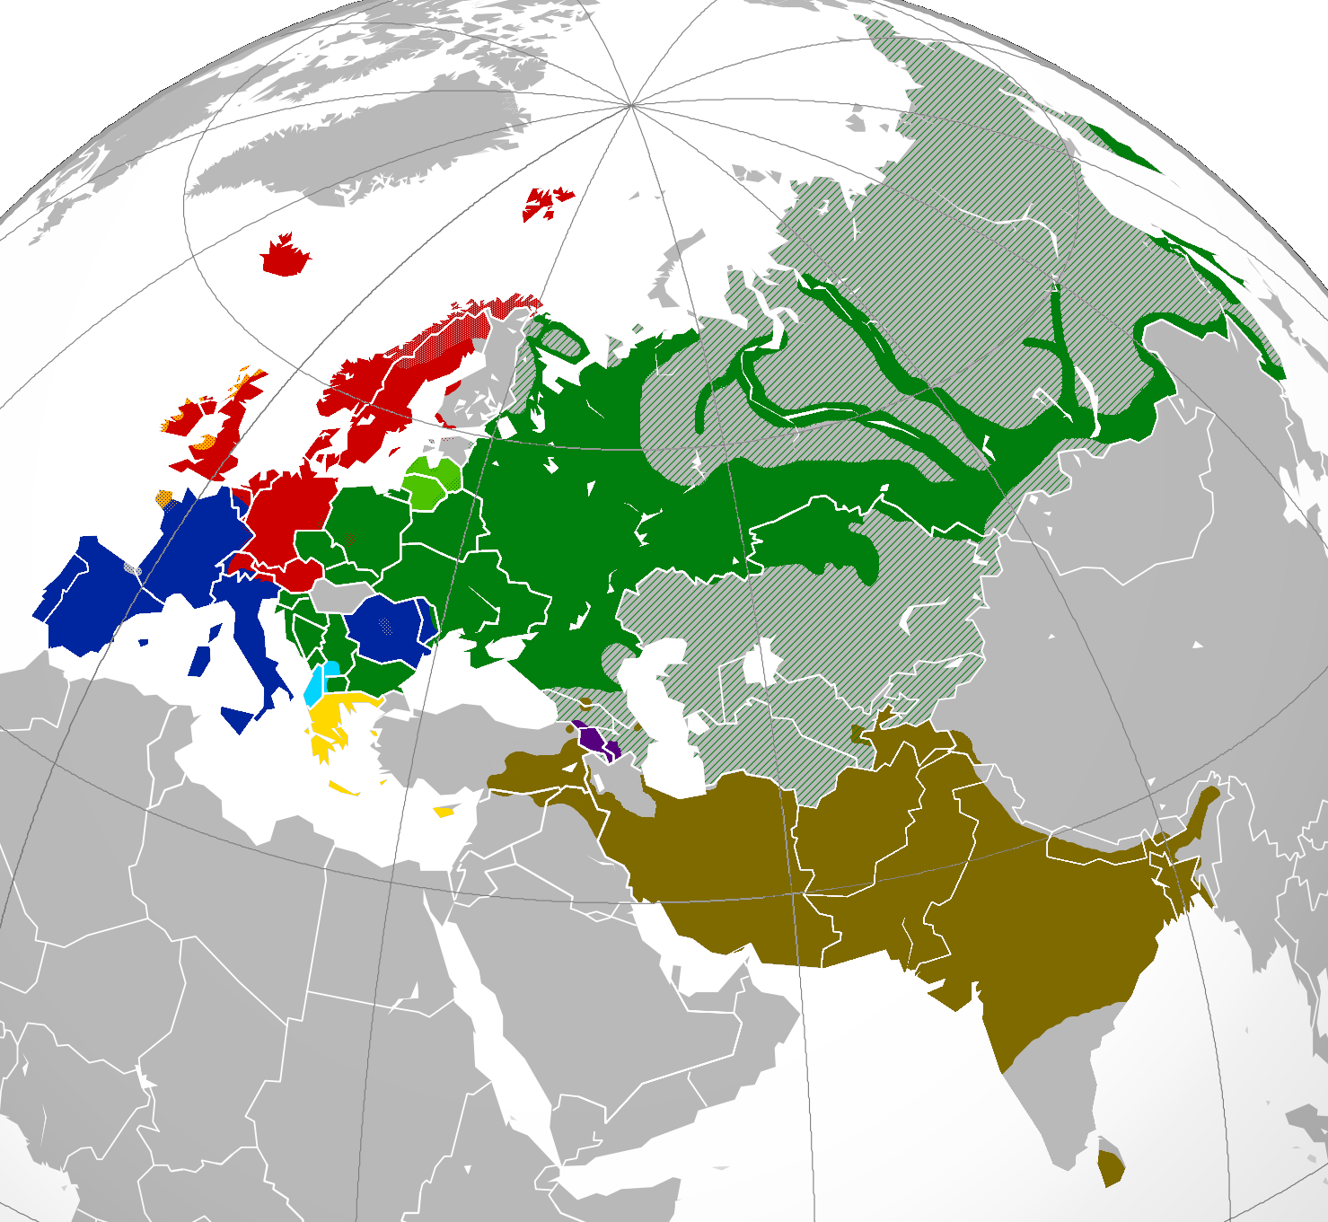
We also discussed the wider Indo-European family, whose distribution as natively spoken within Eurasia (i.e. omitting recent expansion into the Americas and Australasia) is shown above. The principal branches are Celtic (in orange), Germanic (red), Romance (dark blue), Slavonic (dark green), Baltic (light green), Albanian (light blue), Greek (yellow), Armenian (purple) and Indo-Aryan (brown). The grey enclaves are Basque (a language at the wetern end of the Pyrenees with no known realtives), and the Finno-Ugaritic languages (Finnish, Estonian and Hungarian). The map is taken from http://en.wikipedia.org/wiki/Indo-European_languages

Although due to the prestige of Sanskrit (the Indo-European language with the earliest surviving texts if the widely divergent Hittite language of ancient Anatolia is set aside), India was once a candidate for the family’s original homeland, most scholars outside India itself now place this in the western steppes, north of the Black Sea, often equating its speakers with the Kurgan culture of this region and assuming a dispersal beginning around the the 3rd millennium B.C.. There is a rival hypothesis, less popular, originated by Colin Renfrew, which puts the origin considerable earlier (7th millennium B.C.) in Anatolia and assumes Indo-European entered Europe with the migration from Anatolia of the first farmers. Pat explained that widely-shared words in the Indo-European languages, including those for wheel and horse, are consistent with an orign in the region north of the Black Sea and the Caucasus. He also argued that, as there appears to have been a proto-IE word for salmon (*laks, with derivatives Proto-Germanic *lakhs-, Lithuanian laszisza, Russian losos, Polish łosoś and possibly Sanskrit laksha) the homeland must be somewhere near rivers draining into the Baltic. This last argument, however, is weakened by the fact that some scholars thinhk *laks actually referred to the much more widely dispersed salmon trout (J.P. Mallory, In Search of the Indo-Europeans, p.116).

Pat also pointed out that cognates such as Latin tēctum (roof) and English thatch were an indication of the kind of dwellings the earliest Indo-Europeans possessed and that other linguistic evidence indicated they had doors but no windows. The existence of cognate for stone and cut but not for metals (though a handfulf of languages do have words related to Latin aes (bronze)) indicates dispersal started before the end of the Neolithic period. For further discussion of these issues see http://en.wikipedia.org/wiki/Proto-Indo-European_Urheimat_hypotheses

Pat also noted that are a lot of words for which no common Indo-European ancestor can be constructed, including those for `blood’. We note the divergence between this Germanic word, Hindi/Nepali ragat (from Sanskrit rakta), though Latin sanguis, sanguinis (m) is probably related to Latvian asins.

We had started discussing blood after noting that the Romans used viīnum sanguineum as well as vīnum rubrum for red wine and we also noted that vīnum tinctum (literally `stained/coloured wine’) was the origin of the phrases used in many Romance languages. The principal dish we were eating along with the wine was the house speciality, crūs agnīnum tandūrium, tandoori leg of lamb, which was accompanied as usual by by rice (orỹza), nan (pānis Persicus) and assorted vegetables (holera, plural of holus, holeris n).

Finally, Austra is also interested in australia’s indigenous languages and mentiuohned that new names have constantly to be borrowed from other Aboriginal languages because once someone has died there name cannot be used or even mentioned again. For more information on Aboriginnal langiuages, of which there are around 250 spoken by 500 separate nations or ethnic groups. For more information see:
http://theconversation.com/some-australian-indigenous-languages-you-should-know-40155
http://livingknowledge.anu.edu.au/learningsites/aa_map.htm (nations map)
and (specifically for Queensland).
http://www.slq.qld.gov.au/resources/atsi/languages/indigenous-languages-map

ANNEX: FĀBULAE FACILĒS, capita 1-5

1.Haec nârrantur â poêtîs dê Perseô. Perseus fîlius erat Iovis, mâximî deôrum; avus êius Acrisius appellâbâtur. Acrisius volêbat Perseum nepôtem suum necâre; nam propter ôrâculum puerum timêbat. Comprehendit igitur Perseum adhûc infantem, et cum mâtre in arcâ lîgneâ inclûsit. Tum arcam ipsam in mare coniêcit. Danaê, Perseî mâter, mâgnopere territa est; tempestâs enim mâgna mare turbâbat. Perseus autem in sinû mâtris dormiêbat.
2.Iuppiter tamen haec omnia vîdit, et fîlium suum servâre cônstituit. Tranquillum igitur fêcit mare, et arcam ad însulam Serîphum perdûxit. Hûius însulae Polydectês tum rêx erat.
Postquam arca ad lîtus appulsa est, Danaê in harênâ quiêtem capiêbat. Post breve tempus â piscâtôre quôdam reperta est, et ad domum rêgis Polydectis adducta est. Ille mâtrem et puerum benîgnê excêpit, et iîs sêdem tûtam in fînibus suîs dedit. Danaê hôc dônum libenter accêpit, et prô tantô beneficiô rêgî grâtiâs êgit.
3. Perseus igitur multôs annôs ibi habitâbat, et cum mâtre suâ vîtam beâtam agêbat. At Polydectês Danaên mâgnopere amâbat, atque eam in mâtrimônium dûcere volêbat. Hôc tamen cônsilium Perseô minimê grâtum erat. Polydectês igitur Perseum dîmittere cônstituit. Tum iuvenem ad sê vocâvit et haec dîxit: "Turpe est hanc îgnâvam vîtam agere; iam dûdum tû adulêscêns es. Quô ûsque hîc manêbis? Tempus est arma capere et virtûtem praestâre. Hinc abî, et caput Medûsae mihi refer."
4.Perseus ubi haec audîvit, ex însulâ discessit, et postquam ad continentem vênit, Medûsam quaesîvit. Diû frûstrâ quaerêbat; namque nâtûram locî îgnôrâbat. Tandem Apollô et Minerva viam dêmônstrâvêrunt. Prîmum ad Graeâs, sorôrês Medûsae, pervênit. Ab hîs tâlâria et galeam magicam accêpit. Apollô autem et Minerva falcem et speculum dedêrunt. Tum postquam tâlâria pedibus induit, in âera ascendit. Diû per âera volâbat; tandem tamen ad eum locum vênit ubi Medûsa cum cêterîs Gorgonibus habitâbat. Gorgonês autem mônstra erant speciê horribilî; capita enim eârum anguibus omnînô contêcta erant. Manûs etiam ex aere factae erant.
5. Rês difficillima erat caput Gorgonis abscîdere; êius enim cônspectû homines in saxum vertêbantur. Propter hanc causam Minerva speculum Perseô dederat. Ille igitur tergum vertit, et in speculum înspiciêbat; hôc modô ad locum vênit ubi Medûsa dormiêbat. Tum falce suâ caput êius ûnô îctû abscîdit. Cêterae Gorgonês statim ê somnô excitâtae sunt, et ubi rem vîdêrunt, îrâ commôtae sunt. Arma rapuêrunt, et Perseum occîdere volêbant. Ille autem dum fugit, galeam magicam induit; et ubi hôc fêcit, statim ê cônspectû eârum êvâsit.

QUESTIONS ARISING FROM 54th MEETING – 27/5/15

As usual, we went over some of the Latin terms for items used in the meal, including lagoena, -ae f (bottle), extrāculum (cork screw) and clavula, -ae f (chop stick). Strictly speaking, clavula means twig but since we have not yet been able to find the Latin (or Italian) term used by Matteo Ricci, who was probably the first European to describe the use of chopsticks, we continue with this substitute. The Latin equivalent of hei fai (`raise your chosticks’ - an invitation to start eating) is clavulās tollite, while lagoenam aperīre is `to open a bottle’ and `Cheers’, of course prōsit (subjunctive from the compound verb prōsum, prodesse, prōfuī), literally meaning `may it be advantageous [for us]’), from which the German prost derives.

In a fortunately rare occurrence at meetings, John mangaged to knock over (dēturbāre) a wine glass (either hyalus, -ī m or the general word pōculum). The standard word for spill seems to be effundō (effundere, effūdī, effūsum) but this is not a perfect translation of the English as the same verb also means pour out. To capture the idea of unintentional waste the deponent verb dīlabor, dīlābī, dīlāpsus sum, (fall apart, melt away) could possibly be used with vīnum as the subject in the sense be spilt: Smith-Hall’s English-Latin Dictionary (http://www.archive.org/stream/copiouscriticale00smit#page/784/mode/2up) quotes the Vulgate’s (II Kings, xiv, 14) quasi aquae in terram dīlābimur, translating `we are as water spilt on the ground.’

Dishes ordered or considered included choy sum (菜心), which is a member of the cabbage family and has the botanical name brassica rapa or brassica chinensis but is better known in Hong Kong even in English by its Chinese name rather than as `Chinese flowering cabbage’ (for the various names see
http://en.wikipedia.org/wiki/Choy_sum ) Tony also pointed out that the closely related vegetable kai-lan (or gai-lan, 芥蘭), sometimes called `Chinese broccoli’ or `Chinese kale’, is also widely referred to in English by its Cantonese name (see http://en.wikipedia.org/wiki/Kai-lan) The general Latin word for vegetable is holus, holeris n.


Brassica rapa (菜心)

Other items were beef curry (būbula ācer or būbula in iūre ācrī), gallinācea cum castāneīs (chicken with chestnuts), tofu (豆腐) with shrimps cāseus (cheese) ē fabīs (beans) cōnfectus/cāseus fabārum cum squillīs or, more simply daufum ( -ī n) cum squillīs and carō dulcis et acida (sweet and sour meat, gulo yuk, (咕嚕肉)). For those not already familiar with the term, it was pointed out that in Hong Kong this is sometimes also known as gweilo yuk (鬼佬肉) because it is the dish that gweilo (umbrivir, -ī m) using Chinese restaurants are often most familiar with. The general Latin word for meat is carō, carnis f (from which English carnal and carnival derive) and names for different kinds of meat are then formed using this plus an adjective derived from the name of the relevant animal: porcīna (< porcus, pig), būbula (< bōs, bovis, m/f, cow/bull/ox), agnīna (< agnus, lamb), gallīnācea (< gallīna, chicken), anatīna (< anas, anatis f, duck), ānserīna (< ānser, ānserīs, m/f goose). Normally the word carō is omitted so the feminine adjectives on their own are the equivalent of pork, beef etc. Peking duck, which we wanted to order but was off the menu, is therefore carō anatīna Pēkingēnsis in full but more usually just anatīna Pēkingēnsis

Before most people had arrived, there was a request for a recommendation of a good course for self-study by someone who had done some of the basics but neede a refresher. John thought that for people who did not want to much emphasis on grammar, the Cambridge Latin Course was very suitable. Although buying all five parts would be expensive, the reading passages are all freely available on the Inmternet with electroinic glossing of each word (http://www.cambridgescp.com/Upage.php?p=clc^oa_intro^intro). Another grammar-light resource is George Shapely’s Teach Yourself Beginner’s Latin, which features a who-dun-it story set in a medieval monastery. See http://www.amazon.co.uk/Teach-Yourself-Beginners-Latin-TYBL/dp/0340870419/
Also perhaps worth looking at if you also want some Latin conversation practice but rather expensive (US$63 for the first of three parts) is Latin for the New Millennium by husband and wife team Milena Minkova and Terence Tunberg, who are best-known for running the post-graduate Latin immersion courses at the University of Kentucky. For some other courses currently available, there is an annotated list compiled by Juan Coderech, which was sent to Circulus members as an email attachment at the beginning of April.

There was a brief mention of hiking, for which the Latin phrase we normally use is per montēs/in montibus ambulāre, corresponding to Cantonese haang shaan (行山). Hiking in Hong Kong does normally involve climbing hills but it’s theoretically possible to hike on the flat, for which maybe per silvās agrōsque ambulāre/errāre (to walk/wander through the woods and fields) would do.

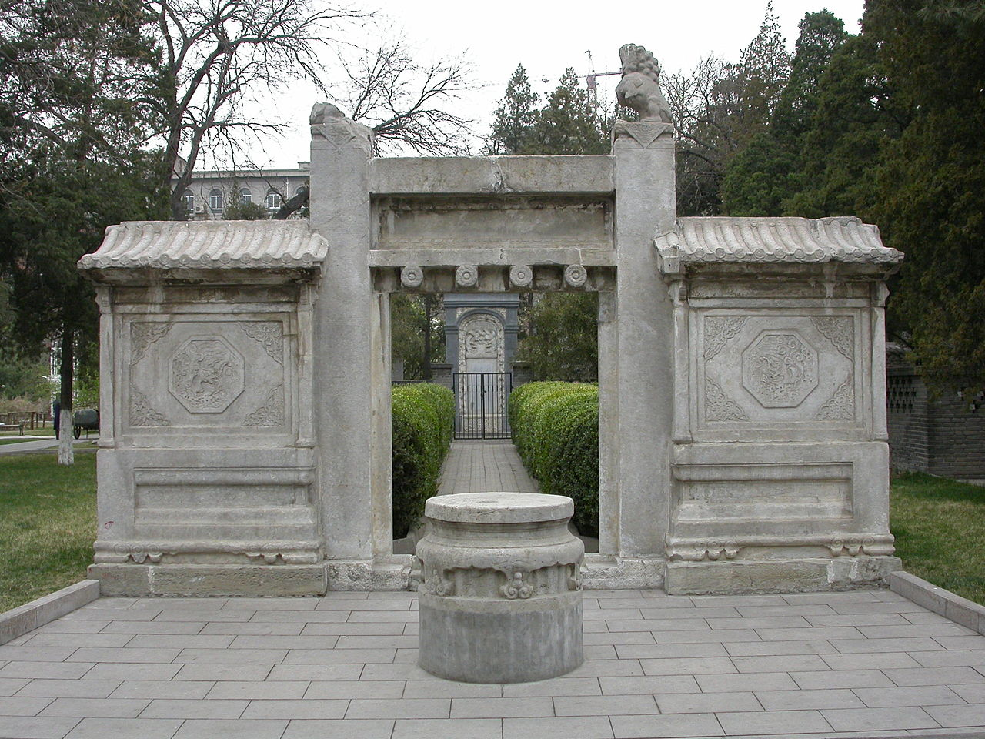

We briefly discussed the pioneer Jesuit missionary to China, Matteo Ricci, whose tomb in Beijing, Don told us, was vandalised during the Cultural Revolution but has now been restored. Ricci was able to impress the Ming emperor with his command of European geographical, astronomical and mechanical knowledge which by the end of the 16th century had surpassed both the Islamic and the Chinese world. Particularly well-known is the world map which he presented, though this met with a frosty reception until the Jesuit had re-arranged the panels to put the Middle Kingdom in the middle! A copy of Ricci’s map is now displayed in the Hong Kong Maritime Museum.

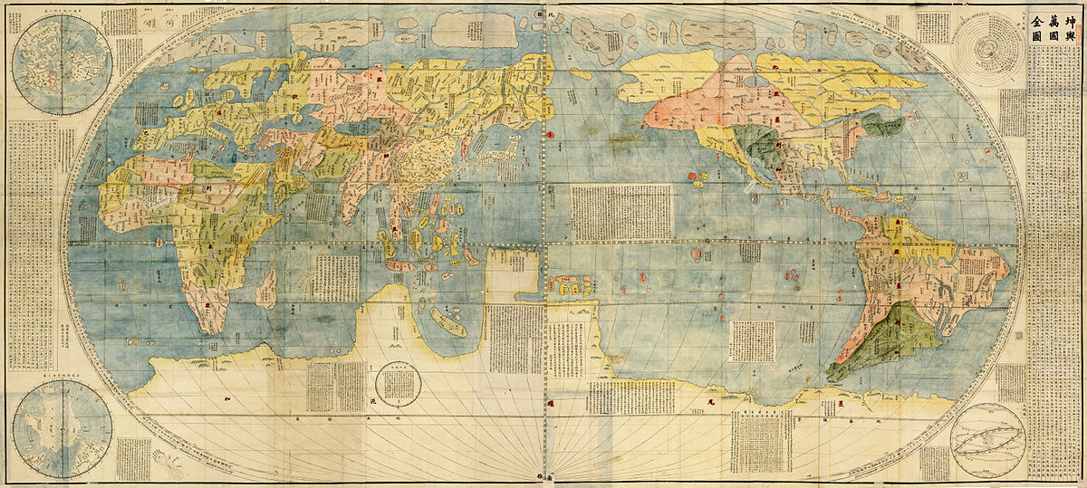
Japanese edition (1604?) of Ricci’s 1602 map

John contrasted Ricci, whose activities in China are an incontrovertible historical fact, with Marco Polo, who some people think never actually made it to the Middle Kingdom but made up a story on the basis of other travellers’ tales. Elizabeth Woods, head of the Chinese section of the British Library, argued in her book Did Marco Polo go to China that the absence of mention of foot binding and of the social role of tea houses, together with the absence of references to him in Chinese sources, were powerful evidence against the historicity of his memoirs. However, none of these ex silentio arguments are conclusive. It could be argued, for example, that footbinding, though it probably originated in the 10th century A.D., might not have spread widely in Chinese society by the 13th century and in any case would not have been practiced by the Yuen (Mongol) dynasty whom Marco Polo claimed to have served. The silence of Chinese sources could conceivably be because record keeping under the short-lived and alien Yuen rulers was probably not as thorough as with other dynasties or because Polo may have played a less important role in the Mongol empire than he claimed. At any rate Don, who has an extensive background in Sinology, believes that Polo did definitely reach China.

Don had brought an issue of the South China Morning Post with a full page feature on major languages and their number of speakers. This lead to a discussion of whether Cantonese should be counted as a separate language or merely a dialect with Tony, who as well as being a native speaker of Cantonese has taken advanced courses on Chinese grammar, was adamant that Cantonese could only be called a dialect whilst John felt that the wide differences in grammatical structure as well as vocabulary at the colloquial level made a case for regarding it as a distinct language. There is a well-known saying that `A language is a dialect with an army and a navy’, and on that political criterion Cantonese, which has never been the official means of communication for an independent state, is simply a dialect. It can also be argued that as speakers of all varieties of Chinese use the same standard written code, there is only one Chinese language: when, as in radio or TV news bulletins, spoken Cantonese is closest to written Chinese, around 90% of the syllables used correspond to standard Chinese morphemes and thus differ from Putonhua only in pronunciations. In colloquial Cantonese, however, only 50 to 70% of the syllables correspond in this way and Cantonese and Putonghua are definitely more distinct than Norwegian and Swedish, which are regarded as different languages. This fact underlines the arbitrariness of the dialect/language dichotomy for spoken language..

We also discussed briefly the vexed question of the number of tones in Cantonese: despending on whose anlalysis you read, the answer can be 9, 7 or 6. The traditional Chinese description of Cantonese certainly distinguishes 9 `tones’ (聲調) but three of these (numbers 7, 8 and 9 - as in 一, 八, 六) differ from 1, 3, 6 (as in 詩, 試, 是) not in tone as understood by musicologists or phonologists but simply in the presence of a `clipped’ or `non-released’ stop consonant (t, p or k) at the end of the syllable.. For this reason, modern textbooks for foreigners learning Cantonese differentiate only six tones for the Hong Kong dialect (seven for Guangzhou where there is still a distinction between .`High Falling’ and `High Level’ which have merged for Hong Kong speakers and in any case have always been conflated as `Tone 1’ under the traditional classification). This is all explained on the web at http://en.wikipedia.org/wiki/Cantonese_phonology and also in most Cantonese textbooks for foreigners.

We read and translated the 22 May 2015 bulletin from Nuniii Latini, the weekly Latin news service prvided since 1989 by Finish Radio. The text with macrons added had been sent to all Circulus members before the meeting but some mistakes were discovered and the corrected version has been added below. New bulletins are uploaded on Fridays to the Finnish Radio’s’s own site (http://areena.yle.fi/1-1931339). This site also archives transcripts (but not all recordings) back to December 2010 and for a fuller, unofficial archive, including recordings from September 2006 onwards, go to http://linguae.weebly.com/nuntii-latini.html .The latter site also has in a single Word document transcripts of almost all bulletins from May 2005 and a less complete file for 2000-2005. Please note that the Linguae page is semi-public (like the adult courses page) and so is not shown in site navigation. You are wlcome to pass on the link to individual friends but I John would prefer not to have it posted in places like Facebook.


The `Nuntii' team from left to right: Satu Tuominen, Suvi Randén, Outi Kaltio, Virpi Seppälä-Pekkanen, Reijo Pitkäranta, Tuomo Pekkanen, Saara Honkanen, Laura Nissin, Antti Ijäs. Photo: Laura Mainiemi/Yle Kuvapalvelu. The photograph accompanies the Finnish site's Latin article on the programme marking its 25th anniversary in 2014.

The Nuntii announcers use the standard Restored Pronunciation of Latin except that, as is often the case in northern Europe, ae and oe are pronounced like ē rather than as `ie’ in die and `oi’ in oil. It should also be noted that one German scolar has recently argued that even in the classical language these digraphs actually represented simple vowels but the mainstream view remains that they remained diphthongs until the early medieval period.

One of the items was on the discontinuation of the train service between Moscow and Tailinn, the capital of Estonia, on which Tanya traveled some years ago. She noted that among the Baltic republics anti-Russian feelings are strongest in Estonia, less so in Latvia (where her own mother was born) and least felt in Lithuania. After these republics, which became independent in 1918, were forcibly incorporated in the Soviet Union in WWII there were large-scale deportations of their inhabitants and sponsored immigration of ethnic Russians to reduce local nationalism. Around 60% of those deported in this way were Estonians. Her Latvian grandparents were deported thre times for ressiting Russification. She also explained that in Latvia there was a tendency for the working classes to accept a switch to Russian whilst middle class parents sought to pass on Latvian to their children.

Nuntii Latini 22.5,15

Nūntiī Latīnī Radiophoniae Finnicae Generalis quōs collegērunt et Latīnē reddidērunt Reijo Pitkäranta, et Saara Honkanen. In studiō Helsinkiēnsī est etiam Laura Nissin.

Quid UE dēcrēverit
Ministrī Ūniōnis Eurōpaeae cōnsilium cēpērunt, quō prohibērētur, nē immīgrantēs marī in Eurōpam clam importārentur. Convēnit dē commūnī āctiōne maritīma suscipiendā, quā contrā negōtiātōrēs huiusmodī commerciī pugnārētur. Placuit classem ē cōpiīs nāvālibus Ūniōnis Eurōpaeae īnstruere, cuius esset omnēs nāvēs, quae in aquīs internātiōnālibus sine vexillō ūllīus cīvitātis nāvigārent, statim occupāre.
(Reijo Pitkäranta)
āctiōnem suscipiō,suscipere, suscēpī, susceptum undertake vexillum. -ī n flag

In Cyprō dē pāce agitur
Nikos Anastasiades, praesidēns Cyprī, et Mustafa Akinci, dux Turcus partis eiusdem īnsulae septentriōnālis, dē pāce in Cyprō restituendā cōnsultāre coepērunt. Concordia, sī inventa erit, et Graecīs et Turcīs magnō ēmolumentō fore existimātur. Cyprus inde ab annō millēsimō nongentēsimō septuāgēsimō quārtō (1974) in duās partēs dīvīsa est.
(Reijo Pitkäranta)
septentrionālis, -e northern inde from that time onwards
magnō ēmolumentō fore to be going to be of great advantage

Mursi capitis damnātus
Muhammed Mursi, pristīnus praesidēns Aegyptī, ūnā cum centum fere aliīs sociīs Ōrdinis frātrum Musulmanōrum capitis damnātus est. Ūniō Eurōpaea hanc sententiam a iūdicibus Aegyptiīs dictam valdē reprehendit. Federīca Mogherini, ministra Ūniōnis ā rēbus exterīs et sēcūritātis negat poenam mortis cum iīs postulātīs congruere, quae iūs internātiōnāle Aegyptiīs imposuerit.
(Reijo Pitkäranta)
capitis damnāre to sentence to death ōrdō, ōrdinis f organization
postulātum, -ī n demand, requirement minister/ministra ā rēbus exterīs minister for external affairs

Dē rē quādam viāriā
Commeātus ferriviārius inter Estōniam et Russiam omnīnō dēsiit, postquam ultimum trāmen, quod Moscuā abierat, diē Martis (19.5.) Tallinnum pervēnit. Operae pretium nōn erat commeātum in eō itinere continuāre, quod numerus viātōrum hāc ferriviā ūtentium valdē deminūtus erat.
(Reijo Pitkäranta)
trāmen, trāminis n train ferriviārius, -a, -um railway adj, ferrivia, -ae f railway
dēsinō, dēsinere, dēsiī cease

De myōpia iuvenum
Myōpia sīve difficultās longē videndīi apud iuvenēs Europaeōs valdē incrēbruit. Ex materiā in dīversīs regiōnibus Eurōpae collectā patet iam dīmidiam fere partem hominum vīgintī quīnque annīs maiōrum, sed ūndētrigintā annīs minōrum illō vitiō labōrāre. Cōnstat iuventūtem Asiae iam prīdem oculōs nōn satis prōspicientēs habēre, et nunc eadem dēbilitās in Eurōpam mānāvit.
(Reijo Pitkäranta)
incrēbrēscō, incrēbrēscere, incrēbruī become stronger or more intense; spread
iam prīdem already for some time

De aestibus fervidīs
Hīs diēbus tempestās in paenīnsulā Pyrenaeā multō calidior fuit quam mēnse Maiō fierī solet. Meteorologī novōs prīmātūs calōris in tabulās rettulērunt, cum temperātūra in Portugalliā meridiānā usque ad quadrāgintā et in partibus Hispāniae orientālibus prope ad quadrāgintā trēs gradūs Celsiānōs ascendisset. Tālēs aestūs ante mediam aestātem rārissimē inveniuntur.
(Saara Honkanen)
prīmātus, -ūs m first place or ranking, record gradus, -ūs m step, rank, grade,

Novī bibendī mōrēs
Cōnsumptiō alcohōlī in Finlandiā etiam annō proximē praeteritō dēscendit. Quod imprīmīs ad ūsum spīritus fortis, vīnī merī, vīnī pōmāriī pertinet, sed etiam cerevisia apud nōs moderātius bibi coepta est. Tālis progressus tam recessiōnī oeconomicae et tribūtīs auctīs quam mōribus bibendī mūtātīs adscrībendus est.
(Reijo Pitkäranta)
proximē praeteitus, -a, -um `most closely past’ (i.e, last)
spīritus, -ūs m fortis strong spirit merus, -a, -um pure, unmixed
vīnum pōmārium apple wine (cider) cerevisia, -ae f beer tribūtum -ī n tax

Haec habuimus quae vōbis hodiē referrēmus. Valēte.
QUESTIONS ARISING FROM 55th MEETING - 26/6/15

We read the beginning of the story of Hercules in chapters 12-16 of Steadman’s edition of Ritchie’s Fābulae Facilēs, which can be downloaded from http://geoffreysteadman.com/ritchies-fabulae-faciles/
or the 2012 hard copy purchased for US$6.95 from Amazon (http://www.amazon.com/Ritchies-Fabulae-Faciles-Vocabulary-Commentary/dp/0984306552/) There are also various other versions of Ritchie’s classic (originally published in 1879) both on the web and available in some book stores. The text which we used (re-printed below) is Steadman’s 2014 on-line version, which was sent to all members of the Circulus Latinus recently, but the corrected June 2015 revision of this is now available on Steadman’s site. His work is largely reliable but usually contains a few macron mistakes.

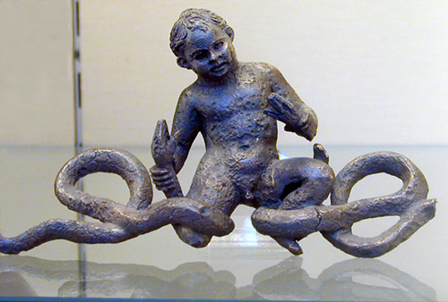

The infant Hercules strangling the snakes sent by Juno to kill him

The occurrence of the word vī in the extract prompted discussion of the legal phrase nec vī nec clam nec precāriō. Tony, a retired professor of law, expained this was used to describe the circumstances in which mere occupation of land was held to confer ownership after a fixed period. The literal meaning is `neither by force, nor secretly, nor by entreaty’ - in other words the occupier did not seize the property violently, conceal what he was doing nor request the original owner’s permission. The Latin precārius, -a, -um is connected with prex, precis f (prayer) and developed the meaning of English precarious later on, presumably because original agreement might be reversed later on. We also wondered about the distinction between necō and interficiō. Both are normally translated kill but some authors suggest necō is used for killing by starvation, poison etc. rather than with a weapon.

Also distributed was a handout `IUNCTURAE SIMPLICES (JUNE 2015)’, which was modified from some of the material at http://linguae.weebly.com/circulus-latinus-honcongensis.html and has also been pasted below. Added items included Āfrica Austrālis (Nuntii Latini’s standard name for South Africa, the adjective of nationality Austrō-Āfricānus (John’s coinage) and professor ēmeritus iūrisprūdentiae for retired law professor, which might also be professor iūrisprūdentiae rude dōnātus, referring to the wooden staff presented to a gladiator when he was relieved of the obligation to continue fighting,

Chris, our South African member, who came to Hong Kong to teach at an independent school, has now resigned from his post but, luckily for us, will be staying in the SAR as a tutor of the many subjects he commands. He explained that, like many white South Africans, he had left the country because affirmative action policies made it difficult to obtain professional employment. He believed the white population, 15% at the end of minority rule, was now down to 6-7%.

Tanya, brought along a copy of Paul Robert’s book on Pompeii and Herculaneum, which was published in 2013 to accompany the British Museum exhibition on the cities, which is alo available on Amazon (http://www.amazon.co.uk/Life-death-Pompeii-Herculaneum-Roberts/dp/0714122823/)
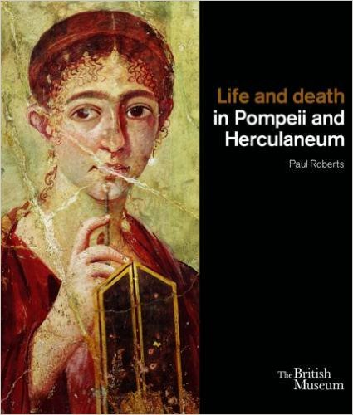
This reveals that the famous bust of Caecilius featured in the Cambridge Latin Course and many other publications is only the top section of what is actually a herm - a pillar endowed with male genitals.The use of phallic symbols -whether realistic imitations or stylized representations- was common in Roman, as in many other cultures, and was believed to ward off the evil eye (see the Circulus discussion in November 2012 - QUESTIONS ARISING (II), p.4-5) and also http://www.wondersandmarvels.com/2013/07/caecilius-willy.html)
.
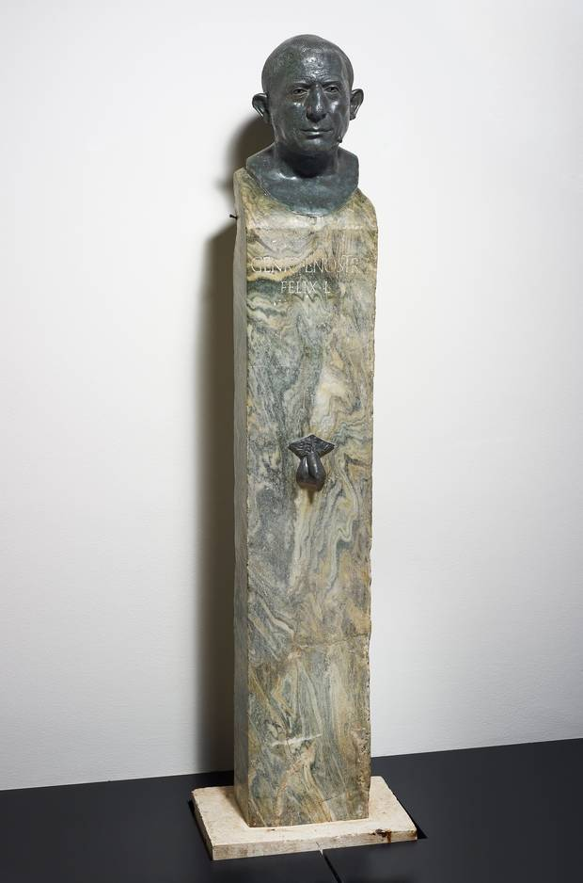
The inscription on the herm reads:

GENIO L[UCIO] NOSTRI
FELIX L[IBERTUS]

This translates: `To the genius (divine spirit) of our Lucius. Felix the freedman [set this up].’ A person’s genius was a kind of guardian deity which was believed to accompany them throughout their life, a little like the Christian concept of a guardian angel, and the genius of the master of the household was worshipped in a similar way to the lares, the guardian spirits of the house.

We are not in fact sure that the bust is the picture of the Lucius Caecilius Iucundus whose banking records were found in the house, nor of the exact relationship between him and Felix. The latter is probably the Lucius Caecilius Felix also mentioned in the records who might even have been the father of Iucundus, as we believehe was the son of a freedman. In that case the bust is of an earlier master of the house. Archaeolgists have argued that the style of the sculpture indicates an Augustan date (i.e before 14 A.D.). Whether or not he is the man represented, `our’ Caecilius probably died not in the 79 A.D. eruption but in the earthquake seventeen years earlier, as his banking records stop in 62 A.D. The records themselves, though found in the remains of the tablīnum, had probably been stored on the upper storey and fallen to the ground floor when the former collapsed.

It is, of course, the Cambridge narrative, not the detailed investigations of archaeologists, that have made so many people familiar with Caecilius’s name. The CLC is now used in over 90% of UK schools and perhaps 50% of American ones and Caecilius himself has featured in a story in the long-running British TV series, Dr. Who (see https://en.wikipedia.org/wiki/The_Fires_of_Pompeii)

Tanya has also recently acquired Mary Beard’s The Fires of Vesuvius: Pompeii Lost and Found (http://www.amazon.co.uk/Fires-Vesuvius-Pompeii-Lost-Found/dp/0674045866/ ), which is also aavailable under the alternative title Pompeii: The Life of a Roman Town - whether through incompetence or disnonesty, Amazon suggests purchasing the two titles together! The value of the book itself is not in doubt, with one Amazon reviwer (himself an archaeologist) writing that it `has a
rare quality of being accessible to an intelligent Junior High School student with an interest in the subject - yet, simultaneously it is so full of new details about individual homes and public buildings as to be endlessly fascinating even to professional scientists and classicists already quite familiar with the cities of Vesuvius.’

A third excellent read, recommended by both Tanya and John, is Robert Harris’s historical novel, Pompeii, whose central character is an aquārius (water engineer) working on the Aqua Augusta, the complex aqueduct system that supplied the towns around the Bay of Naples (see https://en.wikipedia.org/wiki/Aqua_Augusta_(Naples) and terminated at the northern end of the bay in the enormous cistern (the Piscīna Mīrābilis) serving the naval base at Misēnum.

Food ordered included, apart from the usual naan (pānis Persicus) and rice (orӯza), saag paneer (spinach and cheese), which translates as spinacia cum cāseō, alu gobi (potato and cauliflower, solāna cum brassicā Pompēiānā) and a salad of fish and fruit (acētāria (-ōrum, n.pl) ē pisce frūctibusque?). We also had chicken tikka masala, which is chunks (tikka) of chicken in a creamy, spiced sauce and might be translated fusta (pieces) gallīnācea in iūre (sauce) arōmāticō The ingredients also include yoghurt (iogurtum, -ī n) and tomato (lycopersicum). This last word is literally `wolf-peach) because the tomato plant is a member of the night shade family and it was believed in Europe that wizards used night shade to transform themselves into werewolves.

FĀBULA HERCULIS

12. THE HATRED OF JUNO
Herculēs, Alcmēnae fīlius, ōlim in Graeciā habitābat. Hic omnium hominum validissimus fuisse dīcitur. At Iūnō, rēgīna deōrum, Alcmēnam ōderat et Herculem adhūc īnfantem necāre voluit. Mīsit igitur duās serpentēs saevissimās; hae mediā nocte in cubiculum Alcmēnae vēnērunt, ubi Herculēs cum fratre suō dormiēbat. Nec tamen in cūnīs, sed in scūtō magnō cubābant. Serpentēs iam appropinquāverant et scūtum movēbant; itaque puerī ē somnō excitātī sunt.

13. HERCULES AND THE SERPENTS
Īphiclēs, frāter Herculis, magnā vōce exclāmāvit; sed Herculēs ipse, fortissimus puer,haudquāquam territus est. Parvīs manibus serpentēs statim prehendit, et colla eārum magnā vī compressit. Tālī modō serpentēs ā puerō interfectae sunt. Alcmēna autem, māter puerōrum, clamōrem audīverat, et marītum suum ē somnō excitāverat. Ille lūmen accendit et gladium suum rapuit; tum ad puerōs properābat, sed ubi ad locum vēnit, rem mīram vīdit, Herculēs enim rīdēbat et serpentēs mortuās mōnstrābat.

14. THE MUSIC-LESSON
Herculēs ā puerō corpus suum diligenter exercēbat; magnam partem diēī in palaestrā consumēbat; didicit etiam arcum intendere et tēla conicere. Hīs exercitātiōnibus vīrēs eius confirmātae sunt. In musicā etiam ā Linō centaurō ērudiēbatur (centaurī autem equī erant sed caput hominis habēbant); huic tamen artī minus dīligenter studēbat. Hic Linus Herculem ōlim obiurgābat, quod nōn studiōsus erat; tum puer īrātus citharam subitō rapuit, et omnibus vīribus caput magistrī īnfēlīcis percussit. Ille ictū prostrātus est, et paulō post ē vītā excessit, neque quisquam posteā id officium suscipere voluit.

15. HERCULES ESCAPES SACRIFICE
Dē Hercule haec etiam inter alia nārrantur. Ōlim dum iter facit, in fīnēs Aegyptiōrum vēnit. Ibi rēx quīdam, nōmine Būsīris, illō tempore rēgnābat; hic autem vir crūdēlissimus hominēs immolāre cōnsuēverat. Herculem igitur corripuit et in vincula coniēcit. Tum nūntiōs dīmisit et diem sacrificiō ēdīxit. Mox ea diēs appetēbat, et omnia rīte parāta sunt. Manūs Herculis catēnīs ferreīs vinctae sunt, et mola salsa in caput eius inspersa est. Mōs enim erat apud antīquōs salem et far capitibus victimārum impōnere. Iam victima ad āram stābat; iam sacerdōs cultrum sūmpserat. Subitō tamen Herculēs magnō cōnātū vincula perrūpit; tum ictū sacerdōtem prostrāvit; alterō rēgem ipsum occīdit.

16. A CRUEL DEED
Herculēs iam adulēscēns Thēbīs habitābat. Rēx Thēbārum, vir ignāvus, Creōn appellābātur. Minyae, gēns bellicōsissima, Thēbānīs fīnitimī erant. Lēgātī autem ā Minyīs ad Thēbānōs quotannīs mittēbantur; hī Thēbās veniēbant et centum bovēs postulābant. Thēbānī enim ōlim ā Minyīs superātī erant; tribūta igitur rēgī Minyārum quotannīs pendēbant. At Herculēs cīvēs suōs hōc stipendiō līberāre cōnstituit; lēgātōs igitur comprehendit, atque aurēs eōrum abscīdit. Lēgātī autem apud omnēs gentēs sānctī habentur.

17. THE DEFEAT OF THE MINYAE
Ergīnus, rēx Minyārum, ob haec vehementer īrātus statim cum omnibus cōpiīs in fīnēs Thēbānōrum contendit. Creōn adventum eius per explōrātōrēs cognōvit. Ipse tamen pugnāre nōluit, nam magnō timōre affectus erat; Thēbānī igitur Herculem imperātōrem creāvērunt. Ille nūntiōs in omnēs partēs dīmīsit, et cōpiās coēgit; tum proximō diē cum magnō exercitū profectus est. Locum idōneum dēlēgit et aciem īnstrūxit. Tum Thēbānī ē superiōre locō impetum in hostēs fēcērunt. Illī autem impetum sustinēre nōn potuērunt; itaque aciēs hostium pulsa est atque in fūgam conversa.
IŪNCTŪRAE SIMPLICĒS (Iūniī 2015)
Fundamentālia

Iterum dīc, quaesō Say again, please.
Lentē quaesō Slowly, please
Maiōre vōcē, quaesō Louder, please
Scrībe, quaesō Write it down, please
Nōn intellegō I don’t understand
Intellegisne/Intellegitisne? Do you understand?
Nōn intellēxī I didn’t understand?
Intellēxistīne/Intellēxistisne? Did you understand or Have you understood?
Quōmodo dīcitur _____Latīnē/Anglicē How do you say _______ in Latin/English
Quid hoc vocātur? What’s this called?
Ita (est), Etiam Yes
Minimē Not at all
Mihi ignōsce Sorry

In tabernā

Requīrisne vīnum ? Do you want some wine?
Sōlum theam requīrō I only want tea
Aliquidne requīris? Do you want anything?
Cibum poscāmus! Let’s order the food!
Ubi est latrīna? Where’s the toilet
Ibi in fīne illīus andrōnis? At the end of that corridor
Ratiōnem postulā! Ask for the bill!

Salvē/salvēte Hello
Quid/Quod est tibi nōmen ? What’s your name
Mihi nōmen (Anglicum/Sīnicum/Latīnum) My (English/Chinese/Latin) name is _________
est_______
Quid agis? How are you
Bene/Mediocriter/Atrōciter mē habeō I’m fine
Valē/valēte Goodbye

QUAESTIONĒS ET RESPŌNSA

Ubi nātus/nāta es? Where were you born?
In Sīnā/Britanniā/Canadā/ Americā I was born in China/Britain/Canada/America
Francogalliā / Germāniā /Corēā France /Germany/Korea/Australia
Austrāliā/Āfricā Austrālī nātus/nāta sum
Cuius es cīvitātis ? What’s your nationality?
Britannus/a sum I’m British
Candiānus /a Americānus/a Canadian American
Francogāllus/a Germānus/a French German
Sīnēnsis Coreānus/a Chinese Korean
Austrāliānus/a Austro-Āfricānus Australian South-African
Quot annōs nātus/nāta es? How old are you?
------ annōs nātus/nāta sum I’m ____ years old
Habēsne fīliōs vel fīliās? Do you have any sons or daughters?
Habeō nūllum/ūnum fīlium sed/et nūllam/ I have no/one son and/but no/one daughter
ūnam fīliam
Habeō duōs fīliōs/duās fīliās I have two sons/daughters
Quō mūnere fungeris? What’s your job?
Esne advocātus/a? Are you a lawyer?
Sum argentārius/a - grammaticus/a I’m a banker language teacher professor/profestrix - medicus/a professor doctor
diurnārius/a - advocātus/a journalist lawyer
magister/magistra sacerdos – teacher priest
historicus/a scrīptor/scrīptrix - historian writer
mercātor/mercātrix - officiālis businessman/-woman civil servant
professor ēmeritus iūrisprūdentiae retired professor of law
Ubi habitās? Where do you live?
In īnsulā Honcongī / Novemdracōnibus/ On Hong Kong Island/in Kowloon/in the New
In Terrīs Novīs habeō Territories
Antequam Honcongum vēnistī, ubi habitābās? Before you came to HK, where did you live?
Nottinghāmiae/Londīnī/Berolīnī/ I /lived in Nottingham/London/Berlin/Paris/
Lutetiae/in Sīnā continentālī habitābam in mainland China
Cur linguam Latīnam didicistī? Why did you learn Latin?
Nōndum didicī I haven’t learned yet!
Quia cultūra atque historia antīquae mē Because ancient culture and history attract me
alliciunt
Quia mē linguae tenent/alliciunt. Because languages interest/attract me
Quia in schola mea coācti sumus Because we were forced to learn Latin in school
linguam Latīnam discere .
Quībus aliīs linguis loqueris? What other languages do you speak?
Francogallicē, Germānicē, Sīnicē (sermōnē French, German, Chinese (Cantonese or
Cantonēnsī vel normālī), Iaponīcē, Putonghua) Japanese, Korean, Polish,
Coreānicē, Polonicē, Hispanicē, Graecē Spanish, Greek
QUESTIONS ARISING FROM 56TH MEETING -15/7/15

We read chapters 17 to 23 of Fabulae Faciles, which cover the story of Hercules from the defeat of the Minyae to the completion of his 3rd labour, the killing of the Cerynean stag. The text (with some of the editor’s macron mistakes corrected) is given in the annex below.

As usual we discussed the Latin names for various items on the table, including pōculum (cup or glass) and clāvula (chpstick). The latter really means `little twig’ and there may be a preferable alternative in the writings of Matthaeo Ricci or one of the other early Jesuit missionaries as they certainly discussed the subject. Food consumed included Singapore noodles (collӯra ( -ae f) Singapuriāna) and sweet and sour pork (carō dulcis et acida). As mentioned in previous meetings, gulo yuk, (咕嚕肉) is often transformed by long-time British residents in HK into gweilo yuk (鬼佬肉) because, at least in Britain, it was usually the first Chinese name that gweilo learned to name. We also noted the general expression for curry - īus (iūris n) ācre and that the botanical name for lychee is litchi chīnēnsis - the digraph ch in neo-Latin having a similar value to English whereas in the classical language it probably represented a strongly aspirated c. The fruit is not included in in the best Internet neo-Latin dictionary, the `Morgan Lexicon’ (https://archive.org/details/TheLexiconAnglumEtLatinumByDavidMorgan) The compiler was a professor of French but neo-Latin was his main research interest.He can be seen conducting Latin oral assessments at https://www.facebook.com/photo.php?v=579840842026946

There was a brief discussion of the status of Mongolia and Tibet in relation to Han China. John suggested that the KMT government had at least till recently refused to recognise the independence of Outer Mongolia. Andy believed that they had still not officially announced recognition but accepted it in practice. Of course, since there is no question of formal diplomatic relations being established between Taiwan and Mongolia, the issue is purely academic.

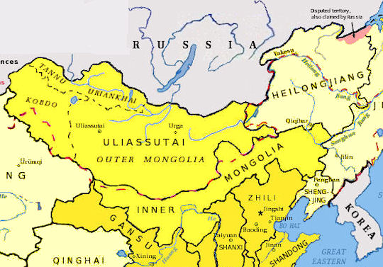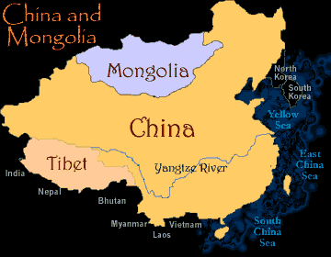
John also mentioned that the distinguished American scholar of the Himalayas, Leo Rose, believed that Tibet might have emerged as an independent state last century if the British had been as weilling to press for this as the Russians were to press for the independence of Outer Mongolia. The British recognised Cinese `suzerainty’ over Tibet - a status whioch no longer exists in international law but was once a half-way house between being part of a larger state and being completely independent. When they ruled India the Brtish were happy for China to maintain some sort of claim over Tibet in order to offset the interesta in the region of the Russians. Rose was tha author of the classic study. Nepal: Strategy for Survival, which analysed how Nepal managed to preserve its independence by collaborating with Brtiish India when China was enfeebled, but at other times balancing between its northern and southern neighbours.

Paul spoke highly of the competence of Chinese civil servants in Hong Kong, arguing that, given the relatively poor performance of Britain’s own bureaucracy at home, credit for achievements here could hardly be given to expat administrators. He was scathing about the record of British governments, except for Clement Attlee’s 1954-1951 administration, which had established the National Health Service and also a system of secondary education for everyone, from which he himself had benefited.

FĀBULA HERCULIS
12. THE HATRED OF JUNO
Herculēs, Alcmēnae fīlius, ōlim in Graeciā habitābat. Hic omnium hominum validissimus fuisse dīcitur. At Iūnō, rēgīna deōrum, Alcmēnam ōderat et Herculem adhūc īnfantem necāre voluit. Mīsit igitur duās serpentēs saevissimās; hae mediā nocte in cubiculum Alcmēnae vēnērunt, ubi Herculēs cum fratre suō dormiēbat. Nec tamen in cūnīs, sed in scūtō magnō cubābant. Serpentēs iam appropinquāverant et scūtum movēbant; itaque puerī ē somnō excitātī sunt.

13. HERCULES AND THE SERPENTS
Īphiclēs, frāter Herculis, magnā vōce exclāmāvit; sed Herculēs ipse, fortissimus puer,haudquāquam territus est. Parvīs manibus serpentēs statim prehendit, et colla eārum magnā vī compressit. Tālī modō serpentēs ā puerō interfectae sunt. Alcmēna autem, māter puerōrum, clamōrem audīverat, et marītum suum ē somnō excitāverat. Ille lūmen accendit et gladium suum rapuit; tum ad puerōs properābat, sed ubi ad locum vēnit, rem mīram vīdit, Herculēs enim rīdēbat et serpentēs mortuās mōnstrābat.

14. THE MUSIC-LESSON
Herculēs ā puerō corpus suum diligenter exercēbat; magnam partem diēī in palaestrā consumēbat; didicit etiam arcum intendere et tēla conicere. Hīs exercitātiōnibus vīrēs eius confirmātae sunt. In musicā etiam ā Linō centaurō ērudiēbatur (centaurī autem equī erant sed caput hominis habēbant); huic tamen artī minus dīligenter studēbat. Hic Linus Herculem ōlim obiurgābat, quod nōn studiōsus erat; tum puer īrātus citharam subitō rapuit, et omnibus vīribus caput magistrī īnfēlīcis percussit. Ille ictū prostrātus est, et paulō post ē vītā excessit, neque quisquam posteā id officium suscipere voluit.

15. HERCULES ESCAPES SACRIFICE
Dē Hercule haec etiam inter alia nārrantur. Ōlim dum iter facit, in fīnēs Aegyptiōrum vēnit. Ibi rēx quīdam, nōmine Būsīris, illō tempore rēgnābat; hic autem vir crūdēlissimus hominēs immolāre cōnsuēverat. Herculem igitur corripuit et in vincula coniēcit. Tum nūntiōs dīmisit et diem sacrificiō ēdīxit. Mox ea diēs appetēbat, et omnia rīte parāta sunt. Manūs Herculis catēnīs ferreīs vinctae sunt, et mola salsa in caput eius inspersa est. Mōs enim erat apud antīquōs salem et far capitibus victimārum impōnere. Iam victima ad āram stābat; iam sacerdōs cultrum sūmpserat. Subitō tamen Herculēs magnō cōnātū vincula perrūpit; tum ictū sacerdōtem prostrāvit; alterō rēgem ipsum occīdit.

16. A CRUEL DEED
Herculēs iam adulēscēns Thēbīs habitābat. Rēx Thēbārum, vir ignāvus, Creōn appellābātur. Minyae, gēns bellicōsissima, Thēbānīs fīnitimī erant. Lēgātī autem ā Minyīs ad Thēbānōs quotannīs mittēbantur; hī Thēbās veniēbant et centum bovēs postulābant. Thēbānī enim ōlim ā Minyīs superātī erant; tribūta igitur rēgī Minyārum quotannīs pendēbant. At Herculēs cīvēs suōs hōc stipendiō līberāre cōnstituit; lēgātōs igitur comprehendit, atque aurēs eōrum abscīdit. Lēgātī autem apud omnēs gentēs sānctī habentur.

17. THE DEFEAT OF THE MINYAE
Ergīnus, rēx Minyārum, ob haec ehementer īrātus statim cum omnibus cōpiīs in fīnēs Thēbānōrum contendit. Creōn adventum eius per explōrātōrēs cognōvit. Ipse tamen pugnāre nōluit, nam magnō timōre affectus erat; Thēbānī igitur Herculem imperātōrem creāvērunt. Ille nūntiōs in omnēs partēs dīmīsit, et cōpiās coēgit; tum proximō diē cum magnō exercitū profectus est. Locum idōneum dēlēgit et aciem īnstrūxit. Tum Thēbānī ē superiōre locō impetum in hostēs fēcērunt. Illī autem impetum sustinēre nōn potuērunt; itaque aciēs hostium pulsa est atque in fūgam conversa.

18. MADNESS AND MURDER
Post hoc proelium Herculēs cōpiās suās ad urbem redūxit. Omnēs Thēbānī propter victōriam maximē gaudēbant; Creōn autem magnīs honoribus Herculem decorāvit, atque fīliam suam eī in mātrimōnium dedit. Herculēs cum uxōre suā beātam vītam agēbat; sed post paucōs annōs subitō in furōrem incidit, atque līberōs suōs ipse suā manū occīdit. Post breve tempus ad sānitātem reductus est, et propter hoc facinus magnō dolōre affectus est; mox ex urbe effūgit et in silvās sē recēpit. Nolēbant enim cīvēs sermōnem cum eō habēre.

19. HERCULES CONSULTS THE ORACLE
Herculēs tantum scelus expiāre magnopere cupiēbat. Constituit igitur ad ōrāculum Delphicum īre; hoc enim ōrāculum erat omnium celeberrimum. Ibi templum erat Apollinis plūrimīs dōnīs ornātum. Hōc in templō sedēbat fēmina quaedam, nōmine Pythia, et cōnsilium dabat eīs quī ad ōrāculum veniēbant. Haec autem fēmina ab ipsō Apolline docēbātur, et voluntātem deī hominibus ēnuntiābat. Herculēs igitur, quī Apollinem praecipuē colēbat, hūc vēnit. Tum rem tōtam exposuit, neque scelus cēlāvit.

20. THE ORACLE'S REPLY
Ubi Hercules fīnem fēcit, Pythia prīmō tacēbat; tandem tamen iussit eum ad urbem Tīryntha īre, et Eurystheī rēgis omnia imperāta facere. Herculēs ubi haec audīvit, ad urbem illam contendit, et Eurystheō rēgī sē in servitūtem trādidit. Duodecim annōs crūdēlissimō Eurystheō serviēbat, et duodecim lābōrēs, quōs ille imperāverat, cōnfēcit; hōc enim ūnō modō tantum scelus expiārī potuit. Dē hīs lābōribus plūrima ā poētīs scrīpta sunt. Multa tamen quae poētae nārrant vix crēdibilia sunt.

21. 1st LABOR: THE NEMEAN LION
Prīmum ab Eurystheō iussus est Herculēs leōnem occīdere quī illō tempore vallem Nemeaeam reddēbat īnfestam. In silvās igitur in quibus leō habitābat statim sē contulit. Mox feram vīdit, et arcum, quem sēcum attulerat, intendit; eius tamen pellem, quae dēnsissimaerat, trāicere non potuit. Tum clāvā magnā quam semper gerēbat leōnem percussit, frūstrā tamen; neque enim hōc modō eum occīdere potuit. Tum dēmum collum mōnstrī bracchiīs suīs complexus est et faucēs eius omnibus vīribus compressit. Hōc modō leō brevī tempore exanimātus est; nūlla enim respīrandī facultās eī dabātur. Tum Herculēs cadāver ad oppidum in umerīs rettulit; et pellem, quam dētrāxerat, posteā prō veste gerēbat. Omnēs autem quī eam regiōnem incolēbant, ubi fāmam dē morte leōnis accēpērunt, vehementer gaudēbant et Herculem magnō
honōre habēbant.

22. 2nd LABOR: THE LERNEAN HYDRA
Paulō post iussus est ab Eurystheō Hydram necāre. Hoc autem mōnstrum erat cui novem erant capita. Herculēs igitur cum amīcō Iolaō profectus est ad palūdem Lernaeam, in quā Hydra habitābat. Mox mōnstrum invēnit, et quamquam rēs erat magnī perīculī, collum eius sinistrā prehendit. Tum dextrā capita novem abscīdere coepit; quotiēns tamen hoc fēcerat, nova capita exoriēbantur. Diū frūstrā lābōrābat; tandem hōc cōnātū dēstitit. Deinde arborēs succīdere et ignem accendere cōnstituit. Hoc celeriter fēcit, et postquam ligna ignem comprehendērunt, face ārdente colla adūssit, unde capita exoriēbantur. Nec tamen sine magnō lābōre haec fēcit; vēnit enim auxiliō Hydrae cancer ingēns, quī, dum Herculēs capita abscīdit, crūra eius mordēbat. Postquam mōnstrum tālī modō interfēcit, sagittās suās sanguine eius imbuit, itaque mortiferās reddidit.

23. 3rd LABOR: THE CERYNEAN STAG
Postquam Eurystheō caedēs Hydrae nuntiāta est, magnus timor animum eius occupāvit. Iussit igitur Herculem cervum quendam ad sē referre; nōluit enim virum tantae audāciae in urbe retinēre. Hic autem cervus, cuius cornua aurea fuisse trāduntur, incrēdibilī fuit celeritāte. Herculēs igitur prīmō vestīgiīs eum in silvā persequēbatur; deinde ubi cervum ipsum vīdit, omnibus vīribus currere coepit. Ūsque ad vesperum currēbat, neque nocturnum tempus sibi ad quiētem relinquēbat, frūstrā tamen; nūllō enim modō cervum cōnsequī poterat. Tandem postquam tōtum annum cucurrerat (ita trāditur), cervum cursū exanimātum cēpit, et vīvum ad Eurystheum rettulit.

